THE MENACE

PROJECT REPORT



INFO-6205

Program Structures and Algorithms

INSTRUCTOR

Prof. Robin Hillyard

TEAM

1.Jayesh Khattar

2. Mayank Yadav

3. Sangram Vuppala

Introduction

Tic-tac-toe, also known as noughts and crosses or Xs and Os, is a two-person paper and pencil game in which each player alternates marking squares in a three-by-three grid with an X or an O. The winner is the player who successfully places three of their markers in a horizontal, vertical, or diagonal row. It's a solved game with a forced draw if both players play their best.

Donald Michie created MENACE (Machine Educable Noughts And Crosses Engine) in 1961, a machine that could learn to play Noughts and Crosses better. MENACE was made out of 304 matchboxes because computers were not readily available at the time.

MENACE starts with four beads of each color in the first move box, three beads in the third move box, two beads in the fifth move box, and one bead in the final move box. When a bead is removed from each box after a loss, it signifies that subsequent movements are more strongly discouraged. This allows MENACE to learn faster because the latter moves are more likely to have resulted in a loss.

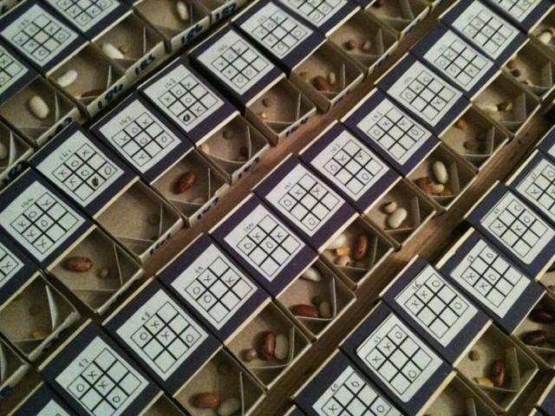

AIM

The aim of the project is to implement menace without matchboxes and by using hash table instead. The keys in the hash-table represents each type of the match boxes which is also the different states of the board.

APPROACH

PROGRAM

DATA STRUCTURES AND CLASSES

ALGORITHM

INVARIENTS

FLOW CHARTS

OBSERVATIONS AND GRAPHICAL ANALYSIS

RESULTS AND MATHEMATICAL ANALYSIS

TESTCASES

CONCLUSION

REFERENCES

-Min Max

* https://www.geeksforgeeks.org/minimax-algorithm-in-game-theory-set-1-introduction/#:~:text=Minimax%20is%20a%20kind%20of,%2C%20Mancala%2C%20Chess%2C%20etc.
* <https://en.wikipedia.org/wiki/Burnside%27s_lemma>
* <https://en.wikipedia.org/wiki/Symmetry_group>

Menace

* <https://www.mscroggs.co.uk/blog/tags/menace>
* <https://en.wikipedia.org/wiki/Matchbox_Educable_Noughts_and_Crosses_E>
* https://www.mscroggs.co.uk/menace/