Ermac Voxel Game v 30 (ARCTIC)
“NEWGEN”
Game name: “Demolition Synergy”

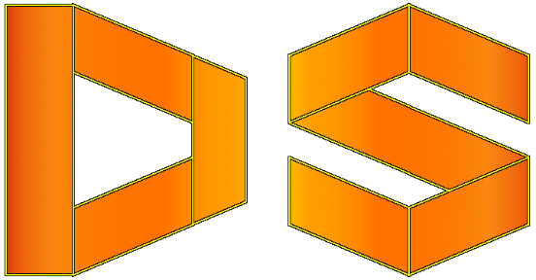

[ARCTIC]
FEATURES:
- Position command (GET Current Position & Chunk,
SET Current Position OR SET Chunk).
- Seed number can be provided to Random Level Generator.

CHANGES:

FIXES:

