Ermac Voxel Game v 16 (PHOSPHORUS)
“NEWGEN”
Game name: “Demolition Synergy”
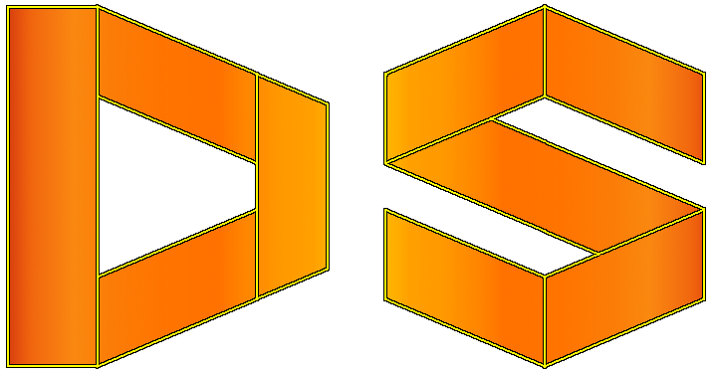

Game Description:
Game combines first person shooter, sandbox and voxel properties. It is uncomplete and in continuous development process.

Game assets structure (by entries):
- effects – contains shaders (according to the OpenGL 3.3 and GLSL 3.3);
- intrface – loading images for interface such as crosshairs, fonts (F2IBuilder) and stuff for menus;
- player – models (.obj format) and textures (.png format) for the player assets;
- sound – contains music and sound fx audio files (.ogg format);
- world – contains models (.obj format) and textures (.png format) for blocks which make environment as it is.
All five entries constitute together one archive which is dsynergy.zip.

Available commands:
In order to type command which is equivalent to options setup press key “~”.
- fps_max<num>, fpsMax<num>: allowing to change max fps (it must be positive number).
- resolution<width><height>, res<width><height>: allowing to change resolution (min resolution is 640x480 whilst max is your native resolution).
- fullscreen: makes your game run fullscreen.
- windowed: makes your game run windowed mode.
- v_sync <bool>, vsync<bool>: whether or not you wanna vsync on or off. If it’s on (you’ve set it to true) your fps is capped to your monitor refresh rate.
- water_efects <bool>: enables (true) or disables (false) water effects (such as reflection).
- mouse_sensitivity<num>, msens <num>: sets mouse sensitivity to this value.
- music <num>, sound <num> : sets respectively music and sound volume to this value.

Notes:
- Game uses LWJGL 3.2.3 since v 02 (BELARUS).
- Game requires Quad Core processor with support for at least 4 threads. Game implementation is multithreaded (at most time 2 threads will be active + 1 additional thread if random level generator is being used or when loading or saving level is in progress).
- Running the game requires OpenGL 3.3 (on graphic cards since March 2010) or later.
- Game is implemented using Java version 1.8. (requires 1.8 or higher).
Author: Alexander “Ermac” Stojanovich (email: coas91@rocketmail.com; Discord: ermac #1844)
Testers: JSomnia, Hellblade64

