Ermac Voxel Game v 49
“Night Zed”
Game name suggestion: “Demolition Synergy”
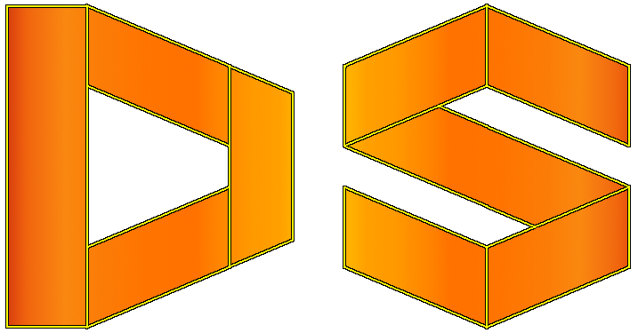
FEATURES:
- Water renderer got implemented, user can see reflections of surroundings in the water;
- New logo and icon are implemented.
CHANGES:
- Text is affected by resolution keeping the same size;
- Mouse input (related to camera) is also affected by resolution giving it “control” over “speed”.
FIXES:
- Fixed glitch when sides of water block are rendered underwater when viewed from above (using OpenGL cull faces);
- Fixed moving through the corners with camera (it has model now);
- Options menu and Editor menu now open Main menu upon closing;
- Camera look from mouse movement and look by turning from keyboard are now in sync.
Available commands:
- fps_max<num>, fpsMax<num>: allowing to change max fps (it must be positive number);
- resolution<width><height>, res<width><height>: allowing to change resolution (min resolution is 640x480 whilst max is your native resolution);
- fullscreen: makes your game run fullscreen;
- windowed: makes your game run windowed mode;
- v_sync <bool>, vsync<bool>: whether or not you wanna vsync on or off. If it’s on (you’ve set it to true) your fps is capped to your monitor refresh rate.
Notes:
- to open command entering dialog press “ ` ” which is “grave accent key”;
- all commands can be written in any case (they will be read as they were written in lower case). Also synonyms are accepted.
Important note:
Reason why LWJGL 3.1.1 is used rather than the latest LWJGL 3.1.3 is because of the mouse input feeling awkwards (too much fluid).

