**Ermac Voxel Game v 23 (XENON)**

**LIGHT VERSION (LEGACY)**

**“NEWGEN”**

**Game name: “Demolition Synergy”**

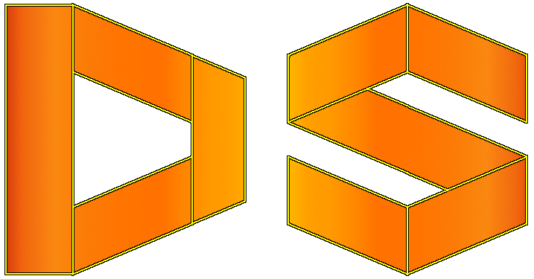

**[XENON]**

**CHANGES:**

* Solid object collision and in the fluid water effect are improved – use approximation of surroundings around the player rather than looping through the many solid objects. Less fps drop when in motion.
* Rework on the fog – fog is everywhere existent and all the objects blend in.
* Random level generator rework – there is 4 type of preexisting levels for the same hardcoded seed. Simplex noise is being used.
* General improvement in multiple object rendering without instancing (for the text rendering and for the old way of block rendering).
* Water effects (non-light, regular version only) are more realistic at low cost to performance (framerate).

**[WARDEN]**

**FEATURES:**

* More ambient tracks & new track when level is randomly generated.
* Credits added to the menu.
* Auto-complete for commands.

**CHANGES:**

* Chunks are determined by using another function.

**[VIVID]**

**CHANGES:**

* Chunk operations are done in timer thread at fixed rate.
* Random level generator uses Noise & Random together to generate random level. First Noise is applied, then random after former is done.
* Block positions are aligned to the even number.

**FIXES:**

* Fixed exceptions when typing in the text causing app to stop.
* Small performance gain.

**[URANIUM]**

**FEATURES:**

* Linear interpolation of framerate (framerate is more stable).

**CHANGES:**

* Chunk operations are done in separate thread. Lesser impact on update per second and faster. [JSomnia]

**FIXES:**

* Game consumes lesser memory (still needs 1.5 GB of RAM for randmax level). [JSomnia]

**\*Notice this is bug/issue fix release.**

**[TITANIUM]**

**FEATURES:**

* Console commands now have post execution status (red if command fails or green if it’s success). If command is not recognized it will have white light bulb.

**CHANGES:**

* Chunk function is improved. Blocks doesn’t appear unexpectedly. [JSomnia]
* Default settings are changed. Mouse sensitivity set from 3.0 to 1.5 and Music and Sound volumes are set from 1.0 to 0.5 [JSomnia]
* Program consumes less memory in general.
* Game is more responsive when loading/saving chunks in general.

**FIXES:**

* [Options Menu] One changed setting doesn’t change all settings unexpectedly.

**[STONEWALL]**

**FEATURES:**

* Safety from unresponsive or failed application is implemented.

If either updates per second or framerate is equal to zero over five seconds application is terminated.

* Console is implemented. Contains history of input commands. [JSomnia]

**CHANGES:**

* Shift key is used when fluids block are being selected or placed adjacently to selected fluid block.
* Selected fluid block has enabled all faces on selection.
* Blocks consume less memory and faster to create.
* Level loading and Random Level generations is much faster now.
* (Debug) Using F4 will print all the chunk data.
* (Editor) Minigun is no more decal yet a separate entity. Lags less.
* Game gains even more fps with the recent changes to the threads.
* Game is organized as main <- Game Object -> Renderer, where Game object is shared Object between two vital threads.

**[RELIC]**

**FEATURES:**

* Use F12 to save screenshots.

**CHANGES:**

* Changes to game loops affecting fps.

**FIXES:**

* Update per second is displayed correctly.

**[PHOSPHORUS]**

**FEATURES:**

* Menu interaction using mouse besides keyboard. Cursor implemented.

**CHANGES:**

* Changes in block add/removal resulting in faster block operations, faster level generation, level saving and loading.

**[OXYGEN]**

**FEATURES:**

* Single player has been unlocked. Player is able to wield one of the six guns (Beretta pistol, SMG P90, Shotgun, Assault rifle AK-47, M60, Sniper Rifle). However there’re no animations for these guns. Neither fire or alt-fire have been implemented yet.
* Entering single player will cancel editor mode and prevent modifying the level unless player choose to go into editor and load level again. Player will be prompted “Start New Game?” and if answer is yes or y game will switch to Single Player mode.

**CHANGES:**

* Game support modifications. Make your own dsynergy_lsv.zip archive or make folders as they’re in archive structure by entries. Game will first check for files in those folders and if they’re not found then will those from archive. Not having game assets at all will result in error.

**KNOWN ISSUESS:**

* Player weapon will be drawn behind blocks if player is close enough to blocks or cause collision with them.

**[NITROGEN]**

**FEATURES:**

* Both music and sounds can be played from the game.
* Game can be run in debug mode (requires setting it to true in .ini file). It includes writing log into the file. [JSomnia]

File is named according to the current date and time.

**CHANGES:**

* [Light support version] -> maximum number of blocks lowered to 20000.
* [Light support version] -> water effects are not longer supported.

**FIXES:**

* Reading water effects from the ini.
* Random level generator generates blocks correctly (same number that was requested).
* Loading randmax.dat doesn’t result in “loading level failed!”.
* Removing fluid blocks doesn’t result in crash when level is loaded. [TODO updating camera and fluids].
* Chunk function which check in which chunk is certain block is now fixed.