**Ermac Voxel Game v 16 (PHOSPHORUS)**

**Light Support Version**

**“NEWGEN”**

**Game name: “Demolition Synergy”**

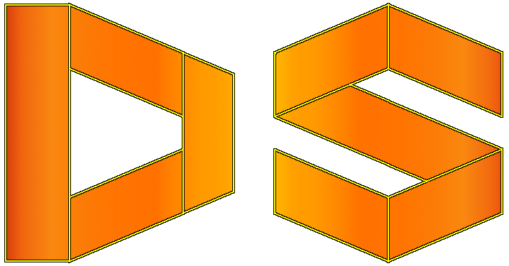

**Game Description:**

Game combines first person shooter, sandbox and voxel properties. It is uncomplete and in continuous development process. This version is lighter than original.

**Source Repository:**

<https://github.com/ErmacMKIII/DemolitionSynergyLight>

**License:**

**GNU General Public License v3.0**

**Game assets structure (by entries):**

* **effects** – contains shaders (according to the OpenGL 2.0 and GLSL 1.1);
* **intrface** – loading images for interface such as crosshairs, fonts (F2IBuilder) and stuff for menus;
* **player** – models (.obj format) and textures (.png format) for the player assets;
* **sound** – contains music and sound fx audio files (.ogg format);
* **world** – contains models (.obj format) and textures (.png format) for blocks which make environment as it is.

**All five entries constitute together one archive which is dsynergy_lsv.zip.**

**Available commands:**

In order to type command which is equivalent to options setup press key “~”.

* fps_max<num>, fpsMax<num>: allowing to change max fps (it must be positive number).
* resolution<width><height>, res<width><height>: allowing to change resolution (min resolution is 640x480 whilst max is your native resolution).
* fullscreen: makes your game run fullscreen.
* windowed: makes your game run windowed mode.
* v_sync <bool>, vsync<bool>: whether or not you wanna vsync on or off. If it’s on (you’ve set it to true) your fps is capped to your monitor refresh rate.
* mouse_sensitivity<num>, msens <num>: sets mouse sensitivity to this value.
* music <num>, sound <num> : sets respectively music and sound volume to this value.

**Notes:**

* Game uses LWJGL 3.2.3 since v 02 (BELARUS).
* Game requires Dual Core processor with support for at least 2 threads. Game implementation is multithreaded (at most time 2 threads will be active + 1 additional thread if random level generator is being used or when loading or saving level is in progress).
* Running the game requires OpenGL 2.0 (on graphic cards since April 2004) or later.
* Game is implemented using Java version 1.8. (requires 1.8 or higher).
* Light support version is lighter version of original designated for computers which are lower spec and prior generations.

Author: Alexander “Ermac” Stojanovich (email: [coas91@rocketmail.com](mailto:coas91@rocketmail.com); Discord: ermac #1844)

Testers: JSomnia, Hellblade64