1. We are entering Android Studio Web page

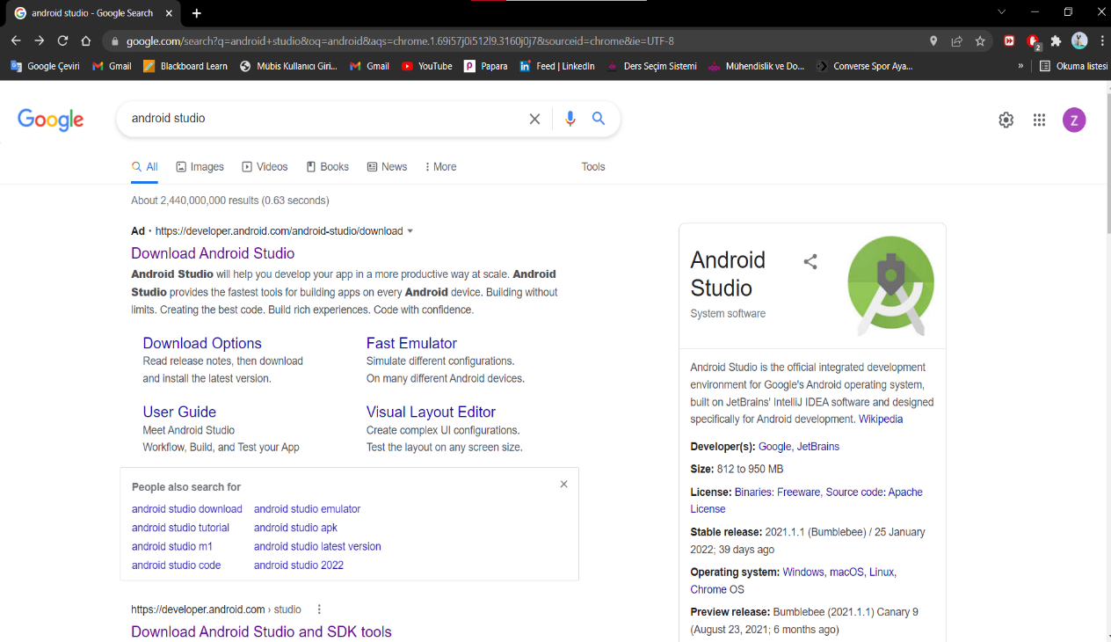

1. metin içeren bir resim

   Açıklama otomatik olarak oluşturulduPress Download Android Studio button
2. 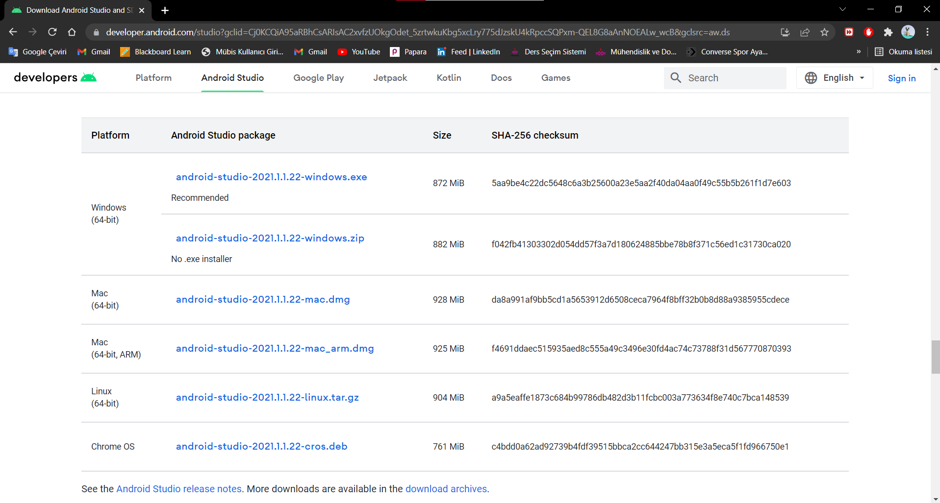Select upper one (android-studio-2021.1.1.2-windows.exe)
3. 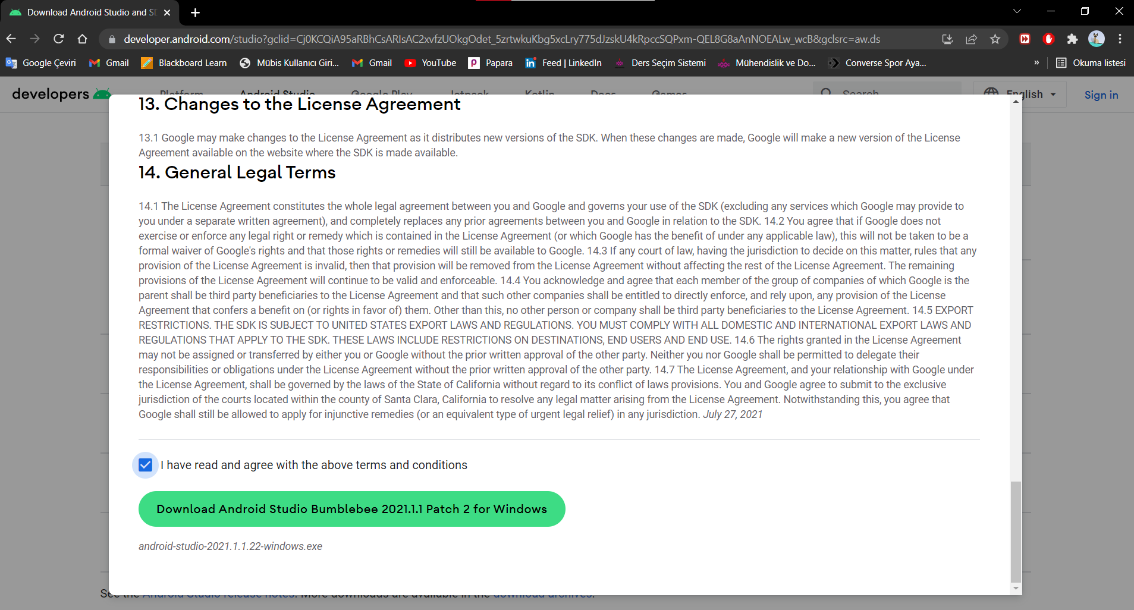We are Excepting terms and conditions, then Pressing Download button
4. Press 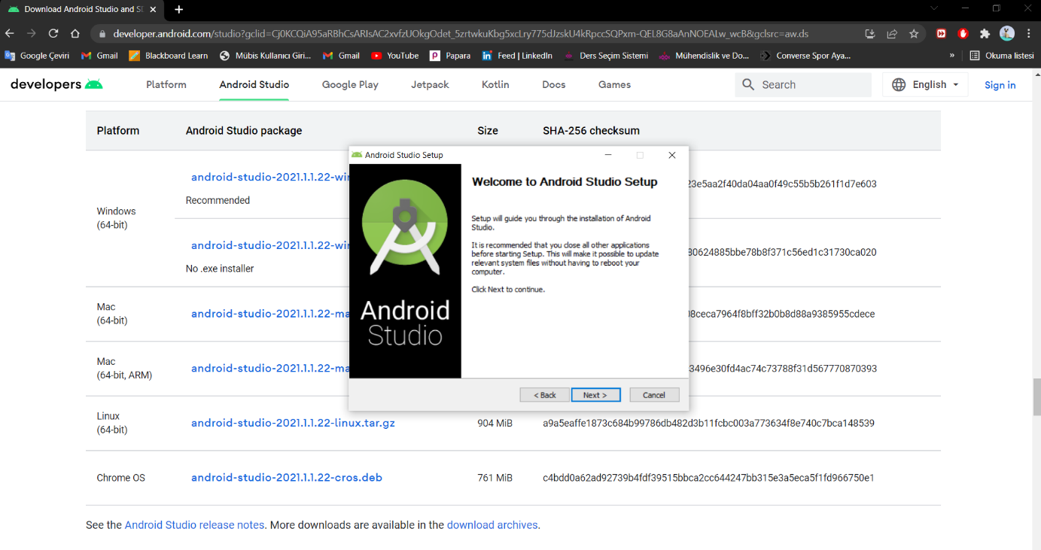next
5. 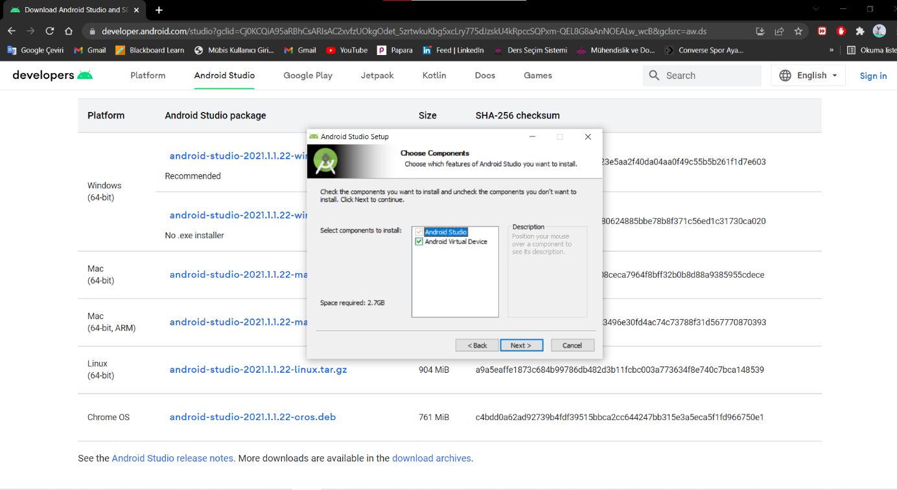Select All and then next
6. 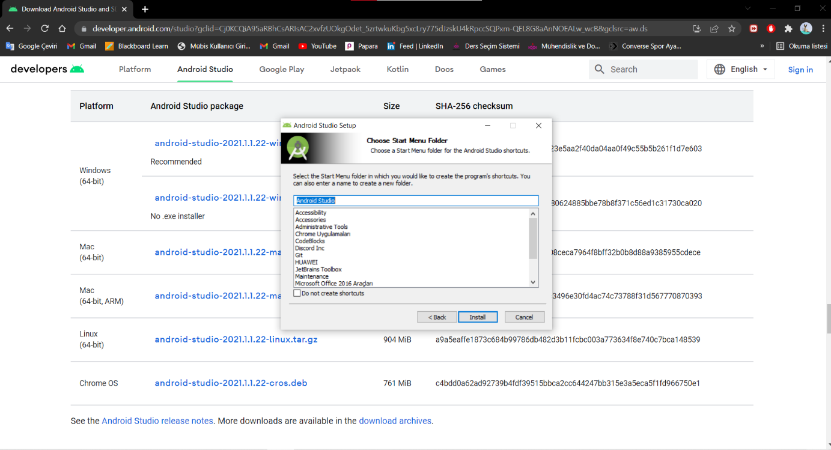Change nothing, Press install
7. Press 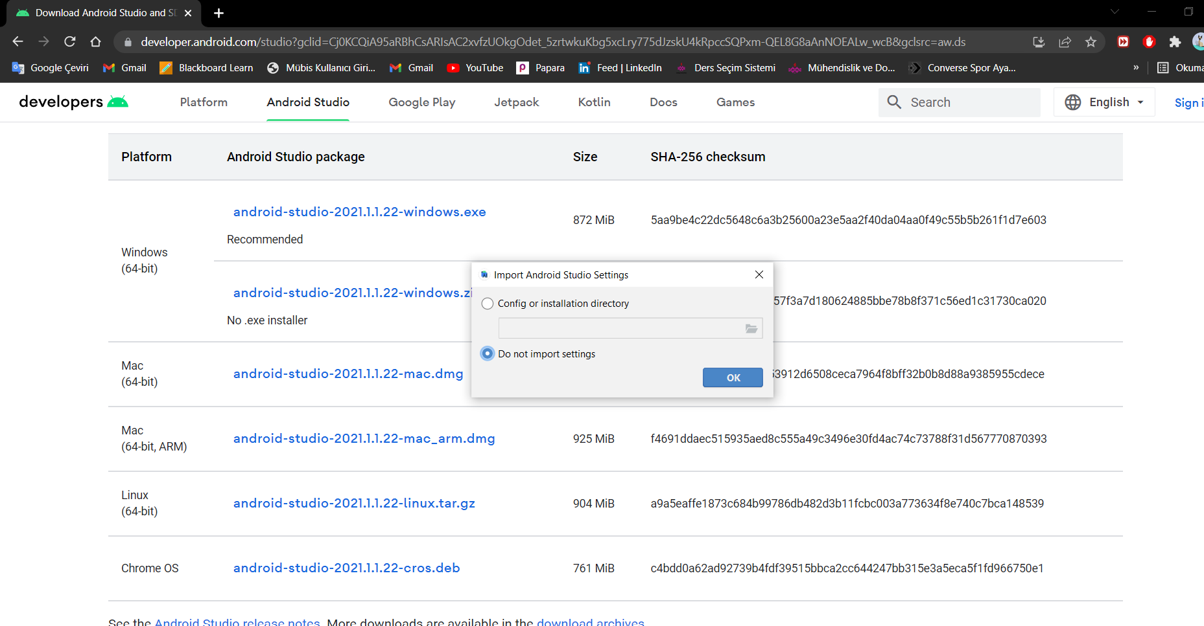Ok
8. Press next

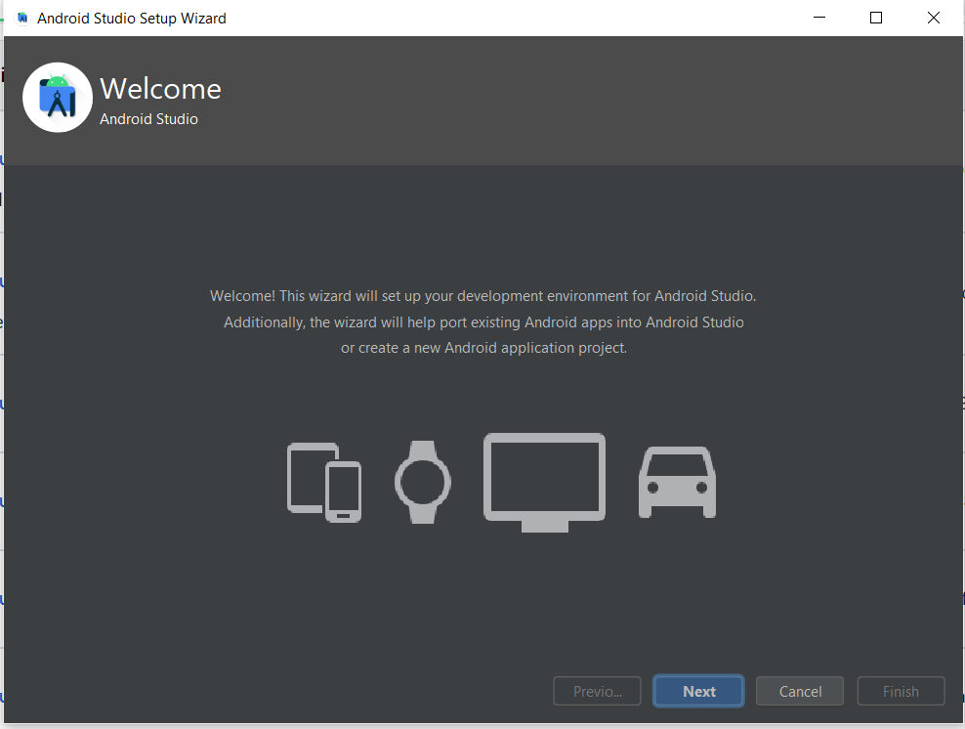

10) 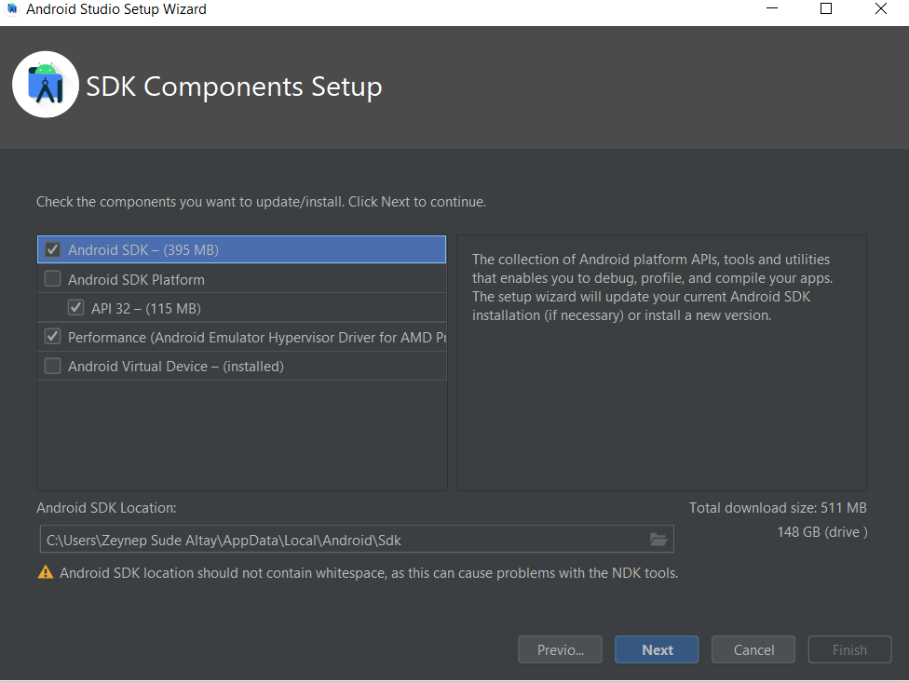Select All (That you can select) And then press next

11) We need to select each of the licenses and accept them, then we can press finish button

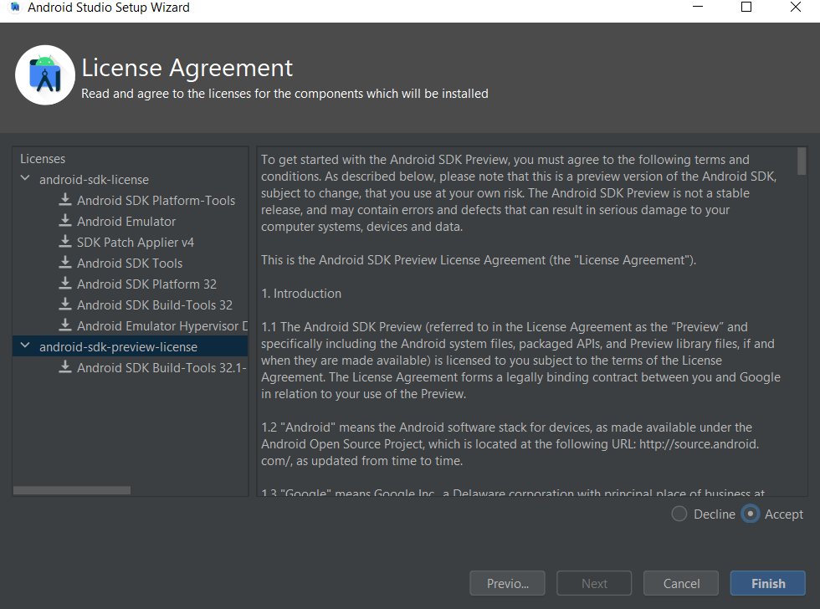

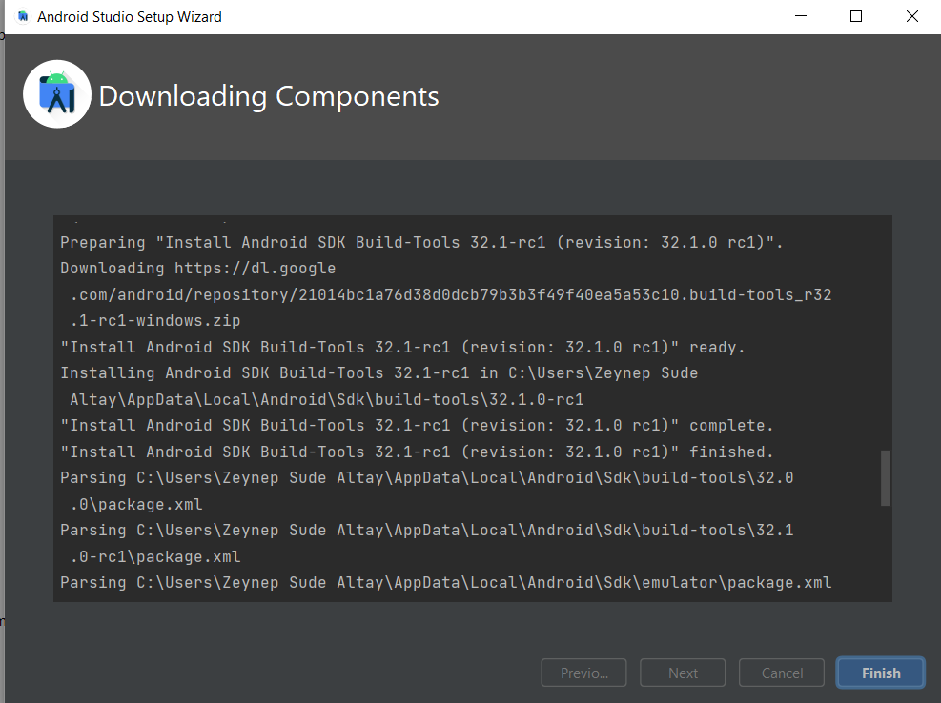12) Press finish

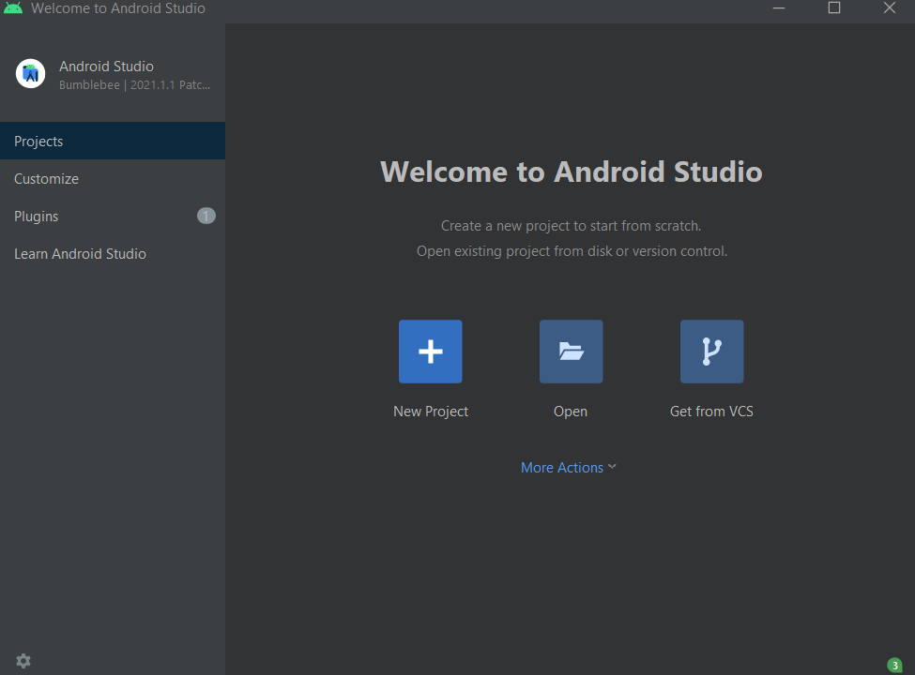13) We are creating a new Project

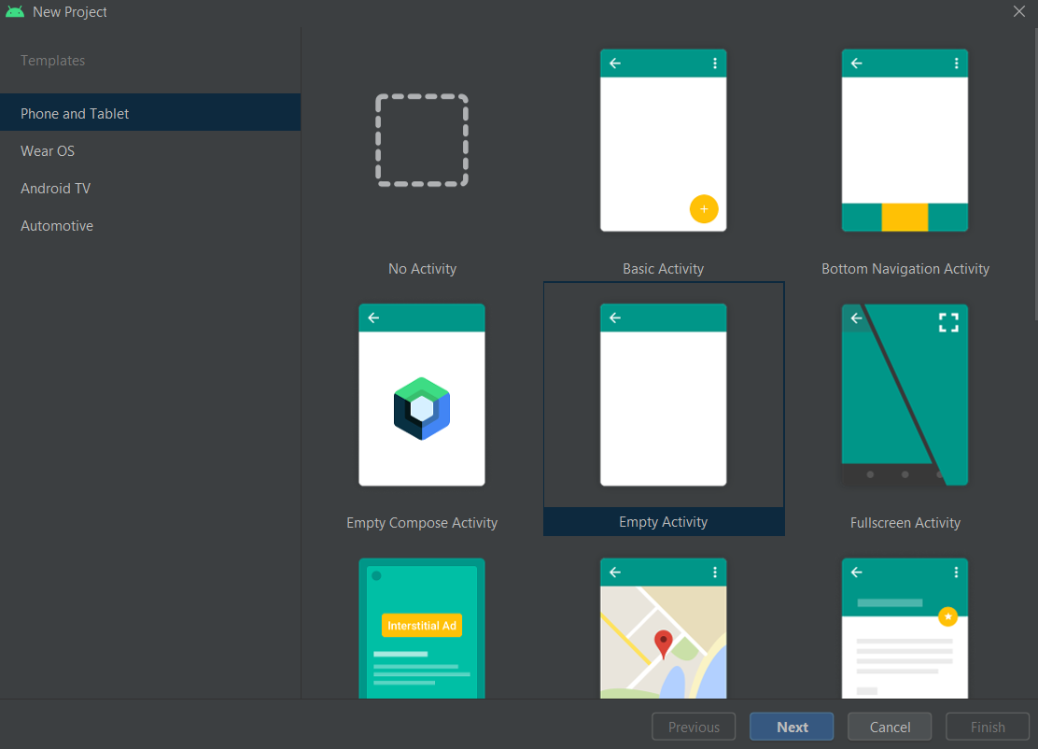14) We can select Empty Activity

15) We are arranging Name, Package name, save location and Minimum SDK than press Finish

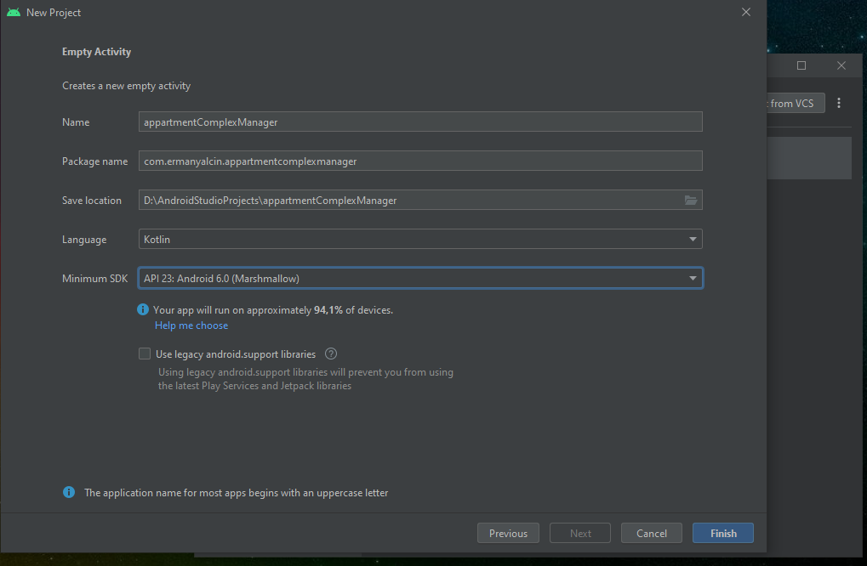

16) Wait until Gradle is finish his job (Red arrow) and until the files appear (Blue arrow)

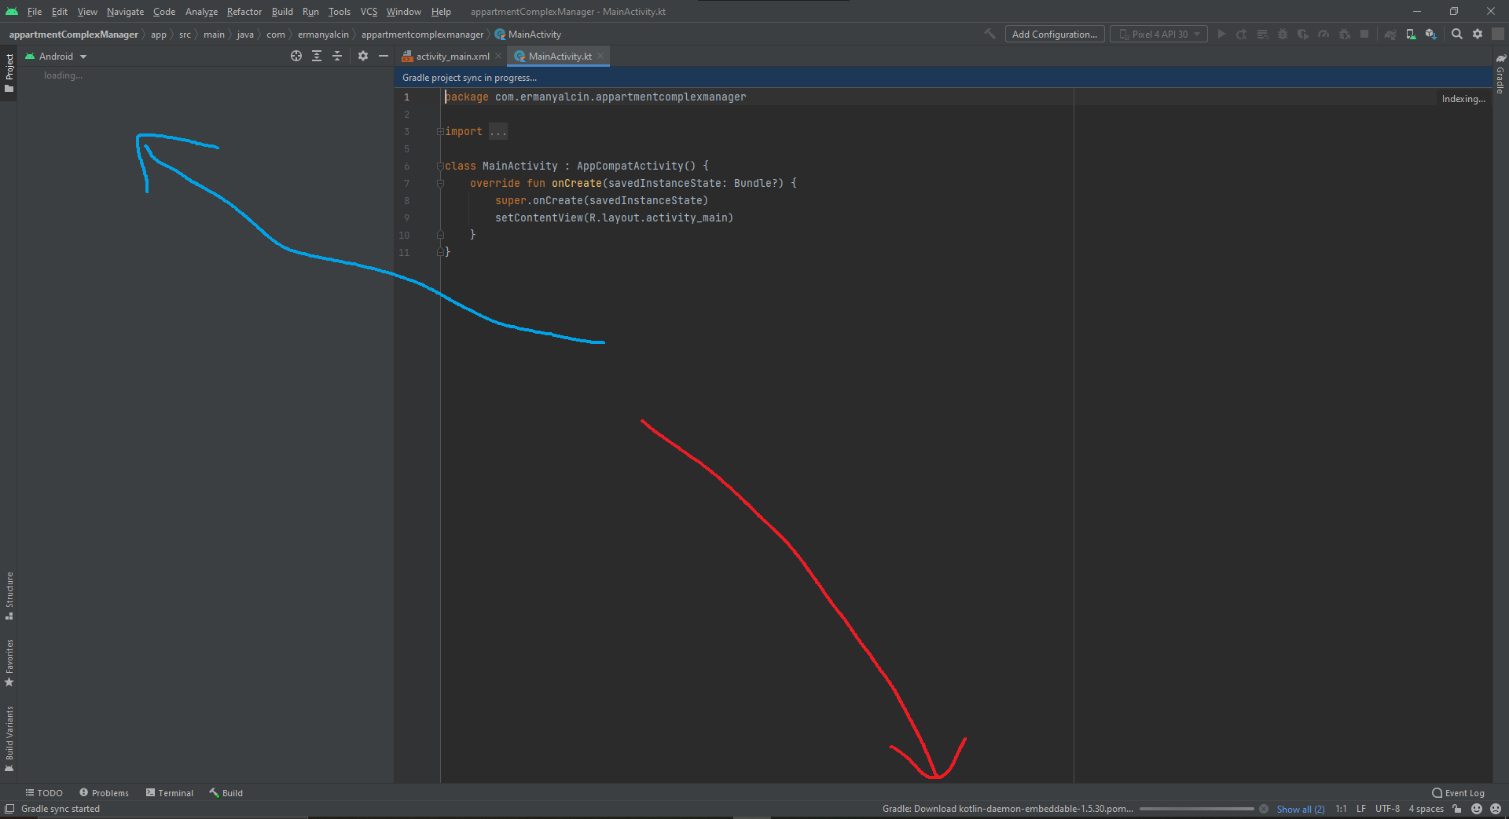

17) We can see our Back-End in MainActivity.kt (Red arrow) and Front-End in activity_main.xml (Green arrow)

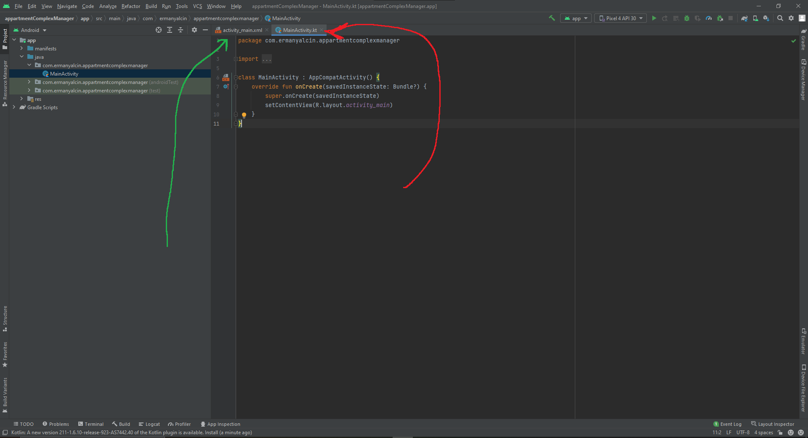

For Installing Emulator

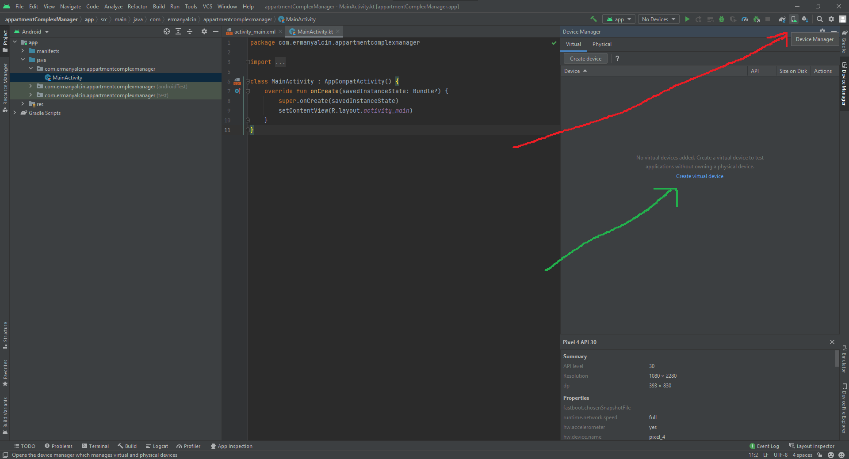18) We are selecting Device Manager from up-right corner (Red Arrow) and then Pressing Create virtual device (Green Arrow)

19) We can select the phone that we want to use (I select Pixel 4) and press next

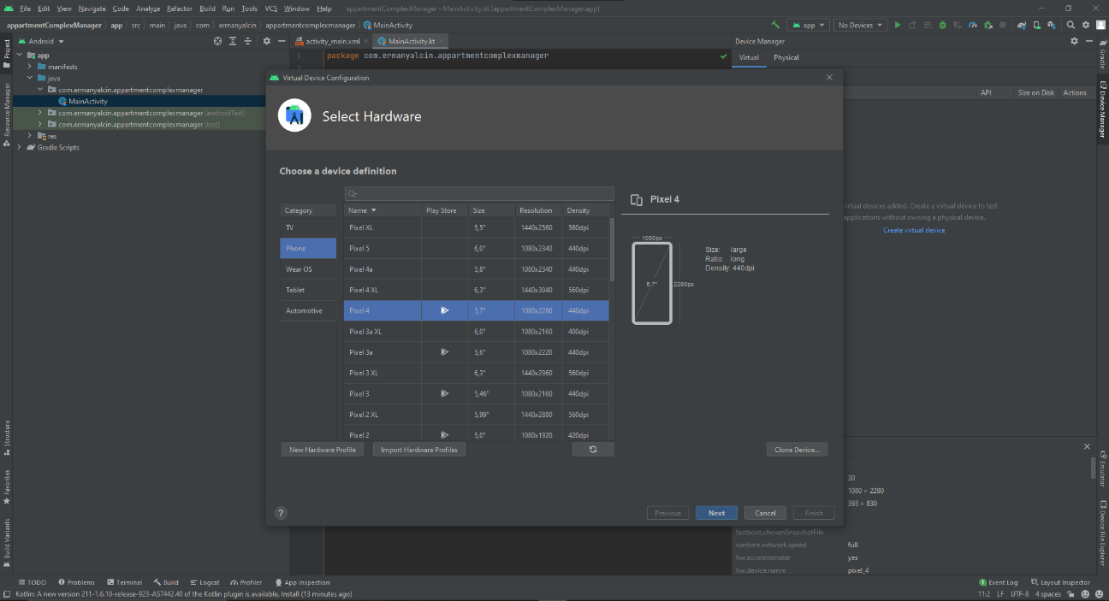

20) We can select a System Image, I select R, and then download it

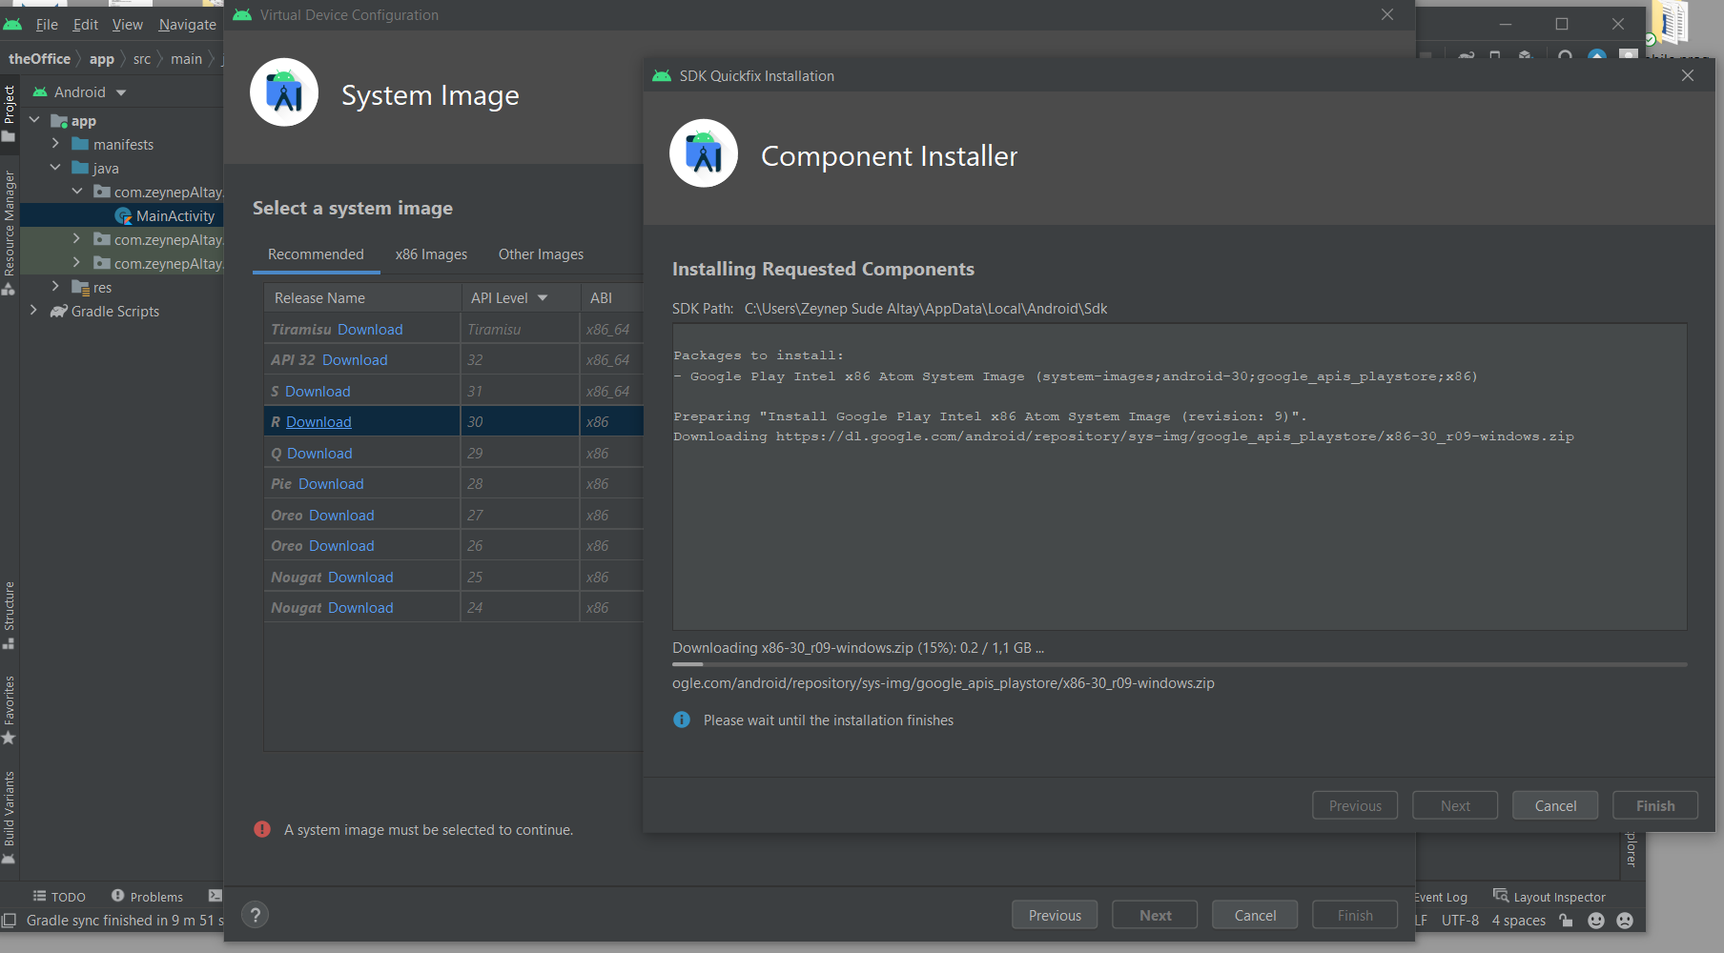

21) When it is Downloaded We can press finish

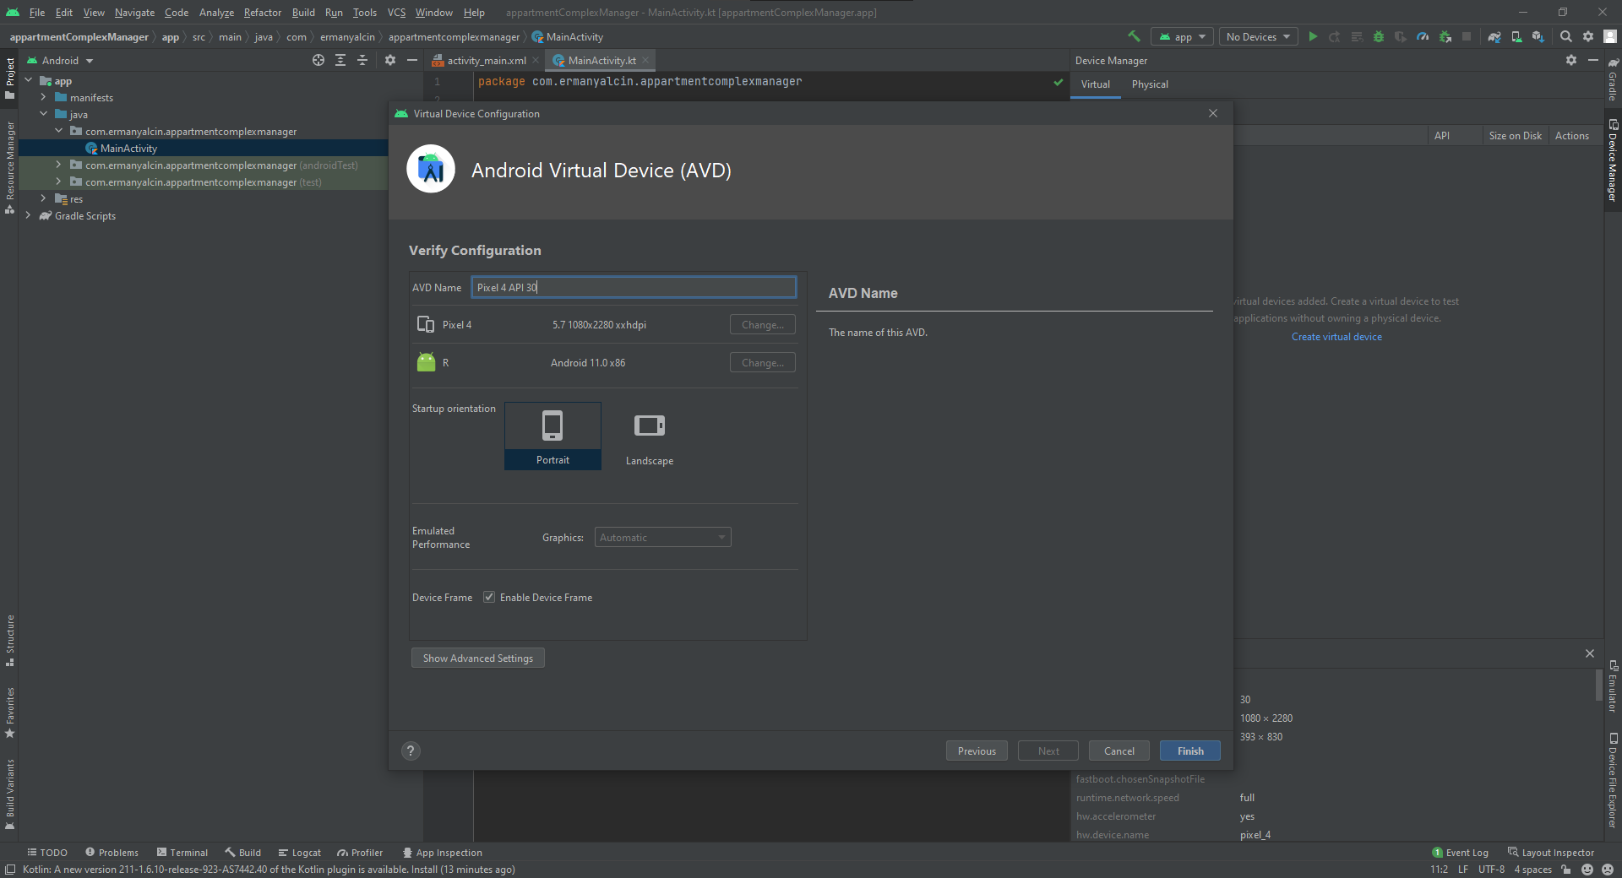

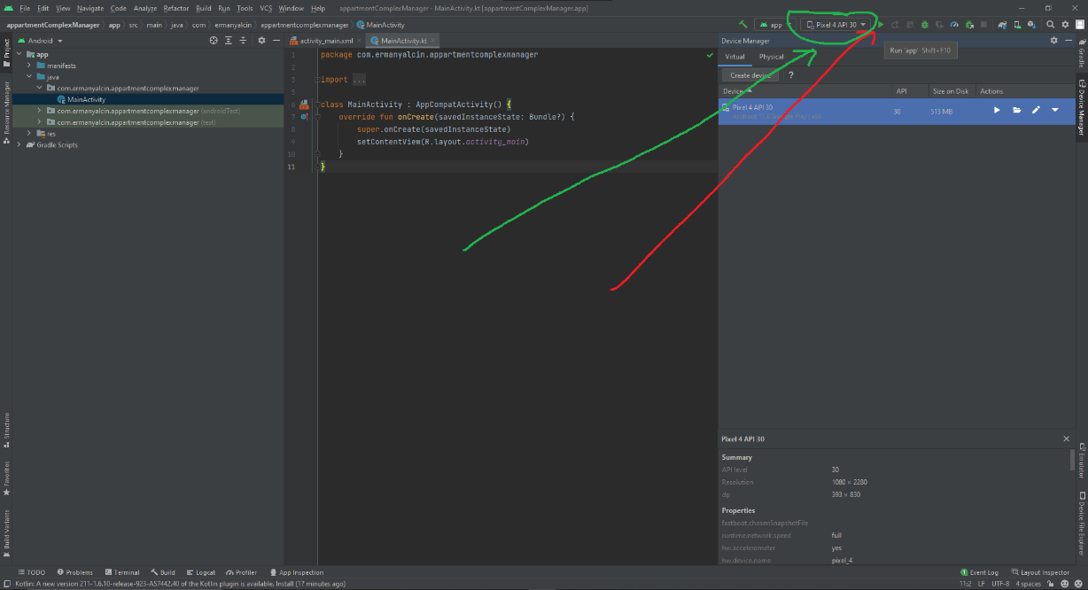22) Now we have the Emulator and we can open it by pressing the Start Button from up-right corner (Red arrow), be careful to select your right phone (Green arrow)