Lab 5.

1.

Yes. Let’s take this table as example. Student_id is primary key.

|  |  |  |
| --- | --- | --- |
| Student_id | Subject_id | Teacher_id |
| 1234 | BIO | 9999 |

Dependency teacher_id -> student_id is not direct. Teacher_id depends on subject_id, which is not primary key.

We convert this table into BCNF.

|  |  |
| --- | --- |
| Student_id | Subject_id |
| 1234 | BIO |

|  |  |
| --- | --- |
| Subject_id | Teacher_id |
| BIO | 9999 |

Dependency teacher_id ->student_id is still conserved, but it’s not observed within one table.

2.

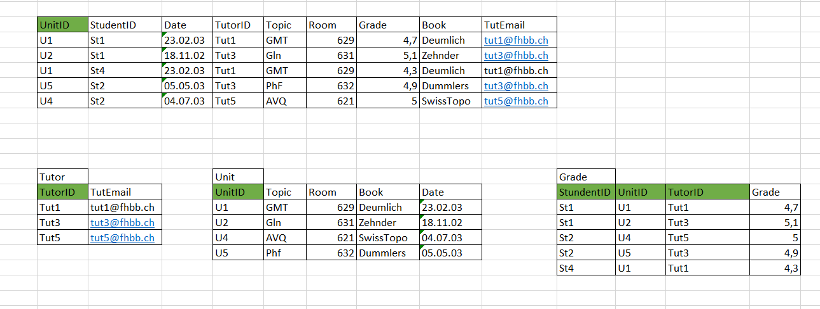

4.



5.

