Alisa Dhima, Henri Shehu
State Pattern — Justification & Class Diagram
What the pattern does: The State pattern allows an object to change its behavior when its internal state changes. The object delegates state-specific behavior to a separate state object, instead of using large if/else or switch chains.
How the diagram reads:
- Booking is the Context — it holds a reference to a BookingState object and delegates calls to it
- BookingState is the interface — declares the operations that vary by state (confirm, cancel, update, checkCancelEligibility)
- PendingState, ConfirmedState, CancelledState, CompletedState are the concrete states — each implements the interface with behavior appropriate to that status
The dashed hollow-triangle arrows mean implements; the solid diamond arrow from Booking to BookingState means has-a (composition).
The State pattern is applied to the Booking class. Without it, methods like cancelBooking() and checkEligibilityForCancel() would rely on repeated conditional checks against a raw status string, making the class fragile and hard to extend. By introducing a BookingState interface and four concrete state classes — PendingState, ConfirmedState, CancelledState, and CompletedState — each state's behavior is encapsulated independently. Booking acts as the context, holding a reference to the current state object and delegating all state-dependent operations to it.
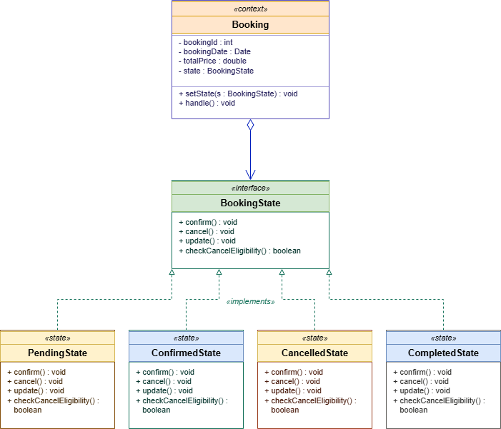

Emri Xhaferi, Era Selmana
Factory Pattern — Justification & Class Diagram
For our project, we picked the Factory Method pattern for creating tour packages. We chose this because, in BR_TM_21, the Operations Agent has to manage three different types of tours (Standard, Premium, and Group). Using this pattern helps us decouple the code, meaning the part of the system that saves the tour doesn't need to know the specific details of how each package is built. As shown in our Class Diagram, this makes it way easier to scale. If we need to add more tour categories in the future, we don't have to change the main creation logic; we just add a new creator class. This keeps our code maintainable and follows the standard design principles we learned.
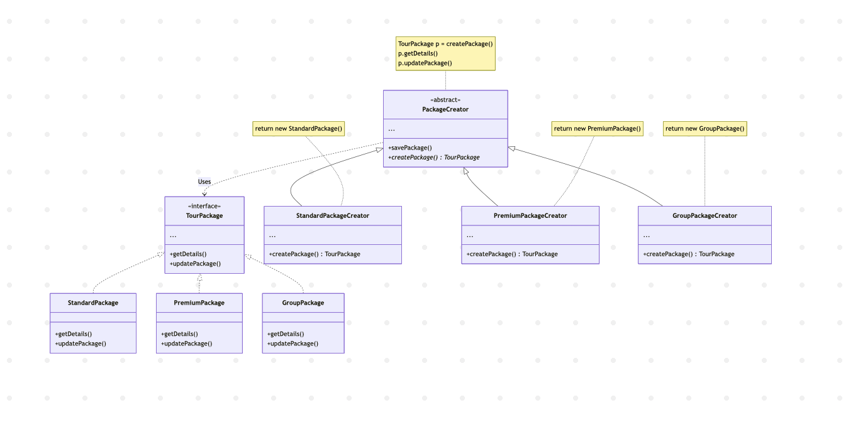

Amanda Stafasani, Enian Xhixha
Singleton Pattern — Justification & Class Diagram
What the pattern does: The Singleton pattern ensures that a class has only one instance throughout the lifetime of the application and provides a single, global point of access to it. The class itself is responsible for keeping track of its sole instance and prevents any other part of the program from creating a new one.
How the diagram reads:
- SystemConfiguration is the Singleton — it holds a private static reference to its own single instance and exposes it through the getInstance() method
- The constructor is marked private (− SystemConfiguration()) so no client can use new to build another instance
- Admin, Booking, Payment, and Ticket are the clients — they all reach the same configuration object through SystemConfiguration.getInstance() instead of holding their own copies
- The static field instance and the static method getInstance() are shown in bold/italic with the {static} tag to emphasise that they belong to the class itself, not to any object
The dashed arrows with open arrowheads represent dependency («uses»): each client class depends on SystemConfiguration but does not own it. The looped arrow on the Singleton itself indicates that getInstance() returns a reference to the same single instance every time it is called.
The Singleton pattern is applied to the SystemConfiguration class. Activity diagram BR_TM_25 (Configuration of system settings) shows the Administrator accessing one settings module, updating configurations, and saving them, after which those settings govern behavior across the entire system. Without the Singleton pattern, different parts of the system could load their own copies of these settings, producing inconsistent rules — for example, one booking applying a different cancellation deadline than another, or two payment requests using different gateway URLs. By making SystemConfiguration a Singleton, the cancellation deadline used by Booking.checkEligibilityForCancel() in BR_TM_11, the payment gateway URL used by Payment.processPayment() in BR_TM_07, and the email server host used by Ticket.sendTicketByEmail() in BR_TM_09 all read from the same authoritative source. The pattern guarantees a single point of truth for system-wide configuration and a global, controlled point of access to it.
