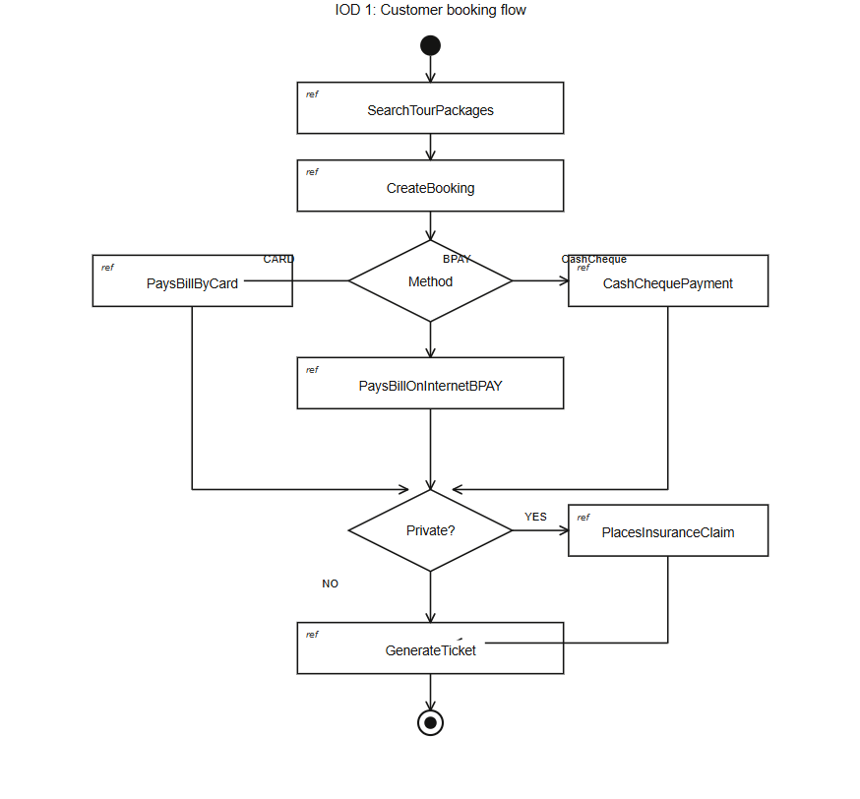
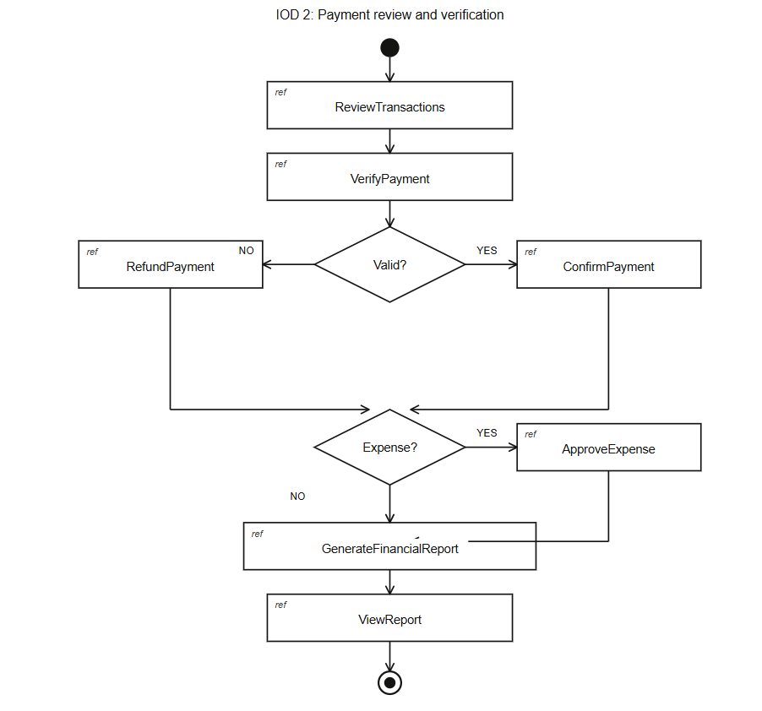
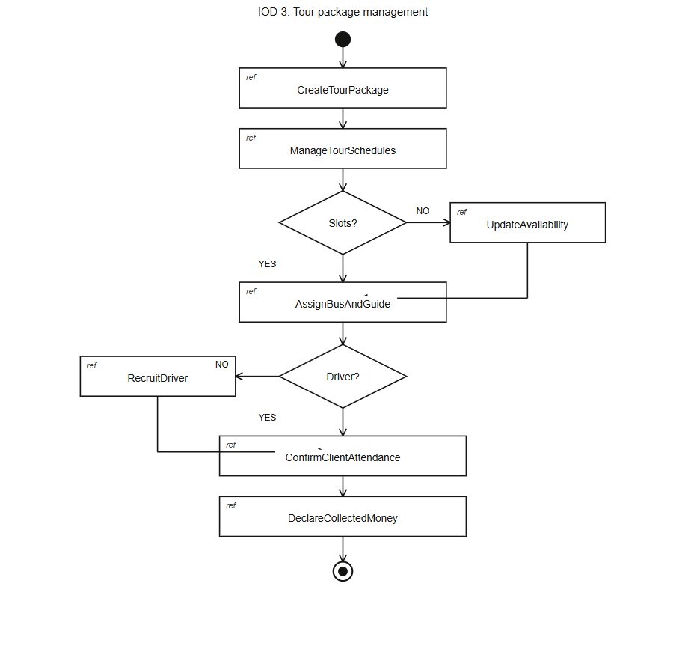

Here are your 3 Interaction Overview Diagrams, all matching the exact format from the slide you shared — filled circle start node, diamond decision nodes, ref boxes with interaction names, and bullseye end node:
IOD 1 — Customer Booking Flow: Customer searches packages → creates booking → chooses payment method (CARD / ONLINE / CASH) → optionally places an insurance claim → ticket is generated.
IOD 2 — Payment Review and Verification: Finance Agent reviews transactions → verifies payment → branches on validity (confirm or refund) → checks for expenses to approve → generates and views financial report.
IOD 3 — Tour Package Management: Operations Agent creates a package → manages schedules → checks slot availability → assigns bus and guide → checks driver assignment (recruits if none) → Tourist Guide confirms attendance and declares collected money.

