Conestoga College – SET

SENG3050 - Milestone 1
Design Documents

Group 9 Members
Mher Keshishian
Ermiyas Gulti (Endalkachew)
Quang Minh Vu
Saje'-Antoine Rose

Date of Submission : 2025-11-20

SENG
(3020)

Revision History
Rev | Date | Description of Change | By
A1 | 2025-11-13 | - Initial revision of document | Mher Keshishian  Ermias Gulti (Endalkachew)  Quang Minh Vu  Saje'-Antoine Rose
A2 | 2025-11-15 | - Added details for each question | Mher Keshishian  Ermias Gulti (Endalkachew)  Quang Minh Vu  Saje'-Antoine Rose
A3 | 2025-11-20 | - Final proof-read and correction | Mher Keshishian  Ermias Gulti (Endalkachew)  Quang Minh Vu  Saje'-Antoine Rose

Table of Contents
Contents
Group 9 Members 1
FDMS Design Overview 4
➢ A high-level summary of your design for the FDMS 4
➢ UML CLASS diagram 4
➢ UML Use case diagram 5
Ground Terminal Database Design 5
➢ Describe all the planned modules to be developed 5
➢ Design Patterns 6
➢ SOLID Design Principles 7
➢ GUI Wireframe Concepts 8
Ground Terminal Database Design 9
➢ the database architecture 9
➢ database engine 10
➢ Table definitions/schemas 10
➢ Connections (Either Remote Or Local) 13
Aircraft Transmission System Design 13
➢ Planned modules 13
➢ Design patterns to be followed 14
➢ SOLID evaluation 14
➢ UML CLASS diagram 16
References 17

FDMS Design Overview
This Flight Data Management System (FDMS) will be designed based on three components consisting of:

A high-level summary of your design for the FDMS
- Ground Terminal Application
  - The Ground terminal app is a Windows Form application written in C#.
  - It provides a user-friendly interface and backend functionality, including real time visualization of telemetry, and search of historical data, and system monitoring.
  - The ground terminal will also manage the network communication, packet parsing, checksum validation, error handling, and storage of telemetry into the SQL Server database.
- FDMS Database (SQL Server)
  - It is a Microsoft SQL Server instance(remotely accessible), that is used for persistent storage of flight, aircraft, and telemetry data.
  - It supports structured queries for historical analysis, indexes(clustered/non clustered) for performance, and links between flights, telemetry samples, and error logs.
- Aircraft Transmission System
  - It will be a lightweight standalone console app, which is responsible for reading recorded telemetry files, format data based on our transmission protocol, compute checksums, and send one packet each second to the ground terminal via TCP.
  - It will be a simulator of an onboard telemetry transmitter.
Communication(data exchange) between the aircraft transmission system, and the ground terminal app will be done by using the FDMS packet format. By following these standards, we try to make sure the data stays valid and reliable, and that it shows up in real time. Overall, the system is meant to be modular and multi-layered, and it should follow the SOLID design principles as much as possible.

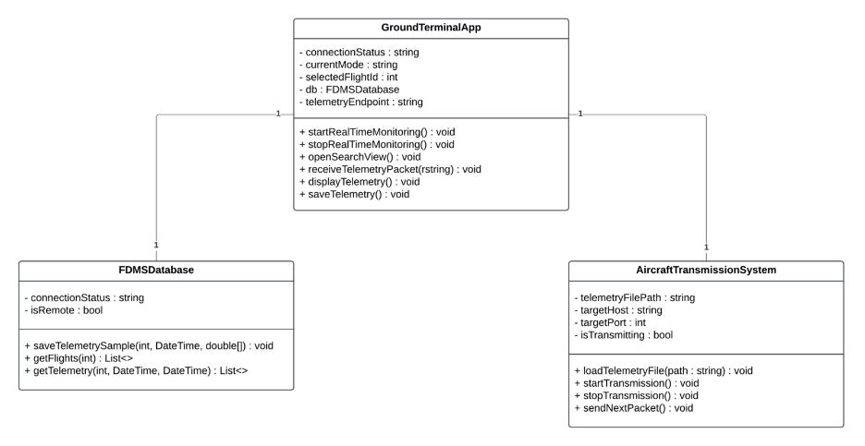
UML CLASS diagram

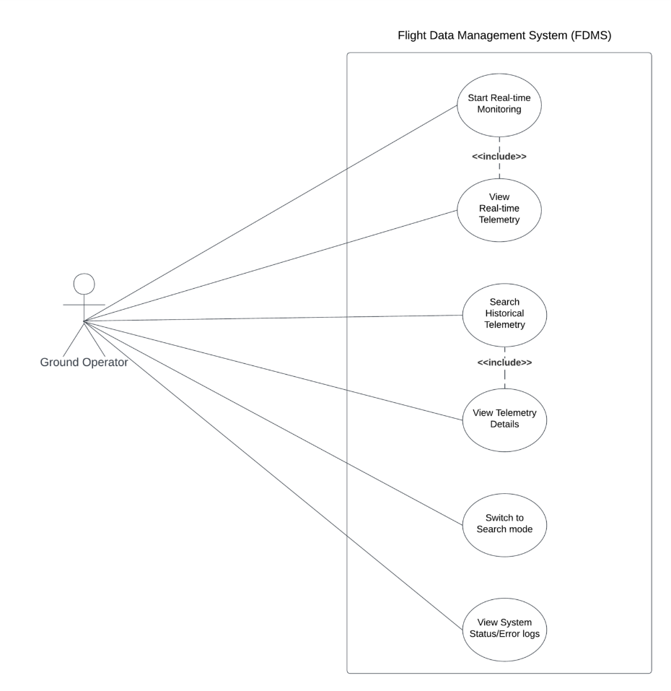
UML Use case diagram

Ground Terminal Database Design

Describe all the planned modules to be developed
The Ground Terminal Application will contain five modules.
- Network Communication Module
- Packet Processing Module
- Data Persistence Module
- Display Management Module
- Search and Query Module
From a systems architecture perspective, these modules will integrate with and have connections to other sections of the FDMS to display aggregated data to the user.

Network Communication Module
The Network Communication Module will be integrated with and is in charge of managing connections with another component of the FDMS, the Aircraft Transmission System. The module listens on a specialized port for receiving packets sent to it from the Aircraft Transmission System. The module is capable of maintaining its state and uses asynchronous programming to maintain consistency between the UI and real-world data (Microsoft, 2024).

Packet Processing Module
The Packet Processing Module receives raw byte streams sent to it from the Network Communication Module and processes them via checksum validation. After the module verifies that the packet is formatted correctly, it then extracts the respective telemetry fields, disregarding corrupt packets.

Data Persistence Module
The Data Persistence Module is integrated with the FDMS Database. The module manages database operations with the SQL Server. The module receives validated data from the Packet Processing Module and sorts the data into their respective tables. This module manages the various connections it has to support using a technique called connection pooling to ensure successful transaction management (Microsoft, 2023).

This module will also include logic that ensures the integrity of the records collected, as it will attempt to reconnect in the event of network issues. Additionally, to address cybersecurity and compliance requirements, it will utilize parameterized queries to reduce the attack surface against tactics such as SQL injection.

Display Management Module
This module will display the aggregated data collected and processed in the other modules of the Ground Terminal Application to users in real-time. The Display Management module will also have the ability for users to look up historical data, further enforcing the principles of data persistence.

Search and Query Module
This module will allow the user to search the database for records and display all results in dashboards for the purpose of tracking KPI's and telemetry data. The module will also support exporting to .txt, .csv, and .xlsx formats.

Design Patterns

Repository Pattern
The Ground Terminal Software has chosen to integrate the repository pattern into the application's design in order to allow for abstract access to the telemetry records in the database (Fowler, M, 2002). A telemetry repository class would provide methods for inserting and querying telemetry records without unnecessarily exposing sensitive SQL details to other modules which would not need to know the data. The repository interface defines operations like “SaveTelemetryRecord” and “GetTelemetryByTailNumber,” while the concrete repository implements these using SQL Server code.

Observer Pattern
We made the decision to utilize the observer pattern in the design for the code so that the Ground Terminal Software can handle updates to the UI in real-time when new data is received (Refactoring Guru, 2014). Whenever a new packet is validated, it notifies the UI component, which is set up as a registered 'observer'. This helps to decouple the processing of data from its presentation.

Model-View-Presenter (MVP)
We chose to use the Model-View-Presenter as it:
- It was originally designed for desktop UI frameworks.
- The 'view' can be clearly separated from the business logic.
- Contains built-in data-binding which helps to automatically update the UI when business logic events occur.
The MVP design pattern also allows for easy testing of application logic as the UI does not need to be automated.

SOLID Design Principles

Single Responsibility Principle
The Single Responsibility Principle defines a rule that every class only has one reason to change. A class named PacketParser could be made thats only responsibility would be handling parsing logic. On the other hand, a class called TelemetryRepository would manage only database operations. If we wanted to modify checksum validation logic, it would only require changes to the PacketParser class without touching any other code in the software. Including logic for things behaviours that have nothing to do with a class within a class can introduce spaghetti code and code debt (Vishwas Kapte, 2024). For this reason, we believe that we follow the Single Responsibility Principle.

Open-Closed Principle
The Open-Closed Principle states that you should be able to add new features to your code without having to modify code that already exists (Chris, 2023). For example, we plan to utilize this principle in the case that a new packet format comes along. Through the use of interfaces, we could provide extensibility for any new packet formats without the need to go back and modify code that was already created. We sufficiently believe that we are compliant to the Open-Closed Principle.

Liskov Substitution Principle
The rules of the Liskov Substitution Principle essentially states that child classes should be able to be substituted for parent classes without causing an issue in the functionality of the program (Wikimedia, 2020).

When it comes to the Ground Terminal Application's implementation of this principle, we plan that all packet parsers should be tied to a common "IPacketParser" interface which contains a respective parse method. With this in place, any parser implementation would be able to be used interchangeably. Our planned implementation satisfies the requirements of the Liskov Substitution Principle.

Interface Segregation Principle
This principle defines rules surrounding the creation of interfaces and stresses specific, targeted interfaces should be created whenever possible instead of one giant monolith (Sharma, 2020). We plan to create targeted interfaces such as focused interfaces such as :
- ITelemetryRepository: which only includes methods to access data.
- ITelemetryDisplay: which only includes display methods.
In this example, UI components that display data call on "ITelemetryDisplay" but do not implement any repository methods they do not use. With this in mind, we believe we have an adequate use of the Interface Segregation Principle in our application design.

Dependency Inversion Principle
The Dependency Inversion Principle creates a framework that values abstraction. The principle states that High-level modules should depend on abstractions rather than concrete implementations (GeeksforGeeks, 2018). In our applications case, presenter classes will be coded to rely on an "ITelemetryRepository" interface rather than an actual repository class. This approach would allow a dev team to change key database logic without having to modify the code to present that data. The app without modifying presenter code.

The design of this application clearly follows the SOLID principles to produce modular, testable, and maintainable code.

GUI Wireframe Concepts

Main Dashboard
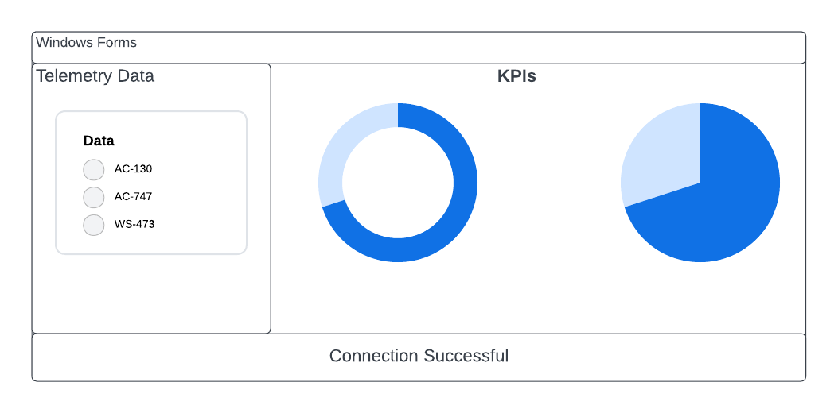

Search Interface
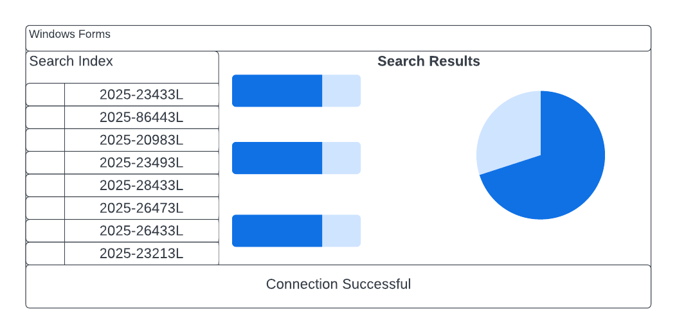

Ground Terminal Database Design

A database design could be the main core part for flight data management system (FDMS). The ground terminal database design can help to store secure and also to retrieve aircraft telemerty and operational data. The data base design helps to enforce accurance completenece and consistency of data flow in the system.

the database architecture
For the database architecture, we think a centralized relational database is the best choice. A centralized database is a database that is well-maintained and stored in a single location, allowing other clients to access it over the internet, such as via LAN or WAN. Therefore, for the ground terminal database, a centralized database design is a suitable choice.The database covers several key domains:
- Aircraft registration
- The daily Flight lifecycle
- Telemetry models
- Transmission error logs
- configuration data
- Security and audit information
To keep the design, clean and scalable, we apply the following database rules
- Data Normalize and tables 3NF
- Using tables for telemertry
- Adding foreign key relationships
Data Processing Flow
Packets are parsed, validated, stored, and then presented through set views and filtered queries and procedures for UI and reporting purposes.
Retention & Archival
Recent telemetry remains online for fast access. Older data is archived in TelemetrySampleHistory or moved to our out-of-storage. Partition switching may be used to make cleanup and editing more efficient.

database engine
For the Database engine, Microsoft SQL Server (remote instance) will be our first choice. And the rationale is that it offers native C#/.NET integration (ADO.NET). A relational database is a database that stores and provides access to data points that are related to one another. Also, essential properties of a relational database transaction include atomicity, consistency, and durability (What Is a Relational Database?, 2021).

Table definitions/schemas

The following are the main tables and important columns we currently consider; however, this table schema could be modified in the future
The database system currently uses a few main tables to track aircraft, flights, telemetry, and system activity. These tables and their columns will be modified as we begin to develop the project details. However, these definitions provide a brief outline of their purpose and the key fields they encompass. The structure may evolve in the future as new requirements appear.
Aircraft
The aircraft table will hold information about each aircraft in the database system. It includes an AircraftID as the primary key, with the aircraft’s TailNumber, which must be a unique value, model, manufacturer, and the year it was built.
Flight
Each flight is represented by a record, identified by a unique Flight ID. A flight is linked to an aircraft via AircraftID. It contains flight details such as the flight number, departure and arrival airports, scheduled and actual departure and arrival times, and the status of the aircraft that defaults to “Scheduled.” The CreatedAtUtc column records the date and time when any flight entry was created. Since we will have a time zone difference, we will also determine how to incorporate it into our database system.
TelemetrySample
Telemetry samples grab the incoming flight data. Each sample has a SampleID as the primary key and is associated with a specific flight using FlightID. The data includes the UTC timestamp, the timestamp taken when the flight started, the message type, the telemetry channel (Channel ID), the sequence number, and the raw or parsed payload (stored as JSON). It also tracks whether the checksum was valid, when the sample was received, and the source IP address of the telemetry packet.
TransmissionErrorLog
This table logs issues detected while receiving telemetry. An ErrorID identifies each log entry and can pair with the flight through its corresponding FlightID. It stores the time the error occurred, an error code, a description of what went wrong, the raw packet that caused the issue, and the source IP of the packet.
Channel (Reference)
Channels describe the different telemetry sources. A channel has a ChannelID along with a name and a brief description of what that channel represents.
PacketFormat (Reference)
Packet formats define the format of incoming telemetry packets. Each format has a FormatID, a unique version number, and a JSON schema describing the expected packet layout.
Security Tables
For password and authentication methods, we plan to use a table called AppUsers. The AppUser table will store the data of our users, including their role in the company, username, password, and an active/inactive flag, as well as timestamps for when the account was first created and last updated. This helps to ensure that every user updates their password periodically to avoid security breaches. Roles are stored separately in the Role table, which includes a RoleID and the role’s name.
Database and Table Schema
Aircraft
- Aircraft_ID – primary key
- Tail_Number – unique aircraft tail number
- Model_Number
- Manufacturer_
- Year_Of_Make
Flight
- Flight_ID – primary key
- Aircraft_ID – foreign key to Aircraft
- Flight_Number
- Departure_Airport
- Arrival_Airport
- Scheduled_Departure
- Scheduled_Arrival
- Actual_Departure
- Actual_Arrival
- Status_ – defaults to Scheduled
- Created_At_Utc
TelemetrySample
- Sample_ID – primary key
- Flight_ID – foreign key to Flight
- TimeInLocalTimeZone
- Message_Type
- Channel_ID – foreign key to Channel
- SeqenceNo
- Payload_Json
- Checksum_Valid
- Received_At_Utc
- Source_IP_Address
SourceIPAdress
TransmissionErrorLog
- ErrorLogID – primary key
- Flight_ID – foreign key to Flight
- Occurred_At_Utc
- Error_Code
- Reason_
- Raw_Packet
- Source_IP
Channel (reference)
- Channel_ID – primary key
- NameOfChanel
- DescriptionOfChannel

PacketFormat (reference)
- MessageFormatID – primary key
- Version_Num – unique
- JsonMessage
Table for App user and Security
AppUser
- User_ID, User_name, Password_, Is_Active, created_Date, Updated_Date
Role
- appUserRole_ID, Name

Connections (Either Remote Or Local)

Local (Development / Testing):
- Use LocalDB or a developer SQL Server instance
- Integrated authentication or another authentication method
- ADO.NET
- Parameterized queries and stored procedures could be used
- No hard-coded credentials for security purposes
Remote
- Remote SQL Server accessed over TLS
- Like Azure AD authentication or strong SQL authentication
- Role-based privilege accounts like Admin, and so on
- Implement retries, backoff, and temporary staging in case of outages
- Monitor connection health, slow queries, and failed authentication
- and tracking the network security and updating the network firmware
Implementation & Operational Notes
We will use batched inserts or table-valued parameters when handling a large amount of telemetry data. Keep the full PayloadJson intact but also extract and store the often-used fields in queries. Avoid adding too many indexes to tables with high write activity, as this can slow down the database performance. Making sure all communication is encrypted using TLS, and we will consider implementing Transparent Data Encryption for data at rest. Also, capture the raw packets along with their checksum results so you can properly investigate errors or support audit requirements.

Aircraft Transmission System Design
An aircraft transmission system could be designed as a collection of modular cohesive and loosely coupled parts that are placed in a layered architecture that is compliant with SOLID principles; common patterns are layered architecture, Strategy, State, Adapter, Facade, and Dependency Injection, with UML diagrams illustrating the clear splitting of control, domain, I/O, and diagnostics components.

Planned modules
- Sensor & Input Abstraction Layer: Provides interfaces and adapters for airspeed, torque, RPM, temperature, gear‑position sensors, pilot commands and engine/flight‑control buses, decoupling domain logic from hardware details.
- Transmission Domain Model: Basic abstractions are Gearbox, Clutch, Shaft, TorquePath, and value objects Torque, RPM, GearRatio; then, there are aggregates like TransmissionAssembly which encapsulate invariants, axioms, and other physical rules.
- Control & Strategy Module: Implements gear‑selection, clutch‑control, and torque‑management (normal, takeoff, emergency, etc.) strategies, all of which use the same interfaces and provide pluggable control laws for use in various mode changes.
- State & Mode Management Module: Manages system states (OFF, STARTUP, IDLE, TAKEOFF, CRUISE, DESCENT, FAIL_SAFE) and failures, orchestrating which strategies and safety systems are active.
- Health Monitoring and Fault Management: Includes condition monitoring, limit checking, fault detection, logging, and fail‑safe reconfiguration (degraded mode, torque limit) which must be cleanly separated from standard control logic and interfaces.
- Command & Interface Services: Services providing APIs to the flight control computer, engine control, and maintenance tools (ITransmissionControlService, IHealthReportService, etc.) and contracting and isolating external clients.
- Persistence / Data Management: The storing of configuration, calibration, fault logs, and usage statistics to repositories or gateways concealing underlying storage (NVM, ARINC‑653 partitioned FS, ground download).
- Configuration & Calibration Module: Verifies and validates the loading and application of certified parameter sets (gearshift maps, torque limits, temperature thresholds) without altering software code.
- Diagnostics & Test Harness: Built‑In Test (BIT) routines, simulation stubs, Loop‑back tests, and ground‑test scaffolds which allow for verification without accessing real aircraft hardware.
- Infrastructure / Platform Layer: OS abstraction, communication stack (e.g. ARINC, CAN, AFDX), timing and scheduling, and safety platform services consistent with modular avionics practices

- Design patterns to be followed
- Layered Architecture (n‑tier): Clearly separate into infrastructure, domain, application (control), and interface layers to localize the change, with strict dependencies only from top to bottom.
- Strategy Pattern: Gear-selection, torque control, and failure-response algorithms implement common interfaces that allow them to be swapped out per mode, configuration, or aircraft type without changing callers.
- State Pattern: System's behavior changes according to the operation mode. In each mode/state object, it encodes how to respond to particular inputs. Examples could be sudden torque spike in TAKEOFF versus CRUISE.
- Adapter Pattern: The hardware‑specific drivers and bus protocols are adapted to clean domain‑level interfaces so that the rest of the system remains independent of particular sensors, actuators, or data buses.
- Facade Pattern: High‑level services provide a simple API (TransmissionControlFacade) that orchestrates many subsystems, reducing coupling from external users like flight‑control computers.
- Dependency Injection/Inversion: High-level logic depends on abstractions (interfaces) rather than on concrete implementations. Concrete strategies, adapters and repositories are composed at startup/config time.
- Repository / Gateway: Use the repository interface to gain access to the persistent log entries and configuration data, encapsulating the storage medium and allowing substitution for testing.

SOLID evaluation
- Single Responsibility Principle (SRP): Each module/layer has their responsibility for only one defined concern. For example, the domain model will have the role to maintain physical rules, control modules have the responsibility to handle decision logic, adapters will manage Input/Output. This makes the certification much easier.
- Open/Closed Principle (OCP): The design allows new control modes, strategies, or hardware have been added by extending existing interfaces, like creating new classes or configurations. From this we don’t need to change the old code anymore
- Liskov Substitution Principle (LSP): Strategy and state implementations respect their base contracts. This is important for secure and dependable mode switching since any IGearShiftStrategy or ISystemMode can be substituted without affecting the code that utilizes them.
- Interface Segregation Principle (ISP): Interfaces are maintained at a minimal size and are role-specific (e.g., read-only sensor interfaces versus actuator command interfaces), ensuring that clients rely just on their utilized components, hence diminishing dependency among avionics partitions.
- Dependency Inversion Principle (DIP): Elevated flight control and transmission logic rely on abstract service and device interfaces, while infrastructure specifics (drivers, protocols, storage) are integrated from underneath, conforming to modular avionics and facilitating platform reutilization.

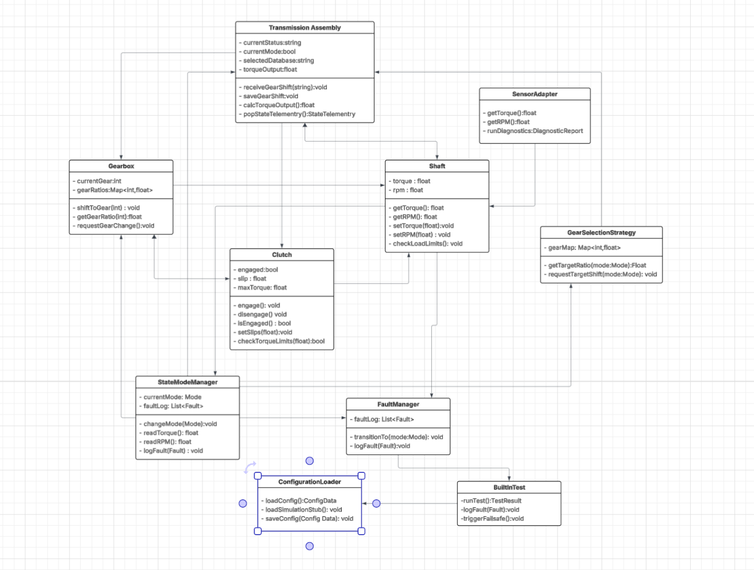

UML CLASS diagram

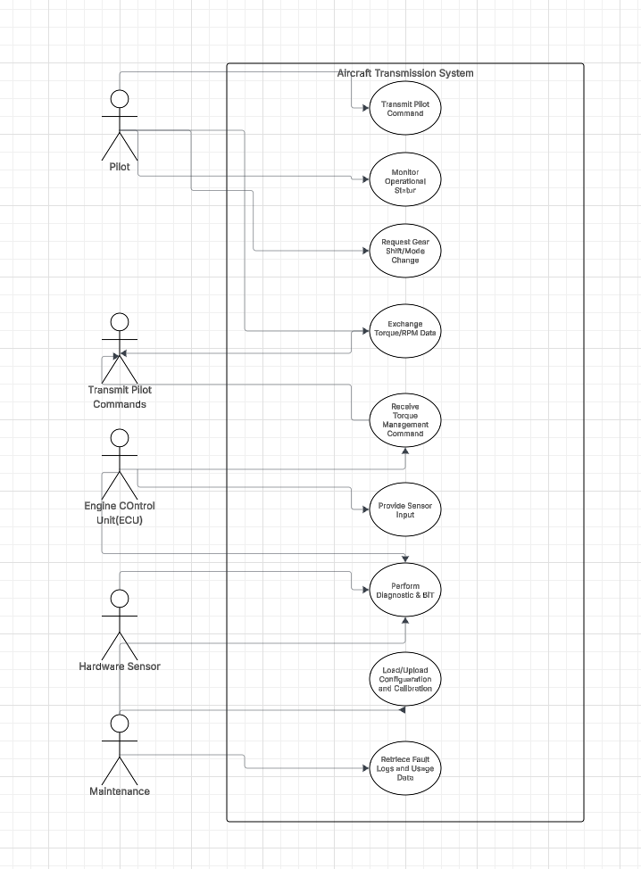

References

Fowler, M. (2002). Patterns of Enterprise Application Architecture. Addison-Wesley. https://martinfowler.com/eaaCatalog/repository.html
Chris, K. (2023, February 22). Open-Closed Principle – SOLID Architecture Concept Explained. FreeCodeCamp.org. https://www.freecodecamp.org/news/open-closed-principle-solid-architecture-concept-explained/
GeeksforGeeks. (2018, March 27). Dependency Inversion Principle (SOLID). GeeksforGeeks. https://www.geeksforgeeks.org/system-design/dependecy-inversion-principle-solid/
Sharma, M. (2020, March 2). Everything You Need to Know About the Interface Segregation Principle. Reflectoring.io. https://reflectoring.io/interface-segregation-principle/
Vishwas Kapte. (2024, January 6). SOLID Principle: Single Resposibility Principle. DEV Community. https://dev.to/vishwaskapte/solid-single-resposibility-principle-30hk
Wikimedia. (2020, July 7). Liskov substitution principle. Wikipedia. https://en.wikipedia.org/wiki/Liskov_substitution_principle
GeeksforGeeks. (2025, July 12). Difference between centralized database and distributed database. GeeksforGeeks. https://www.geeksforgeeks.org/difference-between-centralized-database-and-distributed-database/
Oracle. (2021, June 18). What Is a Relational Database? Retrieved from https://www.oracle.com/ca-en/database/what-is-a-relational-database/
Fly with Magnar. (2025, June 6). What is flight data monitoring (FDM)? | Top aviation expert shares 5 essential flight data tips! [Video]. YouTube. https://www.youtube.com/watch?v=HxvyEzXXTgc

Used in planned module for Aircraft transmission system:
published - Steps Towards Scalable and Modularized Flight.pdf
Reliable_FCS_Architecture_for_Agile_Airborne_Platforms_An_AMP_Approach.pdf
Final after CCADD Review and for printing.PDF

