**sba C-Sharp Client**

**Pre-requisites**:

1. Visual Studio 2019 (VS) Professional
2. .NET Core 3.1 (by default it will be installed with the latest VS)

**Setup**:

Please clone the GIT code including the ***sbaCSharpClient.sln*** file to your local machine.

Open the ***sbaCSharpClient.sln*** file in VS.

Once the project is opened and loaded in VS, open the **appSettings.json** from the Solution Explorer on the right side of the VS.

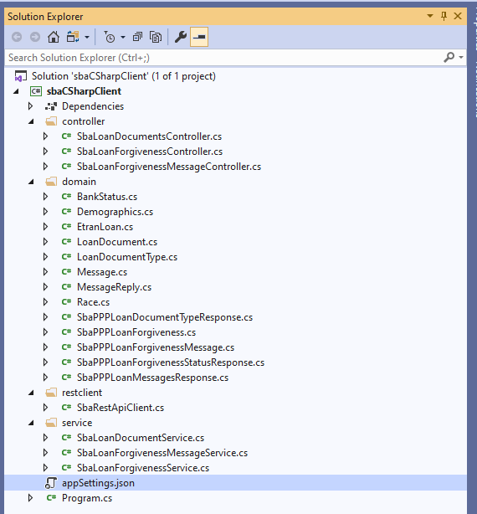

Update the below values in the **appSettings.json** before continuing.

"baseUri": "baseUrivalue",

"api-token": "API_KEY",

"vendor-key": "VENDOR_KEY",

Please make sure that all the URLs are correct for the API methods in the **appSettings.json**.

**Build:**

Once you verified all the values are correct, build the project via either menu **Build 🡪 Build Solution** or keyboard **CTRL + SHIFT + B**.

If any build errors, verify **Error List** on the bottom of VS and correct them before proceeding.



If no errors, then you would see **Build succeeded** message

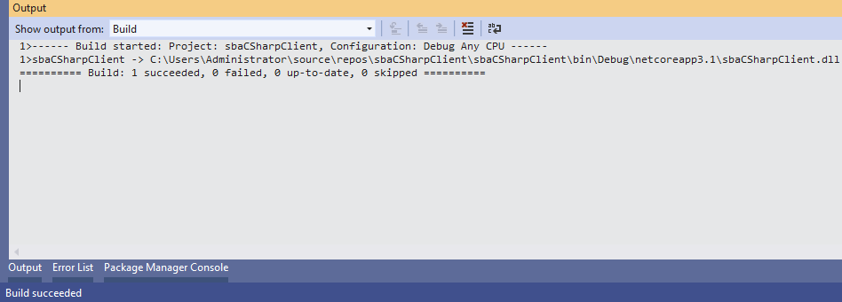

**Execute APIs** via Unit Test file**:**

In **Tests\UnitTests.cs** file, there are individual test methods for each APIs.

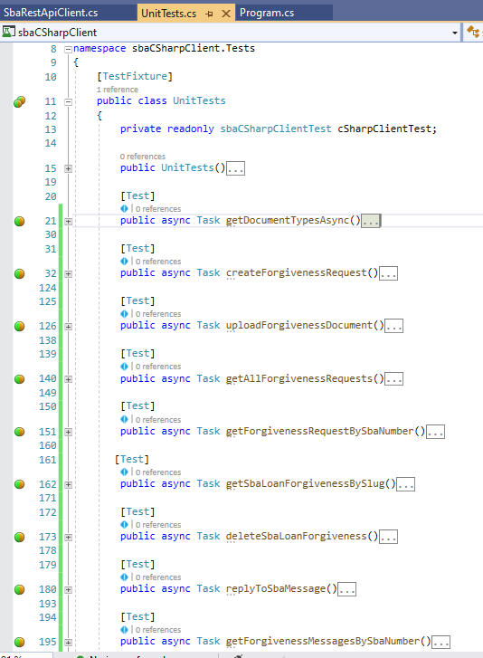

You can run each method individually by right clicking on each test method and choosing **Run Test(s)** or **Debug Test(s)** option.

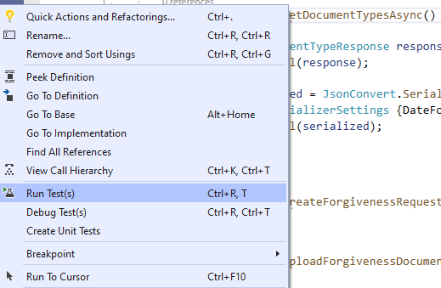

When you run or debug any test method, you will see a **green** tick icon indicate that the test method ran successfully.

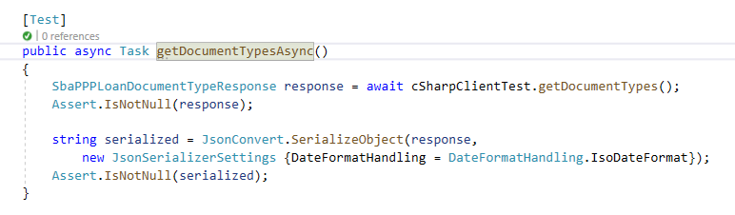

Incase if you see a **red** cross then it means that the test method was failed. You can debug it with break points to see the exact error.

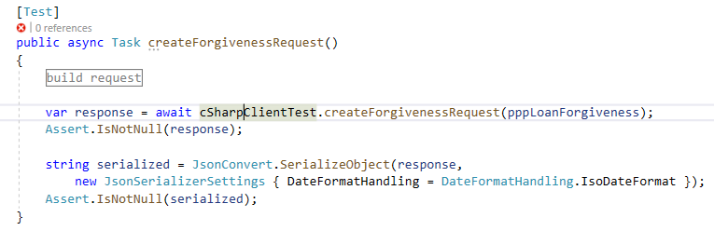

You could also see the results of the test methods in the **Test Explorer.**

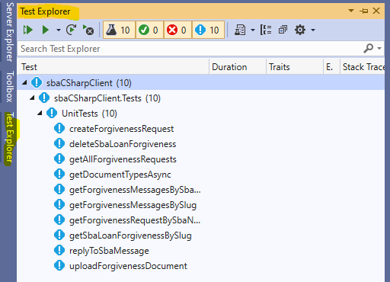

You can run all the test methods in a single click by right clicking on “public class UnitTests”.

