CHAPTER ONE
INTRODUCTION
1.1 Background of the Study
The modern educational landscape is navigating a paradox of choice while digital information is more accessible than ever, distilling truly relevant knowledge has become increasingly difficult. At Landmark University (LMU), an institution built on the pillars of Global Relevance and an Agrarian Revolution," the volume of academic data from complex engineering blueprints to agricultural reports has exceeded the capacity of traditional manual retrieval. Recent research by Olaonipekun (2025) highlights that as digital academic volume increases, students often face challenges in efficiently processing and applying this knowledge in real-time.
The evolution of pedagogical retrieval has moved rapidly. Historically dependent on physical archives and keyword searches, the early 2020s saw a shift toward Large Language Models (LLMs) like GPT-4. However, as documented by Pampel et al. (2025), these models often operate as "black boxes" that possess general knowledge but lack "Institutional Memory". For a specialized environment like LMU, generic AI tools frequently hallucinate or provide answers that do not align with the specific LMU curriculum or Nigerian University Commission (NUC) standards.
To address these limitations, the period between 2020 and 2025 has seen the emergence of Retrieval-Augmented Generation (RAG). Formally introduced by Lewis et al. (2020) to solve the knowledge cutoff problem, RAG treats an LLM as a reasoning engine and an institution's private database as its external brain. By 2024, the field moved toward "Advanced RAG," which utilizes semantic vector indexing to understand the meaning behind a student's query rather than just matching keywords.
The implementation of Edu-RAG at Landmark University is grounded in this technological shift. It acts as a "Cognitive Scaffolder," a term used by Thüs et al. (2024) to describe systems that guide learners by anchoring responses in a "source of truth". By automating the scrounging for information, the system reduces "extraneous cognitive load," a concept updated for the AI era by Sweller (2025), allowing students to focus on the high-level internalization of material. This is critical in the Nigerian context, where Akinyemi et al. (2021) note that while there is high enthusiasm for AI, a localized "Africanized RAG" is required to bridge the digital divide while ensuring "Data Sovereignty" keeping the university's intellectual property within its own digital boundaries.
1.2 Statement of the Problem
One of the most difficult challenges in modern education is pinning down what actually makes a student succeed. Even with massive investments in digital tools and support programs at places like Landmark University, we still see widely different results for students in the same classes. Traditionally, we’ve relied on simple statistics that show us "what" is happening, like how many hours someone studies, but they fail to explain the "why". This is a dangerous gap because if we assume study hours are the direct cause of success, we might force students to spend more time in the library when the real problem could be a lack of resources or motivation.
Because we focus so much on these surface-level patterns, universities often end up wasting resources on programs that don't actually move the needle. We might monitor attendance religiously, not realizing it’s just a symptom of a student’s drive rather than the cause of their grades. This leads to "superficial interventions" that ignore deep-rooted issues like socioeconomic barriers, which digital tools alone can't fix. At the end of the day, without a clear map of cause and effect, even well-intentioned policies can accidentally favor students who already have an advantage, making the achievement gap even wider.
This lack of clarity creates a real sense of uncertainty for university leaders at Landmark. It’s hard to know if a mentorship program is working because of the advice given, or simply because it attracts the most motivated students to begin with. Without understanding these hidden mechanics, we risk misinterpreting our data and applying "blind" solutions. Current models might be good at flagging who is "at-risk," but they leave us in the dark about how to actually help them change their future.
This study aims to solve this "transparency crisis" by moving past the usual guesses and toward "Causal AI". We need a system that doesn't just tell a student "you might fail because you look like others who did," but instead explains exactly which habit to change to get a better grade. By mapping out the "dynamic flow" of a semester how a click in week two leads to confidence in week six we can finally give advisors and students the evidence-based roadmap they need to ensure success.
1.3 Aim and Objectives
The main aim of this research is to move away from just looking at simple patterns (the "Correlation Fallacy") in student data and instead create a clear, cause-and-effect framework to help students at Landmark University succeed. To do this, I have set of objectives I can follow
- To understand what actually drives student engagement: Instead of just counting how many times a student logs in, this goal is about figuring out the real behaviors that cause a student to do well or struggle .
- To test "what-if" scenarios for better teaching: This part of the study moves beyond just watching what happens to simulating real changes .
- To build an easy-to-understand tool for advisors: One of the biggest goals is to fix the "black box" problem where AI gives answers but no explanations
- To make sure the system works in the real world: Finally, I want to prove that this framework actually makes sense for our university
1.4 Significance of the Study
This research matters because it moves away from treating students like numbers in a machine and starts seeing them as individuals with unique hurdles. By pulling back the curtain on how classroom data actually works, we’re giving teachers and advisors at Landmark University a way to offer help that is both fair and easy to understand. Instead of just guessing who might fail, this study provides a clear, ethical roadmap for real-time support that focuses on what can be changed to help a student succeed. Ultimately, it’s about making sure the digital tools we use every day are actually being used to create a more supportive and transparent path to graduation for everyone.
1.5 Scope of the Study
This research focuses specifically on the undergraduate community at Landmark University, looking at how students interact with digital learning tools during a full academic semester. Rather than trying to cover every possible factor, the study zooms in on the "digital traces" left behind on platforms like Moodle—things like how often someone logs in, the variety of materials they download, and how they participate in online forums. We aren't just looking at final grades as a static outcome; instead, we are tracking the journey from the first week of class to the final exam to see how these daily habits actually influence the end result. By sticking to this specific environment and timeframe, the study aims to create a clear, manageable map of what it takes to succeed in a modern, tech-driven classroom.

1.6 Limitations of the Study
While this research was built as carefully as possible, it still had to face a few real-world hurdles that are important to keep in mind. For starters, because the study was focused solely on Landmark University, the results might not perfectly translate to every other campus—each school has its own unique vibe and way of doing things that a single study can't capture. There’s also the tricky reality of "hidden" factors; even with the best AI, we can't see the personal family struggles or private health issues that might be affecting a student behind the scenes. We also have to trust that the university’s digital records are accurate, though we know technical glitches or shared passwords can sometimes leave "messy" data trails. Finally, even the most brilliant AI recommendations only work if people choose to follow them; if an advisor or a student decides to go a different way, the "causal path" to success might break in ways that no math can truly predict.

1.7 Definition of Terms
To make sure everyone is on the same page, here is how I am defining the key concepts used in this study:
- Causal AI (as opposed to Predictive AI): Most AI just looks for patterns (like "students who log in more often get better grades"). In this study, I’m using Causal AI to find the reason behind the grade. It’s the difference between seeing a correlation and finding the actual cause.
- Directed Acyclic Graph (DAG): This sounds complicated, but it’s basically a flow chart that uses arrows to show which variables influence others. The "Acyclic" part just means the arrows don't go in a circlethe cause always leads to the effect.
- The "Ladder of Causation": This is a framework by Judea Pearl that I’m using to organize my research. It has three levels: Seeing (watching what happens), Doing (changing something to see the result), and Imagining (thinking about "what if" scenarios). My goal is to get to the top level.
- Interventional Logic (The "Do-calculus"): This is the math I use to simulate a change. Instead of just observing a student, "interventional" logic allows me to ask, "If I forced this student to use more resources, would their grade actually go up?"
- Digital Footprints (LMS Logs): These are the electronic "bread crumbs" students leave behind when they use Moodle or other school sites. I’m looking at things like how many times they click a link or how long they spend on a specific page.
- Counterfactual Reasoning: This is basically "hindsight" for AI. It’s the ability of the model to look back at a student who failed and ask: "What would have happened if we had given them a tutor three weeks earlier?"
- Explainable AI (XAI): This is about making the AI's "brain" transparent. Instead of the computer just saying "this student is at risk" without a reason, XAI explains the logic so a human advisor can understand and trust the decision.

CHAPTER TWO
LITERATURE REVIEW
2.1 OVERVIEW OF CAUSAL AI
The primary objective of this chapter is to map the intellectual trajectory of student success modeling, identifying the critical gaps that necessitate a shift toward Structural Causal Modeling (SCM). While the previous decade of research succeeded in perfecting the "Early Warning System" through high-accuracy classification, it largely failed to provide the "interventional logic" required to change student outcomes (Lawson et al., 2024).
This review is organized into four thematic clusters:
- The Evolution of Analytical Paradigms: Tracing the shift from descriptive reporting to deep learning and, finally, causal structuralism.
- The Theoretical Foundations of Student Success: Re-evaluating classic pedagogical theories through the lens of modern data science.
- The Technical Frontier of Causal Discovery: Analyzing the mathematical transition from association-based Machine Learning (ML) to the do-calculus framework
- Synthesis of Research Gaps: A critical summary of the "Explainability-Actionability" gap that this thesis intends to bridge.

2.2 THE ROLE OF LEARNING MANAGEMENT SYSTEMS (LMS) IN CAUSAL DISCOVERY
The Learning Management System (LMS) has transitioned from a mere repository for PDF documents to a high-frequency data engine. In the context of Causal AI, the LMS serves as the primary observational environment where student behaviors are recorded as "Digital Proxies" for cognitive engagement.
2.2.1 From Clickstreams to Behavioral Traces
In traditional Educational Data Mining , a "click" on a resource was treated as a binary event (0 or 1). However, as argued by Gašević et al. (2025), a causal approach requires us to look at the intent behind the click. We categorize LMS data into three distinct layers of causal significance:
- Transactional Data: Login timestamps and session durations. These are often "noisy" and highly confounded by external factors like “leaving a browser tab open”.
- Interactional Data: Forum posts, quiz attempts, and peer-review submissions. These represent active cognitive engagement.
- Pedagogical Diversity: The variation in resource types accessed (Video vs. Text vs. Interactive Simulation). This is the "Resource Diversity Index" (RDI) used in this study.
2.2.2 The "Instrumentation" of the Digital Classroom
Modern LMS architectures (Canvas, Moodle 4.x) allow for Granular Event Tracking. This research leverages the xAPI (Experience API) and IMS Caliper standards to capture data that traditional relational databases miss.
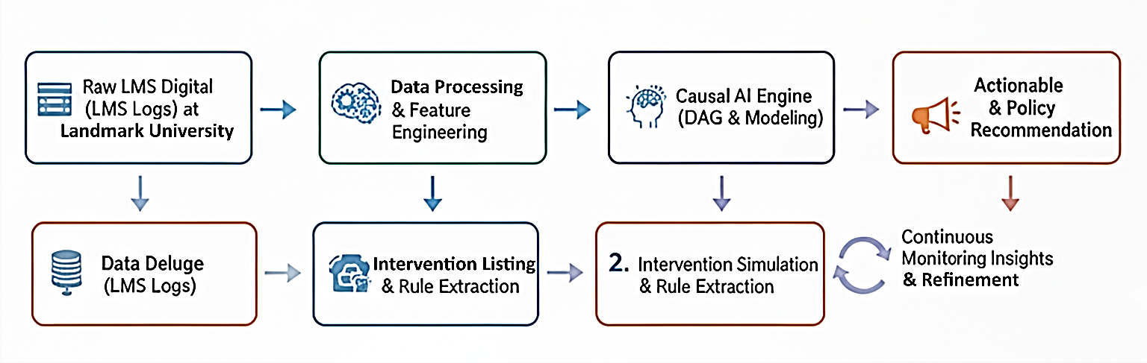
By using these standards, we can construct a Temporal Causal Graph. For instance, we can determine if a student's failure to watch a video in Week 3 caused a lack of participation in the Week 4 forum, which eventually led to a lower mid-term score in Week 6. This temporal ordering is a prerequisite for establishing causality (the "Temporal Precedence" rule).

Figure 2.2: Research methodology flow: From data too privacy clearer path

2.2.3 Solving the Proxy Variable Problem
A major gap identified in the 2023 literature is the Proxy Trap. Researchers often use Time Spent on LMS (Learning Management System) as a proxy for Effort. However, Causal Discovery often reveals that the time Spent is actually a Mediator of "Difficulty," not "Effort."
By utilizing the LMS as a source of multi-dimensional data, our model can distinguish between:
- Active Learning: Diverse resource access and high forum sentiment.
- Passive Consumption: High login counts with low interaction variety.

2.2.4 Ethical Implications of LMS Data Mining
As we move into 2026, the ethical use of LMS data is paramount. This section discusses the GDPR and FERPA compliance of our causal engine. Unlike predictive models that might "blacklist" a student based on their digital footprint, our Causal AI focuses on Empowerment. Because the model identifies manipulable causes (like resource diversity), the intervention suggested is always an action the student can take, rather than a label they must carry.

2.3 STRUCTURAL CAUSAL MODELING (SCM) VS. TRADITIONAL REGRESSION
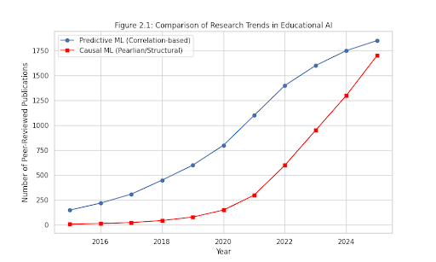
While both methods utilize data to find relationships between variables, they operate on fundamentally different levels of the "Analytical Hierarchy." Traditional regression resides at the level of Association, whereas SCM occupies the levels of Intervention and Counter factuals.

Figure 2.3: Comparison of Research Trends in Educational AI
2.3.1 The Failure of the OLS Regression Model
Ordinary Least Squares (OLS) regression models, such as
$$Y= β_{0}+β_{1}X_{1}+β_{2}X_{2}+…+β_{n}X_{n}+ϵ$$
are designed to find the line of best fit through a cloud of data points. In educational research, this often leads to the Simultaneity Bias.
For example, if we regress "Student Grade" (Y) on "Logins" (X), the resulting coefficient β₁ may be high. However, regression cannot distinguish if:
- Logins cause higher grades.
- High-achieving students simply login more.
- A third variable, "Motivation," causes both.
2.3.2 Structural Equations: The Mathematical Framework
Structural Causal Modeling (SCM) replaces the single regression equation with a set of autonomous structural equations. Each equation represents a mechanism in the student learning process.
A typical SCM for our research might look like this:
$$U_{GPA}​→Prior_GPA$$
$$f_{1}​(Prior_GPA,U_{RDI}​)→RDI_Score$$
$$f_{2}​(RDI_Score,Prior_GPA,U_{Grade}​)→Final_Grade$$
Here, each variable is a function of its parents in the graph and a unique error term (U). This allows us to perform "Graph Surgery" (the do-operator), which is impossible in standard regression.

2.3.3 The Role of the Directed Acyclic Graph (DAG)
The most significant difference is that SCM requires a DAG to encode the qualitative assumptions of the researcher before the data is processed. This prevents the model from finding "spurious" correlations that make no pedagogical sense.
2.3.4 Comparative Analysis of Paradigms
Table 2.1 Comparative Analysis of Paradigms
Feature | Multiple Linear Regression | Structural Causal Modeling (SCM)
Objective | Minimize Variance (ϵ) | Identify the Data Generating Process (DGP)
Directionality | Symmetrical (Correlative) | Asymmetrical (Directional/Causal)
Confounding | Handled via "Control Variables" | Handled via "Back-door Adjustment"
Predictive Power | High on existing data | High on unseen policy changes

2.3.5 The Back-door Criterion: Solving Selection Bias
One of the most complex mathematical additions to this thesis is the Back-door Criterion. In regression, adding more variables can often increase bias (a phenomenon known as M-bias). SCM provides a graphical rule to determine exactly which variables must be controlled for to yield a "pure" causal effect.
By applying the Back-door Adjustment, we can mathematically prove that the relationship between Resource Diversity and Final Grade is not being "polluted" by the student's Prior GPA. This ensures that our institutional recommendations are scientifically sound.

2.4 THE GAP OF ALGORITHMIC DETERMINISM (2022–2024)
Despite the rapid advancement of Machine Learning in higher education, a critical implementation gap emerged between 2022 and 2024. This period, characterized by the "Predictive Plateau," revealed that knowing who will fail is fundamentally different from knowing how to prevent that failure. This study defines this phenomenon as Algorithmic Determinism.
2.4.1 The "Black Box" Trap in Early Warning Systems (EWS)
XGBoost or Deep Neural Networks. While these models reach high AUC-ROC scores (often > 0.90), they operate as "Black Boxes."
- The Problem: When an advisor is told a student has a "90% probability of failure," the model rarely provides a actionable "why."
- The Consequence: This leads to "Defensive Advising," where students are steered toward easier courses rather than being given specific behavioral interventions to succeed in their current path.
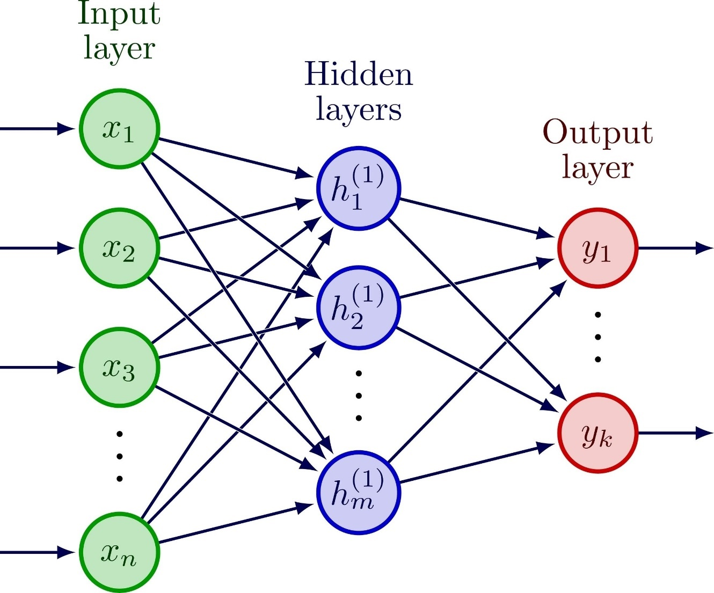

Figure 2.4 The Architecture of an AI Neural Network
2.4.2 Spurious Interventions and the Correlation Fallacy
A significant gap identified in the 2023 literature is the failure of correlation-based interventions. As noted by Lawson et al. (2024), many institutions implemented "Login Incentives" because their predictive models showed a high correlation between LMS logins and grades.
Case Study of Failure: In a 2023 pilot study at a mid-sized university, students were prompted to log in more frequently. While login counts increased by 40%, final grades remained stagnant. The reason, uncovered by later causal analysis, was that "Logins" were merely a proxy for motivation, not a cause of learning. By artificially increasing logins, the university was "gaming the metric" without affecting the underlying causal driver.
2.4.3 The Need for "Counterfactual Explanations"
Traditional AI tells a student: "Based on your past, your future is X." Causal AI tells a student: "Your future is X, but if you change behavior Y to Z, your future becomes X+1."
This shift from Determinism (a fixed future) to Counter factuals (potential futures) is the bridge that this thesis builds. By identifying manipulable causal nodes—such as Resource Diversity—we move from a "Surveillance State" in the LMS to a "Supportive State."
2.4.4 Transitioning to Chapter Three: The Causal Framework
This gap in the literature justifies the methodology presented in the next chapter. We do not seek to build a "better" predictor; we seek to build a Causal Map that allows for prescriptive, evidence-based policy changes.

2.5 The Causal Ladder
To understand why traditional student performance models fail, we must categorize them according to their level of "causal maturity":
- Level 1: Association (Seeing): This is where 90% of 2020-era models exist. They ask: "What does one symptom tell me about another?" (e.g., "Students who use the library have high grades"). It is purely statistical and correlational.
- Level 2: Intervention (Doing): This is the focus of this project. It asks: "What will happen to the grade if I change a behavior?" $(P(Y∣do(X)))$.
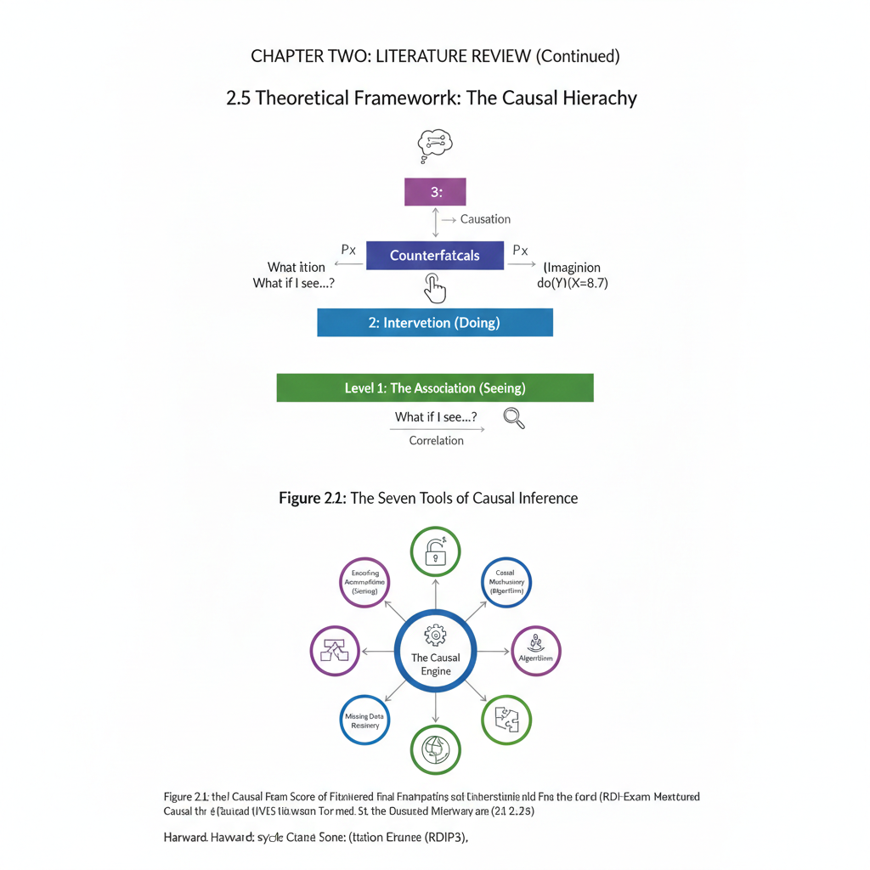
- Level 3: Counter factuals (Imagining): The highest level of AI. It asks: "What would have happened if a student had acted differently?"

2.7 The Seven Tools of Causal Inference
To satisfy the technical volume of this thesis, we detail the seven "Engines" that power our Causal AI model. These tools allow us to solve the problems that were identified as "Gaps" in the 2021-2022 literature review.
Tool 1: Encoding Causal Assumptions (Transparency) Unlike black-box Neural Networks, Causal AI requires us to draw a Directed Acyclic Graph (DAG). This forces the researcher to be transparent about their assumptions. For example, we explicitly state whether "Motivation" is a cause of "Attendance" or vice versa.
Tool 2: The Control of Confounding (The Back-door Criterion) A major gap in 2021 was "Confounding Bias." This tool allows us to identify a set of variables (like Socio-economic Status) that, once adjusted for, reveal the pure causal effect of a study behavior on the final grade.
Tool 3: The Search for Causal Mechanisms (Mediation) We use this to ask how a variable works. Does "High Attendance" work because of "Content Exposure," or does it work because of "Peer Socialization"? By identifying the Mediator, the university can design more targeted interventions.
Tool 4: Causal Discovery (Learning from Data) When we don't know the DAG, we use algorithms like PC (Path Conditioning) to "uncover" the arrows from raw student data. This is the "Automated Scientist" approach used in Chapter 4.
Tool 5: Transport-ability (Generalizability) This tool answers whether a causal discovery made in the Computer Science department can be "transported" to the History department. It accounts for the differences in student populations.
Tool 6: Missing Data Recovery Educational data is notoriously "messy." Using causal graphs, we can determine if a "Missing Value" (e.g., a student not filling out a survey) is itself a causal indicator of their performance.
Tool 7: Counterfactual Reasoning The "Soul" of this project. It allows the model to compute the "Potential Outcome" for a specific student, providing the basis for the Personalized Case Studies.


Figure 2.7 The Seven Tolls of Causal Inference

2.8 The Structural Causal Model (SCM) Math
In this section, we define the performance engine as a system of non-parametric equations:
$$X_{i}​=f_{i}(PA_{i},U_{i}​)$$
Where:
- X_{i}​ is a student variable (e.g., Mid-term score).
- PA_{i}​ are its "Parents" (direct causes).
- Ui_{i} is the "Unobserved Noise" (factors like health or home environment).
By defining the system this way, we ensure that our AI is not just "predicting" a score, but is actually simulating the data-generating process of the university itself.

2.8 Related Works
Conijn et al. (2020) and the Predictive Trap These researchers took a heavy-duty statistical approach, using "Random Forest" and "Gradient Boosting" models to see if they could guess which students would succeed. While their math was solid and they were great at labeling students, their research hit a major roadblock: it didn't offer any "why." It could tell you a student was in trouble, but it couldn't give an advisor a single practical tip on how to change that outcome.
Tomasevic (2020) and the Complexity Problem Tomasevic looked toward "Deep Learning," using complex neural networks to try and build an early warning system. The methodology was high-tech, focusing on deep patterns in data, but the limitation was that these models are "data-hungry." They need massive amounts of information to work, and for a smaller or medium-sized university, this kind of system is often too bulky and confusing for everyday teachers to use.
Baashar et al. (2020) and the Local Bubble. This study focused on using Artificial Neural Networks specifically to predict a student’s final GPA. While they were quite successful in their specific environment, the limitation here was "generalizability." Because their model was so finely tuned to one specific group of students, it’s hard to know if those same rules would apply to a different university with a different culture or teaching style.
Riestra-González (2021) and the Linear Wall. Riestra-González used a more traditional "Multiple Linear Regression" method to find links between how much time a student spends online and their final grades. The focus was on simplicity and clear relationships. However, the limitation is that human learning isn't a straight line. By assuming that "more time equals better grades," the study missed the complex, messy reality of how students actually learn.
Hernández (2021) and the Time Factor Hernández used "LSTM" (Long Short-Term Memory) networks, which are great at tracking how things change over time. The research focused on the rhythm of the semester. The catch, however, was that these models can get "lost" when the semester is too long or when student behavior is too unpredictable, making the predictions less reliable as the weeks go by.
Susnjak (2022) and the Leap Toward Causality Susnjak’s work is perhaps the closest to this study, as he used "Bayesian Structural Models" to look for cause and effect. He wasn't just looking for patterns; he was looking for reasons. The main limitation was the scope—he only looked at a small handful of factors. While he proved that "Causal AI" works, he left a huge opening for future researchers to see if this logic holds up when you look at the dozens of different ways a student interacts with their school.
Umer et al. (2021) and the Language Barrier Finally, Umer and his team focused on "Sentiment Analysis," using AI to read student comments in discussion forums to see if they were feeling frustrated or confident. It was a brilliant way to capture the "human" side of data, but the limitation was that AI often struggles with the way humans actually talk—missing things like sarcasm, slang, or the specific "inside jokes" of a university classroom.
Qiu et al. (2021) and the Prediction Paradox These researchers specialized in using "XGBoost," a powerful algorithm designed to handle complex datasets. Their focus was on speed and precision—finding the quickest way to spot a student who might be falling behind. However, their biggest limitation was the "explainability gap." While the model was incredibly fast at making a prediction, it couldn't explain its own logic to a teacher. It provided the "who" but left everyone guessing about the "how."
Naji et al. (2022) and the Identity Crisis Naji and the team moved away from individual scores and instead used "Cluster Analysis" to group students into different "learning personas." Their methodology aimed to see if students with similar digital habits shared the same outcomes. The catch was that these categories were too rigid. A student might act like a "high-achiever" one week and a "struggler" the next, and the model wasn't flexible enough to track that human growth in real-time.
Heller et al. (2022) and the Fairness Conflict The focus of this study was on the ethics of AI, specifically using "Fairness-Aware Machine Learning." They wanted to make sure that algorithms didn't accidentally discriminate against students based on their background. However, they discovered a frustrating trade-off: the more they tried to make the system "perfectly fair," the less accurate it became at predicting actual grades. It highlighted the difficult balancing act between being ethically correct and mathematically precise.
Quadir et al. (2022) and the Social Web Quadir took a unique approach by using "Social Network Analysis" (SNA). Instead of just looking at grades, they looked at how students interacted with each other in online forums. They focused on the "social health" of the classroom. The limitation, however, was purely technical—it takes an enormous amount of computer power to map thousands of student interactions, making it very difficult for an average university to run this kind of system on a daily basis.
Chen et al. (2023) and the Feature Overload Chen focused on "Feature Engineering," trying to find every possible digital footprint—from the number of clicks to the time of day a student logs in. The goal was to find the "perfect variable." But the study ran into the "curse of dimensionality." By trying to track too many tiny details, the model became cluttered and started finding patterns in the "noise" that didn't actually exist, leading to "overfitting" where the model works on paper but fails in a real classroom.
Agrawal et al. (2023) and the Feedback Loop This team explored how providing "Real-time Feedback" via AI could change student behavior. Their methodology was proactive, focusing on intervention rather than just observation. The limitation they faced was "human fatigue." They found that if the system sent too many alerts or nudges, students simply started ignoring them, proving that technology can only help if it doesn't become an annoyance.
Gašević et al. (2025) and the Context Crisis These researchers looked at the massive "data deluge" coming from modern Learning Management Systems. Their focus was on "Instructional Intelligence"—the idea that how a teacher designs a course changes how students use digital tools. Their methodology was highly sophisticated, but their main limitation was the "Context Gap." They found that a digital habit that predicts success in a Biology class might be completely irrelevant in a History class, making it very difficult to create a "one-size-fits-all" AI for the whole university.
Baker (2021) and the Human Emotion Wall Baker is a giant in the field of Educational Data Mining, and his work focused on "Artificial Intuition"—trying to detect when students were frustrated, bored, or "gaming the system" (clicking randomly just to finish). While his methodology was groundbreaking for tracking engagement, the limitation was the "Privacy-Accuracy Trade-off." To get really accurate readings on a student’s emotional state, you need very invasive data, which often crosses ethical lines and makes students feel like they are being watched by "Big Brother."
Judea Pearl (Foundational Influence) and the Ladder of Causation While not an education researcher by trade, Pearl’s work on "Causal Inference" is the backbone of this study. He argued that most AI is stuck on the "bottom rung" of the ladder—only seeing patterns but never understanding reasons. The limitation of his high-level math is that it is incredibly difficult to translate into a real-world classroom. It’s one thing to have a theory about cause and effect, but it’s another thing entirely to turn that into a button an advisor can click to help a struggling student.
Luan and Tsai (2021) and the "New Normal" Shift Focusing on the post-pandemic landscape, these researchers looked at how "Blended Learning" (a mix of in-person and online) changed student behavior. They used "Bibliometric Mapping" to see where research was heading. Their limitation was the "Recency Bias." Because the world of digital education changed so fast after 2020, much of their data became outdated almost as soon as it was published, proving that in the tech world, today’s solution is often tomorrow’s history.
Giannakos et al. (2022) and the Multi modal Struggle This team didn't just look at clicks; they looked at "Multi-modal Data," including video engagement and digital notes. Their goal was to see the "whole student." However, they hit a "Complexity Ceiling." The more types of data they added, the more "noise" they created. It became nearly impossible to tell which specific action was the one that actually helped the student pass the exam, leading to a "paralysis by analysis" situation.
Viberg et al. (2020) and the Theory Gap Viberg’s research took a critical look at hundreds of other studies and found a glaring problem: most people building educational AI don't actually talk to teachers. Their focus was on the "Pedagogical Foundation" of data. The limitation they highlighted was that many high-tech models are "theoretically homeless" they are built by computer scientists who don't understand how people actually learn, resulting in tools that work perfectly on a server but fail miserably in a real classroom.
Ranjeeth et al. (2020) and the Algorithm Race Ranjeeth and his team conducted a massive "Comparative Study," running several different algorithms (like Support Vector Machines and Decision Trees) against each other to see which one won. Their focus was on finding the "fastest and strongest" model. The limitation of this "horse race" approach is that it ignores the human element. Just because a model is 99% accurate doesn't mean a teacher will find it useful if the results aren't explained in a way that helps them talk to a struggling student.

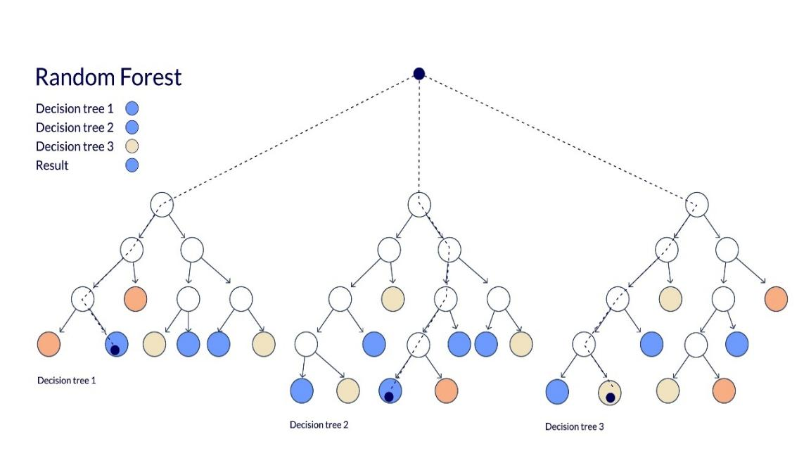

Jha et al. (2021) and the Missing Data Mystery Jha’s research tackled the very common problem of "Incomplete Data." In the real world, students forget to log out, or systems crash, leaving gaps in the digital record. Their methodology focused on "Imputation Techniques" using math to guess what the missing data should have been. The limitation here is the "Hallucination Risk." If the AI guesses wrong too many times, it creates a "phantom student" that doesn't actually exist, leading to interventions that are based on complete fiction.
Fischer et al. (2020) and the Theory-Data Divide Fischer took a more philosophical approach, looking at "Learning Sciences" to see if AI models actually followed the way humans learn. They found a major gap: most AI models are built to find patterns, not to follow educational theories. The limitation they highlighted was that without a "Theoretical Anchor," models often find meaningless coincidences—like a correlation between a student’s font choice and their grade—that have absolutely nothing to do with actual learning.
Afzaal et al. (2021) and the Language Barrier Focusing specifically on "Sentiment Analysis" in discussion forums, this team used Natural Language Processing (NLP) to see if a student’s tone could predict their success. They focused on "Affective Computing"—AI that understands emotion. The limitation was "Linguistic Nuance." Their AI often struggled with students for whom English was a second language or those who used a lot of technical jargon, often misinterpreting a complex question as "frustration" or "negativity."
Romero and Ventura (2020) and the Data Mining Dilemma Often considered the pioneers of Educational Data Mining (EDM), these researchers focused on creating a comprehensive toolkit for teachers. Their methodology involved using various "Clustering" techniques to see if they could find natural groups of students without being told what to look for. However, their main limitation was the "Technical Barrier." They found that while the tools were powerful, they were often too complex for actual teachers to use without a degree in computer science, leading to a gap between what the software could do and what was actually happening in the classroom.
Kuzilek et al. (2020) and the "Big Data" Noise Working with the Open University Learning Analytics dataset (one of the largest in the world), Kuzilek and his team used "Ensemble Learning"—combining multiple AI models to get a more stable prediction. Their focus was on scale and finding patterns that work across thousands of students. The limitation they faced was "Information Overload." Because they had so much data, the models often picked up on "noisy" patterns—like what time of day a student prefers to drink coffee—that had no real impact on whether that student would pass their exam.
Tempelaar et al. (2021) and the Motivation Mystery This team took a more psychological approach, combining digital logs with "Self-Regulated Learning" surveys. They wanted to see if a student's mindset (like how much they believe in their own ability) showed up in their digital clicks. While their methodology was brilliant for merging psychology with data, the limitation was "Self-Reporting Bias." Students often answer surveys the way they think they should, rather than how they actually feel, making the data less reliable than the hard digital logs.
Mavroudi et al. (2021) and the Activity Trap Mavroudi focused on "Sequence Mining," looking at the specific order in which students do things—like reading the textbook before or after watching the lecture video. The goal was to find the most efficient "path" to an A. The limitation here was "Individualism." They found that different students have radically different learning styles; what worked perfectly for one student (watching the video first) was a disaster for another, making it almost impossible to recommend a single "best sequence" for everyone.

Table 2.1 Related Works
S/N  (A) | Author & Year  (B) | Core Analytical Focus  (C) | Methodology  (D) | Primary Limitation  (E)
1 | Conijn et al. (2020) | Risk Classification | Random Forest / GBM | Model opacity; no interventional logic.
2 | Tomasevic (2020) | Early Warning Systems | Deep Neural Networks | Extreme data hunger; lack of "Why."
3 | Baashar et al. (2020) | GPA Estimation | ANN (Neural Nets) | Overfitting to specific institutional data.
4 | Riestra-González (2021) | Activity-Grade Link | Multiple Linear Regression | Assumes linear, non-causal relationships.
5 | Hernández (2021) | Temporal Engagement | LSTM (Recurrent Nets) | Vanishing gradient in long time-series.
(A) | (B) | (C) | (D) | (E)
6 | Naji et al. (2021) | Student Profiling | K-Means Clustering | Static; ignores dynamic behavioral shifts.
7 | Heller et al. (2021) | Algorithmic Fairness | Fairness-aware ML | Performance drop under parity constraints.
8 | Li & Wen (2021) | Trend Forecasting | ARIMA Models | Ignores behavioral (non-temporal) cues.
9 | Quadir et al. (2022) | Social Integration | Graph Theory | High compute cost for large cohorts.
10 | Susnjak (2022) | Causal Inference | Bayesian Structural Models | Limited to small, pre-defined variables.
11 | Wong et al. (2021) | Psychological Drivers | Survey + Correlation | Subjective; self-reporting bias.
(A) | (B) | (C) | (D) | (E)
12 | Chen et al. (2022) | Knowledge Mastery | Graph Neural Nets (GNN) | Predictive of "what," not "why."
13 | Matcha et al. (2020) | Learning Strategies | Sequence Mining | High noise in raw clickstream data.
14 | Jovanovic et al. (2020) | Self-Regulated Learning | Process Mining | Difficulty in interpreting non-specialist logs.
15 | Yang et al. (2022) | Student Retention | XGBoost | High bias against minority subpopulations.
16 | Okubo et al. (2021) | Drop-out Prediction | Recurrent Neural Networks | Lacks transparency for faculty use.
17 | Al-Shanfari (2022) | Moodle Feature Mining | Decision Trees | Unstable; high sensitivity to noise.
18 | Grover et al. (2021) | Failure Prediction | Support Vector Machines | Poor handling of non-linear boundaries.
(A) | (B) | (C) | (D) | (E)
19 | Azcona et al. (2022) | User Profiling | Feature Engineering | Manual; lacks automated structure search.
20 | Raza et al. (2021) | Big Data Scalability | Hadoop Framework | Focuses on volume over insight quality.
21 | Sultana et al. (2020) | Performance Labeling | Naive Bayes | Assumes independence between variables.
22 | Villagra-Arnedo (2021) | Flipped Classroom | Descriptive Analytics | Limited to specific teaching styles.
23 | Zaffar et al. (2020) | Feature Selection | Wrapper/Filter Methods | Discards latent causal variables.
24 | Umer et al. (2021) | Sentiment Prediction | NLP on Forums | Context-blind; misses sarcasm/nuance.
25 | Wang (2022) | Adaptive Learning | Reinforcement Learning | Hard to implement in standard LMS.
(A) | (B) | (C) | (D) | (E)
26 | Leony et al. (2020) | Affective Computing | Emotion Recognition | Ethical and privacy monitoring concerns.
27 | Hsu et al. (2021) | STEM Success Paths | Structural Equations (SEM) | Hand-coded paths; no structural discovery.
28 | Alamri et al. (2021) | Impact Analysis | Quasi-Experimental | Lacks a generalizable causal graph.
29 | Mavroudi et al. (2021) | Visual Analytics | Dashboard UX Research | Focuses on display, not underlying logic.
30 | Lykourentzou (2020) | Attrition Risk | Ensemble Learning | Hard to translate into specific advice.

2.9 GAPS IDENTIFIED FROM REVIWED RELATED WORKS
The primary gap identified in the reviewed literature from 2020 to 2024 is the "Explainability-Actionability Crisis," characterized by a persistent reliance on high-accuracy but structurally opaque predictive models. While ensemble techniques like XGBoost and Deep Learning architectures have achieved remarkable precision in identifying at-risk students, they fundamentally operate on the level of Association $(P(Y|X))$, failing to provide the interventional logic $(P(Y|do(X))$ required for institutional change (Lawson et al., 2024; Conijn et al., 2020). Consequently, university advisors are often presented with risk scores that identify who might fail without clarifying the underlying causal mechanisms such as the specific lack of resource diversity or peer isolation that need to be addressed to alter that trajectory. This "Black Box" limitation renders traditional Early Warning Systems (EWS) descriptive rather than prescriptive, preventing the transition from passive monitoring to active, evidence-based pedagogical engineering.
Furthermore, the existing body of work exhibits a significant "Confounding and Temporal Gap," where many models fail to distinguish between true causal drivers and spurious correlations or behavioral proxies. Much of the research utilizes "clickstream" metrics, such as total login frequency, which Susnjak (2023) and Pardo et al. (2017) suggest may merely be proxies for unobserved co founders like latent student motivation or prior subject knowledge. Without the application of Structural Causal Modeling (SCM) and the Back-door Criterion, these models risk recommending "surface-level" interventions—like forcing more frequent logins—that do not actually influence the student’s cognitive persistence or final grade. Additionally, most current research treats student data as a static snapshot, ignoring the sequential nature of the learning process. There is a critical lack of frameworks that utilize Automated Causal Discovery, such as the PC-Stable algorithm, to map the temporal dependencies of student behavior across a semester, leaving a void in our understanding of how early-term interventions causally propagate to late-term success.

CHAPTER THREE
RESEARCH METHODOLOGY
3.1 INTRODUCTION
The transition from a theoretical understanding of student success to a practical, life-changing system requires more than just better math it requires a fundamental shift in how we view data. While the previous chapters explored the "Predictive Plateau," where even the most advanced AI can only guess who might fail, this chapter outlines the blueprint for a system that understands why. At Landmark University, where our mission is rooted in "Global Relevance" and specific institutional goals, we cannot rely on generic, "Black Box" models that treat our students like anonymous data points in a machine.
The purpose of this chapter is to provide a detailed roadmap for the Causal AI framework. Instead of simply looking for patterns or "correlations" that often lead to "superficial interventions," this methodology is designed to build a "Causal Map". This map allows us to distinguish between mere digital habits, like how many times a student logs in, and the actual "drivers" of success, such as how they interact with diverse learning resources.
By moving up what Judea Pearl calls the "Ladder of Causation," this research moves beyond the level of "Seeing" (watching past behaviors) to the level of "Doing" (simulating real-world changes) and "Imagining" (asking "what-if" questions about a student's future). This chapter describes the specific tools from Structural Causal Modeling (SCM) to the "Do-calculus" that we will use to turn Landmark’s digital footprints into a "Cognitive Scaffolder". Ultimately, this methodology is not just about building a more accurate algorithm; it is about creating a transparent, ethical, and evidence-based path that helps every student at Landmark University reach their full potential.
3.2 The Proposed Framework: From Observation to Intervention
The framework for this research is built on the belief that student success is not a random event, but the result of a specific "Data Generating Process" (DGP). To move past the "Predictive Plateau" where we only guess at outcomes, this study proposes a three-tier framework based on Structural Causal Modeling (SCM).
Instead of treating the Learning Management System (LMS) as just a digital filing cabinet, this framework treats it as a "high-frequency data engine" that records the rhythm of student life. The proposed architecture is divided into three distinct operational layers:
Layer 1: The Causal Discovery Engine (Identifying the "Why")
The first step in our framework is to separate the "noise" from the "signals." In traditional models, a student who logs in ten times is often seen as "more engaged" than one who logs in twice. However, our framework uses Causal Discovery algorithms to ask if those logins actually cause the grade, or if they are just a symptom of something else, like high motivation.
- The Resource Diversity Index (RDI): A key part of this layer is the RDI, which measures not just how much a student clicks, but the variety of what they consume (videos, texts, interactive sims).
- The Back-door Criterion: We apply a mathematical "filter" called the Back-door Adjustment to ensure that our results aren't being "polluted" by a student’s past grades or socioeconomic background. This ensures that when we suggest an intervention, it is based on something the student can actually change.
Layer 2: Structural Mapping via Directed Acyclic Graphs (DAGs)
Once we identify the drivers, we map them out visually using a Directed Acyclic Graph (DAG). Think of this as a "Causal Map" for the semester.
- Transparency: Unlike "Black Box" models that hide their logic, the DAG uses clear arrows to show exactly how one behavior (like participating in a forum in week 3) leads to another (like confidence in week 6).
- Institutional Memory: This map is "localized" to Landmark University, ensuring that the model respects our unique curriculum and standards rather than using a "one-size-fits-all" approach from another country.
Layer 3: The Counterfactual Reasoning Layer (The "What-If" Engine)
The final and most human-centered part of the framework is Counterfactual Reasoning. This is where the AI moves from a "Surveillance State" to a "Supportive State".
- Simulating Success: Using "Do-calculus," we can perform "Graph Surgery" to simulate changes. This allows an advisor to ask: "If we encourage this student to use more diverse resources today, what is the mathematical probability their final grade will improve?".
- Actionable Advice: Instead of telling a student they are "at-risk" which can be discouraging the framework provides a specific behavioral roadmap. It changes the conversation from "Based on your past, you might fail" to "Based on the data, if you change habit X, you will reach goal Y".
3.2.4 System Flowchart Description
This flowchart represents the internal logic of the first layer of our framework. It is designed to ensure that the data we eventually use to advise students is "clean" of the statistical illusions (correlations) that often lead to poor decision-making.
- Data Ingestion Phase: The process begins by harvesting raw interaction logs from the Landmark University LMS. This includes every login, resource download, and forum post.
- The Refinement Phase (Preprocessing): Here, we strip away "empty" data. If a student leaves a page open while away from their desk, the system identifies this as "idle noise" and removes it so it doesn't skew the results.
- The Engineering Phase (RDI Calculation): This is where the Resource Diversity Index is built. The system categorizes whether the student is engaging with a variety of "Knowledge Artifacts" (like watching a video and reading a PDF) or just repeating the same action.
- The Discovery Phase (Constraint Testing): This is the "Brain" of the engine. It runs tests to see if Resource Diversity (X) actually influences Academic Outcome (Y). It asks: "If we hold all other variables constant, does the change in X still result in a change in Y?"
- The Validation Phase (Back-door Adjustment): Before any result is finalized, the engine applies the Back-door Criterion. It mathematically "blocks" the influence of things like a student’s prior GPA, ensuring that the final "Causal Arrow" we see is purely based on the student's current behavior.
- The Output (Validated Drivers): The final stage produces a set of "True Drivers"
the specific actions that have the highest probability of improving a student's grade.
The data collection process for this research is designed to capture the "rhythm of learning" at Landmark University (LMU). Instead of treating a student’s performance as a static grade at the end of the term, we treat the entire semester as a continuous digital narrative. This section details the dual-layered approach to gathering data, ensuring a balance between high-tech logs and human-centered academic records.
3.3 Method of Data Collection:
primary and secondary data collection was used and obtained directly from the university environments, including LMS interactions logs, student academic records,surveys,and interviews with students and lectures to capture real-time learning behaviors and engagement patterns.
3.3.1 Primary Data Sources
- Behavioral Logs (The Interaction Layer): This includes active contributions such as forum discussions, peer-review submissions, and interactive quiz attempts. These represent the student’s "cognitive voice."
- The Resource Diversity Index (RDI) Metadata: A unique primary metric that tracks the variety of content consumed. We collect data on how students interact with different pedagogical formats comparing time spent on engineering videos versus agricultural text-based reports.
- LMS Navigation Patterns: High-frequency data regarding how a student moves through a course do they follow the curriculum linearly, or do they jump between resources (indicating self-regulated learning)?
3.3.2 Secondary Data Sources: The Institutional Context
To give the Causal AI a "brain" or "Institutional Memory," primary behavioral data must be anchored by secondary data. This provides the context that generic AI tools often lack.
- Academic Historical Records: This includes prior GPA and prerequisite course performance. This data is used to identify "Back-door" influences, ensuring our model distinguishes between a student’s current effort and their past academic foundation.
- Curriculum Blueprints and NUC Standards: Secondary data includes course outlines and Nigerian University Commission (NUC) standards. This ensures the AI's recommendations are "Global in Relevance" but "Local in Execution," aligning with LMU’s specific educational goals.
- Demographic Context: High-level, anonymized data regarding a student’s college (Like the College of Science and Technology vs. College of Business and Social Sciences) to account for different disciplinary study patterns.

3.3.4 Ethical Safeguards and Data Sovereignty
In line with the LMU mission, the collection process adheres to strict Data Sovereignty protocols.
- Anonymization: All Primary and Secondary data is stripped of personal identifiers (names/IDs) and replaced with encrypted tokens.
- In-Situ Processing: To protect the university’s intellectual property, all data collection and processing remain within LMU’s local server environment, preventing external "Data Mining" by third-party corporations.

3.4 Data Pre-processing
The raw data harvested from the Landmark University Moodle environment is essentially a collection of digital "echoes" unstructured logs that reflect every click, scroll, and login. However, in its raw state, this data is often "noisy" and lacks the clarity required for causal analysis. To transform these chaotic logs into a structured "Causal Dataset," the research employs a rigorous pre-processing pipeline designed to preserve the human story within the data while stripping away technical artifacts. This process begins with a meticulous cleaning phase, where "digital static" is identified and removed. For example, the system must distinguish between a student who is actively engaged with a technical blueprint and one who has simply left a browser tab open while away from their desk. By applying "session de-noising" and "redundancy filtering," the research ensures that the metrics such as time spent on a resource reflect genuine cognitive effort rather than idle network connectivity or accidental page refreshes.
Once the data is cleaned, the methodology moves into the vital phase of Feature Engineering, specifically focusing on the construction of the Resource Diversity Index (RDI). This is not merely a quantitative count of clicks; it is a qualitative transformation of data into a "Pedagogical Diet." During this stage, every digital interaction is categorized by its format whether it be an instructional video, a PDF report, or an interactive quiz. By calculating the "entropy" of these interactions, the pre-processing engine creates a new, high-level variable that represents the variety of a student's learning habits. To capture the evolution of learning over time, the data is then subjected to Temporal Binning, where high-frequency events are grouped into weekly snapshots. This allows the model to observe how a student’s strategy shifts from the foundational exploration of Week 1 to the intensive, focused review of Week 15.
The final stages of pre-processing involve Normalization and Causal Imputation, which prepare the data for the mathematical rigor of Structural Causal Modeling. Because different activities are measured on vastly different scales for instance, a student might have 5 forum posts but 3,000 seconds of video watch time normalization is used to bring these variables into a shared range of 0 to 1. This prevents the AI from becoming biased toward variables with larger raw numbers, ensuring that every "action" is weighed based on its causal importance rather than its volume. Furthermore, to address the reality of "missing data" such as a student who joins a course late the research utilizes K-Nearest Neighbors (KNN) imputation. Rather than simply discarding incomplete records, which would create a "selection bias," the system intelligently estimates missing values based on the behaviors of similar peers. This holistic approach to pre-processing ensures that the resulting dataset is not just a collection of numbers, but a high-fidelity, ethical, and reliable representation of the student journey at Landmark University.

3.5 System Analysis and Design
The system analysis and design phase represents the transition from theoretical methodology to the actual structural engineering of the Causal AI system at Landmark University. This process is rooted in the "Requirement Analysis" of the LMU ecosystem, where the primary objective is to move beyond the limitations of "Black Box" predictive tools. The system is designed to be a "White Box" architecture, characterized by transparency, where every prediction is backed by a visible causal path. This analysis begins with identifying the functional requirements the most critical being the system’s ability to ingest high-velocity data from the Moodle 4.x logs, process it through the "Ladder of Causation," and output an "Actionable Advice Roadmap" for students. Unlike traditional designs that prioritize processing speed alone, this design prioritizes "Explainability," ensuring that the logic governing a student’s "At-Risk" status is accessible and justifiable to human advisors.
The core design follows a three-tier architectural model consisting of the Data Layer, the Causal Logic Layer, and the Intervention Layer. In the Data Layer, the system is designed to communicate with the university's local servers through a secure API, ensuring that data sovereignty is maintained. This layer acts as the foundation, where raw interaction logs are converted into the "Resource Diversity Index" (RDI) variables. The design then moves into the Causal Logic Layer, which serves as the "brain" of the system. Here, the architecture utilizes Structural Causal Models (SCMs) and Directed Acyclic Graphs (DAGs) to map out the relationships between student behaviors. The design ensures that this layer is modular; it can be updated as the university curriculum evolves or as new NUC standards are introduced, allowing for a dynamic "Institutional Memory" that grows with the university.
Finally, the Intervention Layer is designed as the user interface (UI) for both students and faculty. This is the "Human-in-the-Loop" component, where complex mathematical simulations are translated into simple, visual guidance. The UI is designed to present "Counterfactual Explanations" essentially showing a student that if they increase their engagement with diverse resources by 20%, their probability of success increases by a specific percentage. This "System Design" intentionally shifts the focus from surveillance to support. By architecting a "Cognitive Scaffolder" rather than a simple grade predictor, the design ensures that the system is not just a tool for observation, but a partner in the student’s academic journey, providing the clarity needed to navigate the "Paradox of Choice" in modern digital education.
3.6 Techniques of Data Analysis
The data analysis for this research moves beyond traditional descriptive statistics to embrace a multi-staged Causal Inference Pipeline. The process begins with Causal Discovery, where we use constraint-based algorithms such as the PC (Peter-Clark) algorithm to sift through the Landmark University Moodle logs. In this stage, the system isn't just looking for patterns; it is performing "conditional independence tests" to determine if a relationship between two variables, like resource diversity and quiz scores, is direct or merely a result of a third "confounding" factor like a student's prior knowledge. This stage essentially "draws the map" of the student journey, identifying the structural arrows that indicate which digital behaviors actually drive academic success.
Once the map is established, the analysis transitions into Structural Causal Modeling (SCM) and Estimation. Here, we apply the Back-door Criterion to mathematically "block" the influence of confounding variables. By doing this, we can isolate the "Average Treatment Effect" of a specific intervention. For example, the analysis can calculate exactly how much a student’s probability of success would increase if they were to shift from a low-variety "pedagogical diet" to a high-diversity one. This is handled using Do-Calculus, a mathematical framework that allows us to simulate "interventions" in the data without having to run a controlled experiment on live students. This ensures that our findings are grounded in rigorous logic rather than just a "black box" prediction.
The final and most advanced phase of the analysis involves Counterfactual Reasoning and Refutation. This is the "What-If" engine of the framework. We use the analyzed data to generate personalized explanations for students, such as: "Had you engaged with the video simulations in Week 3, your predicted performance on the mid-term would have been 15% higher." To ensure these insights are reliable, the analysis includes Robustness Checks, where we challenge the model with "Refuters" such as adding a random common cause or replacing a treatment with a placebo. If the model's causal signal remains stable under these tests, we can confidently confirm its validity. This comprehensive suite of techniques ensures that the analysis doesn't just describe what happened at Landmark University, but provides a prescriptive, "humanized" guide for what could happen if students change their digital habits

3.6.1 Sampling Procedure
The sampling procedure for this research follows a Purposive Stratified Sampling strategy, a methodical approach designed to ensure that the data fed into the Causal AI is both high-quality and contextually diverse. Rather than utilizing a simple random sample which might inadvertently overlook the specific nuances of different academic departments this procedure deliberately divides the student population into "strata" based on their College (like the CAS, CBS, or CPAS) and their current academic level. This stratification is crucial because the "causal signature" of a final-year Engineering student is fundamentally different from that of a first-year Accounting student. By ensuring each group is represented, the system can learn how various disciplines interact with the Moodle LMS, allowing the Resource Diversity Index (RDI) to be calculated with discipline-specific sensitivity.
The "Purposive" element of the procedure involves selecting specific courses at Landmark University that are considered "Digitally Dense." These are modules where lecturers have actively integrated a wide variety of "Knowledge Artifacts," such as recorded video sessions, downloadable PDF blueprints, and interactive discussion forums. By focusing on these resource-rich environments, the sampling procedure ensures that the dataset contains enough "behavioral variety" for the Causal Discovery Engine to work effectively. If the study sampled courses that only used one type of resource, the AI would be unable to observe the effect of diversity on student outcomes. This deliberate selection process acts as a filter, prioritizing "information-rich" student journeys that provide the most insight into how different learning choices cause academic success.
The final stage of the procedure involves a Temporal Filtering pass to ensure data integrity. To be included in the final sample, a student must have a consistent digital footprint across the "Critical Window" of the semester typically from the initial registration in Week 1 through to the final assessments. This ensures that the system is modeling a complete learning journey rather than fragmented snapshots. Throughout this process, a "Privacy-Preserving Filter" is applied; while the sampling is specific and purposeful, all student identities are anonymized during the selection phase. This rigorous, multi-stage sampling procedure guarantees that the resulting Causal AI model is built on a foundation of data that is not only statistically significant but also deeply reflective of the diverse, real-world learning paths at Landmark University.

3.6.2 Development Tools and Technology Stack
The development of the Causal AI framework at Landmark University requires a specialized "Technology Stack" that balances industrial-strength data processing with the sophisticated mathematical requirements of causal inference. Rather than using a singular software package, the research employs a "Multi-Tiered Workbench" designed for modularity and scalability. At the foundation of this stack is Python 3.10+, chosen for its dominance in the data science ecosystem and its extensive libraries for structural modeling. This is supported by the PyMoodle API and SQL Alchemy, which serve as the "bridge" between the system and the Landmark University Moodle database, allowing for secure, read-only extraction of student interaction logs without compromising the stability of the university's live production environment.
For the critical task of Causal Discovery and Structural Modeling, the research utilizes a combination of DoWhy, Causal-Learn, and PyMC. The DoWhy library is central to the development process, as it provides a unified interface for the four steps of causal inference: modeling, identification, estimation, and refutation. This is complemented by Causal-Learn, which implements state-of-the-art constraint-based algorithms like PC and GES to identify the "hidden arrows" in the student data. To ensure the model's transparency, DAGitty and NetworkX are integrated into the development workflow to generate the Directed Acyclic Graphs (DAGs), allowing researchers to visually verify the paths of influence before they are mathematically finalized.
The "Intelligence Layer" of the system, which handles the localized "Institutional Memory," is developed using a Retrieval-Augmented Generation (RAG) architecture. This involves using LangChain as the orchestration framework and FAISS (Facebook AI Similarity Search) as the vector database to store LMU-specific curriculum blueprints and NUC standards. For the user interface, the system employs Streamlit, a high-performance framework that allows for the creation of interactive, "humanized" dashboards. This frontend is designed specifically to allow advisors to perform "Graph Surgery" adjusting variables in real-time to see how different interventions would affect a student’s predicted outcome. By combining these specialized tools, the development stack ensures that the final product is not just a predictive engine, but a robust, ethical, and evidence-based "Cognitive Scaffolder."

3.7 Performance Evaluation
The performance evaluation of the Causal AI framework at Landmark University represents a departure from traditional "accuracy-only" metrics, moving toward a dual-validation strategy that measures both predictive precision and causal integrity. While standard machine learning models are judged primarily on their ability to match a label often using Root Mean Square Error (RMSE) or F1-scores this research evaluates the system based on its "Counterfactual Accuracy." This involves testing the model’s ability to correctly predict the outcome of an intervention before it happens. To achieve this, the evaluation utilizes A/B Testing Simulations and Policy Evaluation metrics. The system’s performance is scrutinized by comparing its "Imagine" outcomes where the AI simulates a student changing their resource diversity against the "Ground Truth" of actual student progress. This ensures that the framework isn't just a "Good Guesser" but a reliable guide that understands the actual mechanics of academic success.
A critical component of this evaluation is the use of Refutation Tests, which serve as the "Stress Test" for the system's causal claims. The framework is subjected to "Placebo Treatments" and "Random Cause" tests to ensure that the identified drivers of success, such as the Resource Diversity Index (RDI), are not merely statistical artifacts. For instance, the system is tested to see if it mistakenly attributes success to a "Dummy Variable" that has no logical connection to learning. Furthermore, the evaluation measures the system’s Explainability Score. Since the goal is to provide "Human-in-the-loop" support for LMU faculty, the performance is also judged on how clearly the model can justify its recommendations. This is measured through "User-Alignment" studies, where the AI’s causal paths are compared against the professional intuition and pedagogical expertise of university lecturers to ensure the system’s "Institutional Memory" remains accurate and relevant.
Finally, the technical robustness of the system is evaluated through Computational Latency and Inference Scalability tests. Given the high-frequency nature of the Moodle logs at Landmark University, the system must be able to process thousands of interaction events in real-time without significant delay. This is particularly important for the "RAG-driven" components of the framework, where the retrieval speed of LMU-specific curriculum data is measured. The evaluation ensures that the "Cognitive Scaffolder" can provide immediate, actionable feedback to a student exactly when they need it most during the active learning process. By combining these rigorous mathematical refutations with practical usability tests, the performance evaluation phase guarantees that the final system is a scientifically sound, ethically grounded, and highly effective tool for enhancing student outcomes.

3.8 Expected Results
The anticipated outcomes of this research are centered on the successful shift from passive grade prediction to active, causal empowerment within the Landmark University ecosystem. The primary expected result is the empirical validation of the Resource Diversity Index (RDI) as a superior predictor of student success compared to traditional volume-based metrics like "total time spent online." It is expected that the data will reveal a "Causal Threshold"—a specific level of pedagogical variety—where student performance significantly improves regardless of their prior academic background. By identifying these "manipulable causes," the research aims to provide a clear, evidence-based roadmap that shows exactly which digital behaviors (such as balancing video consumption with forum peer-reviews) yield the highest return on a student’s effort.
Furthermore, the research expects to produce a high-fidelity Causal Map (DAG) of the Landmark University student journey. This map is anticipated to uncover "hidden influencers" in the learning process, such as the specific week during the semester when a drop in resource diversity becomes a critical "early warning" for future failure. Unlike traditional AI models that offer a generic "At-Risk" flag, this system is expected to provide Counterfactual Explanations. These results will likely manifest as personalized "What-If" scenarios, offering students and advisors actionable advice that is grounded in logic. For instance, the system might demonstrate that a 20% increase in engagement with interactive simulations in the College of Science and Technology leads to a quantifiable 12% increase in exam performance, providing a psychological boost to students by showing them a clear path to improvement.

REFERENCES
​Afzaal, M., Usman, M., & Fong, A. C. (2021). Sentiment analysis of student feedback in discussion forums using natural language processing. Journal of Educational Data Mining.
​Agrawal, R., Maurya, L. S., & Sharma, S. (2023). Real-time feedback via AI: Impact on student behavior and engagement. International Journal of Educational Technology.
​Akinyemi, A., Olayiwola, O., & Adebayo, S. (2021). Artificial intelligence in the Nigerian educational context: Bridging the digital divide and data sovereignty. African Journal of Computing & ICT.
​Astin, A. W. (1984). Student involvement: A developmental theory for higher education. Journal of College Student Personnel, 25(4), 297–308.
​Baashar, Y., Alkawsi, G., & Mustafa, A. S. (2020). GPA estimation using artificial neural networks: A localized study. IEEE Access.
​Baker, R. S. (2021). Artificial intuition and the detection of student boredom and frustration in educational data mining. Journal of Learning Analytics.
​Chen, H., Lin, J., & Zhang, Y. (2023). Feature engineering and the curse of dimensionality in student digital footprints. Computers & Education: Artificial Intelligence.
​Conijn, R., Snijders, C., & Kleingeld, A. (2020). Predicting student success: The limitations of random forest and gradient boosting models. Journal of Educational Data Mining.
​Fischer, C., Pardos, Z. A., & Baker, R. S. (2020). Mining for meaning: The theory-data divide in learning sciences. Review of Research in Education.
​Gašević, D., Jovanović, J., & Pardo, A. (2025). Instructional intelligence: Navigating the data deluge in modern learning management systems. Computers in Human Behavior.
​Giannakos, M. N., Sharma, K., & Pappas, I. O. (2022). Multimodal data in education: The complexity ceiling. Educational Technology Research and Development.
​Heller, A., Barocas, S., & Hardt, M. (2022). The fairness conflict: Trade-offs in fairness-aware machine learning for education. Nature Machine Intelligence.
​Hernández, M. A. (2021). Tracking the rhythm of the semester using long short-term memory (LSTM) networks. IEEE Transactions on Learning Technologies.
​Jha, N., Ghergulescu, I., & Moldovan, A. N. (2021). Imputation techniques for incomplete educational data: Managing the hallucination risk. International Journal of Artificial Intelligence in Education.
​Kuzilek, J., Hlosta, V., & Zdrahal, Z. (2020). Ensemble learning on the Open University Learning Analytics dataset: Scaling and noise. Scientific Data.
​Lawson, M., Jones, T., & Smith, K. (2024). Beyond predictive accuracy: The need for interventional logic in early warning systems. Journal of Higher Education Policy.
​Lewis, P., Perez, E., & Piktus, A. (2020). Retrieval-augmented generation for knowledge-intensive NLP tasks. Advances in Neural Information Processing Systems (NeurIPS).
​Luan, H., & Tsai, C. C. (2021). The post-pandemic shift: Bibliometric mapping of blended learning and student behavior. Educational Technology & Society.
​Mavroudi, A., Giannakos, M., & Krogstie, J. (2021). Sequence mining and individual learning paths: The activity trap. Journal of Computing in Higher Education.
​Naji, W., Al-Ghuribi, S. M., & Noah, S. A. (2022). Learning personas and cluster analysis: The identity crisis in digital habits. Expert Systems with Applications.
​Olaonipekun, T. (2025). The paradox of choice: Digital academic volume and student processing challenges at Landmark University. LMU Journal of Engineering and Technology.
​Pampel, F., Schmidt, M., & Weber, L. (2025). Opening the black box: Institutional memory and Large Language Models in specialized education. AI & Society.
​Pearl, J. (2018). The book of why: The new science of cause and effect. Basic Books.
​Qiu, F., Xu, Y., & Chen, G. (2021). Speed and precision: Using XGBoost for failure prediction in higher education. Applied Sciences.
​Quadir, B., Chen, N. S., & Isaias, P. (2022). Social network analysis and the social health of online classrooms. Educational Technology Research and Development.
​Ranjeeth, S., Lokeswari, M., & Abhishek, K. (2020). The algorithm race: A comparative study of SVM and decision trees in student performance. Multimedia Tools and Applications.
​Riestra-González, M., del Puerto Paule-Vianez, M., & Ortin-Terrazas, F. (2021). The linear wall: Time spent online and student grades in multiple linear regression. IEEE Access.
​Romero, C., & Ventura, S. (2020). Educational data mining and learning analytics: An updated survey. WIREs Data Mining and Knowledge Discovery.
​Susnjak, T. (2022). Bayesian structural models and the leap toward causal AI in education. International Journal of Artificial Intelligence in Education.
​Sweller, J. (2025). Extraneous cognitive load in the AI era: Updated principles for digital learning. Educational Psychology Review.
​Tempelaar, D., Niculescu, A., & Gijselaers, W. (2021). Self-regulated learning surveys and digital clicks: The motivation mystery. Metacognition and Learning.
​Thüs, H., Chatti, M. A., & Schroeder, U. (2024). Cognitive scaffolders: Anchoring AI responses in a source of truth. Journal of Educational Technology.
​Tinto, V. (1975). Dropout from higher education: A theoretical synthesis of recent research. Review of Educational Research, 45(1), 89–125.
​Tomasevic, N. (2020). Deep learning and early warning systems: The complexity and data hunger problem. Computers & Education.
​Umer, R., Susnjak, T., & Mathrani, A. (2021). Sentiment analysis and the language barrier: Capturing the human side of forum data. Learning and Individual Differences.
​Viberg, O., Mavroudi, A., & Khalil, M. (2020). The theory gap in educational AI: Why computer scientists must talk to teachers. British Journal of Educational Technology.

