TeleConnect Customer Churn and Revenue Risk Analysis
Complete SQL Portfolio Project Documentation

Project detail | Value
Author | Ernest-Cyril Divine Onyeze
Database | MySQL Server 8.0
Client | MySQL Workbench 8.0 CE
Dataset | 7,043 fictional telecom customers in California
Completed | 18 September 2026

Portfolio: cyrilanalytics.com

Executive Summary
This project uses MySQL to analyse customer churn, historical customer value, service adoption, and retention priorities for TeleConnect, a fictional telecommunications company. A flat 38-column customer file was converted into a normalized five-table relational database. The workflow includes staged data loading, integrity checks, cleaning decisions, basic and advanced SQL analysis, reusable views, and business recommendations.
The verified data contains 7,043 customers: 1,869 churned, 4,720 stayed, and 454 recently joined. Churn was 26.54% across all customers and 28.37% when recent joins were excluded. The strongest descriptive patterns involved contract type, early tenure, competitor pressure, payment method, internet type, and service-bundle depth.
Metric | Verified result
Total customers | 7,043
Churned customers | 1,869
Overall churn rate | 26.54%
Churn rate excluding recent joins | 28.37%
Historical revenue from churned customers | $3,684,459.82
Priority-retention segment | 442 active customers

Business Problem and Objectives
TeleConnect needs to understand who is leaving, why churn occurs, which customer groups require attention, and how SQL analysis can support retention decisions. The project addresses the following objectives:
- Measure customer status and define churn-rate denominators clearly.
- Compare churn across contract, payment method, internet type, tenure, service adoption, revenue tier, and location.
- Identify the most frequent churn categories and specific reasons.
- Quantify historical revenue associated with churned customers without misrepresenting it as future loss.
- Create a transparent rule-based segment for retention outreach.
- Demonstrate reproducible SQL, relational modelling, validation, and documentation practices.

Data Source and Scope
The project uses the Maven Analytics Telecom Customer Churn dataset, based on IBM's fictional telecommunications sample. The source represents a customer snapshot at the end of Q2 2022 and includes demographics, location, subscribed services, billing, customer status, churn categories, and churn reasons.
Source file | Rows | Purpose
telecom_customer_churn.csv | 7,043 | Customer demographics, services, billing, and churn outcome
telecom_zipcode_population.csv | 1,671 | California population by ZIP code
telecom_data_dictionary.csv | 40 definitions | Field descriptions and business meaning

Dataset source: https://mavenanalytics.io/data-playground/telecom-customer-churn

Database Design
The flat source was normalized into five core tables so that demographics, services, billing, churn outcomes, and ZIP-level population could be maintained and queried separately. The design supports meaningful joins and reduces repeated analytical logic.
Table | Purpose | Key
customers | Demographics and customer location | customer_id
customer_services | Phone, internet, streaming, and support services | customer_id
customer_billing | Tenure, contract, payment, charges, and historical revenue | customer_id
customer_churn_status | Status, churn category, and churn reason | customer_id
zip_population | Population by California ZIP code | zip_code

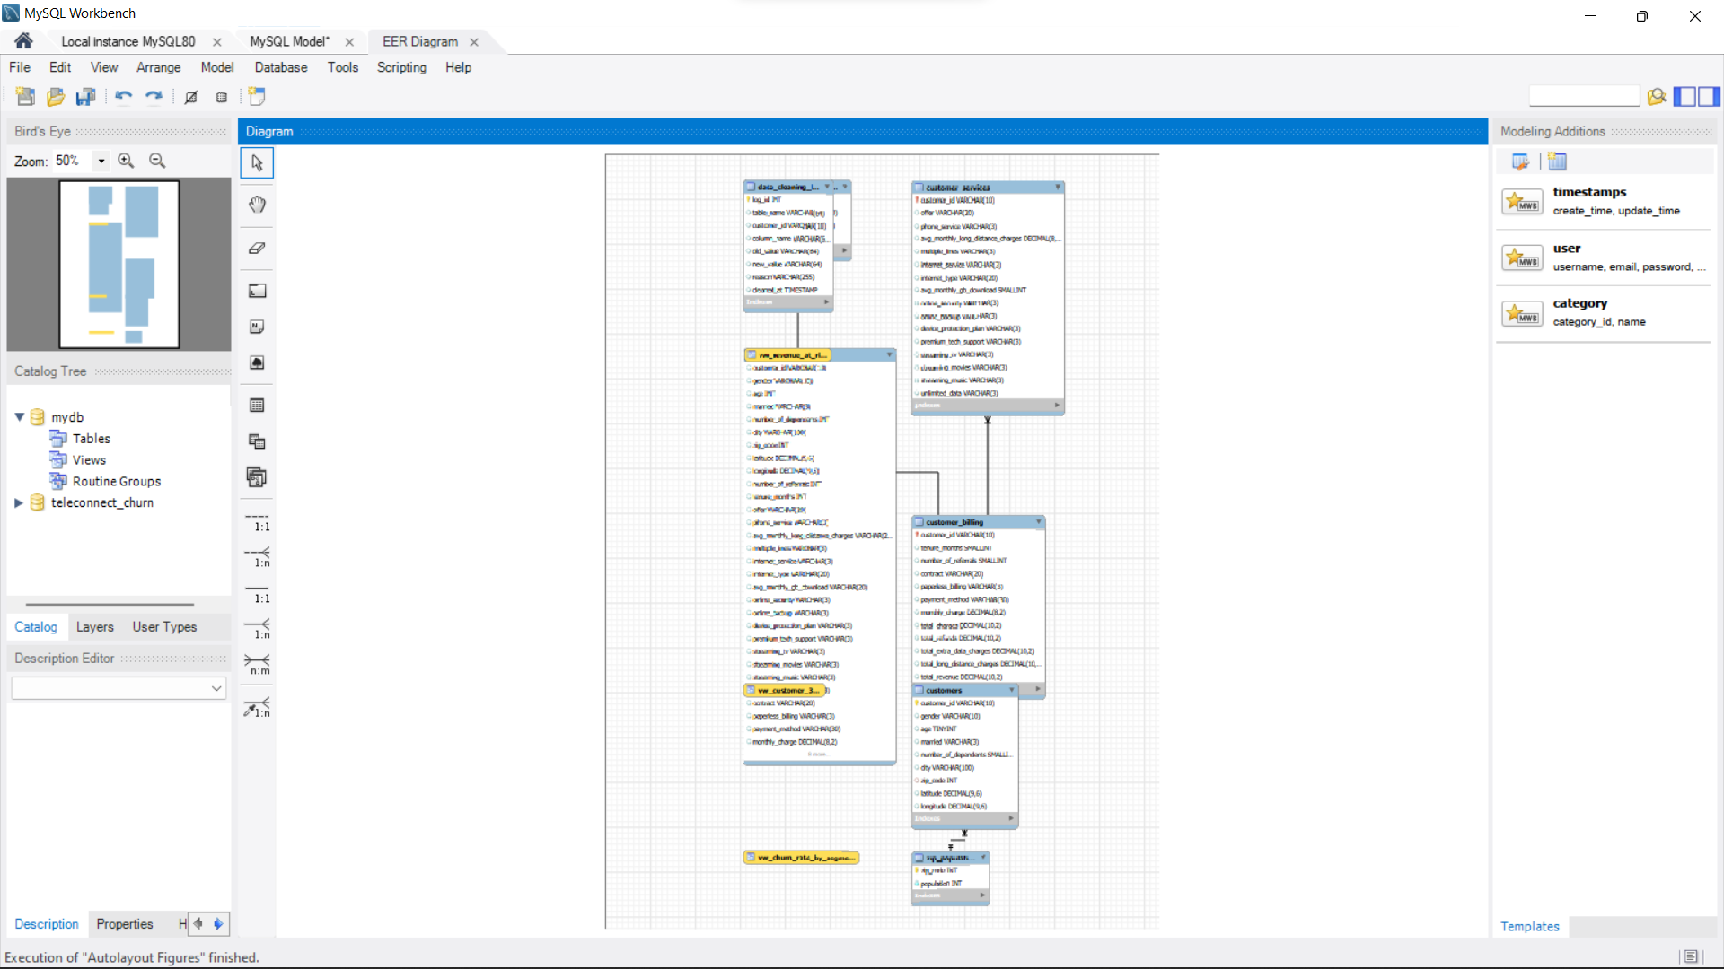
Figure 1. MySQL Workbench EER diagram showing the project tables and relationships.

ETL and Data Validation
The project uses a staging-table pattern. The customer CSV is first loaded into `stg_telecom_raw`, where its original structure is preserved. `INSERT ... SELECT` statements then populate the normalized tables with explicit casts and null handling.

Validation results
Check | Result | Conclusion
Customer IDs | 7,043 unique; 0 duplicates | Primary-key check passed
ZIP-code references | 0 unmatched | Foreign-key coverage passed
Churn reasons | 0 missing among churned customers | Business rule passed
Revenue formula | 0 mismatches | Stored revenue reconciled
Negative monthly charge | 120 records | Flagged; source preserved

Monthly-charge anomaly decision
The source contains 120 monthly-charge values between -10 and -1. The data dictionary does not explain these values, and applying an absolute-value transformation would not establish the true charge. The audited portfolio version preserves and flags the source values, excludes them from monthly-charge averages, and states the limitation explicitly. After exclusion, average monthly charge was $74.62 for churned customers and $62.96 for customers who stayed.

SQL Analysis
Six ordered SQL scripts create the schema, load the data, validate quality, answer business questions, apply advanced techniques, and create reusable views.
Technique | Application
Conditional aggregation | Customer counts and churn rates within grouped segments
Joins | Combined customer, billing, service, status, and population records
CTEs | Contract averages, tenure buckets, and location summaries
Subqueries | Company-wide and segment-level comparison thresholds
Window functions | Revenue quartiles, ranks, and cumulative historical revenue
Views | Customer 360, standardized segment rates, and retention targeting

Verified Results

Customer status and churn rate
Of 7,043 customers, 1,869 churned, 4,720 stayed, and 454 recently joined. Churn is 26.54% when all customers are included. Excluding customers classified as newly joined produces a 28.37% rate across customers who had stayed or churned.
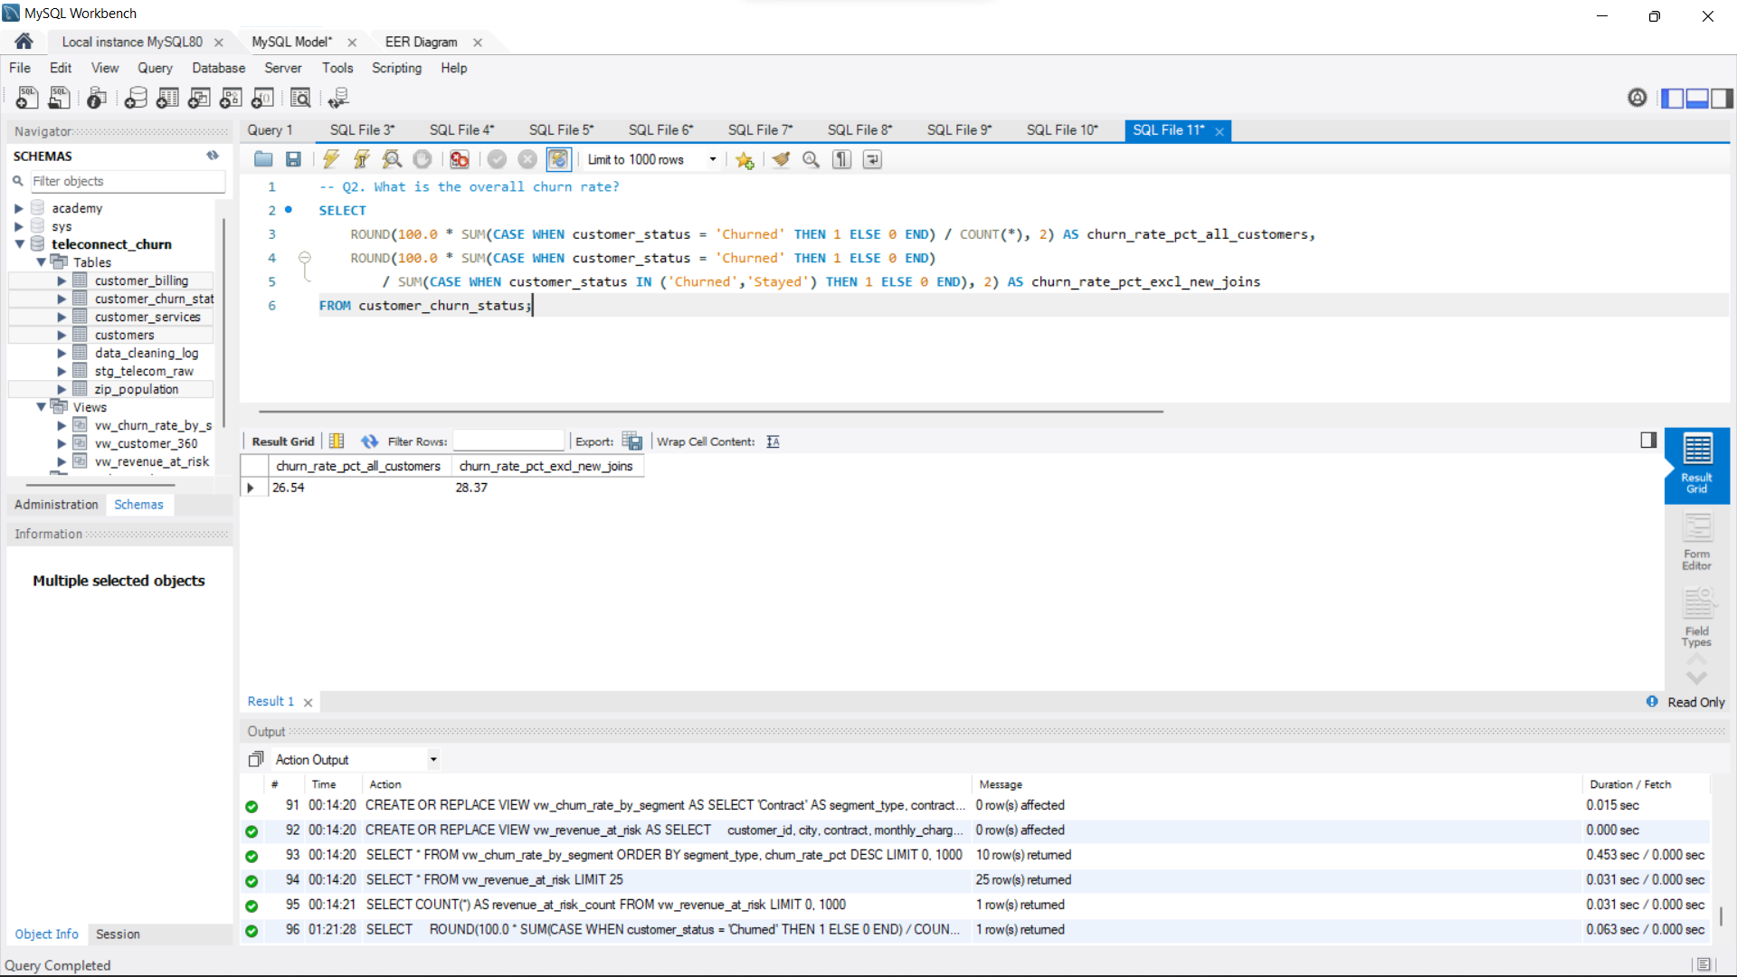
Figure 2. MySQL query and result showing both churn-rate definitions.

Churn by contract
Contract | Customers | Churned | Churn rate
Month-to-Month | 3,610 | 1,655 | 45.84%
One Year | 1,550 | 166 | 10.71%
Two Year | 1,883 | 48 | 2.55%

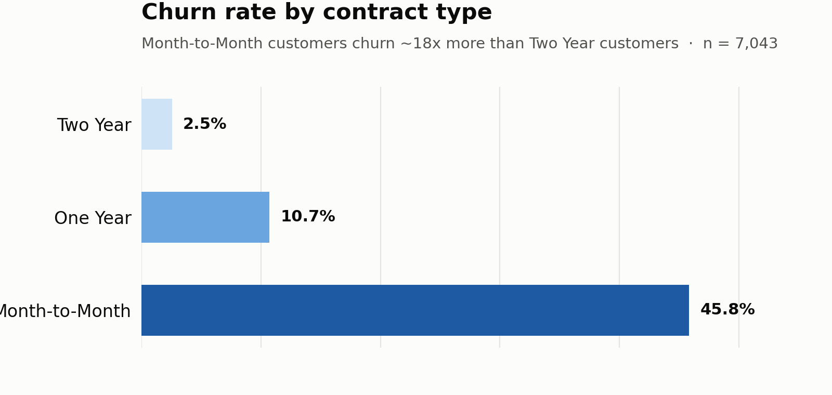
Figure 3. Churn rate by contract type.

Churn by tenure
Tenure | Customers | Churned | Churn rate
0-12 months | 1,732 | 1,037 | 59.87%
13-24 months | 1,024 | 294 | 28.71%
25-48 months | 1,594 | 325 | 20.39%
49+ months | 2,239 | 213 | 9.51%

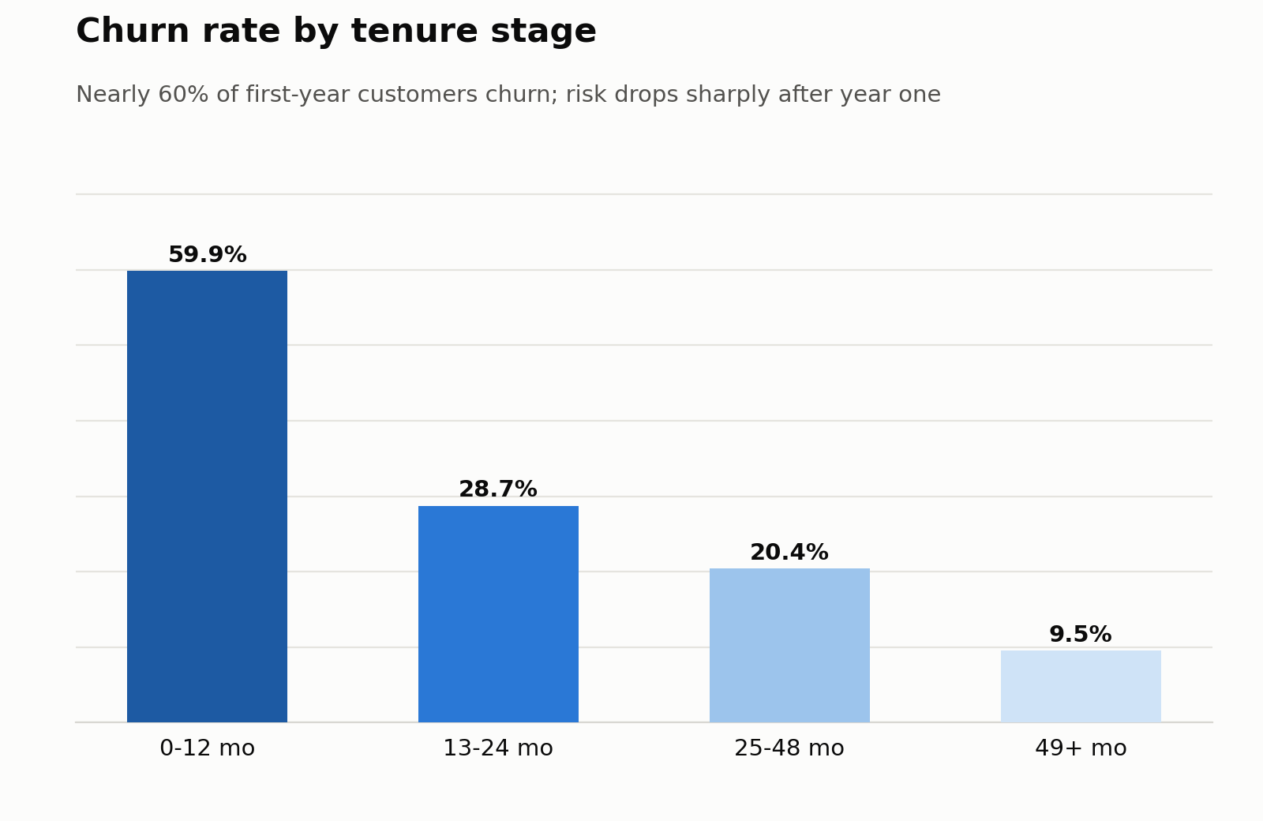
Figure 4. Churn rate by customer tenure.

Payment method and internet type
Segment | Churn rate
Mailed Check | 36.88%
Bank Withdrawal | 34.00%
Credit Card | 14.48%
Fiber Optic | 40.72%
Cable | 25.66%
DSL | 18.58%
No Internet | 7.40%

Churn reasons
Competitor-related reasons accounted for 841 customers, or 45.00% of churn. The leading specific reasons were better devices from a competitor (313), a better competitor offer (311), attitude of a support person (220), an unknown reason (130), and more data from a competitor (117).

Service add-ons
Among internet customers, churn decreased as adoption increased across online security, online backup, device protection, and premium technical support. The pattern is descriptive and may also reflect tenure, contract, or customer-need differences.
Measured add-ons | Customers | Churned | Churn rate
0 | 1,130 | 718 | 63.54%
1 | 1,370 | 570 | 41.61%
2 | 1,340 | 326 | 24.33%
3 | 935 | 117 | 12.51%
4 | 470 | 25 | 5.32%

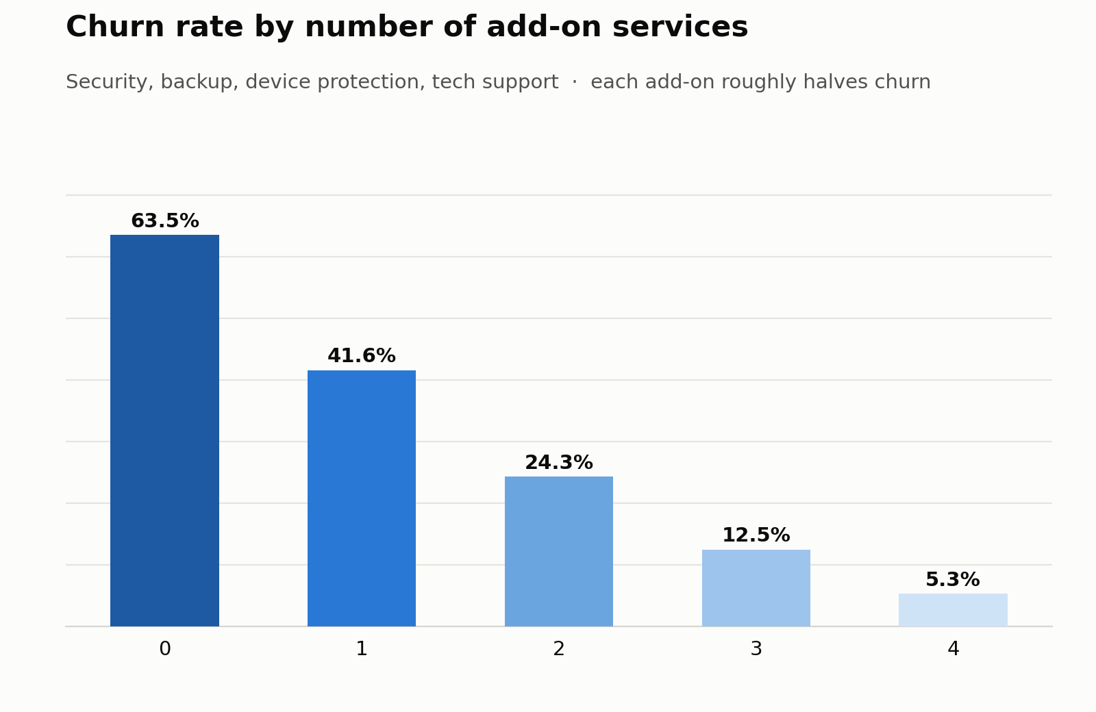
Figure 5. Churn rate by measured service add-on count.

Historical customer value
Churned customers had generated $3,684,459.82 in cumulative historical revenue, averaging $1,971.35 per customer. Customers who stayed had generated $17,632,392.12, averaging $3,735.68. These amounts describe revenue accumulated through the snapshot date; they are not forecasts of revenue that will be lost after churn.
The top ten churned customers by historical revenue had generated $107,437.62 combined. The advanced SQL uses `RANK()` and a running `SUM() OVER()` to preserve row-level detail while showing rank and cumulative value.
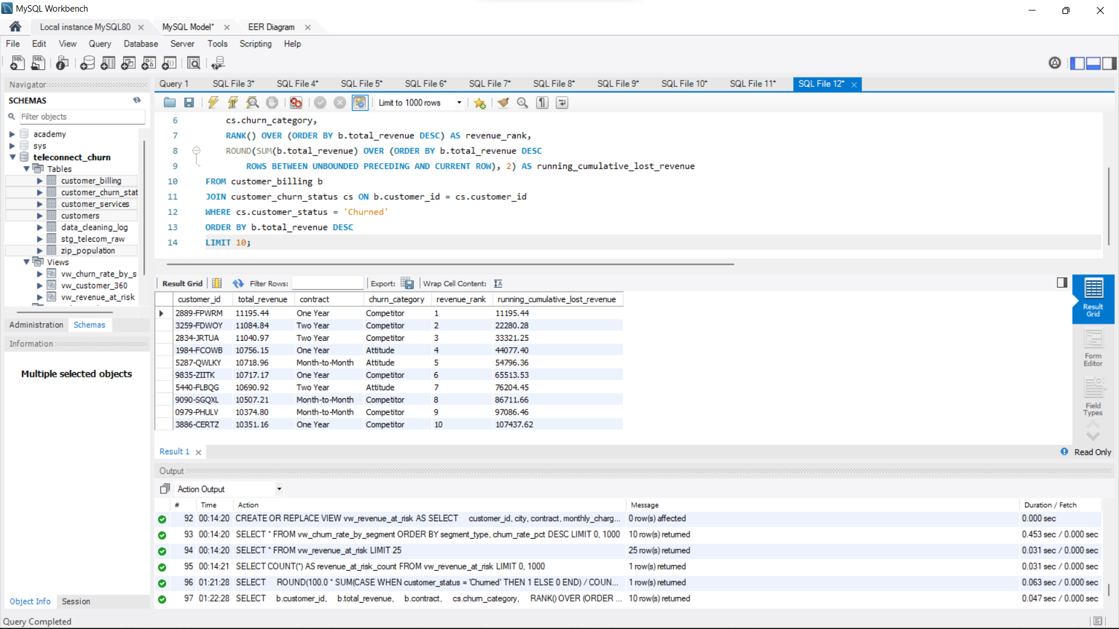
Figure 6. MySQL Workbench evidence for the ranking and cumulative historical-revenue query. The original result alias uses “lost revenue”; the audited interpretation is historical revenue from churned customers.

Priority-retention segment
A transparent rule identified 442 customers who were classified as Stayed, held Month-to-Month contracts, and had total historical revenue above the company average. This segment is useful for targeted outreach but is not a predictive model and does not establish that every selected customer will churn.
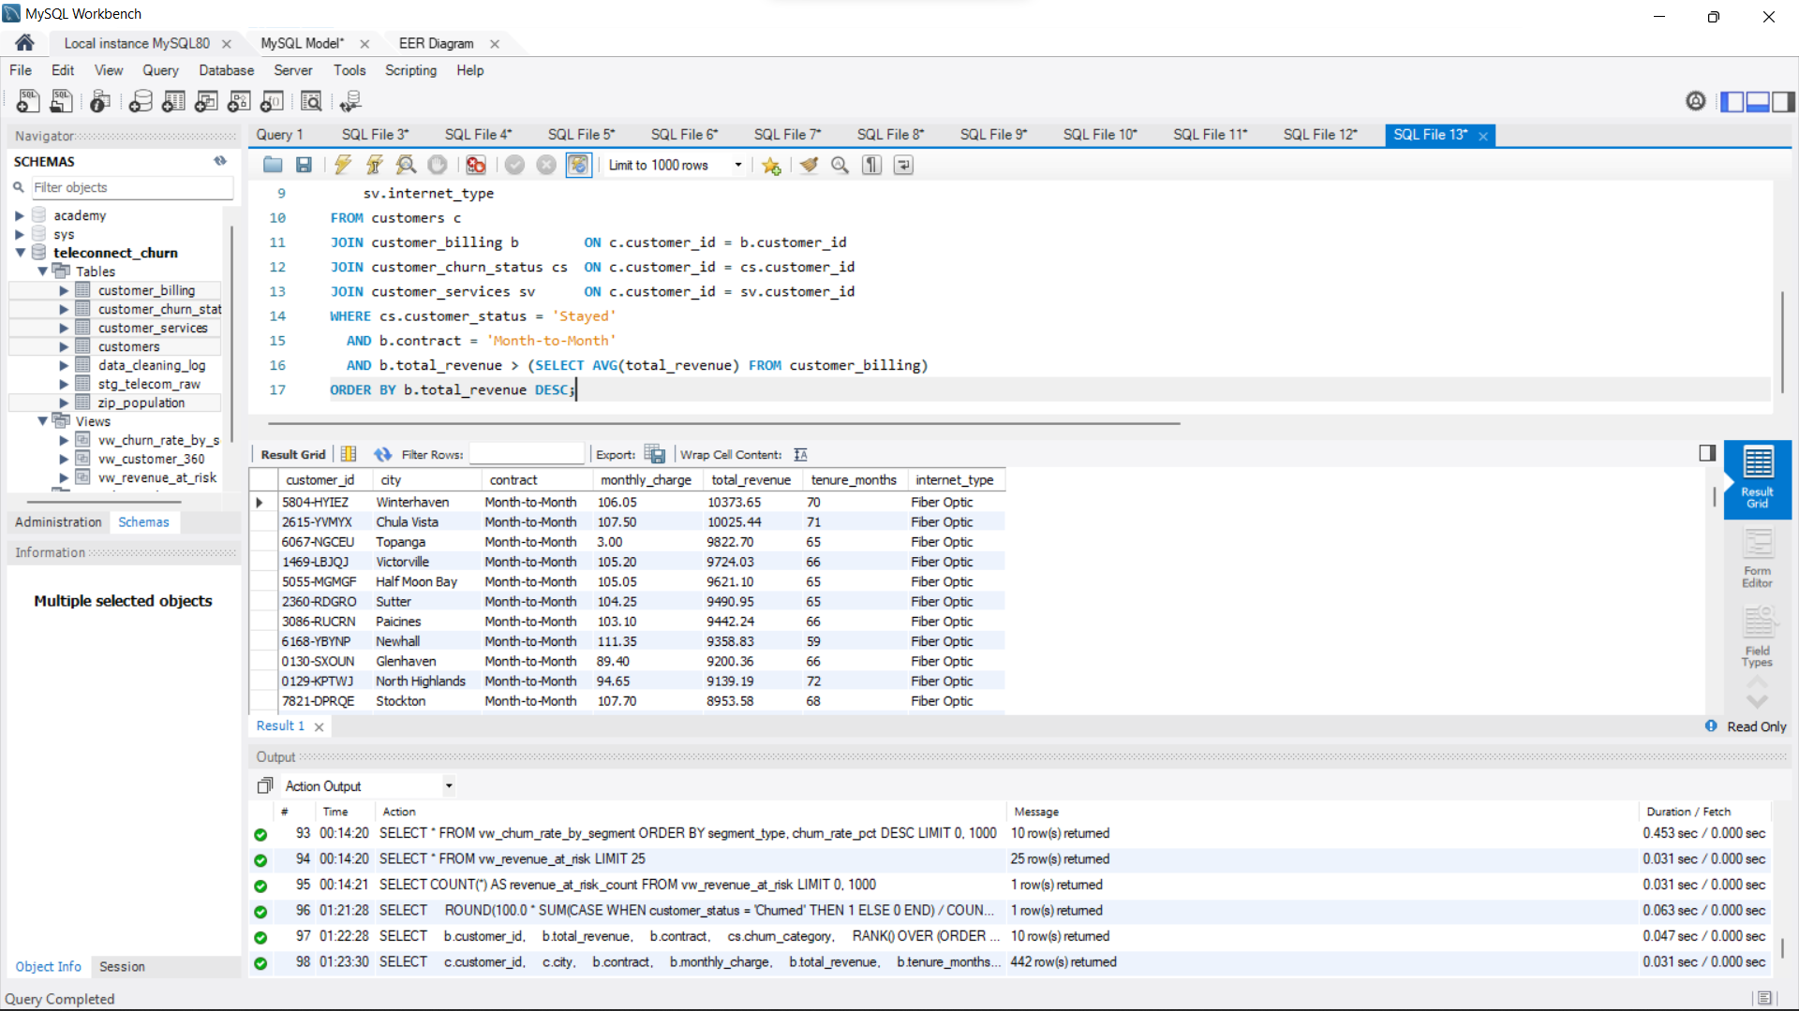
Figure 7. Multi-table SQL query returning the 442-customer priority-retention segment.

Business Recommendations
- Introduce structured onboarding and first-year retention contacts before months 3, 6, and 12.
- Test suitable incentives for Month-to-Month customers to move to longer contracts.
- Review Fiber Optic reliability, support cases, pricing, and competitor comparisons.
- Develop competitor-response offers around devices, plan value, and data allowances.
- Test add-on bundles and measure both retention impact and contribution margin.
- Contact the 442 priority customers with tailored outreach and compare outcomes with a control group.
- Investigate concentrated ZIP-code patterns while accounting for small local sample sizes.

Implementation Challenges
Challenge | Resolution
Workbench import wizard was extremely slow | Used server-side `LOAD DATA INFILE` for bulk loading
`LOAD DATA LOCAL INFILE` returned Error 2068 | Used the server `secure_file_priv` directory
Blank usage fields failed numeric import | Loaded through variables and converted blanks with `NULLIF`
Correlated subquery exceeded the read timeout | Calculated contract averages once in a CTE and joined them
Ambiguous negative monthly charges | Preserved, flagged, and excluded from charge averages

Limitations
- The dataset is a single-quarter snapshot and cannot measure individual customer changes through time.
- The findings identify associations and do not prove causality.
- Historical total revenue is not equivalent to future recurring revenue loss.
- The priority-retention segment is a rule-based shortlist rather than a predicted probability of churn.
- The true values of 120 negative monthly-charge records cannot be established from the supplied source.
- ZIP-code hotspot results contain relatively small customer counts and require cautious interpretation.

Portfolio Deliverables
The repository includes six SQL scripts, three source datasets, query-result exports, a data-quality summary, the MySQL EER diagram, genuine MySQL Workbench screenshots, analytical charts, supporting Markdown documentation, this complete report, and publishing copy for the portfolio website, CV, and LinkedIn.
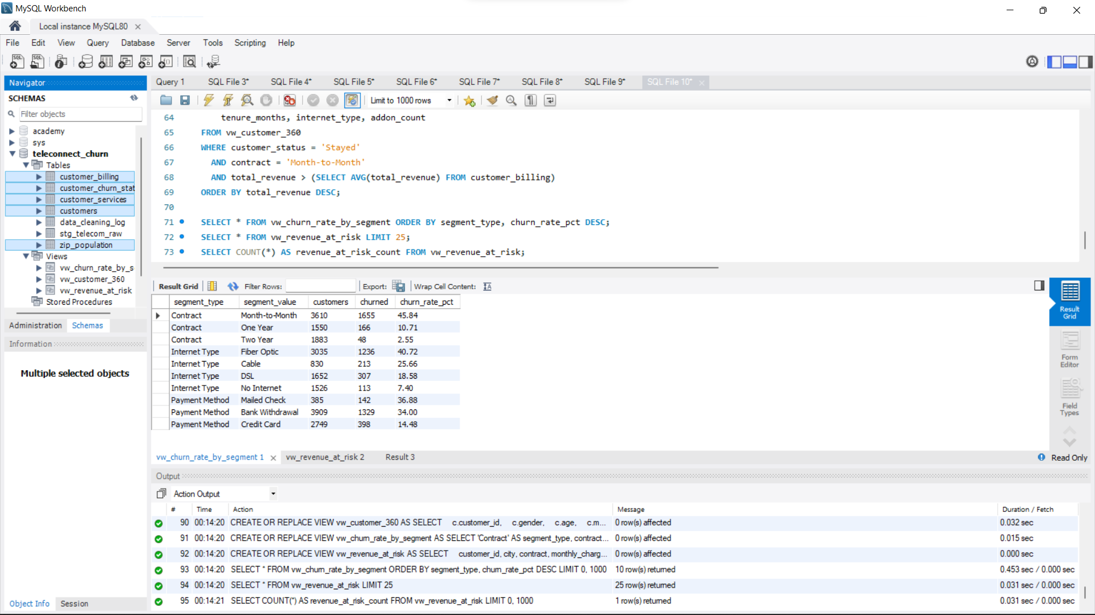
Figure 8. MySQL Workbench schema, tables, views, and verified segment results.

Conclusion
The project demonstrates an end-to-end SQL workflow: relational design, staged data loading, transparent data-quality decisions, reproducible analysis, advanced SQL, business interpretation, and communication. The results support focused retention testing around early tenure, Month-to-Month contracts, competitor pressure, service experience, and targeted outreach, while the documented limitations prevent descriptive findings from being overstated.

References
Maven Analytics. Telecom Customer Churn. https://mavenanalytics.io/data-playground/telecom-customer-churn
IBM Cognos Analytics. Telco customer churn sample. https://www.ibm.com/docs/en/cognos-analytics/12.1.x?topic=samples-telco-customer-churn

