XI’AN JIAOTONG-LIVERPOOL UNIVERSITY
西 交 利 物 浦 大 学
COURSEWORK SUBMISSION
COVER SHEET
Name | Lin | Nan
Student Number | 2252173
Programme | IMIS
Module Title | Computer-Based Trading in Financial Markets
Module Code | IOM301
Assignment Title | Investment Analysis Report
Submission Deadline | 20 May 2026
Module Leader | Liu | Zihua
By uploading or submitting this coursework submission cover sheet, I certify the following:
1. I have read and understood the definitions of collusion, copying, plagiarism, dishonest use of data, and academic offences involving Artificial Intelligence (AI) as outlined in the Academic Integrity Policy of Xi’an Jiaotong-Liverpool University.
2. This work is my own, original work produced specifically for this assignment. It does not misrepresent the work of another person or institution, nor does it present the work generated by AI as my own. Additionally, it is a submission that has not been previously published, or submitted to another module.
3. This work is not the product of unauthorized collaboration between myself and others.
4. This work is free of embellished or fabricated data.
I understand that collusion, copying, plagiarism, dishonest use of data, academic offences involving AI, and submitting procured work are serious academic misconduct. By uploading or submitting this cover sheet, I acknowledge that I am subject to disciplinary action if I am found to have committed such acts.
Signature ……………Nan.Lin……………………… Date ……………………20 May 2026……………………………
For Academic Office use: | Date Received | Working Days Late | Penalty


AI Data Center Power Bottleneck Trade
An Investment Strategy Based on Revenue Growth, Momentum, and Power Infrastructure Exposure
By
Nan.Lin
2252173
Module Leader: Zihua Liu
A Coursework Report Submitted for IOM301 Computer-Based Trading in Financial Markets
International Business School Suzhou
Xi’an Jiaotong-Liverpool University
May 20, 2026

List of Abbreviations
AI | Artificial Intelligence
CAPEX | Capital Expenditure
CRSP | Center for Research in Security Prices
EDA | Exploratory Data Analysis
OLS | Ordinary Least Squares
REIT | Real Estate Investment Trust
WRDS | Wharton Research Data Services

1. Introduction
1.1 Research Background
The rapid development of artificial intelligence has created a new investment problem for financial markets. In the first stage of the AI boom, investor attention concentrated on semiconductor leaders and large technology platforms. However, the next stage of AI adoption depends increasingly on the physical infrastructure needed to deploy high-density computing. AI models require data centers, accelerators, networking equipment, power conversion systems, cooling equipment and reliable electricity supply. Therefore, the investment opportunity may gradually shift from first-order chip exposure to second-order beneficiaries in data center hardware, power equipment, cooling systems, grid services and power supply.
This report studies this theme through the idea of an AI data center power bottleneck trade. The central argument is that artificial intelligence is not only a software or semiconductor story. It is also an electricity and infrastructure story. If demand for AI computing continues to grow, firms that solve the physical constraints of AI deployment may benefit from stronger revenue growth, higher investor attention and medium-term market repricing.
1.2 Research Objective and Contribution
The objective of this report is to design and critically evaluate a data-driven investment strategy based on AI infrastructure exposure. The empirical analysis uses the CRSP-Compustat dataset constructed in Python Assignment 1 and examined in Python Assignment 2. The sample covers 17 listed firms from January 2015 to December 2024, with 1,853 firm-month observations and 1,572 matched CRSP-Compustat observations. The company universe includes semiconductors, data center hardware, power/cooling/grid suppliers, data center REITs and power providers.
The contribution of this report is to move beyond a simple “buy AI stocks” argument. Instead, it proposes a selective strategy based on revenue growth, past stock momentum and direct exposure to AI infrastructure bottlenecks. This approach connects industry logic, financial theory and empirical evidence, while also recognizing important risks such as valuation crowding, capital expenditure uncertainty and limits to arbitrage.
2. Industry Overview and Investment Thesis
2.1 AI Data Center Power Bottleneck
Artificial intelligence has become an electricity-intensive industrial activity. Training and inference workloads require dense clusters of accelerators, memory, networking equipment, storage, power conversion equipment and cooling systems. The International Energy Agency argues that electricity demand is entering a structurally stronger growth phase through 2030, supported by data centers, AI, advanced manufacturing and broader electrification (IEA, 2026). JLL (2026) similarly describes a global data center supercycle in which AI and cloud demand are expected to drive capacity growth, construction cost inflation and a shift toward on-site power solutions.
This creates a second-order investment theme. Semiconductor leaders such as Nvidia and Broadcom are obvious beneficiaries of AI demand, but the market may underappreciate the infrastructure suppliers that enable the deployment of those chips. Deloitte (2026a) notes that inference workloads are growing, but most computation is still likely to occur on expensive, power-hungry chips in large data centers. Deloitte (2026b) also highlights that next-generation AI racks can require much higher power density and cooling capability than traditional data center racks. These points support the idea that AI growth is constrained not only by model quality or chip supply, but also by electricity, thermal management and deployment speed.
2.2 Investment Universe
The investment universe is divided into five segments: semiconductors; data center hardware; power, cooling and grid infrastructure; data center REITs; and power providers. The key hypothesis is that firms closer to high-density AI infrastructure should earn superior medium-term returns when they show both fundamental demand confirmation and market momentum. However, this report does not assume that every AI-linked firm is attractive. The stronger claim is that the market may gradually reprice companies that turn AI infrastructure demand into revenue growth and visible order momentum.
3. Data and Empirical Evidence
3.1 Data and Variable Construction
The dataset is built from WRDS using CRSP monthly stock returns and Compustat annual fundamentals. CRSP provides stock returns, prices, shares outstanding and volume. Compustat provides sales, assets, capital expenditure, R&D, operating profitability, debt and equity. A CRSP-Compustat link table is used to match the stock market identifier permno with the accounting identifier gvkey. To reduce look-ahead bias, accounting variables are treated as available only after a six-month reporting lag.
The main constructed variables include revenue growth, capital expenditure intensity, R&D intensity, profit margin, debt ratio, past 12-month stock return and future returns over one-month, six-month and twelve-month horizons. The one-month return regression is intentionally conservative, because monthly stock returns are noisy. The longer-horizon analysis is more suitable for a medium-term investment theme such as AI infrastructure.
3.2 Segment-Level Performance
Segment | Firms | Obs. | Avg. future monthly return | Monthly volatility
Data Center Hardware | 2 | 212 | 4.10% | 16.55%
Semiconductors | 6 | 637 | 3.10% | 12.13%
Power/Cooling/Grid | 5 | 395 | 2.14% | 10.45%
Power Providers | 2 | 122 | 1.88% | 7.75%
Data Center REITs | 2 | 206 | 1.11% | 6.55%
Table 1. Segment-level CRSP-Compustat sample summary, 2015-2024.
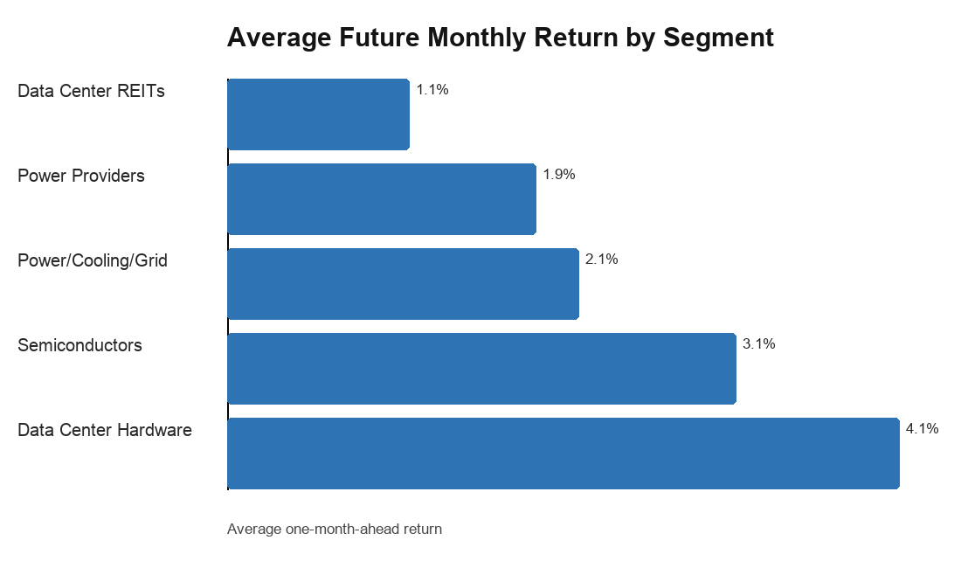
Figure 1. Average one-month-ahead return by AI infrastructure segment.
The segment evidence is intuitive. Data center hardware firms show the highest average one-month-ahead return, about 4.1%, followed by semiconductors at about 3.1%. Power, cooling and grid infrastructure firms also show positive returns, though lower than hardware and semiconductors. Data center REITs and power providers appear less explosive, which is consistent with their more regulated, capital-intensive or real-asset profiles. This ranking supports the thesis that the market rewards firms closest to the direct AI infrastructure buildout, but it also suggests that the theme contains different risk-return profiles rather than a single homogeneous AI trade.
3.3 Regression and Portfolio Sort Evidence
The baseline one-month predictive regression produces weak results. This is not surprising because monthly stock returns reflect market-wide shocks, liquidity conditions and short-term sentiment. The more relevant tests use 12-month forward returns. In that specification, revenue growth is positively related to future returns, while past 12-month return is also positive. Capital expenditure intensity and profit margin enter negatively in the full regression, which is important: spending more on capital projects is not automatically rewarded if it raises execution risk or if the market has already priced in profitable incumbency.
Predictor | Coefficient | Robust t-stat | p-value
revenue growth | 0.344 | 3.21 | 0.001
capex intensity | -1.151 | -3.27 | 0.001
profit margin | -0.769 | -4.87 | 0.000
debt ratio | 0.045 | 0.35 | 0.724
past 12m return | 0.096 | 2.07 | 0.038
Table 2. Exploratory 12-month forward return regression. R-squared = 0.083; N = 1047.
The portfolio sort provides a more direct investment interpretation. Sorting firms monthly by the AI growth-momentum score produces average 12-month forward returns of about 27.7% for the low portfolio, 42.4% for the middle portfolio and 47.2% for the high portfolio. The high-minus-low spread is about 19.5%, with a t-statistic of 3.35 and a p-value below 0.01. This result supports the idea that the theme is more visible over a medium-term horizon than in a one-month regression.
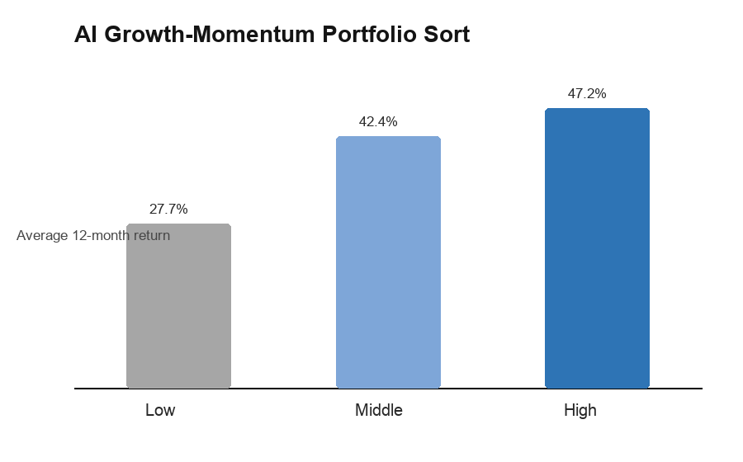
Figure 2. Portfolio sort based on AI growth-momentum score.
4. Trading Strategy Design
4.1 Signal Construction
The proposed strategy is a monthly rebalanced medium-term allocation strategy. At each month, firms are ranked on two dimensions: revenue growth rank and past 12-month return rank. The average of the two ranks is the AI growth-momentum score. Revenue growth captures fundamental confirmation of demand, while past return momentum captures market recognition and the possibility of gradual repricing. The strategy favours the top tercile of the score and avoids or underweights the bottom tercile.
The strategy is designed as a long-only or long-underweight allocation rather than a theoretical short-selling strategy. This is more realistic because many investors cannot short individual stocks easily, and because shorting popular AI-related firms can be risky during momentum-driven markets. The practical interpretation is to allocate more capital to firms with strong AI infrastructure exposure and stronger signals, while reducing exposure to firms with weak growth, deteriorating momentum or excessive financial risk.
4.2 Portfolio Implementation
The strategy should be implemented as a constrained thematic equity portfolio rather than as an unconstrained bet on a single AI winner. A simple implementation is equal weighting across the top tercile. A more conservative version can use volatility-adjusted weights, reducing exposure to firms with unusually high monthly return volatility. Position caps are also necessary because stocks such as Nvidia, Super Micro Computer or Broadcom can otherwise dominate the portfolio.
Risk controls are important because the AI infrastructure trade is highly cyclical. First, the strategy should require positive revenue growth and positive 12-month momentum before entering a position. Second, firms with extreme debt ratios or negative operating profitability should be excluded unless there is a clear transition story. Third, segment diversification should be maintained across semiconductors, data center hardware and power/cooling/grid suppliers. This prevents the strategy from becoming only a semiconductor momentum portfolio. Fourth, the portfolio should be reviewed every six to twelve months rather than traded aggressively every month, because the empirical evidence is strongest over the 12-month horizon.
5. Theoretical Background and Critical Evaluation
5.1 Market-Beating Potential
The strategy is grounded in three strands of finance theory. First, under the efficient market hypothesis, public information should be rapidly incorporated into prices (Fama, 1970). A naive version of the AI trade would therefore be unlikely to beat the market. However, the power bottleneck thesis is not only about public AI excitement; it is about second-order supply constraints that may be recognized with delay as orders, construction schedules and power availability become observable.
Second, momentum theory supports the use of past 12-month returns. Jegadeesh and Titman (1993) show that winners can continue to outperform over intermediate horizons. In this report, momentum is not used alone. It is combined with revenue growth so that the strategy avoids buying price strength without business confirmation. The post-AI interaction analysis strengthens this interpretation: after 2023, past 12-month momentum becomes more informative for 12-month forward returns, suggesting that the AI infrastructure theme became more visible after the generative AI shock.
5.2 Limits to Arbitrage
Limits to arbitrage explain why mispricing may persist. Even if investors believe power infrastructure firms are underappreciated, exploiting the opportunity is difficult because the theme is noisy, capital intensive and exposed to policy, interest rates and construction bottlenecks. Shleifer and Vishny (1997) argue that arbitrageurs face capital and timing constraints. In this case, a correct long-term thesis may still suffer short-term drawdowns if investors question AI capex sustainability or if grid interconnection delays postpone revenue recognition.
A critical weakness of the strategy is that it is partly exposed to a crowded narrative. By 2026, AI infrastructure is no longer an obscure theme. Many investors already understand that data center power, cooling and grid equipment are bottlenecks. The market-beating potential therefore depends on whether second-order beneficiaries continue to surprise expectations, not merely on whether the industry grows. This distinction matters: an excellent industry can still produce poor stock returns if valuations are already too optimistic.
6. Risks and Robustness
The biggest risk is valuation crowding. If the market has already capitalized future orders into prices, later investors may earn lower returns even if the industry grows. The negative coefficient on capex intensity in the 12-month regression is a useful warning: high investment intensity can signal opportunity, but it can also signal pressure to build capacity ahead of uncertain demand, higher depreciation expense, weaker free cash flow or financing strain. For this reason, the strategy should treat capex as a contextual variable rather than a mechanical buy signal.
A second risk is infrastructure timing. Power availability, construction costs and equipment delivery are central constraints in data center development. If grid connections, turbines, transformers or cooling equipment face long lead times, revenue may arrive later than investors expect. A third risk is macro sensitivity. Data center REITs, utilities and infrastructure service firms are affected by interest rates and financing costs. A higher discount rate can reduce the present value of long-duration infrastructure cash flows. Semiconductor firms face a different risk: AI demand may remain strong, but memory, GPU or networking supply cycles can reverse if hyperscaler spending slows or if efficiency gains reduce capacity needs.
The robustness tests help but do not eliminate these risks. The one-month regression is weak; stronger results appear at the 12-month horizon, in post-AI interaction tests and in portfolio sorts. This pattern supports the strategy as a medium-term thematic allocation, not as a high-frequency trading rule. The correct interpretation is therefore conditional: the strategy has potential to outperform if AI infrastructure demand remains strong and if investors continue to reprice firms with confirmed growth and momentum.
7. Conclusion
The AI data center power bottleneck trade is a credible and timely investment theme. Industry evidence shows that AI workloads are increasing the importance of power availability, cooling capacity, data center construction and supply-chain coordination. Empirical analysis of CRSP and Compustat data supports the idea that hardware and semiconductor firms have been the strongest performers, while medium-term results are more informative than one-month returns. The best strategy is not to buy every AI-linked company. It is to build a disciplined portfolio of firms with clear AI infrastructure exposure, revenue growth confirmation and positive momentum, while controlling for leverage, valuation crowding and execution risk.
AI Usage Statement
I used ChatGPT as an academic support tool throughout this coursework. In the Python assignments, I used it to clarify the logic of merging CRSP monthly stock data with Compustat fundamentals, troubleshoot pandas merge_asof errors, improve code comments, and structure the exploratory data analysis. In the investment report, I used it to brainstorm the AI data center power bottleneck theme, refine the report outline, improve the clarity of financial interpretation, and check whether the empirical findings were presented in a cautious and academically appropriate way.
All WRDS data extraction, variable selection, empirical outputs, final investment judgement, and submitted analysis were reviewed and finalized by myself. I did not use AI to fabricate data, alter empirical results, or replace my own decision-making. Instead, AI was used iteratively as a reasoning and writing assistant: I compared its suggestions with the actual Python outputs, rejected unsupported claims, revised the strategy based on the evidence, and ensured that the final report reflected my own interpretation of the data.
References
Deloitte. (2026a). More compute for AI, not less. Deloitte Insights. https://www.deloitte.com/us/en/insights/industry/technology/technology-media-and-telecom-predictions/2026/compute-power-ai.html
Deloitte. (2026b). 2026 Hardware and Consumer Tech Industry Outlook. Deloitte Insights. https://www.deloitte.com/us/en/insights/industry/technology/technology-media-telecom-outlooks/hardware-consumer-tech-outlook.html
Deloitte. (2026c). 2026 Global Semiconductor Industry Outlook. Deloitte Insights. https://www.deloitte.com/us/en/insights/industry/technology/technology-media-telecom-outlooks/semiconductor-industry-outlook.html
Fama, E. F. (1970). Efficient capital markets: A review of theory and empirical work. Journal of Finance, 25(2), 383-417.
Goldman Sachs. (2025). How AI is transforming data centers and ramping up power demand. https://www.goldmansachs.com/insights/articles/how-ai-is-transforming-data-centers-and-ramping-up-power-demand
International Energy Agency. (2026). Electricity 2026. https://www.iea.org/reports/electricity-2026
JLL. (2026). 2026 Global Data Center Market Outlook. https://www.jll.com/en-us/insights/market-outlook/global-data-centers
Jegadeesh, N., & Titman, S. (1993). Returns to buying winners and selling losers: Implications for stock market efficiency. Journal of Finance, 48(1), 65-91.
Shleifer, A., & Vishny, R. W. (1997). The limits of arbitrage. Journal of Finance, 52(1), 35-55.
Wharton Research Data Services. (2026). CRSP monthly stock file and Compustat fundamentals accessed through WRDS.
Appendix: Empirical Method Summary
The empirical dataset uses CRSP monthly stock data and Compustat annual fundamentals from 2015 to 2024. Accounting data are matched to monthly returns using CRSP-Compustat link identifiers and a six-month availability lag. The sample contains 1,853 firm-month observations before removing unmatched fundamentals and 1,572 matched observations used in EDA. Future returns are computed as one-month, six-month and twelve-month forward returns. The AI growth-momentum portfolio score is the average of monthly cross-sectional revenue growth rank and past 12-month return rank.

