CPT202 2024/2025 Semester 2
Final Report for Software Engineering Group Project
<Project Title>
<Date>
< URL of software>

Group number: <***>
Student Name:
Student ID:

Contents
Introduction 3
Software Development Process 3
Software Design 3
Change Management 3
Legal, social, ethical, and professional issues 3
Conclusion 4
References 4
Appendix 4

Introduction
This report documents my personal experience in the development of the Online Meeting Room Booking System at Xi’ an Jiaotong-Liverpool University. The system is designed to address common issues in traditional meeting room booking processes, such as manual errors, low efficiency, and delayed administrative responses. It offers a digital and intelligent solution aimed at improving resource utilization, enhancing user experience, and significantly boosting the operational efficiency of meeting room management. The final delivered system supports role-based access control for various user types, including students, teachers, MRC coordinators, maintenance staff, and super administrators. Key functionalities include online room booking and approval workflows, booking record management, real-time monitoring of room status, fault reporting, and data-driven usage analysis with visualized statistics. Through centralized management and intelligent scheduling, the system effectively reduces resource waste, increases the transparency and efficiency of the booking process, and provides robust data support for future operational analysis and decision-making.
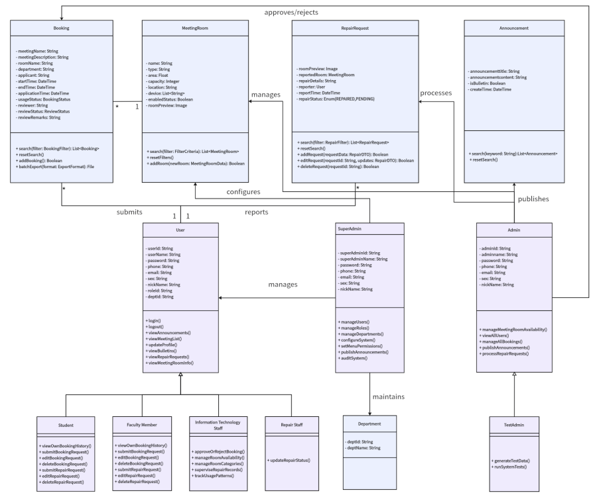
Figure 1-Appendix 1: System module design class diagram
In the early stage of the project, I collaborated with the project lead to define the development roadmap and management standards, including the specification and naming conventions for Product Backlog Items (PBIs). During the development phase, I was primarily responsible for the Meeting Room Management Module (Epic 03), which includes four essential features: adding, editing, deleting meeting rooms, and visualizing room usage statistics (PBI-011 to PBI-014). While the number of PBIs may seem limited, these functionalities serve as the structural core of the system, fundamentally supporting the booking workflow, administrative operations, and data transparency. To implement these features, I developed the front-end interfaces using Vue.js—a progressive JavaScript framework known for its reactive data binding and component-based architecture—enabling modular, maintainable, and responsive user experiences. I also contributed to front-end and back-end integration and participated in full-cycle testing. Collectively, these contributions improved the platform’s usability and empowered administrators with greater efficiency in managing meeting room resources. In the later stages of the project, I also took charge of report writing, documentation compilation and revision, and the production of the demonstration video, ensuring the deliverables were complete, well-documented, and ready for submission.
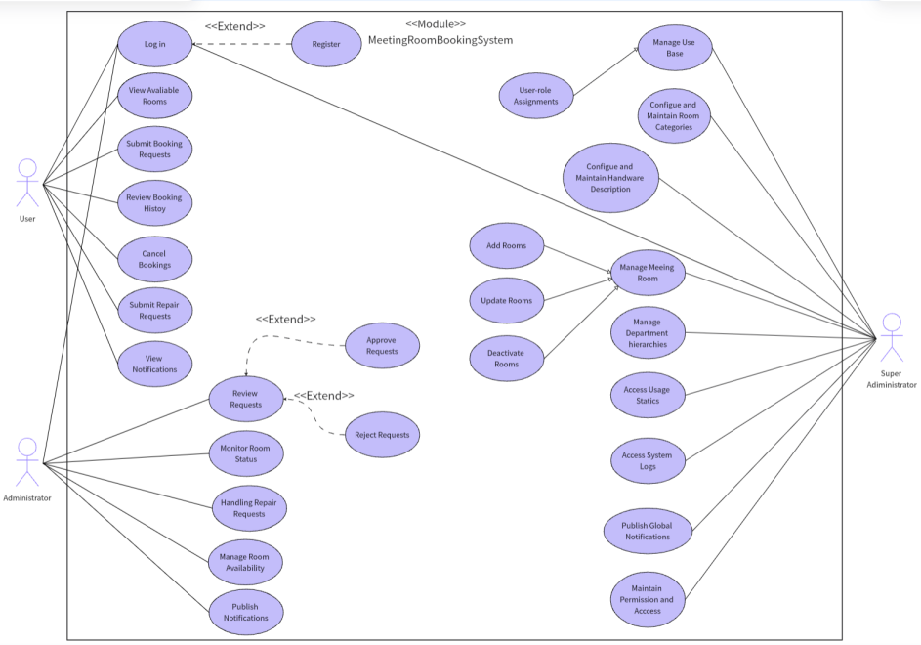
Figure 2-Appendix 2: Use case diagram of the system
This report follows the Scrum agile development framework and elaborates on the development process and my contributions across four key dimensions: Software Development Process, Software Design, Change Management, and Legal, Social, Ethical, and Professional Issues.

Software Development Process
Our team followed the Scrum methodology as outlined in Appendix 3. Through regular Sprint planning, daily stand-ups, and review meetings, we improved development efficiency, adaptability, and transparency. I also contributed to maintaining the shared Sprint tracking document (see Appendix 4). In this project, I focused on the development of the Meeting Room Management module, including functionalities such as adding, editing, and deleting meeting rooms, as well as generating room usage statistics for administrators.
During Sprint 1, my key tasks were the development of the “Add Meeting Room” (PBI-011) and “Edit Meeting Room” (PBI-012) features. I designed the core meeting room fields (including name, area, capacity, location, type, and device) and worked with the project’s general back-end developer, Hanqiu Zhang, to define the API format and data schema, ensuring consistency and compliance of back-end data interfaces. I also maintained close communication with the Booking Module lead, Xinyuan Zhang, to ensure her reservation components (PBI-019/PBI-021) could be built upon the room data foundation I established. During implementation, I encountered technical challenges in supporting image uploads for new rooms. After team discussions and research, I developed a custom UploadImage component (based on Element Plus’s <el-upload>), which enabled image upload, preview, and deletion. By the end of Sprint 1, I successfully completed PBI-011 and PBI-012, laying a solid data foundation for subsequent development tasks.
During Sprint 2, I was primarily responsible for implementing two features: “Delete Meeting Room” (PBI-013) and “Room Usage Statistics and Visualization” (PBI-014). For PBI-013, I collaborated closely with Xinyuan Zhang to address the edge cases associated with deleting rooms that have pending bookings. The finalized logic allows administrators to delete meeting rooms even if there are upcoming reservations (i.e., start_time > current_time). In such cases, the system retains the associated booking records while setting the room_id field to null. This design ensures data integrity and avoids cascading deletions, while enhancing operational flexibility. During the development of PBI-014, I collaborated with Ziwei Zhou and Jiayi Wang to build the visual analytics module on the system’s Main Page dashboard (See Appendix 5). Using ECharts, we designed three responsive chart panels to present key statistics. Although the “Recent Meetings” and “Latest Announcements” panels were not my assigned PBIs, after discussion in the meeting, I assisted Jiayi Wang in integrating them into the Main Page to improve overall information visibility. During the development of the three <el-card> charts, I initially encountered issues where the chart containers failed to mount in time, causing initialization errors, as well as inconsistent backend data formats that led to rendering problems. To address these, I collaborated with the product owner and backend developers to wrap the chart initialization logic inside Vue 3’s nextTick() hook and advocated for standardizing the API response formats. These adjustments ensured seamless data binding with the ECharts components, enabling us to deliver responsive and reliable visualizations on the system dashboard and greatly enhancing administrators’ visibility into usage trends. Additionally, in the latter phase of this sprint, I supported Ziwei Zhou in debugging the enable/disable functionality for meeting rooms (PBI-016 and PBI-018). Given the close logical relationship between room status management, deletion operations, and the booking workflow, we conducted coordinated integration testing to validate system behavior under various combinations of room states. This effort was critical in ensuring the robustness and correctness of the system in complex usage scenarios.
Entering Sprint 3, although my assigned PBIs had been largely completed, I continued to participate in system optimization, particularly by assisting Xinrong Shi in developing the front-end meeting room filtering feature (PBI-036 to PBI-040). During the design of the filter, in order to support filtering by room type, capacity, location, and equipment, Xinrong Shi needed to first clarify the standard definitions for these fields. Therefore, I closely collaborated with her to provide standardized definitions for relevant meeting room attributes and jointly confirmed the mapping rules between the front-end filter components and the meeting room data fields, ensuring data consistency and accuracy throughout the filtering process. Additionally, I compiled and provided an interface model document to support backend developers in maintaining consistent API specifications. This round of cross-module collaboration helped further unify field application standards and laid a solid foundation for enhancing the system’s filtering and query capabilities.
Throughout the three Sprint development cycle, I completed all tasks for the meeting room management module on time and actively collaborated with teammates—including Hanqiu Zhang, Xinyuan Zhang, Jiayi Wang, Ziwei Zhou, and Xinrong Shi—to ensure smooth integration with reservation and filtering features. The structured use of Scrum practices greatly enhanced our team’s coordination and development quality while also supporting my own growth across iterations.

Software Design
The key technologies and methodologies used in this project are detailed in the Appendix 6. The database schema design and ER diagram of this project are detailed in Appendix 7. The following section will focus on the development process of two specific PBIs: “Add Meeting Room Information” (PBI-011) and “Meeting Room Usage Statistics and Visualization” (PBI-014).
PBI-011 Add Meeting Room Information
- Logical Flow (See Appendix 8 for related code)
After logging in with an MRC or Super Admin account, users can navigate to the “Meeting Room Management” page from the Main Page. There, administrators initiate the room creation process by clicking the “Add” button. To ensure completeness, the system requires input for essential fields including Name, Area, Type, Location, Capacity, and Device; submissions with missing required fields are disallowed. The Image field, while optional at creation, can be supplemented later through the editing function.
 | 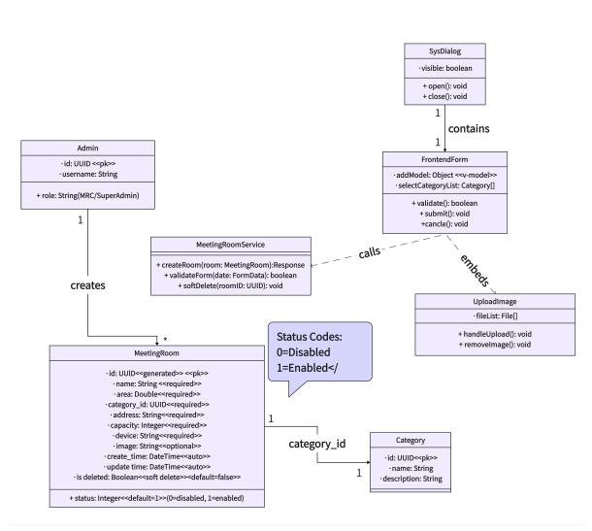
Figure 3-Appendix 9: Activity diagram of PBI-011 | Figure 4-Appendix 10: Class diagram of PBI-011

- Database Design (See Appendix 11 for related code)
This functionality mainly involves the meeting_room table. Each time a new meeting room is added, a new record is created with a unique id automatically generated by the system. The following fields are populated based on user input: name (room name), area (room area), category_id (room type), address (location), contain (capacity), device (equipment info), and image (image path). Timestamps for create_time and update_time are also recorded. By default, the status field is set to enabled (1), and the disable status is (0), allowing for future enable/disable and logical deletion management. To maintain data consistency and integrity, soft deletion is used (logical deletion instead of physical removal), and UUIDs are used to avoid primary key conflicts.
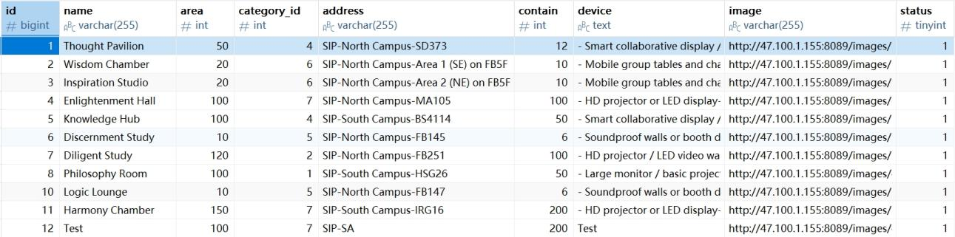
Figure 5-Appendix 12: The Navicat view of the meeting_room table

- Object State Transitions
Add: When the administrator clicks “Add,” they are directed to the meeting room creation form. The object is in a “draft” state and can be modified or cancelled at any time.
Confirm: After completing the form and clicking “Confirm,” the system validates the data. If valid, it calls the backend API to create a new room entry. The object state is then updated to “active.”
Confirm Error: If the form fails validation (e.g., required fields missing or invalid format), an error prompt is shown and no data is saved. The user may revise or cancel.
Cancelled: If the administrator cancels or closes the form before submission, the data is discarded and no changes are saved.
- User Interface Design (See Appendix 13 for related code)
The layout for the Add Meeting Room feature (PBI-011) follows the system’s overall UI style. The form is rendered within a SysDialog modal component. Fields such as room name, area, type, location, capacity, equipment info, and image upload are structured using <el-form> and bound to the addModel object using v-model for real-time data binding. The type field uses <el-select> and loads options dynamically via the selectCategoryListApi. Image uploads are handled using a custom UploadImage component, which wraps Element Plus’s <el-upload> to support preview and deletion. Upon clicking confirm, the commit() function is triggered, validating form data (addRef.value?.validate()) and submitting to the backend via addApi. Any form errors or API issues are communicated through Element Plus message components, improving user feedback and interaction quality.

PBI-014 Meeting Room Usage Statistics and Visualization
- Logical Flow (See Appendix 14 for related code)
After logging in as an MRC or Super Admin, the system automatically displays a set of statistics on the homepage that are closely related to meeting room usage. It first presents an overview of key metrics—including the total number of members, departments, meeting rooms, and pending repairs—to help users quickly grasp the scale of system resources. This is followed by three visual charts showing department member distribution, popular meeting rooms, and the composition of meeting room types, which are generated based on aggregated analysis of recent booking records. By integrating informative summaries with graphical insights, the homepage provides users with a holistic understanding of system operations, thereby supporting more informed resource management and administrative decision-making.
 | 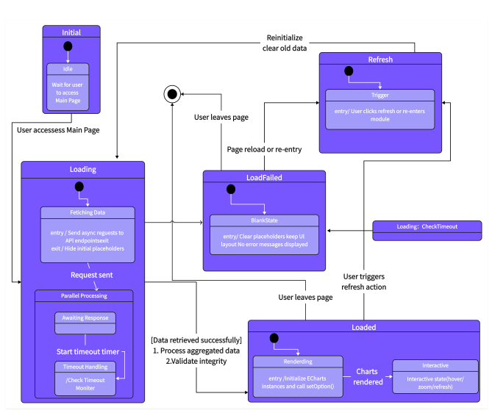
Figure 6-Appendix 15: Sequence diagram of PBI-014 | Figure 7-Appendix 16: State Machine diagram of PBI-014

- Database Design (See Appendix 17 for related code)
This functionality involves five core database tables: sys_user (system users), dept (department information), meeting_room (meeting room information), meeting_book (reservation records), and repair (repair requests). The system dashboard utilizes these tables to display real-time statistics such as the total number of users, departments, meeting rooms, and pending repairs. Additionally, the system performs multi-dimensional aggregation based on the meeting_book table: it summarizes departmental usage by joining with the dept_id field in sys_user, calculates popular meeting rooms by counting entries grouped by room_id, and analyzes booking distribution by room type through the category_id field in meeting_room. These data are encapsulated and served through backend services such as MeetingBookService, UserService, and RepairService, and are rendered on the frontend using the ECharts library. To ensure performance, most of the aggregation is processed at the SQL level using GROUP BY and COUNT functions, allowing for efficient data retrieval and consistent presentation.
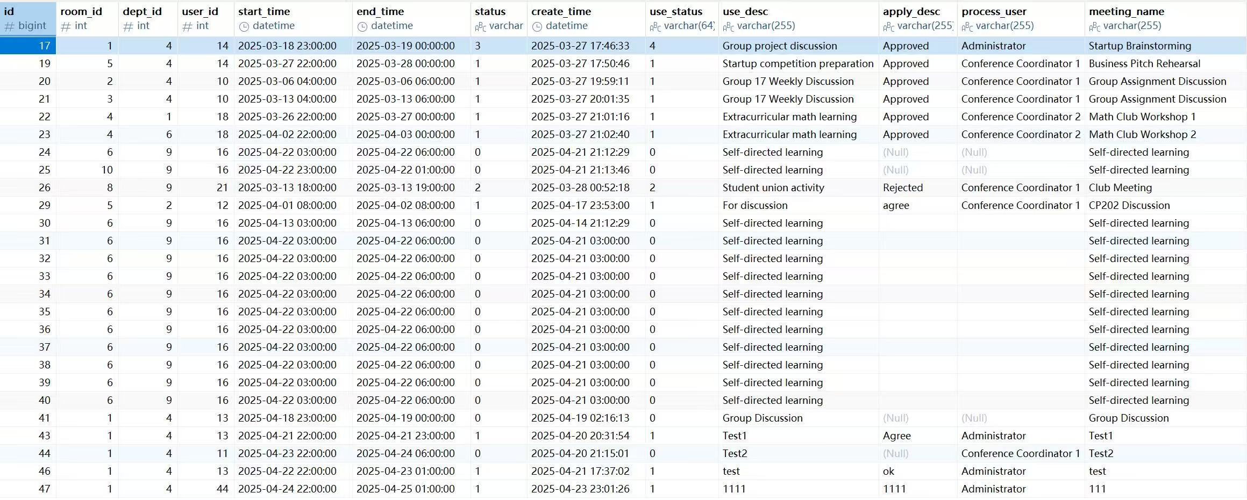
Figure 8-Appendix 18: The Navicat view of the meeting_book table

- Object State Transitions
Initial: When users access the Main Page, the dashboard module automatically initiates a series of asynchronous requests to fetch statistical data. During this phase, visual components remain in a loading state, awaiting backend responses.
Loaded: Once the system successfully retrieves the statistical data, it dynamically initializes the ECharts instances to render both the top-level info cards—displaying total users, departments, meeting rooms, and pending repairs—and the visual charts below. At this point, users can interactively view key insights such as departmental distribution, meeting room popularity, and booking ratios by room type.
Load Failed: If the backend returns no data or encounters an exception, the system defaults to a blank dashboard. No explicit error message is displayed, but the absence of rendered charts signals potential backend unavailability or data insufficiency.
Refresh: Users can refresh the page or re-enter the module, which re-triggers the entire data loading and rendering process, restoring the dashboard’s interactive state when data is successfully retrieved.
- User Interface Design (See Appendix 19 for related code)
The usage statistics and visualization module (PBI-014) is embedded in the Main Page to provide administrators with real-time insights into system usage. The dashboard consists of three sections, of which I was primarily responsible for the top and bottom sections: a top section displaying key aggregate metrics—total users, departments, meeting rooms, and pending repairs—rendered using <el-row> and <el-col> components for responsive layout; and a bottom section comprising three ECharts visualizations. These include a bar chart of department member counts (myChart), a horizontal bar chart of popular meeting rooms (myChart1), and a donut chart showing booking distribution by room type (myChart2). The frontend asynchronously requests data from /api/home/getTotal, /getEcharts, /getLastMeeting, and /getCategoryBook. Upon receiving responses, charts are initialized using global.$echarts.init() and configured via setOption(). To ensure visual consistency and robustness, the rendering is deferred until the DOM is mounted using Vue 3’s nextTick() lifecycle hook. Axis labels are auto-rotated or truncated for clarity, and a unified purple color palette enhances visual coherence. In the event of data loading failures, the system omits error messages and leaves the chart areas blank to preserve the clean layout. This layered visualization design improves administrative awareness of operational trends and provides data support for strategic decisions.

Change Management
In Scrum projects, requirements often evolve throughout the development cycle. To manage these changes effectively, our team strictly adhered to Scrum principles: we captured and discussed changes promptly during Sprint planning meetings and kept our shared Sprint tracking documents updated accordingly. While ensuring both quality and development efficiency, we flexibly integrated changes into ongoing development tasks. Within the meeting room management module I was responsible for (PBI-011 to PBI-014), there were two typical examples of change management.
- Add Meeting Room (PBI-011): Integration of Image Upload Function
In the initial requirement design, PBI-011 (Add Meeting Room Information) only required administrators to fill in basic attributes of the meeting room, such as name, area, location, category, capacity, and device information. The image upload function was originally planned as a separate PBI to be developed in a later stage. However, during the Sprint 1 review meeting, the team concluded that asking administrators to upload images separately after the fact would disrupt the workflow and increase system maintenance complexity. Therefore, after confirming with the product owner and both frontend and backend developers, we decided to integrate the image upload feature into PBI-011 ahead of schedule. I updated the frontend interface by embedding the UploadImage component into the meeting room creation form (SysDialog modal), and modified the backend API to support direct uploading and saving of image paths during the room creation process. This change was successfully completed within the same Sprint and did not impact the overall delivery timeline. The adjustment significantly improved feature cohesion and user experience while maintaining data consistency.
- Adjustment to Meeting Room Deletion Logic (PBI-013)
In the initial design of the project, the deletion function for meeting rooms (PBI-013) was intended to include a reservation check mechanism — that is, if a meeting room had future bookings (where start_time > current_time), deletion would be blocked in order to maintain data consistency. However, during actual development and Sprint review meetings, the team reconsidered this approach based on system simplicity and practical business needs, and revised the logic. The updated rule allows administrators to delete a meeting room even if it has future reservations. These deleted rooms no longer affect the integrity of existing booking records, although the “Room Name” field in the Meeting Room Booking page will appear blank for those records. This design retains users’ historical booking data while avoiding deletion failures caused by foreign key dependencies, thereby improving system flexibility and fault tolerance.

Legal, social, ethical, and professional issues
During the development of the meeting room booking system, we placed strong emphasis on legal compliance, social responsibility, ethical standards, and professional practices. As the system targets internal organizational users and involves public resource management and user data collection, the modules I was responsible for (PBI-011 to PBI-014) gave particular attention to related issues. From a legal perspective, the system collects users’ personal information such as names and departments for reservation management purposes. These types of data fall under the protection scope of laws like the Personal Information Protection Law. To address this, the system clearly informs users of the purpose and scope of data collection during registration, prohibits the use of such data for commercial or external purposes, and enforces access control and encryption for sensitive database fields. Regarding the deletion of meeting rooms, if related booking records exist, the “Room Name” field is displayed as blank. To avoid concerns about data integrity, the system will not delete records in the user interface and will retain the original room information in the backend log for traceability. From a social standpoint, the fair use of public resources is a critical consideration. The system introduces a role-based approval mechanism (e.g., MRC Coordinator review) to ensure that booking processes remain transparent and open. In addition, through the booking statistics feature (PBI-014), the system presents overall departmental usage trends to discourage resource allocation bias and promote fairness within the organization. From an ethical standpoint, the collection and display of departmental reservation data must be handled with care. The system does not rank or publicly compare departments but instead focuses on overall trends. It is also clearly stated that this data is used strictly for internal optimization purposes, helping to avoid misuse for performance evaluation or internal competition, thereby minimizing ethical risks. From a professional perspective, while developing the meeting room management functionality, it was essential to ensure that the system could correctly process user operations and provide clear feedback at key stages. Logical checks and confirmation prompts were implemented before major operations to guide users effectively. This aligns with the IEEE Code of Ethics on providing reliable service and the ACM Code of Ethics regarding maintaining high professional standards.

Conclusion
Through my participation in the development of the meeting room booking system, I gained a more systematic understanding of the software development process. Adopting the Scrum agile methodology allowed us to respond quickly to changing requirements and continuously improve the project through regular Sprint planning meetings and reviews. Although the team initially lacked a deep understanding of Scrum, which led to some delays in development, we gradually mastered and refined our collaboration practices through hands-on experience. On a personal level, I was mainly responsible for the meeting room management module (PBI-011 to PBI-014), including front-end interface design, feature implementation, and data visualization. Throughout this process, I significantly improved my programming skills, system integration capabilities, and user experience design awareness. Of course, there were still some limitations in the project. The current system is only compatible with desktop platforms and lacks mobile adaptation. The approval process relies heavily on manual operation, which lowers efficiency. The role-based access control is relatively rigid, making it less flexible for future feature expansion. Additionally, our test coverage was insufficient, leading to issues being discovered only after deployment. Moving forward, we should enhance responsive design, incorporate automated approval workflows, and strengthen the testing framework. From a professional perspective, I also became more attentive to legal compliance and user privacy. In future projects, I will actively follow accessibility standards such as the WCAG to improve the system’s inclusiveness and reliability.This development experience not only enhanced my technical and collaboration abilities but also laid a solid foundation for my future growth as a professional software engineer.

References (if needed. Not count into the max page limit)

Appendix
Appendix 1: Use Case Diagram
Appendix 2: Modules Design Diagram

