
AI Exposure and Capital Flows: The Role of Investor Attention after the ChatGPT Shock

By
Nan.Lin
2252173

Supervisor: Zihua.Liu

A Dissertation Submitted in Partial Fulfillment of the Requirements for the

BSc Information Management and Information Systems

to

International Business School Suzhou
Xi’an Jiaotong-Liverpool University

May 18, 2026
1. Introduction
1.1 Research Background
The rapid development of generative artificial intelligence has become one of the most important technological events affecting financial markets in recent years. The release of ChatGPT in November 2022 marked a particularly visible turning point, as it substantially increased public awareness of the commercial potential of artificial intelligence and intensified investor attention toward AI-related firms. Following this event, companies associated with semiconductors, cloud computing, machine learning infrastructure, and AI applications attracted considerable market interest, reflecting expectations that generative AI could reshape productivity, firm value, and future economic growth.

This technological shock is particularly relevant to the mutual fund industry. Mutual funds act as major institutional investors and important channels through which household and institutional capital is allocated to financial markets. If investors perceive AI-related firms as future growth opportunities, they may respond not only by purchasing individual AI stocks, but also by reallocating capital toward mutual funds that already hold greater exposure to AI-related assets. Therefore, the ChatGPT shock provides a useful setting to examine whether technological narratives and investor attention translate into measurable fund flow responses.

However, investor reactions may not depend only on AI exposure. Prior fund performance may also matter because investors often interpret past performance as a signal of managerial ability and investment credibility. A fund with high AI exposure and strong historical performance may therefore be viewed as better positioned to benefit from the AI boom than a similarly exposed fund with weaker past performance. In addition, fund managers themselves may respond strategically to the AI shock by adjusting their portfolios toward more exploratory allocations, especially when new technological opportunities emerge rapidly.
1.2 Research Problem and Objectives
Although existing studies have examined artificial intelligence, investor attention, and mutual fund flows separately, relatively limited evidence exists on how a major generative AI shock affects capital allocation within the mutual fund industry. In particular, it remains unclear whether funds with higher pre-existing AI exposure attracted stronger investor inflows after the release of ChatGPT, whether this effect differed across funds with different prior performance, and whether AI-exposed funds subsequently adjusted their investment strategies.

This study addresses this gap by examining the impact of the ChatGPT shock on U.S. mutual fund flows and portfolio behavior. The first objective is to test whether funds with higher AI exposure experienced greater post-shock inflows. The second objective is to investigate whether prior fund performance strengthens this relationship. The third objective is to explore whether AI-exposed funds adopted more exploratory portfolio allocation strategies after the emergence of generative AI.

Based on these objectives, this thesis asks three research questions:

RQ1: Did mutual funds with higher AI-related asset exposure experience significantly greater investor inflows after the release of ChatGPT?

RQ2: Did prior fund performance moderate the relationship between AI exposure and post-ChatGPT fund flows?

RQ3: Did AI-exposed mutual funds exhibit greater exploratory portfolio allocation behavior following the ChatGPT shock?

1.3 Research Design and Contributions
To answer these questions, this study constructs a panel dataset of U.S. mutual funds using CRSP mutual fund return, asset, and holdings-related data. AI exposure is measured based on the proportion of fund holdings allocated to AI-related firms before the release of ChatGPT. The main empirical strategy applies a Difference-in-Differences framework that compares changes in fund flows between funds with different levels of AI exposure before and after the ChatGPT shock. Event-study analysis is further used to examine pre-treatment trends, while heterogeneity analysis and robustness tests are conducted to assess the validity of the results.

This study contributes to the literature in several ways. First, it adds to the emerging research on artificial intelligence and financial markets by shifting attention from firm-level stock reactions to institutional capital allocation through mutual funds. Second, it contributes to the investor attention literature by showing how a highly visible technological event may redirect capital toward funds associated with a popular investment theme. Third, it extends mutual fund research by examining how historical performance interacts with AI exposure in shaping investor responses. Finally, by investigating exploratory portfolio adjustments, this study provides evidence on how fund managers adapt to technological shocks.

1.4 Thesis Structure
The remainder of this thesis is organized as follows. Chapter 2 reviews the relevant literature and develops the research hypotheses. Chapter 3 introduces the data, variable construction, and empirical methodology. Chapter 4 presents the empirical results, including baseline estimations, event-study analysis, heterogeneity tests, and robustness checks. Chapter 5 discusses the findings in relation to existing literature and considers their implications. Chapter 6 concludes the thesis by summarizing the main findings, limitations, and directions for future research.

2. Literature Review and Hypothesis Development
2.1 Artificial Intelligence and Financial Markets
Artificial intelligence has become one of the most influential technological developments affecting modern financial markets. Rapid advances in machine learning, natural language processing, and generative AI technologies have significantly increased investor attention toward firms associated with AI innovation. In particular, the release of ChatGPT in November 2022 accelerated market optimism regarding the future commercial potential of generative artificial intelligence and triggered substantial valuation increases among AI-related firms.

Prior studies suggest that technological innovation can generate significant effects on investor expectations and asset prices because investors often associate emerging technologies with future productivity growth and long-term profitability. During periods of technological excitement, financial markets may exhibit strong thematic investment behavior, where capital flows disproportionately toward firms connected to emerging innovation trends. The rapid rise of AI-related stocks following the emergence of ChatGPT reflects this phenomenon and indicates that investors increasingly viewed artificial intelligence as a transformative economic force.

Existing research on artificial intelligence and financial markets has primarily focused on firm-level outcomes, including stock returns, innovation performance, and AI adoption. However, relatively limited attention has been paid to how AI-related technological shocks influence institutional capital allocation through mutual funds. Since mutual funds represent major institutional investors within financial markets, understanding how they respond to technological shocks is important for examining the broader transmission of AI-related market sentiment into investment behavior.

2.2 Investor Attention and Capital Flows
Investor attention plays an important role in shaping financial market behavior and capital allocation decisions. Prior literature argues that investors face limited attention and therefore tend to allocate capital toward assets or investment themes that receive greater public visibility and media coverage. As a result, highly visible events often attract disproportionate investor interest and generate abnormal trading activity or capital flows.

The emergence of ChatGPT represents a particularly important attention-generating event because it rapidly increased public awareness of generative artificial intelligence technologies within a short period of time. Extensive media coverage, public discussion, and strong stock market reactions surrounding AI-related firms likely increased investor demand for investment vehicles associated with artificial intelligence themes. In this context, mutual funds with greater pre-existing exposure to AI-related firms may have benefited from increased investor attention and thematic capital allocation.

Previous studies on mutual fund flows suggest that investors frequently direct capital toward funds associated with popular market narratives or investment opportunities. Thematic investing behavior is especially common during periods of technological innovation or market optimism, when investors attempt to gain exposure to emerging growth sectors. Therefore, if investors perceived AI-related industries as future growth opportunities after the release of ChatGPT, funds with higher AI exposure may have attracted greater investor inflows relative to less exposed funds.

Based on the above discussion, this study proposes the following hypothesis:

H1: Mutual funds with higher AI-related asset exposure experienced significantly greater investor inflows after the release of ChatGPT.

2.3 Mutual Fund Performance and Investor Response
In addition to thematic exposure, prior fund performance is also an important determinant of investor capital allocation decisions. Extensive literature on mutual fund flows documents that investors tend to allocate more capital toward funds with superior historical performance. This phenomenon, commonly referred to as performance-chasing behavior, reflects the tendency of investors to interpret past returns as signals of managerial skill, investment ability, and information advantages.

Funds with strong historical performance may therefore enjoy greater credibility among investors during periods of market uncertainty or technological change. In the context of the ChatGPT shock, investors may have viewed high-performing AI-exposed funds as being better positioned to benefit from the rapid expansion of AI-related industries. Conversely, funds with weaker historical performance may have been less successful in attracting investor confidence even if they possessed similar AI-related asset exposure.

Prior research also suggests that investor responses to new investment opportunities are often influenced by both market narratives and managerial reputation. Therefore, the relationship between AI exposure and investor fund flows may not be uniform across all funds. Instead, historical performance may strengthen the positive impact of AI exposure on post-ChatGPT investor inflows.

Based on this reasoning, the following hypothesis is proposed:

H2: The positive relationship between AI exposure and post-ChatGPT investor inflows is stronger among funds with superior prior performance.

2.4 Technological Shocks and Institutional Adaptation
Technological shocks may influence not only investor behavior but also institutional investment strategies. When major technological innovations emerge, institutional investors often adjust their portfolio allocation decisions to capture new growth opportunities and respond to changing market expectations. Such adjustments may involve increasing investments in emerging industries, reallocating capital across sectors, or adopting more exploratory investment strategies.

The emergence of generative artificial intelligence may have created strong incentives for fund managers to actively reposition their portfolios toward AI-related opportunities. Since technological innovation can rapidly reshape competitive advantages and future market expectations, institutional investors may attempt to increase exposure to firms associated with emerging technologies in order to improve future performance and maintain competitiveness.

Exploratory investment behavior is particularly relevant during periods of technological transformation because investors face substantial uncertainty regarding which firms or industries will ultimately benefit from innovation. As a result, fund managers may increase portfolio experimentation, diversify into new technological sectors, or adjust investment strategies more aggressively following major technological shocks.

In the context of the ChatGPT shock, mutual funds with higher AI exposure may have been more likely to adopt exploratory portfolio allocation behavior due to stronger incentives to capitalize on AI-related market opportunities. This leads to the following hypothesis:

H3: AI-exposed mutual funds exhibited greater exploratory portfolio allocation behavior following the ChatGPT shock.

2.5 Research Gap
Although previous studies have examined artificial intelligence, investor attention, and mutual fund behavior, several important gaps remain in the existing literature.

First, most studies on artificial intelligence and financial markets focus primarily on firm-level stock reactions, AI adoption, or technological innovation, while comparatively limited attention has been paid to institutional capital allocation through mutual funds. Second, although investor attention literature suggests that highly visible events can influence capital flows, existing research has not sufficiently examined whether the emergence of generative artificial intelligence redirected investor capital toward AI-exposed mutual funds.

Third, prior mutual fund studies largely focus on traditional determinants of fund flows such as performance, risk, and fees, while relatively little evidence exists regarding how technological narratives interact with historical performance to shape investor behavior. Finally, limited research has explored whether institutional investors strategically adjusted their portfolio allocation behavior following the emergence of generative AI technologies.

Therefore, this study seeks to address these gaps by examining how the ChatGPT shock influenced mutual fund flows, how prior performance moderated investor responses, and whether AI-exposed funds adopted more exploratory investment strategies after the emergence of generative artificial intelligence.

3. Research Design and Methodology
3.1 Research Design
This study examines whether the emergence of generative artificial intelligence, represented by the public release of ChatGPT on November 30, 2022, changed mutual fund capital flows and portfolio allocation behavior. The release of ChatGPT rapidly increased investor attention toward AI-related industries and generated substantial optimism regarding the future economic potential of artificial intelligence technologies. As a result, the event provides a useful quasi-natural experiment for examining whether investors reallocated capital toward mutual funds with greater exposure to AI-related firms.

To identify the impact of the ChatGPT shock on mutual fund flows, this study adopts a Difference-in-Differences (DiD) framework using pre-shock AI exposure as treatment intensity. The empirical strategy compares changes in fund flows between funds with relatively high AI exposure and those with lower AI exposure before and after the ChatGPT shock. Because AI exposure is measured prior to the release of ChatGPT, the treatment variable is predetermined and less likely to suffer from reverse causality.

The baseline empirical specification is:

Flow_{i,t} = α + β₁(AIExposureZ_{i} × Post_{t}) + μ_{i} + λ_{t} + ε_{i,t} （1）

where Flow_{i,t} represents mutual fund flow for fund i in month t, AIExposureZ_{i} denotes standardized pre-shock AI exposure, and Post_{t} equals one for periods after December 2022. Fund fixed effects (μ_{i}) control for time-invariant fund characteristics, while time fixed effects (λ_{t}) absorb common monthly shocks affecting all funds.

To improve estimation reliability, the baseline model further includes lagged control variables:

Flow_{i,t} = α + β₁(AIExposureZ_{i} × Post_{t}) + γX_{i,t-1} + μ_{i} + λ_{t} + ε_{i,t} （2）

where X_{i,t-1} includes lagged log assets under management, lagged fund return, and lagged fund flow.

In addition to the baseline DiD specification, this study estimates an event-study model to examine dynamic treatment effects and evaluate the parallel-trend assumption. Heterogeneity analysis and robustness tests are also conducted to examine whether the results remain stable under alternative treatment definitions and model specifications.

3.2 Data Sources
This study combines multiple datasets to construct a comprehensive panel of U.S. mutual funds and their AI-related portfolio exposure.

The first dataset is the AI exposure dataset, obtained from the file ai_exposure_larger100.csv. The raw dataset contains 14,430 fund-year observations covering 2,405 unique mutual funds from 2020 to 2025. The key variable in this dataset is avg_of_avg_percent_tna, which is renamed as AI_exposure. This variable measures the percentage of fund holdings invested in AI-related firms.

The second dataset is the CRSP Mutual Fund Database obtained through WRDS. Monthly mutual fund information is downloaded from the table crsp_q_mutualfunds.monthly_tna_ret_nav, including:

- crsp_fundno
- caldt
- mtna
- mret

The sample period spans from January 2020 to December 2025. Among the 1,425 funds retained in the AI exposure sample, 1,269 funds are successfully matched with CRSP monthly mutual fund data. The initial monthly panel contains 83,984 fund-month observations.

The third dataset contains Fama-French factor data loaded from F-F_Research_Data_Factors-2.csv. The dataset provides monthly factor returns for the market excess return (MKT_RF), size factor (SMB), value factor (HML), and risk-free rate (RF). All percentage values are converted into decimal form before estimation.

To examine portfolio allocation behavior in H3, this study additionally uses portfolio mapping and holdings datasets from CRSP. Fund-to-portfolio mapping is obtained from the table crsp_q_mutualfunds.portnomap, while portfolio holdings information is downloaded from crsp_q_mutualfunds.holdings. The holdings dataset contains 7,907,611 raw observations between 2020 and 2025 and includes variables such as ticker, market value, and portfolio weight.

AI-related firms are identified using a predefined AI ticker list including major technology and semiconductor companies such as NVDA, AMD, MSFT, GOOGL, META, AMZN, AVGO, and ASML.

3.3 Sample Construction
The sample construction process proceeds in several stages.

First, pre-shock AI exposure is constructed by averaging fund-level AI exposure between 2020 and 2022:

AIExposurePre_{i} = 1/N_{i} × ∑_{y=2020}²⁰²²AIExposure_{i,y} （3）

where N_{i} denotes the number of non-missing observations for fund i during the pre-shock period. To improve measurement reliability, the main sample retains only funds with at least two non-missing pre-shock observations. This procedure produces a final exposure sample containing 1,425 unique funds.

Second, the continuous treatment variable is standardized:

AIExposureZ_{i} = (AIExposurePre_{i} - mean(AIExposurePre)) / SD(AIExposurePre) （4）

The standardized exposure variable has mean zero and standard deviation one, allowing coefficient interpretation in terms of standard-deviation changes in AI exposure.

Third, the CRSP monthly mutual fund dataset is cleaned and merged with the AI exposure sample. Fund flow is calculated as:

Flow_{i,t} = [MTNA_{i,t} - MTNA_{i,t-1}(1 + R_{i,t})] / MTNA_{i,t-1} （5）

where MTNA_{i,t} denotes total net assets and R_{i,t} represents monthly fund return.

This measure removes the mechanical effect of investment returns from changes in assets under management and isolates net investor capital flows. To reduce the influence of extreme outliers, the raw flow variable is winsorized at the 1st and 99th percentiles. The winsorized dependent variable is denoted as flow_w.

After removing observations with missing lagged values required for flow calculation, the final monthly panel contains 82,531 fund-month observations spanning February 2020 to December 2025.

The post-treatment indicator is defined as:

Post_{t} = 1[caldt ≥ 2022-12-01] （6）

The main treatment interaction is therefore:

AIpost_{i,t} = AIExposureZ_{i} × Post_{t} （7）

To construct the quarterly panel for H3, the monthly fund panel is converted into a fund-quarter dataset by retaining quarter-end observations. The resulting H3 sample contains 28,034 fund-quarter observations from 2020Q1 to 2025Q4.

3.4 Variable Construction
3.4.1 Dependent Variable: Fund Flow
The primary dependent variable for H1 and H2 is the winsorized mutual fund flow variable (flow_w). Fund flow measures net investor capital movement after adjusting for asset growth caused by fund returns.

The winsorized flow variable is calculated from the raw flow measure defined previously. The 1st and 99th percentile winsorization bounds are -0.3916 and 0.6548, respectively.

3.4.2 AI Exposure Variables
The key explanatory variable is pre-shock AI exposure. This study uses both continuous and dummy-based AI exposure measures.

The continuous measure is the standardized AI exposure variable AIExposureZ_{i}.

For robustness analysis, dummy treatment variables are also constructed using alternative exposure thresholds. The median-split treatment indicator is defined as:

AIHigh_{i} = 1[AIExposurePre_{i} > Median(AIExposurePre)] （8）

where the median cutoff equals 58.4466.

The top-quartile treatment indicator is similarly defined as:

TopQuartileAI_{i} = 1[AIExposurePre_{i} > Q75(AIExposurePre)] （9）

where the 75th percentile cutoff equals 68.8412.

3.4.3 Control Variables
The baseline regressions include three lagged control variables:

- Lagged log assets under management:
log_mtna_lag = log(MTNA_{i,t-1}) （10）

- Lagged monthly return:
mret_lag = R_{i,t-1} （11）

- Lagged fund flow:
flow_lag = Flow_{i,t-1} （12）

These controls account for persistence in fund flows, size effects, and short-term return-driven investor behavior.

3.4.4 Prior Alpha and GoodFund Variable
To examine heterogeneity in investor responses, this study estimates prior fund alpha using the Fama-French three-factor model over the pre-shock period:

R_{i,t} - RF_{t} = α_{i} + β_{MKT,i}MKT_RF_{t} + β_{SMB,i}SMB_{t} + β_{HML,i}HML_{t} + ε_{i,t} （13）

Funds must have at least 12 monthly observations before November 2022 to estimate alpha reliably. This procedure produces 1,231 funds with valid alpha estimates.

Based on estimated alpha values, a high-performance dummy variable is constructed:

GoodFund_{i} = 1[α_{i} > Median(α)] （14）

The median alpha equals -0.002811.

3.4.5 Portfolio Allocation Variables
For H3, two portfolio allocation measures are constructed.

The first variable is the number of newly initiated AI stock positions (new_ai_positions). A new AI position is defined as:

NewAIPosition_{p,s,q} = 1[NoPreviousHolding_{p,s}] or 1[QuarterGap_{p,s,q} > 1] （15）

where p represents portfolio, s denotes ticker, and q represents quarter.

The second variable is the AI portfolio share:

AIShare_{p,q} = ∑_{s∈AIStocks}PercentTNA_{p,s,q} （16）

This variable measures the percentage of portfolio assets allocated to AI-related firms.

3.5 Econometric Specifications
3.5.1 Baseline DiD Model
The baseline model estimates the relationship between AI exposure and post-ChatGPT fund flows:

Flow_{i,t} = α + β₁(AIExposureZ_{i} × Post_{t}) + γX_{i,t-1} + μ_{i} + λ_{t} + ε_{i,t} （17）

The coefficient of interest is β₁, which measures whether funds with higher pre-shock AI exposure experienced stronger inflows after ChatGPT.

3.5.2 Event-Study Specification
To examine dynamic effects and evaluate the parallel-trend assumption, this study estimates the following event-study specification:

Flow_{i,t} = α + ∑_{k=-12,k≠-1}²⁴β_{k}(AIExposureZ_{i} × 1[RelMonth_{t} = k]) + μ_{i} + λ_{t} + ε_{i,t} （18）

Month -1 is omitted as the reference period.

3.5.3 Heterogeneity Model
To test whether prior performance moderates investor responses, the following triple-interaction model is estimated:

Flow_{i,t} = β₁(AIExposureZ_{i} × Post_{t}) + β₂(Post_{t} × GoodFund_{i}) + β₃(AIExposureZ_{i} × Post_{t} × GoodFund_{i}) + γX_{i,t-1} + μ_{i} + λ_{t} + ε_{i,t} （19）

The coefficient β₃ captures whether high-alpha funds experience stronger AI-related inflows after the ChatGPT shock.

3.5.4 Portfolio Allocation Models
The H3 quarterly models are estimated as:

NewAIPositions_{i,q} = β₁(AIExposureZ_{i} × Post_{q}) + γX_{i,q-1} + μ_{i} + λ_{q} + ε_{i,q} （20）

and:

AIShare_{i,q} = β₁(AIExposureZ_{i} × Post_{q}) + γX_{i,q-1} + μ_{i} + λ_{q} + ε_{i,q} （21）

Both specifications include fund fixed effects, quarter fixed effects, and clustered standard errors.

3.6 Methodological Strengths and Limitations
This study has several methodological strengths. First, the use of pre-shock AI exposure helps reduce reverse causality concerns because exposure is measured before the release of ChatGPT. Second, the inclusion of fund and time fixed effects controls for unobserved fund heterogeneity and common macroeconomic shocks. Third, the analysis includes multiple robustness tests, event-study analysis, and heterogeneity specifications that strengthen empirical reliability.

Nevertheless, several limitations should also be acknowledged. The AI exposure measure depends on ticker-based classification of AI-related firms, which may not perfectly capture true AI involvement. In addition, the ChatGPT shock may coincide with broader technology-sector developments and macroeconomic events occurring during the same period. The event-study analysis also shows one significantly negative pre-treatment coefficient, suggesting that the parallel-trend assumption should be interpreted cautiously rather than treated as perfectly satisfied. Finally, holdings-based percent_tna measures occasionally contain extreme values above 100 or below zero due to leverage, derivatives, or reporting conventions, requiring careful interpretation of portfolio-share magnitudes.

4. Empirical Results
This chapter presents the empirical results on whether the release of ChatGPT altered mutual fund capital flows and portfolio allocation behavior. The analysis proceeds in six steps. Section 4.1 describes the estimation sample and the key variables. Section 4.2 reports the baseline Difference-in-Differences results for fund flows. Section 4.3 examines the dynamic pattern around the ChatGPT release. Section 4.4 tests whether prior fund performance moderates investor responses. Section 4.5 studies portfolio allocation and strategic adjustment. Section 4.6 evaluates the robustness of the main results.
4.1 Descriptive Statistics
The empirical analysis is based on the matched CRSP mutual fund panel described in Chapter 3. The AI exposure dataset contains 14,430 fund-year observations for 2,405 unique funds. After requiring at least two non-missing pre-shock exposure observations, the exposure sample contains 1,425 funds. Of these, 1,269 funds are successfully matched to monthly CRSP mutual fund data. The initial matched monthly panel contains 83,984 fund-month observations; after calculating fund flows and the required lagged variables, the main flow regressions use 81,262 observations from March 2020 to December 2025. The holdings-based H3 sample contains 28,034 fund-quarter observations, with 28,016 observations available in the quarterly regressions.
Table 1. Summary Statistics
Variable | Mean | Std. | Min | Max | Median
flow_w | -0.0026 | 0.1080 | -0.3916 | 0.6548 | -0.0068
AIExposureZ | 0.0000 | 1.0000 | -2.0830 | 1.6674 | 0.3260
log_mtna_lag | 3.7447 | 2.8295 | -2.3026 | 11.7812 | 3.8089
mret_lag | 0.0104 | 0.0654 | -0.7420 | 0.6840 | 0.0131
flow_lag | -0.0024 | 0.1079 | -0.3916 | 0.6548 | -0.0067
alpha | -0.0032 | 0.0045 | -0.0456 | 0.0180 | -0.0028
AIShare | 21.6134 | 34.2117 | -9.6300 | 179.9499 | 3.6000
Notes: flow_w is the winsorized monthly mutual fund flow. AIExposureZ is standardized pre-shock AI exposure. alpha is the pre-shock Fama-French three-factor alpha. AIShare is the quarterly percentage portfolio weight allocated to AI-related stocks.
Table 1 shows that monthly mutual fund flows are tightly concentrated around zero. The mean of flow_w is -0.26 percent and the median is -0.68 percent, while the 1st and 99th percentile winsorization bounds are approximately -39.16 percent and 65.48 percent. This pattern is typical of mutual fund flow data: most fund-month observations exhibit modest inflows or outflows, while a small number of observations display large reallocations. The lagged return variable has a positive mean of 1.04 percent, reflecting the generally strong equity-market performance over parts of the sample period.
The distribution of pre-shock AI exposure is central to the identification strategy. The standardized exposure variable has mean zero and standard deviation one by construction, but the underlying pre-shock exposure measure displays substantial cross-sectional heterogeneity. The mean pre-shock AI exposure is 50.59 percent, the median is 58.51 percent, and the standard deviation is 24.29 percentage points. The minimum is zero, while the maximum exceeds 91 percent. This dispersion indicates that mutual funds entered the ChatGPT period with very different degrees of exposure to AI-related firms.
Figure 1. Distribution of Pre-Shock AI Exposure
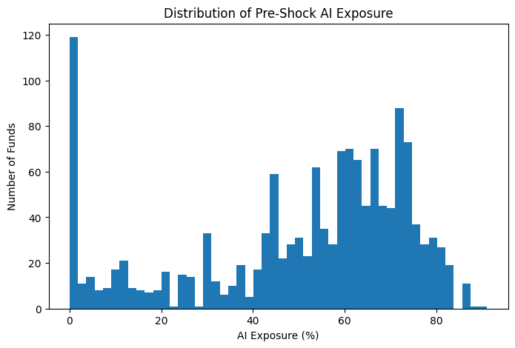
Figure 1 plots the distribution of pre-shock AI exposure. The distribution is not concentrated around a single value. Instead, it shows a sizeable low-exposure mass together with a broad right-side range of funds holding large AI-related positions. This variation is important because the DiD design relies on cross-sectional differences in predetermined exposure before the ChatGPT shock. The presence of substantial heterogeneity across funds supports the use of AIExposureZ as a treatment-intensity measure rather than a narrow binary classification.
The pairwise correlations among the key variables are modest. The correlation between contemporaneous fund flow and AI exposure is close to zero in the full sample, suggesting that the identifying variation is not driven mechanically by unconditional differences in flows between high- and low-AI funds. Fund size is weakly negatively associated with flows, and lagged flow is also mildly negatively related to current flow, consistent with short-run reversal after unusually large inflows or outflows. Overall, the descriptive evidence suggests that the regression results are unlikely to be dominated by simple unconditional correlations.
4.2 Baseline Difference-in-Differences Results
Table 2 reports the baseline DiD results. The coefficient of interest is the interaction between standardized pre-shock AI exposure and the post-ChatGPT indicator. The final specification includes lagged fund size, lagged fund return, lagged fund flow, fund fixed effects, and time fixed effects, with standard errors clustered at the fund level.
Flow_{i,t} = α + β(AIExposureZ_{i} × Post_{t}) + γX_{i,t-1} + μ_{i} + λ_{t} + ε_{i,t} （22）
Table 2. Baseline DiD Regression Results
 | (1)  No controls | (2)  + controls | (3)  + fund FE | (4)  + fund FE + time FE
AIExposureZ x Post | 0.0020***  (0.0006) | 0.0023***  (0.0006) | 0.0054***  (0.0009) | 0.0057***  (0.0009)
log_mtna_lag |  | -0.0013***  (0.0002) | -0.0303***  (0.0023) | -0.0319***  (0.0025)
mret_lag |  | 0.0369***  (0.0090) | 0.0486***  (0.0090) | 0.1369***  (0.0213)
flow_lag |  | -0.0799***  (0.0140) | -0.0903***  (0.0132) | -0.0923***  (0.0132)
Fund FE | No | No | Yes | Yes
Time FE | No | No | No | Yes
Observations | 82,531 | 81,262 | 81,262 | 81,262
R-squared | 0.0002 | 0.0081 | 0.0341 | 0.0371
Notes: The dependent variable is flow_w. Standard errors clustered at the fund level are reported in parentheses. *, **, and *** denote significance at the 10%, 5%, and 1% levels.
The coefficient on AIExposureZ x Post is positive and statistically significant across specifications. In the preferred two-way fixed-effects model in column (4), the coefficient is 0.0057, with a clustered standard error of 0.0009. Economically, a one-standard-deviation increase in pre-shock AI exposure is associated with approximately 0.57 percentage points higher monthly fund inflows after the ChatGPT release. Given that average monthly flow is close to zero, this effect is economically meaningful.
The result is consistent with the investor-attention channel developed in the previous chapters. Funds that already held more AI-related firms before ChatGPT experienced stronger post-shock inflows, suggesting that investors reallocated capital toward funds perceived as better positioned to benefit from technological optimism. The evidence supports H1: mutual funds with higher AI-related asset exposure experienced significantly greater investor inflows after the release of ChatGPT.
4.3 Event Study Analysis
The baseline DiD estimates capture the average post-shock effect. To examine whether the response emerges around the ChatGPT event and to assess the plausibility of the parallel-trend assumption, Figure 2 reports event-study estimates from month -12 to month +24, omitting month -1 as the reference period.
Flow_{i,t} = α + ∑_{k=-12,k≠-1}²⁴β_{k}(AIExposureZ_{i} × EventTime_{k,t}) + μ_{i} + λ_{t} + ε_{i,t} （23）
Figure 2. Event Study Estimates
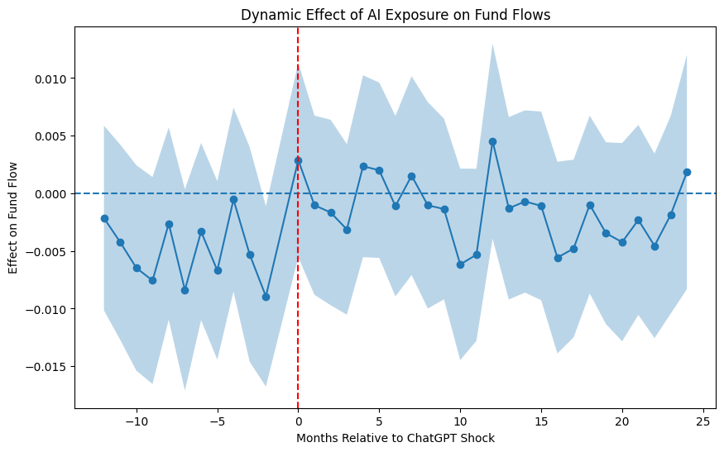
Figure 2 shows that most pre-treatment coefficients are statistically indistinguishable from zero. Although one isolated pre-treatment coefficient is statistically significant, the overall pre-treatment pattern remains relatively stable and does not display a monotonic upward trend before the ChatGPT release. This evidence is broadly consistent with the parallel-trend assumption, while also suggesting that causal interpretation should be made with appropriate caution.
The post-treatment estimates are noisier than the baseline average effect. Several coefficients turn positive after the event, especially around the event month and selected later months, but most confidence intervals include zero. This pattern suggests that the capital-flow response is not a single sharp one-month spike; rather, the average DiD effect in Table 2 summarizes a diffuse post-shock reallocation process. The event-study evidence therefore supports the timing of the attention channel in a balanced way: there is no strong evidence of systematic pre-trending, but the dynamic month-by-month estimates are less precise than the pooled post-period estimate.
4.4 Heterogeneity Analysis
This section tests whether the investor response to AI exposure depends on prior fund performance. GoodFund is defined as an indicator equal to one for funds with pre-shock Fama-French alpha above the sample median. The median prior alpha is -0.002811. The regression includes the interaction between AIExposureZ, Post, and GoodFund, along with the baseline controls and two-way fixed effects.
Flow_{i,t} = β₁(AIExposureZ_{i} × Post_{t}) + β₂(Post_{t} × GoodFund_{i}) + β₃(AIExposureZ_{i} × Post_{t} × GoodFund_{i}) + γX_{i,t-1} + μ_{i} + λ_{t} + ε_{i,t} （24）
Table 3. Heterogeneity by Prior Performance
 | flow_w
AIExposureZ x Post | 0.0023*  (0.0013)
Post x GoodFund | 0.0053*  (0.0028)
AIExposureZ x Post x GoodFund | 0.0064**  (0.0028)
log_mtna_lag | -0.0323***  (0.0026)
mret_lag | 0.1373***  (0.0214)
flow_lag | -0.0937***  (0.0133)
Fund FE | Yes
Time FE | Yes
Observations | 80,492
R-squared | 0.0367
Notes: GoodFund equals one for funds with prior alpha above the median. Standard errors clustered at the fund level are in parentheses.
The triple interaction coefficient is positive and statistically significant at the 5 percent level. The estimate of 0.0064 indicates that the post-ChatGPT flow response to AI exposure is stronger among funds with above-median prior alpha. Combining the baseline AI exposure effect and the triple interaction implies that high-alpha funds experience an AI-related post-shock flow response of roughly 0.87 percentage points per month for a one-standard-deviation increase in AI exposure.
This finding is consistent with the performance-chasing literature in mutual funds. Investors do not appear to respond only to thematic exposure; they also condition their allocation decisions on signals of managerial credibility. A fund with stronger historical alpha may be viewed as more capable of selecting and managing AI-related opportunities, making its pre-existing AI exposure more salient after the ChatGPT shock. H2 is supported.
4.5 Portfolio Allocation and Strategic Adjustment
The previous sections examine investor flows. This section turns to fund portfolio behavior and asks whether AI-exposed funds adjusted their holdings after ChatGPT. Table 4 reports quarterly regressions using two dependent variables: the number of newly initiated AI stock positions and the AI portfolio share.
NewAIPositions_{i,q} = β(AIExposureZ_{i} × Post_{q}) + γX_{i,q-1} + μ_{i} + λ_{q} + ε_{i,q} （25）
AIShare_{i,q} = β(AIExposureZ_{i} × Post_{q}) + γX_{i,q-1} + μ_{i} + λ_{q} + ε_{i,q} （26）
Table 4. Portfolio Adjustment Results
 | (1)  new_ai_positions | (2)  AIShare
AIExposureZ x Post | -0.1146***  (0.0174) | 3.8220***  (0.2912)
log_mtna_lag | 0.0020  (0.0208) | 0.9569***  (0.2893)
mret_lag | 0.1674  (0.2417) | -1.6534  (2.0153)
flow_lag | 0.0096  (0.1066) | -0.0207  (0.6120)
Fund FE | Yes | Yes
Quarter FE | Yes | Yes
Observations | 28,016 | 28,016
R-squared | 0.0015 | 0.0413
Notes: Regressions are estimated at the fund-quarter level. Standard errors are clustered at the fund level.
The two portfolio measures reveal different margins of adjustment. The coefficient on AIExposureZ x Post is negative and significant when the dependent variable is new_ai_positions. This indicates that high-AI-exposure funds did not respond by initiating a larger number of new AI stock names. Instead, the positive and highly significant coefficient in column (2) shows that these funds increased the percentage of portfolio assets allocated to AI-related firms. A one-standard-deviation increase in pre-shock AI exposure is associated with a 3.82 percentage-point increase in AI portfolio share after ChatGPT.
Figure 3. Average AI Portfolio Share Before and After ChatGPT
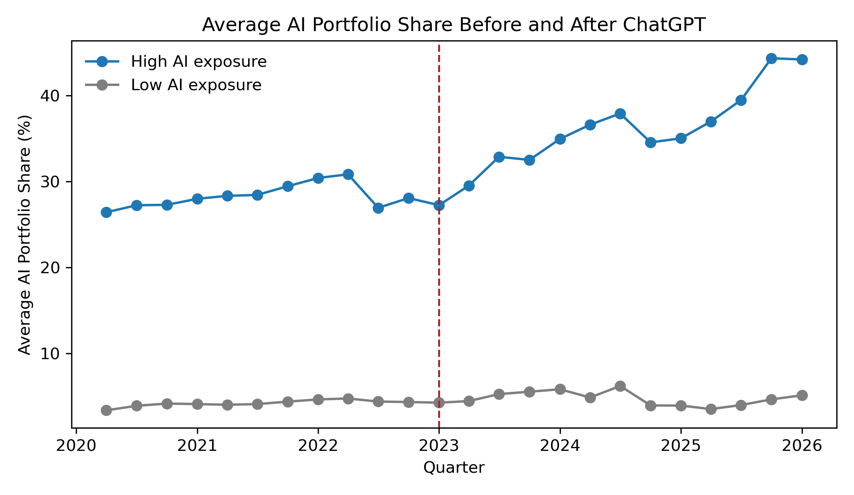
Figure 3 provides a visual representation of this intensive-margin adjustment. High-AI-exposure funds already hold larger AI-related portfolio shares before ChatGPT, but the divergence relative to low-AI-exposure funds becomes more pronounced after 2022. The pattern is consistent with strategic adaptation under technological uncertainty: rather than broadly adding many new AI names, funds with existing AI expertise appear to deepen exposure to firms already viewed as central to the AI investment theme.
Taken together, the H3 evidence supports the central prediction that AI-exposed mutual funds adjusted portfolio allocation after the ChatGPT shock. The adjustment is best characterized as an increase in allocation intensity rather than an expansion in the number of distinct AI positions. H3 is therefore supported with respect to strategic portfolio reweighting toward AI-related assets.
4.6 Robustness Tests
Table 5 reports robustness tests that examine whether the baseline result is sensitive to alternative treatment definitions, timing assumptions, and sample restrictions. The tests include the continuous exposure specification, median-split treatment, top-quartile treatment, a placebo timing test, and a balanced-fund subsample.
Table 5. Robustness Tests
Specification | Coefficient | Std. Err. | Observations | R-squared
Continuous exposure | 0.0057*** | (0.0009) | 81,262 | 0.0371
Median-split treatment | 0.0076*** | (0.0021) | 81,262 | 0.0367
Top-quartile treatment | 0.0085*** | (0.0023) | 81,262 | 0.0367
Placebo timing test | 0.0012 | (0.0014) | 39,688 | 0.0596
Balanced-fund subsample | 0.0055*** | (0.0009) | 71,929 | 0.0402
Notes: The reported coefficient is the treatment interaction in each specification. Standard errors are clustered at the fund level.
The results remain qualitatively unchanged across alternative specifications. The median-split treatment produces a positive coefficient of 0.0076, while the top-quartile treatment produces a coefficient of 0.0085. Both estimates are statistically significant at the 1 percent level, suggesting that the baseline finding is not driven by the use of a continuous treatment variable alone. The balanced-fund subsample also yields a positive and significant coefficient close to the main estimate.
Figure 4. Placebo Test Distribution
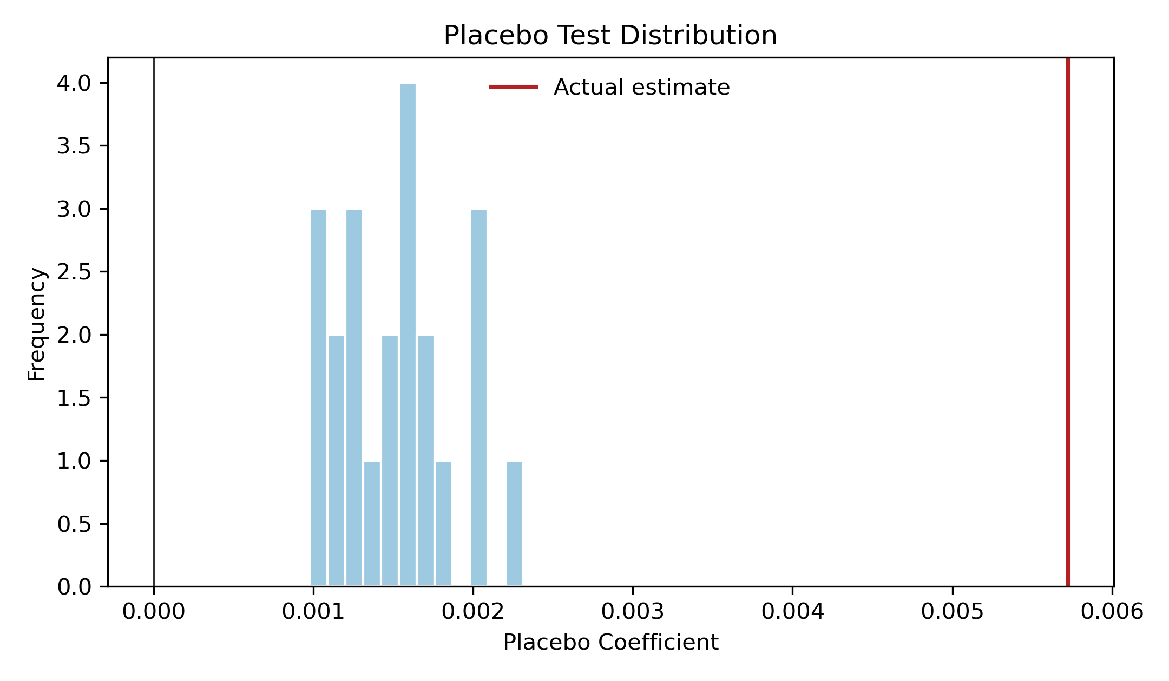
The placebo timing test provides additional evidence that the results are unlikely to be driven by random timing. The placebo coefficient is small and statistically insignificant, while the actual post-ChatGPT estimate lies in the positive tail of the placebo distribution. This pattern strengthens the interpretation that the estimated capital reallocation is related to the ChatGPT shock rather than a generic pre-existing trend among AI-exposed funds.
Overall, the robustness evidence reinforces the baseline conclusion. Across continuous exposure, alternative threshold definitions, placebo timing, and sample restrictions, the estimated effects remain economically meaningful and directionally consistent. The results therefore support the interpretation that investor attention and technological optimism following the release of ChatGPT contributed to capital reallocation toward AI-exposed mutual funds.

