
AI Exposure and Capital Flows: The Role of Investor Attention after the ChatGPT Shock

By
Nan.Lin
2252173

Supervisor: Zihua.Liu

A Dissertation Submitted in Partial Fulfillment of the Requirements for the

BSc Information Management and Information Systems

to

International Business School Suzhou
Xi’an Jiaotong-Liverpool University

May 18, 2026

Abstract
This thesis examines whether the public release of ChatGPT on 30 November 2022 affected U.S. mutual fund capital flows and portfolio allocation through an investor attention channel. Using CRSP mutual fund data, portfolio holdings information, Fama-French factor data, and a fund-level AI exposure measure, the study constructs a panel of U.S. mutual funds from 2020 to 2025. The empirical design uses a Difference-in-Differences framework in which pre-shock AI exposure serves as predetermined treatment intensity. The results show that funds with higher pre-shock AI exposure experienced significantly stronger post-ChatGPT inflows, suggesting that investor attention and technological optimism redirected capital toward AI-exposed funds. The effect is stronger among funds with superior prior risk-adjusted performance, indicating that investors combine thematic demand with managerial credibility. Portfolio-level evidence further shows that AI-exposed funds increased their AI portfolio share after the shock, while the number of newly initiated AI positions declined. This pattern suggests intensive-margin reinforcement rather than broad exploratory diversification. Overall, the findings indicate that generative AI shocks can influence not only stock-level valuations, but also delegated capital allocation and institutional portfolio adjustment.
Keywords: generative AI; investor attention; mutual fund flows; Difference-in-Differences; portfolio allocation

摘要
本文研究2022年11月30日ChatGPT公开发布是否通过投资者关注渠道影响美国共同基金的资金流动和投资组合配置。本文结合CRSP共同基金数据、持仓数据、Fama-French因子数据以及基金层面的AI暴露指标，构建了2020年至2025年的美国共同基金面板数据。实证方法采用双重差分框架，并以冲击前AI暴露作为预先确定的处理强度。研究发现，冲击前AI暴露较高的基金在ChatGPT发布后获得了显著更强的资金流入，说明投资者关注和技术乐观情绪推动资本向AI相关基金重新配置。该效应在具有更高历史风险调整绩效的基金中更强，表明投资者不仅关注AI主题，也会结合基金经理能力和可信度进行判断。进一步的组合层面证据显示，AI暴露较高的基金在冲击后提高了AI资产组合占比，但新增AI股票持仓数量下降。这一结果表明，基金主要通过强化已有AI持仓进行调整，而不是广泛买入新的AI相关股票。总体而言，本文说明生成式AI冲击不仅影响股票估值，也会影响委托投资中的资本配置和机构投资者组合调整。
关键词：生成式人工智能；投资者关注；共同基金资金流；双重差分；投资组合配置

Acknowledgements
As these words are written, my four years of undergraduate life are finally drawing to an end.
Many times, I have felt that life is far shorter than we imagine. The days when I first stepped onto this campus four years ago still feel vivid, almost like yesterday. Yet before I truly realized it, so many people, stories, and moments that once seemed endless have already been quietly carried away by time. Writing these words now, I realize for the first time with such clarity that some journeys really have come to an end.
First and foremost, I would like to express my deepest gratitude to Professor Liu Zihua, James.
Since we first met in the summer of 2024, more than seven hundred days and nights have passed. Looking back, I have never considered myself a truly gifted person. There were too many moments of dullness, slowness, and misunderstanding within me, and because of that, he devoted far more patience, effort, and care than I probably deserved, explaining things to me over and over again until I could finally understand them. Many truths that once sounded ordinary only revealed their meaning to me much later, after enough failures, confusion, and reality had passed through my life.
A teacher’s kindness is as vast as the sea, while I, Nan Lin, remain but unpolished wood. Yet some forms of gratitude are never meant to be spoken too loudly, for the things that truly matter are not preserved in elaborate words, but in remembrance carried throughout one’s life.
I would also like to thank Xing Boxiong, Ricardo.
Over these four years, he was not merely a friend, but more like a companion through some long and difficult nights of my life. Without the courage he gave me, I would never have become the person I am today. Many people see me as calm, determined, or even proud, but only a very small number truly know how much confusion, anger, collapse, and self-doubt I once carried within myself. I have done many brave things in my life, and also many cowardly ones, and Ricardo was one of the very few people who witnessed all of it.
Over the years, he absorbed and endured so much of my frustration, negativity, and inner chaos. Whenever I became trapped in anger, stubbornness, or my own darkness, he was always able to pull me back with a clarity that was almost painfully rational. Perhaps the most precious thing between people is not who stands beside you in moments of glory, but who remains when you are at your worst, when you are difficult to understand, difficult to accompany, and perhaps even difficult to love.
I will always remember that.
I would also like to thank Jingze.
Many people taught me how to move forward, but he was one of the very few who constantly reminded me not to lose myself along the way. Whenever I stood before important choices in life, consumed by ambition, desire, pressure, and the expectations of the world, he reminded me to follow my own heart rather than become completely swallowed by the logic of society and reality.
He taught me that no matter how complicated the world becomes, a person should still preserve their own moral boundaries and principles. This world has a way of making people gradually numb. Once we begin to see more of power, interests, and human nature, it becomes frighteningly easy to justify darkness in the name of “reality.” Yet many times, when I was close to being dragged into those gray and morally confusing whirlpools, he was the one who pulled me back and helped me regain clarity.
What is truly rare is not someone who encourages you to lose control together, but someone who reminds you, at the edge of losing yourself, not to become the kind of person you once despised.
For that, I will always remain grateful.
I would also like to thank my parents.
Over all these years, they have done everything they could to lift me forward. The truth is, I was never an easy child. I carried too many unrealistic dreams, too many stubborn choices, and too many thoughts that others could not understand. Yet they still chose to trust me and support me in pursuing the things I truly wanted.
As I grew older, I slowly came to understand that not everyone in this world is fortunate enough to chase their ideals freely. Many people are forced to bow before reality long before they ever have the chance to dream. The reason I was still able to fail, hesitate, wander, and start over was because behind me, there were always people silently carrying the truly heavy parts of life on my behalf.
When we are young, we often believe our parents are invincible. But growing older means realizing that they are merely ordinary people as well — people who also grow tired, fearful, and powerless. They simply hid those struggles so deeply that for many years, I mistakenly believed everything I had was natural and guaranteed.
Only now do I begin to understand that parents are simply two people who spend their entire lives slowly growing old while trying their best to hold up the world for their child.
Finally, I would like to thank Cinnamon.
During one of the most uncertain and darkest periods of my life, she reminded me that there were still beautiful things left in this world worth believing in. What she gave me was not merely comfort or encouragement, but a completely different way of understanding the world itself.
There was a kind of purity and kindness within her that is difficult to describe. It was not naivety, but rather the ability to remain gentle even after seeing how complicated the world truly is. She made me realize that truly intelligent people are not necessarily sharp or cold, and that maturity does not require the loss of tenderness.
For a very long time, I had grown used to viewing the world through suspicion, caution, and pessimism. Yet she slowly taught me that perhaps people do not always have to live with their edges exposed. She made me understand that kindness is not weakness, and sincerity is not foolishness. In a world that becomes increasingly cynical and cold, the courage to remain genuine may itself be one of the rarest forms of bravery.
I think some people do not enter our lives merely to accompany us for a while, but to ensure that, many years later, we still remember how bright and gentle the world once looked through their eyes.
Lastly, I would like to thank myself, and all the unfinished regrets along the way.
I want to thank the version of myself who stumbled forward imperfectly, who wanted to give up countless times, yet still managed to arrive here in the end. The truth is, I was never as strong as I appeared, nor as fearless as others may have imagined. There were many nights when I questioned myself, questioned the future, and questioned whether any of this truly meant anything at all.
But fortunately, I never completely stopped moving forward.
As for the regrets, the missed chances, and the unfinished stories, I believe they too will forever remain a part of life. Perhaps no one ever truly lives a perfectly complete life. There will always be words left unsaid, destinations never reached, and names that can only slowly fade into the silence of time.
Yet later I came to understand that regrets linger not because they were meaningless, but precisely because they once mattered so deeply.
And finally, to all of my friends, thank you for staying beside me through so many years.
Along the way, there were seasons of blooming and withering, moments of rising and falling. We witnessed one another through our proudest moments, our most broken nights, our confusion, and our determination. Many people may eventually scatter across different cities and different lives, but those years we shared together will always remain somewhere deep within memory.
And because of all of you, even when I must one day walk alone toward places far away, I know I will no longer be defeated so easily by loneliness or solitude.

List of Abbreviations
Abbreviation | Definition
AI | Artificial intelligence
AIExposureZ | Standardized pre-shock AI exposure
AIShare | Percentage of portfolio assets allocated to AI-related firms
AUM | Assets under management
CRSP | Center for Research in Security Prices
DiD | Difference-in-Differences
FE | Fixed effects
HML | High-minus-low value factor
MKT_RF | Market excess return factor
MTNA | Monthly total net assets
RF | Risk-free rate
SMB | Small-minus-big size factor
TNA | Total net assets
WRDS | Wharton Research Data Services

1. Introduction

1.1 Research Background
The rapid development of generative artificial intelligence has become one of the most important technological events affecting financial markets in recent years. Broader economic research links artificial intelligence to automation, labour demand, and productivity change (Acemoglu and Restrepo, 2018). The release of ChatGPT in November 2022 marked a particularly visible turning point, as it substantially increased public awareness of the commercial potential of artificial intelligence and intensified investor attention toward AI-related firms. Recent finance evidence shows that AI capabilities are associated with firm growth and product innovation (Babina et al., 2024). Following this event, companies associated with semiconductors, cloud computing, machine learning infrastructure, and AI applications attracted considerable market interest. This reaction is consistent with the view that AI may generate substantial but delayed productivity effects (Brynjolfsson et al., 2019). Stock market evidence on generative AI exposure further suggests that investors capitalized these expectations into firm values (Eisfeldt et al., 2023).

This technological shock is particularly relevant to the mutual fund industry. Mutual funds act as major institutional investors and important channels through which household and institutional capital is allocated to financial markets. Incomplete-information models imply that investor recognition and visibility can influence asset demand (Merton, 1987). If investors perceive AI-related firms as future growth opportunities, they may respond not only by purchasing individual AI stocks, but also by reallocating capital toward mutual funds that already hold greater exposure to AI-related assets. Evidence from mutual fund holdings shows that delegated managers transmit investment beliefs into portfolio allocations (Wermers, 2000). Fund flows can also generate meaningful trading pressure in underlying equity markets, making mutual funds an important channel for capital reallocation (Coval and Stafford, 2007). Therefore, the ChatGPT shock provides a useful setting to examine whether technological narratives and investor attention translate into measurable fund flow responses.

However, investor reactions may not depend only on AI exposure. Prior fund performance may also matter because investors often interpret past performance as a signal of managerial ability and investment credibility. A fund with high AI exposure and strong historical performance may therefore be viewed as better positioned to benefit from the AI boom than a similarly exposed fund with weaker past performance. In addition, fund managers themselves may respond strategically to the AI shock by adjusting their portfolios toward more exploratory allocations, especially when new technological opportunities emerge rapidly.

1.2 Research Problem and Objectives
Although existing studies have examined artificial intelligence, investor attention, and mutual fund flows separately, relatively limited evidence exists on how a major generative AI shock affects capital allocation within the mutual fund industry. In particular, it remains unclear whether funds with higher pre-existing AI exposure attracted stronger investor inflows after the release of ChatGPT, whether this effect differed across funds with different prior performance, and whether AI-exposed funds subsequently adjusted their investment strategies.

This study addresses this gap by examining the impact of the ChatGPT shock on U.S. mutual fund flows and portfolio behavior. The first objective is to test whether funds with higher AI exposure experienced greater post-shock inflows. The second objective is to investigate whether prior fund performance strengthens this relationship. The third objective is to explore whether AI-exposed funds adopted more exploratory portfolio allocation strategies after the emergence of generative AI.

Based on these objectives, this thesis asks three research questions:

RQ1: Did mutual funds with higher AI-related asset exposure experience significantly greater investor inflows after the release of ChatGPT?

RQ2: Did prior fund performance moderate the relationship between AI exposure and post-ChatGPT fund flows?

RQ3: Did AI-exposed mutual funds exhibit greater exploratory portfolio allocation behavior following the ChatGPT shock?

1.3 Research Design and Contributions
To answer these questions, this study constructs a panel dataset of U.S. mutual funds using CRSP mutual fund return, asset, and holdings-related data. AI exposure is measured based on the proportion of fund holdings allocated to AI-related firms before the release of ChatGPT. The main empirical strategy applies a Difference-in-Differences framework that compares changes in fund flows between funds with different levels of AI exposure before and after the ChatGPT shock. Event-study analysis is further used to examine pre-treatment trends, while heterogeneity analysis and robustness tests are conducted to assess the validity of the results.

This study contributes to the literature in several ways. First, it adds to the emerging research on artificial intelligence and financial markets by shifting attention from firm-level stock reactions to institutional capital allocation through mutual funds. Second, it contributes to the investor attention literature by showing how a highly visible technological event may redirect capital toward funds associated with a popular investment theme. Third, it extends mutual fund research by examining how historical performance interacts with AI exposure in shaping investor responses. Finally, by investigating exploratory portfolio adjustments, this study provides evidence on how fund managers adapt to technological shocks.

1.4 Thesis Structure
The remainder of this thesis is organized as follows. Chapter 2 reviews the relevant literature and develops the research hypotheses. Chapter 3 introduces the data, variable construction, and empirical methodology. Chapter 4 presents the empirical results, including baseline estimations, event-study analysis, heterogeneity tests, and robustness checks. Chapter 5 discusses the findings in relation to existing literature and considers their implications. Chapter 6 concludes the thesis by summarizing the main findings, limitations, and directions for future research.

2. Literature Review and Hypothesis Development

2.1 Artificial Intelligence and Financial Markets
Artificial intelligence has become one of the most influential technological developments affecting modern financial markets. Rapid advances in machine learning, natural language processing, and generative AI technologies have significantly increased investor attention toward firms associated with AI innovation. In particular, the release of ChatGPT in November 2022 accelerated market optimism regarding the future commercial potential of generative artificial intelligence and triggered substantial valuation increases among AI-related firms.

Prior studies suggest that technological innovation can generate significant effects on investor expectations and asset prices because investors often associate emerging technologies with future productivity growth and long-term profitability. During periods of technological excitement, financial markets may exhibit strong thematic investment behavior, where capital flows disproportionately toward firms connected to emerging innovation trends. The rapid rise of AI-related stocks following the emergence of ChatGPT reflects this phenomenon and indicates that investors increasingly viewed artificial intelligence as a transformative economic force.

Existing research on artificial intelligence and financial markets has primarily focused on firm-level outcomes, including stock returns, innovation performance, and AI adoption. However, relatively limited attention has been paid to how AI-related technological shocks influence institutional capital allocation through mutual funds. Since mutual funds represent major institutional investors within financial markets, understanding how they respond to technological shocks is important for examining the broader transmission of AI-related market sentiment into investment behavior.

2.2 Investor Attention and Capital Flows
Investor attention plays an important role in shaping financial market behavior and capital allocation decisions. Prior literature argues that investors face limited attention and therefore tend to allocate capital toward assets or investment themes that receive greater public visibility and media coverage (Hirshleifer and Teoh, 2003). Attention-grabbing news can affect both individual and institutional investor trading decisions (Barber and Odean, 2008). Search-based measures also show that investor attention predicts market behaviour around salient information events (Da et al., 2011). Institutional attention matters because professional investors may still underreact when attention is directed elsewhere (Ben-Rephael et al., 2017).

The emergence of ChatGPT represents a particularly important attention-generating event because it rapidly increased public awareness of generative artificial intelligence technologies within a short period of time. Prior evidence shows that salient narratives can trigger strong market reactions even when fundamental information is limited (Huberman and Regev, 2001). Extensive media coverage, public discussion, and strong stock market reactions surrounding AI-related firms likely increased investor demand for investment vehicles associated with artificial intelligence themes. Category-based learning provides one explanation for why investors may respond to broad technology labels rather than only firm-specific information (Peng and Xiong, 2006). In this context, mutual funds with greater pre-existing exposure to AI-related firms may have benefited from increased investor attention and thematic capital allocation.

Previous studies on mutual fund flows suggest that investors frequently direct capital toward funds associated with popular market narratives or investment opportunities. Costly search can make investors more responsive to funds that become easier to identify or more salient (Sirri and Tufano, 1998). Thematic investing behavior is especially common during periods of technological innovation or market optimism, when investors attempt to gain exposure to emerging growth sectors. Flow-based demand can also influence return patterns across the stock market (Lou, 2012). Therefore, if investors perceived AI-related industries as future growth opportunities after the release of ChatGPT, funds with higher AI exposure may have attracted greater investor inflows relative to less exposed funds. This interpretation is consistent with evidence that mutual fund flows may reflect investor sentiment as well as information (Frazzini and Lamont, 2008).

Based on the above discussion, this study proposes the following hypothesis:

H1: Mutual funds with higher AI-related asset exposure experienced significantly greater investor inflows after the release of ChatGPT.

2.3 Mutual Fund Performance and Investor Response
In addition to thematic exposure, prior fund performance is also an important determinant of investor capital allocation decisions. The growth of actively managed mutual funds has long been linked to investors' willingness to delegate capital despite uncertainty about skill (Gruber, 1996). Extensive literature on mutual fund flows documents that investors tend to allocate more capital toward funds with superior historical performance (Sirri and Tufano, 1998). This phenomenon, commonly referred to as performance-chasing behavior, reflects the tendency of investors to interpret past returns as signals of managerial skill, investment ability, and information advantages. Rational flow-performance models also predict that investors direct capital toward managers perceived to have higher ability (Berk and Green, 2004).

Funds with strong historical performance may therefore enjoy greater credibility among investors during periods of market uncertainty or technological change. Incentive-based models suggest that managerial behaviour and risk taking respond to performance concerns (Chevalier and Ellison, 1997). In the context of the ChatGPT shock, investors may have viewed high-performing AI-exposed funds as being better positioned to benefit from the rapid expansion of AI-related industries. The star-fund literature further suggests that reputation within mutual fund families can influence investor allocation decisions (Nanda et al., 2004). Conversely, funds with weaker historical performance may have been less successful in attracting investor confidence even if they possessed similar AI-related asset exposure.

Prior research also suggests that investor responses to new investment opportunities are often influenced by both market narratives and managerial reputation. Therefore, the relationship between AI exposure and investor fund flows may not be uniform across all funds. Instead, historical performance may strengthen the positive impact of AI exposure on post-ChatGPT investor inflows.

Based on this reasoning, the following hypothesis is proposed:

H2: The positive relationship between AI exposure and post-ChatGPT investor inflows is stronger among funds with superior prior performance.

2.4 Technological Shocks and Institutional Adaptation
Technological shocks may influence not only investor behavior but also institutional investment strategies. When major technological innovations emerge, institutional investors often adjust their portfolio allocation decisions to capture new growth opportunities and respond to changing market expectations. Such adjustments may involve increasing investments in emerging industries, reallocating capital across sectors, or adopting more exploratory investment strategies.

The emergence of generative artificial intelligence may have created strong incentives for fund managers to actively reposition their portfolios toward AI-related opportunities. Industry concentration can reflect informational advantages when active managers specialize in areas where they have stronger beliefs (Kacperczyk et al., 2005). Since technological innovation can rapidly reshape competitive advantages and future market expectations, institutional investors may attempt to increase exposure to firms associated with emerging technologies in order to improve future performance and maintain competitiveness. More active portfolio positioning is also related to manager discretion and differentiated investment views (Cremers and Petajisto, 2009).

Exploratory investment behavior is particularly relevant during periods of technological transformation because investors face substantial uncertainty regarding which firms or industries will ultimately benefit from innovation. As a result, fund managers may increase portfolio experimentation, diversify into new technological sectors, or adjust investment strategies more aggressively following major technological shocks.

In the context of the ChatGPT shock, mutual funds with higher AI exposure may have been more likely to adopt exploratory portfolio allocation behavior due to stronger incentives to capitalize on AI-related market opportunities. This leads to the following hypothesis:

H3: AI-exposed mutual funds exhibited greater exploratory portfolio allocation behavior following the ChatGPT shock.

2.5 Research Gap
Although previous studies have examined artificial intelligence, investor attention, and mutual fund behavior, several important gaps remain in the existing literature.

First, most studies on artificial intelligence and financial markets focus primarily on firm-level stock reactions, AI adoption, or technological innovation, while comparatively limited attention has been paid to institutional capital allocation through mutual funds. Second, although investor attention literature suggests that highly visible events can influence capital flows, existing research has not sufficiently examined whether the emergence of generative artificial intelligence redirected investor capital toward AI-exposed mutual funds.

Third, prior mutual fund studies largely focus on traditional determinants of fund flows such as performance, risk, and fees, while relatively little evidence exists regarding how technological narratives interact with historical performance to shape investor behavior. Finally, limited research has explored whether institutional investors strategically adjusted their portfolio allocation behavior following the emergence of generative AI technologies.

Therefore, this study seeks to address these gaps by examining how the ChatGPT shock influenced mutual fund flows, how prior performance moderated investor responses, and whether AI-exposed funds adopted more exploratory investment strategies after the emergence of generative artificial intelligence.

3. Research Design and Methodology

3.1 Research Design
This study examines whether the emergence of generative artificial intelligence, represented by the public release of ChatGPT on November 30, 2022, changed mutual fund capital flows and portfolio allocation behavior. The release of ChatGPT rapidly increased investor attention toward AI-related industries and generated substantial optimism regarding the future economic potential of artificial intelligence technologies. As a result, the event provides a useful quasi-natural experiment for examining whether investors reallocated capital toward mutual funds with greater exposure to AI-related firms.

To identify the impact of the ChatGPT shock on mutual fund flows, this study adopts a Difference-in-Differences (DiD) framework using pre-shock AI exposure as treatment intensity. The empirical strategy compares changes in fund flows between funds with relatively high AI exposure and those with lower AI exposure before and after the ChatGPT shock. Because AI exposure is measured prior to the release of ChatGPT, the treatment variable is predetermined and less likely to suffer from reverse causality.
The identifying assumption is that the timing of ChatGPT's public release was largely external to individual mutual fund portfolio decisions. Because the event occurred at a common point in time and was not caused by fund-level capital flows, it provides a quasi-natural experiment for studying investor attention. The use of predetermined treatment intensity further reduces reverse causality concerns: AI exposure is measured before November 2022, while the outcome of interest is the subsequent change in fund flows and portfolio allocation. Standard inference in Difference-in-Differences settings requires attention to serial correlation in panel outcomes (Bertrand et al., 2004).

Figure 1 summarizes the research timeline, including the pre-shock exposure measurement window, the ChatGPT release date, and the post-treatment outcome period.
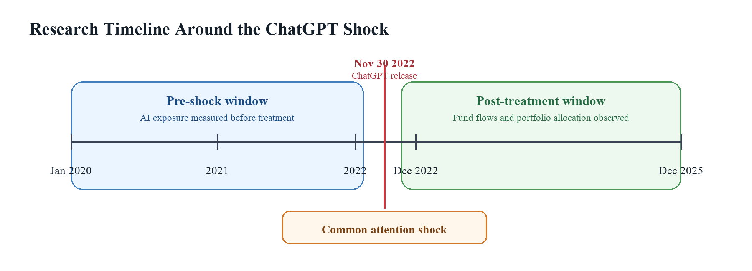
Figure 1. Research Timeline Around the ChatGPT Shock
The baseline empirical specification is:

Flow_{i,t} = α + β₁(AIExposureZ_{i} × Post_{t}) + μ_{i} + λ_{t} + ε_{i,t} （1）

where Flowi,t represents mutual fund flow for fund i in month t, AIExposureZi denotes standardized pre-shock AI exposure, and Postt equals one for periods after December 2022. Fund fixed effects (μi) absorb time-invariant fund characteristics such as investment style, fund family structure, managerial characteristics, and persistent differences in investor clientele. Time fixed effects (λt) absorb common macroeconomic shocks, market-wide trends, and aggregate technology-sector movements that affect all funds in the same month.
Standard errors are clustered at the fund level to account for serial correlation, heteroskedasticity, and within-fund dependence over time. This adjustment is important because fund flows are persistent and repeated observations for the same fund are unlikely to be independent.

To improve estimation reliability, the baseline model further includes lagged control variables:

Flow_{i,t} = α + β₁(AIExposureZ_{i} × Post_{t}) + γX_{i,t-1} + μ_{i} + λ_{t} + ε_{i,t} （2）

where X_{i,t-1} includes lagged log assets under management, lagged fund return, and lagged fund flow.

In addition to the baseline DiD specification, this study estimates an event-study model to examine dynamic treatment effects and evaluate the parallel-trend assumption. Heterogeneity analysis and robustness tests are also conducted to examine whether the results remain stable under alternative treatment definitions and model specifications.

3.2 Data Sources
This study combines multiple datasets to construct a comprehensive panel of U.S. mutual funds and their AI-related portfolio exposure.

The first dataset is the AI exposure dataset, obtained from the file ai_exposure_larger100.csv. The raw dataset contains 14,430 fund-year observations covering 2,405 unique mutual funds from 2020 to 2025. The key variable in this dataset is avg_of_avg_percent_tna, which is renamed as AI_exposure. This variable measures the percentage of fund holdings invested in AI-related firms.

The second dataset is the CRSP Mutual Fund Database obtained through WRDS. Monthly mutual fund information is downloaded from the table crsp_q_mutualfunds.monthly_tna_ret_nav. The key variables are summarized below:
Table 3.1. CRSP Monthly Mutual Fund Variables
Variable | Meaning | Use in Empirical Analysis
crsp_fundno | Unique CRSP mutual fund identifier | Matches AI exposure data to the monthly fund panel and defines fund-level fixed effects.
caldt | Monthly calendar date | Defines the time dimension, the post-treatment indicator, and monthly fixed effects.
mtna | Monthly total net assets | Used to calculate fund flows and lagged fund size.
mret | Monthly fund return | Used to remove return-driven asset growth from flows and to construct lagged return controls.
These variables provide the minimum structure required to construct the fund-month panel: crsp_fundno identifies funds, caldt defines the time index, mtna is used to measure changes in assets under management, and mret allows fund flows to be adjusted for mechanical return effects.

The sample period spans from January 2020 to December 2025. Among the 1,425 funds retained in the AI exposure sample, 1,269 funds are successfully matched with CRSP monthly mutual fund data. The initial monthly panel contains 83,984 fund-month observations.

The third dataset contains Fama-French factor data loaded from F-F_Research_Data_Factors-2.csv. The dataset provides monthly factor returns for the market excess return (MKT_RF), size factor (SMB), value factor (HML), and risk-free rate (RF). All percentage values are converted into decimal form before estimation. These factors follow the standard three-factor framework used to estimate risk-adjusted fund performance (Fama and French, 1993).

To examine portfolio allocation behavior in H3, this study additionally uses portfolio mapping and holdings datasets from CRSP. Fund-to-portfolio mapping is obtained from the table crsp_q_mutualfunds.portnomap, while portfolio holdings information is downloaded from crsp_q_mutualfunds.holdings. The holdings dataset contains 7,907,611 raw observations between 2020 and 2025 and includes variables such as ticker, market value, and portfolio weight.

AI-related firms are identified using a predefined AI ticker list including major technology and semiconductor companies such as NVDA, AMD, MSFT, GOOGL, META, AMZN, AVGO, and ASML.

3.3 Sample Construction
The sample construction process proceeds in several stages.

First, pre-shock AI exposure is constructed by averaging fund-level AI exposure between 2020 and 2022:

AIExposurePre_{i} = 1/N_{i} × ∑_{y=2020}²⁰²²AIExposure_{i,y} （3）

where N_{i} denotes the number of non-missing observations for fund i during the pre-shock period. To improve measurement reliability, the main sample retains only funds with at least two non-missing pre-shock observations. This procedure produces a final exposure sample containing 1,425 unique funds.

Second, the continuous treatment variable is standardized:

AIExposureZ_{i} = (AIExposurePre_{i} - mean(AIExposurePre)) / SD(AIExposurePre) （4）

The standardized exposure variable has mean zero and standard deviation one, allowing coefficient interpretation in terms of standard-deviation changes in AI exposure.

Third, the CRSP monthly mutual fund dataset is cleaned and merged with the AI exposure sample. Fund flow is calculated as:

Flow_{i,t} = [MTNA_{i,t} - MTNA_{i,t-1}(1 + R_{i,t})] / MTNA_{i,t-1} （5）

where MTNA_{i,t} denotes total net assets and R_{i,t} represents monthly fund return.

This measure removes the mechanical effect of investment returns from changes in assets under management and isolates net investor capital flows. Mutual fund flows can contain extreme observations caused by mergers, fund closures, reporting changes, or unusually large subscriptions and redemptions. The raw flow variable is therefore winsorized at the 1st and 99th percentiles. This procedure reduces the influence of extreme observations without eliminating economically meaningful variation in fund flows. The winsorized dependent variable is denoted as flow_w.

After removing observations with missing lagged values required for flow calculation, the final monthly panel contains 82,531 fund-month observations spanning February 2020 to December 2025.

The post-treatment indicator is defined as:

Post_{t} = 1[caldt ≥ 2022-12-01] （6）

The main treatment interaction is therefore:

AIpost_{i,t} = AIExposureZ_{i} × Post_{t} （7）

To construct the quarterly panel for H3, the monthly fund panel is converted into a fund-quarter dataset by retaining quarter-end observations. The resulting H3 sample contains 28,034 fund-quarter observations from 2020Q1 to 2025Q4.

Figure 2 summarizes the sample construction process from the raw AI exposure dataset to the final monthly and quarterly empirical panels.
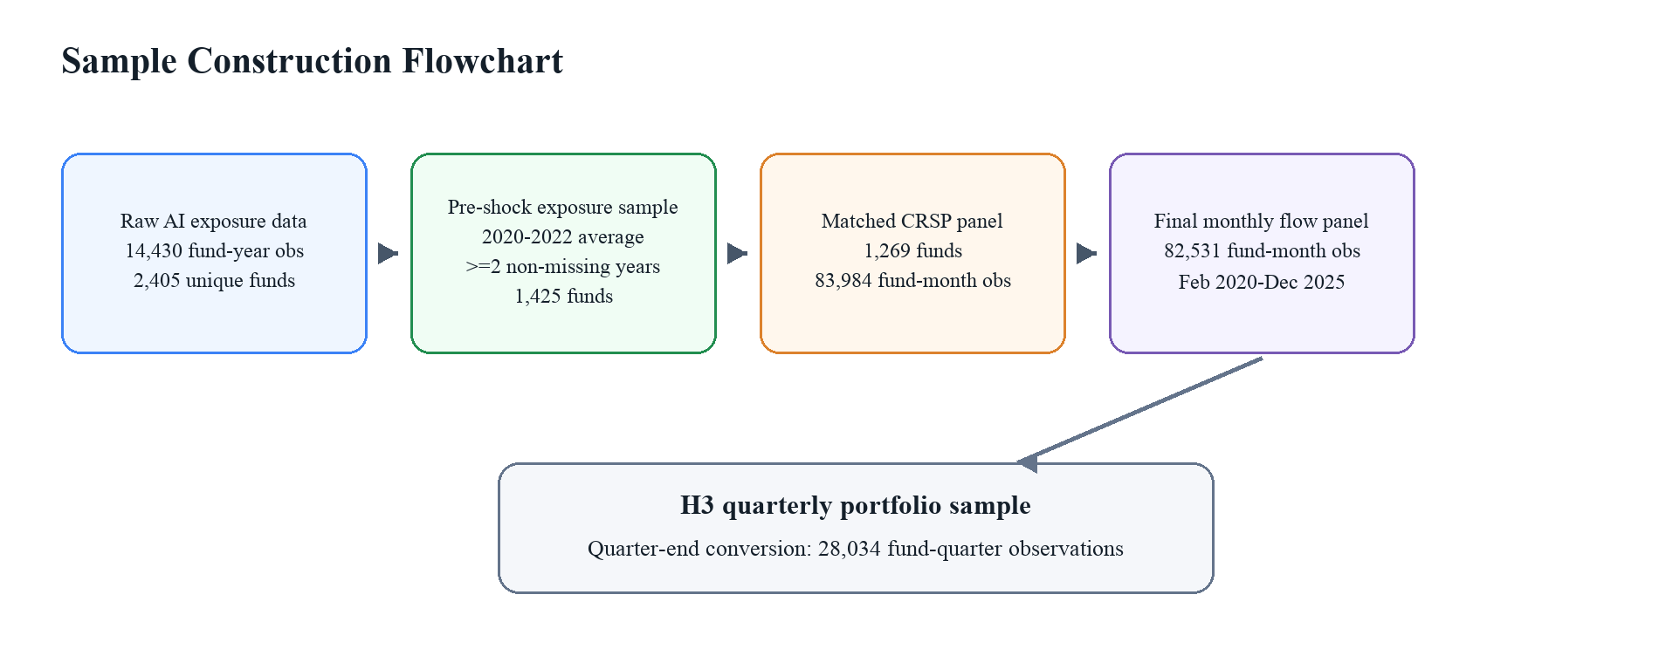
Figure 2. Sample Construction Flowchart

3.4 Variable Construction

3.4.1 Dependent Variable: Fund Flow
The primary dependent variable for H1 and H2 is the winsorized mutual fund flow variable (flow_w). Fund flow measures net investor capital movement after adjusting for asset growth caused by fund returns.

The winsorized flow variable is calculated from the raw flow measure defined previously. The 1st and 99th percentile winsorization bounds are -0.3916 and 0.6548, respectively.

3.4.2 AI Exposure Variables
The key explanatory variable is pre-shock AI exposure. This study uses both continuous and dummy-based AI exposure measures.

The continuous measure is the standardized AI exposure variable AIExposureZ_{i}.

For robustness analysis, dummy treatment variables are also constructed using alternative exposure thresholds. The median-split treatment indicator is defined as:

AIHigh_{i} = 1[AIExposurePre_{i} > Median(AIExposurePre)] （8）

where the median cutoff equals 58.4466.

The top-quartile treatment indicator is similarly defined as:

TopQuartileAI_{i} = 1[AIExposurePre_{i} > Q75(AIExposurePre)] （9）

where the 75th percentile cutoff equals 68.8412.

3.4.3 Control Variables
The baseline regressions include three lagged control variables:

- Lagged log assets under management:
log_mtna_lag = log(MTNA_{i,t-1}) （10）

- Lagged monthly return:
mret_lag = R_{i,t-1} （11）

- Lagged fund flow:
flow_lag = Flow_{i,t-1} （12）

These controls account for persistence in fund flows, size effects, and short-term return-driven investor behavior.

3.4.4 Prior Alpha and GoodFund Variable
To examine heterogeneity in investor responses, this study estimates prior fund alpha using the Fama-French three-factor model over the pre-shock period:

R_{i,t} - RF_{t} = α_{i} + β_{MKT,i}MKT_RF_{t} + β_{SMB,i}SMB_{t} + β_{HML,i}HML_{t} + ε_{i,t} （13）

Funds must have at least 12 monthly observations before November 2022 to estimate alpha reliably. This procedure produces 1,231 funds with valid alpha estimates.

Based on estimated alpha values, a high-performance dummy variable is constructed:

GoodFund_{i} = 1[α_{i} > Median(α)] （14）

The median alpha equals -0.002811.

3.4.5 Portfolio Allocation Variables
For H3, two portfolio allocation measures are constructed.

The first variable is the number of newly initiated AI stock positions (new_ai_positions). A new AI position is defined as:

NewAIPosition_{p,s,q} = 1[NoPreviousHolding_{p,s}] or 1[QuarterGap_{p,s,q} > 1] （15）

where p represents portfolio, s denotes ticker, and q represents quarter.

The second variable is the AI portfolio share:

AIShare_{p,q} = ∑_{s∈AIStocks}PercentTNA_{p,s,q} （16）

This variable measures the percentage of portfolio assets allocated to AI-related firms.
Using both new_ai_positions and AIShare allows the analysis to distinguish between extensive-margin portfolio expansion and intensive-margin allocation reinforcement. New AI positions capture whether funds broaden their exposure by entering additional AI-related stocks, while AIShare captures whether funds increase the weight allocated to AI-related holdings. This distinction is important for interpreting institutional adaptation because managers may respond to technological uncertainty through strategic concentration in familiar positions rather than through broad exploratory diversification.

3.5 Econometric Specifications

3.5.1 Baseline DiD Model
The baseline model estimates the relationship between AI exposure and post-ChatGPT fund flows:

Flow_{i,t} = α + β₁(AIExposureZ_{i} × Post_{t}) + γX_{i,t-1} + μ_{i} + λ_{t} + ε_{i,t} （17）

The coefficient of interest is β₁, which measures whether funds with higher pre-shock AI exposure experienced stronger inflows after ChatGPT.

3.5.2 Event-Study Specification
To examine dynamic treatment effects and evaluate the parallel-trend assumption, this study estimates the following event-study specification in relative event time:

Flow_{i,t} = α + ∑_{k=-12,k≠-1}²⁴β_{k}(AIExposureZ_{i} × 1[RelMonth_{t} = k]) + μ_{i} + λ_{t} + ε_{i,t} （18）

Month -1 is omitted as the reference period.
The event-study design estimates separate interaction coefficients for each relative month, allowing the treatment effect to vary over time rather than imposing a single post-treatment average. Pre-treatment coefficients provide a direct parallel-trend assessment, while post-treatment coefficients trace the dynamic adjustment of investor flows following the ChatGPT shock. This structure follows the broader event-study tradition in empirical finance (MacKinlay, 1997).

3.5.3 Heterogeneity Model
To test whether prior performance moderates investor responses, the following triple-interaction model is estimated:

Flow_{i,t} = β₁(AIExposureZ_{i} × Post_{t}) + β₂(Post_{t} × GoodFund_{i}) + β₃(AIExposureZ_{i} × Post_{t} × GoodFund_{i}) + γX_{i,t-1} + μ_{i} + λ_{t} + ε_{i,t} （19）

The coefficient β₃ captures whether high-alpha funds experience stronger AI-related inflows after the ChatGPT shock.

3.5.4 Portfolio Allocation Models
The H3 quarterly models are estimated as:

NewAIPositions_{i,q} = β₁(AIExposureZ_{i} × Post_{q}) + γX_{i,q-1} + μ_{i} + λ_{q} + ε_{i,q} （20）

and:

AIShare_{i,q} = β₁(AIExposureZ_{i} × Post_{q}) + γX_{i,q-1} + μ_{i} + λ_{q} + ε_{i,q} （21）

Both specifications include fund fixed effects, quarter fixed effects, and clustered standard errors. Fund fixed effects absorb persistent differences in portfolio mandates and investment styles, while quarter fixed effects control for aggregate market conditions and common technology-sector shocks at the quarterly frequency.

3.6 Methodological Strengths and Limitations
This study has several methodological strengths. First, the use of pre-shock AI exposure helps reduce reverse causality concerns because exposure is measured before the release of ChatGPT. Second, fund and time fixed effects control for unobserved heterogeneity and common macroeconomic shocks. Third, alternative exposure thresholds reduce treatment-definition sensitivity, while event-study analysis and heterogeneity specifications provide additional checks on dynamic adjustment and cross-sectional mechanisms. Robustness results are interpreted as supportive when the estimated effects remain qualitatively consistent across specifications.

Nevertheless, several limitations should also be acknowledged. The AI exposure measure depends on ticker-based classification of AI-related firms, which may not perfectly capture true AI involvement. In addition, the ChatGPT shock may coincide with broader technology-sector developments and macroeconomic events occurring during the same period. The event-study analysis also shows one significantly negative pre-treatment coefficient, suggesting that the parallel-trend assumption should be interpreted cautiously rather than treated as perfectly satisfied. Finally, holdings-based percent_tna measures occasionally contain extreme values above 100 or below zero due to leverage, derivatives, or reporting conventions, requiring careful interpretation of portfolio-share magnitudes.

4. Empirical Results

4.1 Descriptive Statistics
This chapter presents the empirical evidence on whether the release of ChatGPT changed investor flows and portfolio allocation among U.S. mutual funds. The final monthly fund-flow panel contains 82,531 fund-month observations from February 2020 to December 2025. The pre-shock exposure sample contains 1,425 funds, of which 1,269 funds are successfully matched to CRSP monthly mutual fund data. The H3 portfolio allocation sample contains 28,034 fund-quarter observations before the regression sample is reduced by lagged controls.
Table 1 reports summary statistics for the main variables used in the empirical analysis. The dependent variable flow_w is centered close to zero, with a mean of -0.0026 and a median of -0.0068, indicating that most monthly fund flows are small relative to lagged assets. The winsorized range, from -0.3916 to 0.6548, shows that the empirical design limits the influence of extreme fund-flow observations while preserving meaningful dispersion in investor capital movements.
Table 1. Summary Statistics
Variable | Mean | Std. | Min | Max | Median
flow_w | -0.002589 | 0.108019 | -0.391568 | 0.654824 | -0.006756
AIExposureZ | 0.008942 | 0.978815 | -2.083038 | 1.667393 | 0.323309
log_mtna_lag | 3.744700 | 2.829496 | -2.302585 | 11.781222 | 3.808882
mret_lag | 0.010386 | 0.065432 | -0.742038 | 0.684039 | 0.013057
flow_lag | -0.002440 | 0.107940 | -0.391568 | 0.654824 | -0.006696
alpha | -0.003180 | 0.004492 | -0.045557 | 0.017952 | -0.002811
AIShare | 21.613358 | 34.211737 | -9.629999 | 179.949946 | 3.599999
Notes: Summary statistics are based on the processed empirical panels used in the saved notebook outputs. AIShare is reported from the H3 fund-quarter panel as percent_tna.
The standardized AI exposure variable AIExposureZ has substantial cross-sectional dispersion, ranging from -2.0830 to 1.6674 in the monthly panel. This variation is important for identification because treatment intensity differs across funds before the ChatGPT shock rather than being assigned uniformly after the event. The prior-alpha variable is negative at the median, consistent with the difficulty of generating positive risk-adjusted performance after controlling for common equity factors.
Table 1B reports the pairwise correlation matrix for the main flow-regression variables. The correlations are modest in magnitude, which reduces concerns that the baseline results are mechanically driven by simple bivariate relationships among fund size, past returns, lagged flows, and AI exposure.
Table 1B. Correlation Matrix
Variable | flow_w | AIExposureZ | log_mtna_lag | mret_lag | flow_lag
flow_w | 1.000
AIExposureZ | 0.011 | 1.000
log_mtna_lag | -0.035 | 0.067 | 1.000
mret_lag | 0.017 | 0.041 | 0.022 | 1.000
flow_lag | -0.079 | 0.010 | 0.020 | 0.065 | 1.000
Notes: The table reports pairwise Pearson correlations using the H1/H2 monthly panel. Only the lower triangle is shown.
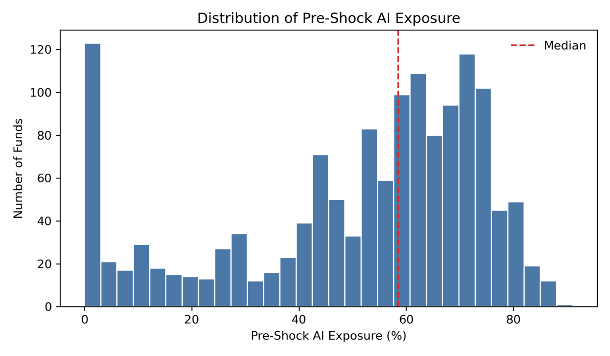
Figure 3. Distribution of Pre-Shock AI Exposure
Source: author’s calculations from the pre-shock AI exposure sample.
Figure 3 plots the distribution of pre-shock AI exposure. The distribution is not concentrated at a single point; instead, it displays substantial cross-sectional heterogeneity across funds. The mean pre-shock exposure is 50.5939, while the median is 58.5125, indicating that lower-exposure funds pull the average below the median. This dispersion provides the cross-sectional treatment variation used in the Difference-in-Differences analysis.

4.2 Baseline Difference-in-Differences Results
Table 2 reports the baseline Difference-in-Differences estimates. Statistical significance in this chapter is assessed using the reported P-value; significance stars are included only as a compact visual convention. The estimating equation relates fund flows to the interaction between pre-shock AI exposure and the post-ChatGPT period:
Flow_{i,t} = α + β(AIExposureZ_{i} × Post_{t}) + γX_{i,t-1} + μ_{i} + λ_{t} + ε_{i,t} （22）
Table 2. Baseline DiD Regression Results
Parameter | Coefficient | Std. Err. | T-stat | P-value | 95% CI
Panel A: No lagged controls; Dependent variable = flow_w
const | -0.0026*** | 0.000008 | -324.59 | 0.0000 | [-0.0026, -0.0026]
AI_post | 0.0024*** | 0.0007 | 3.3777 | 0.0007 | [0.0010, 0.0038]
Observations | 82,531
R-squared | 0.0001
Entities | 1,269
Time periods | 71
Panel B: With lagged controls; Dependent variable = flow_w
const | 0.1153*** | 0.0095 | 12.173 | 0.0000 | [0.0967, 0.1339]
AI_post | 0.0057*** | 0.0009 | 6.4092 | 0.0000 | [0.0040, 0.0075]
log_mtna_lag | -0.0319*** | 0.0025 | -12.603 | 0.0000 | [-0.0368, -0.0269]
mret_lag | 0.1369*** | 0.0213 | 6.4177 | 0.0000 | [0.0951, 0.1787]
flow_lag | -0.0923*** | 0.0132 | -6.9921 | 0.0000 | [-0.1182, -0.0665]
Observations | 81,262
R-squared | 0.0371
Entities | 1,269
Time periods | 70
Notes: Values are transcribed from h1_baseline_result.txt and h1_controls_result.txt. Standard errors are clustered at the fund level. Both panels include entity and time fixed effects. Additional fund-only or pooled specifications are not reported because they are not present in the saved notebook/results outputs. ***, **, and * denote p < 0.01, p < 0.05, and p < 0.10.
The baseline estimates indicate that funds with greater pre-shock AI exposure receive stronger post-ChatGPT inflows. Rather than treating the coefficient only as a statistical object, the result should be interpreted as evidence of attention-induced demand for AI exposure. The controlled estimate of 0.0057 implies that a one-standard-deviation increase in AI exposure is associated with approximately 0.57 percentage points higher monthly net inflows after the shock.
This magnitude is meaningful in economic terms. Using the sample mean lagged total net assets of approximately 871.7 million dollars, a 0.57 percentage point monthly flow effect corresponds to roughly 5.0 million dollars of additional monthly net inflows for an average-sized fund. For a fund with 1 billion dollars in assets under management, the same estimate implies about 5.7 million dollars of additional monthly investor capital. The effect is therefore not only statistically significant; it represents a nontrivial movement of capital across delegated investment vehicles.
The finance interpretation is that ChatGPT shifted investor demand toward funds already positioned to provide AI exposure. This is consistent with thematic reallocation rather than a purely mechanical change in fund assets. In delegated asset management markets, even moderate changes in monthly percentage flows can accumulate into economically important differences in asset growth, portfolio scale, and managerial incentives.

4.3 Event Study Analysis
The event-study specification examines whether the baseline effect emerges around the ChatGPT shock and whether pre-treatment differences are consistent with the identifying assumption:
Flow_{i,t} = α + Σ_{k}β_{k}(AIExposureZ_{i} × EventTime_{k}) + μ_{i} + λ_{t} + ε_{i,t} （23）
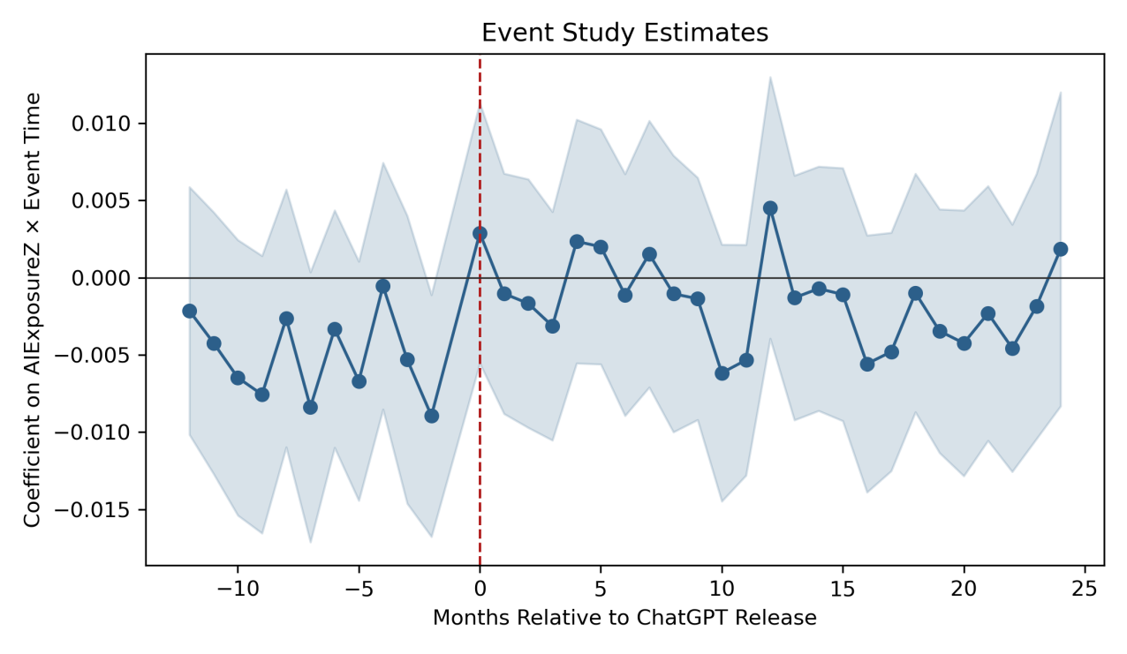
Figure 4. Event Study Estimates
Source: author’s visualization of the event-study estimates from the H1/H2 empirical output.
Figure 4 plots the event-time coefficients and 95% confidence intervals. The saved event-study regression uses 43,508 observations and includes fund and month fixed effects. The pre-treatment estimates are generally close to zero and statistically imprecise. Although one isolated pre-treatment coefficient, event month -2, is statistically significant at the 5% level, the overall pre-treatment pattern remains relatively stable rather than displaying a persistent upward or downward trend.
After the release of ChatGPT, the point estimates become more favorable in several months, but the dynamic estimates are not uniformly significant. This pattern suggests that the baseline DiD result should be interpreted as evidence of an average post-shock reallocation effect rather than as a sharply timed monthly response in every post-event period. The event-study evidence therefore provides cautious support for the identification strategy: it does not indicate a systematic pre-trend, but the presence of one significant pre-treatment coefficient means that the causal interpretation should be made with appropriate care.

4.4 Heterogeneity Analysis
Table 3 examines whether investor responses differ by prior fund performance. GoodFund is defined as an indicator equal to one when a fund's pre-shock Fama-French three-factor alpha is above the sample median of -0.002811. This median split produces 615 high-alpha funds and 616 low-alpha funds among the 1,231 funds with valid alpha estimates.
Flow_{i,t} = β₁(AIExposureZ_{i} × Post_{t}) + β₂(Post_{t} × GoodFund_{i}) + β₃(AIExposureZ_{i} × Post_{t} × GoodFund_{i}) + γX_{i,t-1} + μ_{i} + λ_{t} + ε_{i,t} （24）
Table 3. Heterogeneity by Prior Performance
Parameter | Coefficient | Std. Err. | T-stat | P-value | 95% CI
AI_post | 0.0023* | 0.0013 | 1.6914 | 0.0908 | [-0.0004, 0.0049]
post_good | 0.0053* | 0.0028 | 1.9338 | 0.0531 | [-0.0001, 0.0108]
AI_post_good | 0.0064** | 0.0028 | 2.2823 | 0.0225 | [0.0009, 0.0119]
log_mtna_lag | -0.0323*** | 0.0026 | -12.599 | 0.0000 | [-0.0373, -0.0273]
mret_lag | 0.1373*** | 0.0214 | 6.4096 | 0.0000 | [0.0953, 0.1793]
flow_lag | -0.0937*** | 0.0133 | -7.0668 | 0.0000 | [-0.1196, -0.0677]
Observations | 80,492
R-squared | 0.0367
Entities | 1,231
Time periods | 70
Notes: Values are transcribed from h2_alpha_median_result.txt. Standard errors are clustered at the fund level. The specification includes entity and time fixed effects. ***, **, and * denote p < 0.01, p < 0.05, and p < 0.10.
The triple-interaction coefficient AI_post_good is 0.0064 with a P-value of 0.0225, indicating statistical significance at the 5% level. This estimate shows that the post-ChatGPT inflow response to AI exposure is stronger among funds with better prior risk-adjusted performance. In economic terms, the AI-related inflow sensitivity for high-alpha funds is the sum of the baseline AI exposure effect and the additional high-performance interaction, suggesting that investors place greater weight on AI exposure when the fund manager has stronger prior credibility.
This evidence is consistent with the performance-chasing literature in mutual funds. Investors appear more willing to allocate capital to AI-exposed funds when prior alpha provides a signal of managerial ability. The result also suggests that investor attention to generative AI is filtered through beliefs about whether managers are capable of converting technological opportunities into portfolio performance. H2 is supported.

4.5 Portfolio Allocation and Strategic Adjustment
The H3 analysis shifts from investor flows to fund portfolio behavior. The quarterly specifications examine whether AI-exposed funds changed their holdings after ChatGPT along two margins: the number of newly initiated AI stock positions and the total AI portfolio share.
NewAIPositions_{i,q} = β(AIExposureZ_{i} × Post_{q}) + γX_{i,q-1} + μ_{i} + λ_{q} + ε_{i,q} （25）
AIShare_{i,q} = β(AIExposureZ_{i} × Post_{q}) + γX_{i,q-1} + μ_{i} + λ_{q} + ε_{i,q} （26）
Table 4. Portfolio Adjustment Results
Parameter | Coefficient | Std. Err. | T-stat | P-value | 95% CI
Panel A: Dependent variable = new_ai_positions
AI_post | -0.1146*** | 0.0174 | -6.6000 | 0.0000 | [-0.1486, -0.0806]
log_mtna_lag | 0.0020 | 0.0208 | 0.0975 | 0.9223 | [-0.0387, 0.0427]
mret_lag | 0.1674 | 0.2417 | 0.6924 | 0.4887 | [-0.3064, 0.6411]
flow_lag | 0.0096 | 0.1066 | 0.0899 | 0.9284 | [-0.1994, 0.2185]
Observations | 28,016
R-squared | 0.0015
Entities | 1,269
Time periods | 24
Panel B: Dependent variable = AIShare
AI_post | 3.8220*** | 0.2912 | 13.125 | 0.0000 | [3.2512, 4.3928]
log_mtna_lag | 0.9569*** | 0.2893 | 3.3074 | 0.0009 | [0.3898, 1.5240]
mret_lag | -1.6534 | 2.0153 | -0.8204 | 0.4120 | [-5.6034, 2.2966]
flow_lag | -0.0207 | 0.6120 | -0.0338 | 0.9730 | [-1.2203, 1.1789]
Observations | 28,016
R-squared | 0.0413
Entities | 1,269
Time periods | 24
Notes: Values are transcribed from the saved output in processed_data/H3.ipynb. Standard errors are clustered at the fund level. Both panels include entity and time fixed effects. ***, **, and * denote p < 0.01, p < 0.05, and p < 0.10.
The two portfolio measures reveal a distinction that is important for interpreting institutional behavior. The negative coefficient on new_ai_positions indicates that high-AI-exposure funds did not respond to ChatGPT by broadly initiating many new AI holdings. In finance terms, the result does not look like exploratory diversification across the AI theme. It is more consistent with selective reallocation by managers who already had AI-related positions and did not need to expand the number of names to increase thematic exposure.
Panel B points to the economically relevant adjustment margin. The positive AIShare coefficient indicates conviction-based reinforcement within existing AI allocations. A one-standard-deviation increase in pre-shock AI exposure is associated with a 3.82 percentage point higher AI portfolio share after ChatGPT, suggesting that managers increased concentration in AI-related holdings rather than spreading capital thinly across many new firms. This interpretation is consistent with institutional investors scaling familiar, high-conviction positions under technological uncertainty.
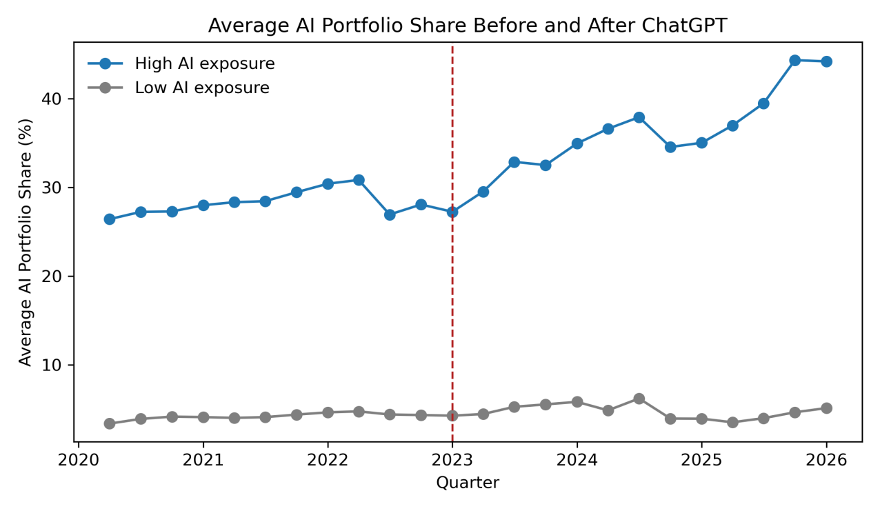
Figure 5. Average AI Portfolio Share Before and After ChatGPT
Source: author’s descriptive visualization from the H3 fund-quarter panel. The figure is descriptive and does not include fixed effects or controls.
Figure 5 provides descriptive evidence consistent with this intensive-margin interpretation. High-AI-exposure funds already hold substantially larger AI portfolio shares before ChatGPT, but the post-2022 widening of the gap suggests strategic reinforcement rather than broad experimentation. The figure does not replace the fixed-effects regression evidence; it provides a visual illustration of the same portfolio concentration mechanism documented in Table 4.
Taken together, the H3 evidence supports strategic adaptation on the intensive margin. Funds already exposed to AI increased the weight of AI-related positions after the shock, but they did not diversify broadly into many additional AI stocks. This mixed pattern is economically plausible: when technological uncertainty is high, informed managers may prefer to reinforce positions where they have research familiarity, liquidity access, and stronger conviction.

4.6 Robustness Tests
Table 5 reports the robustness checks available in the saved notebook outputs. These specifications examine whether the main conclusion is sensitive to alternative definitions of AI exposure. All specifications include fund fixed effects, time fixed effects, lagged controls, and clustered standard errors.
Table 5. Robustness Tests
Parameter | Coefficient | Std. Err. | T-stat | P-value | 95% CI
Panel A: Continuous exposure; Dependent variable = flow_w
const | 0.1153*** | 0.0095 | 12.173 | 0.0000 | [0.0967, 0.1339]
AI_post | 0.0057*** | 0.0009 | 6.4092 | 0.0000 | [0.0040, 0.0075]
log_mtna_lag | -0.0319*** | 0.0025 | -12.603 | 0.0000 | [-0.0368, -0.0269]
mret_lag | 0.1369*** | 0.0213 | 6.4177 | 0.0000 | [0.0951, 0.1787]
flow_lag | -0.0923*** | 0.0132 | -6.9921 | 0.0000 | [-0.1182, -0.0665]
Observations | 81,262
R-squared | 0.0371
Panel B: Median-split treatment; Dependent variable = flow_w
const | 0.1127*** | 0.0094 | 12.009 | 0.0000 | [0.0943, 0.1311]
AI_dummy_post | 0.0076*** | 0.0021 | 3.6305 | 0.0003 | [0.0035, 0.0118]
log_mtna_lag | -0.0317*** | 0.0025 | -12.582 | 0.0000 | [-0.0366, -0.0268]
mret_lag | 0.1363*** | 0.0213 | 6.3885 | 0.0000 | [0.0945, 0.1781]
flow_lag | -0.0922*** | 0.0132 | -6.9832 | 0.0000 | [-0.1181, -0.0664]
Observations | 81,262
R-squared | 0.0367
Panel C: Top-quartile treatment; Dependent variable = flow_w
const | 0.1133*** | 0.0094 | 12.011 | 0.0000 | [0.0948, 0.1318]
AI_dummy_75_post | 0.0085*** | 0.0023 | 3.7154 | 0.0002 | [0.0040, 0.0130]
log_mtna_lag | -0.0316*** | 0.0025 | -12.506 | 0.0000 | [-0.0366, -0.0267]
mret_lag | 0.1355*** | 0.0213 | 6.3478 | 0.0000 | [0.0936, 0.1773]
flow_lag | -0.0923*** | 0.0132 | -6.9887 | 0.0000 | [-0.1182, -0.0664]
Observations | 81,262
R-squared | 0.0367
Notes: Values are transcribed from h1_controls_result.txt, h1_binary_median_result.txt, and h1_top_quartile_result.txt. Standard errors are clustered at the fund level. All specifications include entity and time fixed effects. ***, **, and * denote p < 0.01, p < 0.05, and p < 0.10.
The results remain qualitatively unchanged across the available alternative treatment definitions. The continuous specification produces an AI_post coefficient of 0.0057 with a P-value below 0.0001. The median-split treatment produces a coefficient of 0.0076 with a P-value of 0.0003, while the top-quartile treatment produces a coefficient of 0.0085 with a P-value of 0.0002. These results indicate that the baseline conclusion is not driven by a single treatment construction.
Placebo timing tests and placebo coefficient distributions are not reported because no placebo test is included in the original empirical notebooks. Within the set of robustness checks that are directly available from the saved outputs, the evidence supports the conclusion that funds with greater pre-shock AI exposure experienced stronger post-ChatGPT inflows.

5. Discussion

5.1 AI Shock and Investor Attention
The empirical results indicate that the release of ChatGPT was associated with economically meaningful reallocations of mutual fund capital toward funds with greater pre-shock AI exposure. This pattern is consistent with investor attention theories, which argue that highly salient public events can alter the set of assets and investment vehicles considered by investors (Barber and Odean, 2008). ChatGPT was not merely a technical product release. It was a highly visible technological shock that transformed artificial intelligence from a specialized sector narrative into a broad market theme. In this setting, funds with stronger AI exposure became natural vehicles through which investors could express demand for participation in the perceived AI opportunity. Evidence that generative AI exposure was capitalized into firm values helps explain why investors may have treated AI exposure as an economically relevant fund attribute (Eisfeldt et al., 2023).
The baseline finding supports the interpretation that investor attention operates through thematic capital allocation. Once generative AI became a prominent public narrative, investors appear to have reallocated capital toward mutual funds already positioned in AI-related firms. This mechanism is consistent with search-based evidence that investor attention affects market behaviour around salient information (Da et al., 2011). The effect is economically meaningful because monthly mutual fund flows are usually small and persistent, while the estimated post-shock flow response is large relative to the unconditional distribution of fund flows. This suggests that the ChatGPT shock affected not only individual stock valuations but also the allocation of capital across delegated investment vehicles.
This evidence also highlights the role of public narratives in shaping institutional flows. Although mutual fund investors do not directly choose every underlying portfolio holding, they respond to fund characteristics that map onto salient investment themes. AI exposure became a visible attribute through which investors could identify funds likely to benefit from technological optimism. The results are therefore consistent with attention-induced demand for AI exposure and with the broader literature showing that investor recognition can affect asset demand (Merton, 1987).

5.2 Performance Credibility and Investor Trust
The heterogeneity analysis provides further insight into how investors process AI-related information. The positive triple interaction between AI exposure, the post-ChatGPT period, and the high-alpha fund indicator suggests that investors did not respond mechanically to AI exposure alone. Instead, the flow response was stronger when AI exposure was combined with prior evidence of managerial ability. This pattern is consistent with performance-chasing behavior in the mutual fund literature (Sirri and Tufano, 1998). It also adds an important qualification: investors appear to chase thematic exposure more aggressively when the manager has already established credibility.
Prior alpha can be interpreted as a signal of investment ability, particularly in an environment characterized by technological uncertainty. Generative AI created substantial optimism, but it also increased uncertainty about which firms, business models, and managers would be able to convert AI adoption into durable returns. Under these conditions, investors may use past risk-adjusted performance as a proxy for managerial skill. This interpretation is consistent with rational flow-performance models in which capital is allocated toward managers perceived to have higher ability (Berk and Green, 2004). Funds with high AI exposure and stronger historical alpha are therefore more likely to be perceived as credible vehicles for gaining AI exposure.
This interpretation suggests that investors are not blindly chasing AI narratives. Rather, they appear to combine technological optimism with an assessment of managerial credibility. AI narratives alone may attract attention, but the stronger inflows to high-alpha AI-exposed funds indicate that investors differentiate between managers when allocating capital under uncertainty. Fund-family reputation and star-manager effects provide one channel through which credibility can influence investor allocation decisions (Nanda et al., 2004). The result is consistent with the view that investor confidence depends not only on exposure to a popular theme, but also on the perceived ability of fund managers to implement that theme effectively.

5.3 Strategic Adaptation on the Intensive Margin
The portfolio allocation results offer a more nuanced picture of how mutual funds responded to the ChatGPT shock. The H3 evidence is mixed in a meaningful way: AIShare increases significantly after the shock for funds with higher pre-shock AI exposure, while new_ai_positions declines. This pattern does not support the interpretation that funds broadly expanded into many new AI-related stocks. Instead, it suggests strategic adaptation on the intensive margin, with funds concentrating additional capital within AI-related positions rather than diversifying across a wider set of unfamiliar AI firms. Such concentration is consistent with evidence that active managers may specialize in industries where they possess stronger information or conviction (Kacperczyk et al., 2005).
This distinction between the intensive and extensive margins is central to interpreting the results. An extensive-margin response would imply that funds responded to the AI shock by initiating many new AI positions, potentially reflecting broad exploratory diversification. The negative coefficient on new_ai_positions points in the opposite direction. By contrast, the positive and highly significant AIShare result indicates that funds increased the overall portfolio weight allocated to AI-related firms. The evidence therefore points to portfolio reinforcement rather than broad experimentation. This interpretation is also consistent with active-share evidence that differentiated managers express investment views through concentrated portfolio choices (Cremers and Petajisto, 2009).
Such behavior is plausible for institutional investors facing technological uncertainty. Fund managers may prefer to scale positions in firms they already understand, particularly when those firms are large, liquid, and central to the AI supply chain. Existing AI holdings may reflect prior research capacity, informational familiarity, and stronger conviction about firm fundamentals. In this setting, increasing the weight of existing AI-related positions can be viewed as a conviction-driven allocation response rather than a passive reaction to market narratives. Holdings-based evidence on mutual fund performance highlights the importance of examining portfolio choices directly rather than relying only on fund returns (Wermers, 2000).
The result also suggests that AI-exposed funds used the ChatGPT shock as an opportunity for selective technological exposure. Rather than treating the shock as a reason to purchase a broad basket of AI names, managers appear to have reinforced positions where they already had informational familiarity or strategic conviction. This is consistent with institutional portfolio concentration, where managers respond to new information by increasing exposure to high-conviction themes while avoiding excessive dispersion across less familiar firms. The H3 results therefore support a realistic interpretation of institutional adaptation: funds adjusted meaningfully, but in a targeted and concentrated manner.
Figure 6 illustrates the distinction between intensive-margin reinforcement and extensive-margin expansion in the interpretation of the H3 portfolio results.
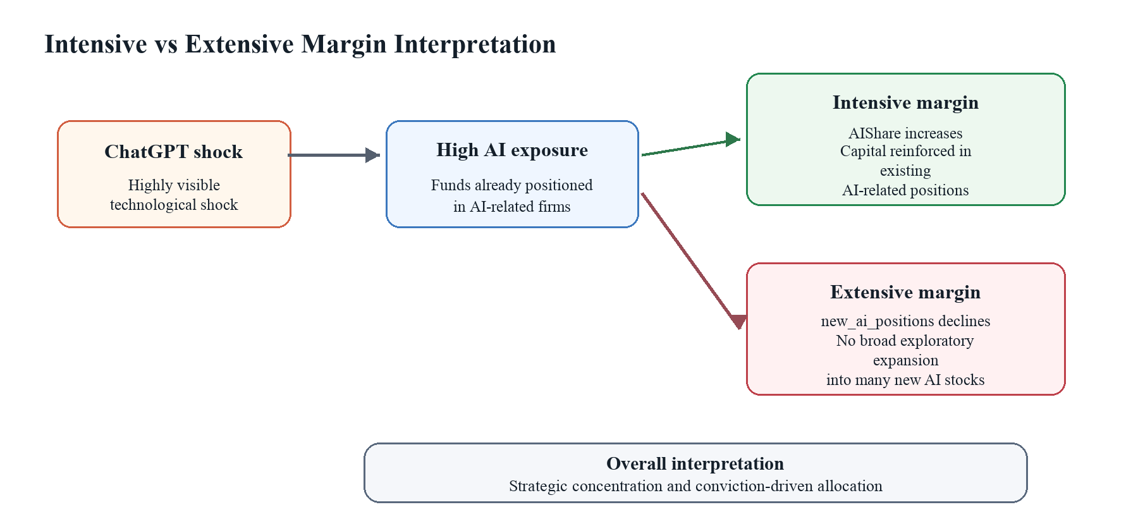
Figure 6. Intensive vs Extensive Margin Interpretation

5.4 Theoretical and Practical Implications

5.4.1 Theoretical Implications
This study contributes to several strands of finance literature. First, it extends investor attention research by showing that attention shocks can operate through delegated investment vehicles, not only through direct trading in individual stocks. The ChatGPT release increased the salience of AI as an investment theme, and the evidence suggests that this attention was transmitted into mutual fund flows. This broadens the scope of investor attention theories by linking public technological narratives to capital allocation across funds.
Second, the findings contribute to the mutual fund flow literature by showing that flows respond not only to past performance, fees, and fund characteristics, but also to thematic exposure. Traditional flow-performance evidence emphasizes the role of past returns in attracting investor capital (Sirri and Tufano, 1998). The heterogeneity results further show that thematic demand is stronger when combined with managerial credibility. This suggests that investors evaluate mutual funds through a joint lens: they respond to salient investment themes, but condition that response on signals of managerial ability.
Third, the study contributes to research on technological shocks and institutional adaptation. Much of the emerging AI finance literature focuses on firm-level stock returns or market valuations. Recent evidence links AI capabilities to firm growth and product innovation (Babina et al., 2024). This thesis shifts attention toward the institutional capital allocation mechanism through which technological optimism is transmitted into fund flows and portfolio choices. The portfolio results also show that institutional adaptation may occur through concentration and reinforcement rather than through broad diversification into new technology-related securities.

5.4.2 Practical Implications
For mutual fund managers, the results imply that thematic exposure can attract investor capital when a technology becomes highly salient. However, the stronger response among high-alpha funds suggests that exposure alone is unlikely to be sufficient. Investors appear to reward AI exposure more strongly when it is paired with a credible record of investment ability. This is consistent with the idea that fund flows respond to perceived managerial skill as well as to fund characteristics (Berk and Green, 2004). Managers seeking to position portfolios around emerging technologies therefore face a dual challenge: communicating thematic exposure while maintaining evidence of disciplined performance.
For institutional investors, the findings highlight the importance of distinguishing between thematic demand and fundamental investment capacity. AI-related funds may attract flows during periods of technological optimism, but such flows can also increase concentration risk if managers reinforce existing positions. The H3 evidence suggests that portfolio adaptation occurred primarily through increased AIShare rather than through many new positions. This pattern may be efficient when managers have strong conviction, but it can also expose investors to greater sector and firm-specific risk. The portfolio-concentration literature suggests that such concentration can reflect information advantages, but it also increases exposure to specific industries and firms (Kacperczyk et al., 2005).
For regulators and market observers, the results suggest that technology-driven capital cycles can influence delegated investment markets. Public narratives around emerging technologies may redirect capital toward certain funds and sectors, potentially amplifying valuation pressures and concentration in popular themes. Flow-driven demand has been shown to affect prices and return predictability in equity markets (Lou, 2012). The findings do not imply that such reallocations are irrational, but they do indicate that investor sentiment and technological optimism can shape institutional capital flows in economically meaningful ways.

5.5 Limitations and Future Research
Several limitations should be acknowledged. First, the AI exposure measure is based on a ticker-based classification of AI-related firms. Although this approach is transparent and suitable for empirical implementation, it may not fully capture the intensity of each firm's AI involvement or the evolving nature of AI-related business models. Some firms may become more or less AI-relevant over time, and ticker-based classifications may miss smaller or less visible firms with meaningful AI exposure.
Second, the ChatGPT shock occurred during a period that also included broader technology-sector movements, changing monetary conditions, and macroeconomic uncertainty. Fund and time fixed effects reduce concerns about time-invariant fund heterogeneity and common shocks, but they cannot eliminate all possible omitted factors. The event-study evidence is generally supportive, but the presence of one significant pre-treatment coefficient means that the parallel-trend assumption should be interpreted cautiously rather than treated as perfectly satisfied. This caveat is important because Difference-in-Differences estimates can be sensitive to serial correlation and pre-existing differential trends (Bertrand et al., 2004).
Third, holdings data impose practical constraints. Portfolio weights can be affected by reporting conventions, derivatives, leverage, and timing differences between reported holdings and actual trading behavior. The H3 results should therefore be interpreted as evidence of reported portfolio allocation changes rather than as a complete reconstruction of all trading decisions. In addition, the post-ChatGPT period remains relatively short, limiting the ability to evaluate whether AI-related flows and portfolio adjustments persist over longer horizons.
Future research could extend the analysis in several directions. One natural extension is to examine exchange-traded funds, where thematic investing is often more explicit and retail attention may be stronger. Another direction is to study international markets to assess whether AI-related capital reallocation differs across institutional settings. Future work could also incorporate direct measures of AI sentiment, search intensity, or media coverage to more precisely identify the attention channel. Finally, as more post-ChatGPT data become available, researchers can examine whether the observed capital reallocation reflects a temporary attention cycle or a more persistent shift in institutional portfolio allocation.

6. Conclusion

6.1 Summary of Findings
This thesis examines whether the release of ChatGPT affected mutual fund capital flows and portfolio allocation through an investor attention channel. Using pre-shock AI exposure as treatment intensity, the analysis shows that funds with greater AI exposure experienced stronger post-ChatGPT inflows. This finding is consistent with technology-driven capital allocation, in which a highly visible innovation shock increases investor demand for funds positioned around the emerging theme.
The evidence also shows that investor responses were stronger for funds with better prior risk-adjusted performance. The positive interaction between AI exposure, the post-shock period, and the high-alpha fund indicator suggests that investors combine technological optimism with managerial credibility. Rather than allocating capital indiscriminately to all AI-exposed funds, investors appear to place greater trust in managers with stronger historical performance.
The portfolio results show that fund managers also adapted strategically. Higher AI exposure is associated with a significant increase in AIShare after ChatGPT, but the number of newly initiated AI positions declines. This pattern indicates that portfolio adjustment occurred primarily on the intensive margin. Funds did not broadly diversify into many new AI stocks; instead, they concentrated capital within AI-related positions, consistent with conviction-based institutional response under technological uncertainty.

6.2 Main Contributions
The study makes three main contributions. First, it contributes to the growing literature on AI and finance by shifting attention from stock-level reactions to institutional capital allocation mechanisms. The findings show that generative AI shocks can influence not only the valuation of AI-related firms but also the flow of capital across mutual funds and the composition of fund portfolios.
Second, the thesis contributes to the mutual fund flow literature by documenting that thematic exposure can shape investor flows when a technology becomes highly salient. The results suggest that mutual fund investors respond to AI exposure as an investment characteristic, particularly when it is paired with credible prior performance. This extends traditional flow-performance analysis by incorporating technological narratives and investor attention as drivers of delegated capital allocation.
Third, the study contributes to research on institutional behavior under technological uncertainty. The portfolio evidence shows that mutual funds respond to AI optimism through strategic adaptation rather than broad exploratory diversification. The distinction between increasing AIShare and reducing new_ai_positions highlights the importance of separating intensive-margin portfolio reinforcement from extensive-margin expansion. This distinction provides a more precise understanding of how institutional investors translate technological narratives into portfolio choices.

6.3 Final Remarks
This study provides suggestive evidence that generative AI narratives can shape financial markets through institutional capital allocation. The ChatGPT shock is associated with stronger flows to AI-exposed mutual funds, a larger response among funds with stronger prior performance, and portfolio adjustment through increased AI concentration. These patterns suggest that institutional investors help transmit technological optimism into real investment behavior, while still filtering that optimism through managerial credibility and portfolio constraints.
The broader implication is deliberately cautious. Emerging technologies may influence capital markets not only through realized productivity gains, but also through the narratives and attention they generate. The evidence in this thesis does not claim that AI exposure mechanically creates superior performance, nor that all AI-related capital flows are irrational. Rather, it shows that after a highly visible technological shock, investors and fund managers appear to adjust in ways that are consistent with attention, trust, and selective portfolio concentration. Understanding these channels will remain important as financial markets continue to respond to technological change.

References
Acemoglu, D. and Restrepo, P. (2018) 'Artificial intelligence, automation, and work', NBER Working Paper, No. 24196. doi: 10.3386/w24196.
Babina, T., Fedyk, A., He, A.X. and Hodson, J. (2024) 'Artificial intelligence, firm growth, and product innovation', Journal of Financial Economics, 151, 103745. doi: 10.1016/j.jfineco.2023.103745.
Barber, B.M. and Odean, T. (2008) 'All that glitters: the effect of attention and news on the buying behavior of individual and institutional investors', Review of Financial Studies, 21(2), pp. 785-818. doi: 10.1093/rfs/hhm079.
Ben-Rephael, A., Da, Z. and Israelsen, R.D. (2017) 'It depends on where you search: institutional investor attention and underreaction to news', Review of Financial Studies, 30(9), pp. 3009-3047. doi: 10.1093/rfs/hhx031.
Berk, J.B. and Green, R.C. (2004) 'Mutual fund flows and performance in rational markets', Journal of Political Economy, 112(6), pp. 1269-1295. doi: 10.1086/424739.
Bertrand, M., Duflo, E. and Mullainathan, S. (2004) 'How much should we trust differences-in-differences estimates?', Quarterly Journal of Economics, 119(1), pp. 249-275. doi: 10.1162/003355304772839588.
Brynjolfsson, E., Rock, D. and Syverson, C. (2019) 'Artificial intelligence and the modern productivity paradox: a clash of expectations and statistics', in Agrawal, A., Gans, J. and Goldfarb, A. (eds.) The economics of artificial intelligence: an agenda. Chicago: University of Chicago Press, pp. 23-57.
Chevalier, J. and Ellison, G. (1997) 'Risk taking by mutual funds as a response to incentives', Journal of Political Economy, 105(6), pp. 1167-1200. doi: 10.1086/516389.
Coval, J. and Stafford, E. (2007) 'Asset fire sales (and purchases) in equity markets', Journal of Financial Economics, 86(2), pp. 479-512. doi: 10.1016/j.jfineco.2006.09.007.
Cremers, K.J.M. and Petajisto, A. (2009) 'How active is your fund manager? A new measure that predicts performance', Review of Financial Studies, 22(9), pp. 3329-3365. doi: 10.1093/rfs/hhp057.
Da, Z., Engelberg, J. and Gao, P. (2011) 'In search of attention', Journal of Finance, 66(5), pp. 1461-1499. doi: 10.1111/j.1540-6261.2011.01679.x.
Eisfeldt, A.L., Schubert, G. and Zhang, M.B. (2023) 'Generative AI and firm values', NBER Working Paper, No. 31222. doi: 10.3386/w31222.
Fama, E.F. and French, K.R. (1993) 'Common risk factors in the returns on stocks and bonds', Journal of Financial Economics, 33(1), pp. 3-56. doi: 10.1016/0304-405X(93)90023-5.
Frazzini, A. and Lamont, O.A. (2008) 'Dumb money: mutual fund flows and the cross-section of stock returns', Journal of Financial Economics, 88(2), pp. 299-322. doi: 10.1016/j.jfineco.2007.07.001.
Gruber, M.J. (1996) 'Another puzzle: the growth in actively managed mutual funds', Journal of Finance, 51(3), pp. 783-810. doi: 10.1111/j.1540-6261.1996.tb02707.x.
Hirshleifer, D. and Teoh, S.H. (2003) 'Limited attention, information disclosure, and financial reporting', Journal of Accounting and Economics, 36(1-3), pp. 337-386. doi: 10.1016/j.jacceco.2003.10.002.
Huberman, G. and Regev, T. (2001) 'Contagious speculation and a cure for cancer: a nonevent that made stock prices soar', Journal of Finance, 56(1), pp. 387-396. doi: 10.1111/0022-1082.00330.
Kacperczyk, M., Sialm, C. and Zheng, L. (2005) 'On the industry concentration of actively managed equity mutual funds', Journal of Finance, 60(4), pp. 1983-2011. doi: 10.1111/j.1540-6261.2005.00785.x.
Lou, D. (2012) 'A flow-based explanation for return predictability', Review of Financial Studies, 25(12), pp. 3457-3489. doi: 10.1093/rfs/hhs103.
MacKinlay, A.C. (1997) 'Event studies in economics and finance', Journal of Economic Literature, 35(1), pp. 13-39.
Merton, R.C. (1987) 'A simple model of capital market equilibrium with incomplete information', Journal of Finance, 42(3), pp. 483-510. doi: 10.1111/j.1540-6261.1987.tb04565.x.
Nanda, V., Wang, Z.J. and Zheng, L. (2004) 'Family values and the star phenomenon: strategies of mutual fund families', Review of Financial Studies, 17(3), pp. 667-698. doi: 10.1093/rfs/hhg054.
Peng, L. and Xiong, W. (2006) 'Investor attention, overconfidence and category learning', Journal of Financial Economics, 80(3), pp. 563-602. doi: 10.1016/j.jfineco.2005.05.003.
Sirri, E.R. and Tufano, P. (1998) 'Costly search and mutual fund flows', Journal of Finance, 53(5), pp. 1589-1622. doi: 10.1111/0022-1082.00066.
Wermers, R. (2000) 'Mutual fund performance: an empirical decomposition into stock-picking talent, style, transactions costs, and expenses', Journal of Finance, 55(4), pp. 1655-1695. doi: 10.1111/0022-1082.00263.

