IOM301 Computer-Based Trading in Financial Markets

AI Data Center Power Bottleneck Trade
An Investment Strategy Based on Revenue Growth, Momentum, and Power Infrastructure Exposure
Student ID | 2252173
Name | Nan.Lin
Coursework component | Investment Analysis Report
Date | 20 May 2026

Executive view: The AI investment opportunity is shifting from first-order chip exposure to the physical infrastructure required to power, cool and connect high-density data centers. The proposed strategy favours firms with evidence of revenue growth and market momentum while avoiding companies where the AI narrative is unsupported by fundamentals or where heavy capital expenditure creates execution risk.

Executive Summary
This report evaluates the investment opportunity created by the power bottleneck in AI data centers. The central thesis is that the first stage of the AI boom rewarded semiconductor leaders, but the next stage may increasingly reward firms that solve the physical constraints of AI infrastructure: data center hardware, power equipment, grid services, cooling systems and reliable electricity supply. This is not a generic “buy AI stocks” argument. It is a more selective strategy that asks whether companies can convert AI demand into measurable revenue growth, profitable infrastructure exposure and sustained market recognition.
The empirical analysis uses a CRSP-Compustat panel created in Python Assignment 1. The sample covers 17 listed firms from January 2015 to December 2024, with 1,853 firm-month observations and 1,572 matched CRSP-Compustat observations. The company universe includes semiconductors, data center hardware, power/cooling/grid suppliers, data center REITs and power providers. Python Assignment 2 shows that one-month returns are noisy, but medium-term evidence is more supportive: data center hardware and semiconductors show the highest average future monthly returns; the 12-month regression finds revenue growth and past momentum positively associated with forward returns; and a portfolio sorted on an AI growth-momentum score produces a high-minus-low spread of about 19.5% over the following 12 months.
The recommended strategy is therefore a medium-term thematic allocation rather than a short-term trading signal. The report proposes going long firms with strong AI infrastructure exposure, positive revenue growth and past 12-month momentum, while underweighting firms with weak demand evidence, excessive leverage or capex expansion without profitability. The main risks are valuation crowding, data center overcapacity, grid interconnection delays, interest-rate sensitivity and limits to arbitrage.

1. Industry Overview and Investment Thesis
Artificial intelligence has become an electricity-intensive industrial activity. Training and inference workloads require dense clusters of accelerators, memory, networking equipment, storage, power conversion equipment and cooling systems. The International Energy Agency argues that electricity demand is entering a structurally stronger growth phase through 2030, supported by data centers, AI, advanced manufacturing and broader electrification (IEA, 2026). JLL (2026) similarly describes a global data center supercycle in which AI and cloud demand are expected to drive capacity growth, construction cost inflation and a shift toward on-site power solutions.
This creates a second-order investment theme. Semiconductor leaders such as Nvidia and Broadcom are obvious beneficiaries of AI demand, but the market may underappreciate the infrastructure suppliers that enable the deployment of those chips. Deloitte (2026a) notes that inference workloads are growing, but most computation is still likely to occur on expensive, power-hungry chips in large data centers. Deloitte (2026b) also highlights that next-generation AI racks can require much higher power density and cooling capability than traditional data center racks. These points support the idea that AI growth is constrained not only by model quality or chip supply, but also by electricity, thermal management and deployment speed.
The investment universe is therefore divided into five segments: semiconductors; data center hardware; power, cooling and grid infrastructure; data center REITs; and power providers. The key hypothesis is that firms closer to high-density AI infrastructure should earn superior medium-term returns when they show both fundamental demand confirmation and market momentum. However, the report does not assume that every AI-linked firm is attractive. The stronger claim is that the market may gradually reprice companies that turn AI infrastructure demand into revenue growth and visible order momentum.

2. Data and Empirical Evidence
The dataset is built from WRDS using CRSP monthly stock returns and Compustat annual fundamentals. CRSP provides stock returns, prices, shares outstanding and volume. Compustat provides sales, assets, capital expenditure, R&D, operating profitability, debt and equity. A CRSP-Compustat link table is used to match the stock market identifier permno with the accounting identifier gvkey. To reduce look-ahead bias, accounting variables are treated as available only after a six-month reporting lag.
Segment | Firms | Obs. | Avg. future monthly return | Monthly volatility
Data Center Hardware | 2 | 212 | 4.10% | 16.55%
Semiconductors | 6 | 637 | 3.10% | 12.13%
Power/Cooling/Grid | 5 | 395 | 2.14% | 10.45%
Power Providers | 2 | 122 | 1.88% | 7.75%
Data Center REITs | 2 | 206 | 1.11% | 6.55%

Table 1. Segment-level CRSP-Compustat sample summary, 2015-2024.
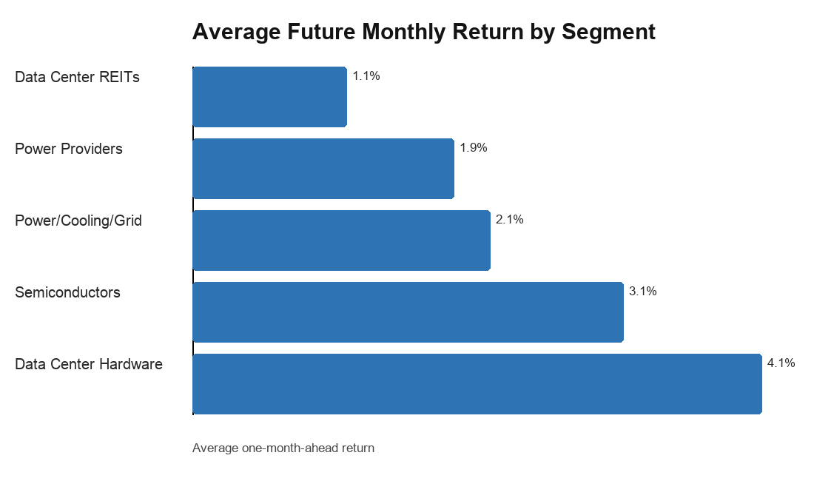
Figure 1. Average one-month-ahead return by AI infrastructure segment.
The segment evidence is intuitive. Data center hardware firms show the highest average one-month-ahead return, about 4.1%, followed by semiconductors at about 3.1%. Power, cooling and grid infrastructure firms also show positive returns, though lower than hardware and semiconductors. Data center REITs and power providers appear less explosive, which is consistent with their more regulated, capital-intensive or real-asset profiles. This ranking supports the thesis that the market rewards firms closest to the direct AI infrastructure buildout, but it also suggests that the theme contains different risk-return profiles rather than a single homogeneous AI trade.
The baseline one-month predictive regression is intentionally conservative and produces weak results. This is not surprising: monthly stock returns are noisy and reflect market-wide shocks, liquidity conditions and short-term sentiment. The more relevant tests use 12-month forward returns. In that specification, revenue growth is positively related to future returns, while past 12-month return is also positive. Capital expenditure intensity and profit margin enter negatively in the full regression, which is important: spending more on capital projects is not automatically rewarded if it raises execution risk or if the market has already priced in profitable incumbency. The evidence therefore supports a selective strategy rather than a simple rule of buying the highest capex firms.
Predictor | Coefficient | Robust t-stat | p-value
revenue growth | 0.344 | 3.21 | 0.001
capex intensity | -1.151 | -3.27 | 0.001
profit margin | -0.769 | -4.87 | 0.000
debt ratio | 0.045 | 0.35 | 0.724
past 12m return | 0.096 | 2.07 | 0.038

Table 2. Exploratory 12-month forward return regression. R-squared = 0.083; N = 1047.

3. Proposed Trading Strategy
The proposed strategy is a monthly rebalanced medium-term allocation strategy. The investable universe contains AI data center and power bottleneck beneficiaries. At each month, firms are ranked on two dimensions: revenue growth rank and past 12-month return rank. The average of the two ranks is the AI growth-momentum score. Revenue growth captures fundamental confirmation of demand, while past return momentum captures market recognition and the possibility of gradual repricing. The strategy favours the top tercile of the score and avoids or underweights the bottom tercile.
- Long candidates: firms with direct AI infrastructure exposure, above-median revenue growth, positive past 12-month momentum and manageable leverage.
- Avoid candidates: firms with weak growth, deteriorating momentum, high debt pressure or capital expenditure expansion without clear demand conversion.
- Holding horizon: 6 to 12 months, because the empirical results are stronger at medium horizons than at one-month horizons.
The portfolio sort is the most practical evidence for this strategy. Sorting firms monthly by the AI growth-momentum score produces average 12-month forward returns of about 27.7% for the low portfolio, 42.4% for the middle portfolio and 47.2% for the high portfolio. The high-minus-low spread is about 19.5%, with a t-statistic of 3.35 and a p-value below 0.01. This does not guarantee future profitability, but it is stronger and more interpretable than relying only on a one-month OLS regression.
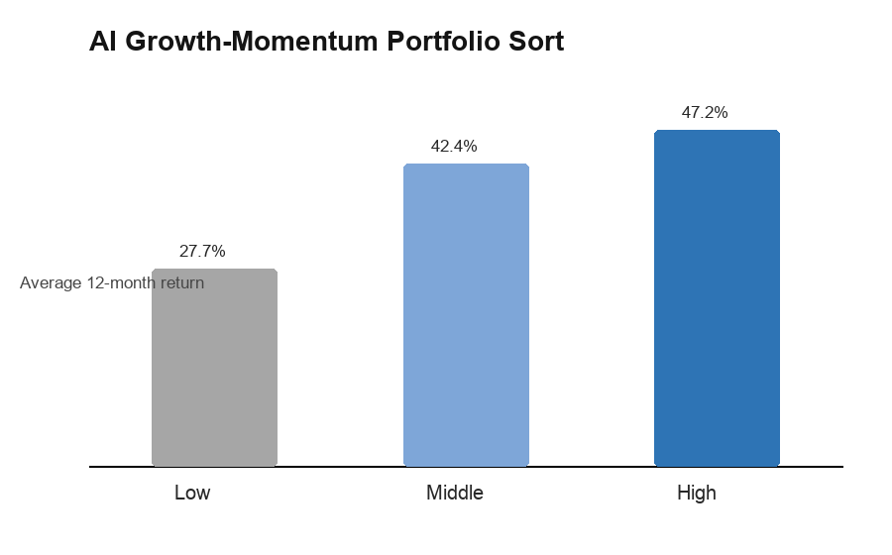
Figure 2. Portfolio sort based on AI growth-momentum score.

4. Theoretical Background and Market-Beating Potential
The strategy is grounded in three strands of finance theory. First, under the efficient market hypothesis, public information should be rapidly incorporated into prices (Fama, 1970). A naive version of the AI trade would therefore be unlikely to beat the market. However, the power bottleneck thesis is not only about public AI excitement; it is about second-order supply constraints that may be recognized with delay as orders, construction schedules and power availability become observable.
Second, momentum theory supports the use of past 12-month returns. Jegadeesh and Titman (1993) show that winners can continue to outperform over intermediate horizons. In this report, momentum is not used alone. It is combined with revenue growth so that the strategy avoids buying price strength without business confirmation. The post-AI interaction analysis strengthens this interpretation: after 2023, past 12-month momentum becomes more informative for 12-month forward returns, suggesting that the AI infrastructure theme became more visible after the generative AI shock.
Third, limits to arbitrage explain why mispricing may persist. Even if investors believe power infrastructure firms are underappreciated, exploiting the opportunity is difficult because the theme is noisy, capital intensive and exposed to policy, interest rates and construction bottlenecks. Shleifer and Vishny (1997) argue that arbitrageurs face capital and timing constraints. In this case, a correct long-term thesis may still suffer short-term drawdowns if investors question AI capex sustainability or if grid interconnection delays postpone revenue recognition.

5. Risks, Robustness and Limits to Arbitrage
The biggest risk is valuation crowding. By 2026, AI infrastructure has become a consensus theme. If the market has already capitalized future orders into prices, later investors may earn lower returns even if the industry grows. The negative coefficient on capex intensity in the 12-month regression is a useful warning: high investment intensity can signal opportunity, but it can also signal heavy financing needs, uncertain project returns or overexpansion.
A second risk is infrastructure timing. JLL (2026) notes that power availability and construction costs are central constraints in data center development. If grid connections, turbines, transformers or cooling equipment face long lead times, revenue may arrive later than investors expect. Goldman Sachs (2025) forecasts large increases in data center power demand, but demand growth does not automatically translate into immediate equity returns for every supplier.
A third risk is macro sensitivity. Data center REITs, utilities and infrastructure service firms are affected by interest rates and financing costs. A higher discount rate can reduce the present value of long-duration infrastructure cash flows. Semiconductor firms face a different risk: AI demand may remain strong, but memory, GPU or networking supply cycles can reverse if hyperscaler spending slows or if efficiency gains reduce capacity needs.
The robustness tests help but do not eliminate these risks. The one-month regression is weak; stronger results appear at the 12-month horizon, in post-AI interaction tests and in portfolio sorts. This pattern supports the strategy as a medium-term thematic allocation, not as a high-frequency trading rule. The correct interpretation is therefore conditional: the strategy has potential to outperform if AI infrastructure demand remains strong and if investors continue to reprice firms with confirmed growth and momentum.
Limits to arbitrage are especially relevant in this setting. If an investor believes that power infrastructure suppliers are underpriced, the timing of the trade remains difficult. Grid projects, power procurement, data center construction and equipment delivery can take years. During that time, the stock can underperform because of rate shocks, policy delays, customer order deferrals or a broad technology sell-off. Shorting overvalued AI names is also risky because thematic momentum can continue longer than valuation-based investors expect. These frictions mean that a rational strategy should be diversified, medium-term and risk controlled rather than a concentrated bet on one stock or one accounting ratio.
The negative relation between capex intensity and 12-month forward returns is also a warning. It suggests that the market may not reward capital expenditure mechanically. In an AI infrastructure boom, high capex can indicate growth investment, but it can also indicate pressure to build capacity ahead of uncertain demand, higher depreciation expense, weaker free cash flow or financing strain. For this reason, the strategy should treat capex as a contextual variable. Capital expenditure is attractive only when it is accompanied by revenue growth, customer demand evidence and manageable leverage.
A critical weakness of the strategy is that it is partly exposed to a crowded narrative. By 2026, AI infrastructure is no longer an obscure theme. Many investors already understand that data center power, cooling and grid equipment are bottlenecks. The market-beating potential therefore depends on whether second-order beneficiaries continue to surprise expectations, not merely on whether the industry grows. This distinction matters: an excellent industry can still produce poor stock returns if valuations are already too optimistic.

7. Critical Evaluation and Limits to Arbitrage
The portfolio sort results support this implementation. The high AI growth-momentum portfolio has a substantially higher 12-month forward return than the low portfolio. However, the signal is not purely fundamental. Revenue growth by itself is not always sufficient, because markets may already discount growth or may penalize growth achieved through costly expansion. Momentum by itself is also incomplete, because price strength can become overvaluation. The combined score is more attractive because it requires both business confirmation and market recognition.
Risk controls are important because the AI infrastructure trade is highly cyclical. First, the strategy should require positive revenue growth and positive 12-month momentum before entering a position. Second, firms with extreme debt ratios or negative operating profitability should be excluded unless there is a clear transition story. Third, segment diversification should be maintained across semiconductors, data center hardware and power/cooling/grid suppliers. This prevents the strategy from becoming only a semiconductor momentum portfolio. Fourth, the portfolio should be reviewed every six to twelve months rather than traded aggressively every month, because the empirical evidence is strongest over the 12-month horizon.
The strategy should be implemented as a constrained thematic equity portfolio rather than as an unconstrained bet on a single AI winner. At the beginning of each month, the investor ranks firms in the AI infrastructure universe using only information available at that date. The primary signal is the AI growth-momentum score, which combines revenue growth rank and past 12-month return rank. The portfolio then allocates to the high-score group, with position sizes capped to prevent a single stock such as Nvidia, Super Micro Computer or Broadcom from dominating the strategy. A simple implementation is equal weighting across the top tercile. A more conservative version can use volatility-adjusted weights, reducing exposure to firms with unusually high monthly return volatility.

6. Strategy Implementation and Portfolio Construction

8. Conclusion
The AI data center power bottleneck trade is a credible and timely investment theme. Industry evidence shows that AI workloads are increasing the importance of power availability, cooling capacity, data center construction and supply-chain coordination. Empirical analysis of CRSP and Compustat data supports the idea that hardware and semiconductor firms have been the strongest performers, while medium-term results are more informative than one-month returns. The best strategy is not to buy every AI-linked company. It is to build a disciplined portfolio of firms with clear AI infrastructure exposure, revenue growth confirmation and positive momentum, while controlling for leverage, valuation crowding and execution risk.

AI Usage Statement
I used ChatGPT to support topic selection, report structuring, Python debugging, interpretation of empirical results and language refinement. The dataset construction, empirical outputs, investment judgement and final submission were reviewed and adapted by myself. AI assistance was used as a learning and drafting tool rather than as a substitute for independent analysis.

References
Deloitte. (2026a). More compute for AI, not less. Deloitte Insights. https://www.deloitte.com/us/en/insights/industry/technology/technology-media-and-telecom-predictions/2026/compute-power-ai.html
Deloitte. (2026b). 2026 Hardware and Consumer Tech Industry Outlook. Deloitte Insights. https://www.deloitte.com/us/en/insights/industry/technology/technology-media-telecom-outlooks/hardware-consumer-tech-outlook.html
Deloitte. (2026c). 2026 Global Semiconductor Industry Outlook. Deloitte Insights. https://www.deloitte.com/us/en/insights/industry/technology/technology-media-telecom-outlooks/semiconductor-industry-outlook.html
Fama, E. F. (1970). Efficient capital markets: A review of theory and empirical work. Journal of Finance, 25(2), 383-417.
Goldman Sachs. (2025). How AI is transforming data centers and ramping up power demand. https://www.goldmansachs.com/insights/articles/how-ai-is-transforming-data-centers-and-ramping-up-power-demand
International Energy Agency. (2026). Electricity 2026. https://www.iea.org/reports/electricity-2026
JLL. (2026). 2026 Global Data Center Market Outlook. https://www.jll.com/en-us/insights/market-outlook/global-data-centers
Jegadeesh, N., & Titman, S. (1993). Returns to buying winners and selling losers: Implications for stock market efficiency. Journal of Finance, 48(1), 65-91.
Shleifer, A., & Vishny, R. W. (1997). The limits of arbitrage. Journal of Finance, 52(1), 35-55.
Wharton Research Data Services. (2026). CRSP monthly stock file and Compustat fundamentals accessed through WRDS.

Appendix: Empirical Method Summary
The empirical dataset uses CRSP monthly stock data and Compustat annual fundamentals from 2015 to 2024. Accounting data are matched to monthly returns using CRSP-Compustat link identifiers and a six-month availability lag. The sample contains 1,853 firm-month observations before removing unmatched fundamentals and 1,572 matched observations used in EDA. Future returns are computed as one-month, six-month and twelve-month forward returns. The AI growth-momentum portfolio score is the average of monthly cross-sectional revenue growth rank and past 12-month return rank.

