XI’AN JIAOTONG-LIVERPOOL UNIVERSITY
西 交 利 物 浦 大 学

COURSEWORK SUBMISSION
COVER SHEET

Name | Lin | Nan
Student Number | 2252173
Programme | Information Management and Information System
Module Title | Final Year Project
Module Code | BUS303
Assignment Title | FYP Proposal
Submission Deadline | 17:00 (Beijing time) on 10th November, 2025
Module Leader | Dr. Zihua Liu
By uploading or submitting this coursework submission cover sheet, I certify the following:
- I have read and understood the definitions of collusion, copying, plagiarism, dishonest use of data, and academic offences involving Artificial Intelligence (AI) as outlined in the Academic Integrity Policy of Xi’an Jiaotong-Liverpool University.
- This work is my own, original work produced specifically for this assignment. It does not misrepresent the work of another person or institution, nor does it present the work generated by AI as my own. Additionally, it is a submission that has not been previously published, or submitted to another module.
- This work is not the product of unauthorized collaboration between myself and others.
- This work is free of embellished or fabricated data.

I understand that collusion, copying, plagiarism, dishonest use of data, academic offences involving AI, and submitting procured work are serious academic misconduct. By uploading or submitting this cover sheet, I acknowledge that I am subject to disciplinary action if I am found to have committed such acts.

Signature ……………Nan.Lin……………………… Date ……………11.10.2025…………………………
For  Academic  Office use: | Date Received | Working Days Late | Penalty



BUS303 FINAL YEAR PROJECT

RESEARCH PROPOSAL

2025/2026 SEMESTER 1

BSC INFORMATION MANAGEMENT AND INFORMATION SYSTEMS

NAN.LIN
2252173

NOVEMBER 9, 2025
CONTENTS
1. Background 4
2. Research Questions 4
3. Literature Review and Potential Contribution 5
3.1 Existing Literature and Theoretical Foundation 5
3.2 Literature Gap 5
3.3 Potential Contribution 6
4. Hypotheses Development 6
5. Methodology 7
5.1 Outcome: Fund Flow 7
5.2 Key Treatment, Shock, and Timing 8
5.3 Baseline DiD for RQ1 (Fund Flow Effect) 8
5.4 Event-Study (Parallel Trend Check) 8
5.5 Moderation by Prior Performance for RQ2 9
5.6 Strategy Adjustment for RQ3: From Exploitative to Exploratory Behavior 9
5.7 Robustness Check for RQ1–RQ3: Continuous AI Exposure 9
6. Execution Plan 10
References 12
Appendix 14

Artificial Intelligence Exposure and Capital Allocation: Mutual
Fund Responses to the ChatGPT Revolution

- Background
Artificial intelligence is changing how investors think about information processing and how markets evolve. The unexpected arrival of ChatGPT at the end of 2022 generated excitement and moved AI from a niche to a mainstream topic in finance. Investors lined up to allocate investment in assets related to the technology. Mutual funds that already contained some AI companies began to see rising capital inflows. Other funds had quickly set themselves up to follow. Investigations related to investor attention and information shocks on capital flows are common in the literature. But we have not explored how disruptive technological innovations such as AI affect the behavior of fund managers. Once a shock occurs, are funds investing capital into more AI exposed companies? Do managers increase trading activity, or allocate their attention toward tech heavy industries? We do not know. The current study seeks to address this gap. This study examines how levels of AI exposure affect the capital flows and management of mutual funds before and after the ChatGPT event. This study uses a panel-data difference-in-differences approach to test whether the introduction of generative AI has changed the capital allocation pattern among mutual funds.

- Research Questions
This study examines the behavior of mutual funds that consist of greater exposure to artificial intelligence in the aftermath of the ChatGPT publication. This is to see whether the emergence of generative AI has changed investment flows and, in turn, affected fund managers’ actions. At the heart of this study is how a single technological innovation might reshape both investor choice and professional judgment.
1. RQ1: Since ChatGPT’s release, have funds with higher levels of AI-related investment experienced more favorable capital inflows? A yes answer would indicate that investors are transferring their capital to the affiliated funds.
2. RQ2: To what extent is that effect contingent on the fund’s prior performance? Funds with better past performance may be viewed as better positioned to take advantage of the new AI opportunities and consequently trigger larger capital inflows at the expense of poorer performing funds.
3. RQ3: After the release of ChatGPT, have funds exposed to artificial intelligence changed their investment methods - such as trying new trading strategies, increasing investment in artificial intelligence-related fields, or adjusting the focus of the portfolio?

- Literature Review and Potential Contribution
  - Existing Literature and Theoretical Foundation
Empirical studies on information shock, change in technology, thematic narratives demonstrate that fluctuations in the market are prone to be based on the narratives instead of support. The fast emergence of digital media has altered how investors get the information and what they are focused on (Liu, Zhao and Kong, 2023). Capital always has a habit of following in when a new technology or any other intriguing news is an interest of the masses. Investors will seek such assets when they get into the headlines of the media and ultimately pick up the momentum (Kaniel, Starks and Vasudevan, 2007). It is also empirically determined that a cumulative influx of attention typically initiates the rise of capital inflows which suggests that shifts in communal concentration can prompt the shift of funds across the various kinds of assets (Cabrera, 2017). Similar results are obtained by study of mutual funds based on thematic investment: themed funds based on concepts like ESG, renewable energy or sustainable development are still able to draw capital inflows despite an identical fundamental (Qu and Su, 2024). On the whole, these articles demonstrate that the focus of investors and storytelling behavior stimulates the growth of funds and the market expansion.
  - Literature Gap
Despite the fact that numerous academic studies on investor attention and thematic investment have been published in the academic literature, there are no cases on the topic of artificial intelligence. The quantity of studies to measure the exposure of mutual funds to artificial intelligence and how it influences the response strategies of the fund to the AI technological shock is limited. Despite the growing number of studies on the topic of adopting artificial intelligence, innovative results or financial performance at the enterprise level (Harb, 2025), the level of understanding of fund managers and institutional investors themselves is comparatively low. Dual flexibility and strategic adaptability are the concepts of management science that have made valuable contributions to (Prange and Schlegelmilch, 2009), but there is still no empirical evidence on whether fund managers modify strategy when putting emphasis on and capital moving to artificial intelligence. The distance that must be filled in is the key to making sense out of how generative artificial intelligence - or any general technological shift - can make a difference in how investors feel, funds operate and investment choices are made.
  - Potential Contribution
In numerous ways, this article has enriched the literature field in this respect. Firstly, the research correlates the exposure of the mutual fund to artificial intelligence with the fund flow, which offers new fund-level data about the impacts of technical discussion in the determination of investment deployment. Secondly, this paper treats the quite natural exposure of artificial intelligence to the general population as a quasi-natural experiment, thereby disjoining the causal efficiency of exposure to artificial intelligence and capital inflow in strategy adjustment. Third, the study sheds light on the degree of learning and strategic adaptation in concentrating on the turnover of the portfolio, and a degree of decentralization and active share to determine those indicators of exploratory behavior. All in all, these features broaden our knowledge of how generative artificial intelligence can transform the apprehensions of investors, fund management approaches and overall trends of capital flow through financial markets.

- Hypotheses Development
Investors’ thinking about technology and future growth has started to be altered by artificial intelligence. Using “attention” as a perspective, large technological shocks can redirect investors’ attention and reallocate capital across the markets (Chen et al., 2025). Even as recently as the end of 2022, the launch of ChatGPT was such an event that it attracted much attention and increased beliefs about future productivity increases due to AI. Given this context, funds that already held investments in AI firms became increasingly salient and attractive to investors hoping to ride the new wave of innovation.
H1. Following the release of ChatGPT, funds with exposure to artificial intelligence experienced significantly higher capital inflows compared to non-AI funds.
The incorporation of AI exposure may result in new money coming into funds, but it does not follow that every fund will benefit commensurately. Previous performance is likely a factor as well (Jain and Wu, 2000). Research observing capital flows shows that investors are usually biased towards investing in funds that have performed well historically, particularly when the underlying market condition is based on other themes, like ESG or sustainability (Vilas, Andreu and Serrano-Cinca, 2024). Similarly, funds that generally perform better will be viewed as being in a better position to seize upon the AI opportunity and will therefore attract a disproportionate amount of capital inflow compared to their less-well-performing peers.
H2. The positive impact of AI exposure on fund inflows is more pronounced among previously high-performing funds (i.e., funds with high α) compared to underperforming funds.
The influence of artificial intelligence extends beyond capital flows. It is changing fund managers’ ways of thinking and responding. Organizational learning theory indicates that discontinuous change induces organizations to leave efficiency-focused routines in favour of exploration and experimentation (Xiao, Cen and Soberg, 2021). These new technological narratives, along with new capital flowing into the asset management space, may cause managers to rebalance their portfolios more regularly, trade more frequently, or increase their exposures to sectors that make intensive use of AI. These actions are forms of adaptation—a method of trying to deal with the opportunities and uncertainties resulting from the emergence of generative AI.
H3. Consequently, after the release of ChatGPT, AI-exposed funds exhibited more exploratory investment behavior, such as higher turnover rates, greater diversification, or a stronger technology sector bias, especially when there was a significant inflow of capital.

- Methodology
  - Outcome: Fund Flow
I measure mutual fund capital flows by removing the mechanical effect of investment returns from changes in assets under management (AUM). For fund i in period t,
$$\text{Flo}{\text{w}}_{\text{i}\text{,}\text{t}}\text{=}\frac{\text{AU}{\text{M}}_{\text{i}\text{,}\text{t}}\text{−}\text{AU}{\text{M}}_{\text{i}\text{,}\text{t}\text{−1}}\text{(1+}{\text{R}}_{\text{i}\text{,}\text{t}}\text{)}}{\text{AU}{\text{M}}_{\text{i}\text{,}\text{t}\text{−1}}}\text{ (1)}$$
where AUMi,t denotes end-of-period assets under management and R i,t is the fund gross return for period t (Sirri and Tufano, 1998). Equation (1) yields the net new money as a fraction of lagged AUM.

  - Key Treatment, Shock, and Timing
I define AI exposure using fund holdings before the AI shock:
• Continuous exposure:$\text{AIS}\text{h}\text{ar}{\text{e}}_{\text{i}\text{,}\text{t}}\text{=}\sum_{\text{j}\text{∈}\text{AI}}{{\text{w}}_{\text{i}\text{,}\text{j}\text{,}\text{t}}}$, representing the portfolio weight of fund i in- vested in AI-related firms at time t. The pre-determined exposure used for treatment classification is computed as $\text{A}{\text{I}}_{\text{i}}^{\text{pre}}\text{=}\text{av}{\text{g}}_{\text{t}}\text{AIS}\text{h}\text{ar}{\text{e}}_{\text{i}\text{,}\text{t}}\text{:}\text{t} \text{≤} \text{Nov}\text{2022}$.
• Binary exposure: $\text{AIExpose}{\text{d}}_{\text{i}}\text{=1(}\text{A}{\text{I}}_{\text{i}}^{\text{pre}} \text{>} \text{τ}\text{)}$, where τ = 50%. A fund is classified as AI-exposed if its average AI-related holdings before November 2022 exceed 50% of its total portfolio.
An investee firm is identified as AI-related if it demonstrates substantial AI engagement - such as intensive AI-related hiring activity or belonging to AI-relevant industries (e.g., semiconductors, cloud computing, or model development) (Babina et al., 2024).
The AI shock indicator is defined as:
$${\text{Post}}_{\text{t}}\text{=}\left\{\begin{matrix}\text{1,} & \text{for} \text{periods} \text{after} \text{t}\text{h}\text{e} \text{public} \text{release} \text{of} \text{C}\text{h}\text{atGPT}\text{ (}\text{Nov}\text{ 2022),} \\ \text{0,} & \text{ot}\text{h}\text{erwise}\text{.}\end{matrix}\right.$$
  - Baseline DiD for RQ1 (Fund Flow Effect)
To examine whether AI-exposed funds attract more capital inflows after the ChatGPT shock, the following difference-in-differences (DiD) model is estimated:
$$\text{Flo}{\text{w}}_{\text{i}\text{,}\text{t}}\text{=}\text{α}\text{+}\text{β}\text{₁(}\text{AIExpose}{\text{d}}_{\text{i}}\text{×}\text{Pos}{\text{t}}_{\text{t}}\text{)+}\text{θ}\text{'}{\text{X}}_{\text{i}\text{,}\text{t}}\text{+}{\text{μ}}_{\text{i}}\text{+}{\text{τ}}_{\text{t}}\text{+}{\text{η}}_{\text{s}\text{(}\text{t}\text{)}}\text{+}{\text{ε}}_{\text{i}\text{,}\text{t}} \text{(2)}$$
Here, ${\text{AIExposed}}_{\text{i}}$ equals one if more than 50% of fund i's portfolio is invested in AI-related firms, and ${\text{Post}}_{\text{t}}$ equals one for periods after the release of ChatGPT in November 2022. ${\text{X}}_{\text{i}\text{,}\text{t}}$ is a vector of fund-level controls, while ${\text{μ}}_{\text{i}}$, ${\text{τ}}_{\text{t}}$, and ${\text{η}}_{\text{s}\text{(}\text{t}\text{)}}$ denote fund, time, and industry-by-time fixed effects, respectively. A positive and significant ${\text{β}}_{\text{1}}$ indicates that AI-exposed funds experienced stronger capital inflows following the emergence of generative AI.
  - Event-Study (Parallel Trend Check)
To validate the parallel-trends assumption and explore dynamic effects, I estimate an event-time specification:
$\begin{matrix} {\text{Flow}}_{\text{i}\text{,}\text{t}}\text{=}\text{α}\text{+}\sum_{\text{k}\text{≠−1}}{{\text{β}}_{\text{k}}}\text{(}{\text{AIExposed}}_{\text{i}}\text{×}\text{1}\text{\{}\text{t}\text{−}{\text{t}}_{\text{0}}\text{=}\text{k}\text{\})+}\text{θ}\text{'}{\text{X}}_{\text{i}\text{,}\text{t}}\text{+}{\text{μ}}_{\text{i}}\text{+}{\text{τ}}_{\text{t}}\text{+}{\text{η}}_{\text{s}\text{(}\text{t}\text{)}}\text{+}{\text{ε}}_{\text{i}\text{,}\text{t}}\text{.}\end{matrix}$ (3)
${\text{t}}_{\text{0}}$ denotes the event year (2022). Each ${\text{β}}_{\text{k}}$ captures the relative flow difference at time $\text{k}$ years from the ChatGPT release, with $\text{k} \text{=} \text{−1}$ omitted as the reference period. Insignificant pre-event coefficients$\text{(}\text{k} \text{<} \text{0)}$ support the parallel-trend assumption, while positive post-event coefficients $\text{(}\text{k} \text{>} \text{0)}$ suggest that AI-exposed funds attracted persistent inflows after 2022.
  - Moderation by Prior Performance for RQ2
To test whether prior performance amplifies the post-event AI fund flow effect, prior performance is defined following existing literature (DeMiguel et al., 2023) as
$${\text{Good}}_{\text{i}\text{,}\text{t}\text{−1}}\text{=}\left\{\begin{matrix}\text{1,} & \text{if} \text{t}\text{h}\text{e} \text{fund}\text{’}\text{s} \text{prior}\text{−}\text{year} \text{abnormal} \text{return}\text{ (}\text{α}\text{) }\text{exceeds} \text{t}\text{h}\text{e} \text{cross}\text{−}\text{sectional} \text{median}\text{,} \\ \text{0,} & \text{ot}\text{h}\text{erwise}\text{.}\end{matrix}\right.$$
The following triple-difference (DDD) model is then estimated:
$$\begin{matrix}{ \text{Flow}}_{\text{i}\text{,}\text{t}}\text{=}\text{α} & \text{+}{\text{β}}_{\text{1}}\text{(}{\text{AIExposed}}_{\text{i}}\text{×}{\text{Post}}_{\text{t}}\text{)+}{\text{β}}_{\text{2}}\text{(}{\text{AIExposed}}_{\text{i}}\text{×}{\text{Post}}_{\text{t}}\text{×}{\text{Good}}_{\text{i}\text{,}\text{t}\text{−1}}\text{)} \\ & \text{+}{\text{λ}}_{\text{1}}{\text{Good}}_{\text{i}\text{,}\text{t}\text{−1}}\text{+}{\text{λ}}_{\text{2}}\text{(}{\text{AIExposed}}_{\text{i}}\text{×}{\text{Good}}_{\text{i}\text{,}\text{t}\text{−1}}\text{)+}{\text{λ}}_{\text{3}}\text{(}{\text{Post}}_{\text{t}}\text{×}{\text{Good}}_{\text{i}\text{,}\text{t}\text{−1}}\text{)} \\ & \text{+}\text{θ}\text{'}{\text{X}}_{\text{i}\text{,}\text{t}}\text{+}{\text{μ}}_{\text{i}}\text{+}{\text{τ}}_{\text{t}}\text{+}{\text{η}}_{\text{s}\text{(}\text{t}\text{)}}\text{+}{\text{ε}}_{\text{i}\text{,}\text{t}}\text{.}\text{ (4)}\end{matrix}$$
${\text{β}}_{\text{1}}$ captures the average post-event difference in flows between AI-exposed and non-AI funds, while ${\text{β}}_{\text{2}}$ measures whether this effect is stronger among funds with good prior performance.
  - Strategy Adjustment for RQ3: From Exploitative to Exploratory Behavior
This section examines whether AI-exposed funds adjust their investment strategies following the Chat-
GPT release, shifting from exploitative (efficiency-oriented) to exploratory (innovation-oriented) behav-
ior. Drawing on organizational learning theory, technological disruptions often induce firms to explore
new opportunities rather than optimize existing routines (Scholten, Sharkey Scott and Fynes, 2019). To
test this mechanism, I estimate a triple-difference model interacting AI exposure, the post-ChatGPT pe-
riod, and fund flow:
${\text{ExploreMetric}}_{\text{i}\text{,}\text{t}}$ includes measures such as turnover, diversification ($\text{Δ}$HHI), and activeness relative to benchmarks (Lu, Huang and Li, 2023). A positive ${\text{ϕ}}_{\text{2}}$ (or negative $\text{Δ}$HHI) indicates stronger exploratory reallocation among AI-exposed funds with larger inflows, reflecting adaptive responses to the generative AI shock.
  - Robustness Check for RQ1–RQ3: Continuous AI Exposure
To ensure that the results are not driven by the binary classification of AI exposure, all baseline and extended models are re-estimated using a continuous measure of pre-determined AI exposure, denoted as ${\text{AI}}_{\text{i}}^{\text{pre}}$, which represents the average share of AI-related assets in each fund’s portfolio prior to November 2022. The estimation framework remains identical to the previous DiD and triple-difference specifications, except that the binary variable ${\text{AIExposed}}_{\text{i}}$ is replaced by ${\text{AI}}_{\text{i}}^{\text{pre}}$:
A positive and statistically significant interaction term would confirm that the results are robust to alternative exposure measures, indicating that the observed effects are driven by the intensity of pre-shock AI exposure rather than the binary classification. As an additional robustness check, alternative cutoff thresholds ($\text{τ}\text{∈\{10\%,25\%,33\%,50\%\}}$) are also applied when defining ${\text{AIExposed}}_{\text{i}}$.

- Execution Plan
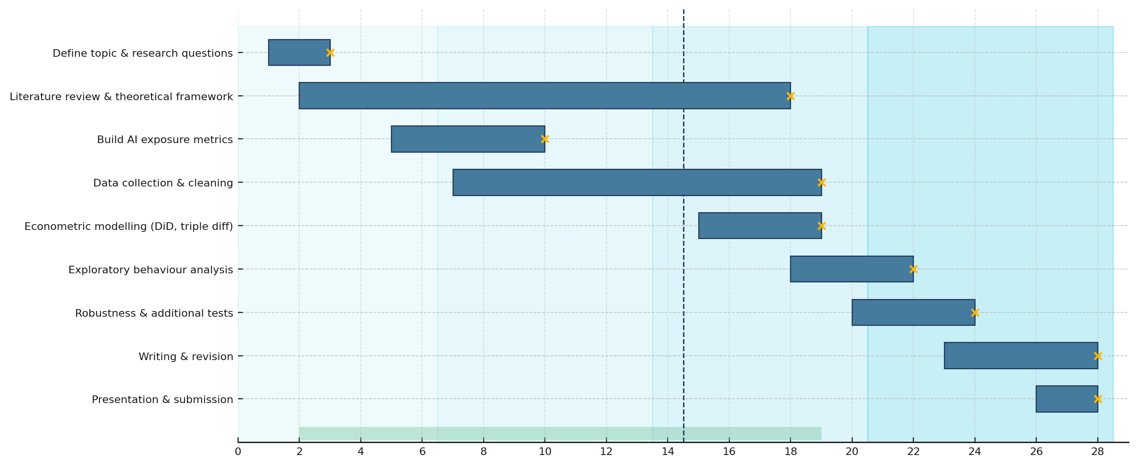
Figure1: Final Year Project Timeline
The project follows a two-semester schedule, with overlapping phases in literature review, data collection, and modelling to ensure research continuity and timely completion.

(word count: 1988)

References
Babina, T., Fedyk, A., He, A. and Hodson, J. (2024) ‘Artificial intelligence, firm growth, and product innovation’, Journal of Financial Economics, 151, 103745.

Cabrera, J.F. (2017) ‘Market making, liquidity provision, and attention constraints: An experimental study’, Unpublished manuscript.

Chen, Y., Hu, J., Chen, H., Chu, Z. and Hu, M. (2025) ‘Public attention, big data technology, and green innovation efficiency: empirical analysis based on spatial metrology’, Journal of Environmental Planning and Management, 68(8), pp. 1807–1833.

DeMiguel, V., Gil-Bazo, J., Nogales, F. and Santos, A.A. (2023) ‘Machine learning and fund characteristics help to select mutual funds with positive alpha’, Journal of Financial Economics, 150(3), 103737.

Harb, E. (2025) ‘Artificial intelligence and its role in increasing companies’ profitability’, JAIET Journal, 2(4), pp. 16–24.

Jain, P.C. and Wu, J.S. (2000) ‘Truth in mutual fund advertising: Evidence on future performance and fund flows’, The Journal of Finance, 55(2), pp. 937–958.

Kaniel, R., Starks, L.T. and Vasudevan, V. (2007) Headlines and bottom lines: Attention and learning effects from media coverage of mutual funds. SSRN Working Paper.

Liu, S., Zhao, H. and Kong, G. (2023) ‘Enterprise digital transformation, breadth of ownership and stock price volatility’, International Review of Financial Analysis, 89, 102713.

Lu, F., Huang, L. and Li, S. (2023) ‘ChatGPT, generative AI, and investment advisory’, SSRN Electronic Journal, SSRN 4519182.

Prange, C. and Schlegelmilch, B.B. (2009) ‘The role of ambidexterity in marketing strategy implementation: Resolving the exploration–exploitation dilemma’, Business Research, 2(2), pp. 215–240.

Qu, W. and Su, Z. (2024) ‘The role of ESG ratings in shaping Chinese investors’ decision-making behavior: An analysis from the fund signaling perspective’, Sustainability, 16(12), 4934.

Scholten, K., Sharkey Scott, P. and Fynes, B. (2019) ‘Building routines for non-routine events: Supply chain resilience learning mechanisms and their antecedents’, Supply Chain Management: An International Journal, 24(3), pp. 430–442.

Sirri, E.R. and Tufano, P. (1998) ‘Costly search and mutual fund flows’, The Journal of Finance, 53(5), pp. 1589–1622.

Vilas, P., Andreu, L. and Serrano-Cinca, C. (2024) ‘The limited role of sustainability in mutual fund investor decisions: A machine learning approach’, Expert Systems with Applications, 247, 123288.

Xiao, Y.J., Cen, J. and Soberg, P. (2021) ‘The impact of disruption on the relationship between exploitation, exploration, and organizational adaptation’, Frontiers in Sociology, 6, 757160.

Appendix
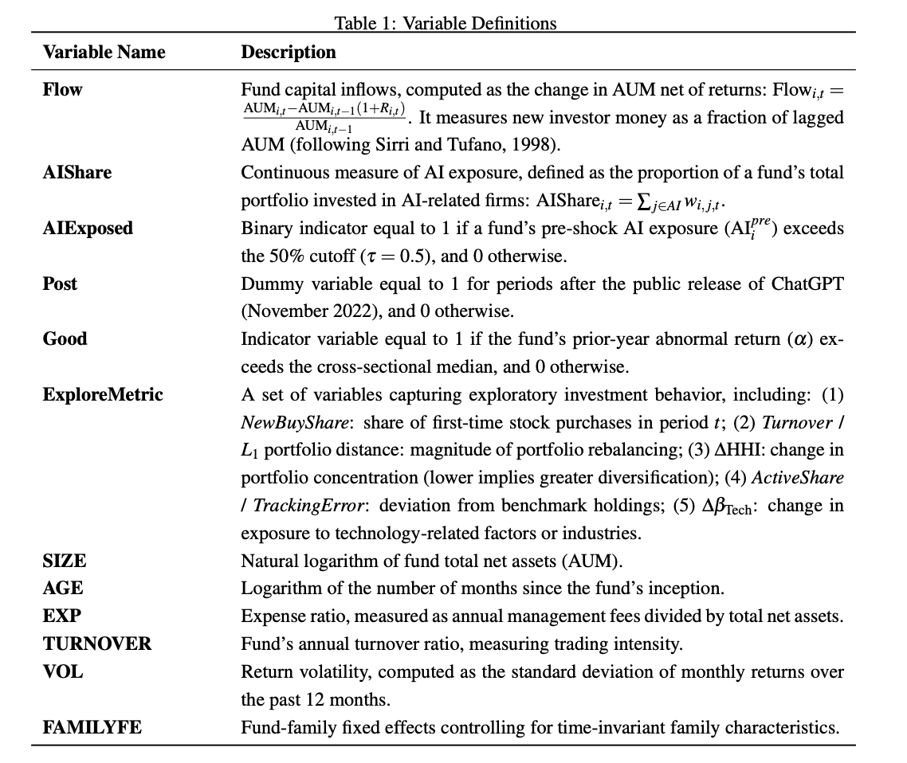
Table 1: Variable Definitions

Please refer to clause 43 (i), (ii) and (iii) of the Code of Practice on Assessment for the standard system of penalties for the late submission of assessment work based on working days.
As a robustness check, I will also compute Net New Money (NNM) using external flow measures where available and confirm that results are consistent.

