CPT203
Coursework 1
2024/2025 Semester 1
2004.11.07

Group number: 80
Student 1 Name: Shenghe.Su Student 1ID:2251046
Student 2 Name: Nan.Lin Student 2 ID:2252173
Student 3 Name: Zizhe.Song Student 3 ID:2257096
Student 4 Name: Xinyuan.Zhang Student 4 ID:2255403
Student 5 Name: Yida.Liu Student 5 ID:2251062

Part 1: System requirements modelling (50 marks and no page limits)
- Produce a use-case description for “Stock Receiving” and “Pack Order” use cases. (10 marks)
Use Case UC1: Pack Order

Primary Actor: Warehouse Clerk

Pre-condition
- The order has been created in the system
- The warehouse staff log in to the web-based system
- The order is in the ‘to be packed’ state

Post-condition
- The order is packed and ready to be shipped
- System update stock quantity
- The customer receives a notification that the package has been packed and is ready for shipping at the dock

Main Success Scenario
1. Staff log in to the web-based system using their user name and password.
2. Staff navigate from the main menu to the ‘Pending orders’ section.
3. Staff click on the ‘Pending orders to pack’ option.
4. The system retrieves all pending orders to pack from the database.
5. The staff member takes the books from the warehouse and packs them according to the order.
6. The order is marked as ‘packed and ready to ship’ by clicking the ‘Pack order’ option, and the stock quantity is updated simultaneously.
7. The staff member logs out of the system.
Alternate Scenario
- Step 5: If the staff member wishes to pack according to the time/size of the order:
  - 5a. Warehouse Clerk Selects specific filter or sort criteria (e.g., by order date, size and so on).
  - 5b. The system applies the selected filter or sort criteria and updates thedisplayed list of orders.
  - 5c. Proceed to step 6 in the Main Success Scenario.
Exception Scenario
- Step 5：If the warehouse clerks discover that there is a shortage of books in stock：
  - 5a. An error message is displayed indicating that the order could not be packed due to insufficient inventory.
  - 5b. The system sends a reorder order for the corresponding book to the supplier.
  - 5c. The supplier receives the order and prepares the corresponding book for shipment to the warehouse.
  - 5d. The Warehouse Clerk receives it and places it in the warehouse, updating the inventory.
  - 5e. The order status is updated and step 6 of the Main Success Scenario is repeated.
- Step 5: If the warehouse clerk finds that the book is out of print and in short supply:
  - 5a. An error message is displayed stating that the order cannot be packed due to insufficient stock and that the book is out of print.
  - 5b. The Warehouse Clerk reports the situation to the Manager.
  - 5c. The Manager contacts the customer to cancel the order.
  - 5d. Continue with step 6 in the Main Success Scenario.
Use Case UC2: Stock Receiving
Primary Actor: Warehouse Clerk
Pre-condition
- Warehouse staff log in to the web-based system
- Publisher has successfully received the reorder and shipped it
- Replenishment order arrived
Post-condition
- The system displays that the reorder order has been completed.
- System update stock quantity
- Staff log out of the system
Main Success Scenario
1. The warehouse staff receive the goods for the replenishment order.
2. The Warehouse Clerk records the time of receipt of the order in the system.
3. The staff sequentially verify the quantity, name, etc. of the books received.
4. Click the ‘Receive Inventory’ option.
5. The system will go through the received order and increase the inventory of each received book based on the quantity ordered.
Alternate Scenario
- Step 3: The staff sorts the items according to the time/size of the order.
  - 3a. Warehouse Clerk Select specific filter or sort criteria (e.g. by order date, size).
  - 3b. The system applies the selected filter or sort criteria and displays the updated order list.
  - 3c. Continue with step 4 in the Main Success Scenario.
Exception Scenario
- Step 1: The staff did not receive the ordered goods.
  - 1a. The warehouse staff report the error to the management system.
  - 1b. The system sends the relevant information (order information, problem, etc.) to the supplier.
  - 1c. The supplier identifies the problem and sends the books back to the warehouse according to the different situations.
  - 1d. Continue to step 2 in the Main Success Scenario.
- Step 2: If the staff member finds that the quantity/content of the books does not match the reorder order:
  - 2a. An error message is displayed indicating that the actual order does not match the original order.
  - 2b. The system reports the problem with the corresponding book and the original order information to the supplier.
  - 2c. After receiving the original order and the problem report, the supplier prepares the corresponding book for re-shipment to the warehouse.
  - 2d. The Warehouse Clerk receives the replenishment order and places it in the warehouse.
  - 2e. The order status is updated and step 3 in the Main Success Scenario is repeated.

- Draw a sequence diagram for the ‘Place Order’, and ‘Cancel Order’ use cases. (10 marks)
Place Order
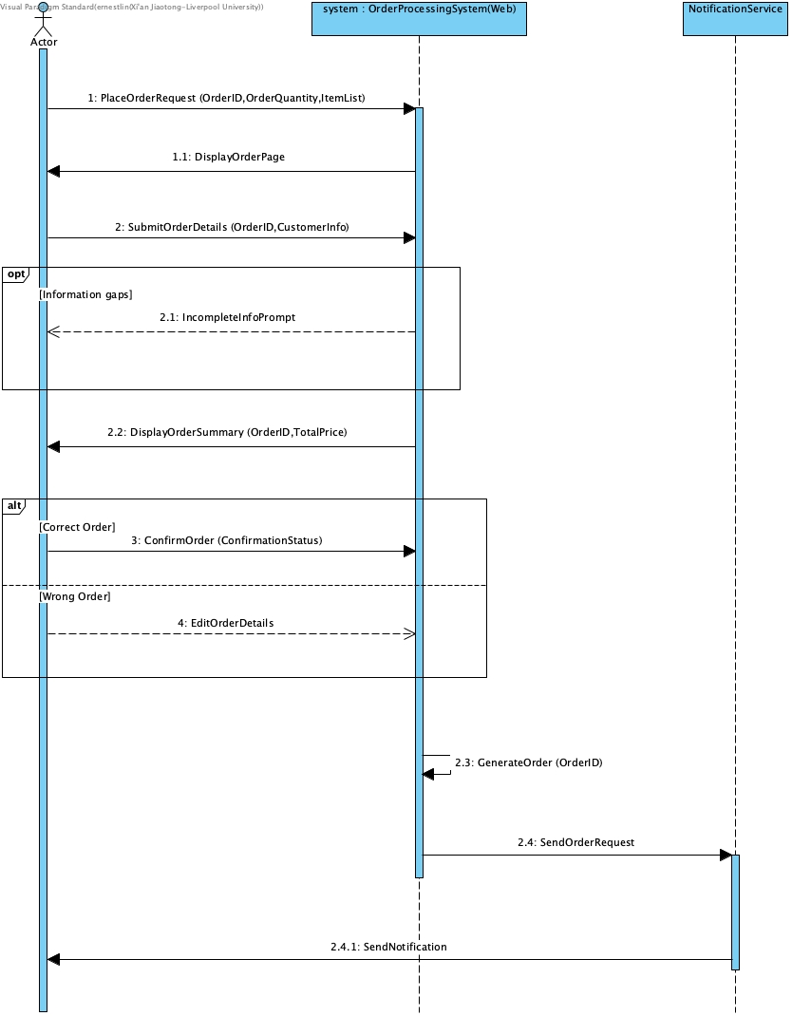

Cancel Order
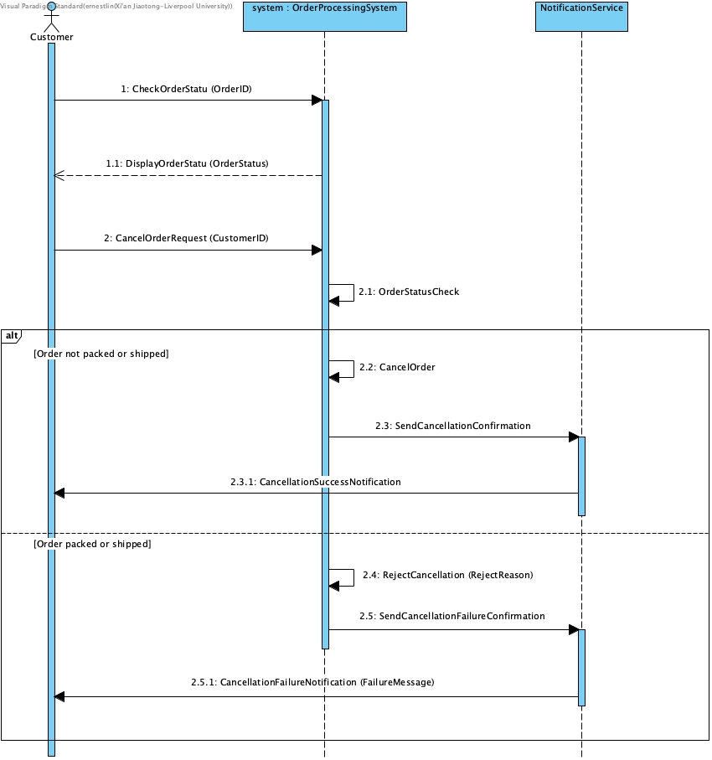

- Draw an activity diagram for the ‘Stock Receiving’ and ‘Manage Out-of-Print’ use case. (10 marks)
Stock Receive
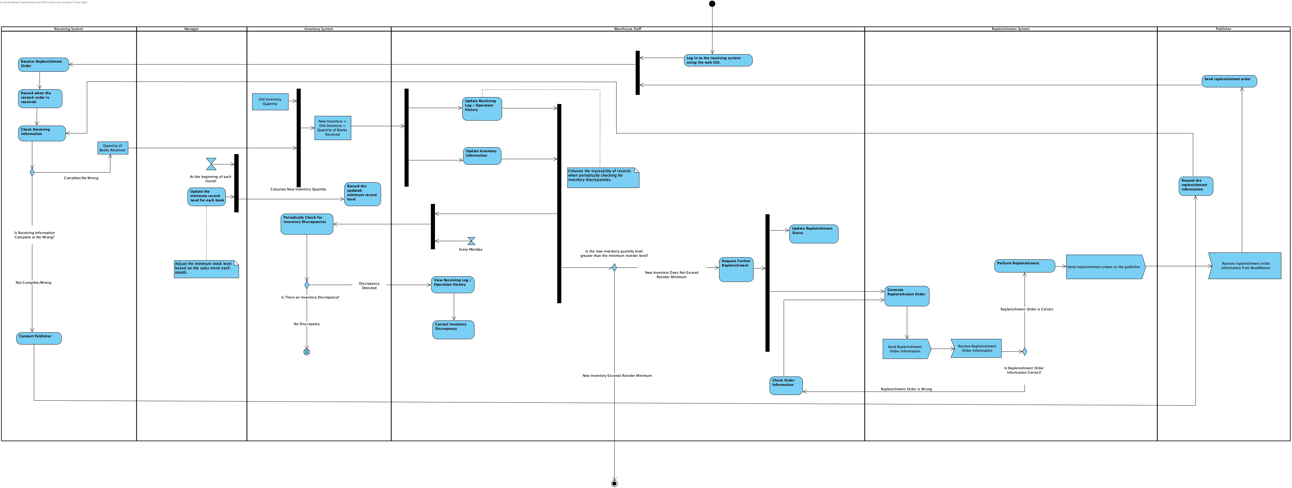
Manage Out-of-Print
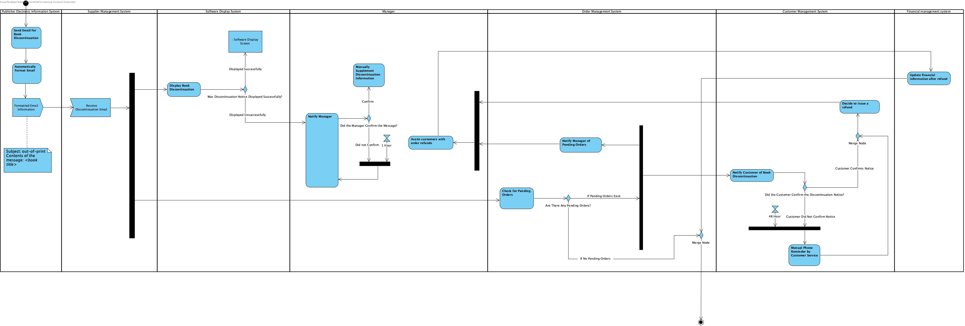

- Draw a class diagram for the system. (10 marks)
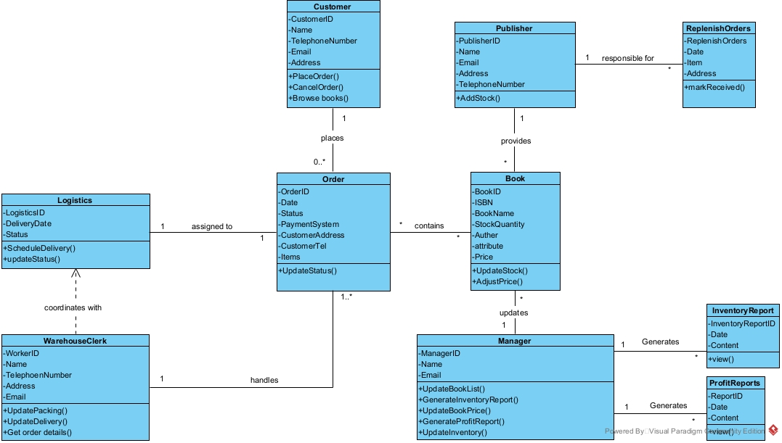

- From the class diagram, identify the classes with potentially complex states. Draw state machine diagrams for these classes. (10 marks)
Book class
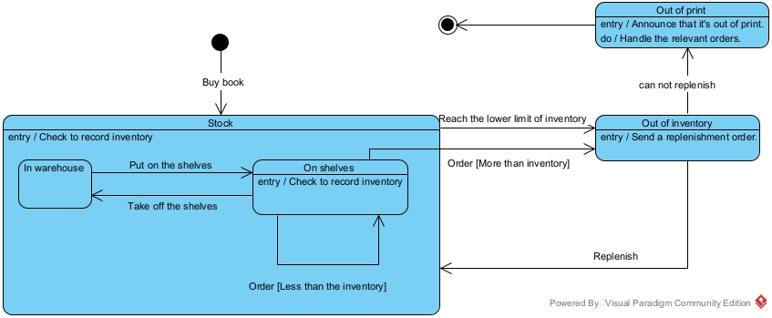

Manger class
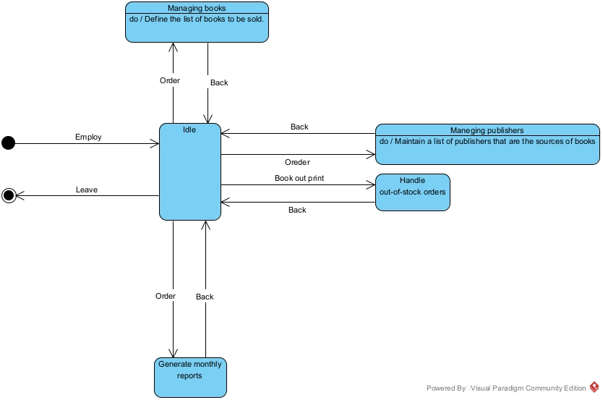
Order class
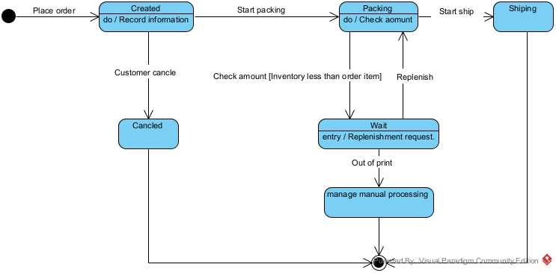
Publisher class
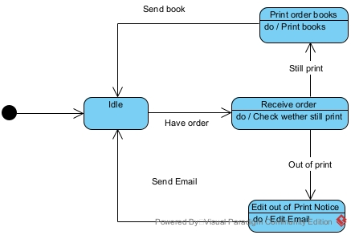

Warehouse clerk class
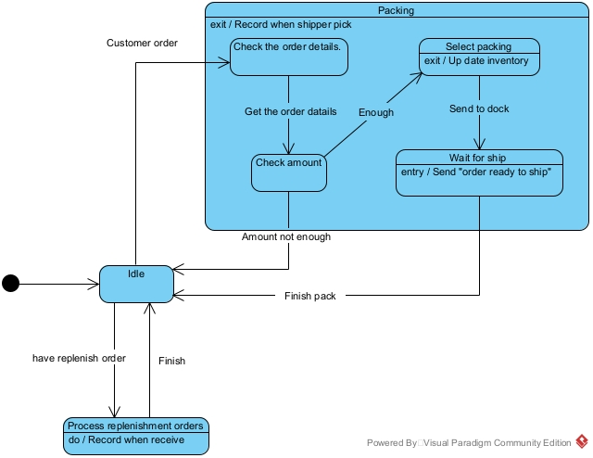

Part 2: Software engineering analysis (50 marks and max 3 pages)
Enter your answers to the following questions:
1. Which software process is most suitable for the project described in the case? Justify your answer. (10 marks)
We chose to use the incremental development model to solve this problem. The specific reasons are as follows:
1: Version-iterative development: The BookMaster software development team did not initially know the full extent of the functionality that the customer wanted. By developing in incremental model, the development team can gradually optimise the building system and gradually meet customer needs through frequent deliveries. The waterfall model is more suitable for projects with clearer requirements and less likely to change, and is not suitable for this project.
2: User feedback: BookMaster customer feedback will become each incremental development of the development team, so that user comments can be incorporated into the development process, which can better help the development team successfully.
3: Flexibility and adaptability: Using the incremental development model, it is easier to respond to changes in BookMaster customer requirements, allowing continuous optimisation and improvement during the development process.
4: Risk management: By breaking down BookMaster into smaller increments, risks are reduced. Problems can be identified and resolved early in the development phase, avoiding significant impacts on the overall project and thus reducing the time and cost of fixing errors.

2. Identify and analyze ethical concerns for the case study and make reasoned ethical choices. (10 marks)
2.1 Privacy and data security: Analysis: BookMaster records customer data (such as purchase history, home address, etc.) and also records employee data (such as performance, salary, etc.). If this data is leaked indiscriminately, it may lead to trust issues.
Ethical choice: For customers, strictly regulate privacy policies and provide customers with the option to access and delete relevant information; for employees, allow employees to manage their data and clarify the company's use of data and only collect data required for specific purposes, while using encryption to protect data at rest and in transit, and finally implement strict access controls to ensure that only authorised personnel can access sensitive data.
2.2 Corporate financial data transparency: Analysis: Lack of data transparency can lead to a crisis of confidence between investors and the rest of BookMaster's stakeholders. If financial data is incorrect, it can mislead investors into making bad investments.
Ethical choice: Regularly publish financial reports, use transparent financial systems, introduce independent audits, adopt corporate accountability systems, and reduce related ethical failures.
2.3 Intellectual property and ownership of books: Analysis: Respect the intellectual property rights of individuals and organisations and prevent unauthorised use or copying. If BookMaster infringes intellectual property rights, it may result in legal penalties and financial losses, and hinder innovation and creativity.
Ethical choice: BookMaster formulates and implements clear IP policies to protect the rights of creators, obtains permission to use third-party IP using licensing agreements, and educates employees to respect intellectual property rights.

3. What are the non-functional requirements that might impact the system, and how might they do so? (10 marks)
Non-functional requirements that may affect the system include reliability, usability, visual design, security, maintainability, response speed, and inclusiveness. These requirements are reflected in all parts of the system, and the implementation of non-functional requirements affects the entire system architecture, not just individual functions.
3.1 Reliability: BookMaster must remain stable during peak user hours while processing a huge number of user requests. Insufficient reliability may cause the system to crash or fail to respond at critical moments, resulting in user unavailability and loss of sales. For example, during peak periods, poor reliability can lead to page loading failures, which can reduce the user experience and book sales.
3.2 Usability: Usability improvements enable users from different backgrounds to clearly understand how to use the software to improve the shopping experience. A low usability level will increase the difficulty for users from different backgrounds, increase the bounce rate and reduce satisfaction, while also leading to inequality. Simple navigation and interfaces can help users meet the needs of users from different backgrounds more quickly, improve the customer experience, and ensure fairness.
3.3 Visual design: Good visual design directly determines the user's willingness to purchase and retention rate. High-quality visual effects can increase the time customers spend on the interface and increase their interest in purchasing. This will improve the sales results of BookMaster, and vice versa.
3.4 Security: Security ensures the overall safety of BookMaster user data and the system. Effective measures such as data encryption and logging reduce the risk of data breaches, build user confidence and encourage repeat usage. An insecure system risks data breaches, which can damage customer relationships and company reputation.
3.5 Maintainability: High maintainability means that systems can be updated and fixed quickly, thereby minimising downtime for BookMaster. Low maintainability can result in excessive downtime during updates, affecting user access and potentially leading to lost revenue and staff turnover, while damaging the user experience. High maintainability ensures high availability and reduces operational risk.
3.6 Responsiveness: Responsiveness directly affects user interactions with the BookMaster system. Slow responsiveness increases wait times, decreases customer satisfaction, and impacts the positive impression users have of BookMaster. Fast responsiveness provides a better experience and increases user retention.

- What challenges might arise when working in collaboration, and what do you propose to overcome these challenges? (10 marks)
4.1 Each team member has a different understanding and focus on knowledge, and there were differences when initially assigning tasks. We first assigned tasks that everyone was more adept at, and then studied them together afterwards. After members completed their respective parts, they identified deficiencies through group discussions, which allowed us to more effectively and comprehensively identify and solve problems, and was also a valuable learning process.
4.2 We initially had different opinions on how to achieve the requirements in the document, which resulted in a waste of time. To solve this problem, we spent more time studying the document. Our discussions focused on implementing the requirements specified in the document, starting with the described functions. When we encountered unclear points, we sought help from our mentor, and in the end, we were able to solve these problems effectively.
4.3 It was difficult to find a time for discussion when everyone was available, so we decided to discuss, analyse and solve problems at three fixed times each week. This method helped to manage conflicting schedules and progress. Having a designated time allowed us to put aside other tasks and devote ourselves fully to the task sprint.

5. What measures can BookMaster take to ensure that the warehouse interface is user-friendly for employees of all backgrounds, including those with different levels of technical proficiency? (10 marks)
5.1 BookMaster uses universal design principles to create a system that can be used by the widest possible range of employees. It follows accessibility standards such as WCAG to ensure that employees with disabilities can access the system. Usability tests are carried out with different groups of user employees to identify and resolve potential barriers and ensure that the system can be used by employees from a variety of backgrounds.
5.2 To ensure that BookMaster has an inclusive interface, the team that developed it was selected to be inclusive. Inclusive language and images are used to create an intuitive interface that is easy for employees from different backgrounds to use.
5.3 BookMaster provides personalisation and multi-level access rights, allowing employees to define shortcuts and interface layouts according to their own usage habits. At the same time, BookMaster should provide two modes of operation: basic mode and advanced mode. New employees or employees with lower skill levels can start with basic mode to familiarise themselves with the basic functions and gradually build confidence. As they become more proficient with the system, they can gradually explore and use advanced functions.
5.4 The BookMaster interface should be simple, with minimal buttons and decorative elements to avoid visual clutter. By placing the main operations and frequently used functions in prominent positions, employees can find the functions they need more quickly, improving operational efficiency. At the same time, avoiding complex sorting and filtering options simplifies the operation process, allowing employees to focus more on their core tasks rather than being distracted by a cumbersome interface.

Section 5. Peer review form template

CPT203 Coursework
Peer review
Individual Contribution for Group Report

Group Number: <x>

Name | ID Number | Contribution (%)  Please enter an integer, for example 15% contribution, please enter 15.  The sum of this column should be 100 | Signature
1. Shenghe.Su | 2251046 | 20
- Nan.Lin | 2252173 | 20
- Zizhe.Song | 2257096 | 20
- Xinyuan.Zhang | 2255403 | 20
- Yida.Liu | 2251062 | 20

END

