Coursework 2
2024/2025 Semester 1
<2024/12/11>

Group number: < 80 >
Student 1 Name: <Shenghe Su> Student 1< ID: 2251046> who submits this on the learning mall

Student 2 Name:Xinyuan Zhang Student 2 ID:2255403
Student 3 Name:Nan Lin Student 3 ID:2252173
Student 4 Name:Zizhe Song Student 4 ID:2257096
Student 5 Name:Yida Liu Student 5 ID:2251062

Q1. You are supposed to draw the class diagram for the case (10 marks).
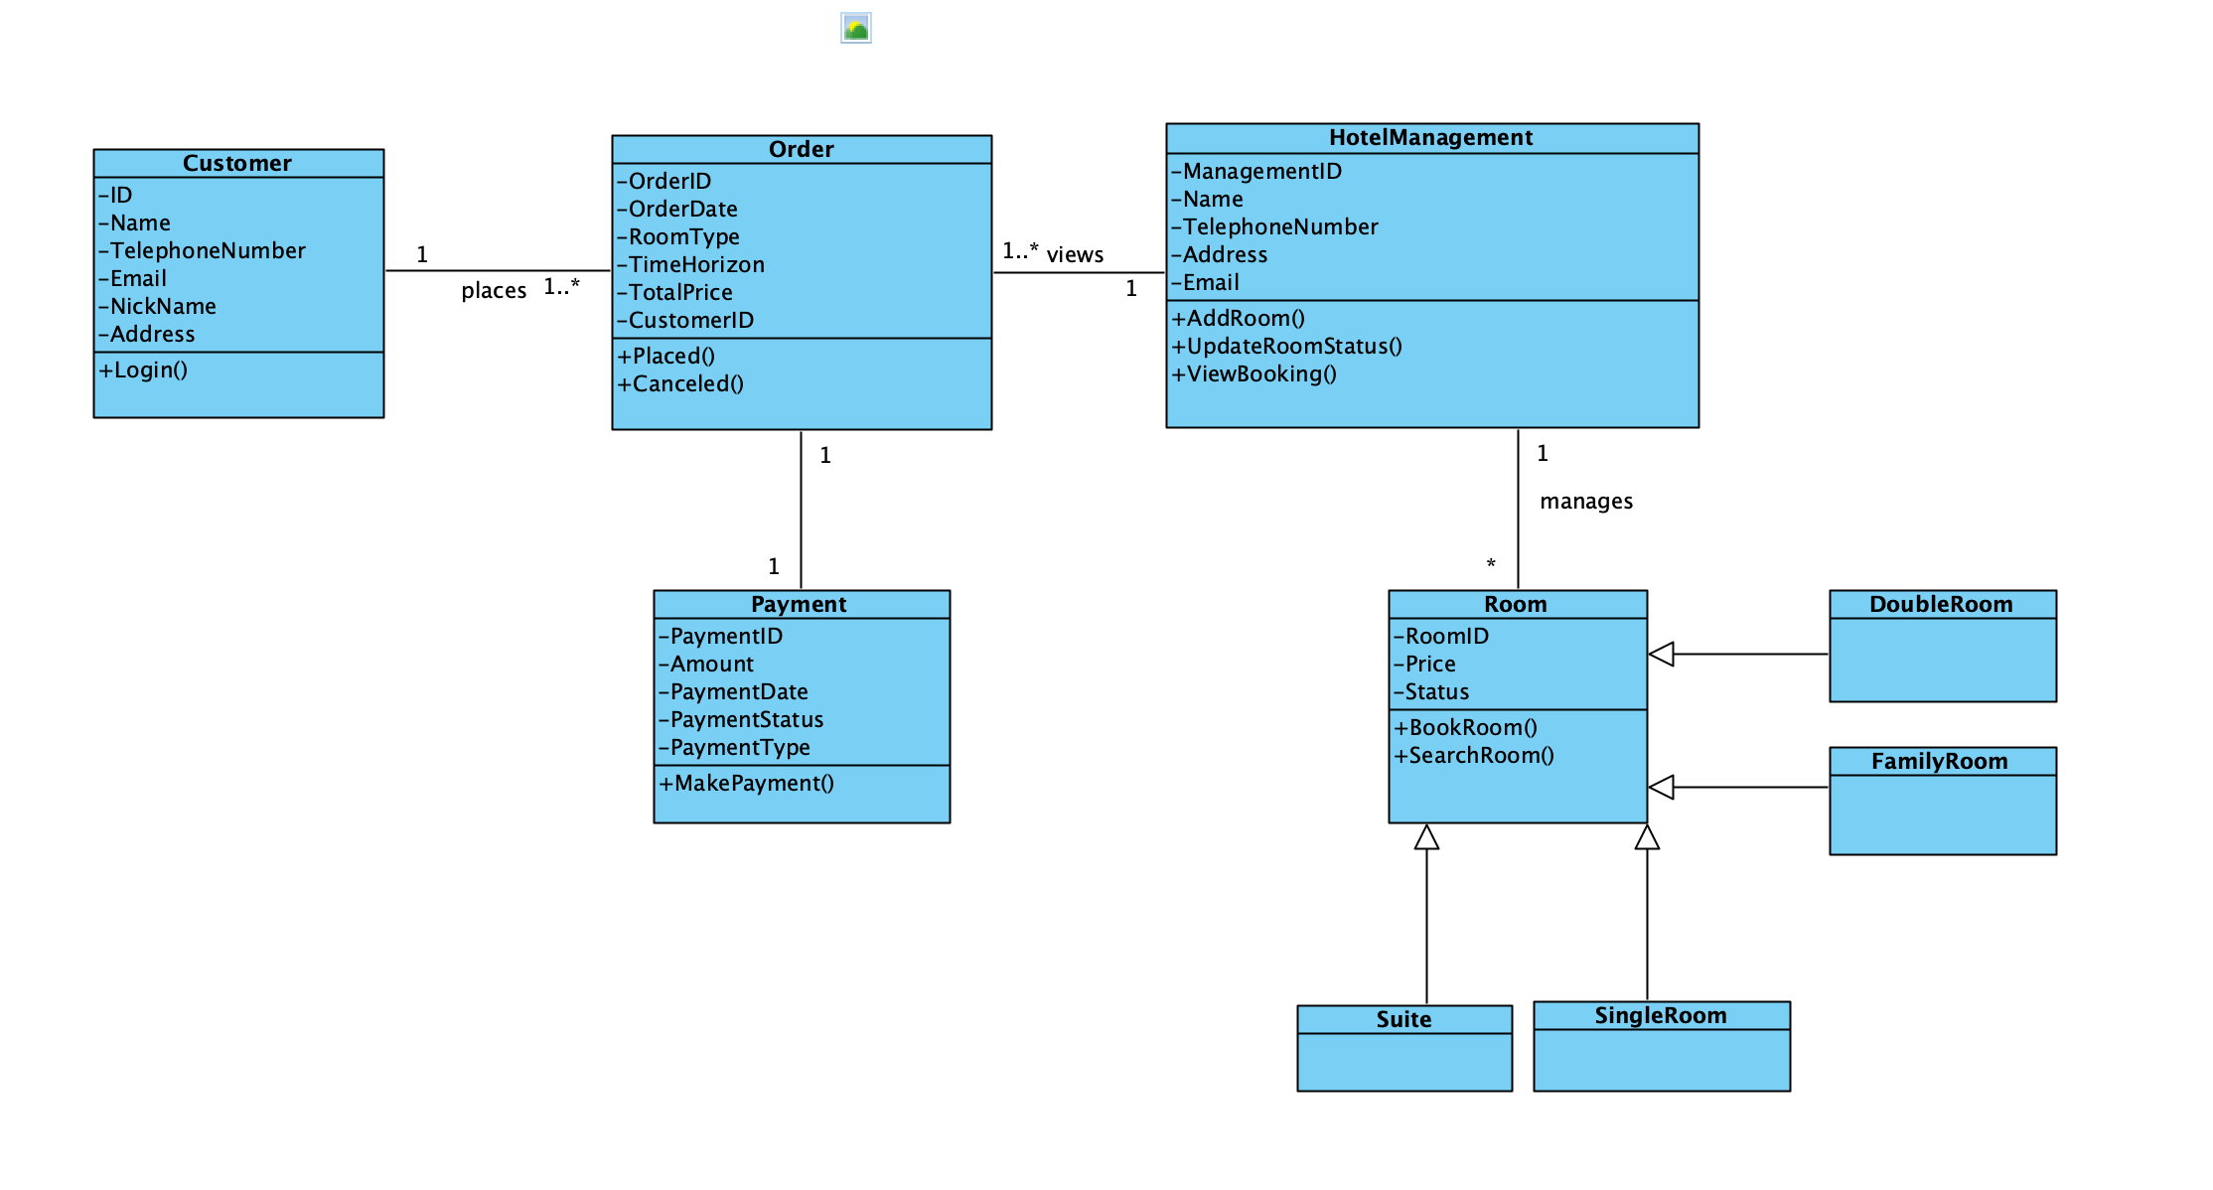
Q2. Evaluate the design principles in the class diagram. (15 marks).
This type of diagram combines a number of object-oriented design principles and describes how to achieve a flexible, maintainable system by carefully designing the class structure.
1.Single Responsibility Principle(SRP): The Single Responsibility Principle requires that each class has only one responsibility, e.g., the 'Customer' class manages customer information, the 'Order' class handles order management, the 'Payment' class handles payment-related transactions, and the 'Room' class manages room information and reservations. Payment' class handles payment-related matters, while 'Room' class is responsible for the management of room information and reservation functions. By simplifying the responsibilities of the classes, it is convenient for subsequent modification and extension.
2.High cohesion and Low coupling: In terms of high cohesion and low coupling, the attributes and methods of each class are closely related, with clear responsibilities (high cohesion), while classes are decoupled from each other through associative relationships (e.g., aggregation, combination). For example, there is a “one-to-many” relationship between 'Customer' and 'Order', and a “one-to-many” relationship between 'Order ' and 'Payment' is a 'one-to-one' relationship. This design helps to reduce system complexity and improve maintainability.
3.Richter's Substitution Principle(LSP): The Richter's Substitution Principle is also applied, e.g., through 'SingleRoom', 'DoubleRoom', 'FamilyRoom ', 'SuiteRoom' subclasses to maintain and extend the operations of the `Room` parent class without breaking the logic of the existing code, thus improving the stability of the system.
4.Dependency Inversion Principle(DIP): The Dependency Inversion Principle achieves decoupling of logic through layered design. For example, the `Order` class relies on the interfaces provided by the `Customer` and `Payment` classes rather than the implementation of specific classes, which enhances the flexibility of the system.
5.Clear relationships: 'Customer' and 'Order' are “one-to-many” relationships, 'Order' and 'Payment' are “one-to-many” relationships, and 'Customer' and 'Payment' are “one-to-many” relationships. and 'Payment' are 'one-to-one' relationships, while 'HotelManagement' and 'Room' are 'one-to-one' relationships. This makes the class diagram more intuitive to understand.
6.Efficient structure: The class diagram is simple, avoiding unnecessarily complex inheritance relationships and redundant methods. For example, there are no nested classes between the Order and Payment modules, but rather simple associations to realize the functionality, which reduces the difficulty of design and implementation and ensures that the system works efficiently with the current requirements.
Q3. You are required to create the UI pages of these functions. (15 marks)
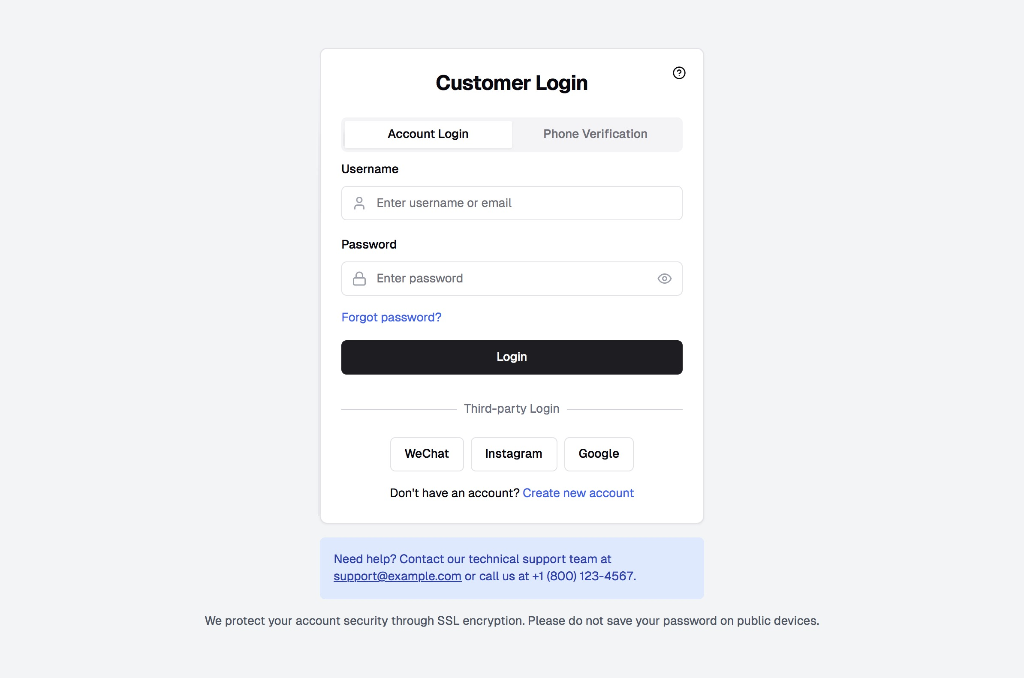
Step1: Log in

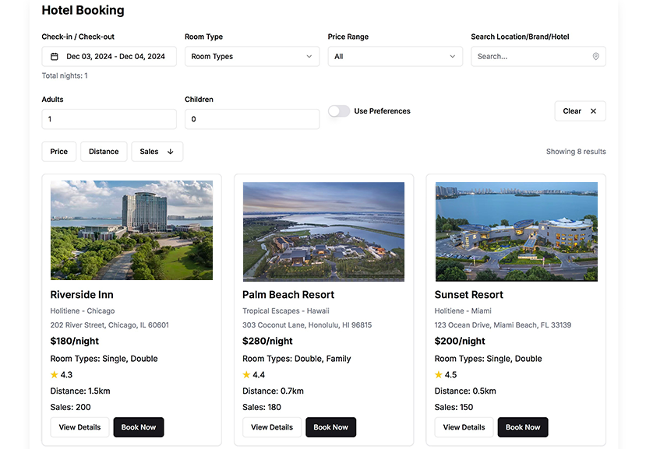
Step2: Hotel Search and Book
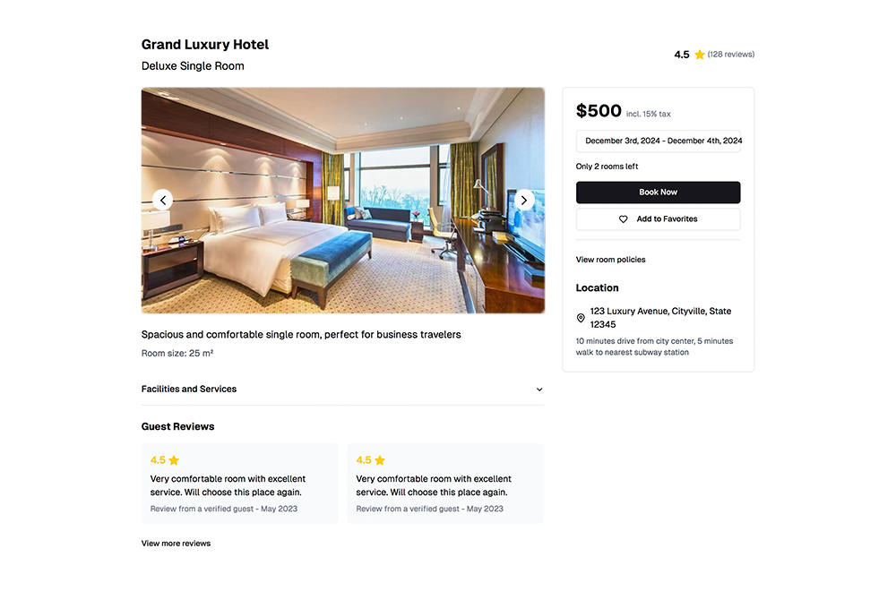
Step 3: Room details and Book
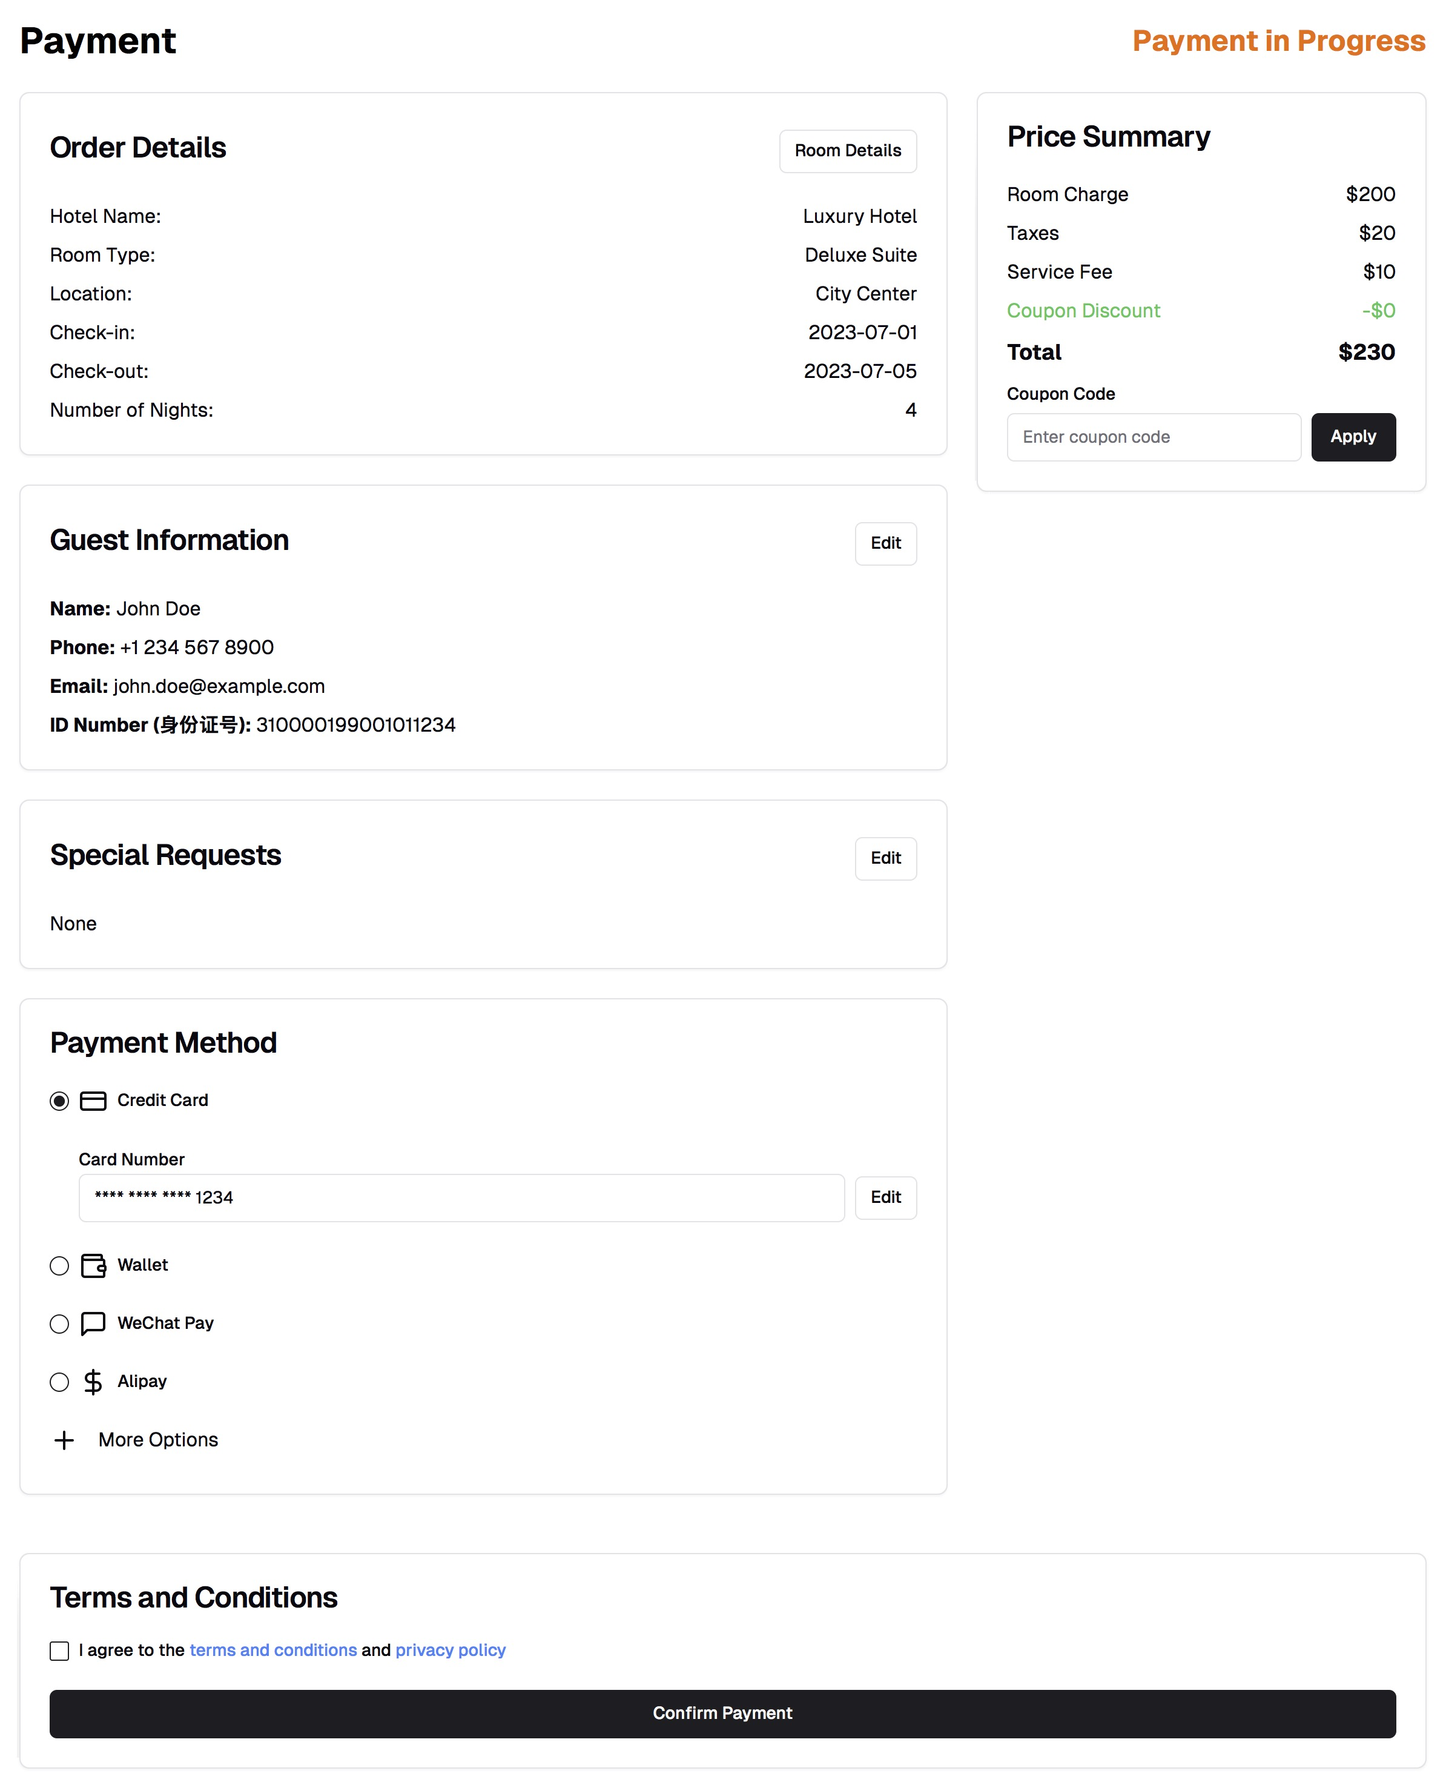
Step 4: Payment Details
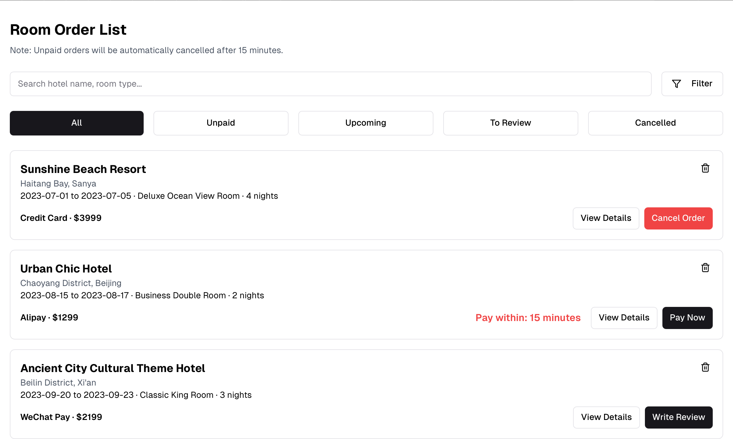
Step 5: Order List Management

Q4.For each user interface page, (1) describe which interface design principles were used, (2) how they were applied through specific examples, and (3) how the interaction between the system and the user was improved (e.g., equality, diversity, and inclusion). (20 points)
Interface 1:
- Place The User in Control
1.1 Flexible: 1.1.1 Login allows customers to use a variety of ways such as account password, cell phone verification and a variety of third-party authorization login methods to meet the different needs of different customers.
1.2 Interruptible and undoable: 1.2.1 If the Customer forgets his/her password, he/she can quickly retrieve it through the "Forgot password" without restarting the whole process.
1.3 Visibility of System Status: 1.3.1 After successful login, the customer can see that he/she has successfully logged in.
1.4 Direct interaction with objects in the interface: 1.4.1. The question mark in the upper right corner can be clicked on to go directly to help the customer solve the problem.
2. Reduce user's memory
2.1 Reduce short-term memory: 2.1.1 Placeholders in the user name and password entry boxes provide users with intuitive operational guidelines and avoid the need for users to memorize additional formats.

Interface 2:
- Place The User in Control
1.1 Flexible 1.1.1 Users can customize the filtering criteria based on date, room type, price range search keywords (e.g., location, brand, or hotel name). 1.2.1 Provides Price, Distance, and Sales sorting options, so that the user can choose the sorting priority according to his/her own needs. 1.3.1 Provides Use Preferences switch to allow users to further customize the search results according to their preferences. 1.4.1 Customers can click Clear to clear all the sorting/selections.
1.2 Visibility of System Status: 1.2.1 "Showing 8 results" explicitly tells the user the number of current search results.
- Reduce user's memory
2.1 Reduce short-term memory.
2.1.1 Users don't need to memorize their filtering criteria, all options (date, room type, price range, etc.) are presented visually. 2.1.2 Each hotel card shows detailed information, including price, room type, rating, distance, etc., avoiding frequent memory for customers.
2.2 Meaningful Defaults: 2.2.1 Default display all room types and hotels, only when the customer to filter according to the conditions to show the results of the requirements.
Interface 3:
- Place The User in Control
- 1 Flexible
1.1.1 Provides a "Book Now" button that allows the user to quickly book a room.1.1.2 Add to Favorites feature that allows the user to save rooms of interest for later viewing.1.1.3 View room policies link that provides the user with the flexibility to view the detailed terms and conditions. 1.1.4 Ability to toggle through photos of the room from different angles and click on "Facilities and Services" to view the amenities and services that are available. Customer can also view historical guest reviews.
1.2 Visibility of System Status.
1.2.1 "Only 2 rooms left" reminder clearly shows the inventory status and lets the user perceive the scarcity of rooms.
2. Reduce user's memory
2.1 Reduce short-term memory
2.1.1 The core information of the room can be clearly displayed on the same page, without the need for users to repeatedly switch pages to memorize details
2.2 Direct interaction with objects in the interface 2.2.1. "Add to Favourite" allows you to add this hotel to favourite list by clicking directly on the heart icon.
Interface 4:
- Place The User in Control
1.1Flexible
1.1.1 Users can modify order information via the "Edit" button, which enhances user flexibility. 1.1.2 Support multiple payment methods to meet different user payment preferences. 1.1.3 Provide " Coupon Code" input box to allow users to apply coupons.
1.2 Visibility of System Status.
1.2.1 The top provides process visibility, when the customer has not paid, the system displays "Payment in Progress", when the payment is completed, it displays "Payment Finished", when the customer cancels the order, it displays "Payment Failure" so that the user knows exactly which stage of the payment process is currently in. 1.2.2 When clicking on "Confirm Payment", a prompt box will pop up to alert the user that the payment is being processed.
2. Reduce user's memory
2.1 Reduce short-term memory.
2.1.1 The order details (e.g. hotel name, room type, etc.) are clearly listed on the left side, so the user does not need to memorize them. 2.1.2 The payment page integrates all the necessary information (order details, payment method, price details), so the user can complete the operation on a single page.2.1.3. When the user forgets to check "I agree to the terms and conditions and privacy policy", the system will prompt "Please check first".2.1.4When the customer will pay, "I agree to the terms and conditions and privacy policy", the system will prompt the user to "Please check the box first". 2.1.5 The system will automatically deduct the amount of the coupon when it is used. 2.1.6 The system will automatically deduct the amount of the discount when it is used.
2.2 Meaningful Defaults.
2.2.1 Only secure placeholders (e.g. 1234) are shown in the "Card Number" input box to avoid exposing the user's privacy. 2.2.2 Credit card payment is selected by default as the most common payment method for most of the users. 2.2.3 There are no special requests in Special Requests by default. 2.2.4 The Guest Information box automatically pops up the personal information reserved for the most recent booking of the account. Customer can use it directly.
Interface 5:
- Place The User in Control
- 1 Flexible
1.1.1 Provide categorized filters (All, Unpaid, Upcoming, To Review, Cancelled) to allow users to quickly locate the status of an order.1.1.1 Users can quickly locate a specific order by using the "Search hotel name, room type..." search box to quickly locate a specific order. 1.3.1 Provide action buttons, such as "Cancel Order" and "Pay Now", which allow users to perform direct actions on an order.
1.2 Visibility of System Status.
1.2.1 Display the countdown "Pay within: 15 minutes" directly on the unpaid order to remind the user of the urgency of the order.
2. Reduce user's memory
2.1 Reduce short-term memory.
2.1.1 Key information (hotel name, location, room type, date, payment method and amount) is clearly displayed on each order card, avoiding the need for users to memorize complex details. 2.1.2 Action buttons (e.g. "Cancel Order", "Pay Now", "Write Review") appear directly on the relevant order so that the user does not need to jump to a page to complete the action. 2.1.3 Filter buttons (e.g. "Unpaid", "Upcoming") help the customer to know where the order is in the process, whether it is unpaid, unavailable, canceled or completed.
2. 2 Meaningful Defaults.
2.2.1. "All Orders" category is displayed by default, which is convenient for users to view all orders quickly. 2.2.2 Orders are sorted by the most recent payment status or creation time, which meets the needs of the majority of users.
All of the above interfaces use gray, black, white and red colors as the main tone, make the interface consistent.
- Payment-related: In the payment page and order management page, the payment methods (e.g. credit card, WeChat Pay, Alipay) are displayed in the form of icons familiar to users, which are unified and easy to recognize.
- Action buttons: buttons such as "View Details", "Cancel Order", "Pay Now", etc. are uniform in style, color (e.g., red for Cancel, black for Confirm) and position.
- Status labels: Order statuses (e.g., "Unpaid" vs. "Pay within: 15 minutes") are highlighted in a consistent text format and color so that users can easily understand the meaning of the status.
We also used some icons related to the real world, such as the "question mark" and "lock" in the login screen, the "love" in the Room Details and Book screen, etc. The corresponding functions are all related to the real world, which is in line with the interface design principles. "The corresponding functions in the Room Details and Book interface are all related to the real world, which is in line with the interface design principles.

Q5. Please describe how would you test the function in cases that it is working and NOT working (e.g., boundary input). For each of the test cases, please also specify what can be the solution to the problem. (10 marks)
Function Objective: Customers need to input check-in and check-out dates, and the system validates these inputs for correctness.
Function Requirements: Firstly, the check-in date must be earlier than the check-out date (no same-day check-out, no hourly rates). Secondly, the date cannot be earlier than the current date. Thirdly, the stay duration must be between 1 and 30 days (extensions require a new order). Fourthly, reservations can be made up to 365 days in advance. Fifth, the date format must follow YYYY-MM-DD. Finally, the date fields cannot be left blank.
Testing Approach: The test consists of two parts: normal conditions and abnormal conditions. The boundary test method is also used to further test the stability and usability of the system functions. The specific test design is described below.
- Normal case testing: Ensure that the customer enters valid data and that the system processes this data correctly. Also that the system displays the correct message as expected.
Test Case | Check-in Date | Check-out Date | Expected Result
1 | 2024-12-01 | 2024-12-05 | Valid input, booking accepeted
2 | Current date | Current date+1 | Valid input, booking accepeted
3 | Current date | Current date+30 | Valid input, booking accepeted
4 | Current date+180 | Current date+181 | Valid input, booking accepeted
5 | Current date+180 | Current date+210 | Valid input, booking accepeted
6 | Current date+365 | Current date+366 | Valid input, booking accepeted
7 | Current date+365 | Current date+395 | Valid input, booking accepeted
NOTE: Test Case 1 simulates actual usage scenarios, assuming 2024-12-1 to 2024-12-05 meet all Functional Requirements, confirming normal operation. Test Cases 2 and 3 perform boundary tests on the earliest and latest check-out times to verify the length-of-stay requirements. Test Cases 4–7 extend Cases 2 and 3 to test future check-in reservations. The current date is the earliest, current date + 400 the latest, and current date + 200 the intermediate check-in date, while also verifying the 30-day maximum stay limit.
- Invalid Case Testing: Test for invalid input situations and verify that the system can correctly detect errors and provide solutions.
- Check-in Date is Later than Check-out Date
Test Case | Check-in Date | Check-out Date | Expected Result
8 | 2024-12-05 | 2024-12-01 | Error: “Check-in date cannot be later than check-out date”
Solution: A notification will pop up saying ‘The check-in date is later than the check-out date. Please select a new date’ to help customers select the correct dates.
Note: Test Case 8 is used to simulate a real world scenario where 2024-12-05 is later than 2024-12-01 in the real world, so the system will display an error.
- Past Dates
Test Case | Check-in Date | Check-out Date | Expected Result
9 | 2004-12-01 | 2004-12-05 | Error: “Past dates are not allowed”
10 | Current date-1 | Current date+1 | Error: “Past dates are not allowed”
Solution: A message will appear stating 'You cannot select a date in the past. Please select a correct date.' to help customers select the correct date.
NOTE: Test Case 9 simulates a realistic scenario with past dates (2004-12-01 and 2004-12-05), triggering a system error. Test Case 10 abstracts this exception and serves as a boundary testing example.
- Check-in Date and Check-out Date are the Same
Test Case | Check-in Date | Check-out Date | Expected Result
11 | 2024-12-01 | 2024-12-01 | Error: “Check-in and check-out dates cannot be the same”
12 | Current date | Current date | Error: “Check-in and check-out dates cannot be the same”
Solution: A notification will pop up saying ‘The check-in date and the check-out date cannot be the same. Please select again’ to help customers select the correct dates.
NOTE: Test Case 11 simulates a realistic scenario where hourly rooms are excluded, so 2024-12-01 cannot be used for check-in or check-out. Test Case 12 abstracts this exception for boundary testing.
- Stay longer than 30 days
Test Case | Check-in Date | Check-out Date | Expected Result
13 | 2024-12-01 | 2025-01-05 | Error: “Staying period exceeds the maximum of 30 days”
14 | Current date | Current date+31 | Error: “Staying period exceeds the maximum of 30 days”
Solution: A notification pops up saying ‘Your stay exceeds the maximum length. Please choose again’ to help customers choose another date.
NOTE: Test Case 13 simulates a realistic scenario. The period from 2024-12-01 to 2025-01-05 exceeds 30 days, and the system prompts an error. Test case 12 is an abstract representation of this type of exception and is also tested as an example to follow the boundary testing principle.
- Book beyond time range
Test Case | Check-in Date | Check-out Date | Expected Result
15 | Current date+366 | Current date+367 | Error: “The scheduled move-in date exceeds the maximum of 365 days.”
16 | Current date+366 | Current date+396 | Error: “The scheduled move-in date exceeds the maximum of 365 days.”
Solution: Help customers rebook their rooms by displaying the message 'Your check-in date is outside the next 365 days, please try again'.
NOTE: Test Cases 15 and 16 fail as their dates exceed the 365-day limit. Current date + 366 is tested for boundary conditions, with check-out times set to 1 and 30 days later to avoid overlapping with error type 4--Stay longer than 30 days-- and ensure variable control.
- Invalid Format
Test Case | Check-in Date | Check-out Date | Expected Result
17 | 2024/12/01 | 2024/12/05 | Error: “Invalid date format”
18 | 12-01-2024 | 12-05-2024 | Error: “Invalid date format”
Solution: The notification ‘The date you entered is not in the correct format. Please re-enter it’ helps customers change the date format.
NOTE: Test cases 17 and 18 simulate real-life scenarios and are both formatted incorrectly, as they are not written in the YYYY-MM-DD format. Therefore, the system prompts an error.
- Missing Dates
Test Case | Check-in Date | Check-out Date | Expected Result
19 | NULL | NULL | Error: “Dates must be provided”
20 | 2024-12-01 | NULL | Error: “Dates must be provided”
21 | NULL | 2024-12-05 | Error: “Dates must be provided”
Solution: A message will pop up reminding the customer to enter a date.
NOTE: In Test Cases 19, 20 and 21, the check-in and check-out dates cannot be left blank.

Q6. Fill in the following code first and provide test cases verifying if the exceptions are thrown successfully. (10 marks)
// Q6.1 - Fill in the Code
- package org.example;
- public class Payment {

- private int paymentID;
- private int bookingID;
- private double amount;
- private String paymentMethod; // Example: "Alipay", "Wechat"
- private boolean isProcessed;

- public Payment(int paymentID, int bookingID, double amount, String paymentMethod) {
- this.paymentID = paymentID;
- this.bookingID = bookingID;
- this.amount = amount;
- this.paymentMethod = paymentMethod;
- this.isProcessed = false;
- }

- //How to process the order (added code)
- public boolean processPayment() throws IllegalArgumentException {

- //Handle exceptions with a negative amount
- if (amount <= 0) {
- throw new IllegalArgumentException("The payment amount must be greater than zero!");
- }
- //Handle payment method exceptions
- if (!paymentMethod.equals("Alipay") && !paymentMethod.equals("Wechat")) {
- throw new IllegalArgumentException("Payment method is not valid! Only Alipay and Wechat are supported.");
- }

- isProcessed = true; // payment processing succeeded
- return isProcessed;
- }

- public boolean isProcessed() {
- return isProcessed;
- }

- public double getAmount() {
- return amount;
- }
- }

//Q6.2 - Test cases
- package org.example;
- import org.junit.jupiter.api.*;
- import static org.junit.jupiter.api.Assertions.*;

- class PaymentTest {

- @Test//Check the payment success status.
- public void testProcessPaymentSuccess() {
- Payment payment = new Payment(1, 101, 100.0, "Alipay");
- assertDoesNotThrow(() -> {
- assertTrue(payment.processPayment());
- });
- assertTrue(payment.isProcessed());
- }

- @Test//The amount is negative throw check
- public void testProcessPaymentNegativeAmount() {
- Payment payment = new Payment(2, 102, -10.0, "Wechat");
- Exception exception = assertThrows(IllegalArgumentException.class, () -> payment.processPayment());
- assertEquals("The payment amount must be greater than zero!", exception.getMessage());
- }

- @Test//Payment method problem raised check
- public void testProcessPaymentInvalidPaymentMethod() {
- Payment payment = new Payment(3, 103, 50.0, "CreditCard");
- Exception exception = assertThrows(IllegalArgumentException.class, () -> payment.processPayment());
- assertEquals("Payment method is not valid! Only Alipay and Wechat are supported.", exception.getMessage());
- }

- @Test//Check whether the return value is true
- public void testIsProcessedFlag() {
- Payment payment = new Payment(4, 104, 200.0, "Wechat");
- assertDoesNotThrow(() -> payment.processPayment());
- assertTrue(payment.isProcessed());
- }

- }

Q7. Please describe what would you organize this process as a team. (20 marks)
With the system becoming better, we reach to the stage of user testing for our system. Please describe how would you organize this process as a team. Make sure the potential problems (you can suppose any questions derived from the user testing) and related solutions are also considered from the perspective of the continuous improvement of the product. (20 marks)
- Organise user testing as a team: User testing is divided into three main stages: alpha testing, beta testing and acceptance testing. Each stage will emphasise teamwork to maximise efficiency. At the same time, throughout the CW2 team we adhere strictly to the four standard people management factors of consistency, respect, inclusion and honesty.
1.1 Alpha Testing
Purpose: This testing team works with users to test and discover problems in the system that the development team is not aware of. By identifying problems in the early stages of user testing, we can avoid costly fixes later, and increase user identification with the product, making them more supportive of the system.
Testing and team structure: We chose different people for different positions based on the different personalities of our CW2 team members to maximise the overall efficiency of collaboration. Yida.Liu is an interraction-oriented person, so he acts as the team leader, actively communicating with customers and allocating resources according to the severity of the problem, promoting communication and collaboration within the team. Xinyuan.Zhang and Zizhe.Song, on the other hand, are motivated by the work itself and are the strongest members in terms of technical skills. As task-oriented people, they act as developers and quickly fix the bugs found at this stage. The remaining Nan.Lin and Shenghe.Su are driven by personal goals and are good at pushing the work forward and completing it. Therefore, they act as testers and perform functional and boundary tests according to predefined test cases, playing to their strengths as Self-Oriented people.
Result: Problems in blind spots are identified, reducing the cost of later changes.
1.2 Beta Testing
Purpose: The CW2 team released a beta version to selected users and interested parties prior to full release. This was done to identify problems with the interaction between the software and the real user environment and to gather feedback for improvement. It also served as a form of market promotion and verification of technical requirements.
Testing and team structure: The public beta version was released to selected users with different technical backgrounds and levels of expertise who provided different perspectives as beta testers. The CW2 development team, as the support team behind the software, each played their part to the full: Yida.Liu continuously collected real user test information in this test and handled stakeholder issues; Xinyuan.Zhang and Zizhe.Song continuously modified the test version through feedback to improve non-functional requirements and add new functional requirements, striving to meet user needs before the final release; Nan.Lin and Shenghe.Su quickly integrated the improved code and improved the structure of the software documentation.
Result: Improved usability of the system and resolution of problems encountered by real users in the field.
1.3 Acceptance Testing
Purpose: A key phase in the software development lifecycle that focuses on assessing whether the system meets the pre-agreed requirements and specifications of the business or end users. By verifying, inspecting and assuring these three aspects, the CW2 team ultimately confirms that the software system can run smoothly in the production environment and to the satisfaction of the user.
Testing and Team Structure: The CW2 team strictly implements the various steps of acceptance testing: At the beginning of system development, Yida.Liu defines the acceptance criteria in consultation with the customer and stakeholders, and uses tools such as a requirements tracking system to dynamically record and update the acceptance criteria to account for changes that may occur during development. In the second step, Nan.Lin and Shenghe.Su plan the acceptance tests and determine the required test coverage, including core functions and boundary conditions. Next, they designed the acceptance test cases, specifying the test input, expected output and success criteria for each case. All team members then worked together to run the acceptance tests, negotiate the test results with the customer and discuss the decision to accept the system. The whole team kept abreast of progress through regular stand-ups (Scrum), while developers, testers and user representatives performed acceptance tests together, ensuring that the system was evaluated from multiple perspectives and that objectivity was maintained.
Result: Stakeholder approval was obtained for the final release of the system.
- Possible problems in user testing and solutions
2.1 Usability problems: The user interface is too complex and some functions are difficult to use and implement.
Solutions: 1: Collect user feedback through beta testing to optimise the interface design. 2: Use the continuous improvement principle to iteratively update the UI/UX and optimise the user experience. 3: Collect structured user feedback after each testing phase. Assess user satisfaction through Net Promoter Score (NPS) and customer satisfaction.
2.2 Performance bottleneck: Under heavy load, the system may crash or response time may slow down.
Solution: 1: Monitor performance indicators such as mean time to recovery and defect density. 2: Optimise system operations, refactor problematic code and improve system stability.
2.3 Missing features: User feedback mentions the need to add unplanned features.
Solution: 1: Use agile development methods to organise frequent sprints and prioritise critical functional requirements. 2: Use the Scrum framework to conduct retrospectives after each sprint, and use the JIRA tool to identify issues with unclear task descriptions and improve requirements. 3: Use the Kanban tool to visualise and manage new requirements to ensure timely response.
2.4 Feedback overload: There is too much user feedback and it is difficult to prioritise.
Solution: 1: Use a feedback-driven improvement cycle to group problems and prioritise key issues. 2: Use collaborative tools (such as JIRA) to efficiently track and resolve issues and optimise team productivity.
2.5 Inadequate test coverage: Some use cases were not adequately tested.
Solution: 1: Diversify the background of testers to ensure that different user scenarios are covered. 2: Share the results of missing tests and lessons learned from test cases within the team to build a knowledge base of best practices. 3: Run A/B tests to compare the effects of different designs or features to optimise the user experience.

Section 4. Peer review form template

CPT203 Coursework
Peer review
Individual Contribution for Group Report

Group Number: <x>

Name | ID Number | Contribution (%)  Please enter an integer, for example 15% contribution, please enter 15.  The sum of this column should be 100 | Signature
1. Shenghe Su | 2251046 | 20
2.Xinyuan Zhang | 2255403 | 20
3.Nan Lin | 2252173 | 20
4.Zizhe Song | 2257096 | 20
5.Yida Liu | 2251062 | 20

END

