2.Architectural Design
  - System Architecture
Our Meeting Booking System is developed based on the MVC (Model-View-Controller) architectural pattern, a widely adopted paradigm in modern software engineering for its ability to decouple concerns, promote modular design, and support scalable development. Given the system’s need for dynamic user interaction, secure data processing, and multi-role functionality, the MVC structure serves as the optimal framework.
Architectural Justification
The MVC architecture separates the system into three core layers:
- Model: Manages the data, business logic, and state of the application.
- View: Responsible for rendering the user interface and presenting data.
- Controller: Handles incoming requests, invokes appropriate services, and manages interactions between the View and Model.
This separation significantly enhances maintainability, testability, and development efficiency. Team members can independently work on specific layers (e.g., backend services vs. frontend UI) with minimal dependency conflicts, facilitating effective collaborative development under the Scrum framework.
Implementation in Our Project
• Model Layer:
The Model layer uses MySQL (5.7.27) as the relational database system, with MyBatis-Plus and MyBatis-Plus-Join serving as the ORM frameworks. Tables are designed according to third normal form (3NF), and foreign key constraints are enforced to preserve referential integrity across entities such as sys_user, meeting_room, meeting_book, and sys_role. Druid (1.2.1) is employed for efficient database connection pooling and monitoring.
• View Layer:
The frontend interface is built using Vue.js 3 (3.3.4), enhanced by TypeScript for strong type checking. Vite (4.4.5) is used as the build tool to accelerate development, while Vue Router (4.2.4) supports dynamic routing. UI components are rendered using Element Plus (2.3.12), and Axios (1.7.2) handles RESTful API interactions. The interface is further enriched with ECharts (5.4.3) for data visualization and FullCalendar (6.1.15) for scheduling functionality. The view logic is organized into modular components to support reuse and maintainability across different user roles.
• Controller Layer:
The backend controller logic is implemented using Spring Boot (3.2.7), adopting a RESTful API design with support for HTTP methods such as GET, POST, PUT, and DELETE. Controllers coordinate with service and mapper layers to process business operations including meeting room bookings, role-based access, announcements, and repair workflows. User authentication and role-based authorization are enforced via Sa-Token, while password security is enhanced using Spring Security Crypto for robust encryption.
Supporting Infrastructure
• Development Tools: We used Visual Studio Code (1.98.0) as the primary IDE, Navicat (11.1.13) for database visualization, and Word for formal documentation.
• Version Control & Project Management: Code was collaboratively managed using Git with remote repositories hosted on Coding.net. Agile practices, including sprint planning and task tracking, were facilitated using Scrum boards and Wiki-based documentation.
• Testing: The backend logic was verified using JUnit, while Jest/Mocha were employed for frontend component testing.
• Deployment: The system is deployed on a production-grade Alibaba Cloud server. The frontend is locally built using npm run build and served via Nginx, which delivers static assets and proxies API requests to the backend. Node.js (v18.20.8) is used during the build process. The backend is packaged into a self-contained Spring Boot JAR via Maven (v3.8.1) and deployed to the cloud server for execution.
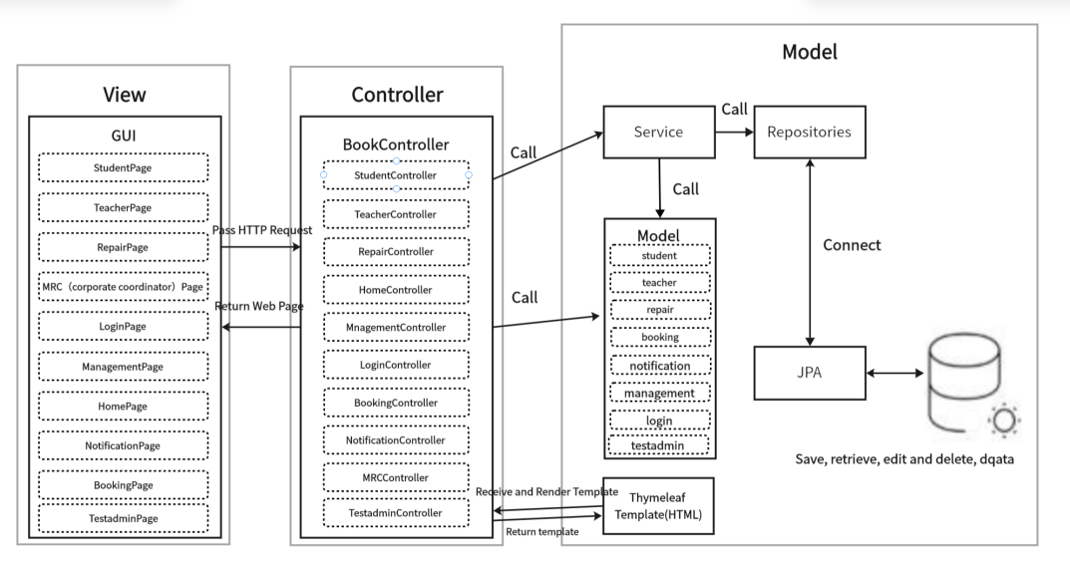
Figure1: MVC architecture
In summary, the adoption of the MVC architecture, together with a robust technology stack and structured development workflow, has enabled our team to deliver a secure, modular, and scalable Meeting Booking System.
  - Frontend System
The frontend of our Meeting Booking System was developed using Vue.js 3 (v3.3.4), a progressive JavaScript framework known for its performance, modularity, and ease of integration with modern toolchains. Leveraging TypeScript throughout the codebase ensures stronger typing and improved maintainability. Our frontend architecture supports Single Page Application (SPA) patterns, allowing dynamic view rendering and responsive user interaction without frequent page reloads.

Core Technologies and Frameworks
The project integrates the Vite (v4.4.5) build tool for ultra-fast development and hot module replacement (HMR). Routing is handled by Vue Router (v4.2.4), supporting nested and dynamic routes across user roles. The UI layer incorporates Element Plus (v2.3.12) as the component library, delivering reusable and accessible components such as modals, forms, calendars, and tables.
We utilize Axios (v1.7.2) for efficient HTTP communication with backend services. For interactive scheduling, FullCalendar (v6.1.15) enables intuitive drag-and-drop interfaces, while ECharts (v5.4.3) powers our data visualization dashboards, supporting bar, line, and pie charts for displaying room usage trends.

UI/UX & Optimization
The system integrates Vue-Tippy (v6.6.0) to deliver contextual tooltips and instructional prompts. We adopted accessibility-first practices and applied structured routing and role-based guards to restrict unauthorized views. Frontend performance optimization strategies included lazy-loading routes and asynchronously importing large third-party modules.

In summary, our frontend system offers a modular, dynamic, and maintainable user interface tailored to the functional diversity of the Meeting Booking System. With strong integration of visualization, interactivity, and security, it serves as a robust client-side foundation for the overall platform.
  - Backend System
The backend architecture of our Meeting Booking System is implemented following a layered MVC structure, promoting separation of concerns and facilitating maintainability, testability, and scalability. It consists of the Controller, Service, DAO, and Entity layers, each handling a distinct set of responsibilities.
Controller Layer:
The Controller layer maps incoming RESTful API requests to service-layer operations using Spring Boot’s @RestController and @RequestMapping annotations. Controllers are role-sensitive and serve endpoints such as:
1．/api/bookings for managing meeting room reservations.
2．/api/rooms for retrieving available room lists and metadata.
3．/api/users for role-based user management.
4．/api/repair for repair request submission and resolution.
5．/api/statistics for returning room usage and booking distribution data.
The controller layer is integrated with Spring Boot Security and JWT filters to restrict access and protect endpoint data. Each API is documented and structured with proper response models, supporting seamless interaction with the Vue.js frontend.
Service Layer:
The Service layer contains the business logic and workflow coordination across components. It employs Spring’s @Service and dependency injection to integrate DAO components. Key responsibilities include:
1．Checking room availability before booking.
2．Coordinating approval flows for MRC roles.
3．User login, session management, and permission control are managed via Sa-Token, with secure password validation handled by Spring Security Crypto.
4．Generating data for charts using ECharts-compatible formats.
5．Sending notifications or processing repair updates.
The service layer enforces validation, handles transactional logic, and ensures consistency between frontend expectations and backend state.
DAO (Data Access Object) Layer:
The DAO layer leverages MyBatis-Plus (3.5.7) and MyBatis-Plus-Join (1.4.7.2) to abstract SQL operations and simplify CRUD logic. Each DAO interface is responsible for operations related to a specific table, including:
1．Room and category creation, retrieval, and modification.
2．Reservation status updates and history lookups.
3．User and role assignment management.
4．Aggregated data queries for statistical dashboards.
By encapsulating database logic, this layer provides a reusable and centralized structure for persistence access.
Entity Layer:
The Entity layer defines Java classes that directly correspond to tables within the MySQL (5.7.27) relational database. These include: meeting_category, meeting_room, meeting_book, sys_dept, sys_user, sys_role, sys_menu, sys_role_menu, sys_user_role, sys_notice and repair.
These entities use annotations such as @TableName and @TableField (via MyBatis-Plus) to map to their respective database tables and fields. Relationships are managed through foreign keys and join tables to ensure data integrity.

This well-defined backend architecture supports efficient request handling, secure data management, and the modular scalability required for the ongoing evolution of the Meeting Booking System.
  - High-level Database Design
Our database design adopts MySQL (v5.7.27) as the underlying relational database management system to support the persistent storage and logical organization of the core entities involved in the Meeting Booking System. The database schema is structured using a normalized Entity-Relationship Diagram (ERD), ensuring a robust, scalable, and consistent data model that reflects the system’s operational logic. Relationships between tables are enforced using foreign key constraints, maintaining referential integrity throughout the system.
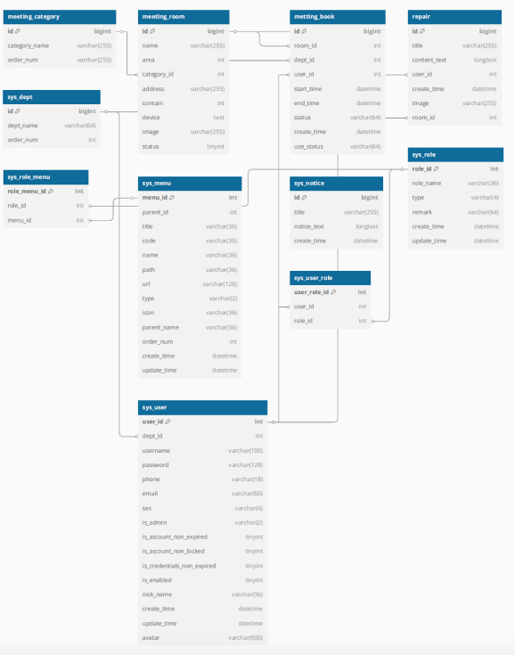
Figure2: ERD

Entity Identification
Key entities were identified based on the system's functional modules and role-based access model. The selected entities, designed to encapsulate semantically coherent data, include:
- sys_user (Users): Captures login credentials, contact details, and status flags for all system users across roles.
- sys_dept (Departments): Represents department affiliations for users, facilitating hierarchical access control and booking permissions.
- meeting_room (Meeting Rooms): Stores data such as room name, capacity, location, available equipment, and status (e.g., active, under repair).
- meeting_category (Meeting Categories): Classifies meeting rooms for filtering and organizational purposes.
- meeting_book (Reservations): Logs meeting room booking records, including time slots, approval status, requester ID, and associated department.
- sys_role (Roles): Defines system roles including Student, Teacher, MRC, Repair Staff, and Test Admin.
- sys_menu (Menus): Maintains mappings of accessible routes or functional modules within the system’s frontend UI.
- sys_role_menu (Role-Menu Mapping): Manages granular role-to-menu permission mappings for secure interface access.
- sys_user_role (User-Role Mapping): Tracks many-to-many relationships between users and roles.
- sys_notice (Notices): Stores public announcements and system bulletins shared across user types.
- repair (Repair Records): Captures maintenance-related issues submitted by users and updated by repair staff, including status logs and resolution notes.
These entities form the backbone of the system, supporting multi-role interactions, scheduling processes, access management, and communication flows.

Data Normalization
The schema was designed in compliance with Third Normal Form (3NF) to ensure data independence and eliminate redundancy. By isolating single-subject data into discrete tables and establishing foreign key relationships, the design promotes:
- Minimal duplication of data across entities.
- High data integrity and consistency.
- Efficient update and deletion operations without cascading anomalies.

The final ERD aligns with the modular architecture of the application, ensuring each data table directly supports one or more service endpoints while enabling seamless scalability and feature extension in future iterations.
3.Software Design
3.1 Software Modules
In our Meeting Booking System, we designed and implemented five core software modules based on the distinct user roles within the system. These roles include: Student, Teacher, MRC (Conference Coordinator), Repair Staff, and Super Admin (Test Admin). Each role is granted specific access permissions and system functionalities tailored to their responsibilities.
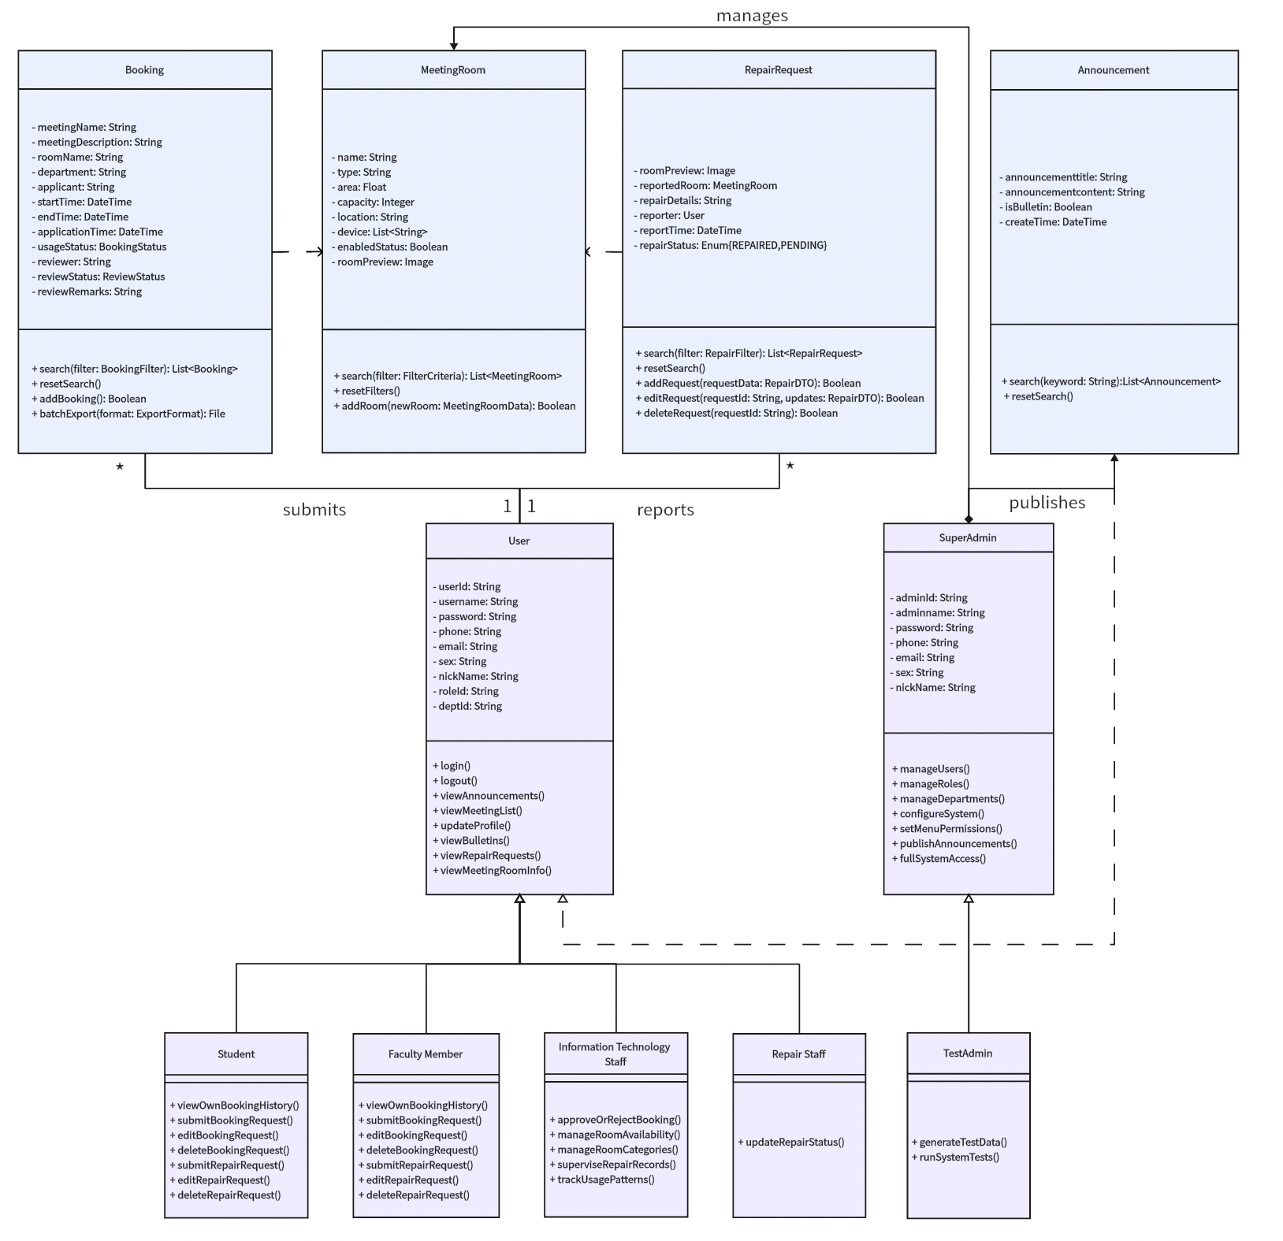
Figure3: Software Modules Design

- Student Module: Students serve as standard users who can browse available meeting rooms, make booking requests, view booking history, check announcements and bulletins, and report issues via the Repair Management module. Their permissions are limited to their own data, ensuring a simplified and secure user experience.
- Teacher Module: Teachers share a similar interface with students but may have slightly expanded permissions depending on institutional policies. They can manage their bookings, access meeting lists, announcements, and submit repair requests. Their role focuses on personal scheduling and participation in meetings.
- MRC (Conference Coordinator) Module: MRC users act as approvers and supervisors for the meeting spaces. They can review, approve or deny reservation requests, manage room availability and categories, oversee repair records and track usage patterns. This module plays a crucial role in ensuring the integrity and efficiency of the meeting scheduling process.
- Repair Staff Module: This module is designed for personnel responsible for maintaining and repairing meeting rooms. Repair staff can view submitted repair requests, update repair statuses (e.g., pending, in progress, repaired), and manage associated images or notes. Their dashboard is streamlined for task tracking and completion.
- Super Admin (Test Admin) Module: The Super Admin has comprehensive control over the entire system, including user, role, and department management, system configuration, menu permissions, and announcement publishing. This role is primarily used for system setup, deployment, and high-level oversight.

In addition to role-specific modules, there are several reusable core functionalities accessible across roles, such as the Announcement and Bulletin modules (providing official communications), and the Repair Management module (allowing users to submit repair issues). These modules ensure consistent experiences across roles while maintaining functionality segregation.

From a modular design perspective, the internal structure of each module maintains high cohesion, with related business logic grouped tightly together. At the same time, inter-module dependencies are minimized, allowing the system to be scalable, maintainable, and easy to extend or modify.

3.2 High-level Process Flow
The Meeting Booking System integrates a full suite of core functionalities for managing institutional meeting room reservations, with each module logically separated and collaboratively coordinated to streamline both user experience and administrative oversight. The process flow is illustrated in Appendix 2.

Entry and Authentication Flow
Upon accessing the system homepage, users may choose to register by submitting account credentials and essential personal information. Following successful registration, they are able to log in. The system employs secure session management, including duplicate-login prevention and session expiration control.

Upon successful authentication, the system detects the user’s role and automatically redirects them to their corresponding dashboard:

Role-Based Routing and Functional Flow
• Student / Teacher Users:
Redirected to a personalized user dashboard. They can:
- Browse available meeting rooms in a calendar-integrated view (powered by FullCalendar)
- Submit and manage booking requests
- Track booking status and history
- Submit repair requests for rooms
- Access announcements and system bulletins
• MRC (Conference Coordinator):
Redirected to an approval and scheduling dashboard. Core features include:
- Reviewing, approving, or rejecting booking applications
- Managing meeting room availability and metadata
- Monitoring room usage trends and repair ticket statuses
- Accessing a fixed information pane, implemented with Vue 3 + Element Plus, that persistently displays pending approvals and system alerts via Vue Router and <keep-alive>
• Repair Staff:
Directed to the repair management module with features such as:
- Viewing repair submissions from users
- Updating maintenance records (e.g., in progress, completed)
- Uploading images or notes for issue verification
- Filtering repair tasks by urgency or status
• Test Admin (Super Admin):
Granted access to the full administrative backend. Key functions include:
- Managing users, departments, and roles
- Defining permission menus (sys_menu) and binding them to roles
- Publishing global announcements (sys_notice)
- Monitoring all bookings and repair flows
- Operating within a persistent admin layout enhanced by router caching and <keep-alive> to maintain state across subviews and reduce UI rendering overhead
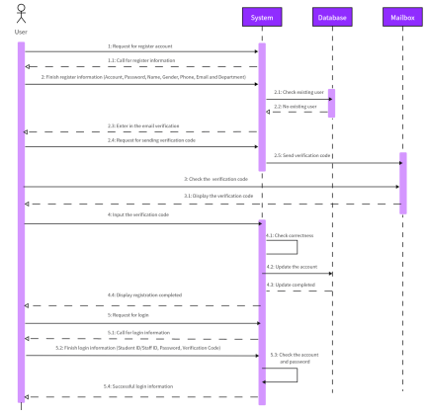 | 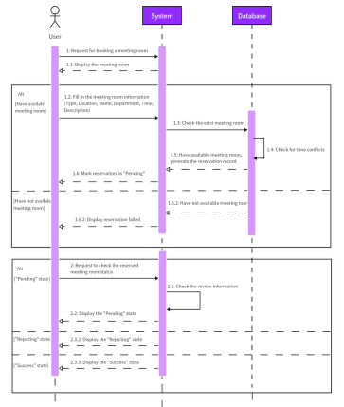 | 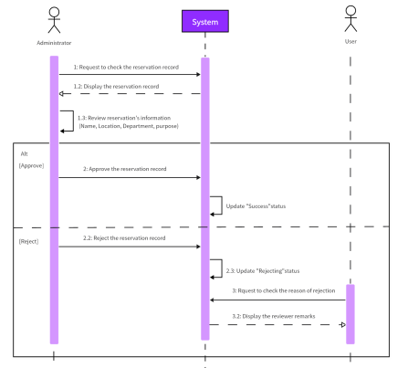

Technical Integration and Responsiveness
All user actions are served by asynchronous frontend-backend communication using Axios, and the interface dynamically updates using Vue.js 3’s reactive rendering capabilities. Element Plus provides a uniform design language across modules, while backend services—developed using Spring Boot—ensure secure RESTful request processing, token-based authentication (via JWT), and business logic enforcement.

This role-driven, modular process flow supports high usability, system reliability, and functional scalability across diverse user scenarios.

3.3 Software Support Service
Our Meeting Booking System relies on a suite of software tools and service integrations that collectively enhance development efficiency, system performance, and operational maintainability. These services span across database development, interface navigation, and infrastructure management.

Database-Related Services
• MySQL (v5.7.27):
MySQL serves as the primary relational database management system, supporting normalized table structures and high-performance query execution. Foreign key constraints ensure robust referential integrity between core entities such as users, meeting rooms, reservations, and permissions.

• MyBatis-Plus + MyBatis-Plus-Join:
We adopted MyBatis-Plus (v3.5.7) and MyBatis-Plus-Join (v1.4.7.2) as our ORM solution to streamline SQL operations. These tools allow concise query writing, auto-generation of boilerplate code, and advanced conditional query support, significantly reducing the complexity and redundancy of database access logic.

• Navicat (v11.1.13):
Navicat was used during the development phase to visually manage the MySQL database. It enabled collaborative access to table structures, ERD diagrams, test queries, and data population across development environments.

Web Navigation Services
The system features a role-adaptive sidebar navigation built with Vue.js 3 and Element Plus, supporting collapsible, hierarchical menus with route-based access control. Navigation state is persistently maintained using Vue Router and <keep-alive> to ensure smooth user experiences across modules. This responsive layout guarantees accessibility across varied screen resolutions and supports interface consistency for students, teachers, MRCs, repair staff, and administrators.

Other Supporting Services
• Spring Boot Mail Service:
The system integrates Spring Boot’s JavaMailSender for email-based verification. During registration, the backend generates a secure, randomized code and sends it to the user's provided email. The mail service is designed to be event-driven and extensible for future use cases such as reservation status notifications and administrative announcements.

• Git + Coding.net:
Source code versioning was managed via Git, with remote repositories hosted on Coding.net. Each team member developed within independent branches following a Gitflow-like model, using pull requests for integration and code reviews. Coding.net also supported Scrum task tracking and Wiki documentation.

• Maven (v3.8.1):
Maven was used as the backend’s dependency and build management tool. It helped manage transitive dependencies, resolve version conflicts, and package the Spring Boot application into a JAR file for production deployment. Maven’s standard project structure also facilitated better collaboration among backend developers.

Together, these services form a cohesive foundation that supports rapid development, modular deployment, and stable maintenance throughout the project lifecycle.
3.4 Coding Structure and Convention
Project Directory Structure
Following best practices under the Spring Boot framework, the backend is organized using a conventional multi-layered directory structure—typically segmented into controller, service, mapper, entity, config, and utils packages. Each directory encapsulates specific responsibilities, aligning with the Model-Service-Controller design pattern. Detailed definitions of each directory's function are maintained in our internal technical documentation (see Appendix 1).
On the frontend, the Vue.js 3 application adopts a modular structure supported by Vite. The source code is organized into logical folders, including views, components, router, assets, store, and api, which facilitates component-based development, scoped styling, and role-based route access.

Method Invocation Convention
To promote loose coupling and enhance maintainability, the Controller layer invokes business logic strictly through Service interfaces. Each service interface can correspond to one or more implementation classes. This abstraction provides flexibility for future logic extension or swapping of implementation details without affecting the interface layer. It also facilitates mocking during unit testing.

Naming Convention
We adhered to standardized naming practices for consistency and clarity:
- Methods and variables: camelCase (e.g., createBookingRequest)
- Class names: PascalCase (e.g., BookingController)
- Constants: UPPER_CASE with underscores (e.g., MAX_ROOM_CAPACITY)
- Naming principle: all names are semantically meaningful and follow the "entity + action" pattern when applicable (e.g., getUserPermissionList)
- Interface implementation classes: suffixed with Impl (e.g., RoomServiceImpl)

Code Maintenance Standards
During collaborative development, code maintainability was emphasized:
- Developers are expected to write self-documenting code with concise and relevant inline comments
- Prior to any Git commits, unused code segments and outdated comments are cleaned up to preserve repository hygiene
- Code formatting follows IDE-configured style guides across the team to maintain structural consistency

Task Management and Code Completion
Unfinished features and pending implementations are not marked with inline TODOs. Instead, we adopted a structured task-tracking workflow using Coding.net’s Scrum board and Wiki documentation. Task items are divided by Sprint and categorized under Epic/Story/Task structures, allowing all group members to clearly track development progress, assign responsibilities, and manage future implementation priorities. Daily stand-ups and milestone meetings ensure timely communication of pending development tasks.

This convention-centric, layered coding framework enhances system readability, developer onboarding, and long-term scalability.
3.5 Software Configuration and Production Environmen
Software Configuration
The software stack of our Meeting Booking System is composed of decoupled yet tightly integrated technologies that support modular development, role-based access, and dynamic data rendering across user groups.
• Frontend Configuration:
The user interface is developed using HTML, CSS, JavaScript, and Vue.js 3 (v3.3.4), with TypeScript employed for improved static type checking and code robustness. We adopted Vite (v4.4.5) as the frontend build tool to enable rapid module bundling and hot module replacement (HMR).
Component-based design is achieved using Element Plus (v2.3.12), which supports highly customizable UI widgets. Axios (v1.7.2) handles HTTP communication with the backend APIs, and Vue Router (v4.2.4) manages role-based routing. Additional libraries such as ECharts (v5.4.3) and FullCalendar (v6.1.15) support data visualization and scheduling functionality, respectively.
• Backend Configuration:
The backend follows the Spring Boot (v3.2.7) framework structured under the MVC (Model-View-Controller) paradigm. The logic is distributed across controller, service, and mapper layers, ensuring clear responsibility separation. MyBatis-Plus (v3.5.7) and MyBatis-Plus-Join (v1.4.7.2) facilitate ORM mapping and multi-table joins, while Druid (v1.2.1) manages connection pooling and database monitoring. Sa-Token (v1.38.0) serves as the core framework for managing authentication, authorization, and session control, while Spring Security Crypto is employed specifically for secure password hashing during user registration and login.
• Database Layer:
We selected MySQL (v5.7.27) as the relational database management system, optimized through third normal form (3NF) schema design and enforced with foreign key constraints. Navicat (v11.1.13) was used during development for database visualization and query debugging.

Production Environment
The system is deployed on a virtual instance hosted on Alibaba Cloud (Aliyun), providing a real-world, scalable production environment.
- The frontend is compiled using Vite and deployed to the server’s dist directory.
- The backend is packaged as a .jar file via Maven (v3.8.1) and independently executed as a Spring Boot service.
- Nginx acts as a reverse proxy to route HTTP(S) requests between the frontend and backend servers.
- The system supports multiple user roles with independent routing logic and dynamic module loading.

All development was performed using Visual Studio Code (v1.98.0), with Git for version control and Coding.net as the collaboration and code repository platform. The system’s deployment process incorporated environment testing, incremental builds, and role-specific UI validation to ensure deployment consistency and operational reliability.

The production environment ensures high availability, secure access control, and support for future scalability through containerized deployment or cloud-native service expansion if required.

