XI’AN JIAOTONG-LIVERPOOL UNIVERSITY
西 交 利 物 浦 大 学


COURSEWORK SUBMISSION COVER SHEET
Name and ID | Nan.Lin 2252173
Programme | Information System and Information Management
Module Title | E-business Systems
Module Code | IOM201
Assignment Title | Individual Coursework
Submission Deadline | 23:59pm, Sunday, December 15, 2024 (China Standard Time, UTC/ GMT+8)
Module Leader | Dr. Bingjie Deng

By uploading or submitting this coursework submission cover sheet, I certify the following:
- I have read and understood the definitions of PLAGIARISM, COLLUSION, and the FABRICATION Of DATA, as outlined in the Postgraduate Student Handbook of Xi’an Jiaotong-Liverpool University and as posted on the University Website.
- This work is my own, original work produced specifically for this assignment. It does not misrepresent the work of another person or institution as my own. Additionally, it is a submission that has not been previously published, or submitted to another module.
- This work is not the product of unauthorized collaboration between myself and others.
- This work is free of embellished or fabricated data.
- This work does not make use of Generative AI in content generation unless the assessment has explicitly permitted it. I acknowledge it is my responsibility to ascertain what use of Generative AI permitted, if at all, on each individual assessment.

I understand that PLAGIARISM, COLLUSION, USE OF GENERATIVE AI WITHOUT PERMISSION, and SUBMISSION OF FABRICATION WORK are serious disciplinary offences. By uploading or submitting this cover sheet, I acknowledge that I am subject to disciplinary action if I am found to have committed such acts.

Marking Scheme
Business activity and IS adoption-40
Future IS adoption-20
Use of knowledge, facts and data-30
Report formatting-10
Total | 0

Student: Please start your assignment on the next page.

Content
1. Introduction to Apple Inc. 5
2. Business Activities and Information Systems Analysis at Apple Inc. 5
2.1 Apple's Core Business 5
2.1.1 Product Design and Development 6
2.1.2 Production and Manufacturing of Products 7
2.1.3 Distribution of Products 7
2.1.4 Marketing of Products 8
2.1.5 After-sales Service for Products 9
2.1.6 Apple's Seamless Ecosystem Services 10
2.2 Information System that Supports Apple's Core Business 12
2.2.1 ERP System (SAP): Coordinating Core Business Activities 12
2.2.2 SCM and PLM Systems: Driving Development, Manufacturing, and Distribution 13
2.2.3 iCloud and App Store Connect: Strengthening Apple’s Seamless Ecosystem Services 14
3. Future Directions in IS and Technology Adoption 15
3.1 Addressing Supply Chain Challenges through IoT and Edge Computing 15
3.2 Blockchain-Based Revenue Transparency: Resolving Developer Concerns 16
4. Conclusion 18
5. Reference List 19

Apple Inc.: A Strategic Analysis of Business Activities, Information Systems, and Future IS/Technology Adoption

- Introduction to Apple Inc.
Headquartered in Cupertino, California, Apple Inc. is a leading multinational technology company with a market capitalisation of more than $2.8 trillion. Apple is renowned for its innovation, efficient supply chain, and seamless ecosystem, all supported by advanced information systems such as the enterprise management system SAP, the Apple Internal System for supply chain management, Product Lifecycle Management, as well as ecosystem tools like iCloud and App Store Connect. This report analyzes Apple’s use of these systems and explores technologies to enhance its competitiveness.
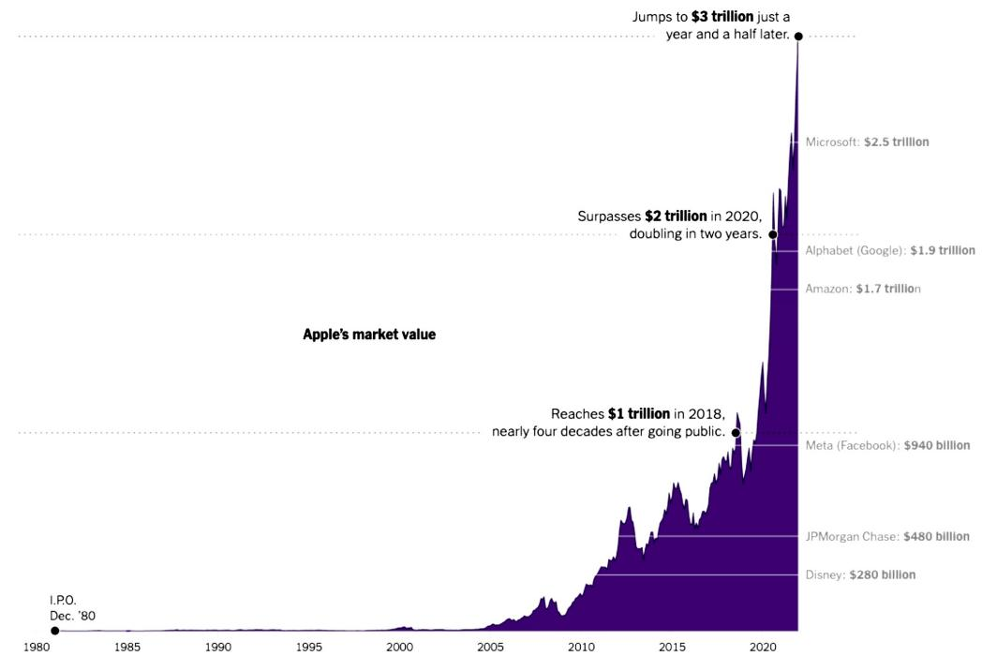
Figure 1: Apple's market value from 1980 to 2024 (From Yahoo Finance)

- Business Activities and Information Systems Analysis at Apple Inc.

2.1 Apple's Core Business
Apple's core business includes innovative product development, efficient production supported by a global supply chain, omnichannel sales, marketing and customer service, which partially matches the traditional value chain model (Kohnová and Salajová, 2023). In addition, Apple emphasizes its seamless ecosystem service through subscription services like Apple Music, iCloud, and the App Store, creating an integrated experience that fosters long-term engagement among users and software developers.
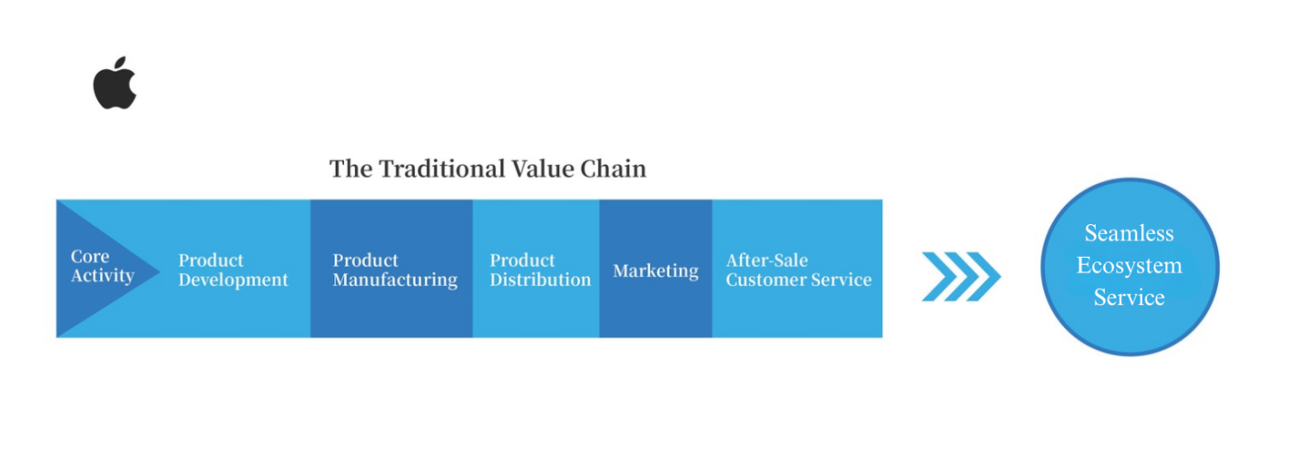
Figure 2: Apple Inc.’s Core Business Value Chain

2.1.1 Product Design and Development
In product design and development, Apple employs a vertically integrated model, designing its own hardware (e.g., A-series chips), operating systems (e.g., iOS), and services (e.g., Apple Pay), reducing reliance on suppliers like Intel and AMD. This approach enables deep software-hardware optimization, enhancing user experience. Concurrently, Apple continues to innovate with products like the 2024 Apple Vision Pro and its anticipated self-driving car project. In 2023, Apple invested over $30 billion in R&D, underscoring its dedication to technological advancement.
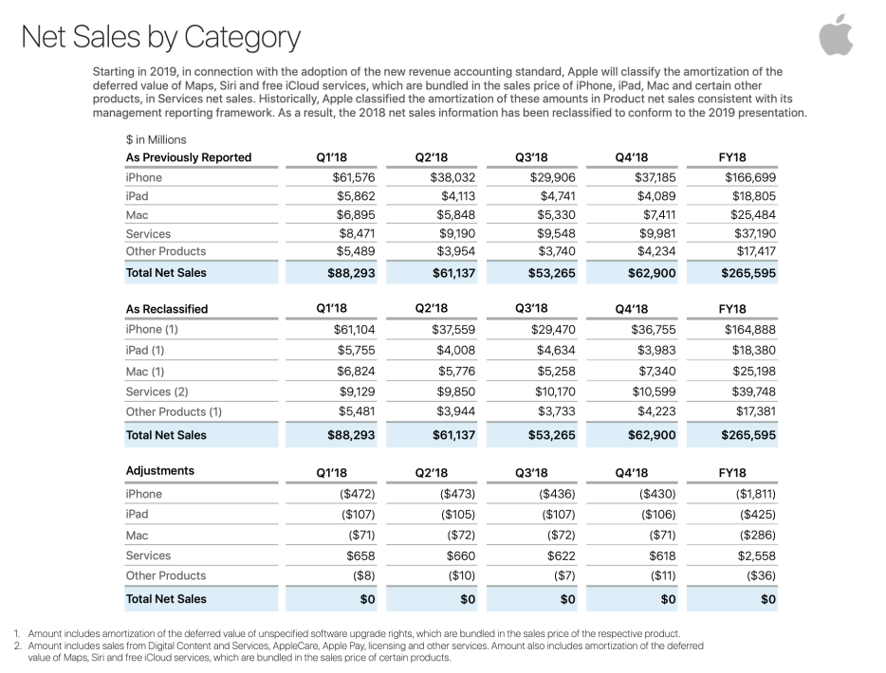
Figure 3: Net profit from each of Apple's innovative products (From Apple Investor Relations)

2.1.2 Production and Manufacturing of Products
Apple's production and manufacturing operations are of vital importance to Apple. In terms of the parts business, Apple sources key components such as Samsung displays and Sony cameras from external suppliers. In terms of the assembly business, Apple outsources such repetitive and mechanical labour to Foxconn and Pegatron, reducing its labour costs and internal transaction costs. These outsourcing and procurement strategies not only allow Apple to focus on core research and development, but also reduce market transaction costs and further improve production efficiency, in line with the dictates of transaction theory (Benson, 2019).
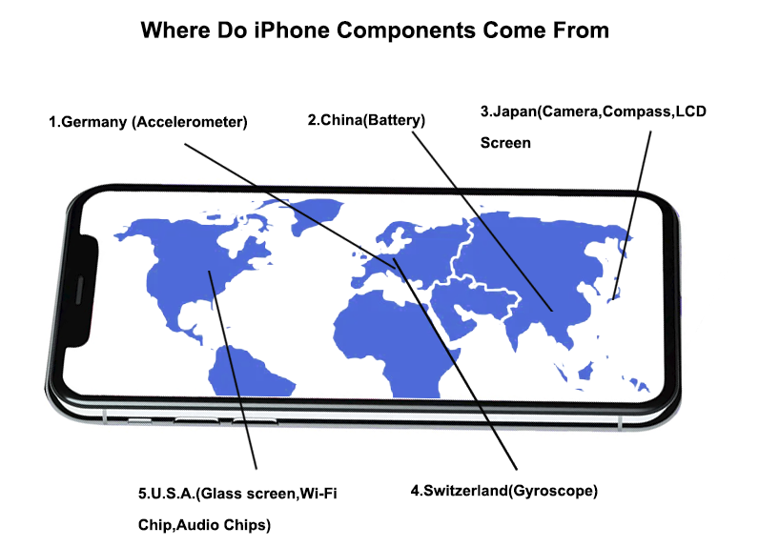
Figure 4: Apple + Foxconn model

2.1.3 Distribution of Products
Apple's global distribution and retail network has become an important pillar of its core business. Apple has more than 500 retail stores worldwide, providing customers with an immersive brand experience. At the same time, Apple has also partnered with authorised retailers such as Best Buy and telecommunications operators such as AT&T and Verizon to further expand its market share.
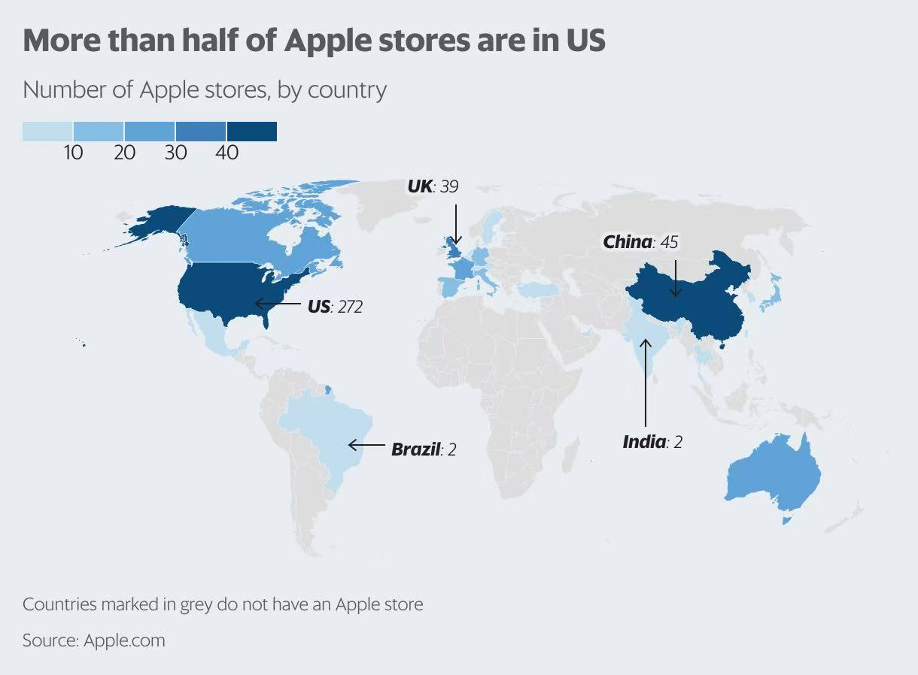
Figure 5: Map of Apple Retail Stores Worldwide (From Hilco Global)

2.1.4 Marketing of Products

In marketing, Apple has established itself as an industry leader through precise positioning and effective brand management. It has attracted high-end users with premium product promotions (e.g., iPhone Pro series) and annual events (e.g., WWDC). Simultaneously, it has captured the mid-range market and expanded its user base with initiatives like trade-in programs. These differentiated strategies effectively balance high-end and mid-range market demands while showcasing Apple’s strong execution of the Red Ocean strategy.
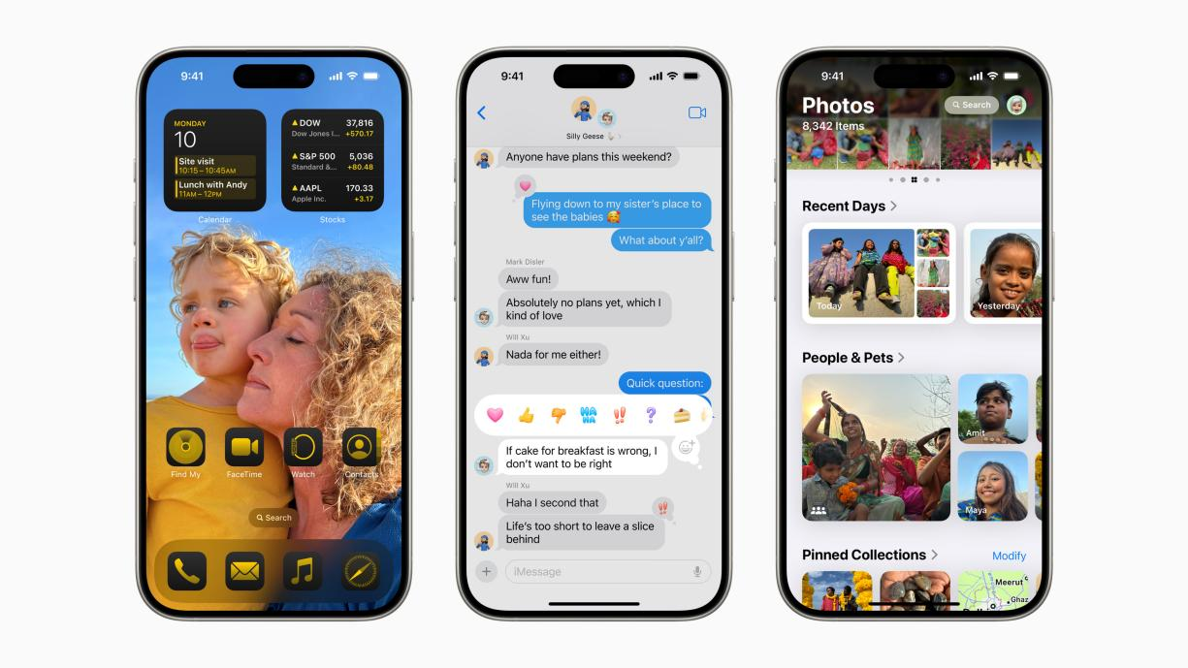
Figure 6: Apple's high-end product (iPhone Pro series) (From Apple Inc.)

Figure 7: Craig Federighi with developers at WWDC24 (From Apple Inc.)

2.1.5 After-Sales Service for Products
In terms of after-sales service, Apple provides real-time technical support through Genius Bars (Apple, 2024), online chat and the Apple Support app. This high-quality, responsive customer service has helped the company retain a large number of customers.
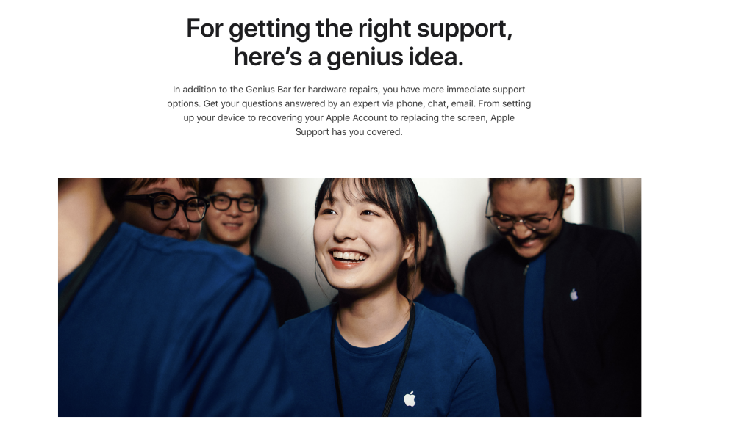
Figure 8: Genius Bar customer service (From Apple Inc.)

2.1.6 Apple's Seamless Ecosystem Services
Apple's seamless ecosystem services have become an important driving force behind its market share growth. Users generate direct and indirect revenue for Apple and developers by subscribing to paid services such as Apple Music, Apple Arcade, iCloud and Apple News+. Developers, in turn, enrich the ecosystem with high-quality apps and services using tools provided by Apple, such as Xcode and TestFlight. This mutually beneficial relationship between users and developers strengthens users' dependence on Apple devices and services, creating a win-win closed-loop ecosystem.
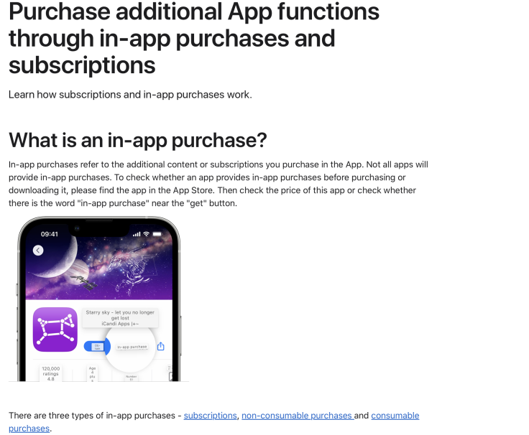
Figure 9: App Purchase User Service - a seamless ecosystem service for users (From Apple Inc.)
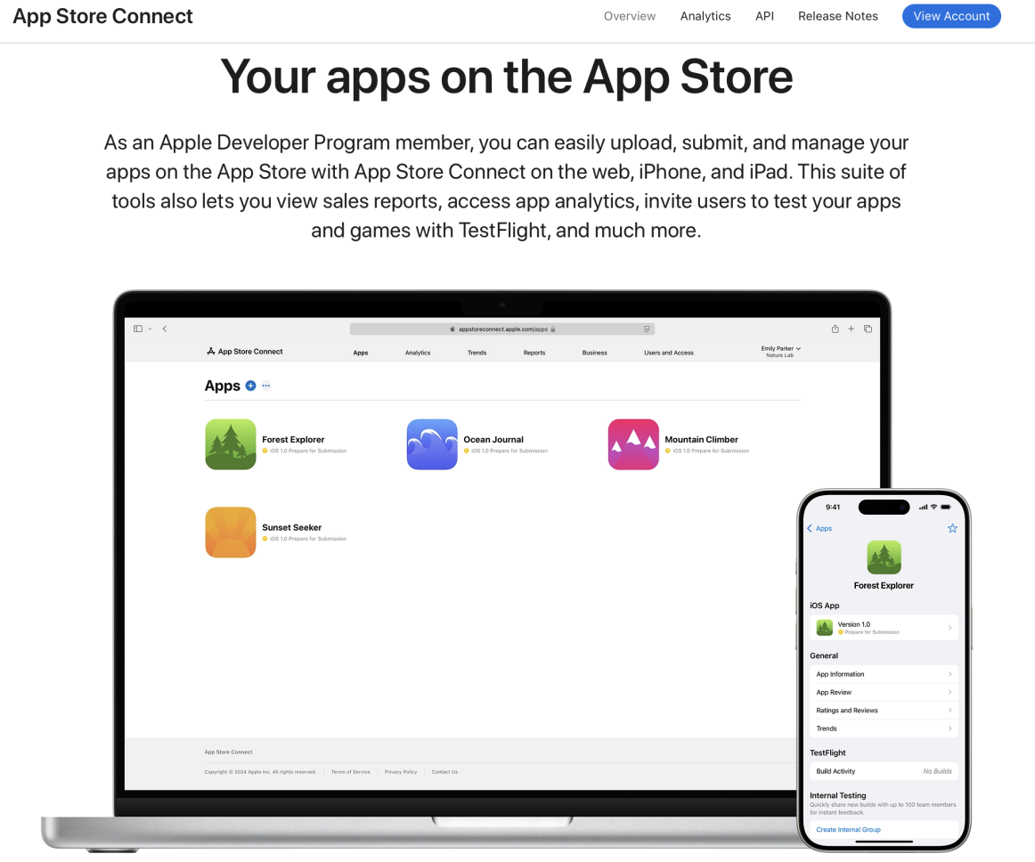
Figure 10: TestFlight Developer Tools Service - a seamless ecosystem service for developers (From Apple Inc.)

2.2 Information System that Supports Apple's Core Business

2.2.1 ERP System (SAP): Coordinating Core Business Activities
To support these core business activities, Apple implemented a number of information systems to improve overall performance. The first step was to implement an Enterprise Resource Planning (ERP) system. Apple's ERP system, SAP, operates through a centralised database that supports core internal activities, allowing different departments to share consistent data and streamline cross-departmental collaboration. This system integrates key workflows such as inventory management, financial reporting and supply chain coordination, ensuring the seamless operation of product lines such as the iPhone, MacBook and Apple Watch. However, due to Apple's frequent product updates and diverse portfolio, the company faces challenges in adapting SAP to meet the unique requirements of each product line. This requires extensive customisation of the ERP system, including configuring specific modules for hardware components, regional compliance, and production schedules. While these customisations add functionality, they significantly increase both the cost of implementation and the complexity of maintaining the system (Jean-Jules and Vicente, 2021).
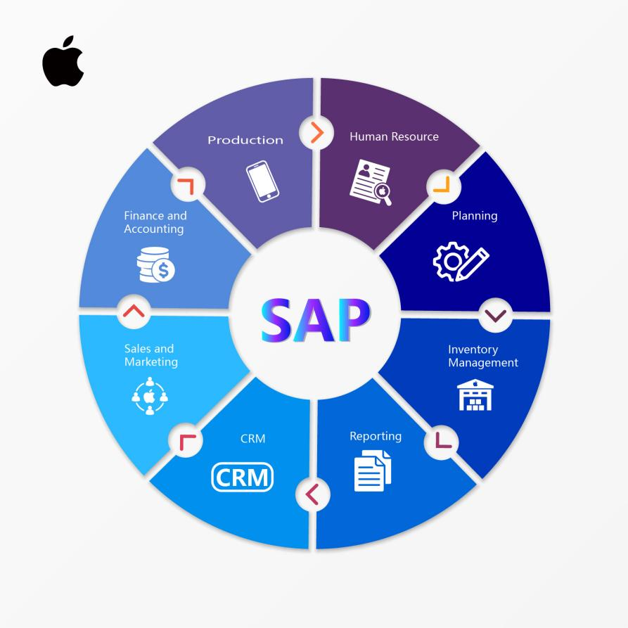
Figure 11: Apple Inc.’s ERP System

2.2.2 SCM and PLM Systems: Driving Development, Manufacturing, and Distribution
Second, Apple's supply chain management system is at the heart of product design, manufacturing and distribution. As an extension of the ERP system (SAP), it provides strong support for the company's external operations. For new product development, Apple’s supply chain management system integrates with the Product Lifecycle Management (PLM) system using advanced APIs and real-time data synchronization to enable a parallel supply chain model. Design data, such as 3D CAD files and bills of materials (BOM), is securely transmitted for real-time updates and collaboration through a cloud-based platform equipped with shared dashboards and automated workflows, facilitating team interaction and addressing inefficiencies in traditional linear supply chains. For mature products, the system leverages data analytics and demand forecasting to implement a pull-based model, combining Just-in-Time (JIT) inventory management with logistics sensors for real-time monitoring. This approach reduces the long whip effect, lowers inventory costs, and stabilizes the supply chain through predictive modeling and machine learning. Despite the obvious advantages of Apple internal system, it also faces challenges. On the one hand, in a synchronized supply chain, multi-party collaboration is challenging as it relies on seamless communication and real-time data sharing. Integrating systems like warehouse and transportation management tools is essential but prone to disruptions, such as delays in EDI (Electronic Data Interchange) transmissions or API failures, which can affect overall efficiency (Lockamy, 2017). This interconnectedness increases the complexity of maintaining workflows, requiring advanced tools like IoT and edge computing to improve collaboration and mitigate risks. On the other hand, the Apple Internal System has significant limitations in localization, making it particularly unsuitable for regions with weak infrastructure. In such areas, unreliable transportation networks, a lack of advanced logistics facilities, and unstable communication systems can severely hinder the efficiency of the Just-in-Time strategy and the pull model. Delays in delivering critical components may disrupt production schedules, while inadequate storage facilities could force companies to rely on costly emergency inventory strategies.
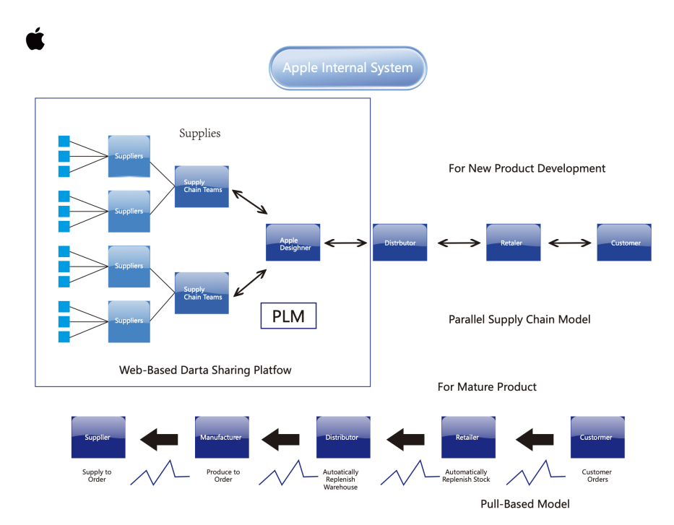
Figure 12: Apple Inc.’s SCM System and PLM System

2.2.3 iCloud and App Store Connect: Strengthening Apple’s Seamless Ecosystem Services
Finally, the iCloud cloud service system and the App Store Connect developer system work closely together to support Apple's ecosystem services. For users, iCloud utilizes advanced cloud storage and synchronization technologies to enable seamless data sharing across Apple devices, ensuring real-time updates and a consistent user experience. For developers, App Store Connect provides a powerful suite of tools driven by data analytics and machine learning, supporting app publishing, updates, performance analysis, and A/B testing to optimize applications. iCloud provides users with powerful storage support, while App Store Connect provides developers with detailed user behaviour insights by analysing stored data to help optimise product design. The synergy between the two further strengthens the closed-loop effect of the Apple ecosystem. However, these systems also have certain limitations. For users, although Apple's closed ecosystem supports seamless switching between iCloud devices, it limits cross-platform collaboration and makes it difficult for users to easily migrate data to other platforms (such as OneDrive or Google Drive) (Arif et al., 2019). For developers, App Store Connect's 30% cut of app sales and subscriptions has long been a source of dissatisfaction that not only undermines their enthusiasm, but also poses a long-term threat to the overall innovation capacity of the Apple ecosystem. As a result, there have been widespread calls in the industry for the introduction of a more flexible or tiered pricing structure that better meets the needs of developers of different sizes.
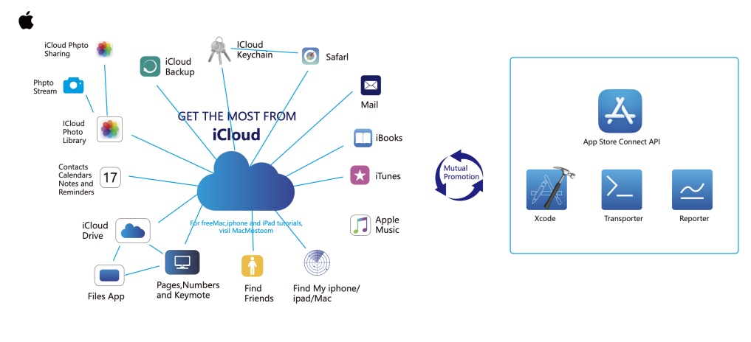
Figure 13: iCloud cloud service system and the App Store Connect developer system

- Future Directions in IS and Technology Adoption

3.1 Addressing Supply Chain Challenges through IoT and Edge Computing
Hardware production and distribution is one of Apple's main sources of revenue, so the efficient and stable operation of Apple internal system is critical. To address the challenges of complex supply chain collaboration and just-in-time strategies in hard-to-reach areas, Apple can deploy Internet of Things and edge computing technologies (Shanmugam, 2022) to improve competitiveness. IoT enables real-time data collection and sharing through smart sensors, allowing teams to access and adjust plans instantly. Edge computing reduces delays by processing data locally, supporting real-time decision-making. The effective combination of these two technologies enhances collaboration efficiency and addresses the challenges of complex supply chain coordination. In addition, with reference to Amazon's supply chain practices, the newly established Internet of Things and edge computing can also dynamically optimise transport routes and adjust delivery plans based on real-time traffic data, solving the problem of logistics efficiency in areas with poor traffic conditions. However, these technologies also have limitations, with one major challenge being data standardization. Different companies and regions often use incompatible data formats and communication protocols. For instance, Foxconn uses the Oracle ERP system to record production and inventory data, while Samsung relies on the SAP system to manage parts delivery schedules. The differences in system interfaces between these platforms not only complicate data sharing but also increase the likelihood of errors, delays, and miscommunication. Furthermore, the lack of universally accepted data exchange standards adds extra costs for customizing IoT and edge computing integrations. Amid the rising tide of deglobalization, geopolitical factors further hinder seamless collaboration while exerting political pressure on smaller supply chain teams.
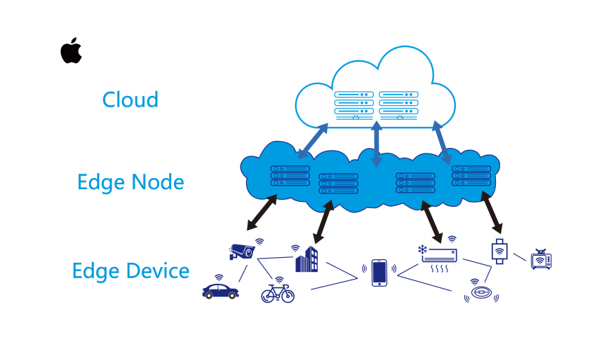
Figure 14: Internet of Things (IoT) and edge computing technologies

3.2 Blockchain-Based Revenue Transparency: Resolving Developer Concerns
Moreover, developers are at the heart of Apple's app innovation, and the 30% revenue share policy of App Store Connect has caused long-term dissatisfaction among developers and undermined their confidence in the Apple ecosystem. To solve this problem, Apple could introduce a blockchain-based revenue transparency system (Borikar et al., 2023) to improve competitiveness. By introducing blockchain technology and a dynamic revenue share mechanism, this system could significantly improve the transparency and fairness of the revenue sharing process. On the one hand, developers' app sales and subscription revenue records will be stored on the blockchain, ensuring that the data cannot be tampered with and is traceable. On the other hand, the system introduces a dynamic sharing ratio mechanism. For example, for small and medium-sized developers, the system can set a lower sharing ratio (such as 15%), reducing the cost of entering the ecosystem; for developers with higher revenue, the sharing ratio can be maintained at 30% to support the long-term profitability of the Apple platform. This tiered sharing model can not only encourage more small and medium sized developers to join, but also ensure that high revenue developers contribute more revenue to the Apple ecosystem. However, this system raises issues of privacy and transparency. On the one hand, the transparency of the blockchain requires transaction records to be public and traceable, but excessive transparency could expose developers' revenue information, market strategies and other sensitive data. This information could be used by competitors, harming developers' interests. On the other hand, laws and regulations such as the CCPA and GDPR have strict requirements for user data privacy (Kurtz et al., 2022). If data protection is not done properly or there is a serious leak, Apple will face a fine of up to 4% of its annual global turnover or 20 million euros (whichever is higher).
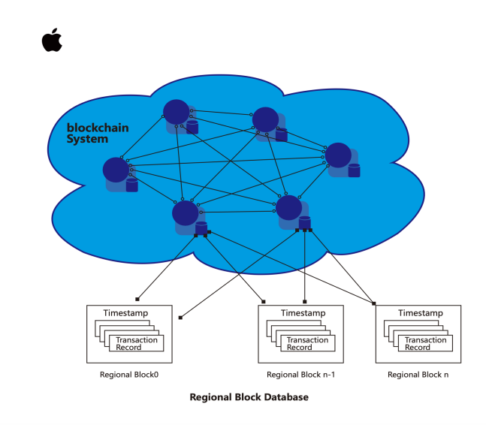
Figure 15: The blockchain-based revenue transparency system

- Conclusion
Apple has strengthened its position as a global technology leader through innovative product development, efficient supply chain manufacturing, a globally connected distribution network, targeted marketing, comprehensive customer services and a seamless ecosystem. Meanwhile, information systems such as ERP systems, SCM systems integrated with PLM, iCloud cloud services and App Store Connect provide strong support for its vast business. However, as the company continues to grow, its supply chain management and developer relationships face many challenges. IoT and edge computing technologies can enhance supply chain collaboration efficiency through real-time data collection and dynamic route optimization, but data standardization and geopolitical factors remain significant bottlenecks. Similarly, blockchain-based revenue sharing systems offer developers greater transparency and fairness, but privacy and compliance risks remain. By deploying innovative technologies to address these challenges, Apple can not only maintain its competitive advantage in the supply chain, but also build a more inclusive and resilient ecosystem that creates greater value for the company and its stakeholders.

(Word Count: 1999)

- Reference List
Apple (2024) Genius Bar. Available at: https://www.apple.com.cn/retail/geniusbar/ (Accessed: 6 December 2024).

Apple Inc. (2023) Annual report 2023. Available at:
https://s2.q4cdn.com/470004039/files/doc_earnings/2023/q4/filing/_10-K-Q4-2023-As-Filed.pdf (Accessed: 6 December 2024).

Arif, H. et al. (2019) ‘A Comparison between Google Cloud Service and iCloud’, 2019 IEEE 4th International Conference on Computer and Communication Systems (ICCCS), Computer and Communication Systems (ICCCS), 2019 IEEE 4th International Conference on, pp. 337-340. doi:10.1109/CCOMS.2019.8821744.

Borikar, D.A. et al. (2023) ‘Towards a Secure and Reliable Digital Repository for Land Records in India : A Blockchain-based Approach’, 2023 OITS International Conference on Information Technology (OCIT), Information Technology (OCIT), 2023 OITS International Conference on, pp. 681-686.
doi:10.1109/OCIT59427.2023.10431340.

Jean-Jules, J. and Vicente, R. (2021) ‘Rethinking the implementation of enterprise risk management (ERM) as a socio-technical challenge’, Journal of Risk Research, 24(2), pp. 247-266. doi:10.1080/13669877.2020.1750462.

Kohnová, L. and Salajová, N. (2023) ‘Impact of Industry 4.0 on Companies: Value Chain Model Analysis’, Administrative Sciences (2076-3387), 13(2), p. 35. doi:10.3390/admsci13020035.

Kurtz, C. et al. (2022) ‘Accountability of platform providers for unlawful personal data processing in their ecosystems-A socio-techno-legal analysis of Facebook and Apple’s iOS according to GDPR’, Journal of Responsible Technology, 9. doi:10.1016/j.jrt.2021.100018.

Lockamy, A. (2017) ‘An examination of external risk factors in Apple Inc.’s supply chain’, Supply Chain Forum: International Journal, 18(3), pp. 177-188. doi:10.1080/16258312.2017.1328252.

Peter Benson (2019) Justice in Transactions : A Theory of Contract Law. Cambridge, Massachusetts: Belknap Press. Available at:
https://search.ebscohost.com/login.aspx?direct=true&db=nlebk&AN=2260009&site=eds-live&scope=site (Accessed: 6 December 2024).

Shanmugam, K. (2022) IoT Edge Computing with MicroK8s : a hands-on approach to building, deploying, and distributing production-ready Kubernetes on IoT and Edge Platforms. Packt Publishing, Limited. Available at:
https://search.ebscohost.com/login.aspx?direct=true&db=cat01010a&AN=xjtlu.0002500388&site=eds-live&scope=site (Accessed: 6 December 2024).

