心理健康问题不仅影响个体的幸福感，也影响组织的生产力，导致人员流失的增加。
Cao, X. et al. (2022) ‘The influence of mental health on job satisfaction: Mediating effect of psychological capital and social capital’, Frontiers in Public Health, 10. doi:10.3389/fpubh.2022.797274.

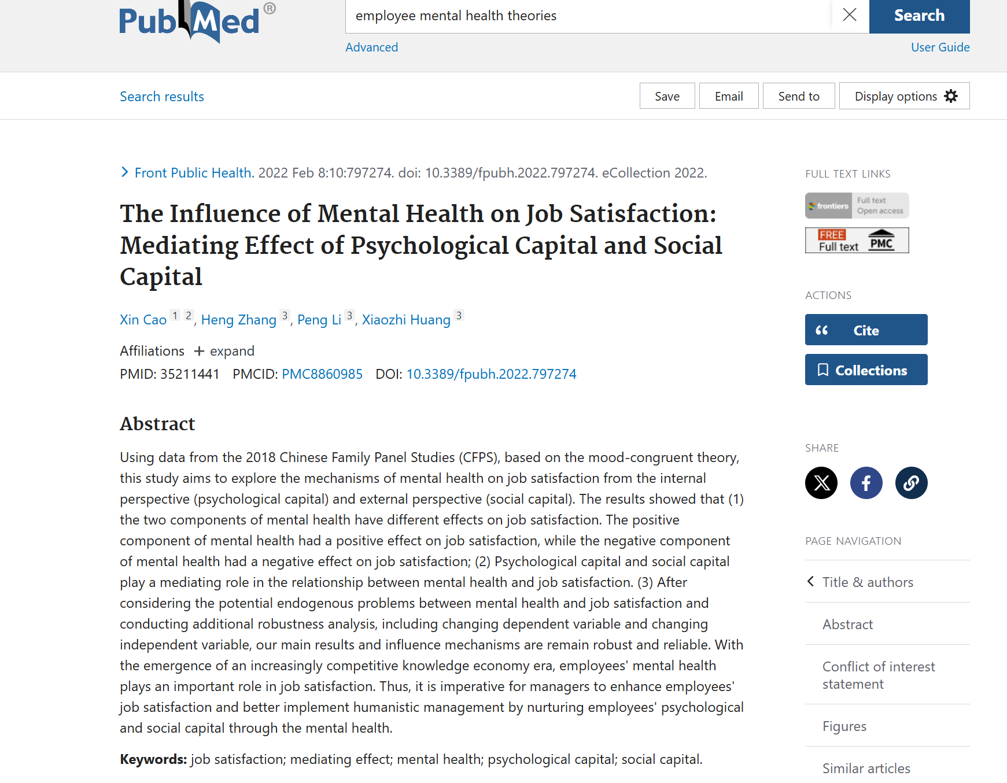

NLP
Advances in generative AI, particularly in large language models, have revolutionized NLP, allowing for the development of systems that can recognize and respond to emotions more effectively. These models are now being used in various applications, such as virtual companions and educational tools, to provide personalized, empathetic responses​生成式人工智能的进步，特别是在大型语言模型方面的进步，彻底改变了NLP，使系统能够更有效地识别和响应情感。这些模型现在被用于各种应用程序，如虚拟伴侣和教育工具，以提供个性化的、同理心的回应Hagos, D.H., Battle, R. and Rawat, D.B. (2024) ‘Recent advances in Generative AI and large language models: Current status, Challenges, and perspectives’, IEEE Transactions on Artificial Intelligence, pp. 1–21. doi:10.1109/tai.2024.3444742.
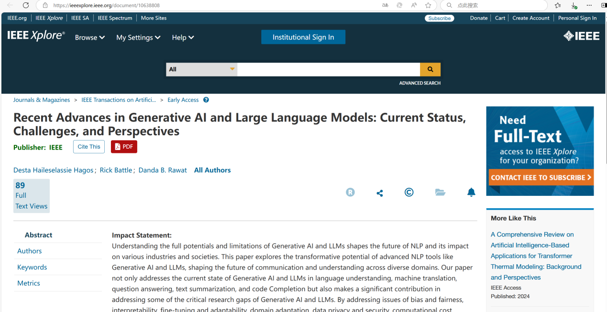

Frontiers in Psychology highlights that work stress negatively impacts employee performance by affecting mental health. The study shows that addressing mental health issues in the workplace can fully mediate the negative effects of stress, leading to improved employee productivity​
Chen, B. et al. (2022) ‘Work stress, mental health, and employee performance’, Frontiers in Psychology, 13. doi:10.3389/fpsyg.2022.1006580.
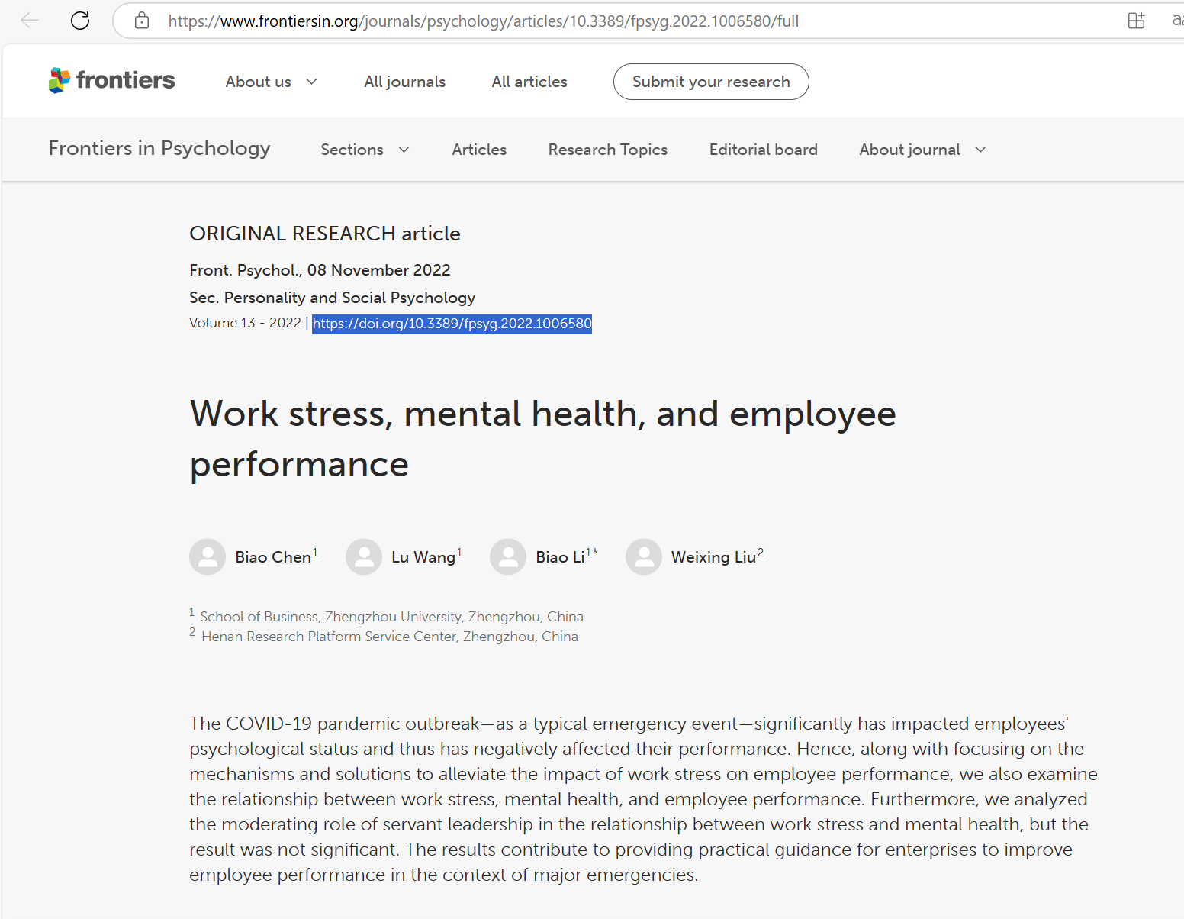

领导成员交换理论（Leader-Member Exchange Theory, LMX）
领导-成员交换与心理健康支持
一些研究表明，管理者通过建立高质量的LMX关系，能够更好地理解员工的情绪状态。高质量的LMX关系不仅能够减少员工的情绪撤退行为，还能够增强员工的心理赋权和工作投入。这为管理层获取员工情绪数据并及时采取心理干预措施提供了基础。通过高质量的关系，管理者可以及早发现员工的情绪波动，并提供适当的支持，从而避免员工心理健康问题的恶化​
Aggarwal, A. et al. (2020) ‘Leader–member exchange, work engagement, and psychological withdrawal behavior: The mediating role of psychological empowerment’, Frontiers in Psychology, 11. doi:10.3389/fpsyg.2020.00423.
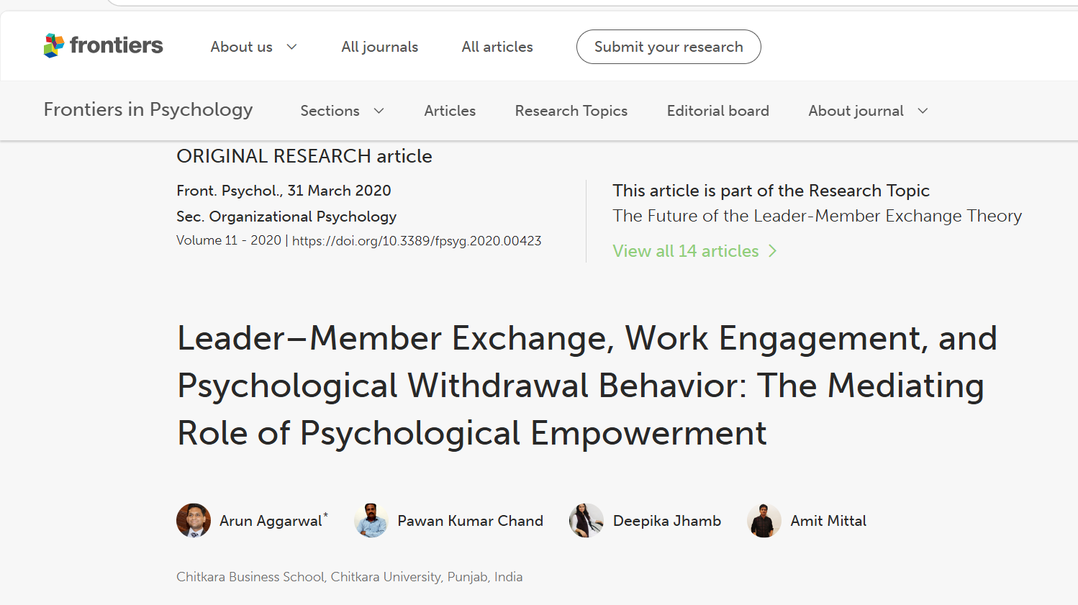

权变理论（Contingency Theory）
在现代人力资源管理中，情绪数据的获取是企业心理健康管理的重要一环。研究表明，企业在复杂和压力大的环境中，管理者如果能够实时获取员工的情绪状态，将能够更好地做出决策，提供个性化的心理支持，从而缓解员工的情绪压力，提高员工的工作表现和心理健康
Connelly, S. and Torrence, B.S. (2018) ‘The relevance of discrete emotional experiences for human resource management: Connecting positive and negative emotions to HRM’, Research in Personnel and Human Resources Management, pp. 1–49. doi:10.1108/s0742-730120180000036001.

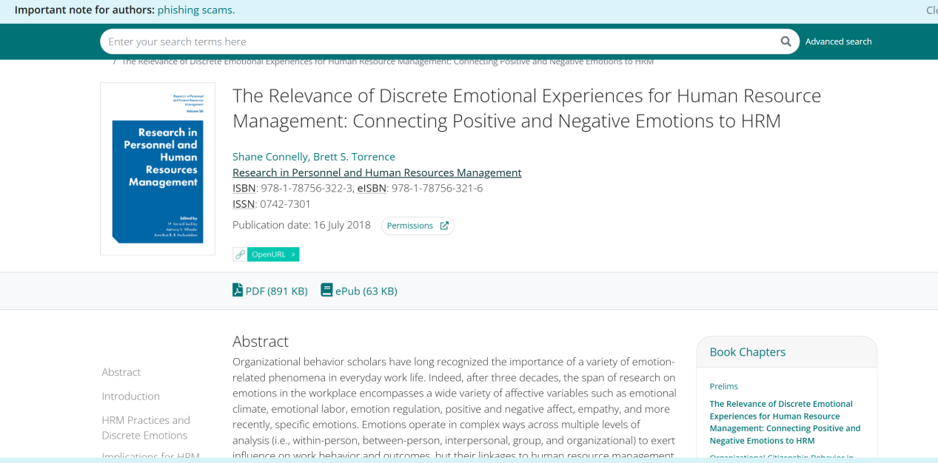

Studies show that if employees perceive they are being overly monitored or that their private data, such as emotional information, could be misused, it can lead to a breakdown in trust. This perception can make employees feel their privacy is not respected, reducing their acceptance of monitoring systems and leading to lower engagement and job satisfaction.
Chang, S.E., Liu, A.Y. and Lin, S. (2015) ‘Exploring privacy and trust for employee monitoring’, Industrial Management &amp; Data Systems, 115(1), pp. 88–106. doi:10.1108/imds-07-2014-0197.
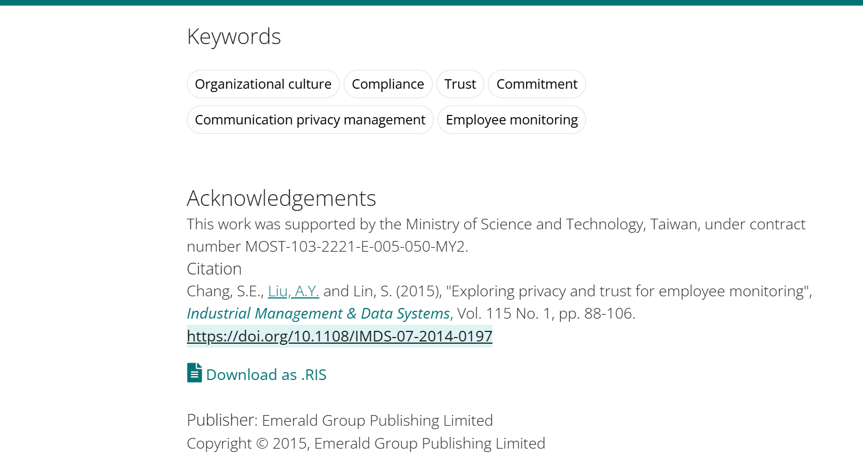

peer support interventions
There is significant evidence supporting the idea that peer understanding and support can improve an individual's mental health. Studies have shown that peer support interventions (PSIs) are effective in enhancing mental health outcomes by fostering shared experiences, which can provide emotional and social understanding.
Smit, D. et al. (2022) ‘The effectiveness of peer support for individuals with mental illness: Systematic review and meta-analysis’, Psychological Medicine, 53(11), pp. 5332–5341. doi:10.1017/s0033291722002422.
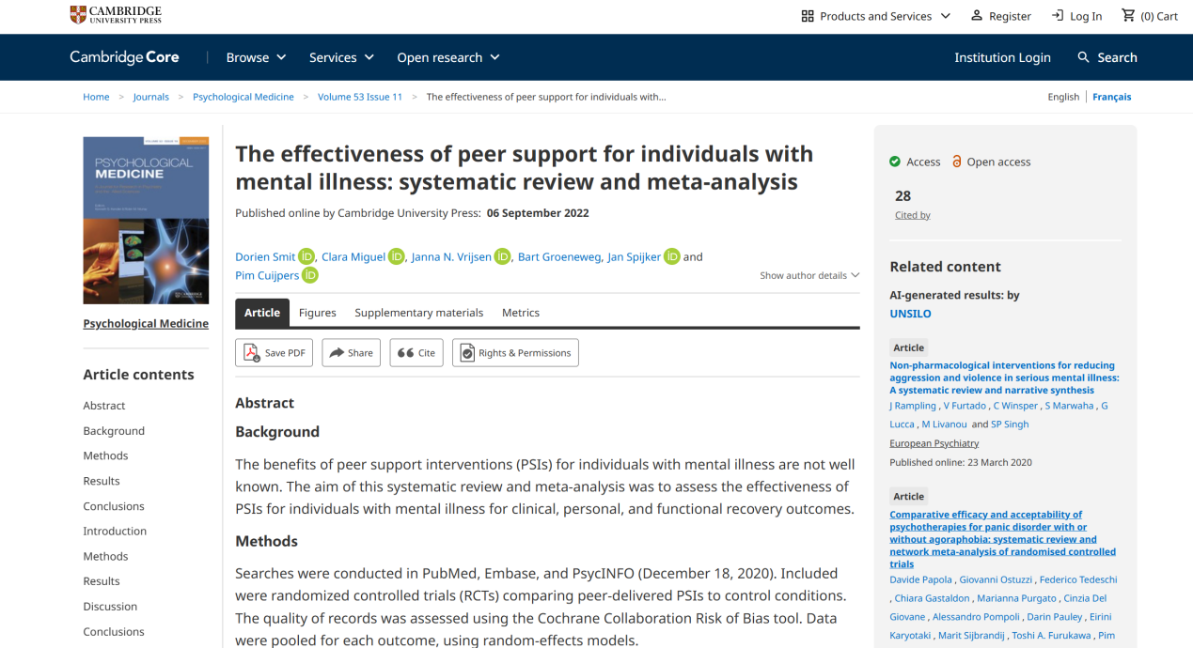

情绪传染理论（Emotional Contagion Theory）
研究表明，负面情绪（如愤怒或焦虑）会导致团队成员之间的情绪传染，增加团队的情绪压力，进而影响团队创新的表现。特别是在复杂或高压力的环境中，负面情绪更容易加剧团队内部的冲突，导致团队信任度下降，合作减少，并延迟创新决策的实施。持续的负面情绪不仅会降低团队凝聚力，还会导致团队成员产生低动机，进一步影响他们的工作表现和心理健康。此外，组织内部多样性和领导方式的负面影响也会通过情绪放大，进一步削弱团队创新的能力和整体效率。

Jordan, P.J., Lawrence, S.A. and Troth, A.C. (2006) ‘The impact of negative mood on Team Performance’, Journal of Management &amp; Organization, 12(2), pp. 131–145. doi:10.5172/jmo.2006.12.2.131.
