CPT202 Assignment 2
Group Report for Software Engineering Group Project

2024/2025 Semester 2
An online meeting booking system
27 April 2025
http://121.43.36.102/

Group number: 17
Submitted by: < Xiangyi Zhu, 2251651>
Group Members:
- < Xiangyi Zhu, 2251651 >
- < Xinrong Shi, 2251997 >
- < Zimo Zheng, 2147369 >
- < Nan Lin, 2252173 >
- < Xiaoya Li, 2255207 >
- < Ziwei Zhou, 2253073 >
- < Jiayi Wang, 2255986 >
- < Hanqiu Zhang, 2251903 >
- < Xinyuan Zhang, 2255403 >
Contents
1. Introduction 3
1.1. Background and Requirements 3
1.2. Aims of The Project 3
1.3. User Characteristics 3
1.4. Project Scope 3
1.5. Assumptions and Dependencies 4
1.6. Project Risks 4
2. Architectural Design 4
2.1. System Architecture 4
2.2. Frontend System 5
2.3. Backend System 6
2.4. High-level Database Design 7
3. Software Design 8
3.1. Software Modules 8
3.2. High-level Process Flow 9
3.3. Software Support Services 10
3.4. Coding Structure and Convention 10
3.5. Software Configuration and Production Environment 11
4. Software testing 12
4.1. Unit Test 12
4.2. Integration Test 12
4.3. Acceptance Test 13
5. Conclusion and future work 14
6. References 15
7. Appendix 17

1. Introduction

1.1. Background and Requirements
In recent years, the increasing complexity of academic and administrative activities within schools has led to a significant increase in the demand for online conference room booking systems. This trend highlights the urgent need for efficient resource management and convenient collaboration tools. However, many schools' existing conference room booking systems still face many challenges, including complex user interfaces, inefficient booking processes, insufficient conflict management, and lack of real-time notification functions. These issues often lead to poor user experience, low resource utilization, and inefficient communication (Sanchez et al., 2019).

In order to effectively address these challenges, it is essential to develop a robust and user-friendly school conference room booking system. The system should be designed with users in mind, provide an intuitive interface and simplify the booking process, support real-time resource status updates to prevent conflicts, and integrate automatic notification functions to ensure that users receive booking confirmations and reminders in a timely manner. In addition, the system should also be seamlessly connected with existing school scheduling, payment systems, and permission management tools to comprehensively improve administrative efficiency (Shili et al., 2009).

By optimizing resource allocation and improving user experience, the system can not only help schools manage conference room resources more efficiently, but also provide teachers and students with a smoother collaborative environment, thereby promoting the orderly development of academic and administrative activities.

1.2. Aims of The Project
The primary objective of this project is to design and implement an intuitive web-based school meeting room booking system:

• For users (e.g., students and teachers), they can register for an account to become platform users. The system provides a simple and user-friendly interface for viewing the availability of meeting rooms, submitting booking requests, and receiving real-time notifications and confirmations.

• For administrators, the system offers a management backend for monitoring and managing meeting room resources. This backend supports a range of functions, including real-time updates on meeting room status, automatic detection of booking conflicts, user permission management, and data visualization analysis. These features help administrators allocate resources more efficiently, optimize meeting room usage, and support the school's teaching and administrative activities.

1.3. User Characteristics
The system supports three main user roles: ordinary users, administrators, and super administrators.
Ordinary users can log in to the system to view conference rooms, submit reservation applications, view reservation history, cancel reservations, submit maintenance requests, and view notifications. Administrators (usually department-level or floor managers) are responsible for approving reservation applications, monitoring conference room usage, handling maintenance requests, managing conference room status, and issuing internal notifications.
As the highest-level operator of the system, the super administrator is responsible for maintaining data integrity and system performance. His main permissions include managing user roles, configuring conference room classifications, adding, updating or deactivating conference rooms, maintaining conference room information, managing permission allocation, and reviewing system logs.
The three roles work together to ensure the efficient operation of the system and achieve the orderly advancement of resource optimization and administrative supervision.

1.4. Project Scope
The scope of the project is illustrated in the Figure 1:
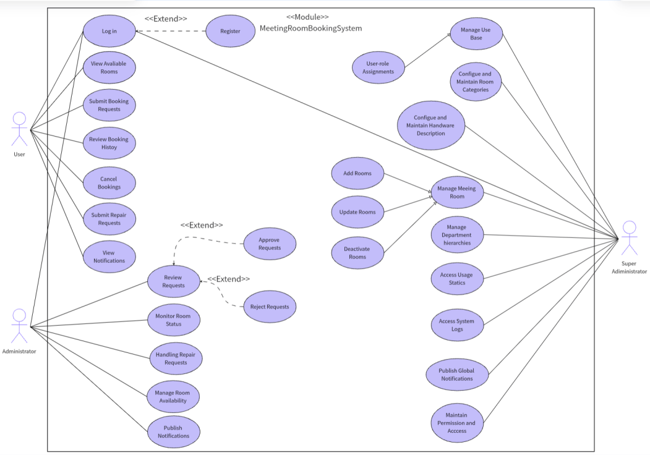
Figure 1: the Use Case Diagram of the System

1.5. Assumptions and Dependencies
The successful implementation of the project depends on a series of prerequisites and external environmental factors, such as resource availability, technical support, team collaboration, and data integrity. In addition, the project also depends on the stability of third-party API services (such as payment processing and email notifications), reliable network connections, and the fulfillment of external service agreements. During the project implementation process, these prerequisites and dependencies need to be continuously monitored and managed to reduce potential risks and ensure the smooth achievement of project goals.

1.6. Project Risks
Although this project has brought many opportunities in managing conference room bookings and improving team reporting and presentation efficiency, it also comes with some risks that need to be carefully managed. These risks include uneven resource allocation, technical challenges such as system integration and data processing, potential security vulnerabilities, and the need for rigorous testing to ensure the reliability and performance of the reporting and presentation platform. In addition, the successful implementation of the project also depends on team collaboration, resource availability, and the stability of external services. Throughout the project, these factors need to be continuously monitored and managed to effectively reduce risks and ensure the smooth achievement of project goals.

2. Architectural Design

2.1. System Architecture
Our Meeting Booking System employs the MVC (Model-View-Controller) architecture due to its clear separation of concerns, modularity, and scalability, making it suitable for dynamic interactions, secure data management, and multi-role functionality (Ganeshan, 2016).
Architectural Justification：
MVC separates the system into distinct layers—the Model managing data and logic, the View presenting user interfaces, and the Controller coordinating interactions between them. This structure significantly improves maintainability, testability, and promotes effective collaborative development within a Scrum framework.
Implementation in Our Project：
• Model Layer:
Our Model layer uses MySQL (5.7.27) with MyBatis-Plus and MyBatis-Plus-Join as ORM frameworks. Tables follow third normal form (3NF) with foreign keys for integrity among key entities. Druid (1.2.1) provides efficient database connection pooling and monitoring.
• View Layer:
Built with Vue.js 3 (3.3.4) (Shavin, 2023) and TypeScript for type safety, our frontend leverages Vite (4.4.5) for rapid builds, Vue Router (4.2.4) for routing, and Element Plus (2.3.12) for UI components. Axios (1.7.2) manages RESTful API calls, while ECharts (5.4.3) and FullCalendar (6.1.15) support data visualization and scheduling. Modular component structures promote reusability and maintainability.
• Controller Layer:
Spring Boot (3.2.7) facilitates RESTful API development, handling HTTP requests and orchestrating business logic across services and mappers (Heckler, 2021). Sa-Token manages authentication and role-based access, with password encryption secured by Spring Security Crypto.

Supporting Infrastructure：
• Development Tools: We used Visual Studio Code (1.98.0) as the primary IDE, Navicat (11.1.13) for database visualization, and Word for formal documentation.
• Version Control & Project Management: Code was collaboratively managed using Git with remote repositories hosted on Coding.net. Agile practices, including sprint planning and task tracking, were facilitated using Scrum boards and Wiki-based documentation.
• Testing: The backend logic was verified using JUnit, while Jest/Mocha were employed for frontend component testing.
• Deployment: The system is deployed on a production-grade Alibaba Cloud server. The frontend is locally built using npm run build and served via Nginx, which delivers static assets and proxies API requests to the backend. Node.js (v18.20.8) is used during the build process. The backend is packaged into a self-contained Spring Boot JAR via Maven (v3.8.1) and deployed to the cloud server for execution.
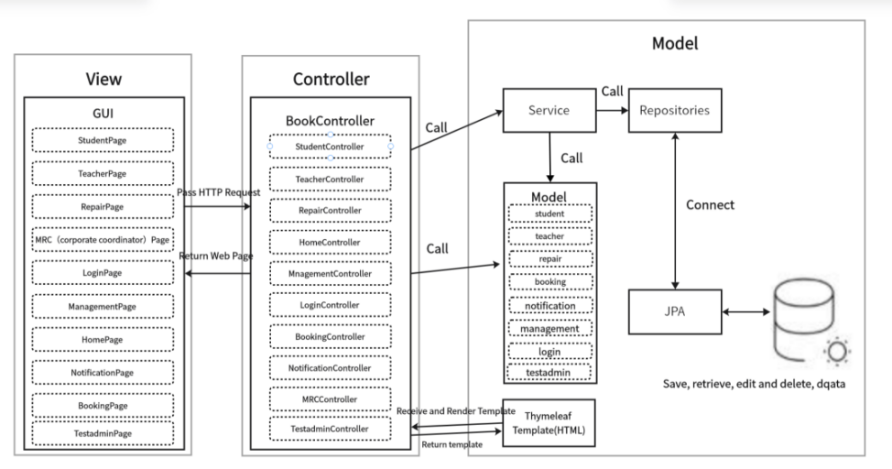
Figure 2: MVC architecture

In summary, the adoption of the MVC architecture, together with a robust technology stack and structured development workflow, has enabled our team to deliver a secure, modular, and scalable Meeting Booking System.

2.2. Frontend System
The front end of our conference room booking system is developed using Vue.js 3 (v3.3.4), a progressive JavaScript framework known for its high performance, modularity, and easy integration with modern tool chains. The entire code base uses TypeScript for stronger type constraints and higher maintainability. Our front-end architecture supports the single-page application (SPA) model, which enables dynamic view rendering and smooth user interaction experience, avoiding frequent page refreshes.

Core Technologies and Frameworks：
This project integrates Vite (v4.4.5) as a build tool to achieve ultra-fast development and hot module replacement (HMR). Routing management is handled by Vue Router (v4.2.4), which supports nested routing and dynamic routing based on user roles.
The UI layer uses Element Plus (v2.3.12) as a component library, providing reusable and barrier-free components such as pop-ups, forms, calendars, and tables.
We use Axios (v1.7.2) for efficient HTTP communication to connect to backend services. In order to achieve interactive scheduling, the system integrates FullCalendar (v6.1.15) to support intuitive drag-and-drop schedule operations; at the same time, ECharts (v5.4.3) is used to build a data visualization dashboard, which supports multiple chart forms such as bar charts, line charts, and pie charts to show conference room usage trends.

UI/UX & Optimization：
The system integrates Vue-Tippy (version 6.6.0) to provide contextual tips and operation guides.
We follow the accessibility-first development principle and use structured routing and role-based permission guards to limit unauthorized access. In terms of front-end performance optimization, we implemented a lazy loading strategy for routing and asynchronously imported large third-party modules to improve page loading speed and overall response performance.

In summary, our front-end system builds a modular, dynamic and easy-to-maintain user interface that fully meets the functional diversity requirements of the conference room booking system. Through the powerful integration of visualization, interactivity and security, the front-end provides a solid and reliable client foundation for the entire platform.

2.3. Backend System
The backend architecture of our Meeting Booking System is implemented following a layered MVC structure, promoting separation of concerns and facilitating maintainability, testability, and scalability. It consists of the Controller, Service, DAO, and Entity layers, each handling a distinct set of responsibilities.

Controller Layer:
The Controller layer maps incoming RESTful API requests to service-layer operations using Spring Boot’s @RestController and @RequestMapping annotations. Controllers are role-sensitive and serve endpoints such as:
1．/api/bookings for managing meeting room reservations.
2．/api/rooms for retrieving available room lists and metadata.
3．/api/users for role-based user management.
4．/api/repair for repair request submission and resolution.
5．/api/statistics for returning room usage and booking distribution data.
The controller layer is integrated with Spring Boot Security and JWT filters to restrict access and protect endpoint data. Each API is documented and structured with proper response models, supporting seamless interaction with the Vue.js frontend.

Service Layer:
The Service layer contains the business logic and workflow coordination across components. It employs Spring’s @Service and dependency injection to integrate DAO components. Key responsibilities include:
1．Checking room availability before booking.
2．Coordinating approval flows for MRC roles.
3．User login, session management, and permission control are managed via Sa-Token, with secure password validation handled by Spring Security Crypto.
4．Generating data for charts using ECharts-compatible formats.
5．Sending notifications or processing repair updates.
The service layer enforces validation, handles transactional logic, and ensures consistency between frontend expectations and backend state.

DAO (Data Access Object) Layer:
The DAO layer leverages MyBatis-Plus (3.5.7) and MyBatis-Plus-Join (1.4.7.2) to abstract SQL operations and simplify CRUD logic. Each DAO interface is responsible for operations related to a specific table, including:
1．Room and category creation, retrieval, and modification.
2．Reservation status updates and history lookups.
3．User and role assignment management.
4．Aggregated data queries for statistical dashboards.
By encapsulating database logic, this layer provides a reusable and centralized structure for persistence access (Li et al., 2020).

Entity Layer:
The Entity layer defines Java classes that directly correspond to tables within the MySQL (5.7.27) relational database. These include: meeting_category, meeting_room, meeting_book, sys_dept, sys_user, sys_role, sys_menu, sys_role_menu, sys_user_role, sys_notice and repair.
These entities use annotations such as @TableName and @TableField (via MyBatis-Plus) to map to their respective database tables and fields. Relationships are managed through foreign keys and join tables to ensure data integrity.

This well-defined backend architecture supports efficient request handling, secure data management, and the modular scalability required for the ongoing evolution of the Meeting Booking System.

2.4. High-level Database Design
Our database design adopts MySQL (v5.7.27) as the underlying relational database management system to support the persistent storage and logical organization of the core entities involved in the Meeting Booking System. The database schema is structured using a normalized Entity-Relationship Diagram (ERD), ensuring a robust, scalable, and consistent data model that reflects the system’s operational logic. Relationships between tables are enforced using foreign key constraints, maintaining referential integrity throughout the system (DuBois, 2013).
Figure 3: ER diagram is in APPENDIX 1

Entity Identification：
Key entities were identified based on the system's functional modules and role-based access model. The selected entities, designed to encapsulate semantically coherent data, include:
1. sys_user (Users): Captures login credentials, contact details, and status flags for all system users across roles.
2. sys_dept (Departments): Represents department affiliations for users, facilitating hierarchical access control and booking permissions.
3. meeting_room (Meeting Rooms): Stores data such as room name, capacity, location, available equipment, and status (e.g., active, under repair).
4. meeting_category (Meeting Categories): Classifies meeting rooms for filtering and organizational purposes.
5. meeting_book (Reservations): Logs meeting room booking records, including time slots, approval status, requester ID, and associated department.
6. sys_role (Roles): Defines system roles including Student, Teacher, MRC, Repair Staff, and Test Admin.
7. sys_menu (Menus): Maintains mappings of accessible routes or functional modules within the system’s frontend UI.
8. sys_role_menu (Role-Menu Mapping): Manages granular role-to-menu permission mappings for secure interface access.
9. sys_user_role (User-Role Mapping): Tracks many-to-many relationships between users and roles.
10. sys_notice (Notices): Stores public announcements and system bulletins shared across user types.
11. repair (Repair Records): Captures maintenance-related issues submitted by users and updated by repair staff, including status logs and resolution notes.

These entities form the backbone of the system, supporting multi-role interactions, scheduling processes, access management, and communication flows.

Data Normalization:
Our database schema design follows the third normal form (3NF) specification to ensure data independence and eliminate redundancy. By dividing the data of a single subject into independent tables and establishing foreign key associations, the design achieves the following goals:
1. Minimize data duplication between entities;
2. Ensure high data integrity and consistency;
3. Support efficient data update and deletion operations to avoid cascading exceptions.
The resulting entity relationship diagram (ERD) is consistent with the modular architecture of the application, ensuring that each data table can directly support one or more service endpoints, while providing a good scalability foundation for future system expansion and functional iteration (Mendoza and Piedra, 2020).

3. Software Design

3.1. Software Modules
In our Meeting Booking System, we designed and implemented five core software modules based on the distinct user roles within the system. These roles include: Student, Teacher, MRC (Conference Coordinator), Repair Staff, and Super Admin (Test Admin). Each role is granted specific access permissions and system functionalities tailored to their responsibilities.
1. Student Module: Students serve as standard users who can browse available meeting rooms, make booking requests, view booking history, check announcements and bulletins, and report issues via the Repair Management module. Their permissions are limited to their own data, ensuring a simplified and secure user experience.
2. Teacher Module: Teachers share a similar interface with students but may have slightly expanded permissions depending on institutional policies. They can manage their bookings, access meeting lists, announcements, and submit repair requests. Their role focuses on personal scheduling and participation in meetings.
3. MRC (Conference Coordinator) Module: MRC users act as approvers and supervisors for the meeting spaces. They can review, approve or deny reservation requests, manage room availability and categories, oversee repair records and track usage patterns. This module plays a crucial role in ensuring the integrity and efficiency of the meeting scheduling process.
4. Repair Staff Module: This module is designed for personnel responsible for maintaining and repairing meeting rooms. Repair staff can view submitted repair requests, update repair statuses (e.g., pending, in progress, repaired), and manage associated images or notes. Their dashboard is streamlined for task tracking and completion.
5. Super Admin (Test Admin) Module: The Super Admin has comprehensive control over the entire system, including user, role, and department management, system configuration, menu permissions, and announcement publishing. This role is primarily used for system setup, deployment, and high-level oversight.

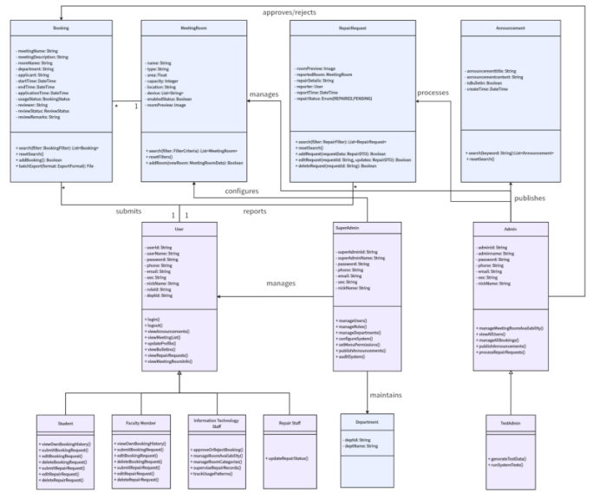
In addition to role-specific modules, there are several reusable core functionalities accessible across roles, such as the Announcement and Bulletin modules (providing official communications), and the Repair Management module (allowing users to submit repair issues). These modules ensure consistent experiences across roles while maintaining functionality segregation (Farouk, 2017). From a modular design perspective, the internal structure of each module maintains high cohesion, with related business logic grouped tightly together. At the same time, inter-module dependencies are minimized, allowing the system to be scalable, maintainable, and easy to extend or modify.
Figure 4/APPENDIX 2(clearer): Software Modules Design

3.2. High-level Process Flow
The Meeting Booking System integrates a full suite of core functionalities for managing institutional meeting room reservations, with each module logically separated and collaboratively coordinated to streamline both user experience and administrative oversight.
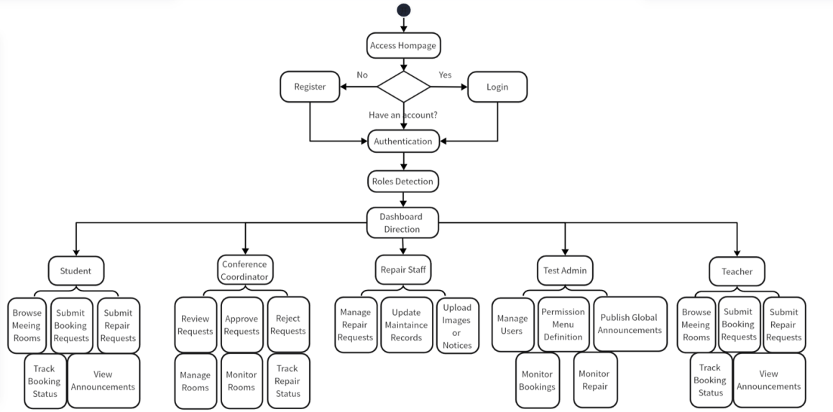
Figure 5: Process Flow
Entry and Authentication Flow：
Upon accessing the system homepage, users can register by submitting account credentials and essential personal information. After successful registration and login, the system enforces secure session management, including duplicate-login prevention and session expiration control. Upon authentication, users are redirected to dashboards based on their assigned roles:

Role-Based Routing and Functional Flow
• Student / Teacher Users are redirected to a personalized dashboard where they can browse available meeting rooms (integrated with FullCalendar), submit and manage booking requests, track booking history, report facility issues, and view system announcements and bulletins.
• MRC (Conference Coordinator) users access an administrative dashboard to review, approve, or reject booking applications, manage meeting room availability and metadata, monitor room usage trends and repair statuses, and interact with a fixed information pane implemented via Vue 3, Element Plus, and <keep-alive> to persistently display pending approvals and alerts.
• Repair Staffs are directed to the repair management module, where they can view repair submissions from users, update maintenance records (e.g., in progress, completed), upload supporting images or notes, and filter tasks based on urgency or status to prioritize repair workflows.
• Test Admin (Super Admin) users are granted full administrative access, enabling them to manage users, departments, roles, and permission menus (sys_menu), publish global announcements (sys_notice), monitor booking and repair activities across the system, and operate within a persistent admin layout optimized by router caching and <keep-alive> to maintain navigation state and enhance administrative efficiency.

Figure 6: Time series diagram: User registration and login is in APPENDIX 3
Figure 7: Time series diagram: User reserved meeting room is in APPENDIX 4
Figure 8: Time series diagram: Administrator reviews meeting room booking records is in APPENDIX 5

Technical Integration and Responsiveness:
All user actions are served by asynchronous frontend-backend communication using Axios, and the interface dynamically updates using Vue.js 3’s reactive rendering capabilities. Element Plus provides a uniform design language across modules, while backend services—developed using Spring Boot—ensure secure RESTful request processing, token-based authentication (via JWT), and business logic enforcement (Muratovic and Tanovic, 2024).

This role-driven, modular process flow supports high usability, system reliability, and functional scalability across diverse user scenarios.

3.3. Software Support Services
Our Meeting Booking System relies on a suite of software tools and service integrations that collectively enhance development efficiency, system performance, and operational maintainability. These services span across database development, interface navigation, and infrastructure management.

Database-Related Services
• MySQL (v5.7.27):
MySQL serves as the primary relational database management system, supporting normalized table structures and high-performance query execution. Foreign key constraints ensure robust referential integrity between core entities such as users, meeting rooms, reservations, and permissions.
• MyBatis-Plus + MyBatis-Plus-Join:
We adopted MyBatis-Plus (v3.5.7) and MyBatis-Plus-Join (v1.4.7.2) as our ORM solution to streamline SQL operations. These tools allow concise query writing, auto-generation of boilerplate code, and advanced conditional query support, significantly reducing the complexity and redundancy of database access logic.
• Navicat (v11.1.13):
Navicat was used during the development phase to visually manage the MySQL database. It enabled collaborative access to table structures, ERD diagrams, test queries, and data population across development environments (Ozar, 2012).

Web Navigation Services
The system features a role-adaptive sidebar navigation built with Vue.js 3 and Element Plus, supporting collapsible, hierarchical menus with route-based access control. Navigation state is persistently maintained using Vue Router and <keep-alive> to ensure smooth user experiences across modules. This responsive layout guarantees accessibility across varied screen resolutions and supports interface consistency for students, teachers, MRCs, repair staff, and administrators.

Other Supporting Services
• Spring Boot Mail Service:
The system integrates Spring Boot’s JavaMailSender for email-based verification. During registration, the backend generates a secure, randomized code and sends it to the user's provided email. The mail service is designed to be event-driven and extensible for future use cases such as reservation status notifications and administrative announcements (Deinum, 2024).
• Git + Coding.net:
Source code versioning was managed via Git, with remote repositories hosted on Coding.net. Each team member developed within independent branches following a Gitflow-like model, using pull requests for integration and code reviews. Coding.net also supported Scrum task tracking and Wiki documentation (Guthals, 2023).
• Maven (v3.8.1):
Maven was used as the backend’s dependency and build management tool. It helped manage transitive dependencies, resolve version conflicts, and package the Spring Boot application into a JAR file for production deployment. Maven’s standard project structure also facilitated better collaboration among backend developers (Varanasi, 2019).

Together, these services form a cohesive foundation that supports rapid development, modular deployment, and stable maintenance throughout the project lifecycle.

3.4. Coding Structure and Convention
Following best practices under the Spring Boot framework, the backend is organized using a conventional multi-layered directory structure—typically segmented into controller, service, mapper, entity, config, and utils packages. Each directory encapsulates specific responsibilities, aligning with the Model-Service-Controller design pattern. Detailed definitions of each directory's function are maintained in our internal technical documentation (Figure 9 JAVA directory see APPENDIX 6).
On the frontend, the Vue.js 3 application adopts a modular structure supported by Vite. The source code is organized into logical folders, including views, components, router, assets, store, and api, which facilitates component-based development, scoped styling, and role-based route access.

Method Invocation Convention
To promote loose coupling and enhance maintainability, the Controller layer invokes business logic strictly through Service interfaces. Each service interface can correspond to one or more implementation classes. This abstraction provides flexibility for future logic extension or swapping of implementation details without affecting the interface layer. It also facilitates mocking during unit testing.

Naming Convention
We adhered to standardized naming practices for consistency and clarity:
1. Methods and variables: camelCase (e.g., createBookingRequest)
2. Class names: PascalCase (e.g., BookingController)
3. Constants: UPPER_CASE with underscores (e.g., MAX_ROOM_CAPACITY)
4. Naming principle: all names are semantically meaningful and follow the "entity + action" pattern when applicable (e.g., getUserPermissionList)
5. Interface implementation classes: suffixed with Impl (e.g., RoomServiceImpl)

Code Maintenance Standards
During collaborative development, code maintainability was emphasized:
1. Developers are expected to write self-documenting code with concise and relevant inline comments
2. Prior to any Git commits, unused code segments and outdated comments are cleaned up to preserve repository hygiene
3. Code formatting follows IDE-configured style guides across the team to maintain structural consistency

Task Management and Code Completion
Unfinished features and pending implementations are not marked with inline TODOs. Instead, we adopted a structured task-tracking workflow using Coding.net’s Scrum board and Wiki documentation. Task items are divided by Sprint and categorized under Epic/Story/Task structures, allowing all group members to clearly track development progress, assign responsibilities, and manage future implementation priorities. Daily stand-ups and milestone meetings ensure timely communication of pending development tasks.
This convention-centric, layered coding framework enhances system readability, developer onboarding, and long-term scalability.

3.5. Software Configuration and Production Environment
Software Configuration
Our Meeting Booking System is built on a modular, integrated technology stack designed for dynamic data rendering and secure role-based access.
• Frontend Configuration:
Developed with HTML, CSS, JavaScript, and Vue.js 3 (v3.3.4), enhanced by TypeScript for type safety. Vite (v4.4.5) enables fast builds and HMR. UI components are built with Element Plus (v2.3.12), Axios (v1.7.2) manages API communication, and Vue Router (v4.2.4) controls routing. ECharts (v5.4.3) and FullCalendar (v6.1.15) support visualization and scheduling (Jansen, Vane and Wolff, 2016).
• Backend Configuration:
Implemented using Spring Boot (v3.2.7) with an MVC structure. MyBatis-Plus (v3.5.7) and MyBatis-Plus-Join (v1.4.7.2) support ORM operations, Druid (v1.2.1) handles connection pooling, and Sa-Token (v1.38.0) with Spring Security Crypto ensures authentication, authorization, and password security.
• Database Layer:
MySQL (v5.7.27) is used with a 3NF-compliant schema and enforced foreign key constraints. Navicat (v11.1.13) facilitated database management during development.
Production Environment
System | Ubuntu 22.04 64x
Processor | Intel ® Xeon ® Platinum Scalable Processors, 4-core (vCPU), 8 GiB
Public network | bandwidth 5 Mbps
Java OpenJDK | version 17.0.14
MySQL | Version 5.7.27
Our system is deployed on the AliyunServer (ecs.e-c1m2.xlarge) with enhanced network performance and dedicated VPC. This ensures high availability, secure isolation, and stable operation for our application.

Software testing
We wrote code to test the functionality of the software, mainly focusing on unit and integration tests, as shown in APPENDIX 9. Acceptance tests were performed by using the web, and all of the tests results are ‘pass’.

4.1. Unit Test
Unit tests verify isolated functionality such as logic correctness and method response, ensuring that each unit of code works accurately. We used the JUnit framework, Mockito ,and other simulation tools to emulate the service layer behavior so that the controller methods are tested independently of the Spring Boot lifecycle to ensure that the individual functions and components work as expected before integration.We focus on User Registration.

Test Description:Create a simulated user object containing a username and password, then by simulating the behavior of the user's service layer (assuming that the user does not exist and that the save operation is successful), call the registration interface and check that the relevant service methods (query user, save user, and roles) have been called correctly and as expected.
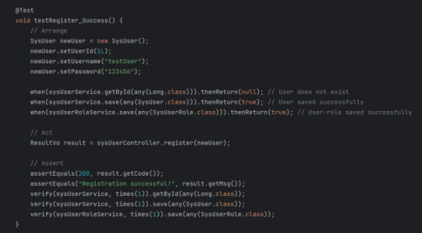
Test Code:
Figure 10/APPENDIX 11 (clearer): Unit test of user registration

4.2. Integration Test
Integration testing verifies the correctness of interfaces, interactions and co-operation between multiple modules, which includes controller-to-service communication, database interaction and data validation mechanisms.
We focus on new meeting room reservation and mail system integration.

Test Case:New meeting room reservation
Test Description:We used the Spring Boot framework and JUnit testing framework, as well as the MockMvc tool to simulate HTTP requests and implement JSON serialization through ObjectMapper to test an interface for booking meeting rooms. First we constructed the request object containing the title, remark and start/end time, sent a POST request to the interface and converted the request body to JSON format; then we verified that the HTTP response status code was as expected and checked the correctness of specific fields in the returned data.

Test Code:
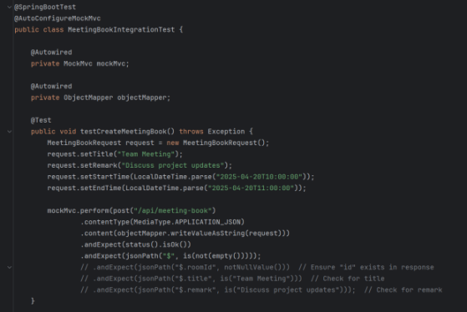

Figure 11/APPENDIX 12 (clearer) : Integration test of new meeting room reservation

Test Case:Mail system integration
Test Description:
Step 1: User fills in the registration information and submits it
Front-end: Users enter their account,phone, email and other necessary information on the registration page. The front-end verifies the email format in real time, and after passing the verification, the user clicks the ‘Next’ button, and the front-end sends the registration information to the back-end.
Back-end: Receive the registration request from the front-end and verify the completeness and accuracy of the information again. If the information is incorrect, the error message is returned to the front-end.
Step 2: The back-end generates a verification code and sends an email.
Back-end: After the registration information is verified, generate a random number verification code. Use the mail server to send the verification code email to the user's mailbox.
Database: Store the verification code and its related information (mailbox, sending time).
Step 3: The user view the verification code in the email
Front-end: Prompt the user to go to the mailbox to check the verification mail.
User operation: User logs into the mailbox, finds the verification code email and gets the verification code, and inputs it into the verification code input box on the registration page.
Step 4: Check verification code and update user status
Front-end: After the user inputs the verification code, the front-end sends the code together with the email address to the back-end for verification.
Back-end: Query the database for the verification code record and check whether the code is correct. If the verification code is correct, update the user's status in the database and return success information to the front-end; If the verification code is wrong, return the corresponding error information to the front-end.
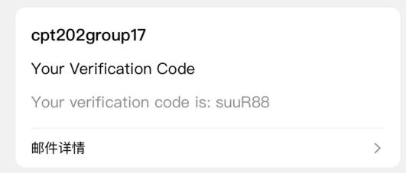
Figure 12: Verification E-mail

4.3. Acceptance Test
Acceptance testing is to verify that the system under the software meets the business requirements and can function properly in real applications and be accepted by users (Dong, 2013). Our acceptance testing includes business process testing, compatibility and user experience testing, security and performance testing, and accessibility testing.
Figure 13: Test Case ID:PBI-032 Users cannot book for more than 8 hours
In addition, the user interface (UI) should enable users to use the web pages and complete conference room bookings efficiently, easily and pleasantly.Acceptance testing is not just about checking that the UI elements ‘look right’, but more importantly verifying that the UI ‘works right’.This is an example of user and meeting room visual charts.
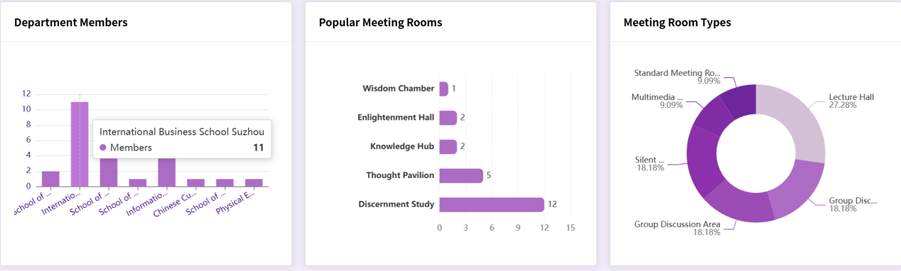

Figure 14: User and meeting room usage dashboard

5. Conclusion and future work
To date, our group has made significant progress in developing a functional and efficient Meeting Booking System. We translated project requirements into a well-structured system design, adopting the MVC architecture to achieve a decoupled and maintainable framework. The frontend and backend, built with Vue.js and Spring Boot, deliver a responsive user experience and robust server-side processing. A high-level database design ensures data integrity and consistency, while software modules tailored to different user roles (Students, Teachers, MRC, Repair Staff, and Super Admin) support operations such as room booking, availability viewing, repair requests, and resource management. The integration of software support services has further enhanced system functionality and reliability. Overall, our system addresses key limitations of traditional booking methods.

Despite our achievements, several challenges and issues have arisen during the implementation of the project. First, ensuring seamless integration between different modules is a complex task that requires careful coordination and testing to resolve any compatibility issues. So far, our web pages have only been adapted for computers, and the performance on cell phones needs to be improved. Secondly, optimizing the system performance to handle many concurrent users and bookings is still a task that needs further attention, in our envisioned scenario, a professional operator needs to control the booking of a conference room, in the future, we hope this feature can become fully automated. Thirdly, a few minor bugs and usability issues were identified during the testing phase that needed to be addressed to improve the user experience. Finally, as the project progressed, there were some changes to the requirements, which required some adjustments to the initial plan by adapting and incorporating these changes into the design and implementation process.

Looking ahead, our team plans to undertake several tasks to further enhance and improve the online meeting booking system. We will focus on optimizing the performance of the system to ensure that it can efficiently handle high-traffic usage scenarios, which involves database optimization, code optimization and improving server-side processing power. We will conduct extensive testing, including unit testing, integration testing and acceptance testing, to identify and fix any remaining bugs and issues to ensure the stability and reliability of the system. We will actively collect feedback from our users to gain insight into their experience and expectations, and based on this feedback, we will make necessary improvements to the functionality and user interface of the system (A/B tests) to improve usability and user satisfaction. In addition, we will explore the possibility of adding new features and functionalities to the system, such as integration with videoconferencing tools or advanced analysis of resource utilization, to provide users with more value-added services and to further improve the overall efficiency of on-campus meeting room management. Through these continuous efforts, we aim to provide a high-quality online meeting booking system that meets the evolving needs of the school community and sets a benchmark for resource management systems.

References
Amuthan Ganeshan (2016) Spring MVC: Beginner’s Guide - Second Edition. Birmingham: Packt Publishing. Available at: https://search-ebscohost-com-s.elink.xjtlu.edu.cn:443/login.aspx?direct=true&db=nlebk&AN=1295342&site=eds-live&scope=site (Accessed: 26 April 2025).

Deinum, M. (2024) Java Enterprise Services. Berkeley, CA: Apress. doi:10.1007/979-8-8688-0113-6_7.

DuBois, P. (2013) MySQL. Fifth edition. Addison-Wesley. Available at: https://search-ebscohost-com-s.elink.xjtlu.edu.cn:443/login.aspx?direct=true&db=cat01010a&AN=xjtlu.0000506143&site=eds-live&scope=site (Accessed: 26 April 2025).

Farouk, M. (2017) Infrastructure Software Modules for Enterprises. [electronic resource] : Flexible Software Systems, Module Use-Cases, and Wireframes. Apress. Available at: https://search.ebscohost.com/login.aspx?direct=true&db=cat01010a&AN=xjtlu.0001289263&site=eds-live&scope=site (Accessed: 26 April 2025).

Gökhan Ozar (2012) MySQL Management and Administration with Navicat : Master the Tools You Thought You Knew and Discover the Features You Never Knew Existed with This Book and Ebook. [Place of publication not identified]: Packt Publishing. Available at: https://search.ebscohost.com/login.aspx?direct=true&db=nlebk&AN=486649&site=eds-live&scope=site (Accessed: 26 April 2025).

Guthals, S. (2023) GitHub. 2nd edition. John Wiley & Sons, Inc. (For dummies). Available at: https://search.ebscohost.com/login.aspx?direct=true&db=cat01010a&AN=xjtlu.0002445372&site=eds-live&scope=site (Accessed: 26 April 2025).

Heckler, M. (2021) Spring boot : up and running : building Cloud Native Java and Kotlin applications. First Edition. O’Reilly Meida, Inc. Available at: https://search-ebscohost-com-s.elink.xjtlu.edu.cn:443/login.aspx?direct=true&db=cat01010a&AN=xjtlu.0001901260&site=eds-live&scope=site (Accessed: 26 April 2025).

Jansen, R.H., Vane, V. and Wolff, I.G. de (2016) TypeScript: Modern JavaScript Development. Birmingham, UK: Packt Publishing. Available at: https://search-ebscohost-com-s.elink.xjtlu.edu.cn:443/login.aspx?direct=true&db=nlebk&AN=1444389&site=eds-live&scope=site (Accessed: 26 April 2025).

Li, Y.Z. et al. (2020) ‘Research and Application of Template Engine for Web Back-end Based on MyBatis-Plus’, Procedia Computer Science, 166, pp. 206–212. doi:10.1016/j.procs.2020.02.052.

Mendoza, D. and Piedra, N. (2020) ‘TutNorBD: Assistant for teaching and learning process of relational database normalization up to 3NF from a universal table’, 2020 XV Conferencia Latinoamericana de Tecnologias de Aprendizaje (LACLO), Tecnologias de Aprendizaje (LACLO), 2020 XV Conferencia Latinoamericana de, pp. 1–8. doi:10.1109/LACLO50806.2020.9381184.

Sanchez, L.M. et al. (2019) ‘Smart Meeting Room Management System Based on Real-Time Occupancy’, 2019 IV Jornadas Costarricenses de Investigación en Computación e Informática (JoCICI), Investigación en Computación e Informática (JoCICI), 2019 IV Jornadas Costarricenses de, pp. 1–6. doi:10.1109/JoCICI48395.2019.9105174.

Shavin, M. (2023) Learning Vue : core concepts and practical patterns for reusable, composable, and scalable user interfaces. First edition. O’Reilly Media, Inc. Available at: https://search-ebscohost-com-s.elink.xjtlu.edu.cn:443/login.aspx?direct=true&db=cat01010a&AN=xjtlu.0002533318&site=eds-live&scope=site (Accessed: 26 April 2025).

Shili, S., et al., 2009. Design of the Booking Meeting System on the Electronic Commercial Manageability. Journal of Liaoning University (Natural Science Edition), 36(1), pp.59–63. doi:10.3969/j.issn.1000-5846.2009.01.017.

Varanasi, B. (2019) Introducing Maven. [electronic resource] : A Build Tool for Today’s Java Developers. 2nd ed. 2019. Apress. Available at: https://search.ebscohost.com/login.aspx?direct=true&db=cat01010a&AN=xjtlu.0001649509&site=eds-live&scope=site (Accessed: 26 April 2025).

Appendix

Appendix 1- Figure 3: ER diagram
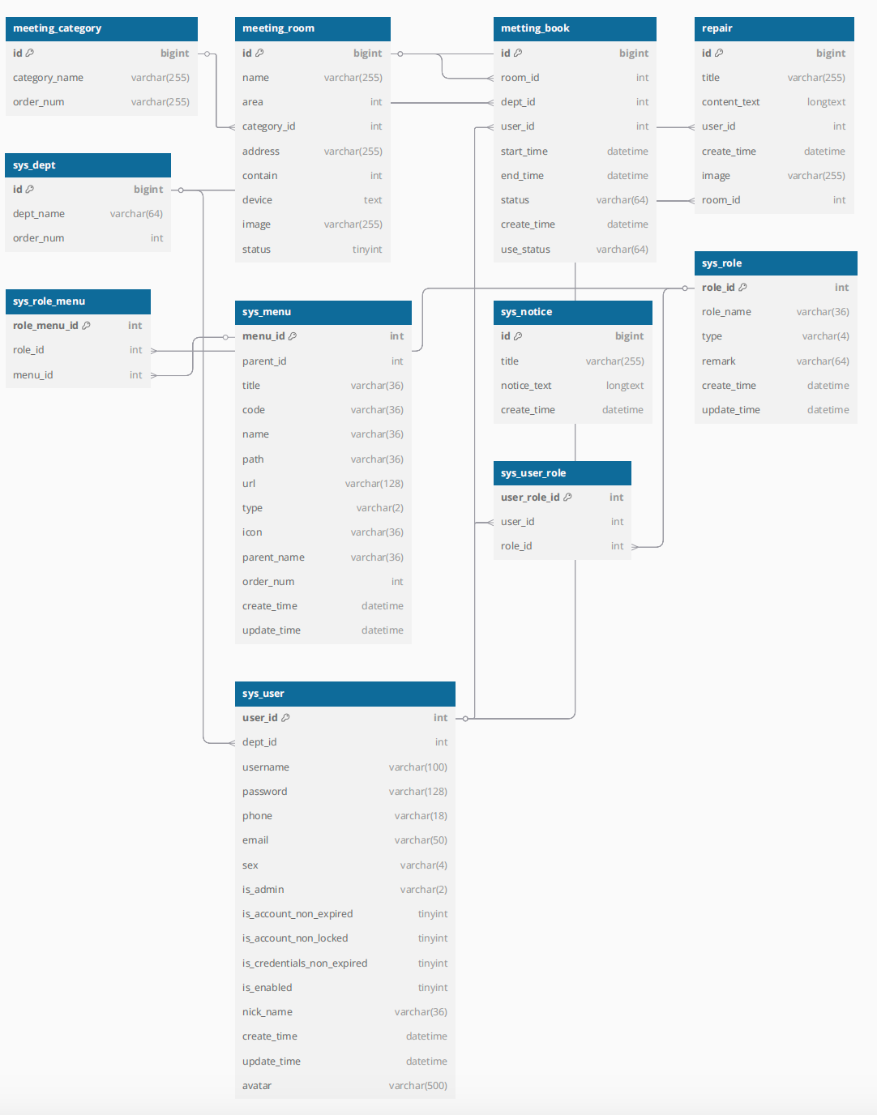
Appendix 2- Figure 4: Software Modules Design

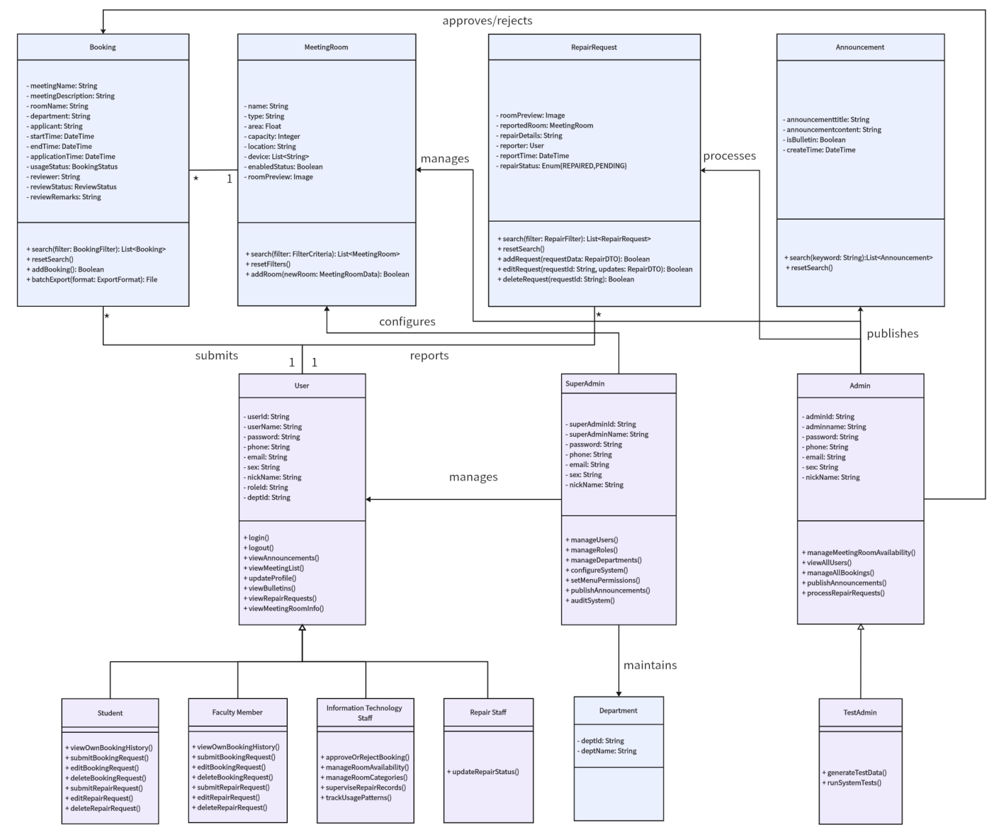

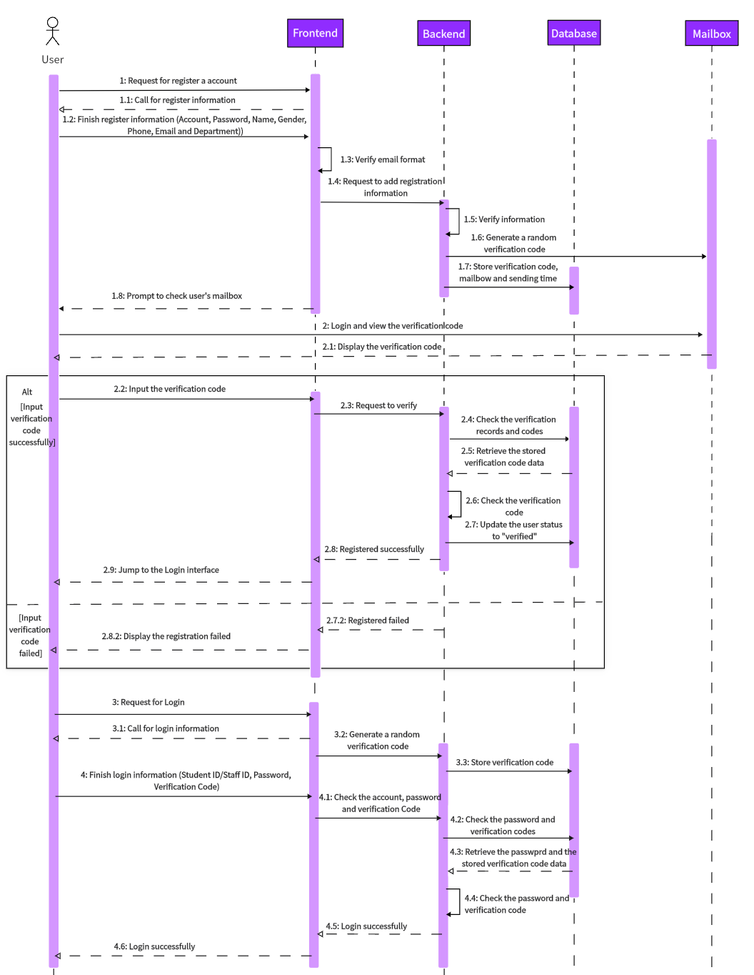
Appendix 3- Figure 6: Time series diagram: User registration and login

Appendix 4- Figure 7: Time series diagram: User reserved meeting room
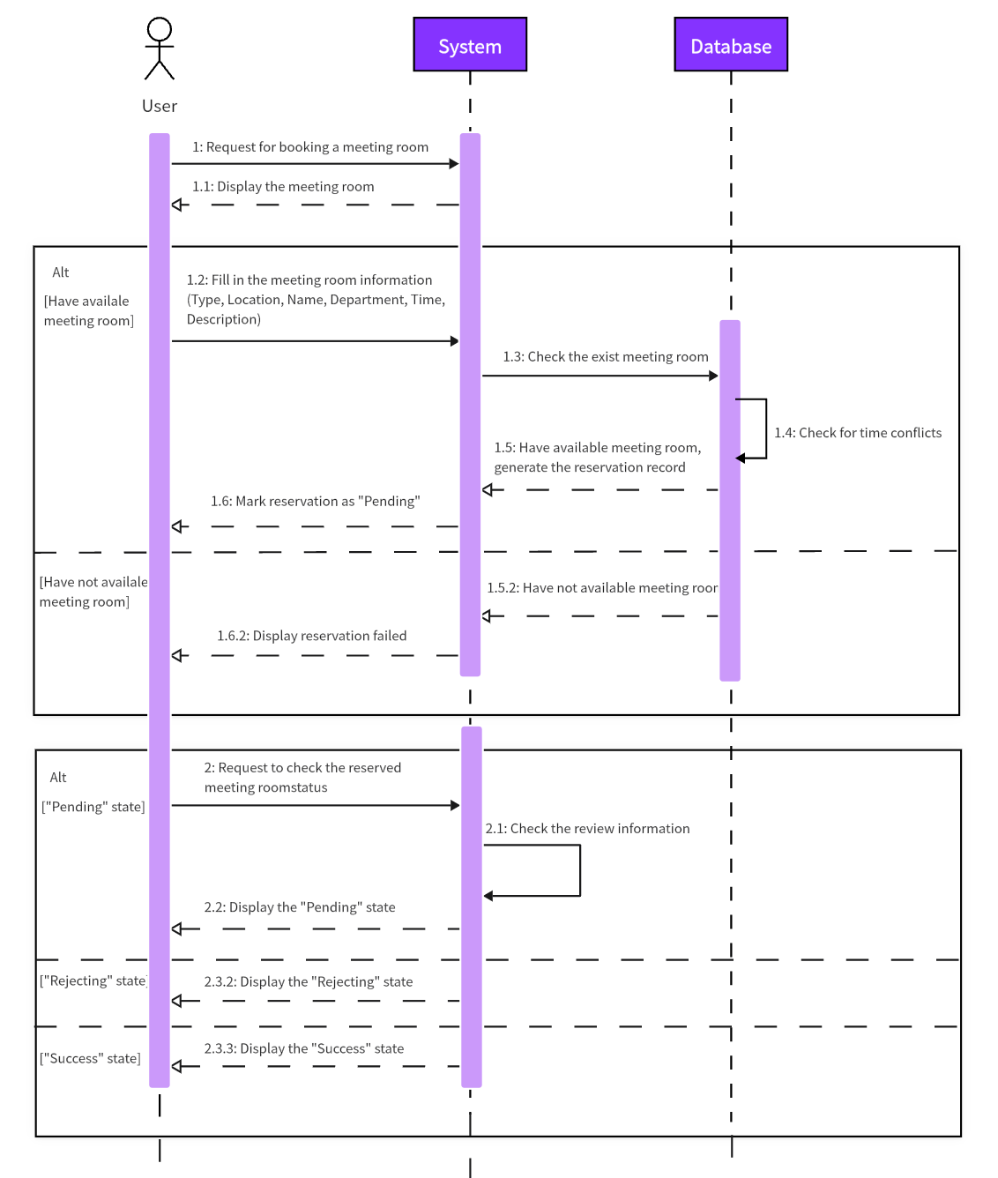

Appendix 5- Figure 8: Time series diagram: Administrator reviews meeting room booking records
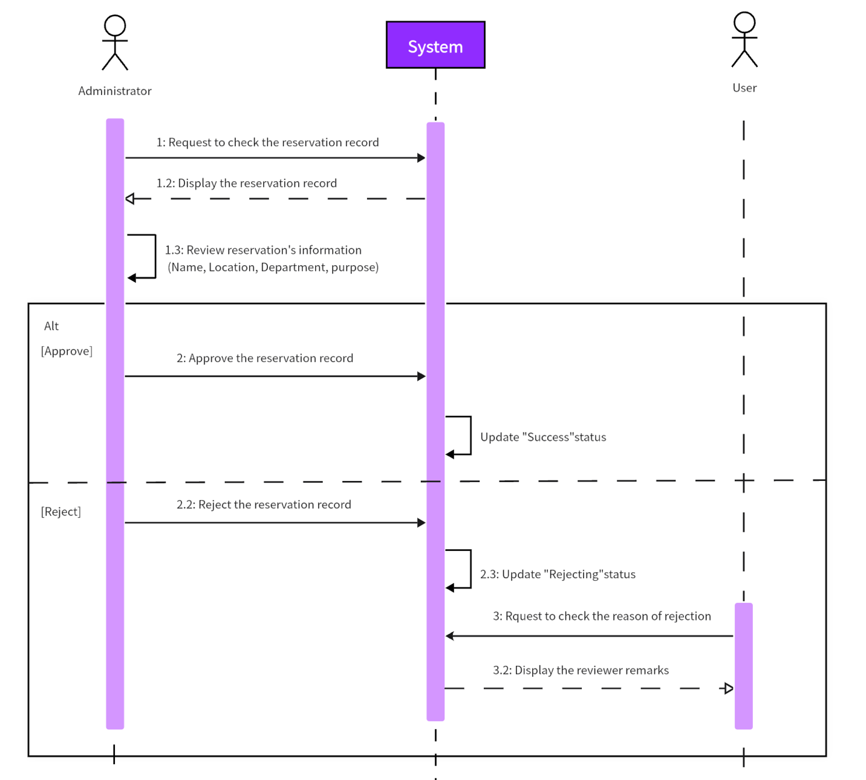

Appendix 6- Figure 9: JAVA directory
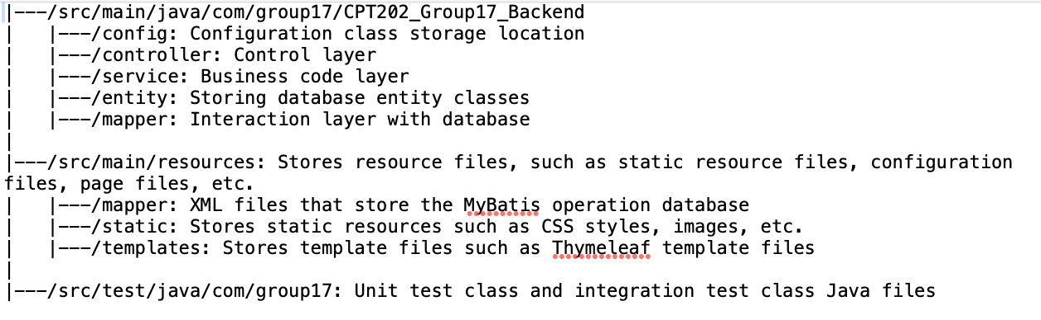

Appendix 7: Sprint Process Report
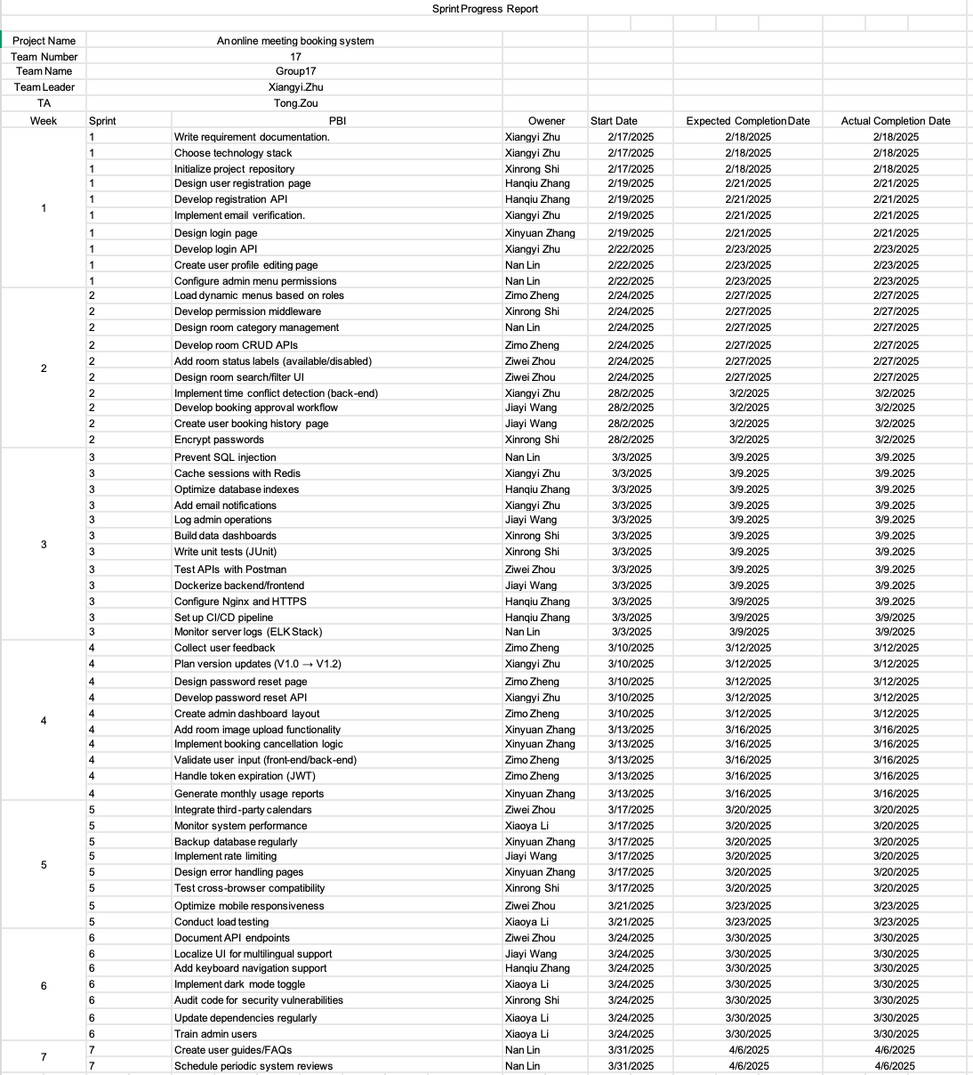

Appendix 8: Role login division flow chart
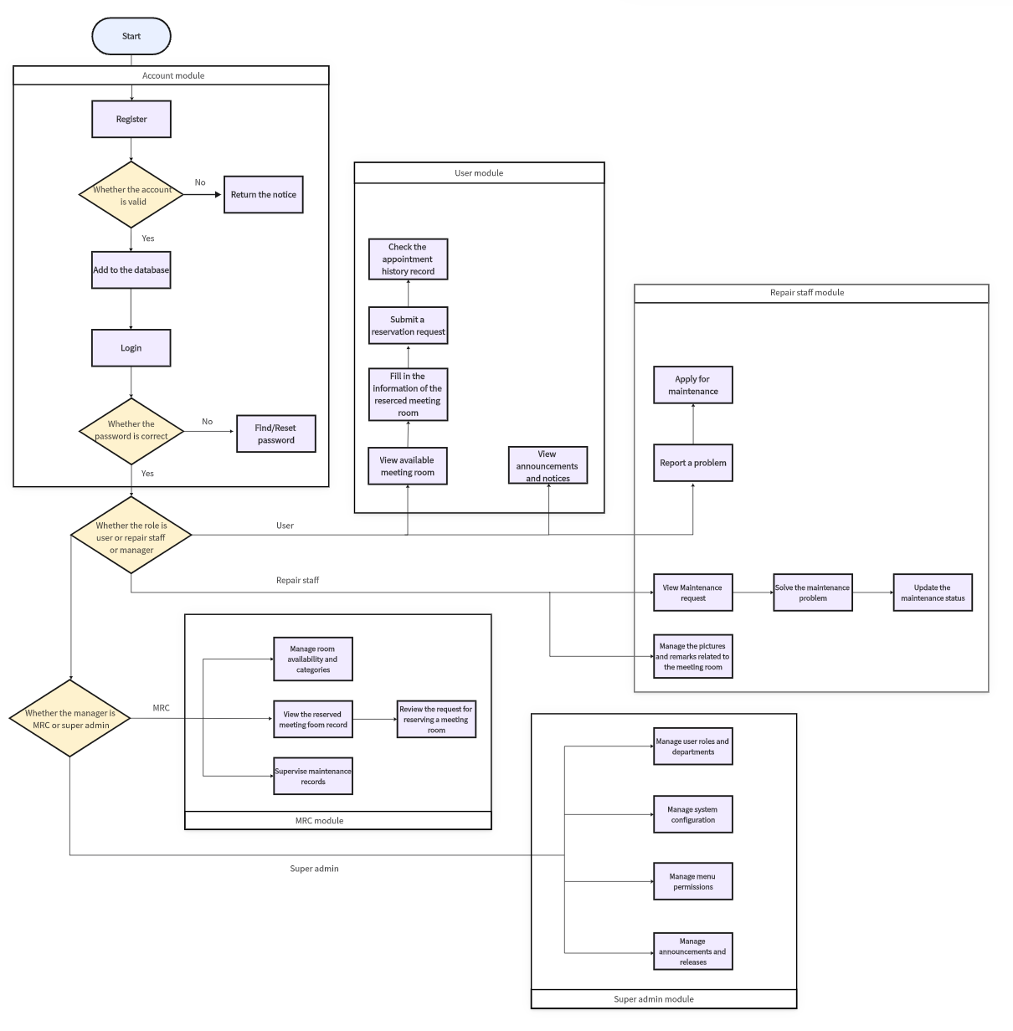

Appendix 9 (1): Database Table Structure Documentation
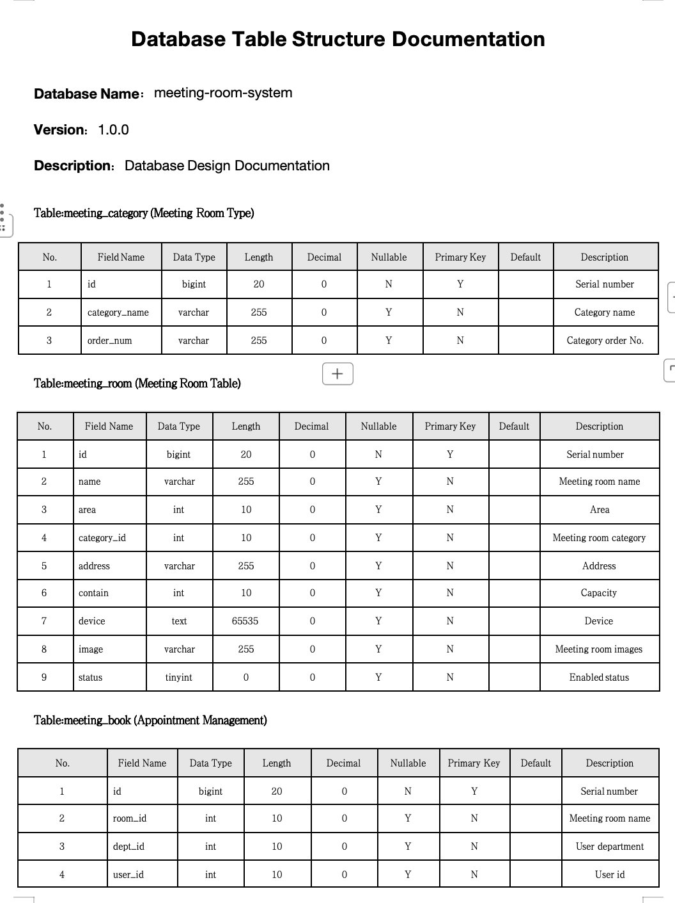

Appendix 9 (2): Database Table Structure Documentation
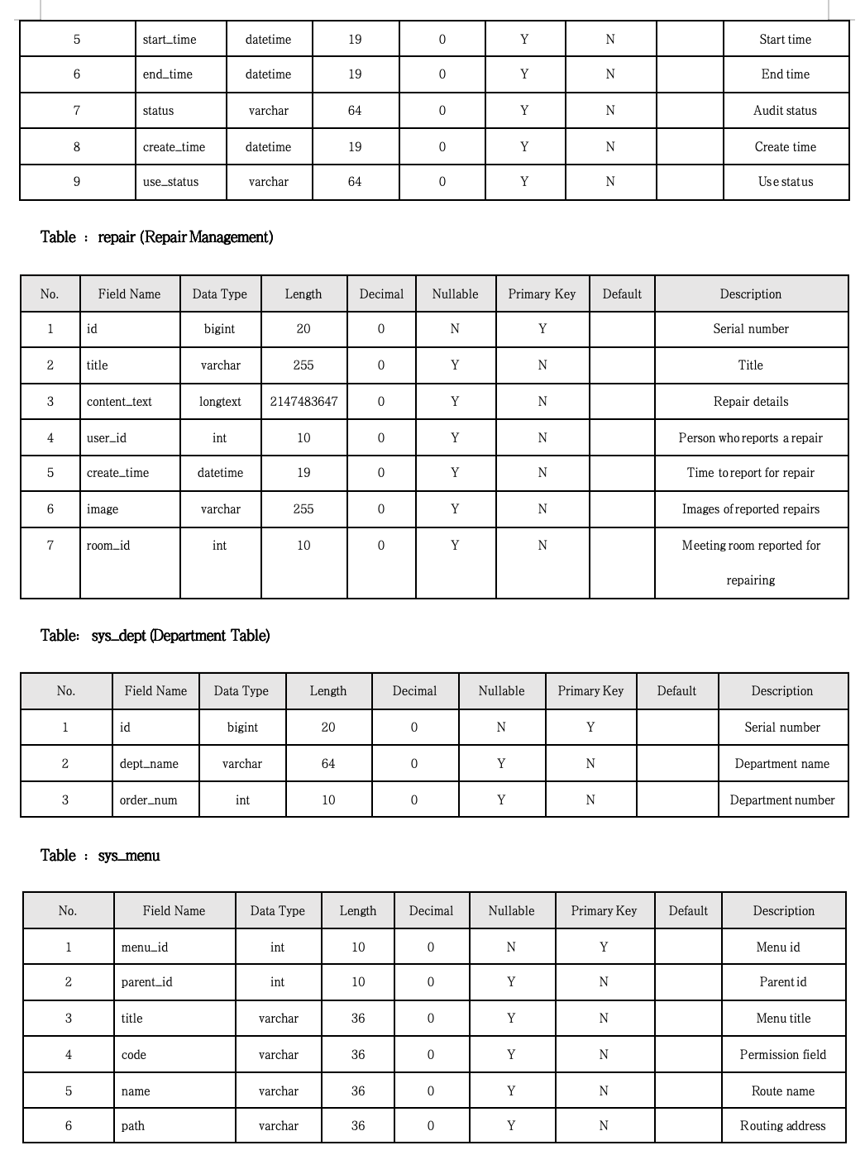

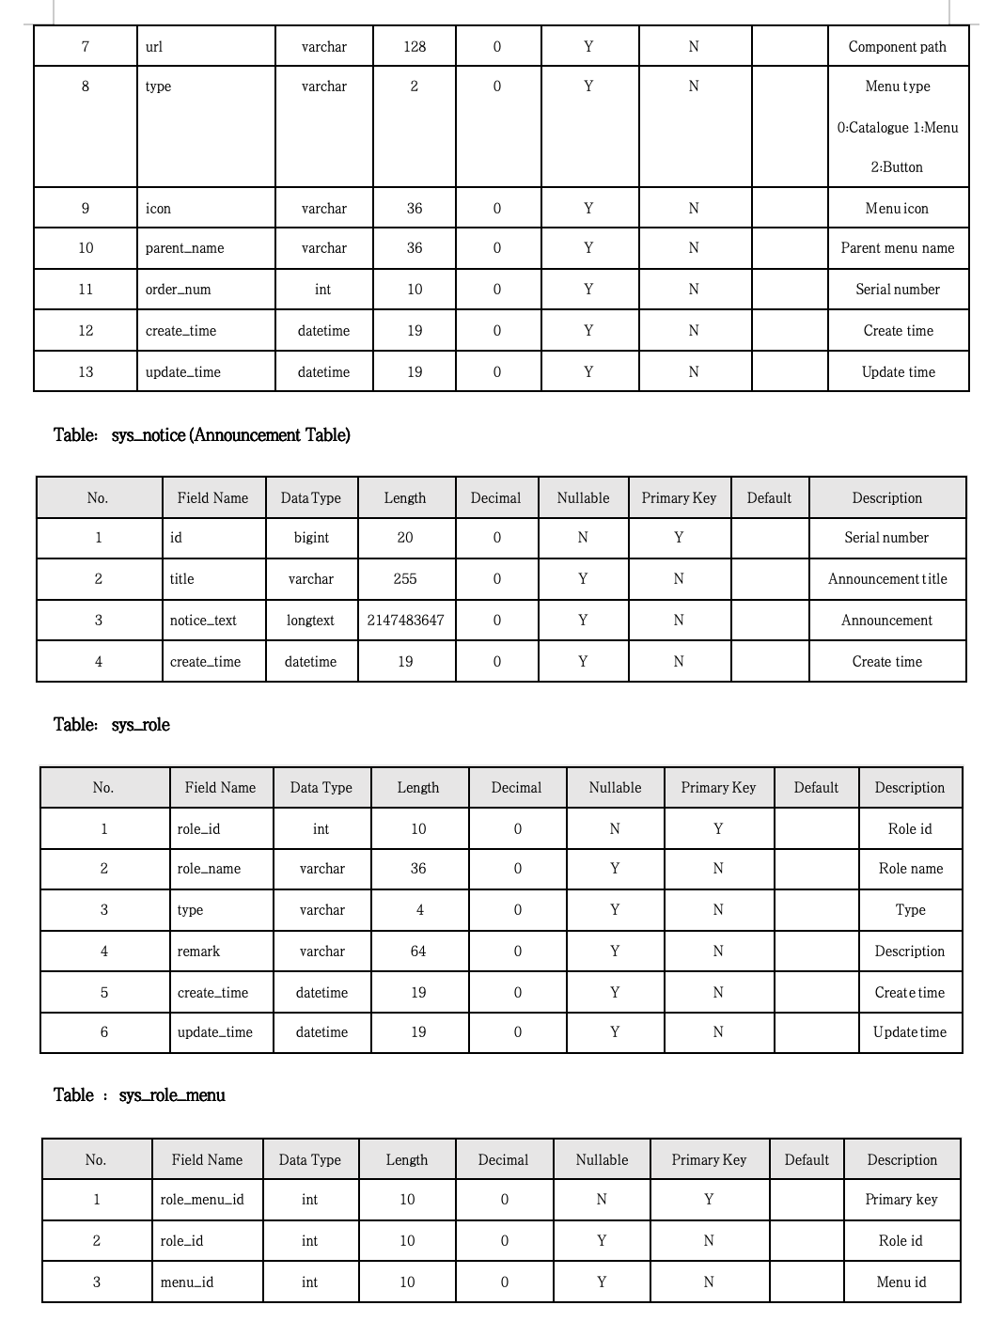
Appendix 9 (3): Database Table Structure Documentation

Appendix 9 (4): Database Table Structure Documentation
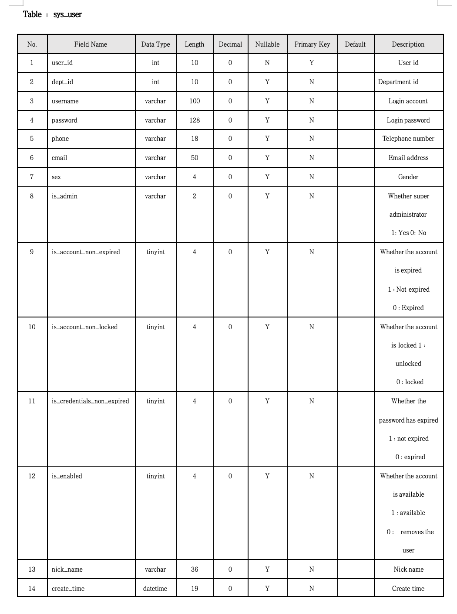
Appendix 9 (5): Database Table Structure Documentation
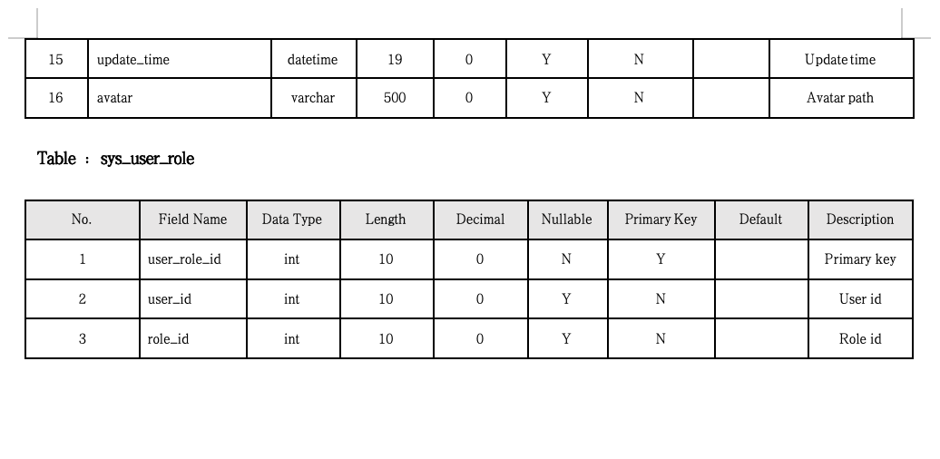

Appendix 10: Overview of our test part in IDE
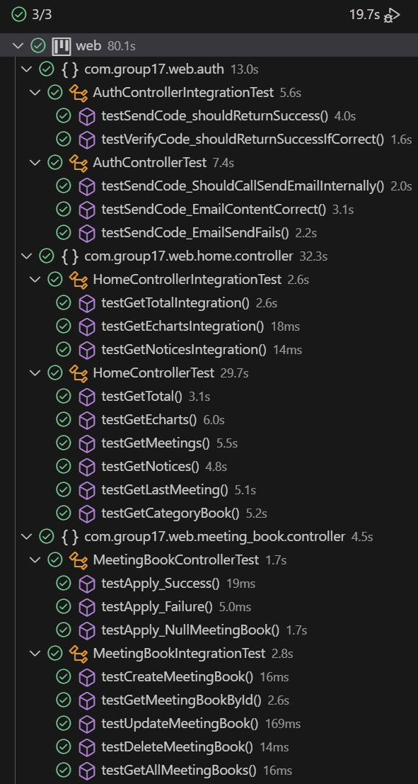
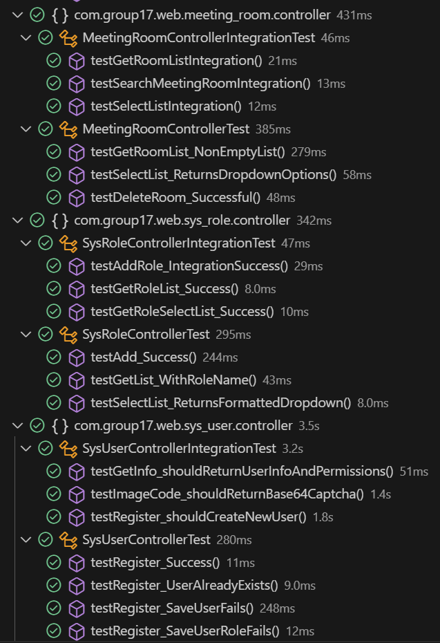

Appendix 11 (1): Schematic diagram of some key data tables of Navicat--meeting_book
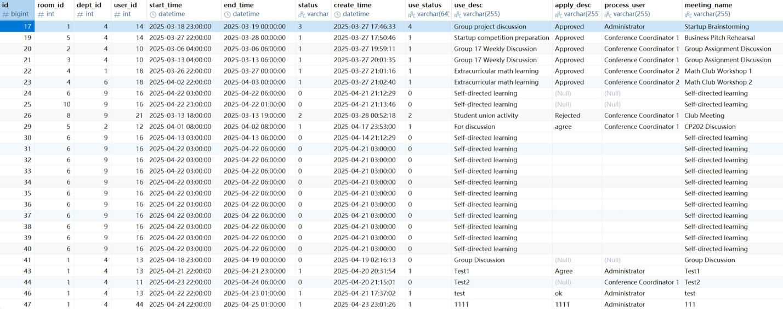

Appendix 11 (2): Schematic diagram of some key data tables of Navicat--meeting_category
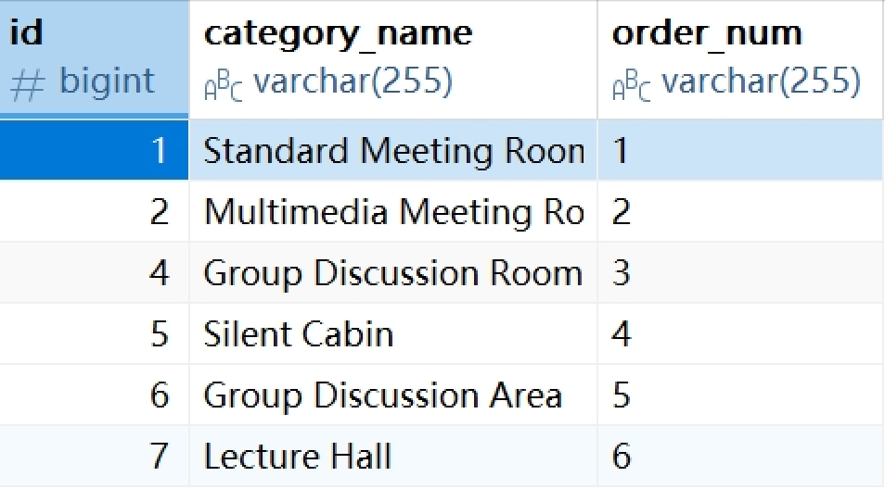

Appendix 11 (3): Schematic diagram of some key data tables of Navicat--meeting_room
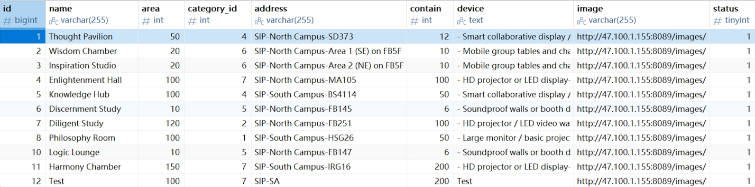

Appendix 11 (4): Schematic diagram of some key data tables of Navicat--repair
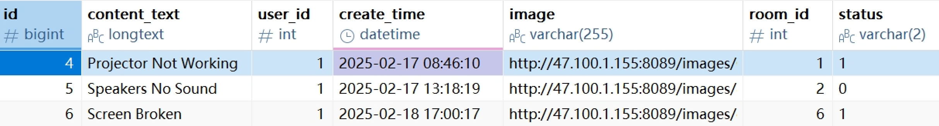

Appendix 11 (5): Schematic diagram of some key data tables of Navicat--sys_dept
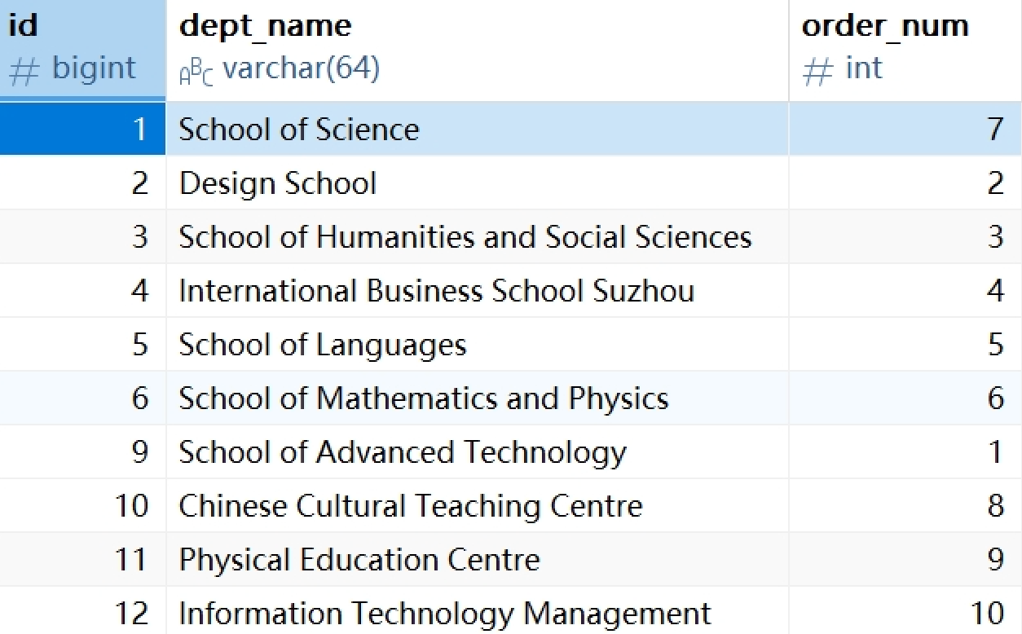

Appendix 11 (6): Schematic diagram of some key data tables of Navicat--sys_menu
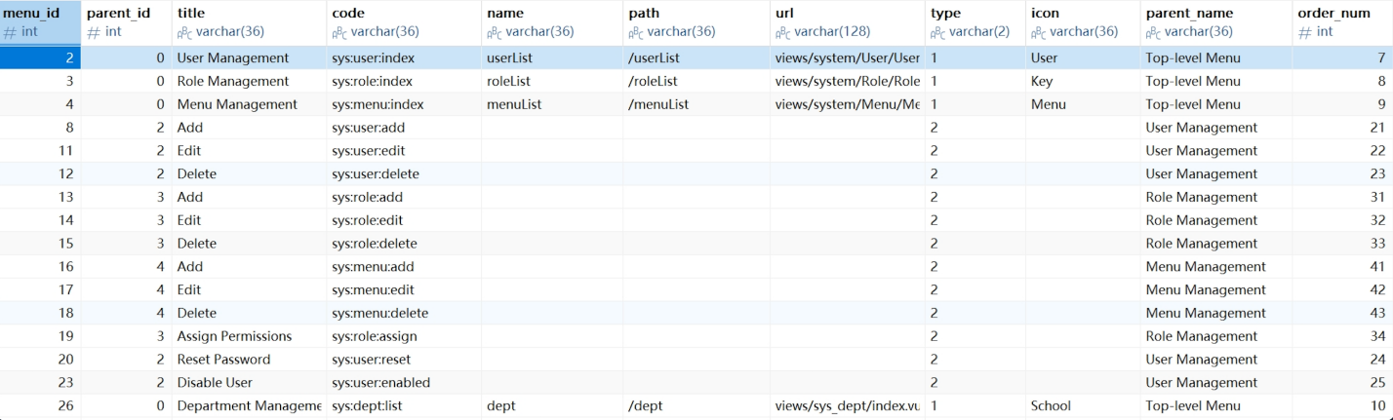

Appendix 11 (7): Schematic diagram of some key data tables of Navicat--sys_role
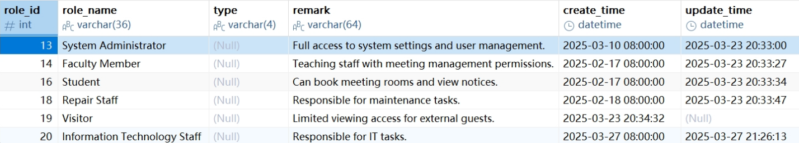

Appendix 11 (8): Schematic diagram of some key data tables of Navicat--sys_user
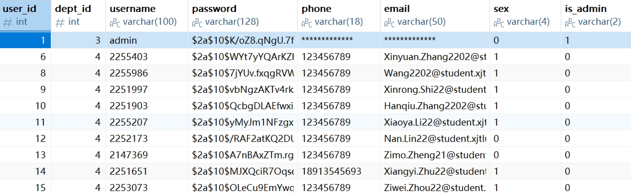

Appendix 12: Unit Testing-Register
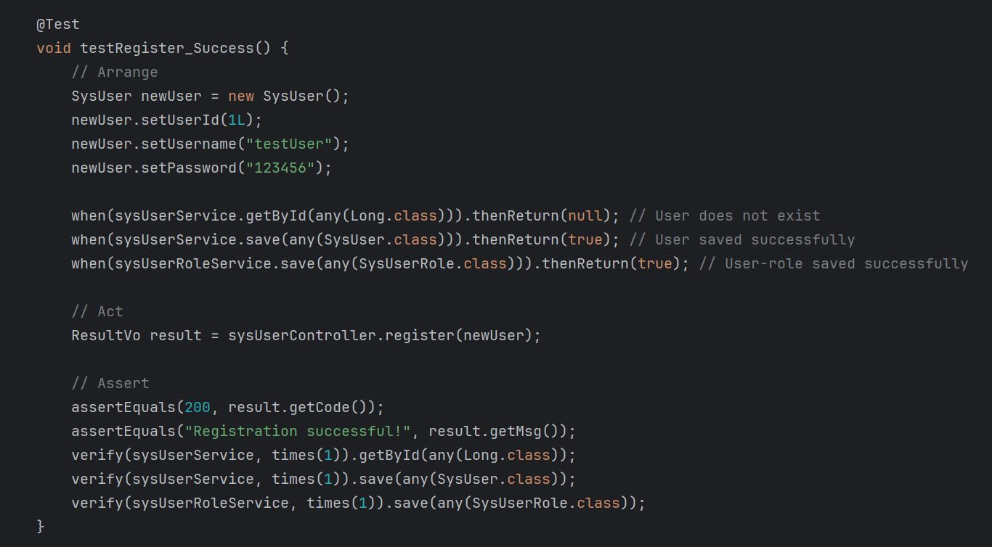

Appendix 13: Integration Testing-Create new booking
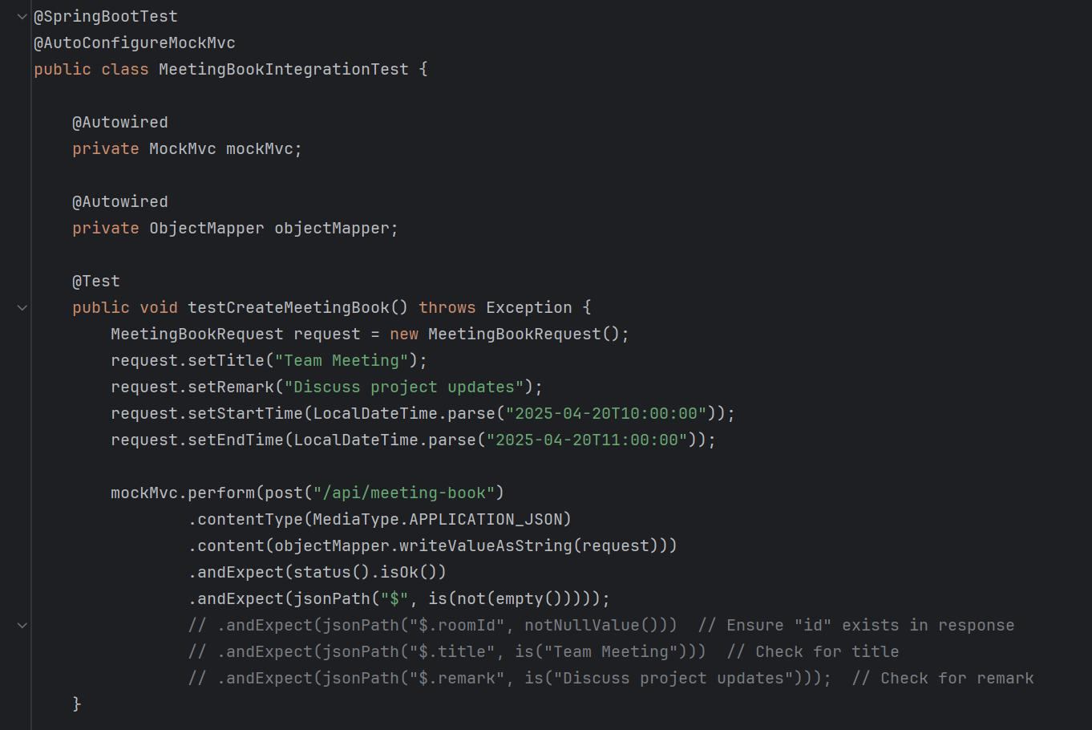

Appendix 14 (1): Technical Documentation--Development Tools
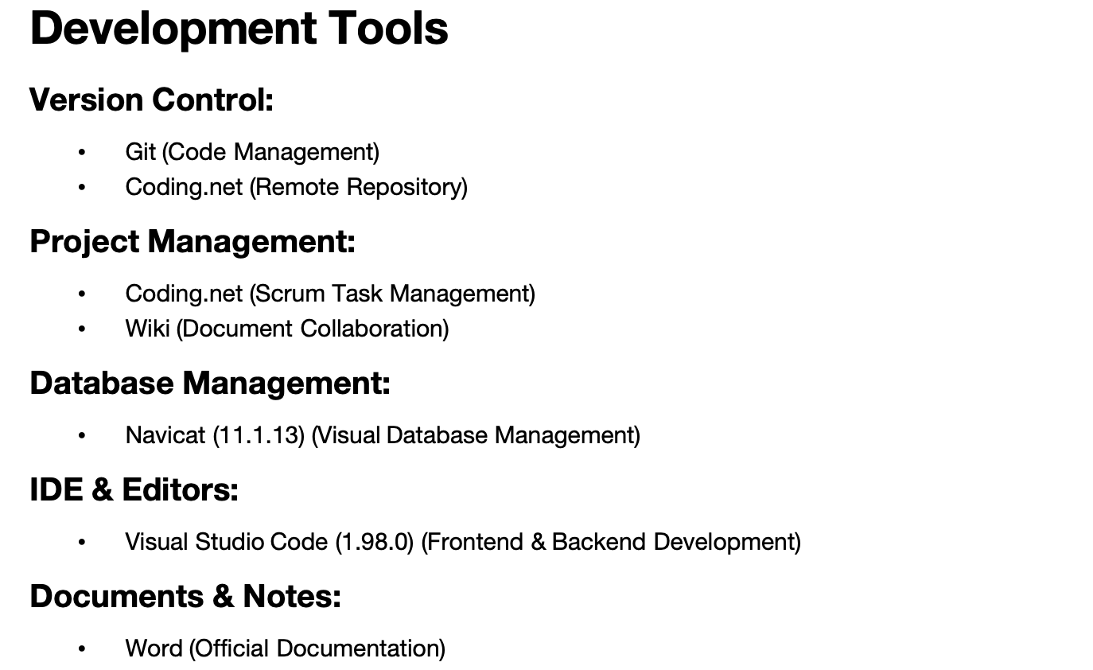

Appendix 14 (2): Technical Documentation--Programming Languages
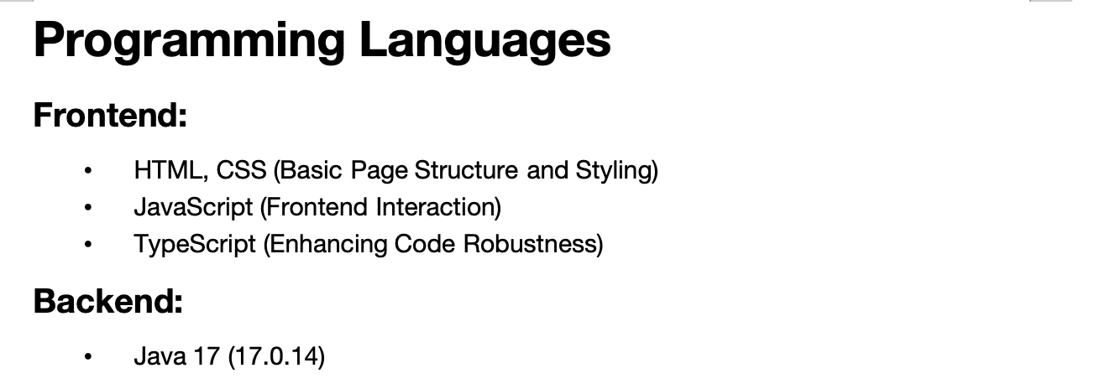

Appendix 14 (3): Technical Documentation--Main Frameworks & Libraries
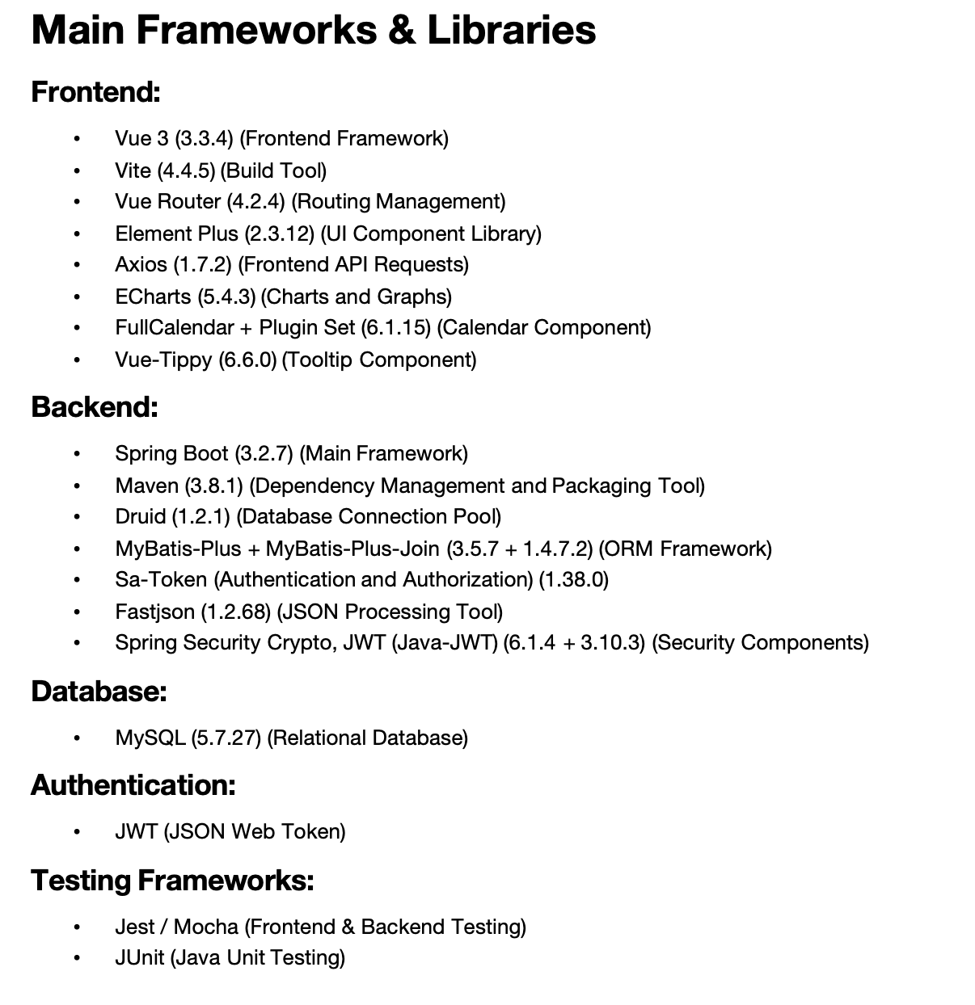

Appendix 14 (4): Technical Documentation--Required Knowledge
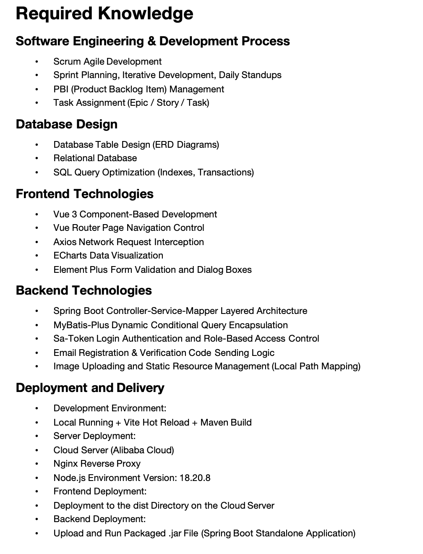

Appendix 14 (5): Technical Documentation--Suggested Workflow
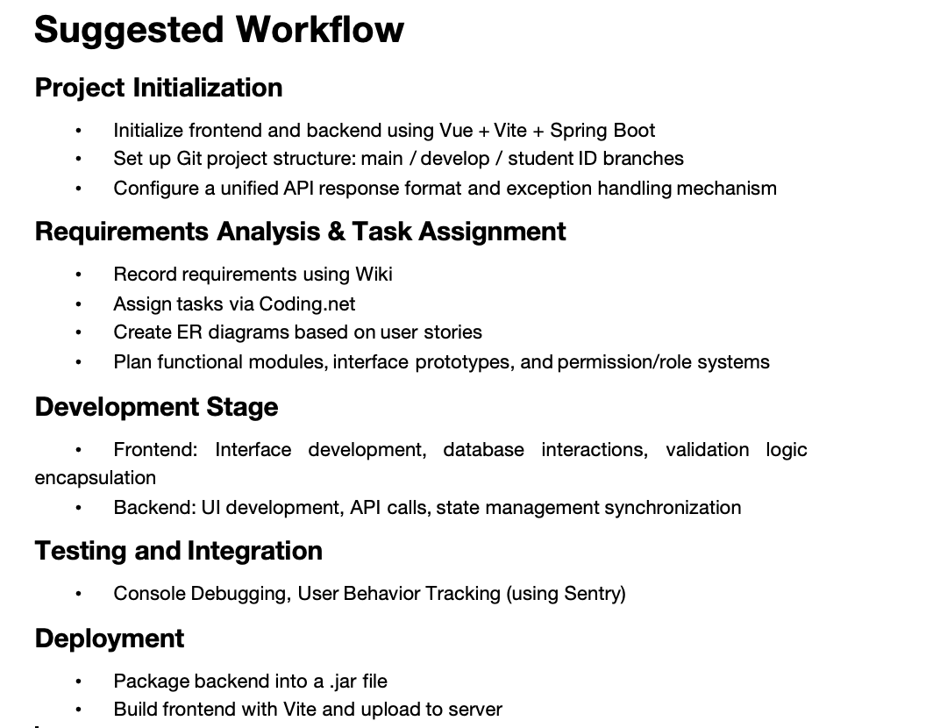

Appendix 15:Individual Contribution for Group Report and Presentation

CPT202 Assignment 2
Individual Contribution for Group Report and Presentation

Group Number:
Name | ID Number | Contribution (%)
1. Xiangyi Zhu | 2251651 | 11.11
2.Xinrong Shi | 2251997 | 11.11
3.Zimo Zheng | 2147369 | 11.11
4.Nan Lin | 2252173 | 11.11
5.Xiaoya Li | 2255207 | 11.11
6.Ziwei Zhou | 2253073 | 11.11
7. Jiayi Wang | 2255986 | 11.11
8.Hanqiu Zhang | 2251903 | 11.11
9. Xinyuan Zhang | 2255403 | 11.11

Signed by all members:

