XI’AN JIAOTONG-LIVERPOOL UNIVERSITY
西 交 利 物 浦 大 学


COURSEWORK SUBMISSION COVER SHEET
Name and ID | Zizhe Song 2257096
Programme | Information management and information system
Module Title | - Business System
Module Code | IOM201
Assignment Title | Individual Coursework
Submission Deadline | 23:59pm, Sunday, December 15, 2024 (China Standard Time, UTC/ GMT+8)
Module Leader | Dr. Bingjie Deng

By uploading or submitting this coursework submission cover sheet, I certify the following:
- I have read and understood the definitions of PLAGIARISM, COLLUSION, and the FABRICATION Of DATA, as outlined in the Postgraduate Student Handbook of Xi’an Jiaotong-Liverpool University and as posted on the University Website.
- This work is my own, original work produced specifically for this assignment. It does not misrepresent the work of another person or institution as my own. Additionally, it is a submission that has not been previously published, or submitted to another module.
- This work is not the product of unauthorized collaboration between myself and others.
- This work is free of embellished or fabricated data.
- This work does not make use of Generative AI in content generation unless the assessment has explicitly permitted it. I acknowledge it is my responsibility to ascertain what use of Generative AI permitted, if at all, on each individual assessment.

I understand that PLAGIARISM, COLLUSION, USE OF GENERATIVE AI WITHOUT PERMISSION, and SUBMISSION OF FABRICATION WORK are serious disciplinary offences. By uploading or submitting this cover sheet, I acknowledge that I am subject to disciplinary action if I am found to have committed such acts.
Marking Scheme
Business activity and IS adoption-40
Future IS adoption-20
Use of knowledge, facts and data-30
Report formatting-10
Total | 0

Catalogue
- Introduction …………………………3
- Business Activity …………………………4
2.1 Supply Chain…………………………4
2.1.1 Data-driven decision-making capabilities…………………………4
2.1.2 Information sharing and cooperation mechanisms ……………………4
2.1.3 Automation …………………………5
2.2 Marketing and Sales …………………………5
2.2.1 Data Collection and Integration …………………………6
2.2.2 Future Demand Forecasting …………………………7
2.3 Customer Services …………………………7
2.3.1 Before Sale …………………………8
2.3.2 During Sale …………………………8
2.3.3 After Sale …………………………8
3. Future Adoption …………………………9
4. Conclusion ………………………… 11

- Introduction
Walmart is a major worldwide retail company from the United States, created from 1962 and has become one of the largest companies in the world. By analyzing Walmart's value chain (Figure 1), its main business includes the supply chain consisting of Inbound logistics, Operations and Outbound logistics, the sales of goods in both online and offline and provide customers with a full range of services. Among them, Inbound logistics, Operations and Outbound Logistics form Walmart's supply chain. At the same time, Walmart has evolved its business model to meet the changing needs of its global customer base by applying information systems to these business activities. (D’ Monte Cited in Kumar, 2022). This report will further analyze the information systems used by Walmart Stores Inc. In each of the three main activities, supply chain, sales and customer service, and envision what information systems and technologies the company can use in the future to improve its performance, as well as point out the possible risks involved.
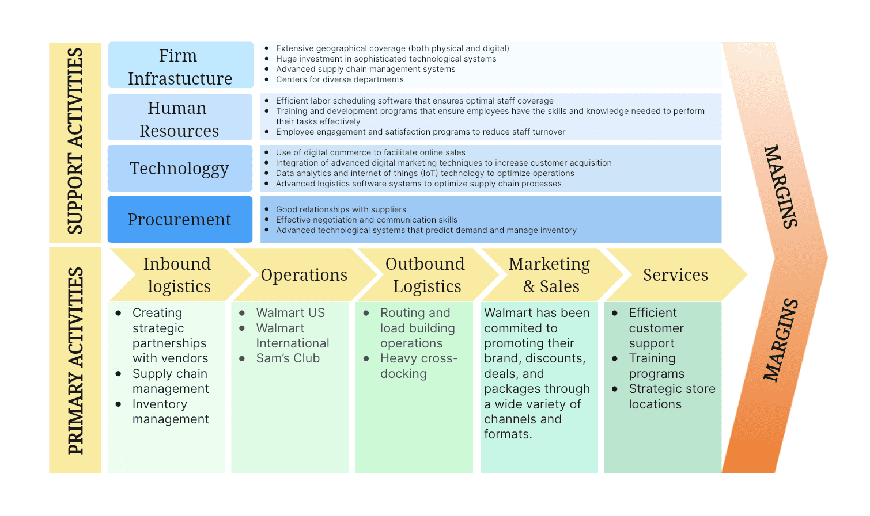
Figure 1: Walmart Value Chain Analysis
https://boardmix.com/analysis/walmart-value-chain/
2. Business Activities
2.1 Supply Chain
Walmart has a supply chain and supply chain management system "Retail Link" with a huge system. By working with suppliers worldwide, Walmart can ensure the quality of its products to meet the needs of consumers. "Retail Link helps Walmart to compete in the retail market in the following ways.
2.1.1 Data-driven decision-making capabilities
RFID(Figure 2) has proven to be an effective way to manage supply chain processes (Radiant, 2022). By pioneering the use of RFID tags on all items worldwide, Walmart has been able to triple the speed of replenishment and reduce out-of-stocks by 16%(Garcia, 2021). With the use of RFID, Walmart has been able to achieve granular data collection at all points in the supply chain, and this large amount of collected data provides Walmart with a rich sample to analyze and utilize. By analyzing these samples, Walmart is able to accurately allocate resources according to the actual situation, thus improving operational efficiency (Chaturvedula, 2022).
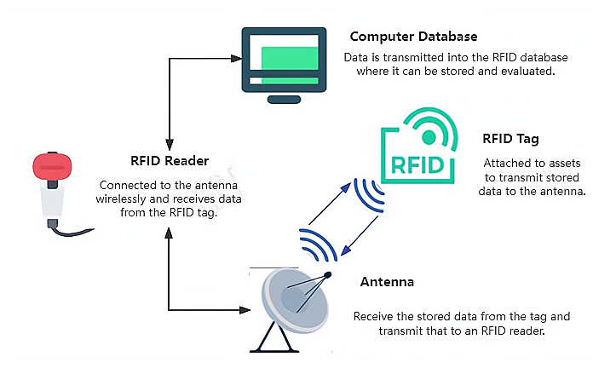
Figure 2: Working Principle of RFID System
2.1.2 Information sharing and cooperation mechanisms
Walmart and its suppliers can manage inventory together through the Retail Link system. Through this system, suppliers have real-time access to store-level sales data, which allows them to quickly understand changes in the marketplace and adjust production strategies. Walmart, in turn, has access to detailed demand insights through the system, allowing it to make timely adjustments to sales strategies and inventory allocation based on the information shared through the platform. Through co-management, Walmart can closely match the actual market demand, reduce the waste of resources due to information asymmetry, thus reducing the possibility of the bullwhip effect (Figure 3), and improve profitability as a whole.
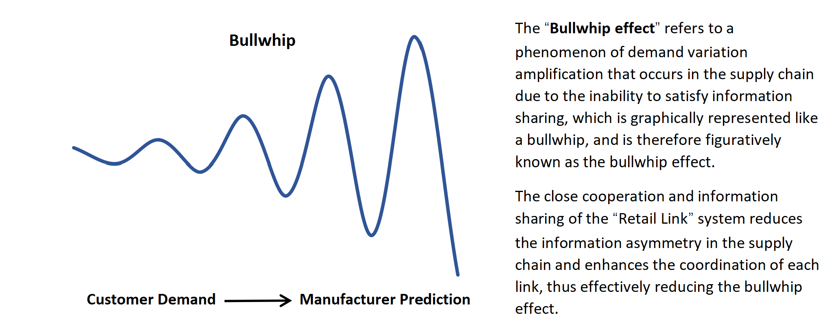
Figure 3: How Bullwhip Effect is Reduced by Retail Link.
2.1.3 Automation
By applying automation technology in Regional Distribution Centers (RDCs), such as the introduction of intelligent warehousing systems and the application of automated picking technology, this efficient automation technology has made Retail Link a highly efficient and competitive set of SCMs, which has laid a solid foundation for Walmart's sustainable development. Meanwhile enterprise application of KM has been proven to increase efficiency and productivity, customer satisfaction and sustainability (Pison, 2023). Walmart has developed a Learning Content Database (LCD), an enterprise knowledge management system to create a highly integrated information sharing platform. This platform is designed to encourage employees to record automated process questions and have them answered by a dedicated person, effectively improving the team's expertise and productivity.
However, in the context of data-driven and information sharing, data security is a great challenge. With the widespread application of Retail Link system and RFID technology, the volume of data collected and processed by Walmart has shown explosive growth, and the risk of data exposure has increased in a complex environment. So how to ensure data security has become an important issue for Walmart.
2.2 Marketing and sales
In terms of marketing and sales, Walmart has been able to offer diverse, high-quality merchandise through its global market presence and continues to open stores that appeal to a wide range of consumers (Figures 4 & 5). Together, these strategies have contributed to Walmart's continued growth in sales, and in doing so, Walmart has achieved a number of positive goals through the deployment of SAP ERP (Figure 6).
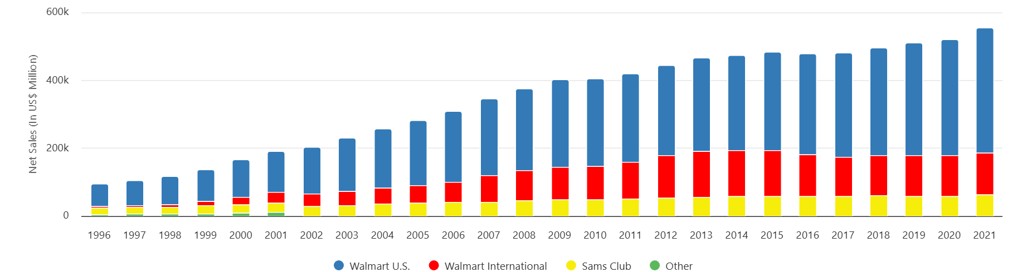 | 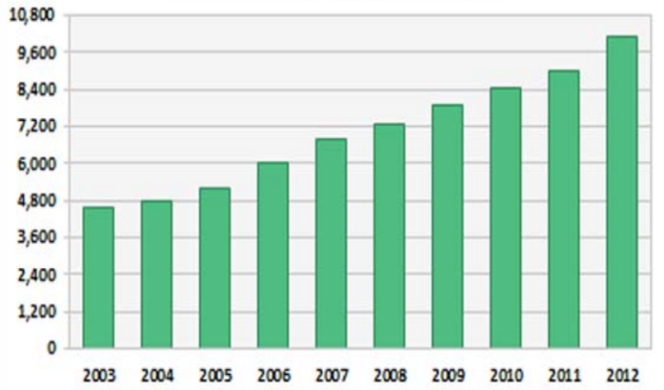
Figure 4: Walmart Annual Net Sales by Segment（By fiscal year ended January 31.）  https://dazeinfo.com/2020/03/06/walmart-annual-net-sales-by-segment-graphfarm/ 1996 to 2020 - Dazeinfo | Figure 5: Walmart-Annual Store Count Growth  https://www.scdigest.com/assets/newsviews/13-08-15-1.php

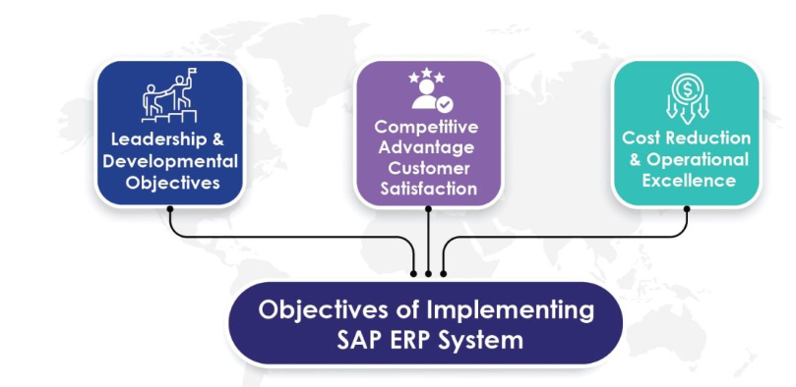
Figure 6: Purpose of Implementing SAP ERP
https://pangrow.com/blog/business-automation/walmarts-custom-sap-erp-solution-for-operational-excellence-a-case-study/

2.2.1 Data Collection and Integration
When a customer makes a purchase, the Point of Sale (POS) system quickly records detailed information about each transaction, which can be transmitted and aggregated to a centralized database in real time. Through the continuous collection and integration of sales data from stores around the world, Walmart is able to gain a comprehensive view of sales trends for all categories of merchandise through SAP ERP. At the same time, Walmart based on the collected data to find the factors affecting sales and make targeted measures, and ultimately can effectively improve sales performance and operational efficiency and reduce costs.
2.2.2 Future Demand Forecasting
Walmart's ERP system utilizes a variety of advanced forecasting models and algorithms to significantly improve its ability to analyze market trends and forecast future demand. The system combines multiple sources of data, such as historical sales data and the macroeconomic environment, to forecast future sales of different commodities. These forecasts provide the basis for Walmart's purchasing plans, inventory management, and staffing arrangements, allowing Walmart to understand the potential psychology of consumers in advance and make more accurate judgments to enhance customer satisfaction.
Although the SAP ERP system has helped Walmart to develop its sales activities, data analysis still inevitably creates unavoidable biases leading to poor decision making. Over-reliance on such automated systems for future forecasting, especially in a changing market environment, is a strategy that needs to be carefully considered.
2.3 Customer Services
Finally, Walmart facilitates customer service operations by assigning each of the three components of CRM (Figure 7) to a different process (Figure 8). Walmart's customer service runs through the entire sales process, building a comprehensive network of quality experiences. It attracts consumers at the pre-sales stage through various services, and makes personalized recommendations for consumers during the sale by integrating information from ERP. Finally, it focuses on solving problems for customers through an efficient and diversified after-sales policy.
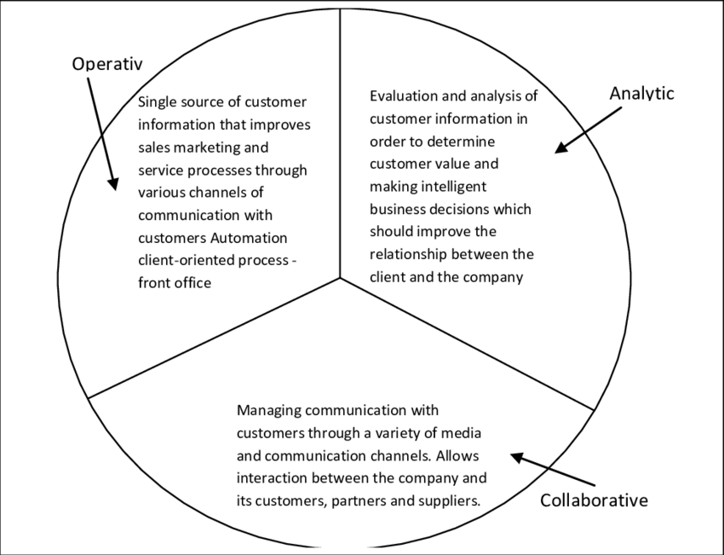

Figure 7: CRM 3 Components
https://www.researchgate.net/figure/Components-of-CRM-16_fig1_261104015
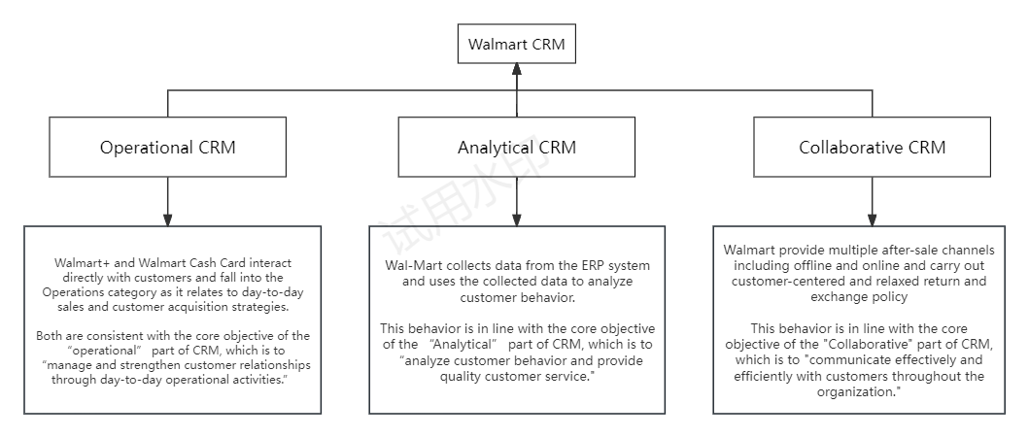
Figure 8: Supporting Evidence for Correspondence

2.3.1 Pre-Sales
Walmart begins by offering customers a full range of choices and support in pre-sales services through a variety of ways (Operational) (Wells, 2024). For example, customers can pay a monthly fee to unlock Walmart+, which gives them access to a number of premium services, as well as getting cash back on purchases by opening a Walmart Cash Card: 1% on the website, 2% in stores, 3% at gas stations and adding direct deposit. These measures can be effective in attracting potential customers and increasing brand impact.
2.3.2 During Sale
In terms of in-sale services, Walmart, by integrating ERP and CRM, the collected customer data can be analyzed in depth (Analytical), and based on the analysis results, personalized recommendations or changes in the arrangement of products for customers, which improves the likelihood of customers purchasing products and effectively enhances the customer experience. A successful example of this is that in 2020, Walmart launched a new store design aimed at creating a seamless omni-channel shopping experience that saves customers' time and inspires them in-store, online or on their mobile devices (Viktor, 2024).
2.3.3 After Sale
For after-sales service, Walmart's extremely efficient and liberal after-sales service is an important part of enhancing the level of its business activities. By providing a variety of after-sales channels (Collaborative), such as offline stores, online customer service, after-sales hotline and other channels, customers can easily solve the corresponding after-sales problems, thus increasing their trust in the company. Walmart's in-depth application of the Customer Relationship Management (CRM) module has enabled it to achieve excellent results in all three stages of customer service.
However, most of these advantages are only realized when shopping online. Offline shoppers may be affected by geographic differences, information asymmetry, and other factors that affect the shopping experience. The same loose return policy may lead to some malicious returns and exchanges, resulting in losses for the company.
- Future Adoption
In the future, Gen AI has been proven to be effective in improving operational efficiency and driving business value growth (Vazquez and Goodwin, 2024). Therefore Walmart can first address some of the threats through Generative Artificial Intelligence (Gen AI). First of all, SAP ERP has strong information collection and integration capabilities, through cooperation with Microsoft, OpenAI and other technology giants to enhance the reliability and stability of its AI applications and can enhance its ability to analyze information and reduce decision-making errors due to data redundancy, human bias and other risks, thus improving the efficiency of processing and utilization of information, and taking a head start over competitors. In addition, Walmart can also apply AI to CRM System to increase the efficiency of problem handling. Through cooperation with large technology companies, Walmart can train a dedicated AI customer service to help solve the relatively basic problems of customers, making the consultation of labor costs greatly reduced; at the same time can do personalized guide, according to the needs of customers recommend products, increase customer experience. At the same time, AI customer service can also intelligently identify return problems, reducing the possibility of malicious return situations. This is undoubtedly a key factor to stand out in the fierce market competition.
To solve the data security problem in the supply chain, Walmart can apply Differential Privacy and Generative Adversarial Networks (GAN) to solve the problem. First Walmart can apply Differential Privacy (Figure 9) to add noise to the data to hide sensitive content. This processed data is similar to the original data in terms of statistical characteristics, but does not contain sensitive information. For example, 100 people purchased a product, but with the addition of noise, the statistics might show 98 or 103. This noise is carefully designed so that it protects the privacy of individual users without having much impact on the overall statistical analysis, thus preventing the attacker from analyzing the data to infer specific results at the root. Similarly, Generative Adversarial Networks (GANs) (Figure 10) can help Walmart address enhanced data security.GANs (Generative Adversarial Networks) are able to simulate the distributional characteristics of Walmart's sales data to create synthetic data that mimics real sales records. These synthetic data are used to replace the real sensitive sales data, ensuring data security from the root. These two technologies can prevent competitors from stealing key sales data and maintain Walmart's competitive advantage in the market.
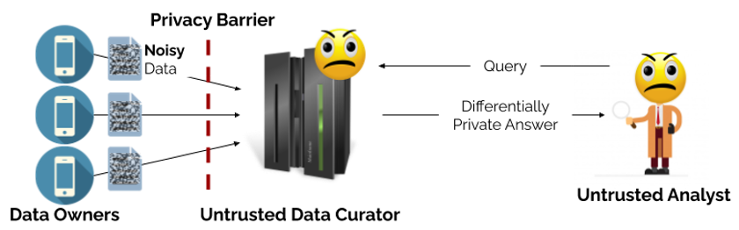
Figure 9: Local Model of Differential Privacy
https://www.nist.gov/image/privacy-blog-figure-2-local-model-differential-privacy

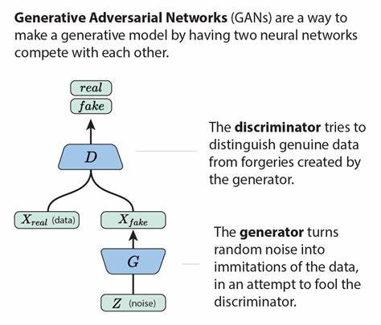
Figure 10: General Model Structure for GAN
https://www.yinglinglow.com/blog/2018/02/13/GAN-walkthrough

However, there are still some predictable drawbacks to the new technology. For Gan AI, data quality issues can lead to bias. Training AI models requires massive amounts of data, and if the data is biased, the models can make poor decisions. For example, when predicting future demand for commodities, if the data fails to cover a particular time period or niche market, the model may give the wrong advice. Similarly, Differential Privacy and GAN are designed to protect data security, but GAN-generated data can be used maliciously to mislead market analysis or competitors; improper parameterization of the noise added to Differential Privacy can lead to excessive data distortion or the risk of privacy leakage still exists. Therefore, if Walmart can gain in-depth insight into these pros and cons and carefully weigh them in the process of promoting the application of new technologies, actively explore optimization solutions and continuously improve its technology application strategy, so as to maximize the potential of new technologies, it will certainly be able to create unique competitive barriers in the fierce market competition, and solidify its leading position in the retail industry.
- Conclusion
Overall, Walmart as a leading global retail chain, has realized efficient management of supply chain, accurate grasp of sales trend and comprehensive customer service by deeply integrating ERP, SCM and other information systems. These information systems have not only enhanced Walmart's operational efficiency and customer satisfaction, but also provided strong support for its competition in the global market. However, the application of these IS has made Walmart also face challenges such as data security, forecast bias, and geographical differences. In the future, however, Walmart can further enhance its decision-making capabilities, improve operational efficiency and ensure data security by applying advanced technologies such as Gen AI, Differential Privacy and GANs to cope with complex and changing environments, maintain its competitive edge and achieve sustainable development.
（Word Count: 1988）

Reference List
Camilo, V. and Goodwin, M. (2024) ‘What is artificial intelligence (AI) in business?’, IBM, 20 February. Available at: https://www.ibm.com/topics/artificial-intelligence-business (Accessed: 11 December 2024).
Chaturvedula, B. (2022) ‘Disrupting the Supply Chain Game – The Walmart Way’, Walmart Global Tech, 18 January. Available at: https://tech.walmart.com/content/walmart-global-tech/en_us/blog/post/disrupting-the-supply-chain-game-the-walmart-way.html (Accessed: 10 December 2024).
D’Monte, L. (2022) ‘How Walmart CTO get tech to adapt to the customer’, Mint, 8 March. Available at: https://www.livemint.com/companies/people/how-walmart-s-cto-gets-tech-to-adapt-to-the-customer-11709804703828.html (Accessed: 10 December 2024).
Flora, M. (2024) ‘Walmart’s Supply Chain: 6 Keys to Success’, Shipbob, 21 November. Available at: https://www.shipbob.com/blog/walmart-supply-chain/ (Accessed: 11 December 2024).
Garcia, T. (2021) ‘Walmart to invest nearly $14 billion in automation and other business areas in fiscal 2022’, MarketWatch, 22 February. Available at: https://www.marketwatch.com/story/walmart-to-invest-nearly-14-billion-in-automation-and-other-business-areas-in-fiscal-2022-11613752795 (Accessed: 10 December 2024).
Ken. (2022) ‘Walmart Distribution Center Locations’. Available at: https://warehouse.ninja/walmart-distribution-center-locations/#:~:text=Walmart%20is%20estimated%20to%20have%20at%20least%20210,who%20unload%20and%20ship%20over%20200%20trucks%20daily (Accessed: 10 December 2024).
Pison, D. (2023) ‘Knowledge management: A game-changer for your business’, Liveagent, 22 August. Available at: https://www.liveagent.com/blog/knowledge-management/#:~:text=KM%20helps%20growth%20and%20sustainability%20by%20keeping%20institutional,25%25%20improvement%20in%20productivity%2C%20leading%20to%20organizational%20growth (Accessed: 10 December 2024).
Qiong, A. (2024) ‘Interpreting the Walmart business model: a comprehensive analysis’, appscrip, 24 June. Available at: https://appscrip.com/zh-CN/blog/walmart-business-model/ (Accessed: 10 December 2024).
Radiant (2022) ‘Should You Use RFID In Supply Chain Management?’, 7 October. Available at: https://radiantrfid.com/blog/rfid-in-supply-chain-management/ (Accessed: 11 December 2024).
Vector. (2024) ‘Walmart’s Supply Chain: A Detailed Look at How They Manage It’, Available at: https://www.withvector.com/blog/walmarts-supply-chain-a-detailed-look-at-how-they-manage-it/ (Accessed: 10 December 2024).
Viktor, A. (2024) ‘Walmart CRM Strategy: A Decade-Long Secret You Never Knew’, CRMside, 7 August. Available at: https://crmside.com/walmart-crm-strategy/ (Accessed: 11 December 2024).
Wells, T. (2024) ‘The Ultimate Guide to Contacting Walmart Customer Service: Email, Phone, Chat, and More’, Marketing Scoop, 20 April. Available at: https://www.marketingscoop.com/consumer/what-is-walmarts-email-address/ (Accessed: 10 December 2024).

