

IOM205 Advanced Database Management

Individual Coursework Report

UniBooks Database

Nan.Lin 2252173
CONTENTS
ID2.2: The operation of the system 3
2.2.1 Log in 3
2.2.2 Specific Operations and Usage 5
ID2.3: Significant Database Features 13
2.3.1 Adds a new order and updates stock based on order size 13
2.3.2 Return Processing with One-Step Inventory Update 15
ID2.4: Non-Trivial queries 17
2.4.1 Step1: Initial State - No Data Binding Established 17
2.4.2 Step2: Entering Data in the Seller_Order_Item Subform 17
2.4.3 Step 3: Creating a New Order in the Seller_Order Table 18
2.4.4 Step 4: Linking Order Details in the Subform to the New Order 19
2.4.5 Step 5: Establishing the Data Binding Relationship 20
ID2.5: Management Report 22
2.5.1 Order invoice for the Seller Order and Seller Order Item details 22
2.5.2 Order invoice for the Publisher Buyer Order and Publisher Buyer Order Item details 22
ID2.6: Non-trivial chart 23
2.6.1 Employee Monthly Sales Chart 23
ID2.7: Testing 25
2.7.1 Add new publisher and books 25
2.7.2 The functionality of purchasing and selling books, along with the line chart statistics of book sales 27
ID2.8: Reflection 30
2.8.1 Advantages 30
2.8.2 Disadvantages 30
2.8.3 Solutions and self-evaluation 30
References 31

ID2.2: The operation of the system

2.2.1 Log in
Double-click to open Access Database, a login interface will appear, users need to enter the appropriate account and password to log in, as shown in the following figure:

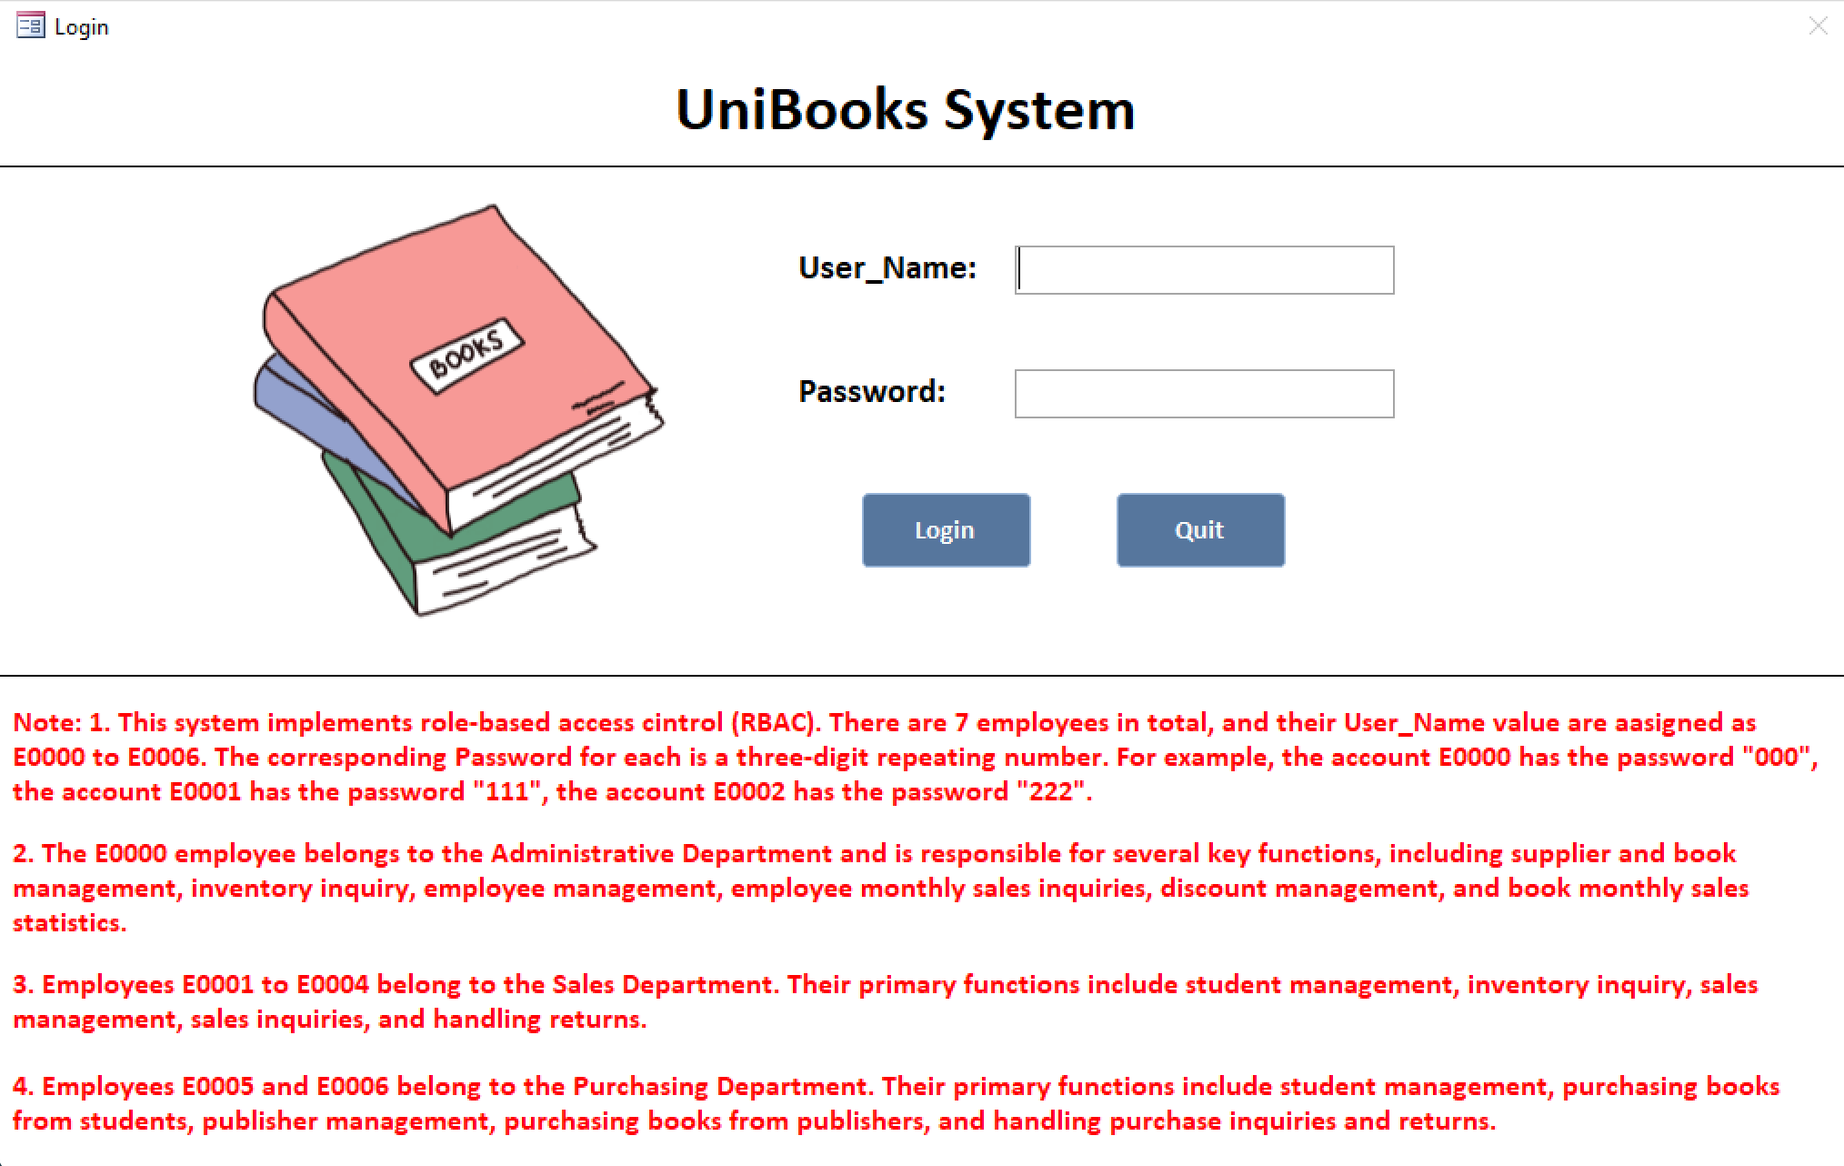
Figure1: UniBooks Login Interface

However, if the account number and password are entered incorrectly, an error screen will pop up, as shown in the figure:

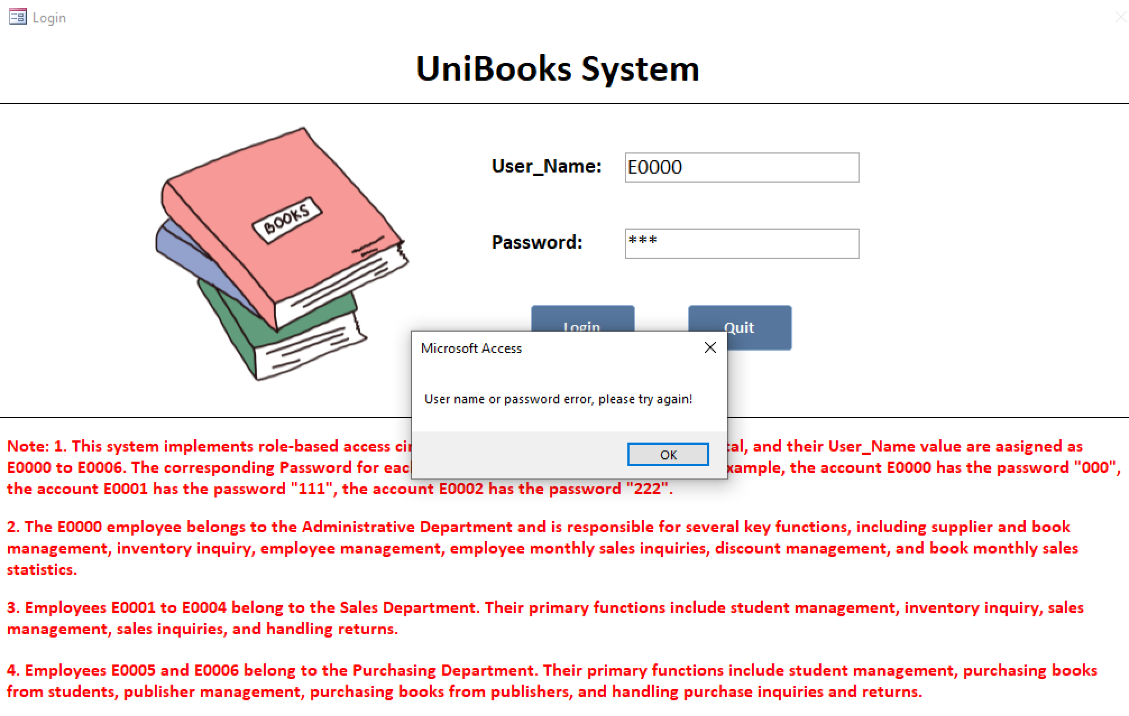
Figure2: Account or password error screen
Annotation: The passwords for the respective accounts are as follows:
• E0000: 000
• E0001: 111
• E0002: 222
• E0003: 333
• E0004: 444
• E0005: 555
• E0006: 666
This system adopts a decentralized management approach, dividing UniBooks employees into three departments: The Administrative Department manages employees, discounts, and operational data; the Sales Department handles sales and returns; and the Purchasing Department oversees procurement and related returns. The structure is shown in the diagram below:

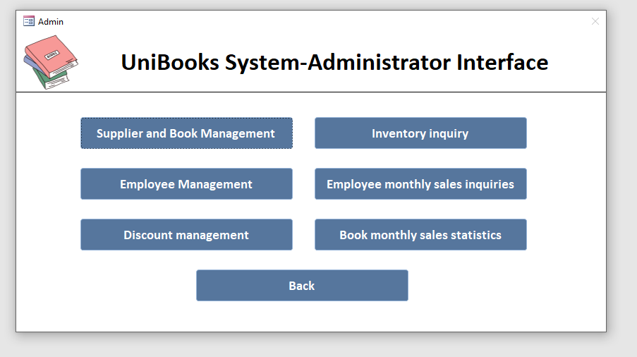
Figure3: UniBooks System-Administrator Interface
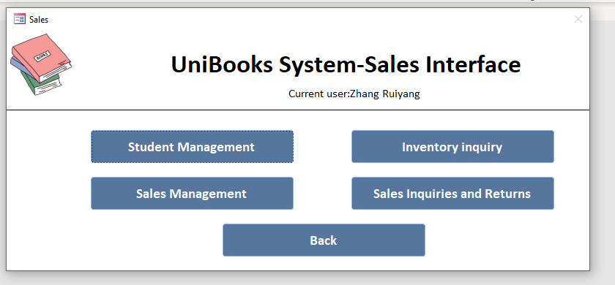
Figure4: UniBooks System-Sales Interface
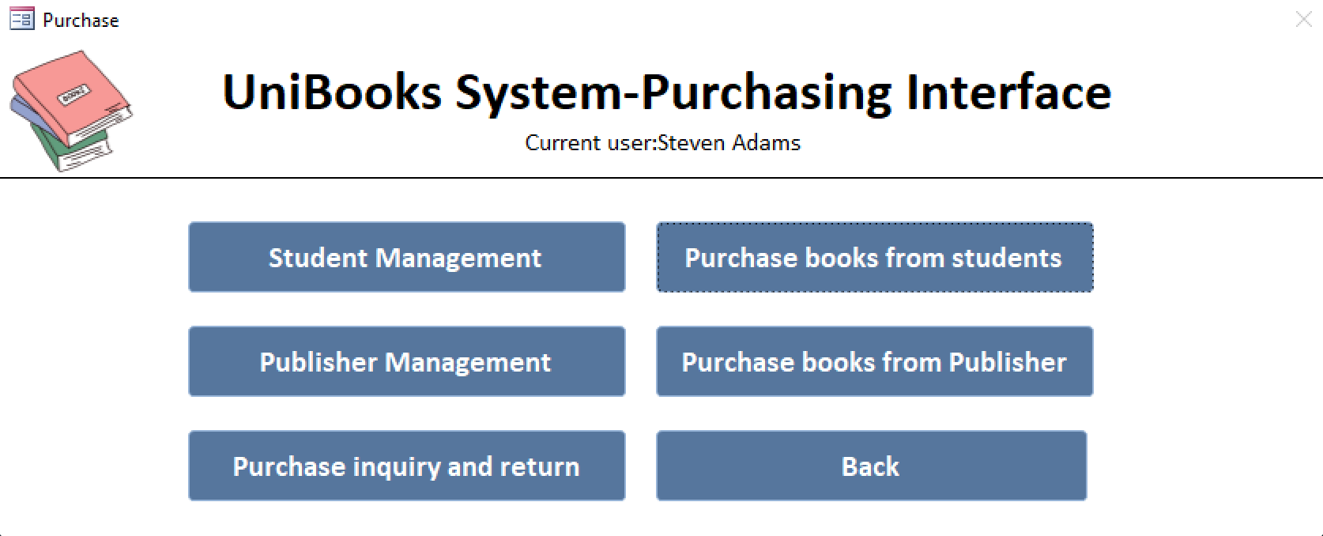
Figure5: UniBooks System-Purchasing Interface

2.2.2 Specific Operations and Usage
Administrative Department employees can log in to perform strategic tasks like Employee, Supplier, Book, and Discount Management, and view detailed sales data, as shown in the diagram below.

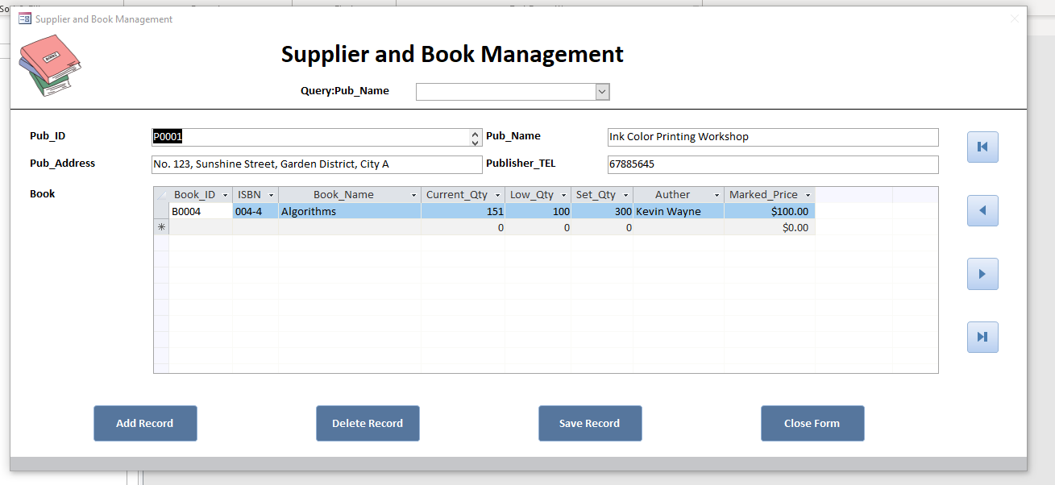
Figure6: Supplier and Book Management
Annotation: Here, you can not only manage publisher information but also add books published by the corresponding publisher. Additionally, you can use the query function above to quickly search for information about their published books.
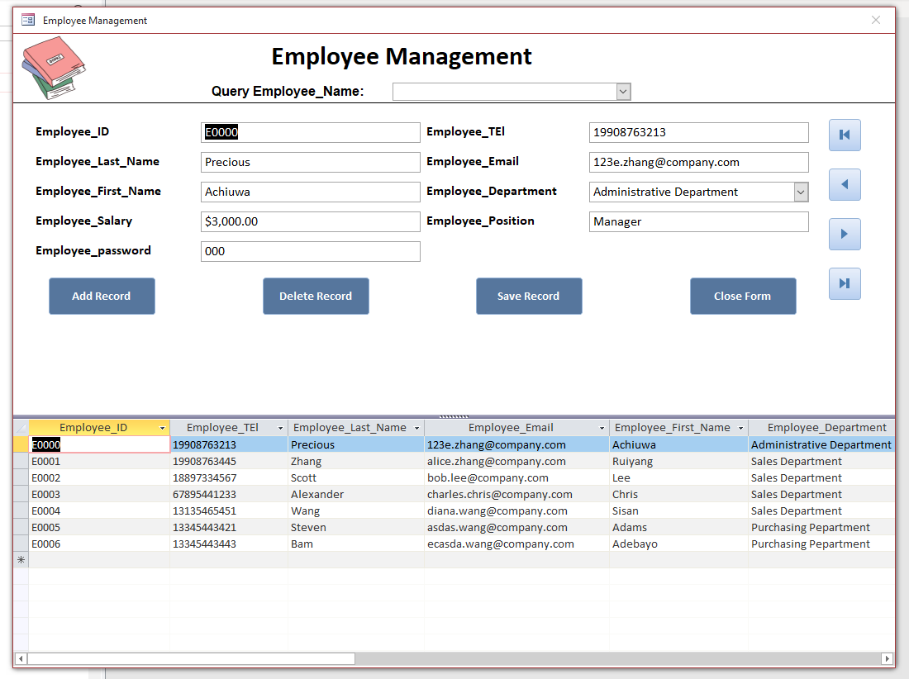
Figure7: Employee Management
Annotation: Due to the decentralized management system, only system administrators are authorized to modify employee information, preventing employees from maliciously altering their colleagues’ data.
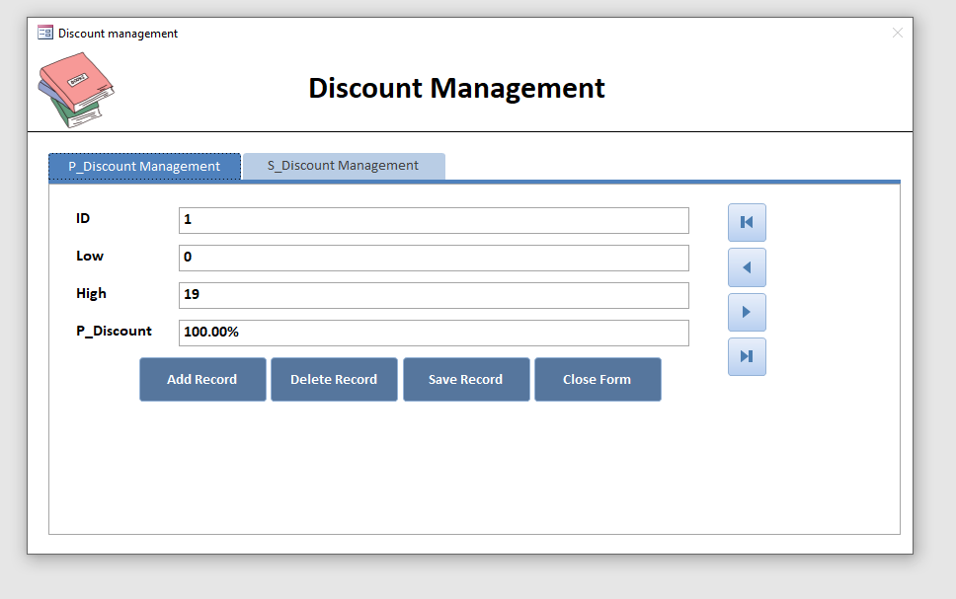
Figure8: Discount Management
Annotation: In Discount Management, new discounts can be added. For example, sellers may receive an 80% discount if they sell more than 80 books in the future.
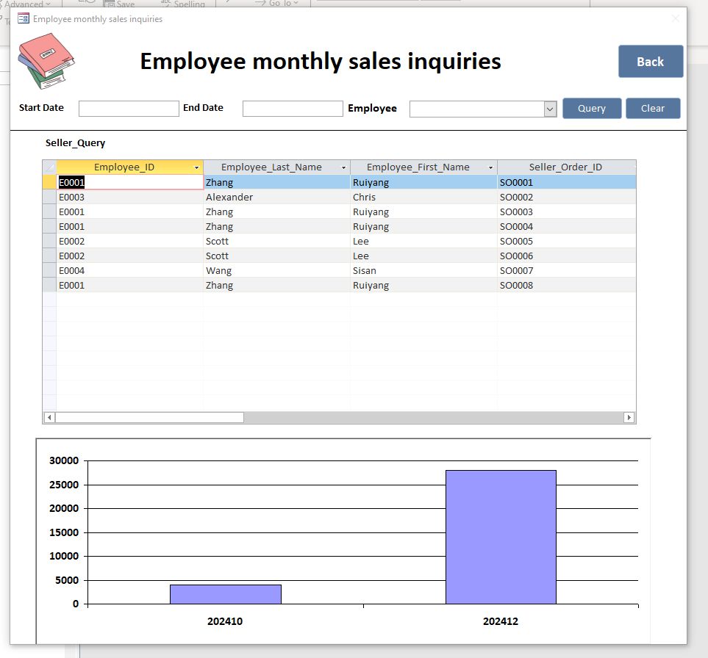
Figure9: Employee monthly sales inquiries
Annotation: The specific details will be elaborated in the chart section later.
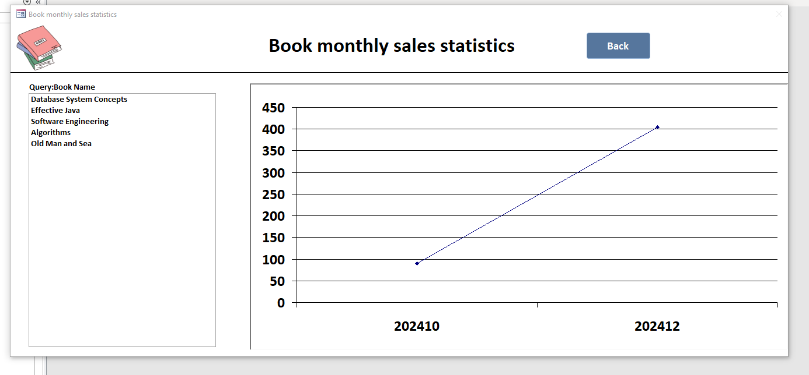
Figure10: Book monthly sales statistics
Annotation: The specific details will be elaborated in the chart section later.

If the employee belongs to the Sales Department, they can perform functions such as Inventory Inquiry, Sales Management, Sales Inquiries, and Returns.

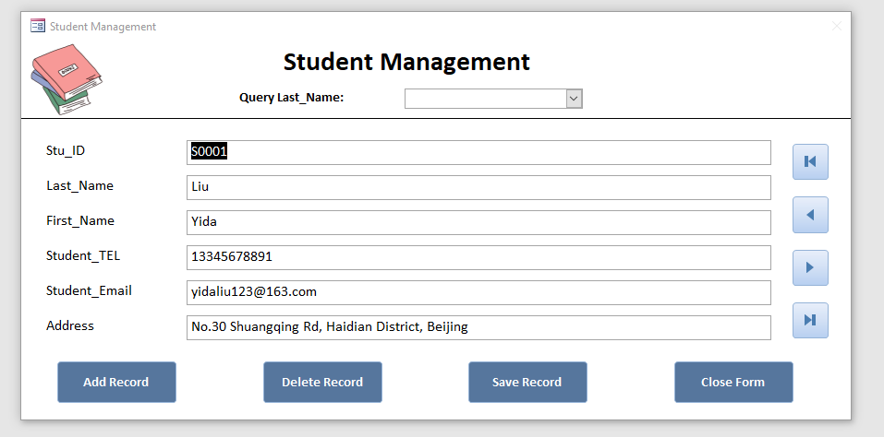
Figure11: Student Management
Annotation: You can use queries to quickly search for student information.
At this point, the student is the target customer for our book sales.
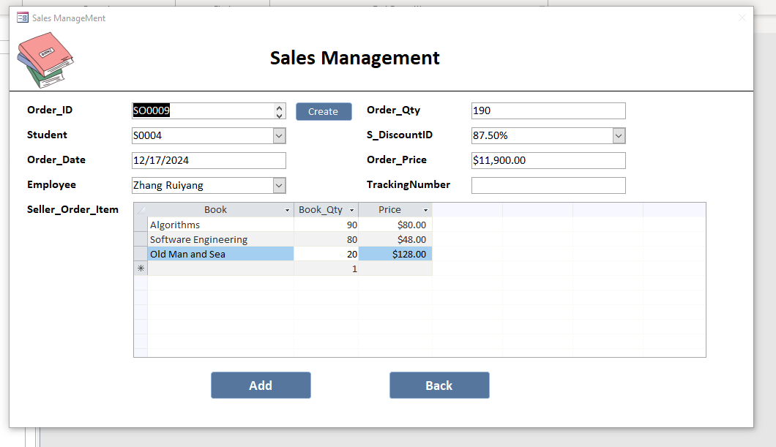
Figure12: Sales Management
Annotation: In this form, the Price in the subform is 80% of the book’s marked price. The Order_Qty automatically sums up based on Book_Qty, while S_Discount and Order_Price are auto-calculated. The Employee field auto-fills the current account to distinguish orders, and Order_Date is fixed to the current day, preventing edits to past or future dates.
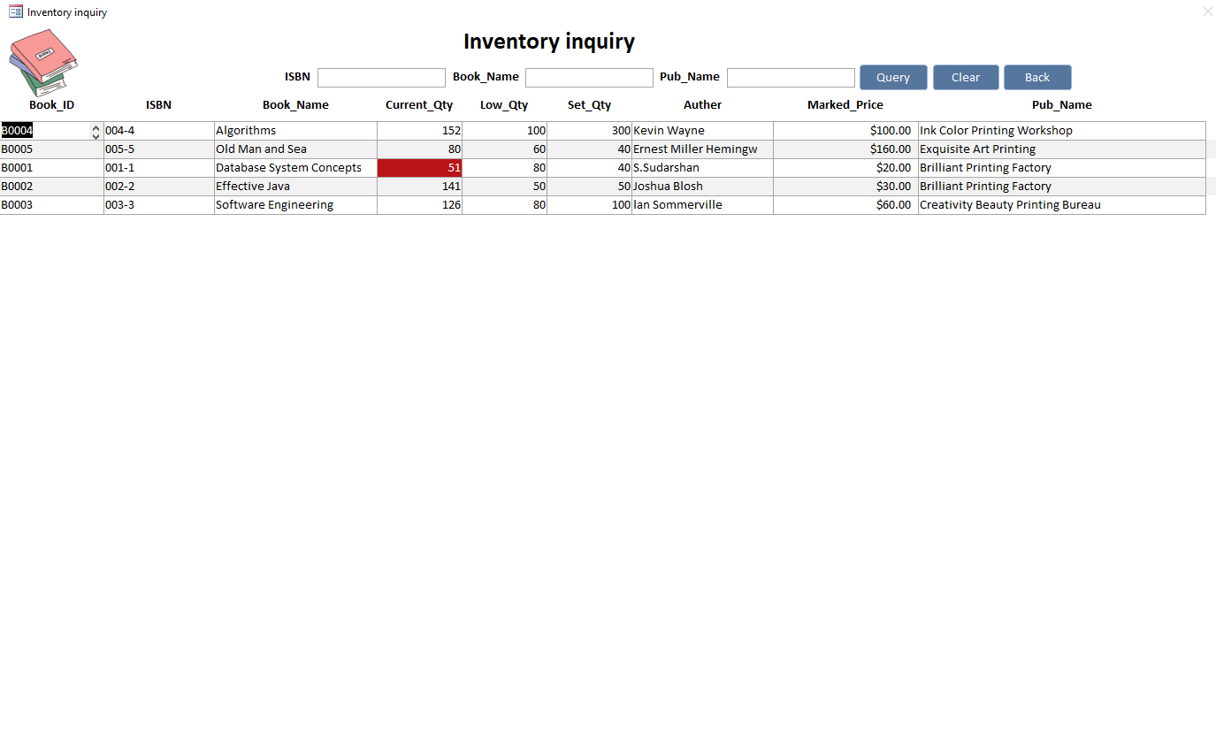
Figure13: Inventory inquiry
Annotation: When Current_Qty is less than Low_Qty, a red marker will automatically warn the user.
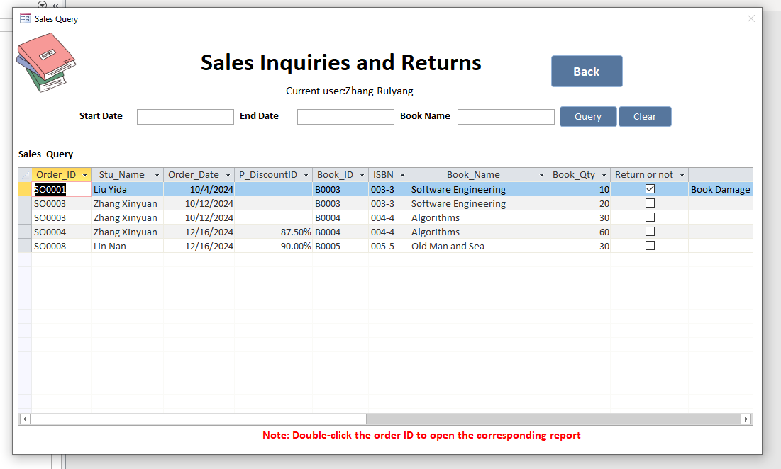
Figure14: Sales Inquiries and Returns
Annotation: Double-click the Order_ID can open the corresponding report
The specific return operation will be demonstrated in detail below.
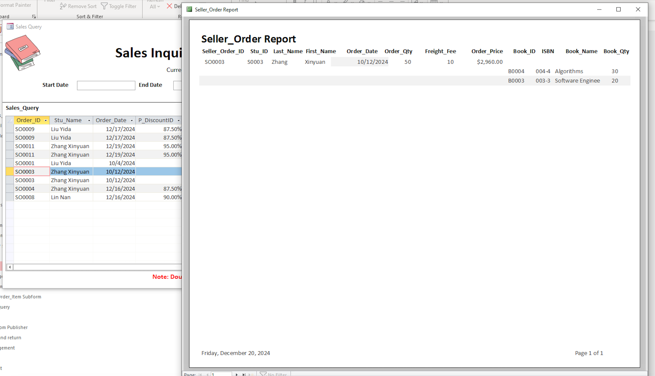
Figure15: The related seller_order_item information corresponding to seller_order
Annotation: After double-clicking the Order_ID, the system navigates to the Report Invoice interface. In this case, the invoice for Order_ID SO0003 was double-checked.

If our employee belongs to the Purchasing Department, they can perform operations such as purchasing books from students/publishers, among others.

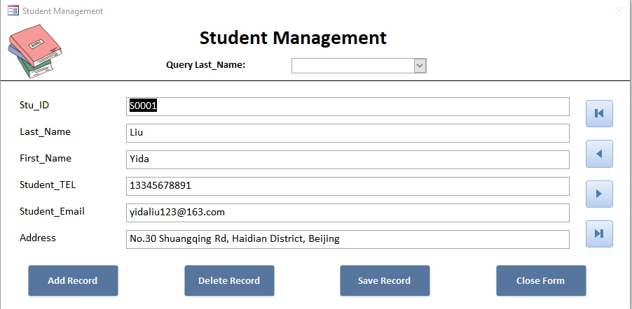
Figure16: Student Management
Annotation: You can use queries to quickly search for student information.
At this point, At this point, we are purchasing books from students.
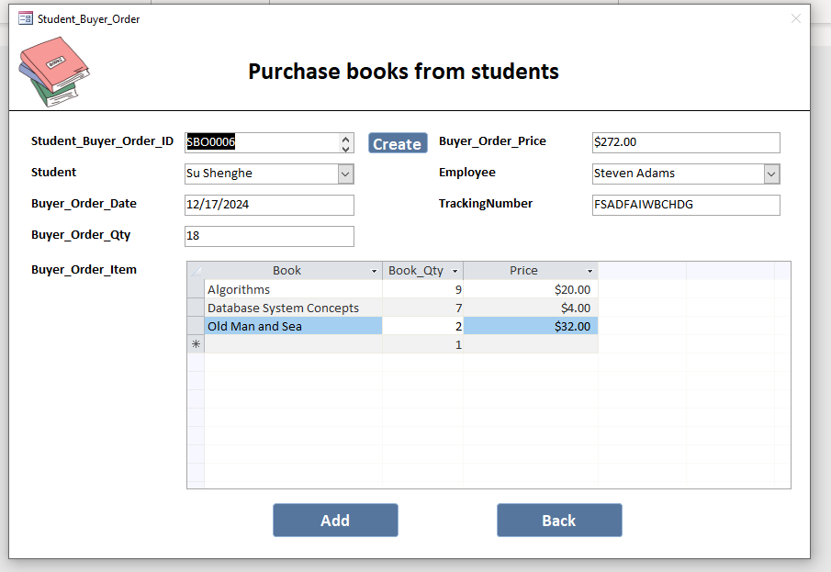
Figure17: Purchase books from students
Annotation: This process is similar to the sales process, where the book quantity and price are automatically calculated. The only difference is that purchasing books from students does not include any discounts.
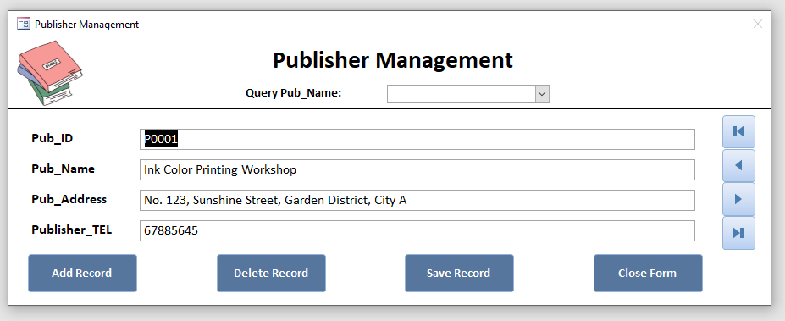
Figure18: Pulisher Management
Annotation: You can use queries to quickly search for Publisher information.
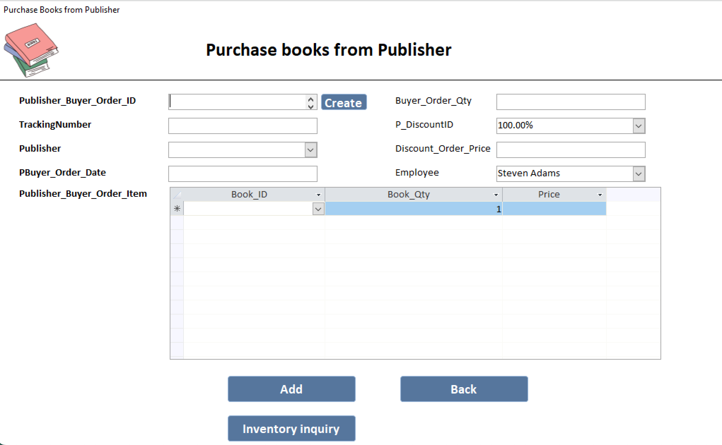
Figure19: Purchase books from Publisher
Annotation: The specific operations are similar to the sales process.
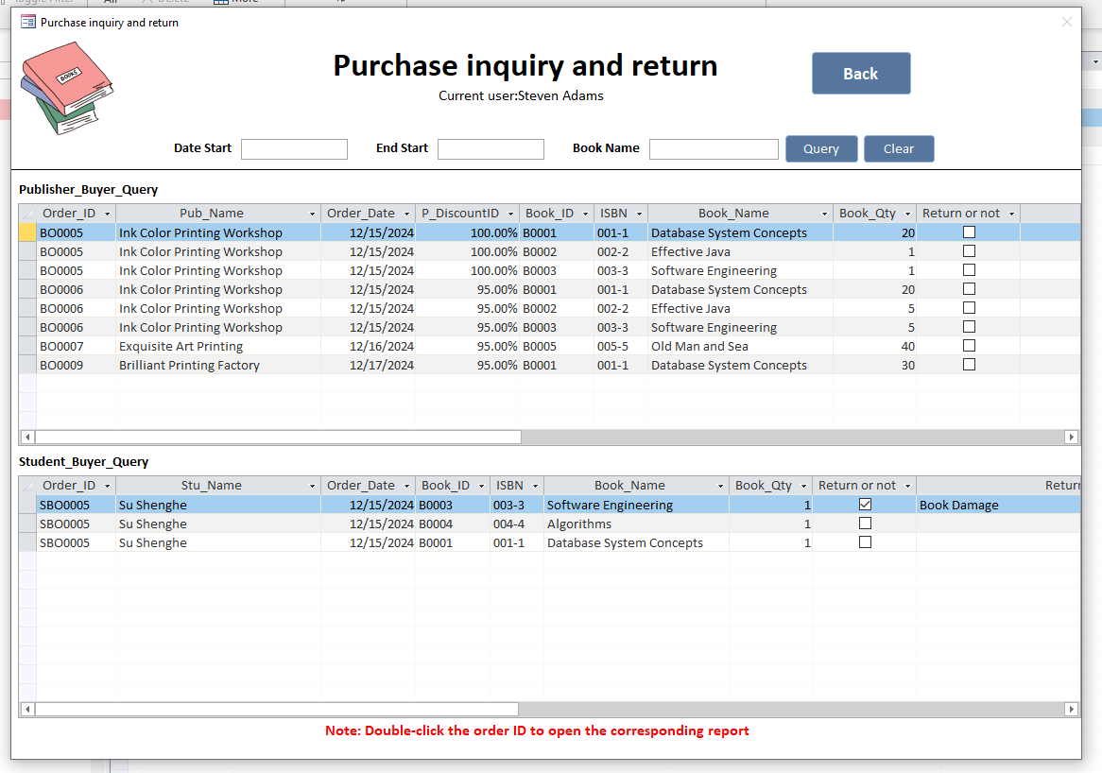
Figure20: Purchase inquiry and return
Annotation: The specific operations are similar to the aforementioned Sales Inquiries and Returns.

ID2.3: Significant Database Features
The operations for sales and purchases are the same; the following examples will use sales as an illustration.

2.3.1 Adds a new order and updates stock based on order size
This functionality combines order creation and inventory updates into one step, reducing workload, minimizing errors from manual updates, and allowing employees to focus on more critical tasks, thereby improving efficiency (Chiru, 2015).

Additionally, due to the system’s decentralized management mechanism, orders are automatically assigned to the current account’s employee. This ensures clear accountability and prevents order mix-ups, as each order is distinctly linked to the responsible employee. Such a mechanism enhances data accuracy, simplifies tracking, and promotes a well-organized workflow, which is essential for maintaining smooth operations within the company.

Annotation: Notably, during this step:
- The total book quantity (Order_Qty) is automatically calculated by summing up the detailed Book_Qty from the subform.
- S_Discount is determined based on the total book quantity.
- Order_Price is also automatically calculated.
This automation eliminates the need for manual calculations, greatly improving work efficiency.

The process of creating an order and updating inventory in a single step is as follows:
First, this is the inventory before the order is created. As shown, Old Man and Sea and Database System Concepts have 80 and 81 copies, respectively.

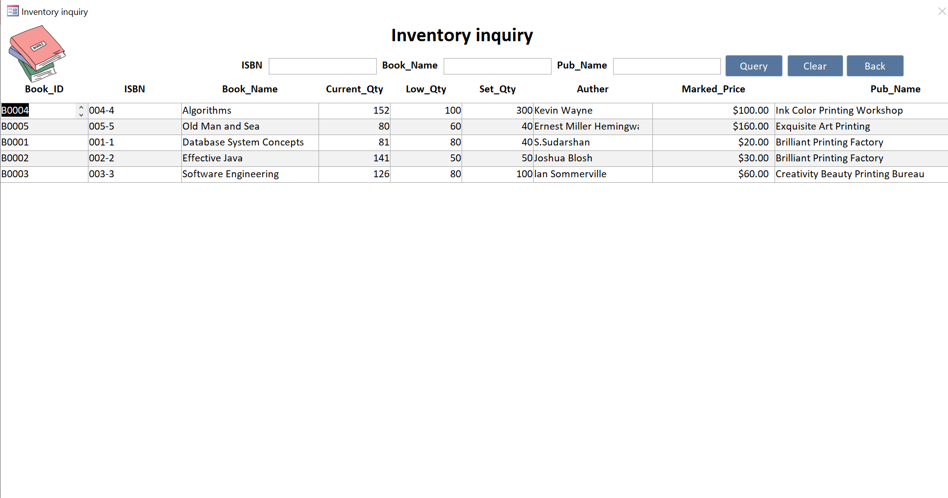
Figure21: The inventory before any operation has been performed

Next, we purchase 30 copies of each of these two books.

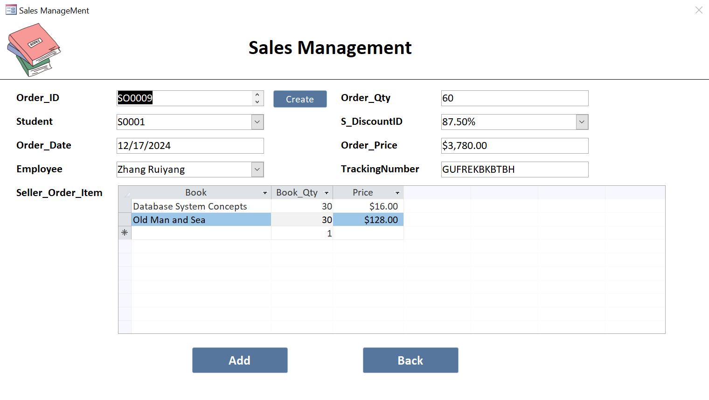
Figure22: Order Placement Interface
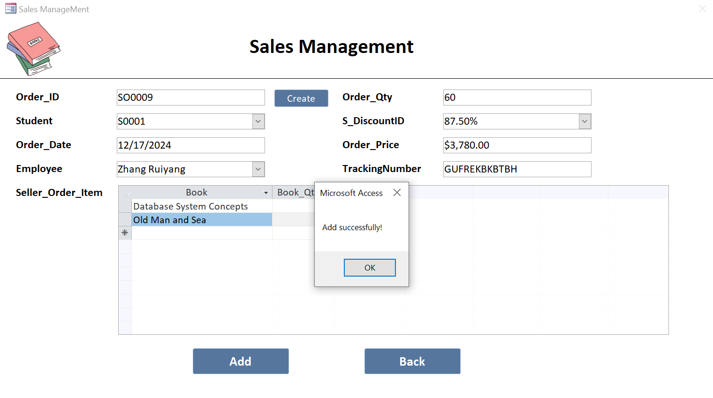
Figure23: Order successfully placed

Then, checking the inventory levels reveals that the Current_Qty for both books has decreased by 30 copies. Since both quantities are now below the Low_Qty, they are marked in red.
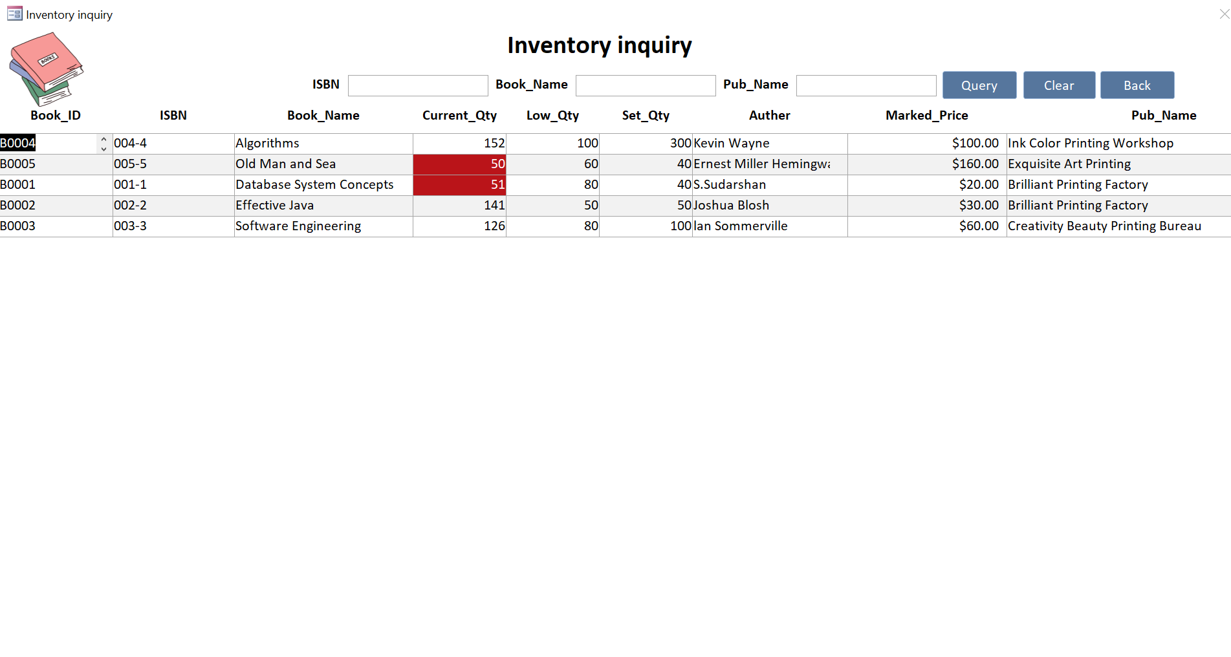
Figure24: Inventory levels after placing the order

Finally, my employee’s sales records are also updated simultaneously.

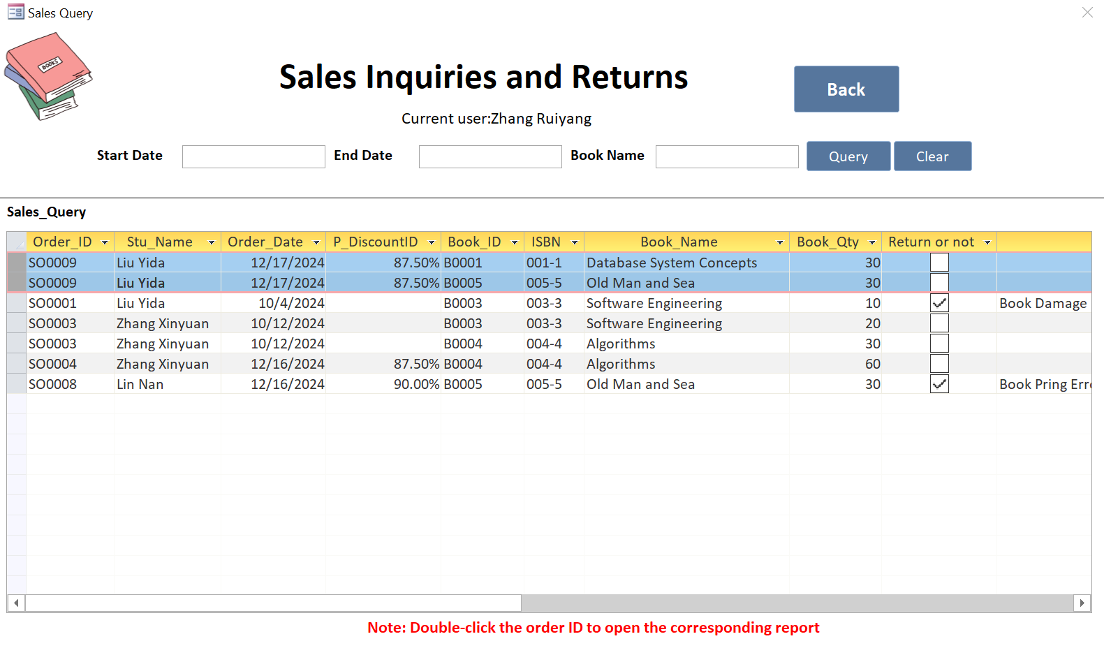
Figure25: Employee records are updated simultaneously

2.3.2 Return Processing with One-Step Inventory Update
The system efficiently handles real-world return scenarios, including partial and multiple returns for a single order. This streamlines operations, reduces manual workload, minimizes errors, and enhances customer satisfaction by offering a smoother return process. The specific operations are as follows:

First, open Sales Inquiries and Returns, select the details of the recently placed order, check the Return or Not attribute, and enter the return reason.

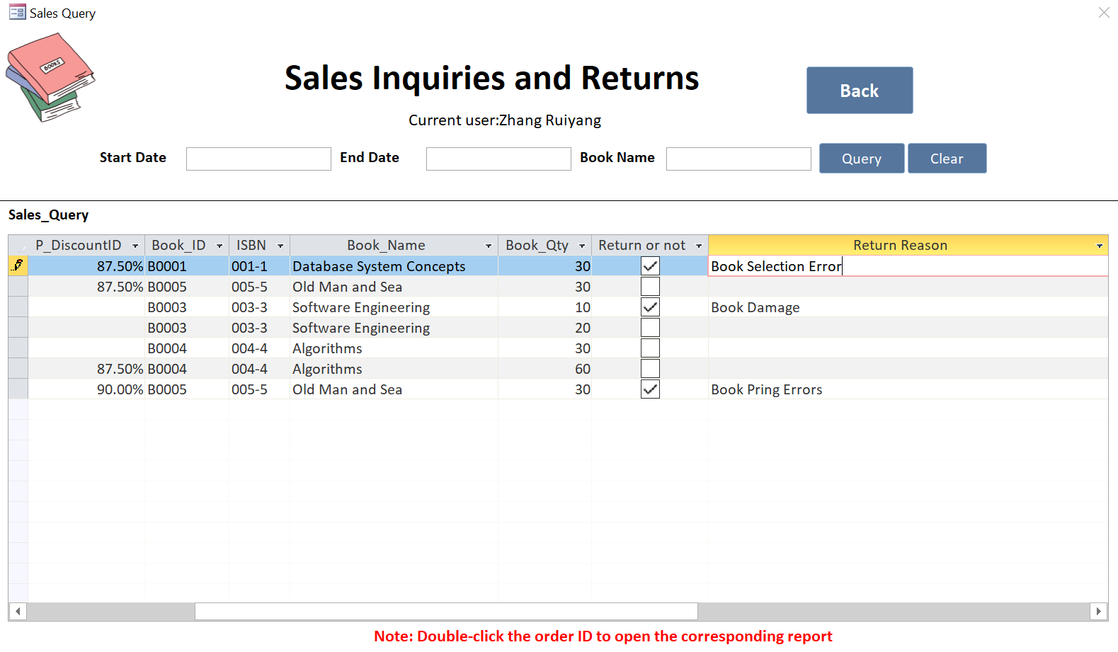
Figure26: Process Returns with Return Reason Input

Next, check the inventory levels and observe that the returned 30 copies of Database System Concepts have been restocked. The Current_Qty of 81 now exceeds the Low_Qty of 80, and the red marker has been removed.

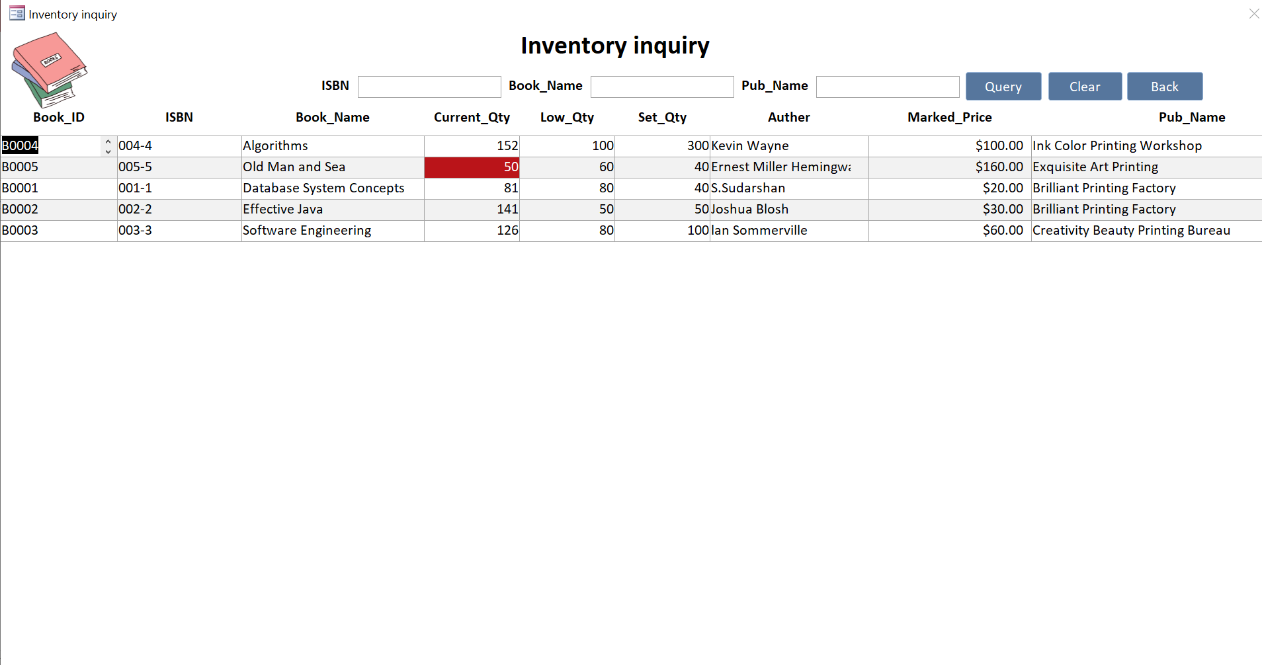
Figure27: Real-Time Inventory Update After Returns

ID2.4: Non-Trivial queries
In this section, I will use three non-trivial queries to explain in detail how I create orders and update data.

2.4.1 Step1: Initial State - No Data Binding Established
Initially, there is no data binding between the Seller_Order main form and the Seller_Order_Item subform. The main form shows no data, the subform is empty, and users can only manually add order details in the subform.

2.4.2 Step2: Entering Data in the Seller_Order_Item Subform
At this stage, the user manually enters the order details into the Seller_Order_Item subform. However, the Seller_Order_ID in the subform is intentionally left blank, resulting in a NULL value. The data source of the subform is based on the following SQL query:

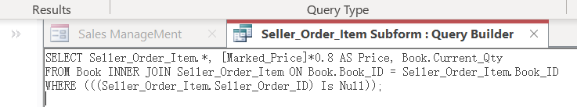
Figure28: Seller_Order_Item_Query

And its Design View is below:

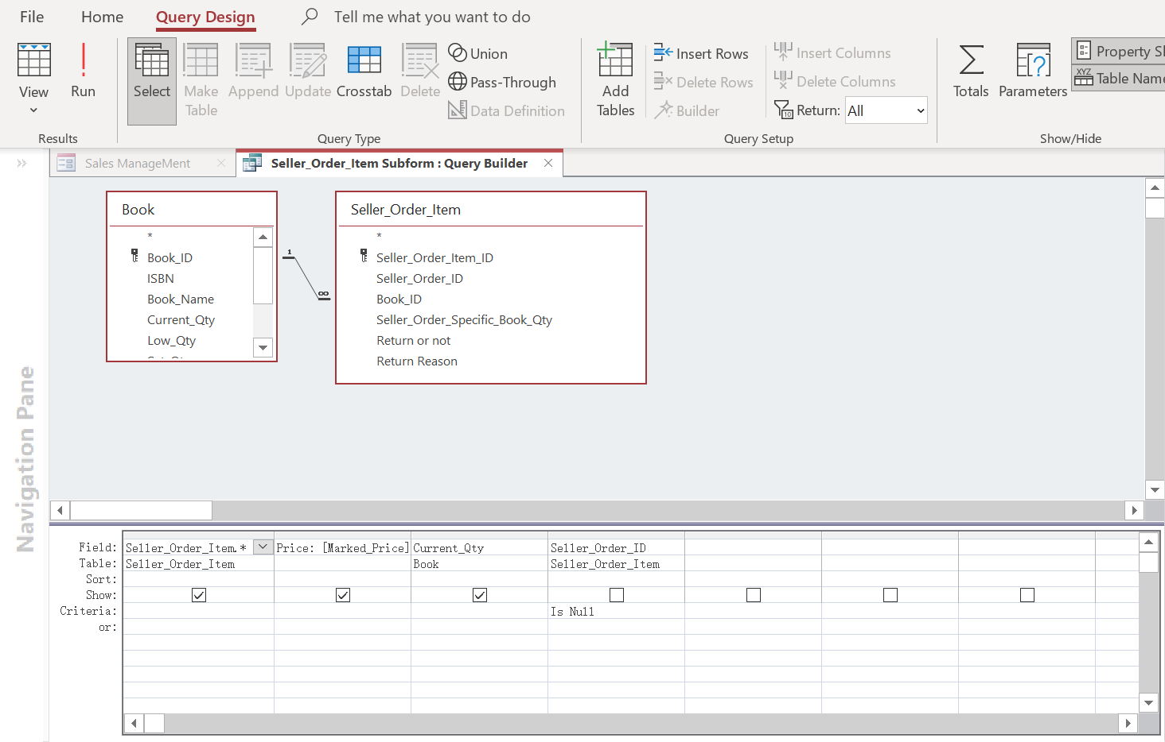
Figure29: Seller_Order_Item_Query Design View

This query retrieves all fields from the Seller_Order_Item table, automatically calculates a discounted price (Price) by multiplying Marked_Price by 0.8, and displays the current stock quantity (Current_Qty) from the Book table. An INNER JOIN connects the Book table and the Seller_Order_Item table through the Book_ID field, ensuring that only records with matching Book_ID values are included. The condition WHERE Seller_Order_Item. Seller_Order_ID Is Null filters the results to show only unassigned order details where Seller_Order_ID remains NULL, indicating that these records are not yet associated with any order. In the subform, users can select a book (Book_ID) and enter the quantity (Seller_Order_Specific_Book_Qty), while the Price field is automatically calculated and cannot be manually edited. The entered data is saved directly into the Seller_Order_Item table with Seller_Order_ID still being NULL at this stage. The subform dynamically displays these unassigned records, enriched with the book’s current stock and discounted price, in preparation for linking them to a specific order in the subsequent steps (Ulrich-Fuller, 2022).

Annotation: The SELECT statement, which is an inline query, is in the Record Source of the Seller_Order_Item subform, which is a subform of the Sales Management main form.

2.4.3 Step 3: Creating a New Order in the Seller_Order Table
In the main form, users input order details to create a new order. The following INSERT INTO statement is executed to save this data into the Seller_Order table:

INSERT INTO Seller_Order ( Seller_Order_ID, Stu_ID, Seller_Order_Date,
All_Seller_Order_Qty, All_Seller_Order_Price, Employee_ID, S_DiscountID, TrackingNumber )
SELECT [forms]![Sales ManageMent]![Seller_Order_ID] AS Expr1,
[forms]![Sales ManageMent]![Stu_ID] AS Expr2,
[forms]![Sales ManageMent]![Seller_Order_Date] AS Expr3,
[forms]![Sales ManageMent]![All_Seller_Order_Qty] AS Expr4,
[forms]![Sales ManageMent]![All_Seller_Order_Price] AS Expr5,
[forms]![Sales ManageMent]![Employee_ID] AS Expr6,
[forms]![Sales ManageMent]![S_DiscountID] AS Expr7,
[forms]![Sales ManageMent]![TrackingNumber] AS Expr8;

The Design View is below:
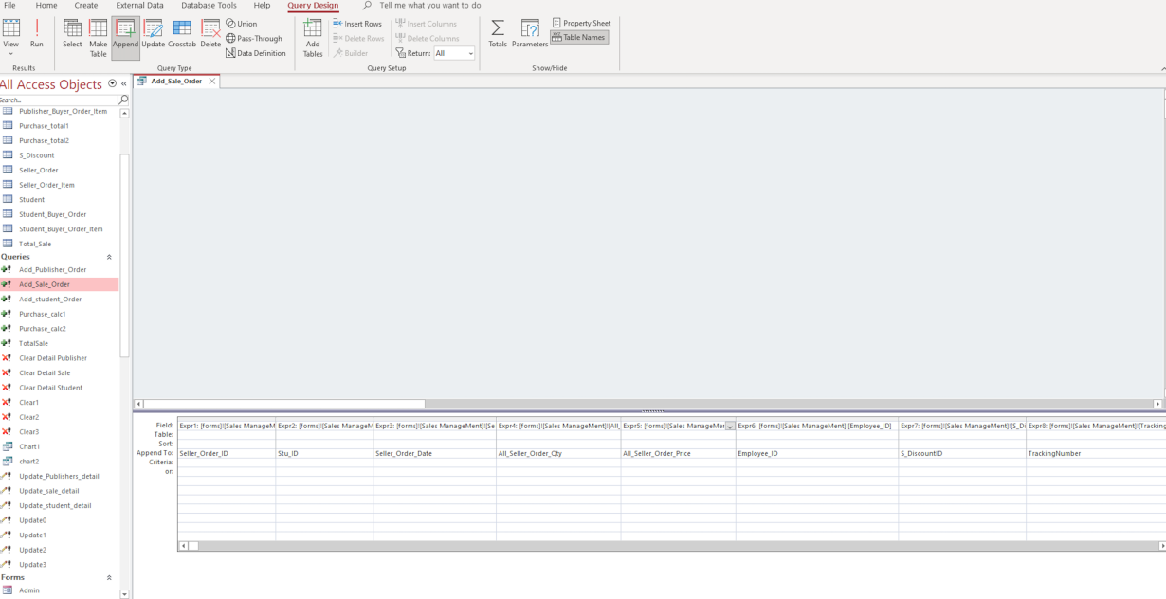
Figure30: Add_Sale_Order Design View

This SQL statement inserts order information from the main form into the Seller_Order table. The process is as follows: First, the INSERT INTO clause specifies the target table Seller_Order and the fields to be populated: Seller_Order_ID, Stu_ID, Seller_Order_Date, All_Seller_Order_Qty, All_Seller_Order_Price, Employee_ID, S_DiscountID, and TrackingNumber. Then, the SELECT clause retrieves the corresponding data from the controls on the main form [Sales ManageMent] to be inserted into the table. For example, [forms]![Sales ManageMent]![Seller_Order_ID] provides the new order ID, and [forms]![Sales ManageMent]![Stu_ID] provides the student ID. Similarly, other controls’ data are mapped to their respective fields. As a result, this SQL statement saves the order information entered in the main form into the Seller_Order table, creating a new order record. Each field is populated with the data entered in the main form controls to ensure accuracy. In summary, this SQL statement retrieves user input from the main form and inserts it into the Seller_Order table, completing the creation of a new order.

2.4.4 Step 4: Linking Order Details in the Subform to the New Order
The following UPDATE statement is executed:
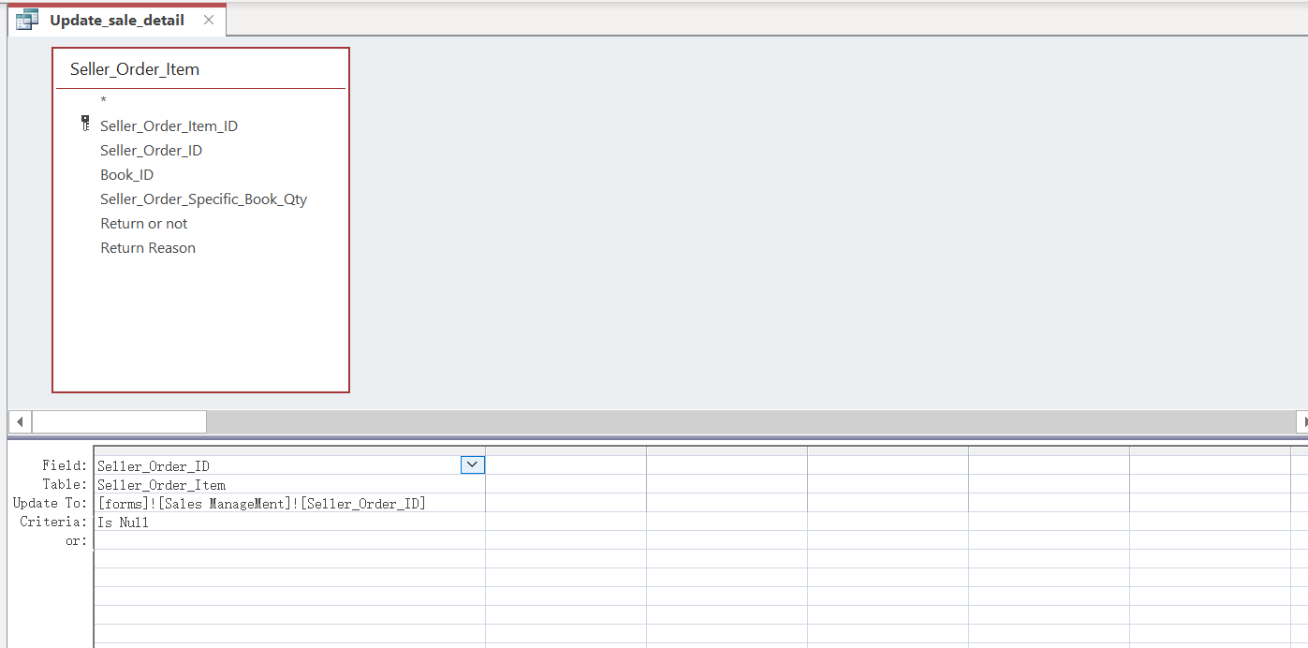
Figure31: Update_sale_detail Design View
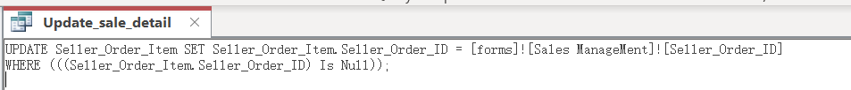
Figure32: Update_sale_detail SQL

This statement updates all order details in the Seller_Order_Item table where Seller_Order_ID is NULL. The SET clause assigns the new Seller_Order_ID from the main form to these unallocated records. As a result, previously unassigned order details are now associated with the new order, This means that the previously intentionally left blank Seller_Order_ID in the order details now adopts the Seller_Order_ID of the current Seller_Order, linking the order details to the main order. This process effectively updates both tables simultaneously (Jiang and Naumann, 2020).

2.4.5 Step 5: Establishing the Data Binding Relationship
At this stage, the main form and subform are linked. Employees fill in order details (excluding Seller_Order_ID) in the subform and complete the new order in the main form, synchronized with the Seller_Order table. An update query then assigns Seller_Order_ID to Seller_Order_Item, fully establishing the relationship.
The input and output screenshots are shown below, respectively:
Figure33: Input Screenshot
Figure34: Output Screenshot1
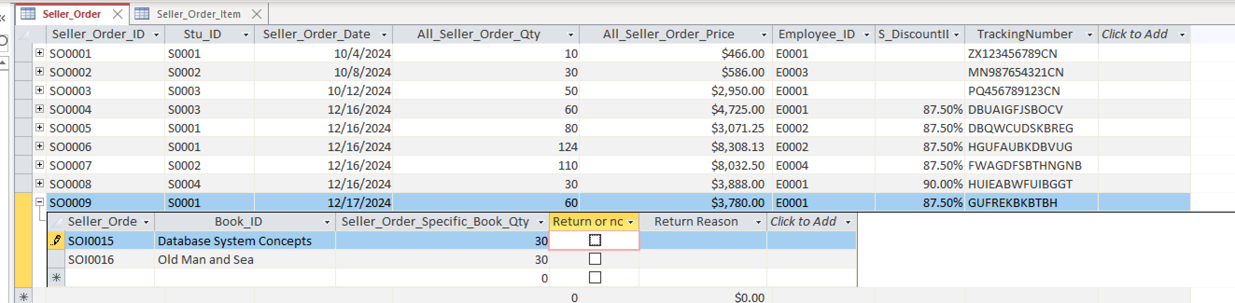
Figure35: Output Screenshot2

ID2.5: Management Report

2.5.1 Order invoice for the Seller Order and Seller Order Item details
This report is highly valuable to senior management as it provides detailed information about sales orders, including customer details, dates, total quantity, and total sales amount. These data enable senior management to monitor sales activities. Additionally, the invoice report for each order includes specific book details, which help management understand current market demand for books and identify trends.
Annotation: If you want to view the invoice for the Seller_Order Report, first click the Sales Inquiries and Return button to enter the form, then double-click the Order_ID of the order to open the corresponding report.

Figure36: Seller_Order Report Form View
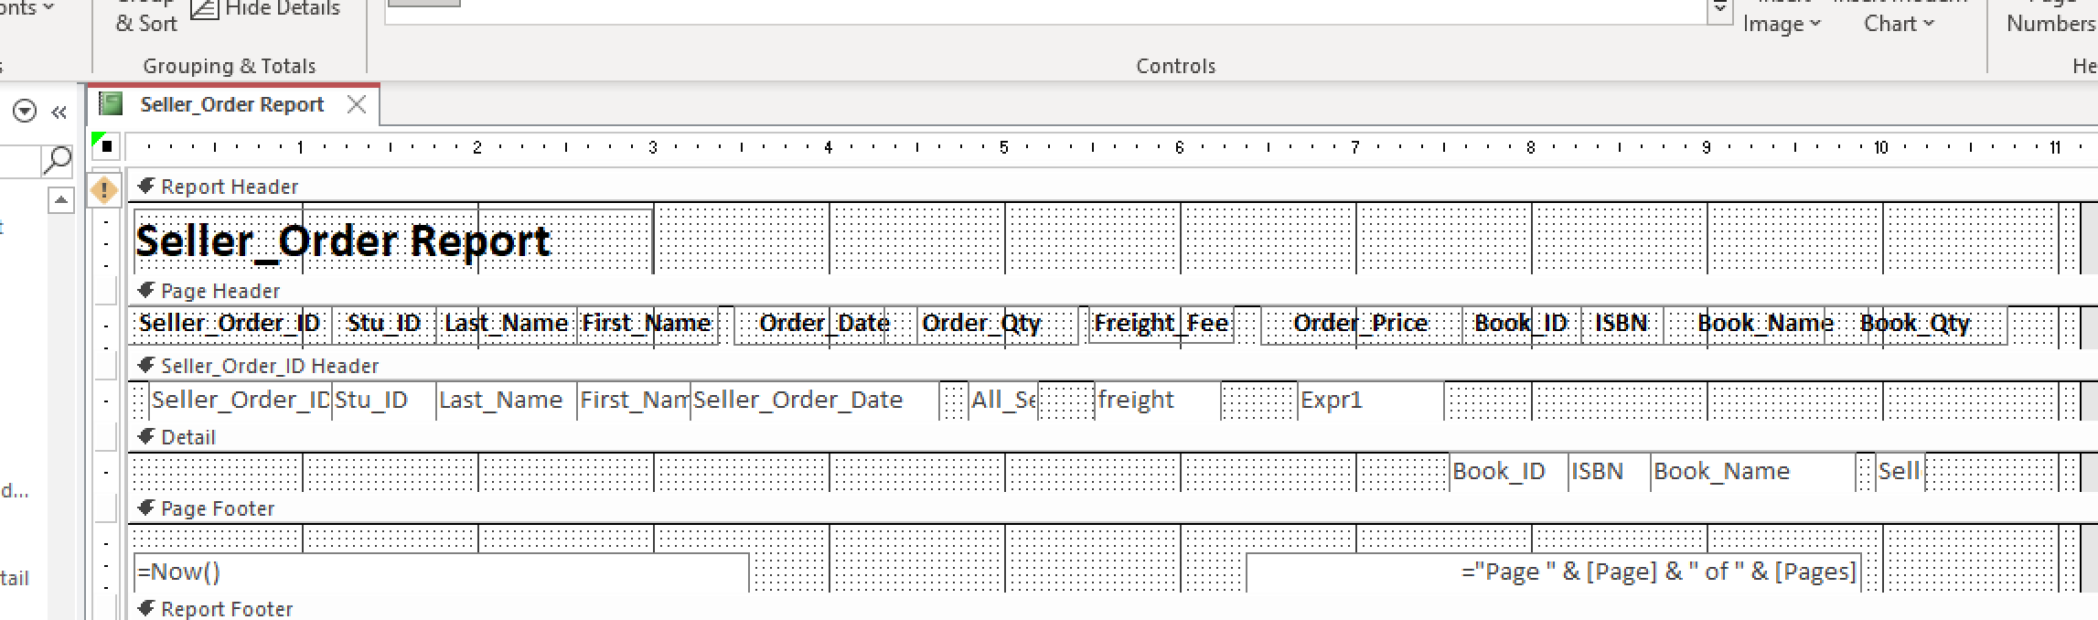
Figure37: Seller_Order Report Design View

2.5.2 Order invoice for the Publisher Buyer Order and Publisher Buyer Order Item details
This report reflects the company’s procurement of books from publishers. It helps senior management monitor the cost of purchasing second-hand books and evaluate the profitability of the repurchase program. The report also lists the detailed book items for each purchase order, making it more specific and informative.
Annotation: If you want to view the invoice for the Publisher_Buyer_Order, first click the Purchase Inquiries and Return button to enter the form, then double-click the Order_ID of the order to open the corresponding report. The same process applies to viewing the invoice for the Student_Buyer_Order, which will not be elaborated further here.

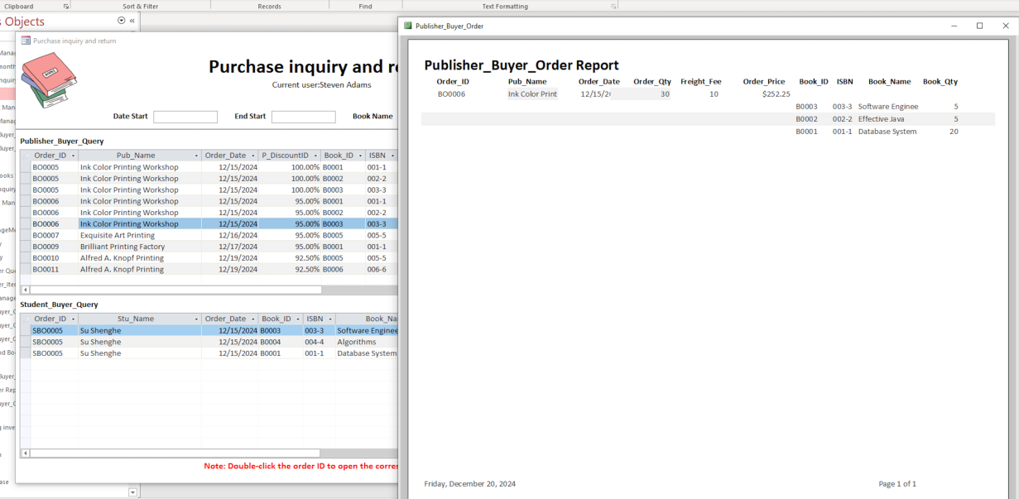
Figure38: Publisher_Buyer_Order Report Form View
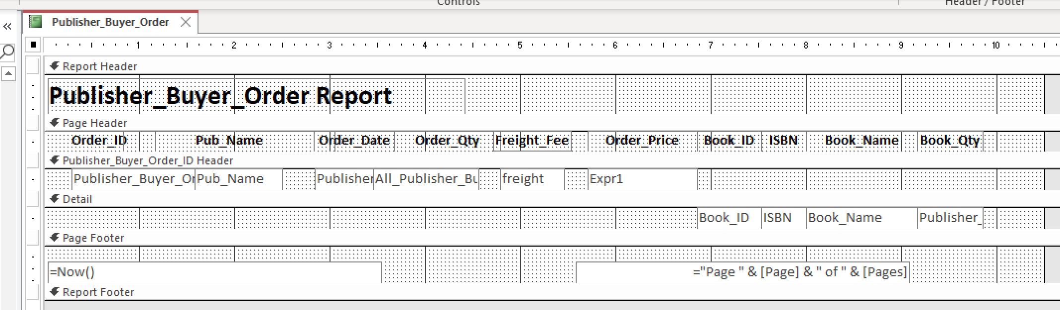
Figure39: Publisher_Buyer_Order Report Design View

ID2.6: Non-trivial chart

2.6.1 Employee Monthly Sales Chart
This bar chart shows book sales over a specific period, with customizable start and end dates. Queries can filter individual employee performance, helping management assess business performance, reward high achievers, and address underperformance.
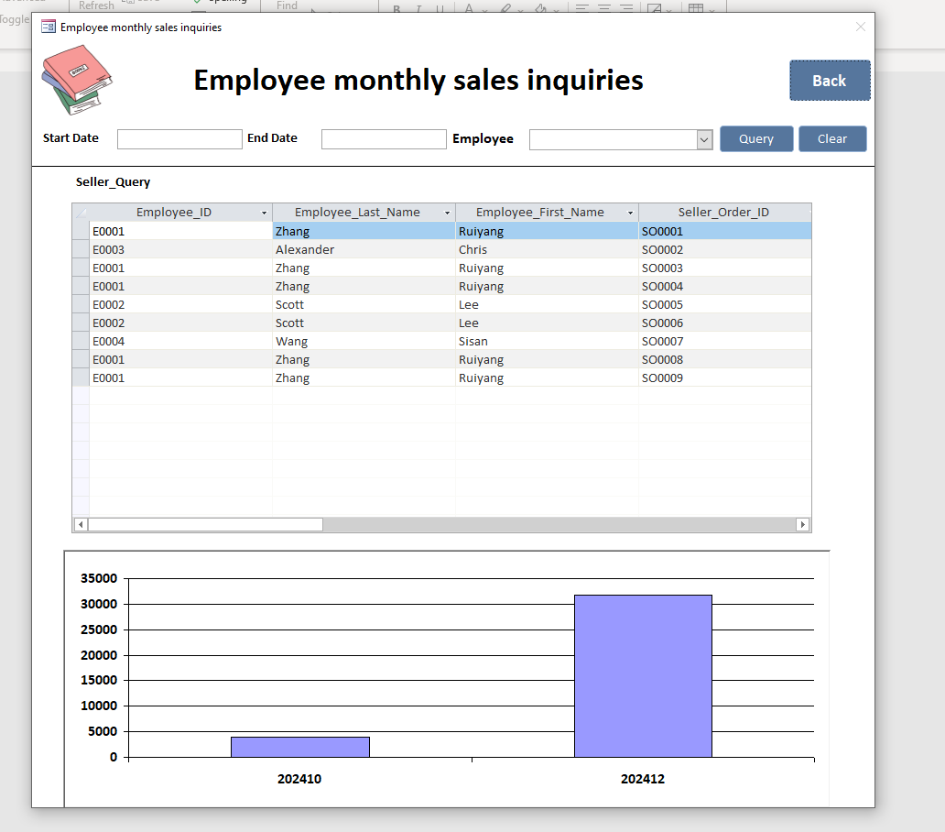
Figure40: Employee Monthly Sales Chart

Next, conduct a detailed search for employees.

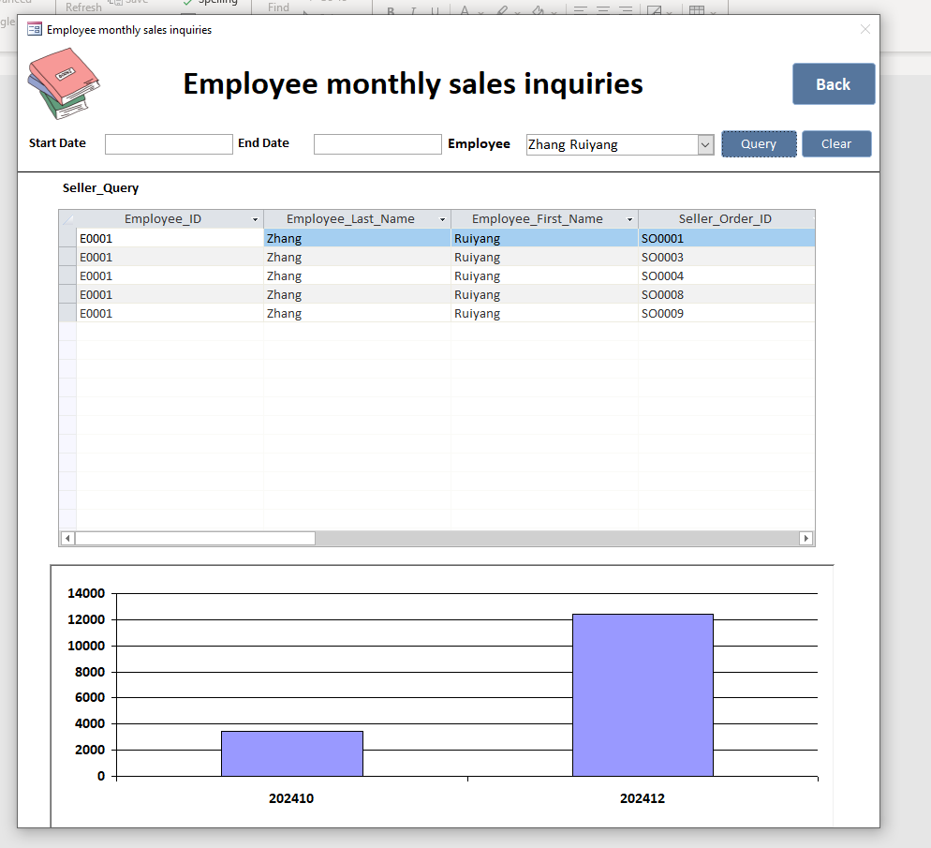
Figure41: Detailed search for employees

Finally, restrict the time period.
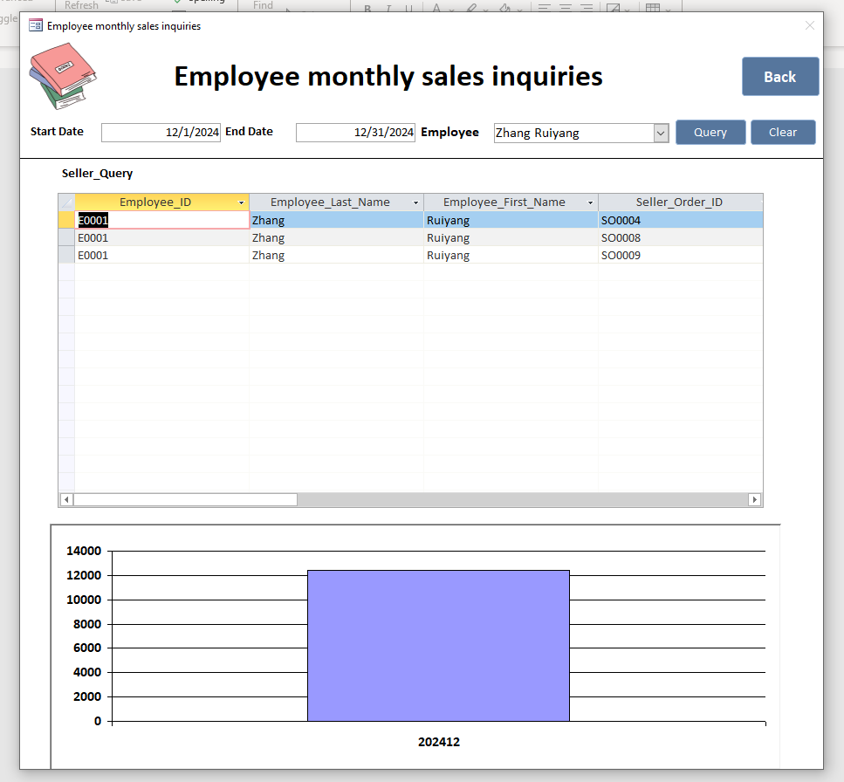
Figure42: Specifically restrict the time period

The Design View is below:

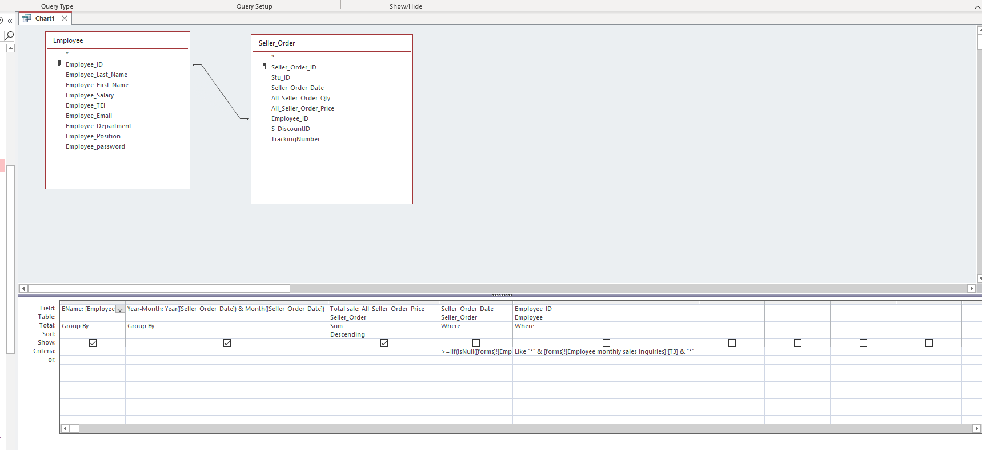
Figure43: The Design View of Figure39

ID2.7: Testing

2.7.1 Add new publisher and books
Original books and suppliers are below:
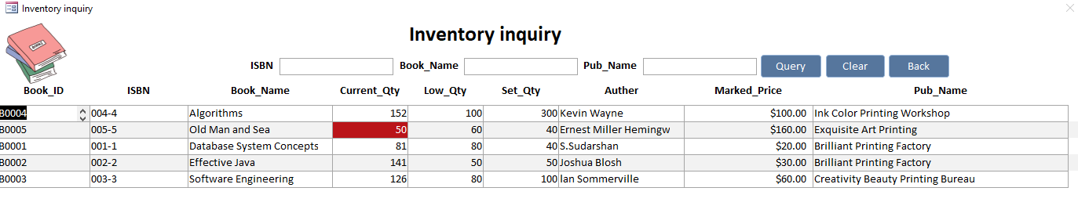
Figure44: Original books and suppliers

Next, we add new publishers and books.

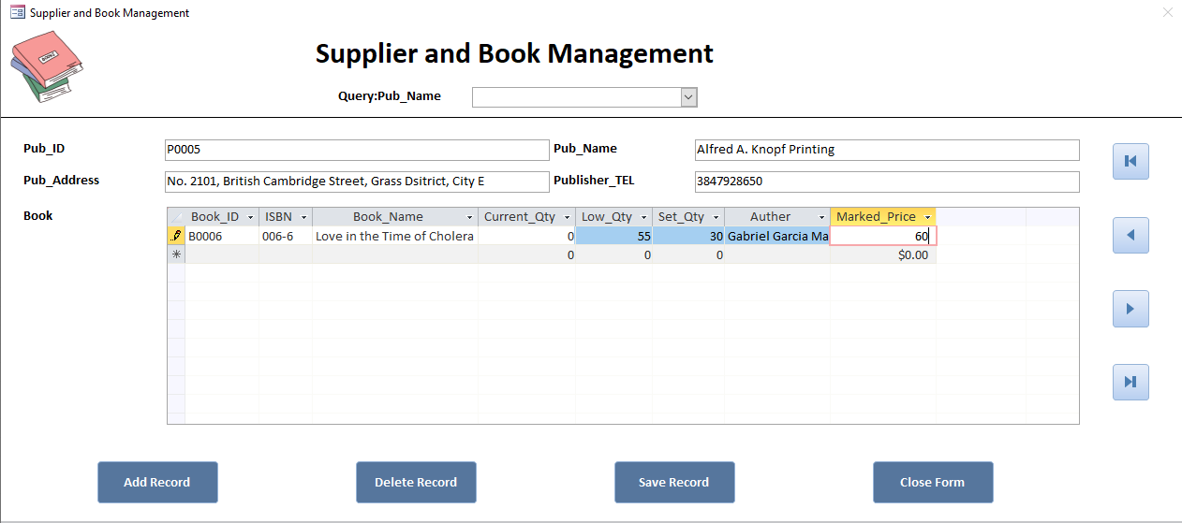
Figure45: Add new publisher and book

The result, as shown in the figure, is accurate and functions properly.

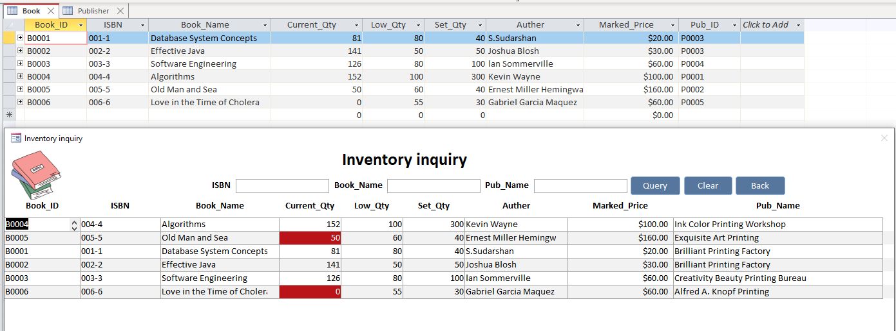
Figure46: The output result of the books
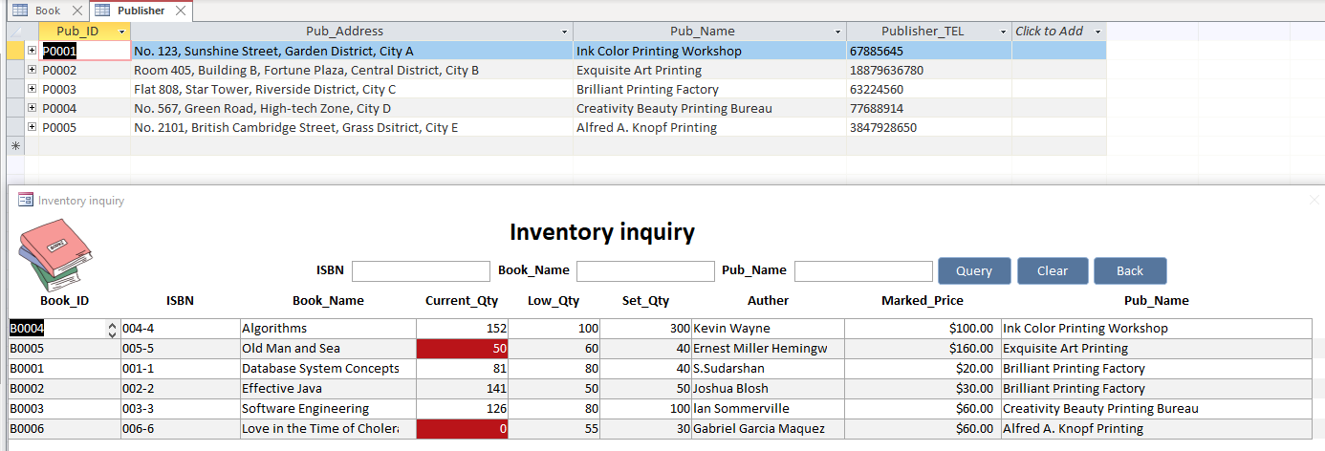
Figure47: The output result of the publishers

2.7.2 The functionality of purchasing and selling books, along with the line chart statistics of book sales
At first, Love in the Time of Cholera did not display any sales.

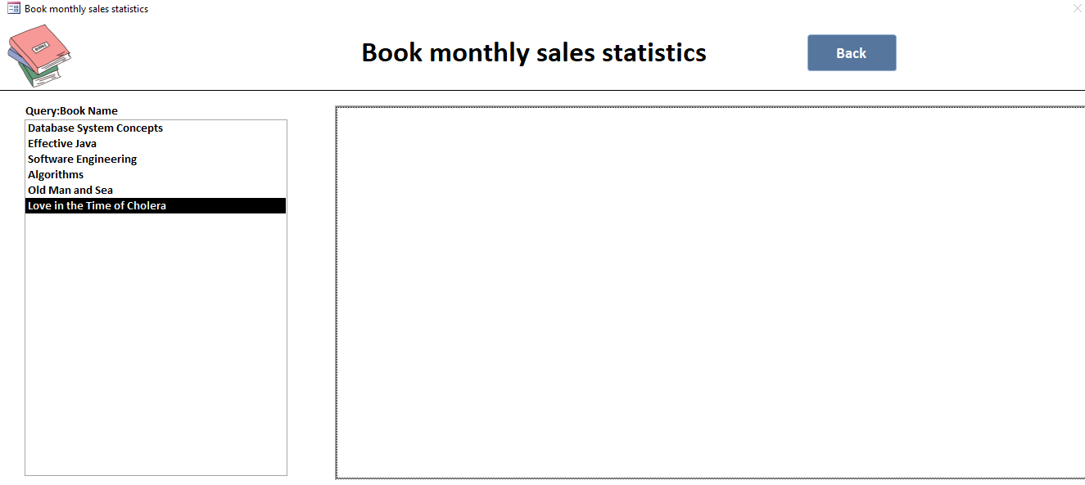
Figure48: The initial chart of Love in the Time of Cholera

The initial purchase orders and inventory levels.

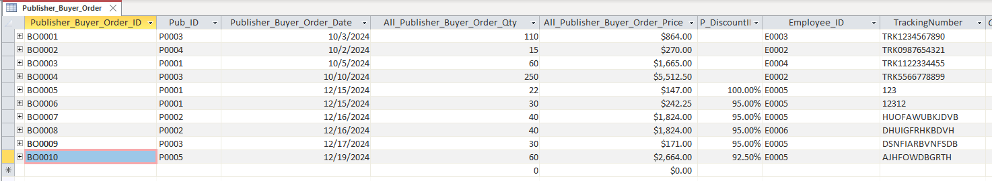
Figure49: The initial purchase orders
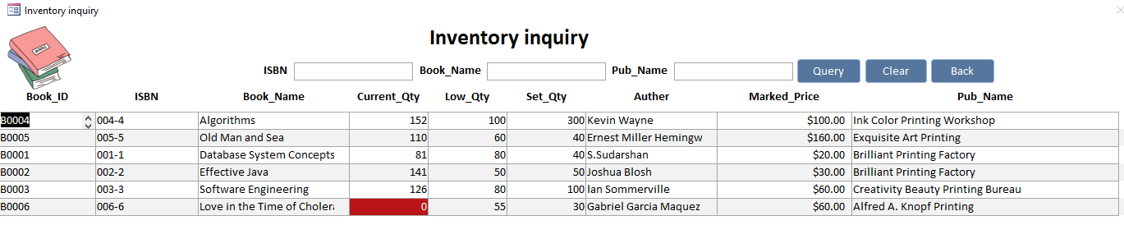
Figure50: The initial inventory levels

Next, we purchased 60 copies of Love in the Time of Cholera.
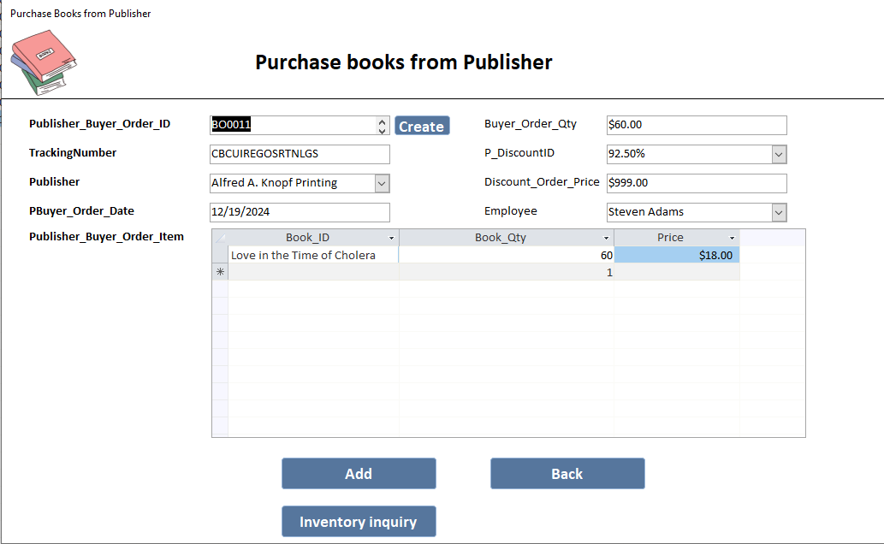
Figure51: Purchase 60 copies of Love in the Time of Cholera

The output result is correct; the order was successfully added, and the inventory was successfully updated. As the Current_Qty exceeded the Low_Qty, the red highlight on the book was removed.

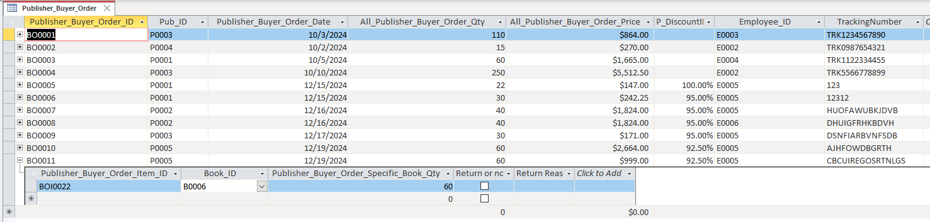
Figure52: The order was add successfully
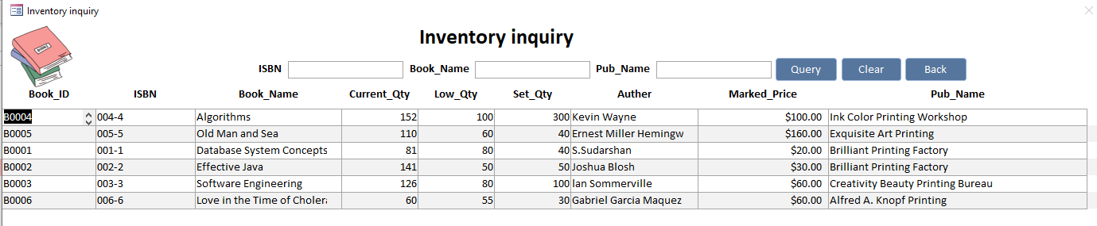
Figure53: The inventory was updated successfully

Next, we sold 30 copies.
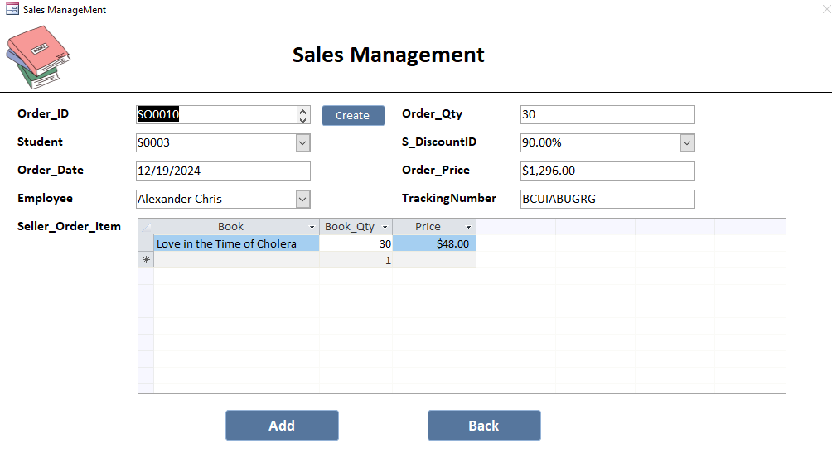
Figure54: Sell 30 copies of Love in the Time of Cholera

The order was successfully created. Additionally, as the Current_Qty fell below the Low_Qty, the book was highlighted in red.

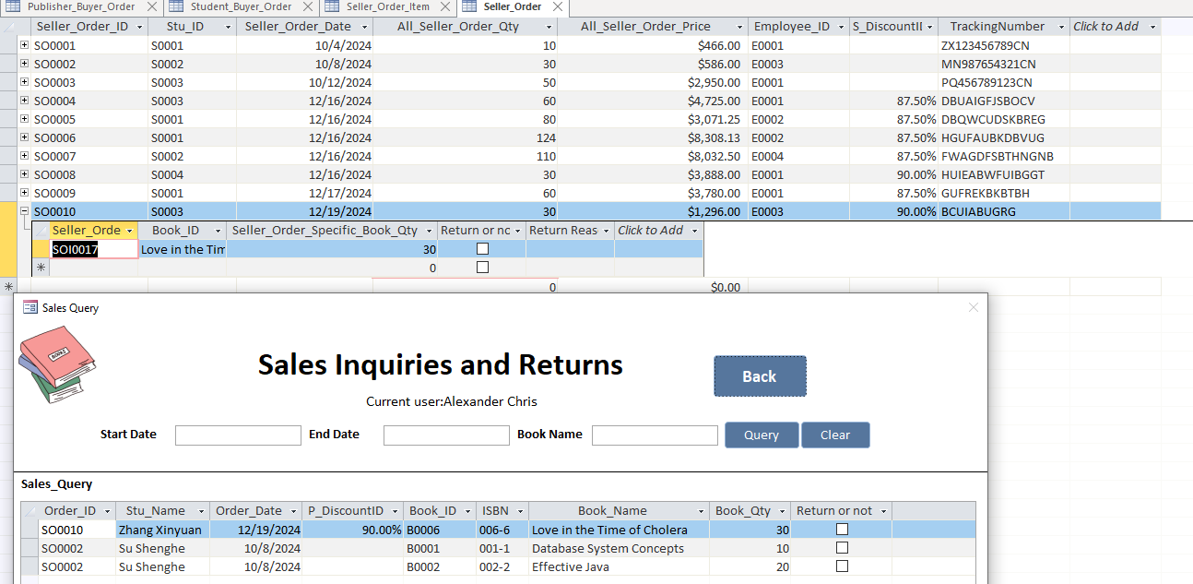
Figure55: The order was created successfully
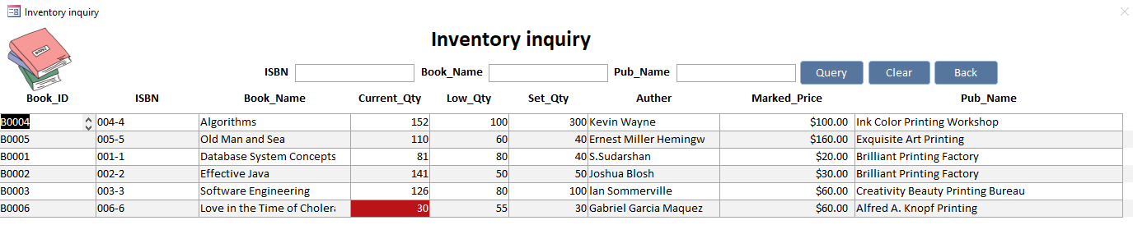
Figure56: The inventory was updated successfully

Finally, our line chart dynamically displayed the sales for December 2024 for the book, showing 30 copies sold. The functionality was successfully implemented.
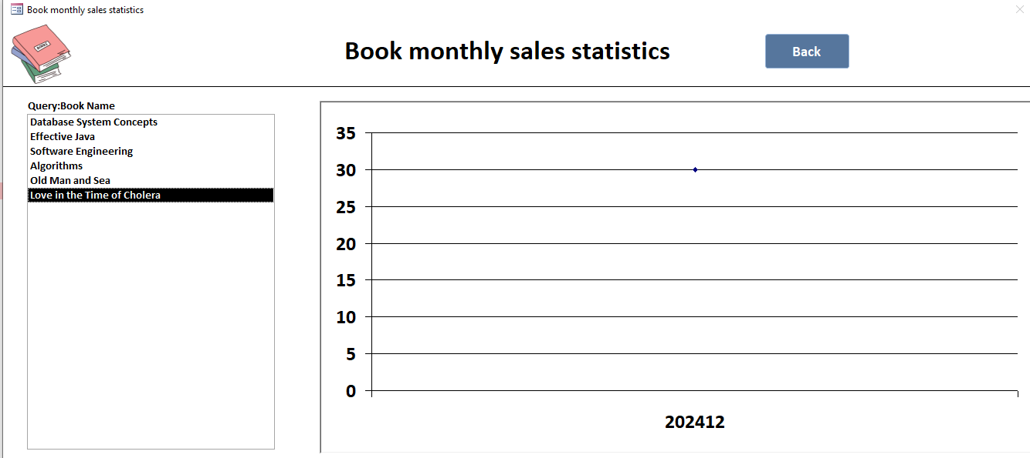
Figure57: The monthly sales chart of Love in the Time of Cholera

ID2.8: Reflection

2.8.1 Advantages
The system employs decentralized management to clarify departmental responsibilities and improve efficiency. Discounts were categorized into a separate table for easier price calculations, and automated discount and price calculations enhance accuracy and reduce errors. Order processing integrates inventory updates and order creation, minimizing employee workload. Monthly sales charts reveal trends for book procurement, while employee sales data encourage performance. Books with Current_Qty below Low_Qty are highlighted in red, prompting timely restocking.

2.8.2 Disadvantages
Limitations of Returns
First, the limitation of returns requires customers to return the entire quantity of books from a single order detail, which is highly inconvenient. This rigid approach does not allow partial returns, creating dissatisfaction for customers who may only wish to return a portion of the books, thereby reducing the system’s flexibility.
Lacks password recovery
Second, the lack of a “Forgot Password” or password recovery feature makes it impossible for employees to regain access if they forget their passwords. This results in operational inefficiency and a potential security risk due to reliance on manual password reset processes.

2.8.3 Solutions and self-evaluation
Flexible Partial Return Process
Introducing a flexible partial return process by adding a field for specifying the return quantity will allow customers to return only the books they need to, significantly improving user experience and operational flexibility.
Secure Password Recovery System
Implementing a secure password recovery system with a “Forgot Password” feature will enable employees to recover their passwords through a security question or email-based reset. Integrating multi-factor authentication (MFA) with external systems will further strengthen system security by preventing unauthorized access (Ciotirnae and Anton, 2024).
Self-evaluation
Familiarizing myself with the system deepened my understanding of database operations, improved my data analysis and problem-solving skills, and enhanced my attention to detail, strengthening both my technical and analytical abilities.

(Word Count: 1625)

References
Chiru, G. (2015) ‘Logistical stock management methods - organizational performance evaluation means’, Journal of Accounting & Management (2284-9459), 5(2), pp. 38-46. Available at:
https://search.ebscohost.com/login.aspx?direct=true&db=bsu&AN=114599335&site=eds-live&scope=site (Accessed: 19 December 2024).

Ciotirnae, P. and Anton, D. (2024) ‘Multi-Factor Secure Authentication Method Used for Accessing Sensitive Data Bases’, 2024 15th International Conference on Communications (COMM), Communications (COMM), 2024 15th International Conference on, pp. 1-6. doi:10.1109/COMM62355.2024.10741457.

Jiang, L. and Naumann, F. (2020) ‘Holistic primary key and foreign key detection’, Journal of Intelligent Information Systems: Integrating Artificial Intelligence and Database Technologies, 54(3), pp. 439-461. doi:10.1007/s10844-019-00562-z.

Ulrich-Fuller, L. (2022) Access®. Edited by K. Cook. John Wiley & Sons (For dummies). Available at:
https://search.ebscohost.com/login.aspx?direct=true&db=cat01010a&AN=xjtlu.0002353960&site=eds-live&scope=site (Accessed: 19 December 2024).

