CPT202 Assignment 2
Group Report for Software Engineering Group Project

2024/2025 Semester 2
An online meeting booking system
27 April 2025
http://121.43.36.102/

Group number: 17
Submitted by: < Xiangyi Zhu, 2251651>
Group Members:
- < Xiangyi Zhu, 2251651 >
- < Xinrong Shi, 2251997 >
- < Zimo Zheng, 2147369 >
- < Nan Lin, 2252173 >
- < Xiaoya Li, 2255207 >
- < Ziwei Zhou, 2253073 >
- < Jiayi Wang, 2255986 >
- < Hanqiu Zhang, 2251903 >
- < Xinyuan Zhang, 2255403 >
Contents
1. Introduction 3
1.1. Background and Requirements 3
1.2. Aims of The Project 3
1.3. User Characteristics 3
1.4. Project Scope 3
1.5. Assumptions and Dependencies 4
1.6. Project Risks 4
2. Architectural Design 5
2.1. System Architecture 5
2.2. Frontend System 6
2.3. Backend System 7
2.4. High-level Database Design 8
3. Software Design 8
3.1. Software Modules 8
3.2. High-level Process Flow 10
3.3. Software Support Services 11
3.4. Coding Structure and Convention 12
3.5. Software Configuration and Production Environment 13
4. Software testing 14
4.1. Unit Test 14
4.2. Integration Test 14
4.3. Acceptance Test 15
5. Conclusion and future work 15
6. References 16
7. Appendix 17

1. Introduction

1.1. Background and Requirements
In recent years, the increasing complexity of academic and administrative activities in schools has driven a significant rise in demand for online meeting room booking systems. This trend highlights the urgent need for efficient resource management and convenient collaboration tools. However, many existing meetings room booking systems in schools face several challenges, including complex user interfaces, inefficient booking processes, insufficient conflict management, and a lack of real-time notification features. These issues often lead to user inconvenience, low resource utilization, and poor communication efficiency (Sanchez et al., 2019).

To address these challenges effectively, it is critical to develop a robust and user-friendly school meeting room booking system. Such a system should prioritize user-centric design principles, offering an intuitive interface and streamline booking processes, support real-time resource status updates to prevent conflicts and integrate automated notification features to ensure users receive timely booking confirmations and reminders. Additionally, the system should seamlessly integrate with existing school calendars, payment systems, and permission management tools to enhance overall administrative efficiency (Shili et al., 2009).

By optimizing resource allocation and improving user experience, this system can not only help schools manage meeting room resources more efficiently but also provide a smoother collaboration environment for faculty and students, thereby facilitating the smooth operation of academic and administrative activities.

1.2. Aims of The Project
The primary objective of this project is to design and implement an intuitive web-based school meeting room booking system:

• For users (e.g., students and teachers), they can register for an account to become platform users. The system provides a simple and user-friendly interface for viewing the availability of meeting rooms, submitting booking requests, and receiving real-time notifications and confirmations.

• For administrators, the system offers a management backend for monitoring and managing meeting room resources. This backend supports a range of functions, including real-time updates on meeting room status, automatic detection of booking conflicts, user permission management, and data visualization analysis. These features help administrators allocate resources more efficiently, optimize meeting room usage, and support the school's teaching and administrative activities.

1.3. User Characteristics
The system supports three primary user roles: regular users, administrators, and super administrators. Regular users can log in to view meeting rooms, submit booking requests, review booking history, cancel bookings, submit repair requests, and view notifications. Administrators, typically department-level or floor managers, are responsible for approving bookings, monitoring room usage, handling repair requests, managing room statuses, and posting internal notices. Super administrators, the system's highest-level operators, maintain data integrity and system performance. Their main authorities include managing user roles, configuring meeting room categories, adding, updating, or deactivating rooms, maintaining room information, managing permissions, and reviewing system logs. Together, these roles ensure the system's efficient operation, optimizing resource allocation and administrative oversight.

1.4. Project Scope
The scope of the project is illustrated in the Figure 1:
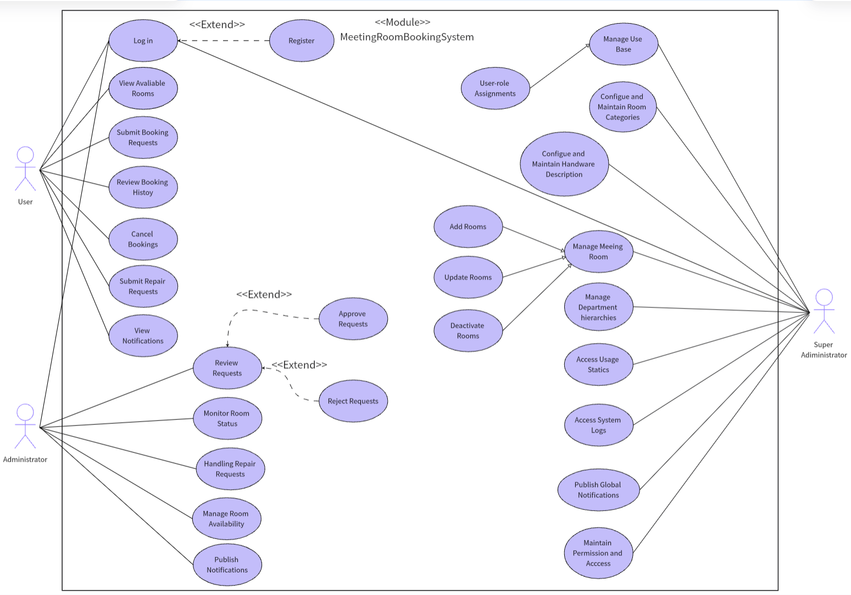
Figure 1: the Use Case Diagram of the System

1.5. Assumptions and Dependencies
The successful implementation of the project relies on a series of assumptions and external conditions, such as the availability of resources, technical support, team collaboration, and data integrity. Additionally, the project depends on the stability of third-party API services (e.g., payment processing and email notifications), reliable network connectivity, and the fulfillment of external service agreements. These assumptions and dependencies need to be continuously monitored and managed during the project implementation to mitigate potential risks and ensure the achievement of project objectives.

1.6. Project Risks
While the project presents numerous opportunities for managing meeting room bookings and enhancing the efficiency of team reports and presentations, it also entails certain risks that need to be carefully managed. These risks include uneven resource distribution, technical challenges (such as system integration and data processing), potential security vulnerabilities, and the need for robust testing to ensure the reliability and performance of the reporting and presentation platform. Additionally, the successful implementation of the project depends on team collaboration, resource availability, and the stability of external services. These factors need to be continuously monitored and managed throughout the project to mitigate risks and ensure the achievement of project objectives.

2. Architectural Design

2.1. System Architecture
Our Meeting Booking System employs the MVC (Model-View-Controller) architecture due to its clear separation of concerns, modularity, and scalability, making it suitable for dynamic interactions, secure data management, and multi-role functionality (Ganeshan, 2016).
Architectural Justification：
MVC separates the system into distinct layers—the Model managing data and logic, the View presenting user interfaces, and the Controller coordinating interactions between them. This structure significantly improves maintainability, testability, and promotes effective collaborative development within a Scrum framework.
Implementation in Our Project：
• Model Layer:
Our Model layer uses MySQL (5.7.27) with MyBatis-Plus and MyBatis-Plus-Join as ORM frameworks. Tables follow third normal form (3NF) with foreign keys for integrity among key entities. Druid (1.2.1) provides efficient database connection pooling and monitoring.
• View Layer:
Built with Vue.js 3 (3.3.4) (Shavin, 2023) and TypeScript for type safety, our frontend leverages Vite (4.4.5) for rapid builds, Vue Router (4.2.4) for routing, and Element Plus (2.3.12) for UI components. Axios (1.7.2) manages RESTful API calls, while ECharts (5.4.3) and FullCalendar (6.1.15) support data visualization and scheduling. Modular component structures promote reusability and maintainability.
• Controller Layer:
Spring Boot (3.2.7) facilitates RESTful API development, handling HTTP requests and orchestrating business logic across services and mappers (Heckler, 2021). Sa-Token manages authentication and role-based access, with password encryption secured by Spring Security Crypto.

Supporting Infrastructure：
• Development Tools: We used Visual Studio Code (1.98.0) as the primary IDE, Navicat (11.1.13) for database visualization, and Word for formal documentation.
• Version Control & Project Management: Code was collaboratively managed using Git with remote repositories hosted on Coding.net. Agile practices, including sprint planning and task tracking, were facilitated using Scrum boards and Wiki-based documentation.
• Testing: The backend logic was verified using JUnit, while Jest/Mocha were employed for frontend component testing.
• Deployment: The system is deployed on a production-grade Alibaba Cloud server. The frontend is locally built using npm run build and served via Nginx, which delivers static assets and proxies API requests to the backend. Node.js (v18.20.8) is used during the build process. The backend is packaged into a self-contained Spring Boot JAR via Maven (v3.8.1) and deployed to the cloud server for execution.
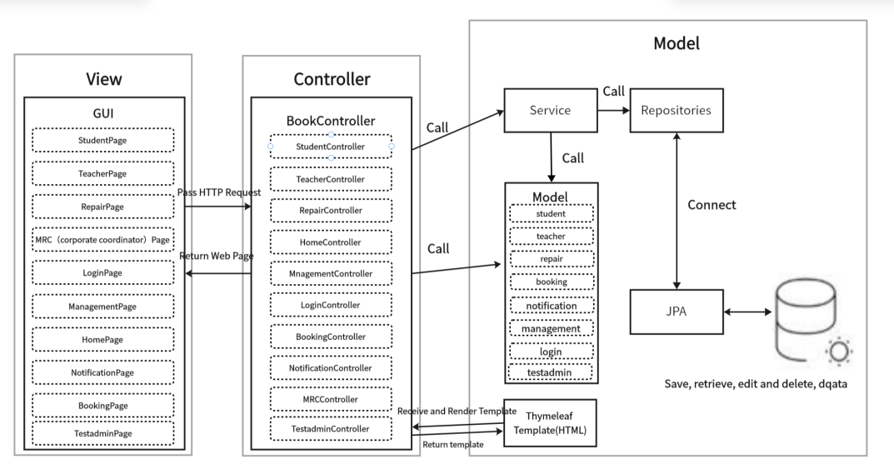
Figure 2: MVC architecture

In summary, the adoption of the MVC architecture, together with a robust technology stack and structured development workflow, has enabled our team to deliver a secure, modular, and scalable Meeting Booking System.

2.2. Frontend System
The frontend of our Meeting Booking System was developed using Vue.js 3 (v3.3.4), a progressive JavaScript framework known for its performance, modularity, and ease of integration with modern toolchains. Leveraging TypeScript throughout the codebase ensures stronger typing and improved maintainability. Our frontend architecture supports Single Page Application (SPA) patterns, allowing dynamic view rendering and responsive user interaction without frequent page reloads.

Core Technologies and Frameworks：
The project integrates the Vite (v4.4.5) build tool for ultra-fast development and hot module replacement (HMR). Routing is handled by Vue Router (v4.2.4), supporting nested and dynamic routes across user roles. The UI layer incorporates Element Plus (v2.3.12) as the component library, delivering reusable and accessible components such as modals, forms, calendars, and tables.
We utilize Axios (v1.7.2) for efficient HTTP communication with backend services. For interactive scheduling, FullCalendar (v6.1.15) enables intuitive drag-and-drop interfaces, while ECharts (v5.4.3) powers our data visualization dashboards, supporting bar, line, and pie charts for displaying room usage trends.

UI/UX & Optimization：
The system integrates Vue-Tippy (v6.6.0) to deliver contextual tooltips and instructional prompts. We adopted accessibility-first practices and applied structured routing and role-based guards to restrict unauthorized views. Frontend performance optimization strategies included lazy-loading routes and asynchronously importing large third-party modules.

In summary, our frontend system offers a modular, dynamic, and maintainable user interface tailored to the functional diversity of the Meeting Booking System. With strong integration of visualization, interactivity, and security, it serves as a robust client-side foundation for the overall platform.

2.3. Backend System
The backend architecture of our Meeting Booking System is implemented following a layered MVC structure, promoting separation of concerns and facilitating maintainability, testability, and scalability. It consists of the Controller, Service, DAO, and Entity layers, each handling a distinct set of responsibilities.

Controller Layer:
The Controller layer maps incoming RESTful API requests to service-layer operations using Spring Boot’s @RestController and @RequestMapping annotations. Controllers are role-sensitive and serve endpoints such as:
1．/api/bookings for managing meeting room reservations.
2．/api/rooms for retrieving available room lists and metadata.
3．/api/users for role-based user management.
4．/api/repair for repair request submission and resolution.
5．/api/statistics for returning room usage and booking distribution data.
The controller layer is integrated with Spring Boot Security and JWT filters to restrict access and protect endpoint data. Each API is documented and structured with proper response models, supporting seamless interaction with the Vue.js frontend.

Service Layer:
The Service layer contains the business logic and workflow coordination across components. It employs Spring’s @Service and dependency injection to integrate DAO components. Key responsibilities include:
1．Checking room availability before booking.
2．Coordinating approval flows for MRC roles.
3．User login, session management, and permission control are managed via Sa-Token, with secure password validation handled by Spring Security Crypto.
4．Generating data for charts using ECharts-compatible formats.
5．Sending notifications or processing repair updates.
The service layer enforces validation, handles transactional logic, and ensures consistency between frontend expectations and backend state.

DAO (Data Access Object) Layer:
The DAO layer leverages MyBatis-Plus (3.5.7) and MyBatis-Plus-Join (1.4.7.2) to abstract SQL operations and simplify CRUD logic. Each DAO interface is responsible for operations related to a specific table, including:
1．Room and category creation, retrieval, and modification.
2．Reservation status updates and history lookups.
3．User and role assignment management.
4．Aggregated data queries for statistical dashboards.
By encapsulating database logic, this layer provides a reusable and centralized structure for persistence access (Li et al., 2020).

Entity Layer:
The Entity layer defines Java classes that directly correspond to tables within the MySQL (5.7.27) relational database. These include: meeting_category, meeting_room, meeting_book, sys_dept, sys_user, sys_role, sys_menu, sys_role_menu, sys_user_role, sys_notice and repair.
These entities use annotations such as @TableName and @TableField (via MyBatis-Plus) to map to their respective database tables and fields. Relationships are managed through foreign keys and join tables to ensure data integrity.

This well-defined backend architecture supports efficient request handling, secure data management, and the modular scalability required for the ongoing evolution of the Meeting Booking System.

2.4. High-level Database Design
Our database design adopts MySQL (v5.7.27) as the underlying relational database management system to support the persistent storage and logical organization of the core entities involved in the Meeting Booking System. The database schema is structured using a normalized Entity-Relationship Diagram (ERD), ensuring a robust, scalable, and consistent data model that reflects the system’s operational logic. Relationships between tables are enforced using foreign key constraints, maintaining referential integrity throughout the system (DuBois, 2013).
Figure 3: ER diagram is in APPENDIX 1

Entity Identification：
Key entities were identified based on the system's functional modules and role-based access model. The selected entities, designed to encapsulate semantically coherent data, include:
1. sys_user (Users): Captures login credentials, contact details, and status flags for all system users across roles.
2. sys_dept (Departments): Represents department affiliations for users, facilitating hierarchical access control and booking permissions.
3. meeting_room (Meeting Rooms): Stores data such as room name, capacity, location, available equipment, and status (e.g., active, under repair).
4. meeting_category (Meeting Categories): Classifies meeting rooms for filtering and organizational purposes.
5. meeting_book (Reservations): Logs meeting room booking records, including time slots, approval status, requester ID, and associated department.
6. sys_role (Roles): Defines system roles including Student, Teacher, MRC, Repair Staff, and Test Admin.
7. sys_menu (Menus): Maintains mappings of accessible routes or functional modules within the system’s frontend UI.
8. sys_role_menu (Role-Menu Mapping): Manages granular role-to-menu permission mappings for secure interface access.
9. sys_user_role (User-Role Mapping): Tracks many-to-many relationships between users and roles.
10. sys_notice (Notices): Stores public announcements and system bulletins shared across user types.
11. repair (Repair Records): Captures maintenance-related issues submitted by users and updated by repair staff, including status logs and resolution notes.

These entities form the backbone of the system, supporting multi-role interactions, scheduling processes, access management, and communication flows.

Data Normalization:
The schema was designed in compliance with Third Normal Form (3NF) to ensure data independence and eliminate redundancy. By isolating single-subject data into discrete tables and establishing foreign key relationships, the design promotes:
1. Minimal duplication of data across entities.
2. High data integrity and consistency.
3. Efficient update and deletion operations without cascading anomalies.
The final ERD aligns with the modular architecture of the application, ensuring each data table directly supports one or more service endpoints while enabling seamless scalability and feature extension in future iterations (Mendoza and Piedra, 2020).

3. Software Design

3.1. Software Modules
In our Meeting Booking System, we designed and implemented five core software modules based on the distinct user roles within the system. These roles include: Student, Teacher, MRC (Conference Coordinator), Repair Staff, and Super Admin (Test Admin). Each role is granted specific access permissions and system functionalities tailored to their responsibilities.
1. Student Module: Students serve as standard users who can browse available meeting rooms, make booking requests, view booking history, check announcements and bulletins, and report issues via the Repair Management module. Their permissions are limited to their own data, ensuring a simplified and secure user experience.
2. Teacher Module: Teachers share a similar interface with students but may have slightly expanded permissions depending on institutional policies. They can manage their bookings, access meeting lists, announcements, and submit repair requests. Their role focuses on personal scheduling and participation in meetings.
3. MRC (Conference Coordinator) Module: MRC users act as approvers and supervisors for the meeting spaces. They can review, approve or deny reservation requests, manage room availability and categories, oversee repair records and track usage patterns. This module plays a crucial role in ensuring the integrity and efficiency of the meeting scheduling process.
4. Repair Staff Module: This module is designed for personnel responsible for maintaining and repairing meeting rooms. Repair staff can view submitted repair requests, update repair statuses (e.g., pending, in progress, repaired), and manage associated images or notes. Their dashboard is streamlined for task tracking and completion.
5. Super Admin (Test Admin) Module: The Super Admin has comprehensive control over the entire system, including user, role, and department management, system configuration, menu permissions, and announcement publishing. This role is primarily used for system setup, deployment, and high-level oversight.

In addition to role-specific modules, there are several reusable core functionalities accessible across roles, such as the Announcement and Bulletin modules (providing official communications), and the Repair Management module (allowing users to submit repair issues). These modules ensure consistent experiences across roles while maintaining functionality segregation (Farouk, 2017). From a modular design perspective, the internal structure of each module maintains high cohesion, with related business logic grouped tightly together. At the same time, inter-module dependencies are minimized, allowing the system to be scalable, maintainable, and easy to extend or modify.

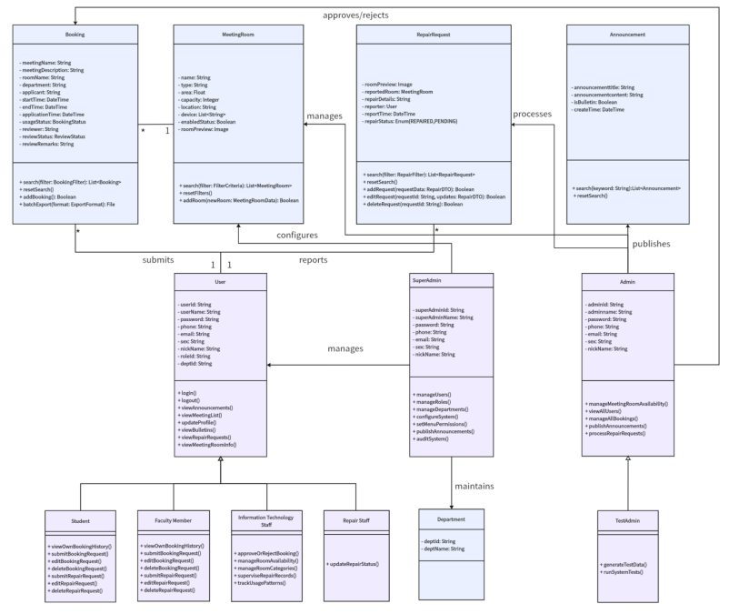
Figure 4: Software Modules Design

3.2. High-level Process Flow
The Meeting Booking System integrates a full suite of core functionalities for managing institutional meeting room reservations, with each module logically separated and collaboratively coordinated to streamline both user experience and administrative oversight.
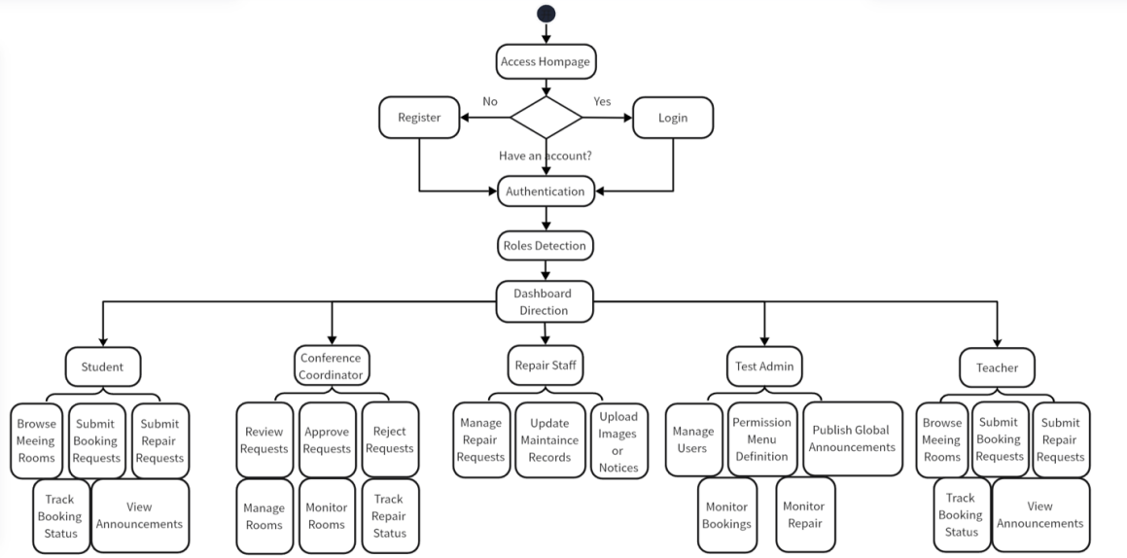
Figure 5: Process Flow
Entry and Authentication Flow：
Upon accessing the system homepage, users can register by submitting account credentials and essential personal information. After successful registration and login, the system enforces secure session management, including duplicate-login prevention and session expiration control. Upon authentication, users are redirected to dashboards based on their assigned roles:

Role-Based Routing and Functional Flow
• Student / Teacher Users are redirected to a personalized dashboard where they can browse available meeting rooms (integrated with FullCalendar), submit and manage booking requests, track booking history, report facility issues, and view system announcements and bulletins.
• MRC (Conference Coordinator) users access an administrative dashboard to review, approve, or reject booking applications, manage meeting room availability and metadata, monitor room usage trends and repair statuses, and interact with a fixed information pane implemented via Vue 3, Element Plus, and <keep-alive> to persistently display pending approvals and alerts.
• Repair Staffs are directed to the repair management module, where they can view repair submissions from users, update maintenance records (e.g., in progress, completed), upload supporting images or notes, and filter tasks based on urgency or status to prioritize repair workflows.
• Test Admin (Super Admin) users are granted full administrative access, enabling them to manage users, departments, roles, and permission menus (sys_menu), publish global announcements (sys_notice), monitor booking and repair activities across the system, and operate within a persistent admin layout optimized by router caching and <keep-alive> to maintain navigation state and enhance administrative efficiency.

Figure 6: Time series diagram: User registration and login is in APPENDIX 2
Figure 7: Time series diagram: User reserved meeting room is in APPENDIX 3
Figure 8: Time series diagram: Administrator reviews appointment meeting room records is in APPENDIX 4

Technical Integration and Responsiveness:
All user actions are served by asynchronous frontend-backend communication using Axios, and the interface dynamically updates using Vue.js 3’s reactive rendering capabilities. Element Plus provides a uniform design language across modules, while backend services—developed using Spring Boot—ensure secure RESTful request processing, token-based authentication (via JWT), and business logic enforcement (Muratovic and Tanovic, 2024).
This role-driven, modular process flow supports high usability, system reliability, and functional scalability across diverse user scenarios.

3.3. Software Support Services
Our Meeting Booking System relies on a suite of software tools and service integrations that collectively enhance development efficiency, system performance, and operational maintainability. These services span across database development, interface navigation, and infrastructure management.

Database-Related Services
• MySQL (v5.7.27):
MySQL serves as the primary relational database management system, supporting normalized table structures and high-performance query execution. Foreign key constraints ensure robust referential integrity between core entities such as users, meeting rooms, reservations, and permissions.
• MyBatis-Plus + MyBatis-Plus-Join:
We adopted MyBatis-Plus (v3.5.7) and MyBatis-Plus-Join (v1.4.7.2) as our ORM solution to streamline SQL operations. These tools allow concise query writing, auto-generation of boilerplate code, and advanced conditional query support, significantly reducing the complexity and redundancy of database access logic.
• Navicat (v11.1.13):
Navicat was used during the development phase to visually manage the MySQL database. It enabled collaborative access to table structures, ERD diagrams, test queries, and data population across development environments (Ozar, 2012).

Web Navigation Services
The system features a role-adaptive sidebar navigation built with Vue.js 3 and Element Plus, supporting collapsible, hierarchical menus with route-based access control. Navigation state is persistently maintained using Vue Router and <keep-alive> to ensure smooth user experiences across modules. This responsive layout guarantees accessibility across varied screen resolutions and supports interface consistency for students, teachers, MRCs, repair staff, and administrators.

Other Supporting Services
• Spring Boot Mail Service:
The system integrates Spring Boot’s JavaMailSender for email-based verification. During registration, the backend generates a secure, randomized code and sends it to the user's provided email. The mail service is designed to be event-driven and extensible for future use cases such as reservation status notifications and administrative announcements (Deinum, 2024).
• Git + Coding.net:
Source code versioning was managed via Git, with remote repositories hosted on Coding.net. Each team member developed within independent branches following a Gitflow-like model, using pull requests for integration and code reviews. Coding.net also supported Scrum task tracking and Wiki documentation (Guthals, 2023).
• Maven (v3.8.1):
Maven was used as the backend’s dependency and build management tool. It helped manage transitive dependencies, resolve version conflicts, and package the Spring Boot application into a JAR file for production deployment. Maven’s standard project structure also facilitated better collaboration among backend developers (Varanasi, 2019).

Together, these services form a cohesive foundation that supports rapid development, modular deployment, and stable maintenance throughout the project lifecycle.

3.4. Coding Structure and Convention
Following best practices under the Spring Boot framework, the backend is organized using a conventional multi-layered directory structure—typically segmented into controller, service, mapper, entity, config, and utils packages. Each directory encapsulates specific responsibilities, aligning with the Model-Service-Controller design pattern. Detailed definitions of each directory's function are maintained in our internal technical documentation (Figure 9 JAVA directory see Appendix 5).
On the frontend, the Vue.js 3 application adopts a modular structure supported by Vite. The source code is organized into logical folders, including views, components, router, assets, store, and api, which facilitates component-based development, scoped styling, and role-based route access.

Method Invocation Convention
To promote loose coupling and enhance maintainability, the Controller layer invokes business logic strictly through Service interfaces. Each service interface can correspond to one or more implementation classes. This abstraction provides flexibility for future logic extension or swapping of implementation details without affecting the interface layer. It also facilitates mocking during unit testing.

Naming Convention
We adhered to standardized naming practices for consistency and clarity:
1. Methods and variables: camelCase (e.g., createBookingRequest)
2. Class names: PascalCase (e.g., BookingController)
3. Constants: UPPER_CASE with underscores (e.g., MAX_ROOM_CAPACITY)
4. Naming principle: all names are semantically meaningful and follow the "entity + action" pattern when applicable (e.g., getUserPermissionList)
5. Interface implementation classes: suffixed with Impl (e.g., RoomServiceImpl)

Code Maintenance Standards
During collaborative development, code maintainability was emphasized:
1. Developers are expected to write self-documenting code with concise and relevant inline comments
2. Prior to any Git commits, unused code segments and outdated comments are cleaned up to preserve repository hygiene
3. Code formatting follows IDE-configured style guides across the team to maintain structural consistency

Task Management and Code Completion
Unfinished features and pending implementations are not marked with inline TODOs. Instead, we adopted a structured task-tracking workflow using Coding.net’s Scrum board and Wiki documentation. Task items are divided by Sprint and categorized under Epic/Story/Task structures, allowing all group members to clearly track development progress, assign responsibilities, and manage future implementation priorities. Daily stand-ups and milestone meetings ensure timely communication of pending development tasks.

This convention-centric, layered coding framework enhances system readability, developer onboarding, and long-term scalability.

3.5. Software Configuration and Production Environment
Software Configuration
Our Meeting Booking System is built on a modular, integrated technology stack designed for dynamic data rendering and secure role-based access.
• Frontend Configuration:
Developed with HTML, CSS, JavaScript, and Vue.js 3 (v3.3.4), enhanced by TypeScript for type safety. Vite (v4.4.5) enables fast builds and HMR. UI components are built with Element Plus (v2.3.12), Axios (v1.7.2) manages API communication, and Vue Router (v4.2.4) controls routing. ECharts (v5.4.3) and FullCalendar (v6.1.15) support visualization and scheduling (Jansen, Vane and Wolff, 2016).
• Backend Configuration:
Implemented using Spring Boot (v3.2.7) with an MVC structure. MyBatis-Plus (v3.5.7) and MyBatis-Plus-Join (v1.4.7.2) support ORM operations, Druid (v1.2.1) handles connection pooling, and Sa-Token (v1.38.0) with Spring Security Crypto ensures authentication, authorization, and password security.
• Database Layer:
MySQL (v5.7.27) is used with a 3NF-compliant schema and enforced foreign key constraints. Navicat (v11.1.13) facilitated database management during development.
Production Environment
System | Ubuntu 22.04 64x
Processor | Intel ® Xeon ® Platinum Scalable Processors, 4-core (vCPU), 8 GiB
Public network | bandwidth 5 Mbps
Java OpenJDK | version 17.0.14
MySQL | Version 5.7.27
Our system is deployed on the AliyunServer (ecs.e-c1m2.xlarge) with enhanced network performance and dedicated VPC. This ensures high availability, secure isolation, and stable operation for our application.

4. Software testing

4.1. Unit Test
Unit tests are designed to ensure that each individual unit of code works accurately. We tested in four areas, authentication (login, register, forget password), search (single and multiple criteria search), booking (status, time, modification and cancellation) and administration (administrator approval, rejection and cancellation of the booking record). For back-end logic verification, JUnit was utilized. This ensures that individual functions and components perform as expected before integration (Ke, 2019). Here, we use the booking time as an example.

4.2. Integration Test
Integration testing is to verify the correctness of interfaces, interactions and co-operation between multiple modules, mainly focusing on whether the data transfer, call relationships and dependencies between modules can achieve the expected performance (Mukherjee and Mall, 2019). Our integration testing mainly includes the integration of authentication and booking function, the integration of search and booking function, the integration of booking and management function, and the integration of mail system. We use the mail system integration as an example.
We use the mail system integration as an example:
Step 1: User fills in the registration information and submits it.
Front-end: Users enter their account, phone, email, and other necessary information on the registration page built with Vue.js 3 and Element Plus. The front-end verifies the email format in real time. After passing verification, the user clicks the ‘Next’ button, and the front-end sends the registration information to the back-end using Axios.
Back-end: The Spring Boot application receives the registration request from the front-end. It verifies the completeness and accuracy of the information again. If the information is incorrect, an error message is returned to the front-end.
Step 2: The back-end generates a verification code and sends an email.
Back-end: After the registration information is verified, the backend generates a random number verification code. It uses the integrated Spring Boot Mail Service (JavaMailSender) to send the verification code email to the user's mailbox.
Database: The verification code and its related information (mailbox, sending time) stored.
Step 3: The user views the verification code in the email.
Front-end: Prompts the user to check their mailbox for the verification mail.
User operation: The user logs into their mailbox, finds the verification code email, gets the verification code, and inputs it into the verification code input box on the registration page.
Step 4: Check verification code and update user status.
Front-end: After the user inputs the verification code, the front-end sends the code along with the email address to the back-end for verification using Axios.
Back-end: Queries necessary data (potentially user record or temporary code storage) and checks if the code is correct. If the verification code is correct, it updates the user's status in the sys_user table in the MySQL database and returns success information to the front-end. If the verification code is wrong, it returns the corresponding error information to the front-end.
Test Results: As expected, we received an email with a verification code.
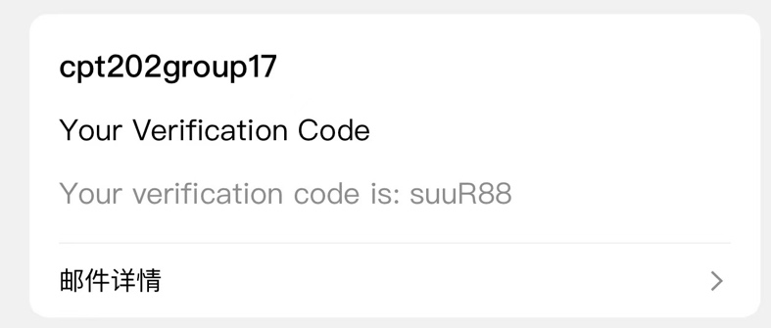
Figure 10: Verification E-mail

4.3. Acceptance Test
Acceptance testing is to verify that the system under the software meets the business requirements and can function properly in real applications and be accepted by users (Dong, 2013). Our acceptance testing includes business process testing, compatibility and user experience testing, security and performance testing, and accessibility testing.
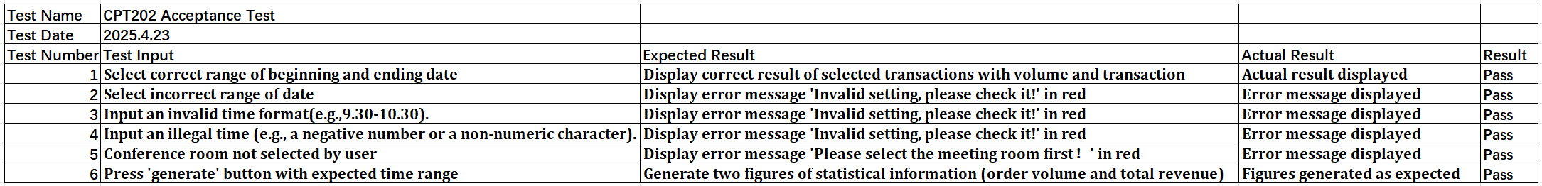
Figure 11: Test Case ID:PBI-032 Users cannot book for more than 8 hours

In addition, the user interface (UI) should enable users to use the web pages and complete conference room bookings efficiently, easily and pleasantly.Acceptance testing is not just about checking that the UI elements ‘look right’, but more importantly verifying that the UI ‘works right’.This is an example of user and meeting room visual charts.
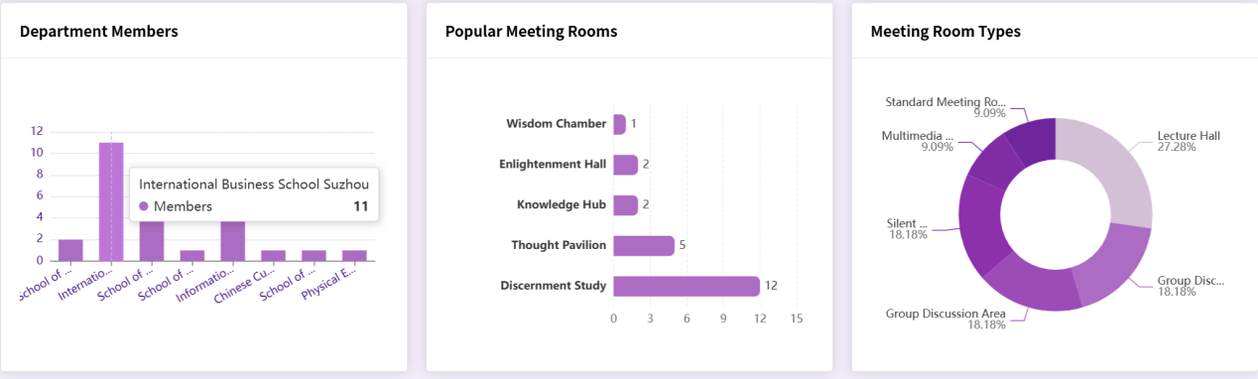

Figure 12: User and meeting room usage dashboard

5. Conclusion and future work
To date, our group has made significant progress in developing a functional and efficient Meeting Booking System. We translated project requirements into a well-structured system design, adopting the MVC architecture to achieve a decoupled and maintainable framework. The frontend and backend, built with Vue.js and Spring Boot, deliver a responsive user experience and robust server-side processing. A high-level database design ensures data integrity and consistency, while software modules tailored to different user roles (Students, Teachers, MRC, Repair Staff, and Super Admin) support operations such as room booking, availability viewing, repair requests, and resource management. The integration of software support services has further enhanced system functionality and reliability. Overall, our system addresses key limitations of traditional booking methods.

Despite our achievements, several challenges and issues have arisen during the implementation of the project. First, ensuring seamless integration between different modules is a complex task that requires careful coordination and testing to resolve any compatibility issues. So far, our web pages have only been adapted for computers, and the performance on cell phones needs to be improved. Secondly, optimizing the system performance to handle many concurrent users and bookings is still a task that needs further attention, in our envisioned scenario, a professional operator needs to control the booking of a conference room, in the future, we hope this feature can become fully automated. Thirdly, a few minor bugs and usability issues were identified during the testing phase that needed to be addressed to improve the user experience. Finally, as the project progressed, there were some changes to the requirements, which required some adjustments to the initial plan by adapting and incorporating these changes into the design and implementation process.

Looking ahead, our team plans to undertake several tasks to further enhance and improve the online meeting booking system. We will focus on optimizing the performance of the system to ensure that it can efficiently handle high-traffic usage scenarios, which involves database optimization, code optimization and improving server-side processing power. We will conduct extensive testing, including unit testing, integration testing and acceptance testing, to identify and fix any remaining bugs and issues to ensure the stability and reliability of the system. We will actively collect feedback from our users to gain insight into their experience and expectations, and based on this feedback, we will make necessary improvements to the functionality and user interface of the system (A/B tests) to improve usability and user satisfaction. In addition, we will explore the possibility of adding new features and functionalities to the system, such as integration with videoconferencing tools or advanced analysis of resource utilization, to provide users with more value-added services and to further improve the overall efficiency of on-campus meeting room management. Through these continuous efforts, we aim to provide a high-quality online meeting booking system that meets the evolving needs of the school community and sets a benchmark for resource management systems.

References
Amuthan Ganeshan (2016) Spring MVC: Beginner’s Guide - Second Edition. Birmingham: Packt Publishing. Available at: https://search-ebscohost-com-s.elink.xjtlu.edu.cn:443/login.aspx?direct=true&db=nlebk&AN=1295342&site=eds-live&scope=site (Accessed: 26 April 2025).

Deinum, M. (2024) Java Enterprise Services. Berkeley, CA: Apress. doi:10.1007/979-8-8688-0113-6_7.

Dong, N., 2013. ‘Research on software project acceptance testing’, Software Guide, (10), p.36. Available at: https://search.ebscohost.com/login.aspx?direct=true&db=edscqv&AN=edscqv.47454752&site=eds-live&scope=site (Accessed: 26 April 2025).

DuBois, P. (2013) MySQL. Fifth edition. Addison-Wesley. Available at: https://search-ebscohost-com-s.elink.xjtlu.edu.cn:443/login.aspx?direct=true&db=cat01010a&AN=xjtlu.0000506143&site=eds-live&scope=site (Accessed: 26 April 2025).

Farouk, M. (2017) Infrastructure Software Modules for Enterprises. [electronic resource] : Flexible Software Systems, Module Use-Cases, and Wireframes. Apress. Available at: https://search.ebscohost.com/login.aspx?direct=true&db=cat01010a&AN=xjtlu.0001289263&site=eds-live&scope=site (Accessed: 26 April 2025).

Gökhan Ozar (2012) MySQL Management and Administration with Navicat : Master the Tools You Thought You Knew and Discover the Features You Never Knew Existed with This Book and Ebook. [Place of publication not identified]: Packt Publishing. Available at: https://search.ebscohost.com/login.aspx?direct=true&db=nlebk&AN=486649&site=eds-live&scope=site (Accessed: 26 April 2025).

Guthals, S. (2023) GitHub. 2nd edition. John Wiley & Sons, Inc. (For dummies). Available at: https://search.ebscohost.com/login.aspx?direct=true&db=cat01010a&AN=xjtlu.0002445372&site=eds-live&scope=site (Accessed: 26 April 2025).

Heckler, M. (2021) Spring boot : up and running : building Cloud Native Java and Kotlin applications. First Edition. O’Reilly Meida, Inc. Available at: https://search-ebscohost-com-s.elink.xjtlu.edu.cn:443/login.aspx?direct=true&db=cat01010a&AN=xjtlu.0001901260&site=eds-live&scope=site (Accessed: 26 April 2025).

Jansen, R.H., Vane, V. and Wolff, I.G. de (2016) TypeScript: Modern JavaScript Development. Birmingham, UK: Packt Publishing. Available at: https://search-ebscohost-com-s.elink.xjtlu.edu.cn:443/login.aspx?direct=true&db=nlebk&AN=1444389&site=eds-live&scope=site (Accessed: 26 April 2025).

Ke, C., 2019. ‘JUnit framework implementation for Java unit testing’, Electronic Technology & Software Engineering, (21), p.42. Available at: https://search.ebscohost.com/login.aspx?direct=true&db=edscqv&AN=edscqv.7100161726&site=eds-live&scope=site (Accessed: 26 April 2025).

Li, Y.Z. et al. (2020) ‘Research and Application of Template Engine for Web Back-end Based on MyBatis-Plus’, Procedia Computer Science, 166, pp. 206–212. doi:10.1016/j.procs.2020.02.052.

Mendoza, D. and Piedra, N. (2020) ‘TutNorBD: Assistant for teaching and learning process of relational database normalization up to 3NF from a universal table’, 2020 XV Conferencia Latinoamericana de Tecnologias de Aprendizaje (LACLO), Tecnologias de Aprendizaje (LACLO), 2020 XV Conferencia Latinoamericana de, pp. 1–8. doi:10.1109/LACLO50806.2020.9381184.

Mukherjee, D. and Mall, R., 2019. ‘An integration test coverage metric for Java programs’, International Journal of System Assurance Engineering and Management, 10(4), pp.576–601. doi:10.1007/s13198-019-00787-9.

Muratovic, A. and Tanovic, A. (2024) ‘Innovative Approach to Accelerating Laravel Backend Generation from Vue.js Components Using Axios, Artificial Intelligence and Artisan Commands’, 2024 32nd Telecommunications Forum (TELFOR), Telecommunications Forum (TELFOR), 2024 32nd, pp. 1–4. doi:10.1109/TELFOR63250.2024.10819138.

Sanchez, L.M. et al. (2019) ‘Smart Meeting Room Management System Based on Real-Time Occupancy’, 2019 IV Jornadas Costarricenses de Investigación en Computación e Informática (JoCICI), Investigación en Computación e Informática (JoCICI), 2019 IV Jornadas Costarricenses de, pp. 1–6. doi:10.1109/JoCICI48395.2019.9105174.

Shavin, M. (2023) Learning Vue : core concepts and practical patterns for reusable, composable, and scalable user interfaces. First edition. O’Reilly Media, Inc. Available at: https://search-ebscohost-com-s.elink.xjtlu.edu.cn:443/login.aspx?direct=true&db=cat01010a&AN=xjtlu.0002533318&site=eds-live&scope=site (Accessed: 26 April 2025).

Shili, S., et al., 2009. Design of the Booking Meeting System on the Electronic Commercial Manageability. Journal of Liaoning University (Natural Science Edition), 36(1), pp.59–63. doi:10.3969/j.issn.1000-5846.2009.01.017.

Varanasi, B. (2019) Introducing Maven. [electronic resource] : A Build Tool for Today’s Java Developers. 2nd ed. 2019. Apress. Available at: https://search.ebscohost.com/login.aspx?direct=true&db=cat01010a&AN=xjtlu.0001649509&site=eds-live&scope=site (Accessed: 26 April 2025).

Appendix

Appendix1- Figure 3: ER diagram
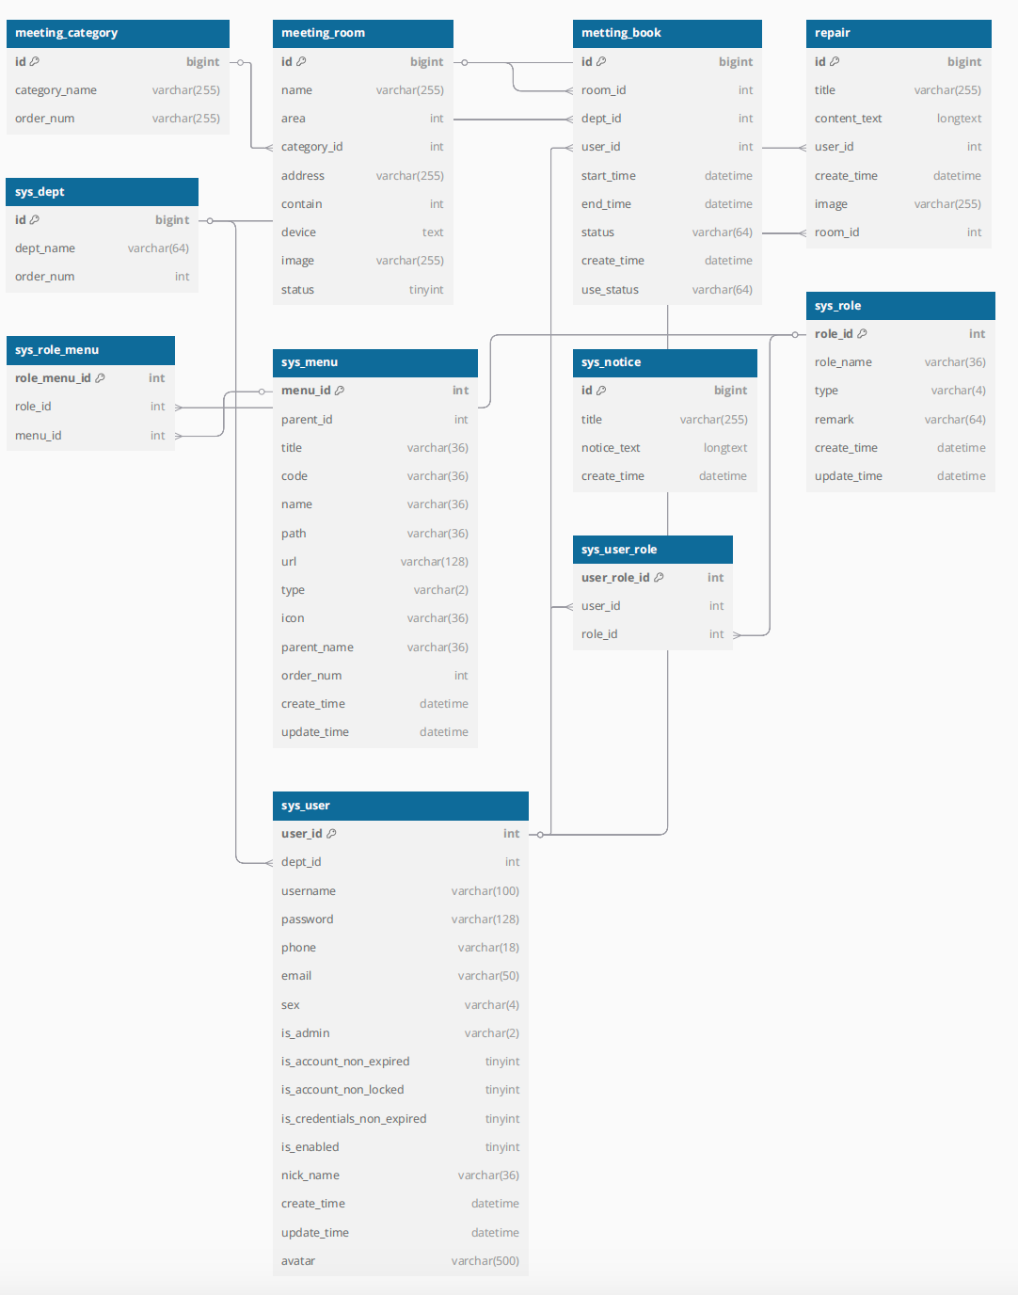

Appendix2- Figure 6: Time series diagram: User registration and login
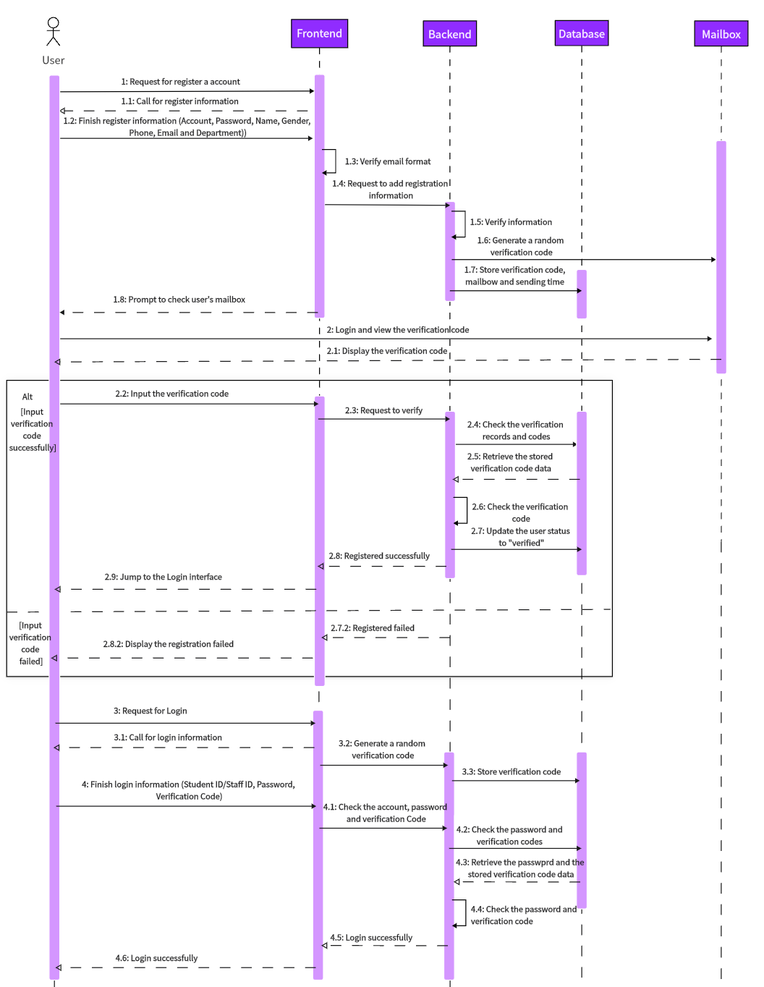

Appendix3- Figure 7: Time series diagram: User reserved meeting room
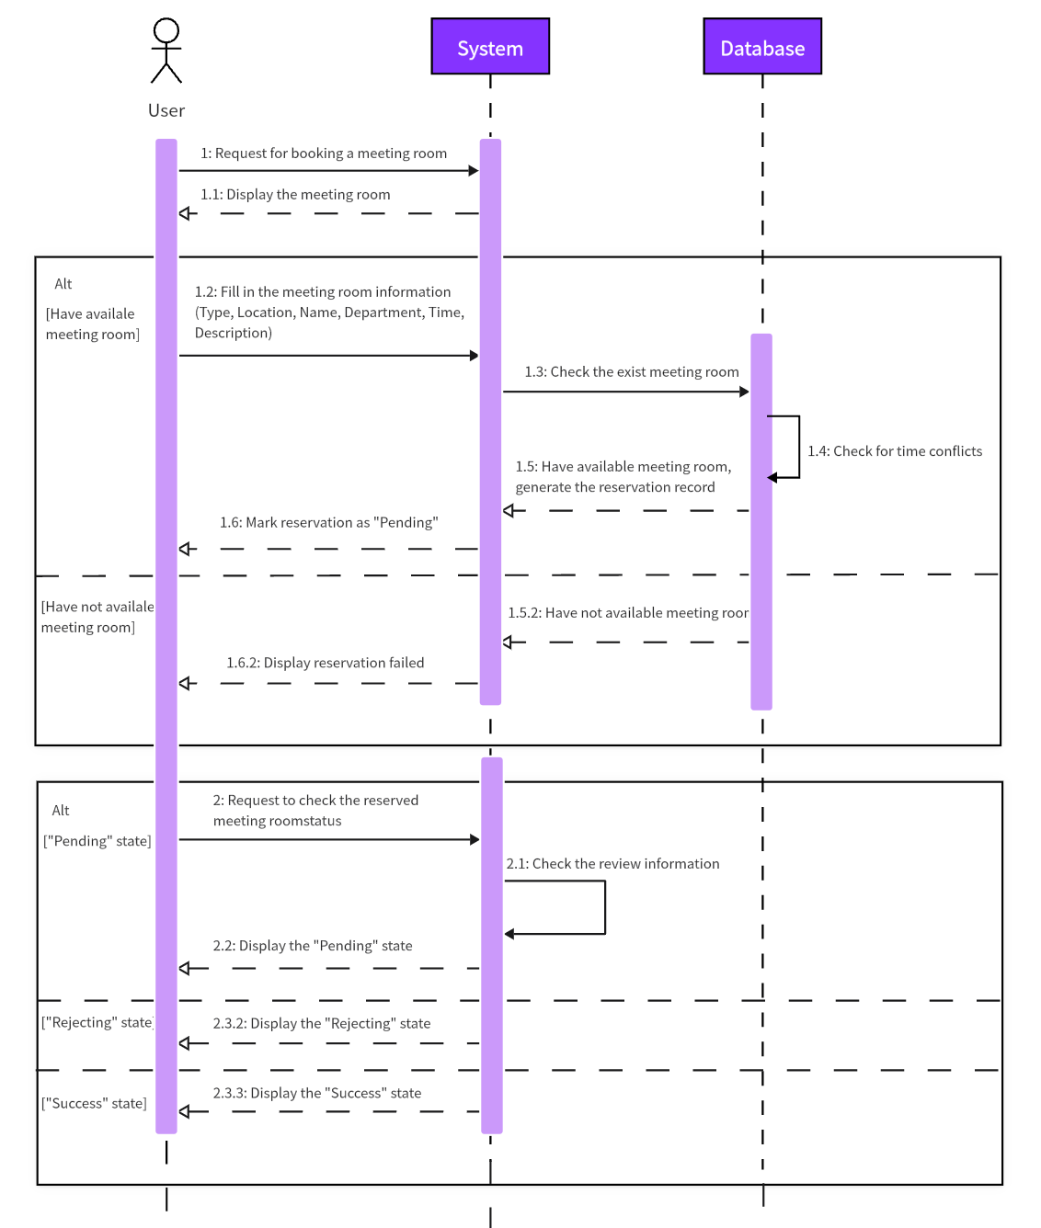

Appendix4- Figure 8: Time series diagram: Administrator reviews appointment meeting room records
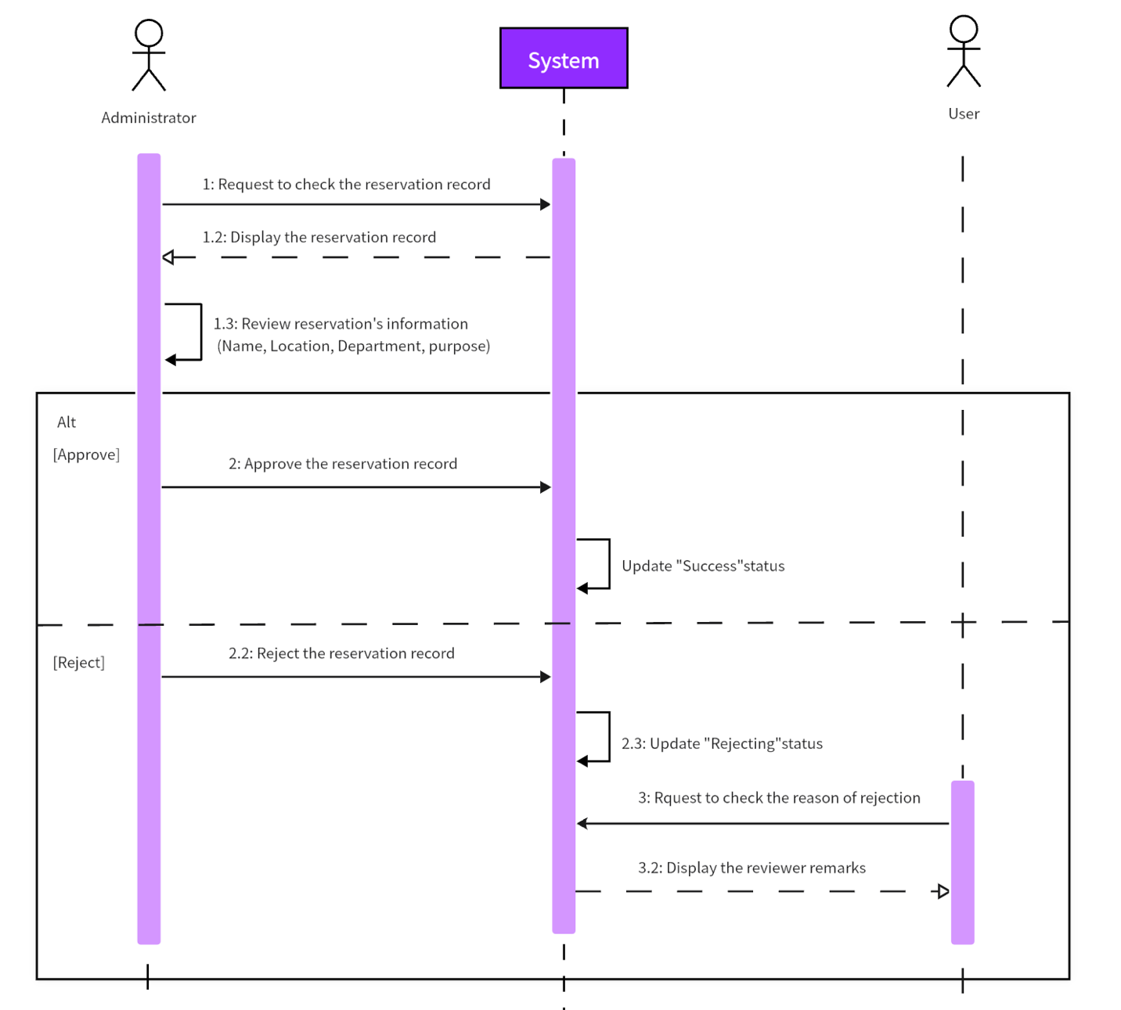

Appendix5- Figure 9: JAVA directory
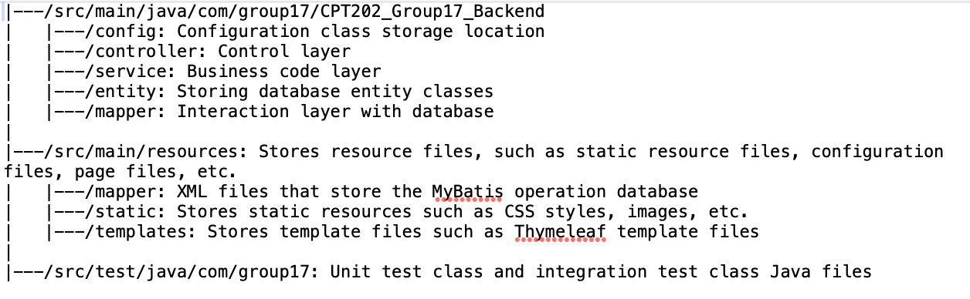

Appendix6: Sprint Process Report
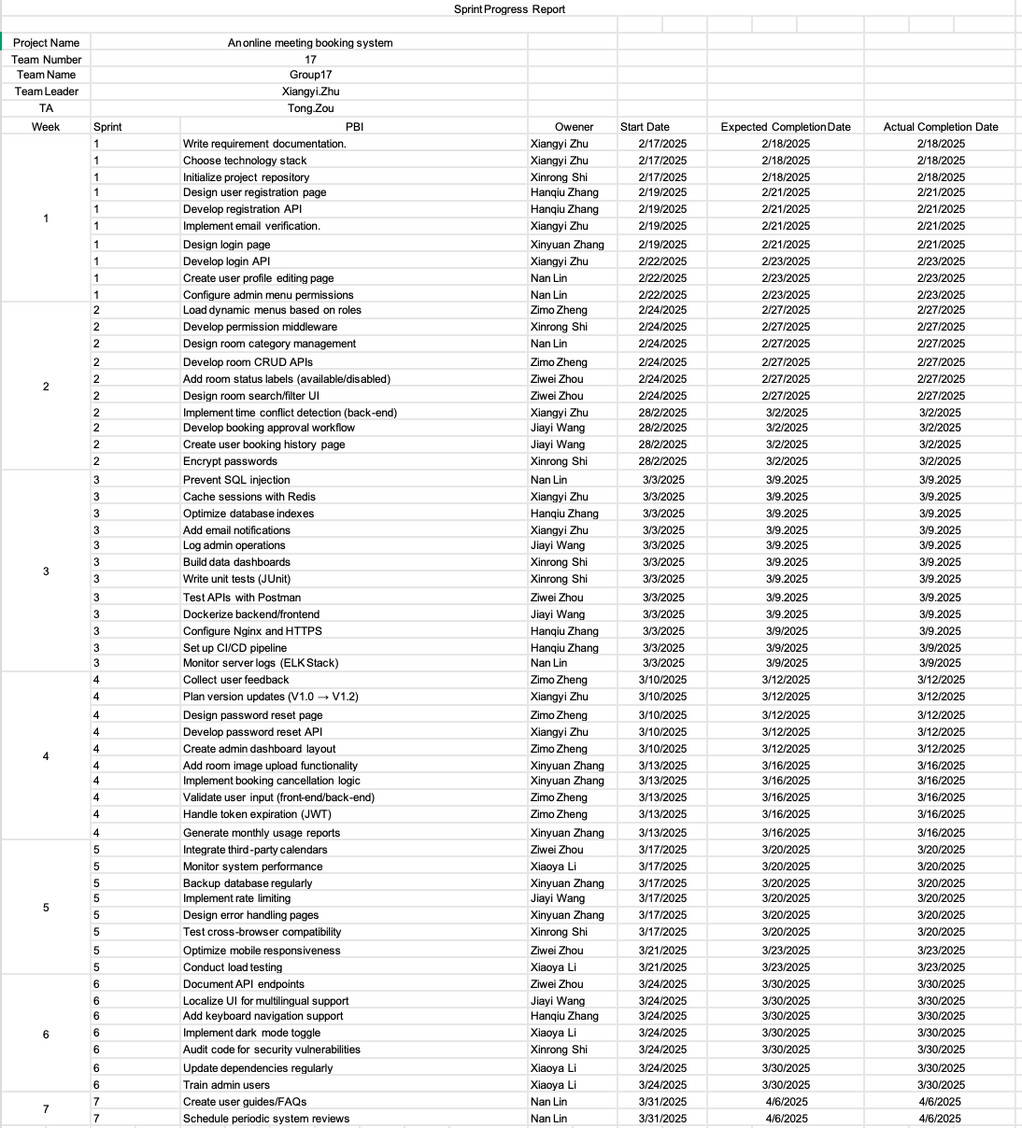

Appendix7: Role login division flow chart
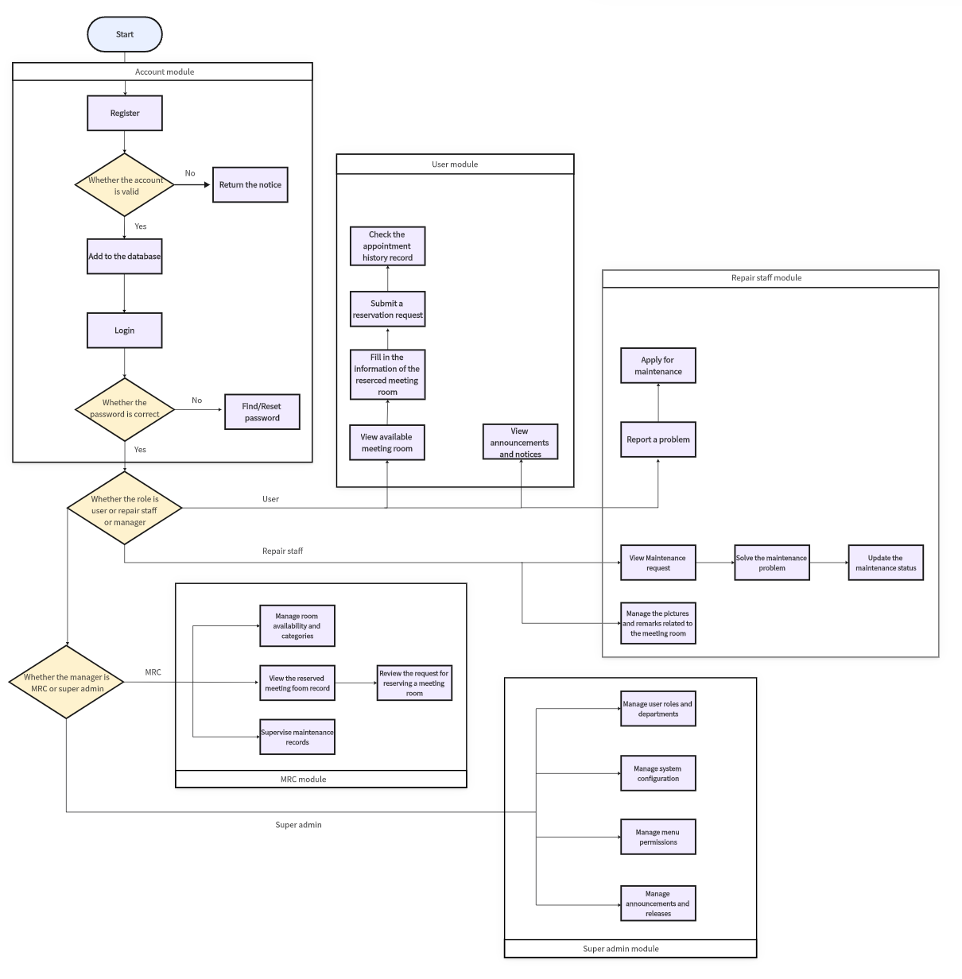

Appendix8 (1): Database Table Structure Documentation
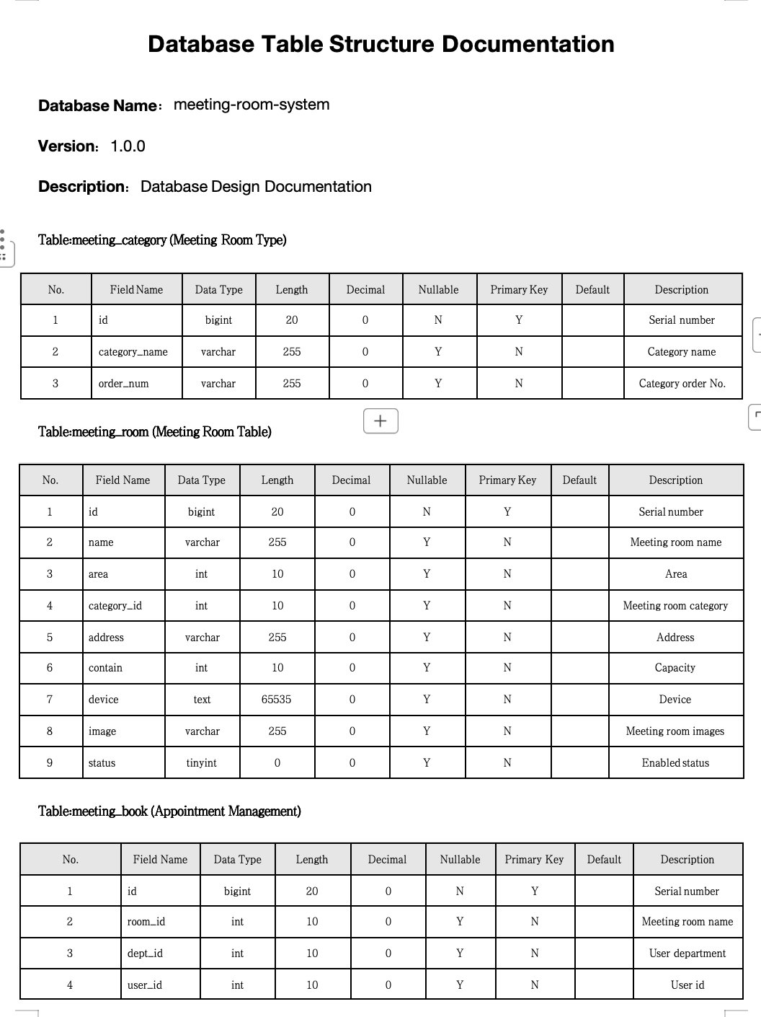

Appendix8 (2): Database Table Structure Documentation

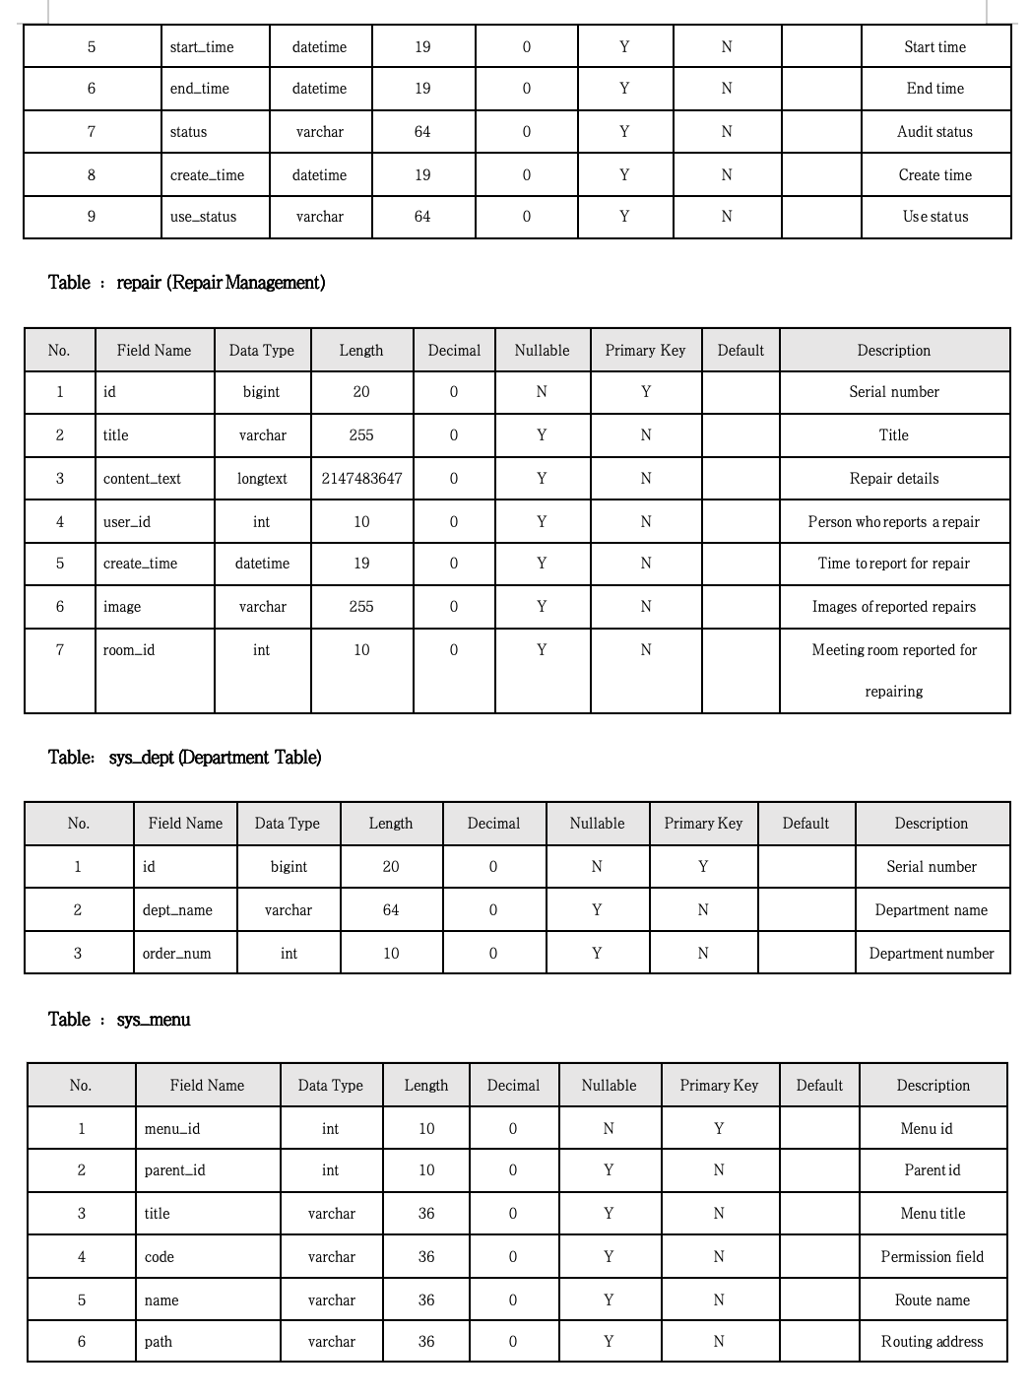

Appendix8 (3): Database Table Structure Documentation
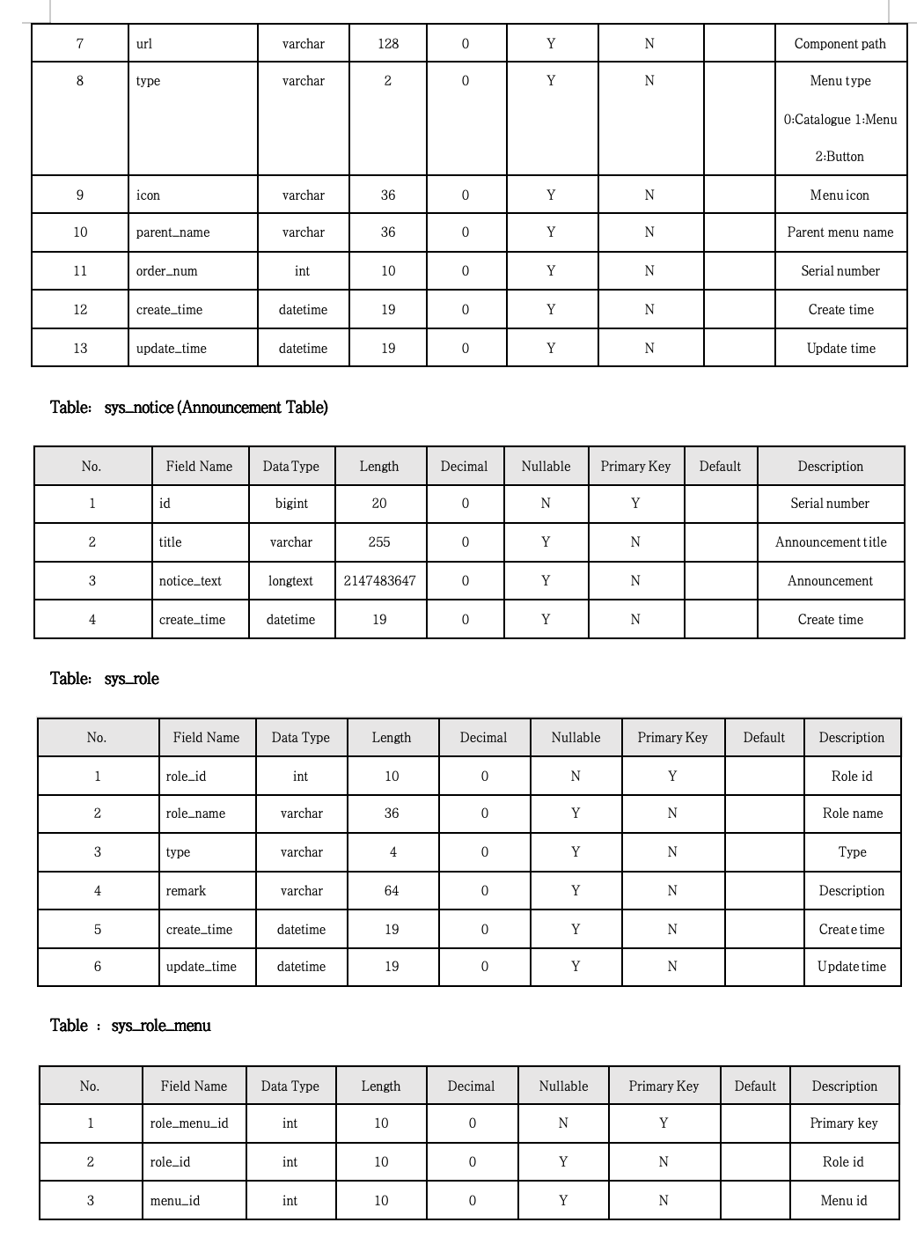

Appendix8 (4): Database Table Structure Documentation
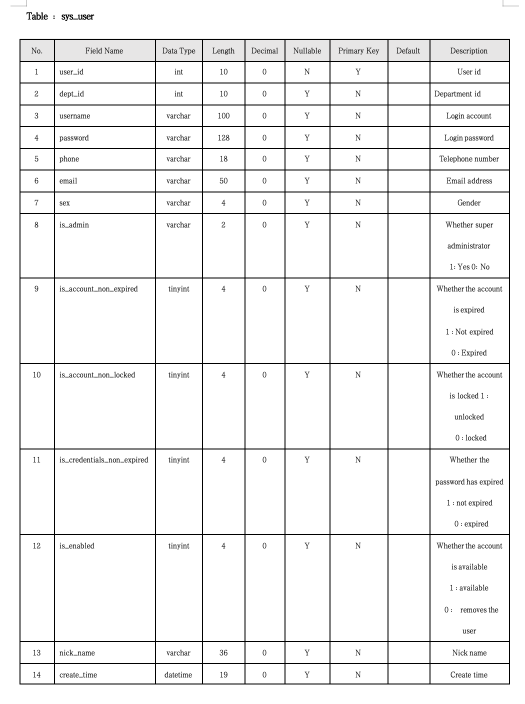

Appendix8 (5): Database Table Structure Documentation
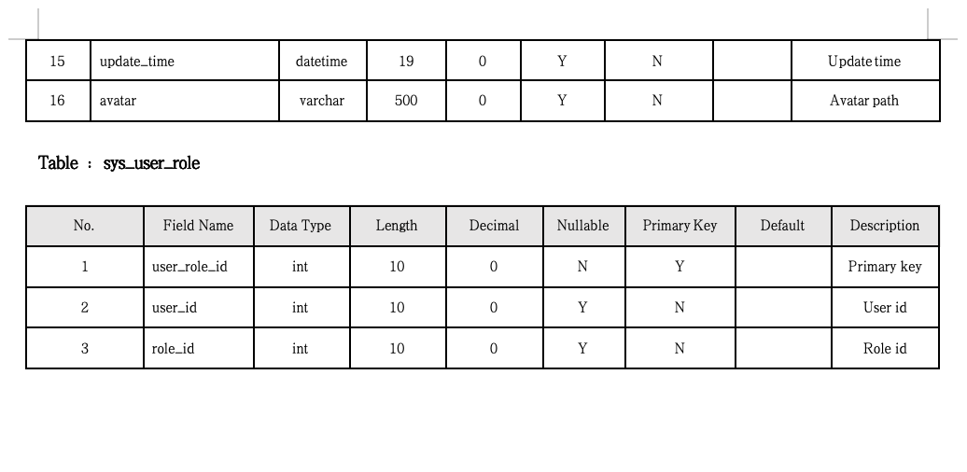

Appendix9: Examples of unit tests and partial integration tests

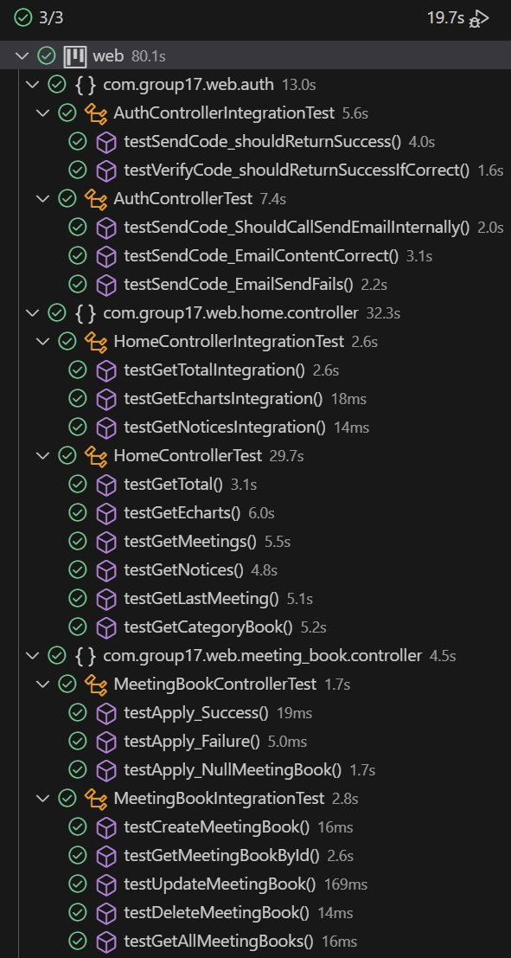

Appendix10 (1): Schematic diagram of some key data tables of Navicat--meeting_book
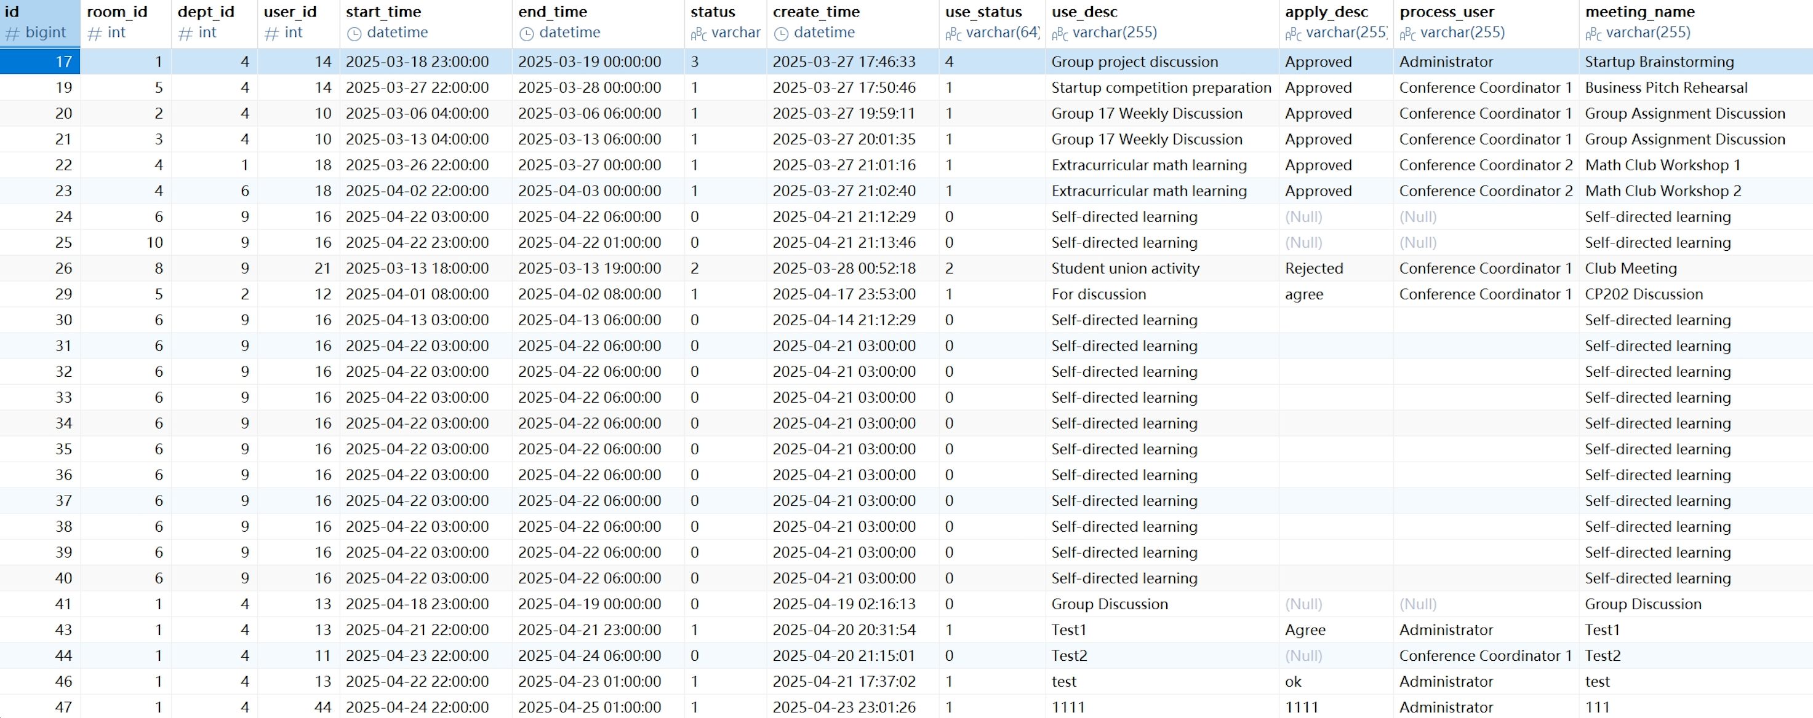

Appendix10 (2): Schematic diagram of some key data tables of Navicat--meeting_category
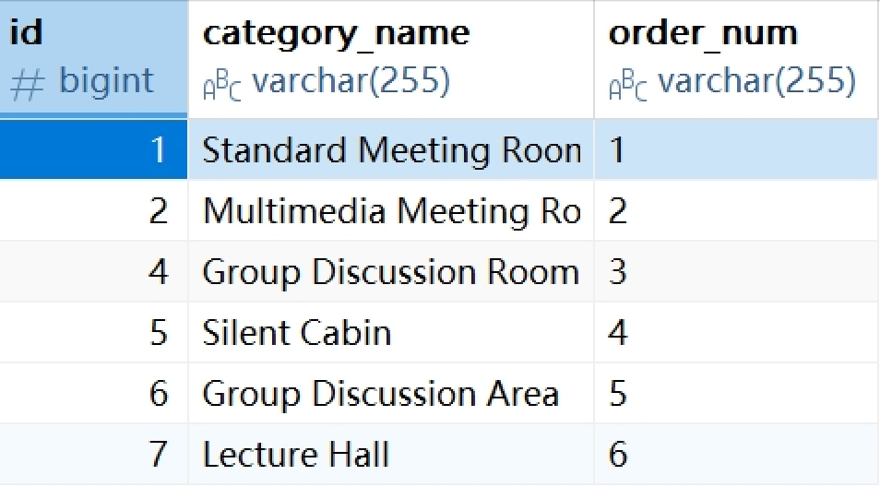

Appendix10 (3): Schematic diagram of some key data tables of Navicat--meeting_room
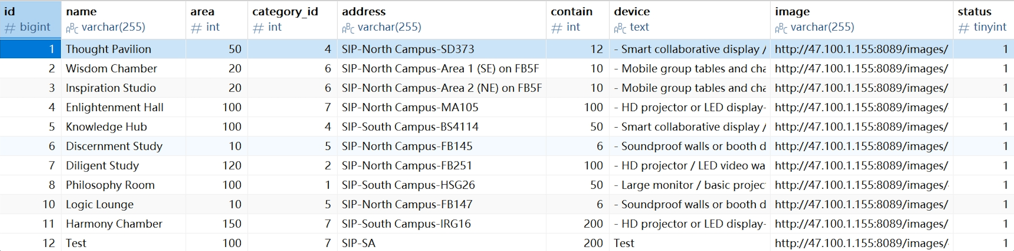

Appendix10 (4): Schematic diagram of some key data tables of Navicat--repair
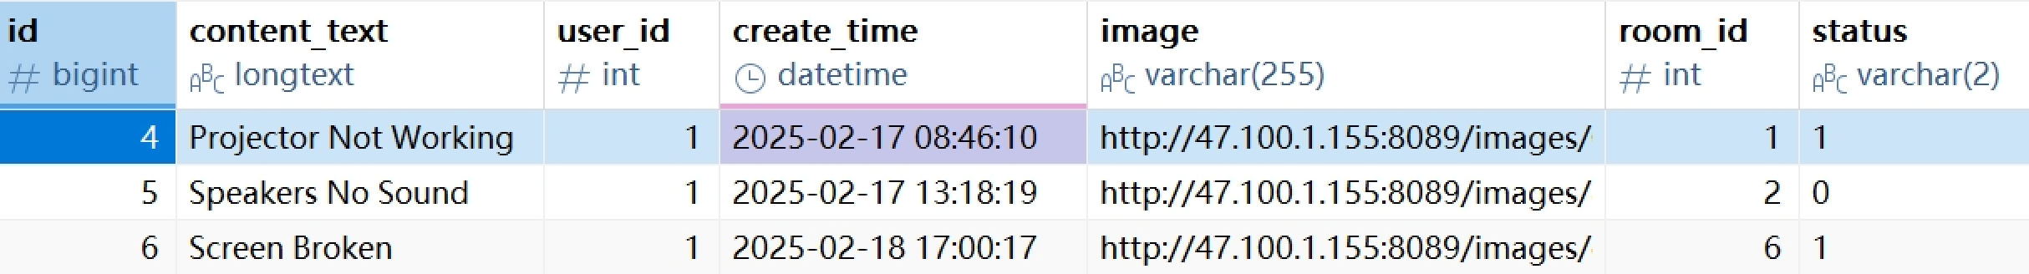

Appendix10 (5): Schematic diagram of some key data tables of Navicat--sys_dept
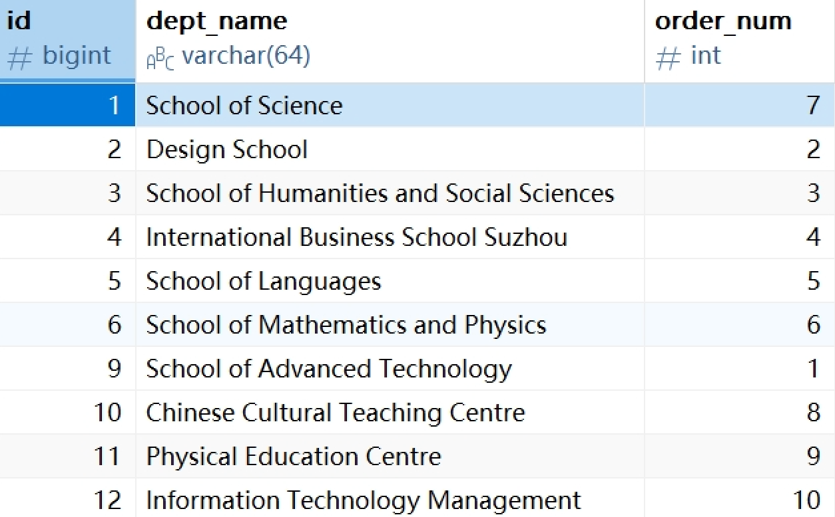

Appendix10 (6): Schematic diagram of some key data tables of Navicat--sys_menu
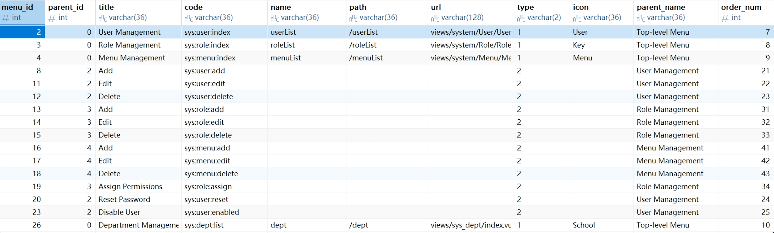

Appendix10 (7): Schematic diagram of some key data tables of Navicat--sys_role
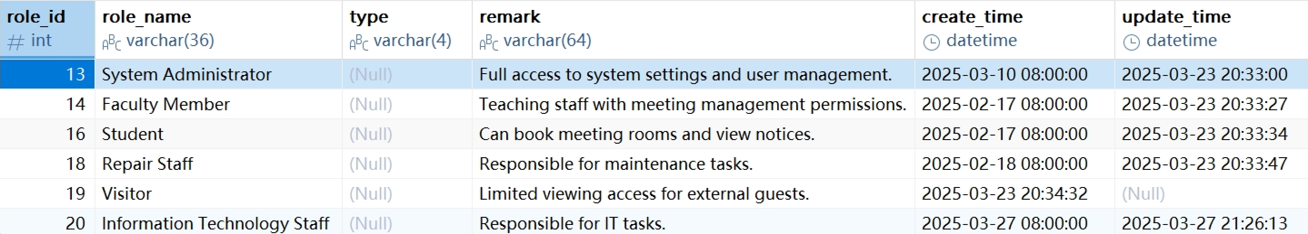

Appendix10 (8): Schematic diagram of some key data tables of Navicat--sys_user
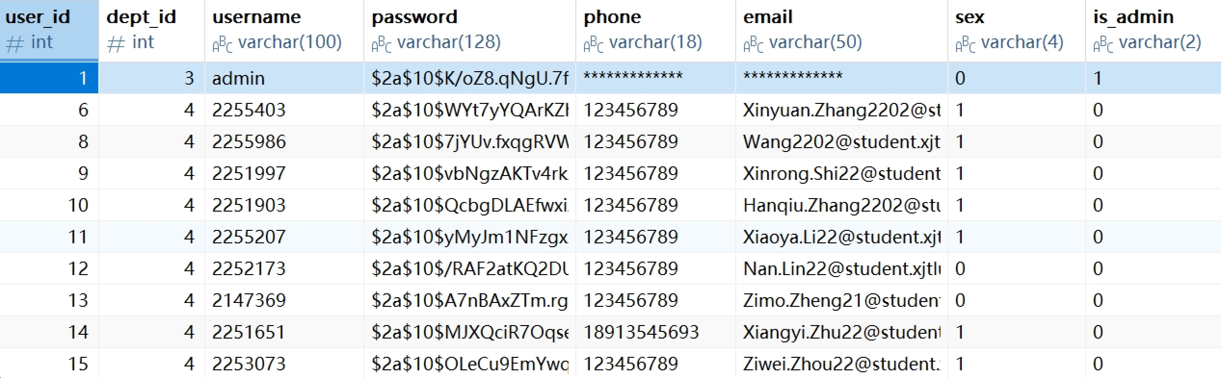

Appendix11: Unit Testing-Register
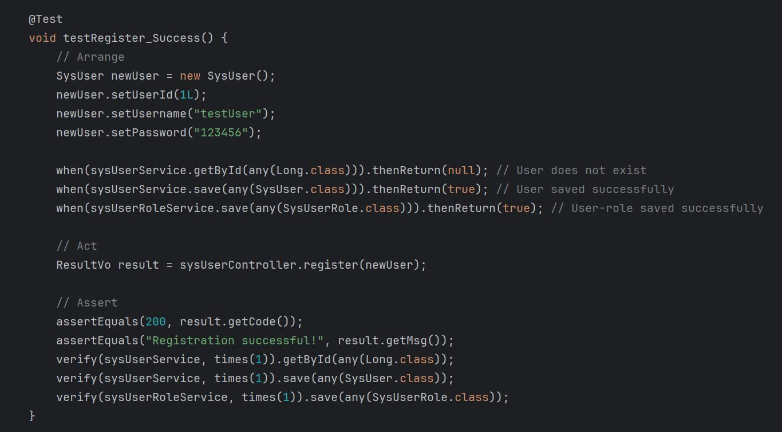

Appendix12: Integration Testing-Create new booking
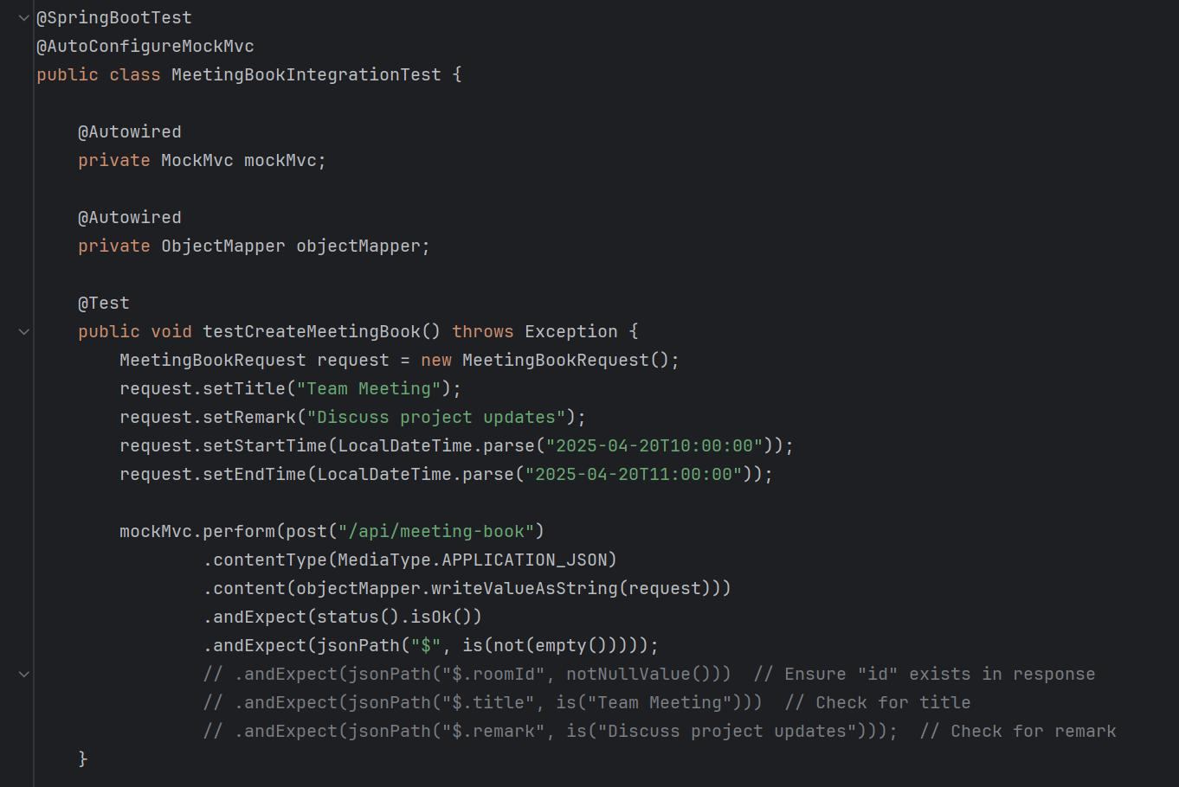

Appendix13 (1): Technical Documentation--Development Tools
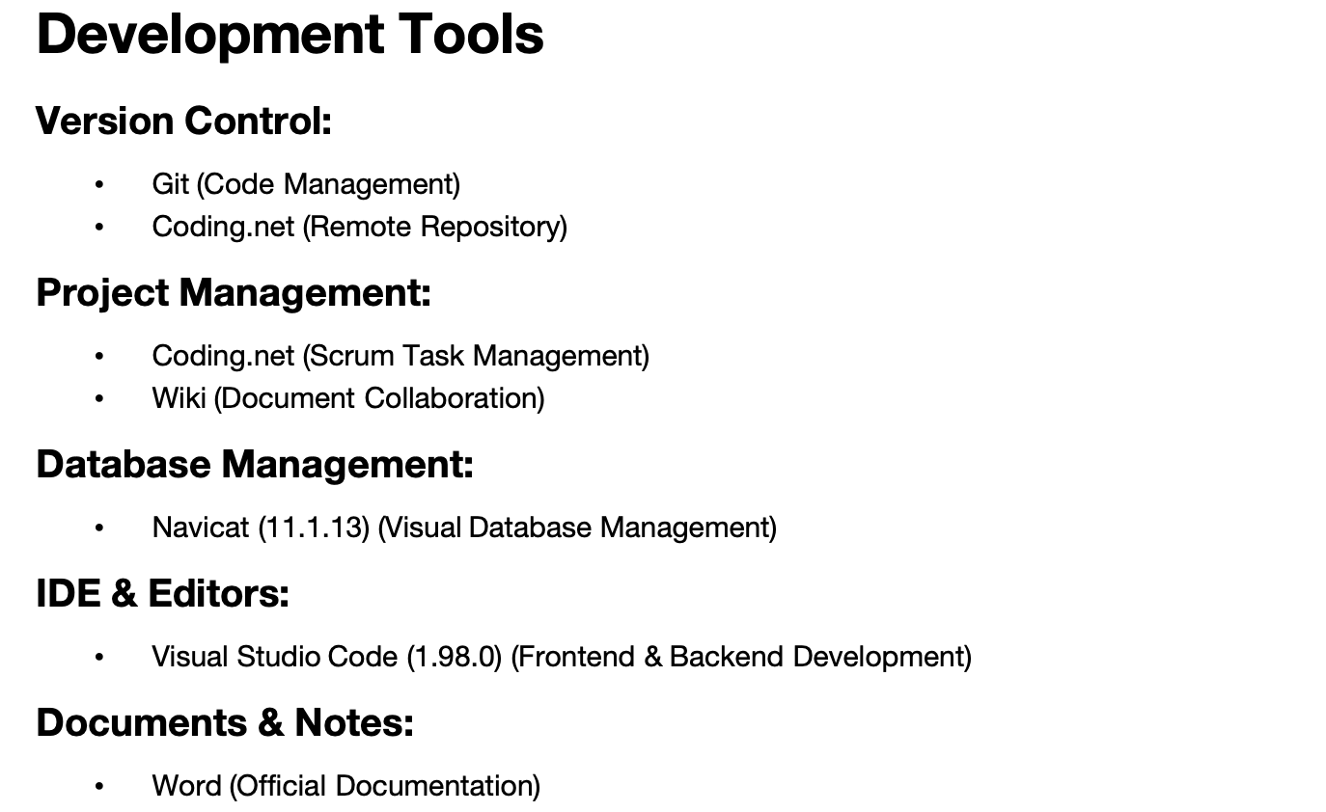
Appendix13 (2): Technical Documentation--Programming Languages
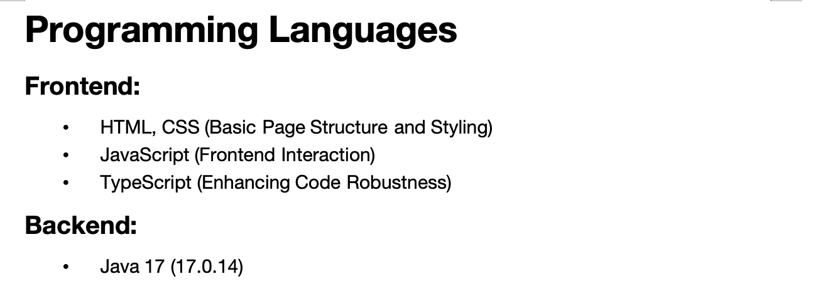

Appendix13 (3): Technical Documentation--Main Frameworks & Libraries
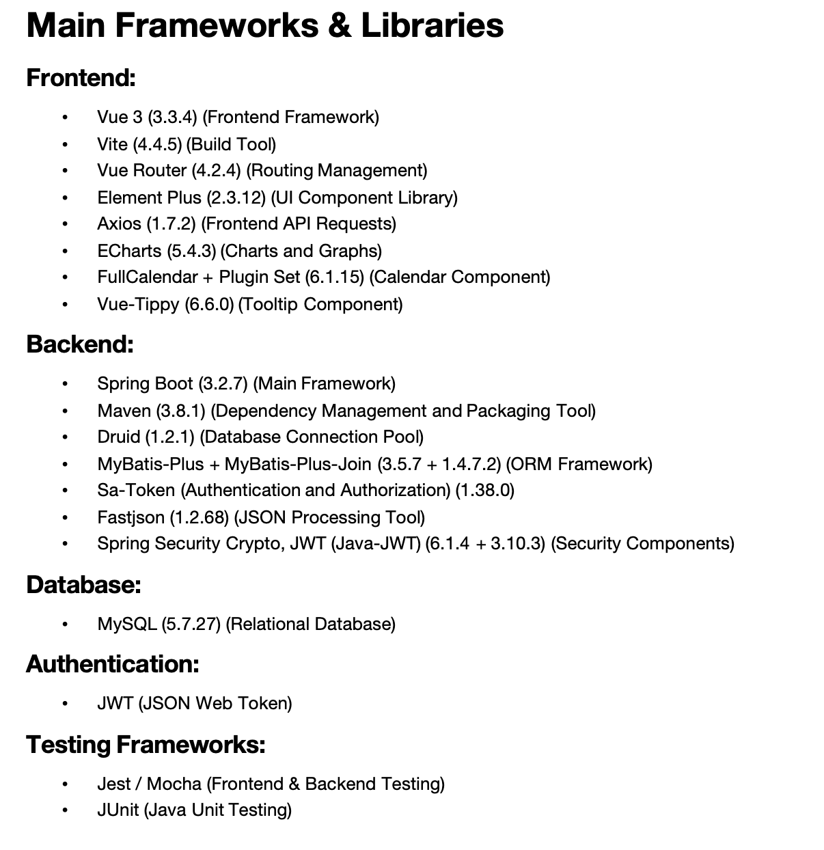
Appendix13 (4): Technical Documentation--Required Knowledge
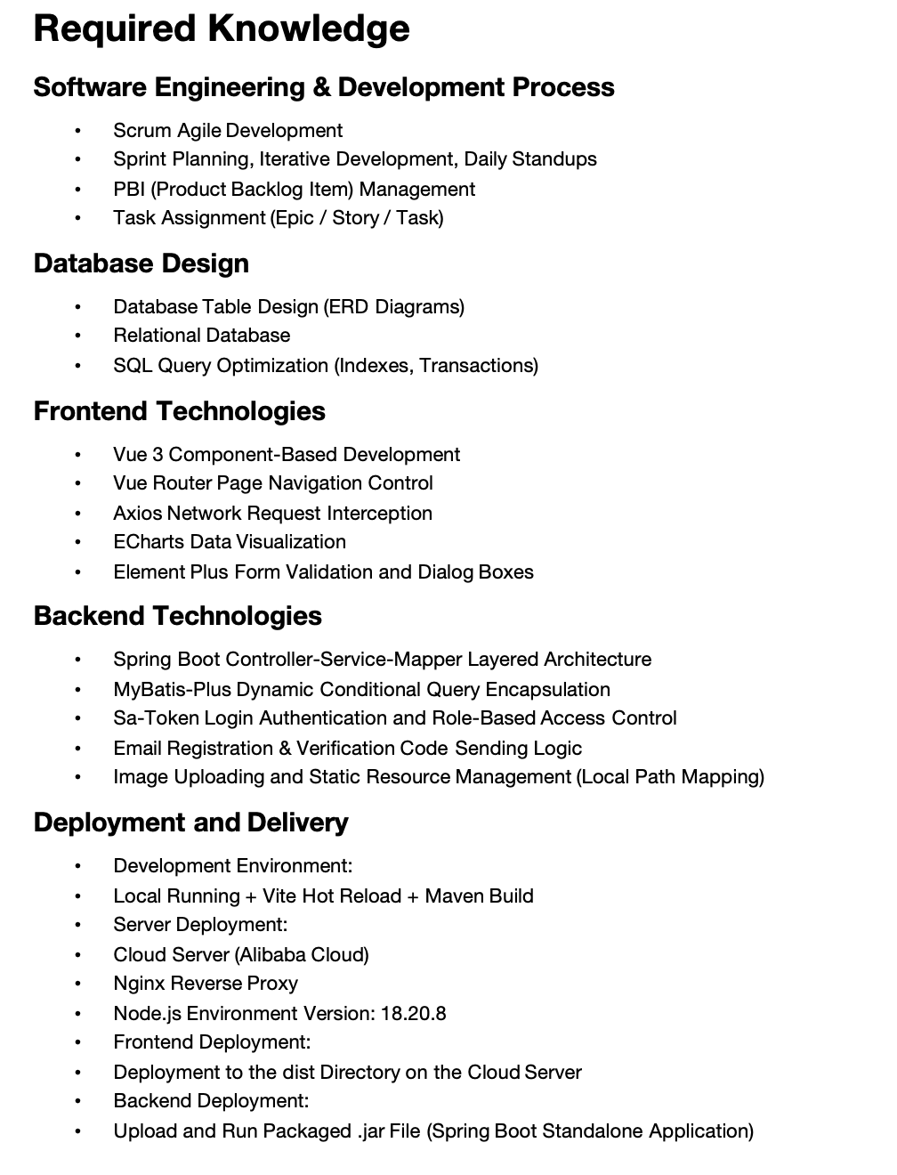

Appendix13 (5): Technical Documentation--Suggested Workflow
