Distributed Systems – Labs

Python - Programming with HTTP for the Internet

Tasks

Task 1. Downloading data from an HTTP server
We will see how to write a simple HTTP client to fetch some data from any web server using the native HTTP protocol. This can be the very first steps towards creating your own HTTP browser.
Examine PT1\4_1_download_data.py that is a code for a simple HTTP client:
4_1_download_data.py will by default fetch a page from https://www.w3schools.com/.
You can run this recipe with or without the host argument. You may choose to fetch any specific web page by passing the URL as an argument. If this script is executed, it will show the following output:
> python 4_1_download_data.py --host=http://www.python.org
You will get output similar to this:

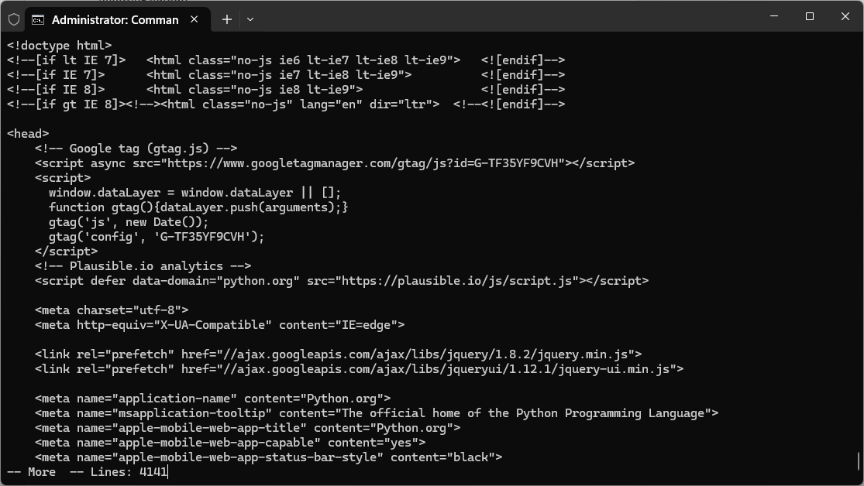
This recipe will also work for any page in the sites. Not just the home page:
> python 4_1_download_data.py --host=https://www.python.org/downloads/

This recipe defines an urllib.request module that fetches data from the remote host. urllib.request.urlopen() opens the given web page and fetches it.

Task 2: Serving HTTP requests from your machine
We will see how to create your own web server. Your web server should handle client requests and send a simple hello message.
Python ships with a very simple web server that can be launched from the command line as follows:
- python -m SimpleHTTPServer 8080
As we are running Python 3, you will get error as ‘No module named SimpleHTTPServer. It’s because in python 3, SimpleHTTPServer has been merged into http.server module. You can use below command to run python http server in Python 3.
http.server is not recommended for production. It only implements basic security checks. In Python 3 you start it as follows, passing port number to run.

- python -m http.server 5000

Or
- python3 -m http.server 5000

This will launch an HTTP web server on port 5000. You can access this web server from your browser by typing http://localhost:5000 or http://127.0.0.1:5000
This will show the contents of the current directory from where you run the preceding command. If there is any web server index file, for example, index.html, inside that directory, your browser will show the contents of index.html.
If you want to create your own web server, you need to launch your customized HTTP server.
Examine the code in PT1\4_2_simple_http_server.py
4_2_simple_http_server.py gives the code for the simple custom HTTP web server:
When you run it you should get something similar to this|:
>python 4_2_simple_http_server.py --port=8800
Custom HTTP server started on port: 8800
127.0.0.1 - - [07/Oct/2024 12:06:34] "GET / HTTP/1.1" 200 -
If you run this web server and access the URL from a browser (http://localhost:8800), this will send the one text ‘Hello from server!’to the browser, like this:

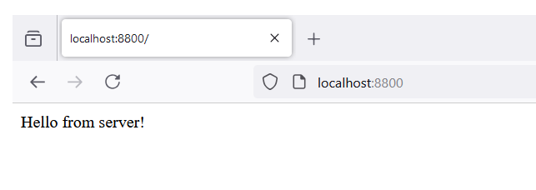
In this recipe (4_2_simple_http_server.py), created CustomHTTPServer class inherited from the HTTPServer class. In the constructor method, the CustomHTTPServer class sets up the server address and port received as a user input. In the constructor, our web server's RequestHandler class has been set up. Every time a client is connected, the server handles the request according to this class.
The RequestHandler defines the action to handle the client's GET request. It sends an HTTP header (code 200) with a success message ‘Hello from server!’ using the write() method.

References
- Chapter 4, Kathiravelu P., Sarker F., Python Network Programming Cookbook, Second Edition, Packt Publishing Ltd, 2017
- https://www.python.org/

