OS_Practice Homework

B0521229 林威廷

一、Set System Environment

在GUI的Windows XP上,按著講義步驟架設µC/OS-II環境,基本沒什麼問題,但還是有些瑣碎步驟要設,如Virtualbox 和 Host之間的一些便利性調整(安裝Guest Additions等)稍耗時間。

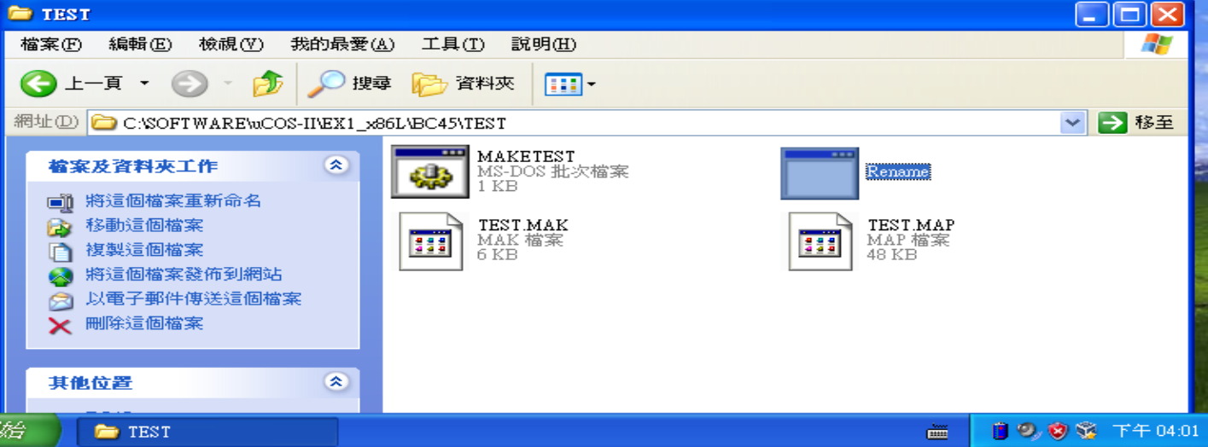

figure1. Rename TEST.EXE

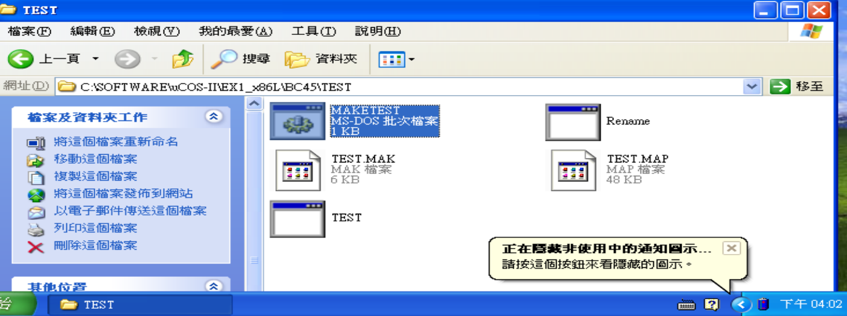

figure2. After Running MAKETEST.BAT(TEST.EXE appears again)

二、Extra Exercise

Application Source Code

Example 1:主要引導讀者

(1)如何初始化系統

(2)如何建立tasks

此範例共有13個tasks 包含了2個重要的Kernel tasks:(1)Idle task(which executes when no other task is ready to run) (2)statistic task(which computes CPU usage), 而另外11個tasks為user tasks:隨機在螢幕上印出0-9的數字

main() function之important functions

1.OSInit():初始化µC/OS-II內部架構環境

2.PC_DOSSaveReturn():allows you to return to DOS

3.PC_VectSet(......):install the context switch handler

4.OSSemCreate():A binary semaphore is created to guard access to the random-number generator

5.OSTaskCreate():Create User tasks and use the given arguments to set attribution ofeach task

重要步驟

1. OSInit():初始化µC/OS-II

2. PC_DOSSaveReturn():儲存DOS狀態

3.OSStart():啟動µC/OS-II

4.PC_DOSReturn():multitasking is halted,application return to DOS(not main(),但在嵌入式系統環境下無意義)

Example 2:主要介紹

(1)增加create task的設定: OSTaskCreateExt()

(2)Stack使用在各task上

(3)浮點數計算

(4)MailBox

說明

(1)OSTaskCreate()=>OSTaskCreateExt():

Modified the stack and also because we want to check the stack size of each task at run time.

(2)Stack usage on each task

Local variables、ISR等會用到stack

OSTaskStkCheck()=>檢查stack有無overflow

(3)OSTaskStkInit_FPE_x86(&ptos)

Modified the top-of-stack、bottom-of-stack pointer,also modified the size of the stack

task needs FP operations=>stack space should be reserved

(4)Mailbox(可用於同步)=>exchange data among tasks

A mailbox allows a task or an ISR to send a pointer to another task

Example 3:主要介紹

(1)message queues

(2)Hook function

說明

(1)message queue=>mail box之強化版

A message queue is like a mailbox except that instead of sending a single pointer,a queue can hold more than one message

OSQPost(): A message is appended to the queue

OSQPend():A message is removed from the queue

(2)Hook function=>(user program event handler),and is called by µC/OS-II

EX:task switch hook:OSTaskSwHook():context switch發生時 此函式都會被呼叫

Example 4

三角函數計算範例示範