**OSP-Lab1-Bonus-B0521229**

Set Up an NFS on my ubuntu 16.04(lots of pics=>lots of pages)

## Prerequisites

## lab1-pre.jpg

server: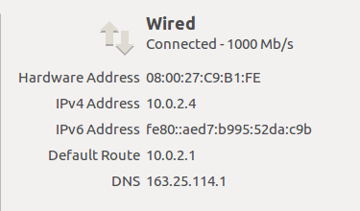client: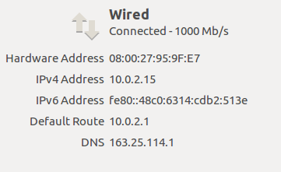

**Step 1 — Downloading and Installing the Components**

Server$ sudo apt-get install nfs-kernel-server

Client$ sudo apt-get install nfs-common

## Step 2 — Creating the Share Directories on the Host

## Server$ sudo mkdir /var/nfs/general –p

## NFS will translate any root operations on the client to the nobody:nogroup credentials as a security measure. Therefore, we need to change the directory ownership to match those credentials

## Server$ sudo chown nobody:nogroup /var/nfs/general

## Step 3 — Configuring the NFS Exports on the Host Server

## Server$ sudo gedit etc/exports

## We’ll dive into the NFS configuration file to set up the sharing of these resources(On Server Side)

## lab1-1.jpg

## to make the shares available to the clients that you configured, restart the NFS server with the following command:

## Server$ sudo systemctl restart nfs-kernel-server

## Step 4 — Adjusting the Firewall on the Host

## Server$ sudo ufw allow from 10.0.2.15 to any port nfs

## lab1-2.PNG

## where 10.0.2.15 is client IP

## Step 5 — Creating the Mount Points on the Client

## Now that the host server is configured and serving its shares, we’ll prepare our client.

## Client$ sudo mkdir –p /nfs/general

## Step 6 — Mounting the Directories on the Client

## Client$ sudo mount 10.0.2.4:/var/nfs/general /nfs/general

## Client$ df –h

## result:lab1-3.jpg

## Step 7 — Testting NFS Access

## Next, let’s test access to the shares by writing something to each of them.

## The general purpose share:

## First, write a test file to the /var/nfs/general share:

## Client$ sudo touch /nfs/general/hello.test

## Then, check its ownership:

## Client$ ls-l /nfs/general/hello.test

## lab1-4.PNG

Because we mounted this volume without changing NFS’s default behavior and created the file as the client machine’s root user via the sudo command, ownership of the file defaults to nobody:nogroup.

**Step 8 — Mounting the Remote NFS Directories at Boot (Permanently)**

Client$ sudo gedit /etc/fstab

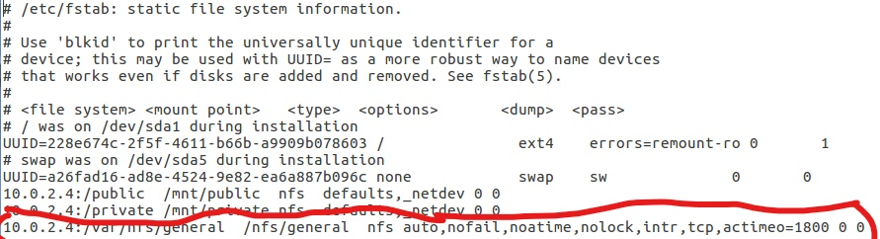

**Step 9 — Unmounting an NFS Remote Share**

No longer want the remote directory to be mounted on your system, you can unmount it by moving out of the share’s directory structure and unmounting

Client$ sudo umount /nfs/general

Client$ df –h

remove the remote shares, leaving only my local storage accessible

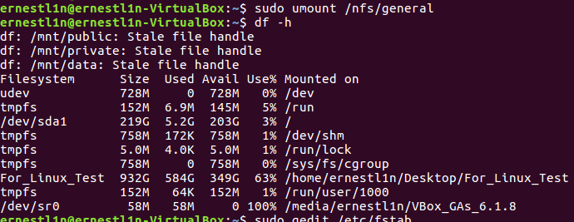

**Reference:** <https://www.digitalocean.com/community/tutorials/how-to-set-up-an-nfs-mount-on-ubuntu-16-04#step-7-%E2%80%94-testing-nfs-access>