**Core Network Technology of Internet of Things Homework 1**

授課:蘇銓清老師 學生:林威廷

Question: Please calculate the zigbee node addresses in the figure according to the cskip algorithm

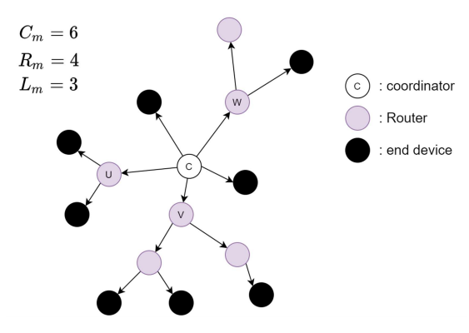

Fig.1

I then convert the original zigbee topology(Fig.1) to tree structure(Fig.2) as follow(mark with number!!!!!):

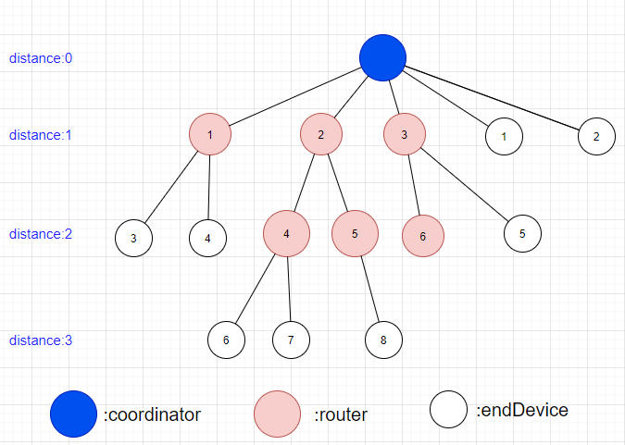

Fig.2

Definition of my code:

一、The key point I want you to realize is the initialization of my input,which there exists “null” in it.

There are two conditions where null appears:

1. while the node has no childern anymore,I separate this condition with a “null”

2. If the node has no childern,I declare this condition with a “null” as well

二、Then I build a class node(coordinator、router、endDevice all fit),which has function to compute its Cskip value and Address of that node(Actually endDevices don’t have to compute Cskip value)

三、Finally I use the level order traversal(with queue implementation) to traverse all nodes then print out all its depth、Cskip value、and Address

