**Explain reconsilers in react using bulllet point tables and charts**

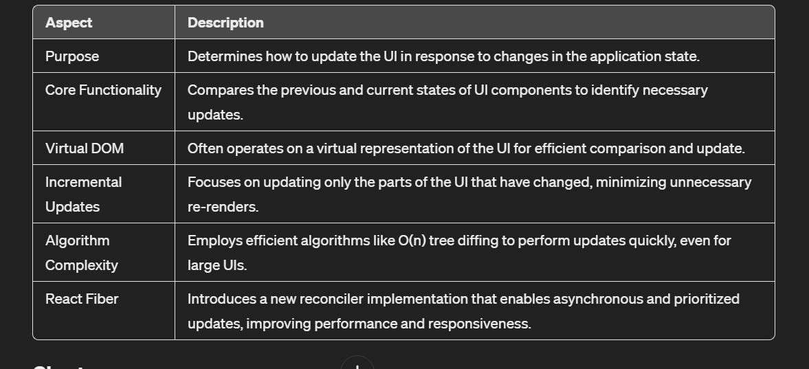

The reconciler's core functionality includes tree diffing and determining incremental updates.

These aspects collectively contribute to efficient UI updates in React applications.

ORMs

| **Aspect** | **Description** |
| --- | --- |
| Definition | ORM is a programming technique for converting data between incompatible type systems, namely object-oriented programming languages and relational databases. |
| Components | - Entities/Models: Represent database tables as classes in the application code.<br>- Attributes/Fields: Represent columns in database tables as properties of the entity classes.<br>- Relationships: Represent associations between tables as relationships between entity classes. |
| Process | - Mapping: Establish a mapping between entities and tables, attributes and columns, and relationships between tables.<br>- CRUD Operations: Perform CRUD (Create, Read, Update, Delete) operations on objects, automatically translated into SQL queries.<br>- Querying: Write queries using an object-oriented syntax provided by the ORM framework, translated into SQL queries and executed against the database.<br>- Transactions: Manage database transactions using methods provided by the ORM framework to ensure data consistency and integrity. |
| Advantages | - Simplified Development: Work with objects and classes, reducing the need to write complex SQL queries.<br>- Database Portability: Ability to switch between different database systems without major code changes.<br>- Productivity: Reduced amount of boilerplate code, leading to faster development and fewer errors.<br>- Security: Built-in security features such as parameterized queries to prevent SQL injection attacks. |
| Disadvantages | - Performance Overhead: May introduce overhead in terms of query execution time and memory consumption compared to handwritten SQL queries.<br>- Learning Curve: Developers need to learn the ORM framework's API and conventions, which may have a steep learning curve.<br>- Limited Control: Abstraction of SQL queries may limit fine-grained control over database operations. |