Kerman Space Systems
125 cm fairings and payload bays
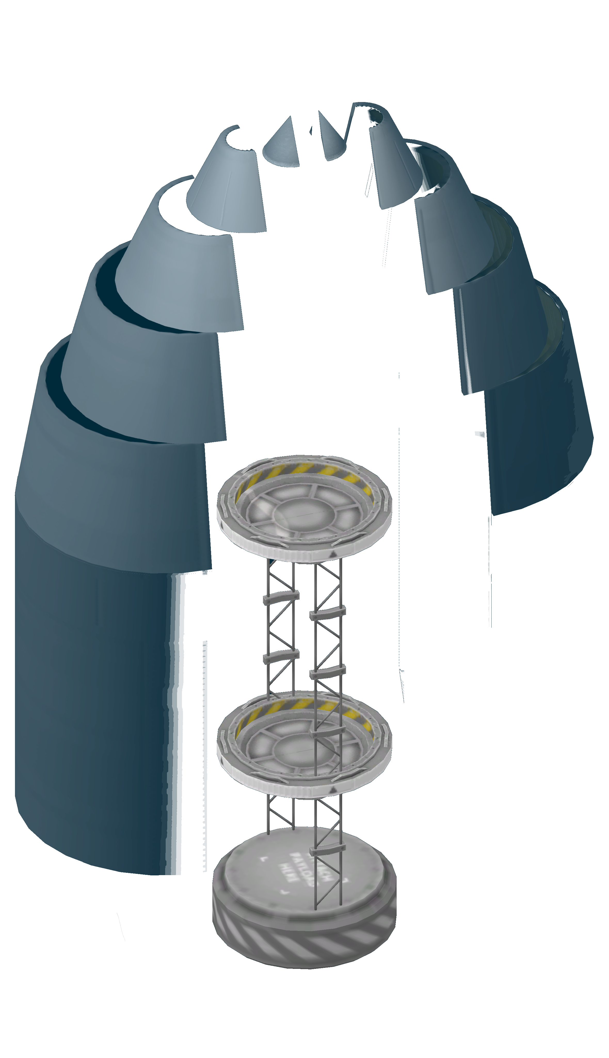
Table of Contents
Single payload bay 3
Dual payload bay 3
Type A payload fairing 4
Type B payload fairing 4
Type C payload fairings 4
Fairing blueprint interpretation guidelines 5
Type A1 fairing blueprints, single launch 6
Type A1 fairing blueprints, dual launch 7
Type A2 fairing blueprints, single launch 8
Type A2 fairing blueprints, dual launch 9
Type A3 fairing blueprints, single launch 10
Type A3 fairing blueprints, dual launch 11
Type B1 fairing blueprints, single launch 12
Type B2 fairing blueprints, single launch 13
Type B2 fairing blueprints, dual launch 14
Type C1 fairing blueprints, single launch 15
Type C1 fairing blueprints, dual launch 16
Type C2 fairing blueprints, single launch 17
Type C2 fairing blueprints, dual launch 18
Type C3 fairing blueprints, single launch 19
Type C3 fairing blueprints, dual launch 20
Test data 21
Test report: test#4 23
Test type 23
Payload 23
Failure type 23
Root cause 23
Corrective measures 23
Test re-run 24
Test report: test #7 25
Test type 25
Payload 25
Failure type 25
Root cause 25
Corrective measures 26

Single payload bay
- Includes 1 metre avionics bay
- Single payload bay, limited by fairing size
- Compatible with 125 and 62.5 cm payload axial attachments
- Attaches to 125 cm axial interface
- Avionics bay size is adjustable

Dual payload bay
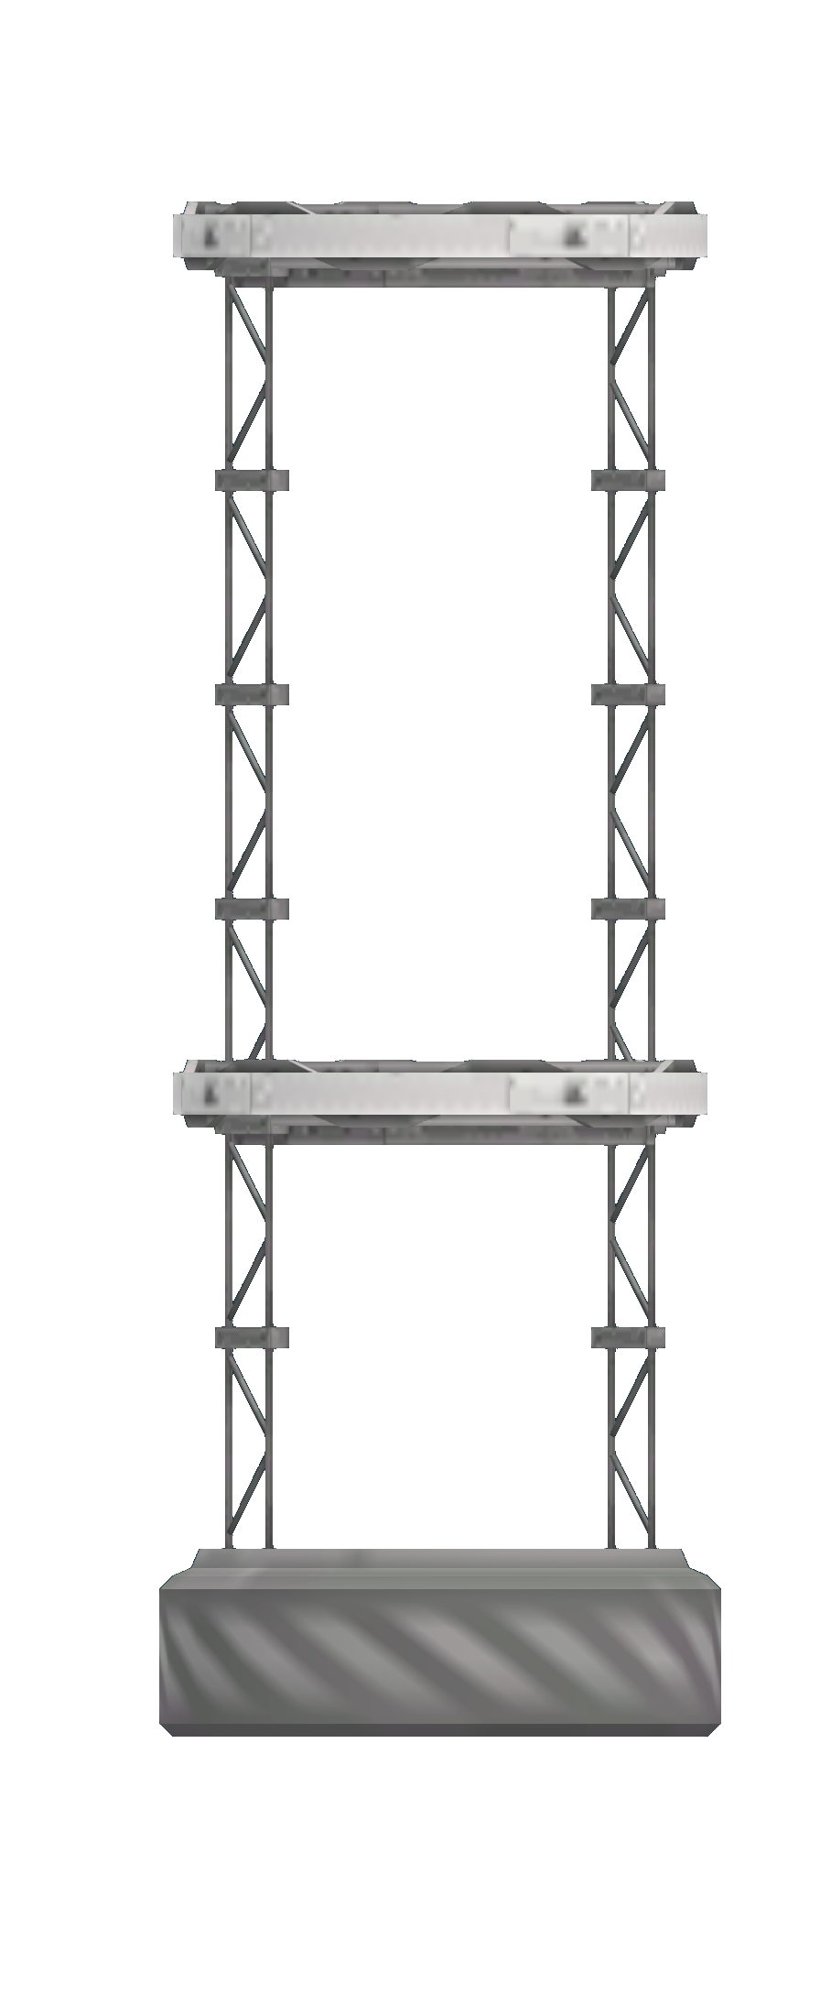
- Includes 1 metre avionics bay
- Two payload bays
- Compatible with 125 and 62.5 cm payload axial attachments
- Lower 190 cm high payload bay
- Zero ejection force decoupler in lower bay
- Upper payload bay is limited only by fairing size
- Upper payload bay uses decoupler to minimise debris creation
- Avionics bay size is adjustable and can be reduced to increase space in the lower payload bay
- Separator option for upper bay to simplify deployment

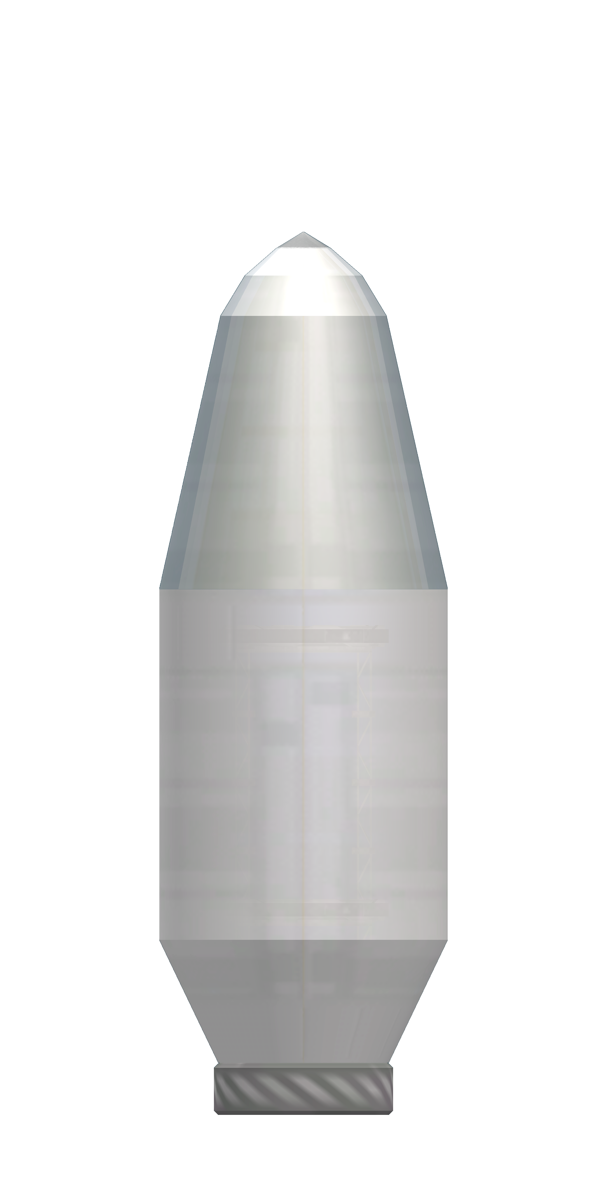
Type A payload fairing
- Straight fairing with angled, rounded nose cone
- 3 different sizes
- Types A2 and A3 support dual launches
- Type A1 supports miniature upper payload
- Soyuz ST/Ariane 4/Long March 3 analogue
- Splits in 3 sections on deployment

Type B payload fairing
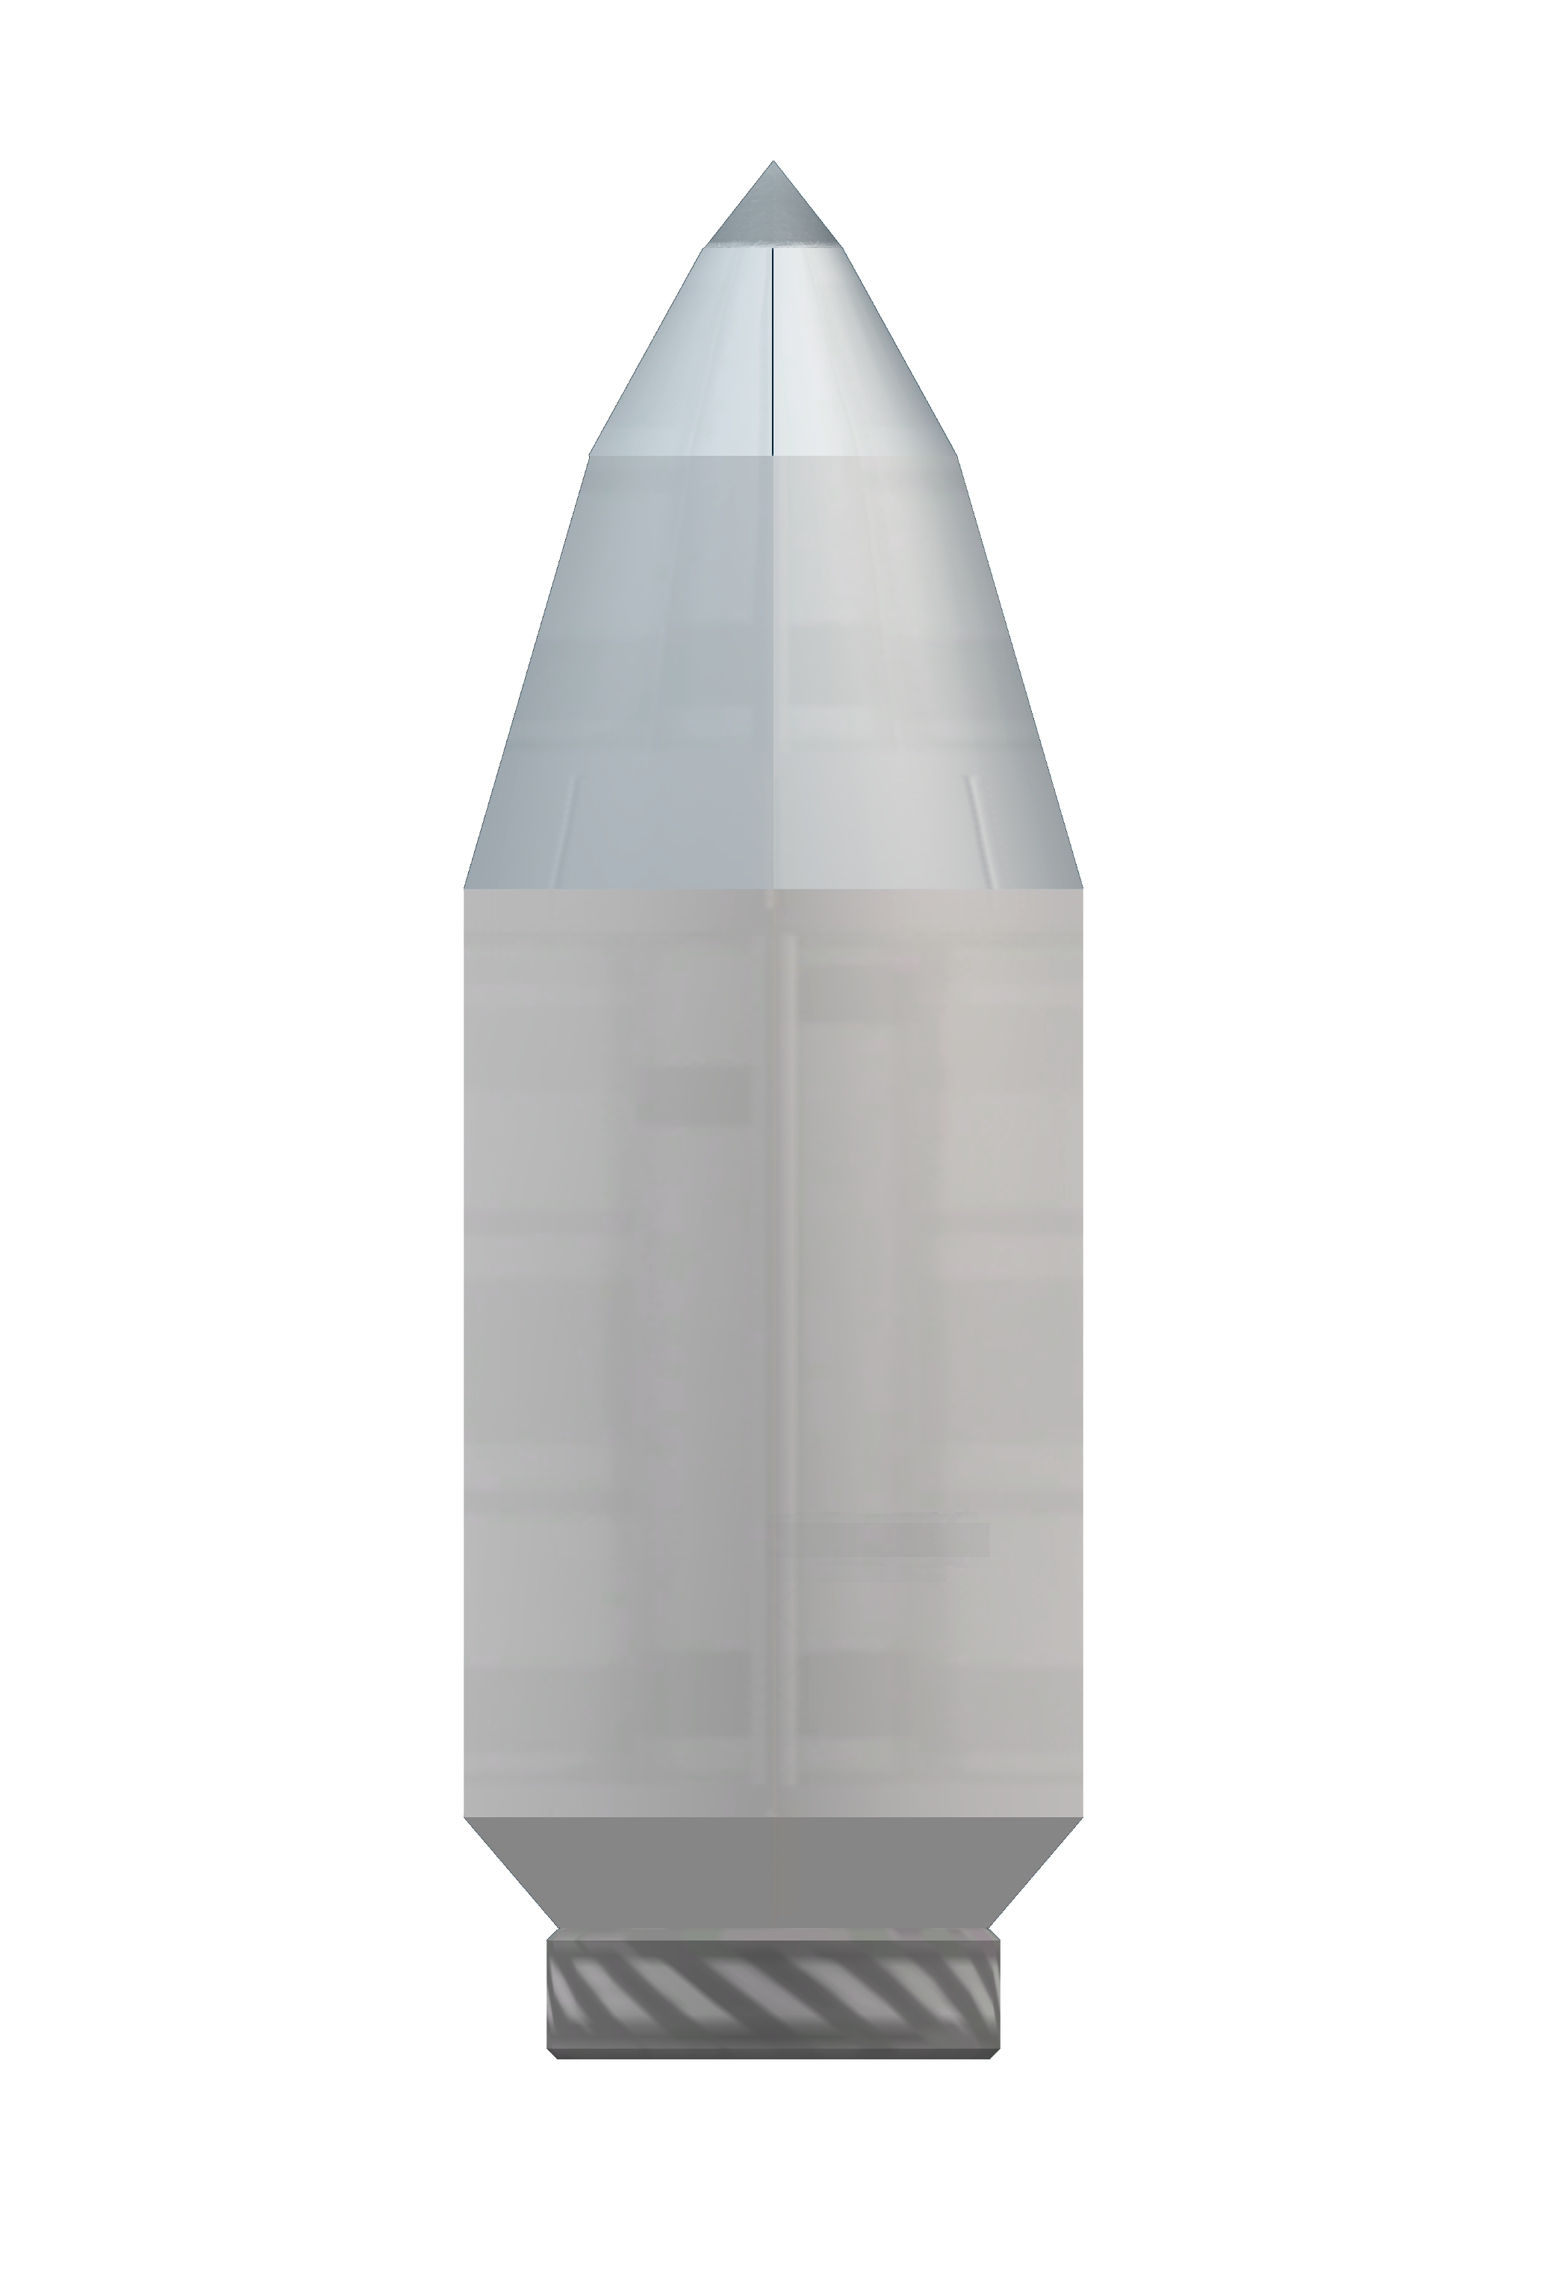
- Straight fairing with pointed nose cone
- 2 different sizes
- Type B2 supports secondary upper payload
- Soyuz S/Titan 3/Atlas 5-400 analogue
- Splits in four when deployed

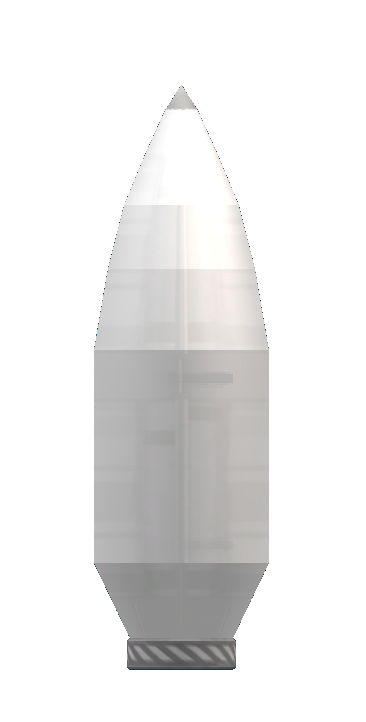
Type C payload fairings
- Fairing with ogival nose cone
- 3 different sizes
- All variants support dual payloads
- Falcon 9/Atlas 5-500/Vega analogues
- Splits in two when deployed

Fairing blueprint interpretation guidelines
Each blueprint contains an outline of the fairing and payload bay being described. Marked over this outlines are lines indicating the fairing diameter. To the left of the outline, markers indicate the height of different payload sections. The left markers show the fairing’s physical characteristics. Dimensional data for each fairing section can be derived by combining the left markers with the diameter markings.
To the right, a series of markers show all heights relevant to payload integration and handling. The right markers show the size of the avionics and payload bays, including decouplers. The right markers indicate, from bottom to top:
- Avionics bay size
- Lower/single bay decoupler size
- For dual launches, lower payload bay size
- For dual launches, upper bay decoupler
- Upper bay size, up to 1250 mm diameter
- Upper bay size, up to 625 mm diameter
The last two markers may not have a corresponding diameter marker over the blueprint. The diameter of the fairing at those points can be assumed to be as specified above.
All sizes are in millimetres. Fairing starts 50 mm below the attachment point of the fairing base.
Payload bay mass is 80Kg for dual bays and 40Kg for single bays. Fairing mass is shown below.
Type | Mass (Kg)
A1 | 329
A2 | 424
A3 | 491
B1 | 267
B2 | 323
C1 | 369
C2 | 436
C3 | 502

Type A1 fairing blueprints, single launch
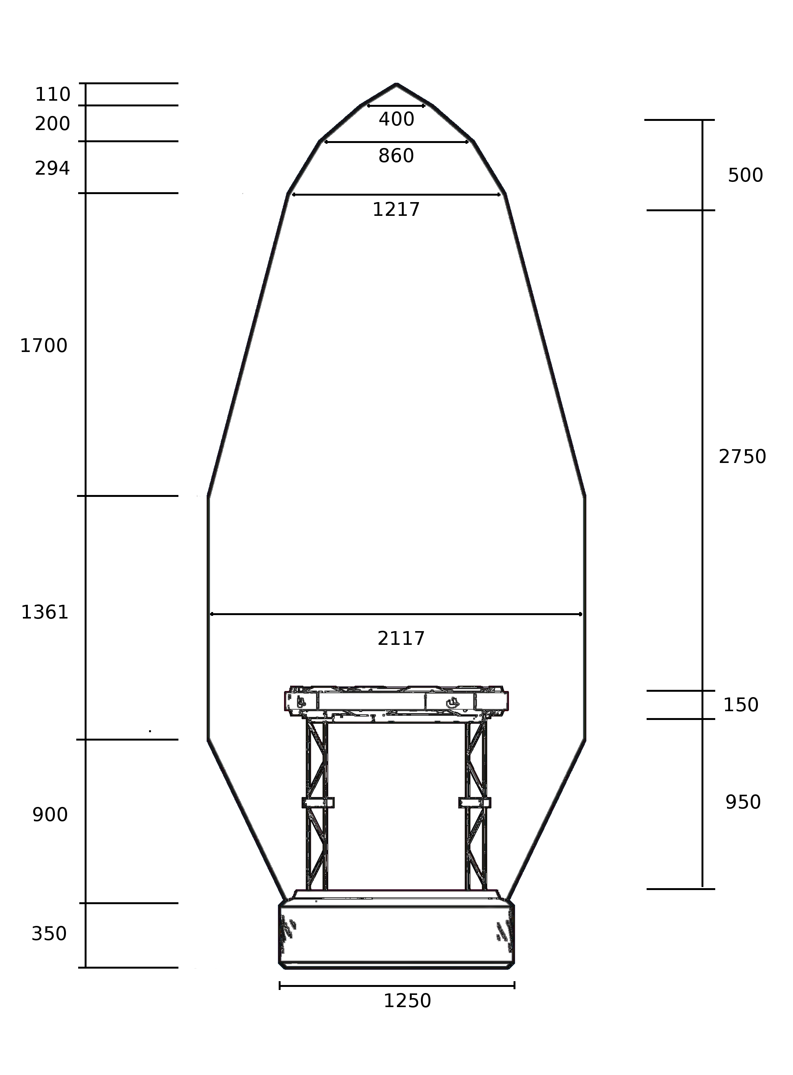

Type A1 fairing blueprints, dual launch

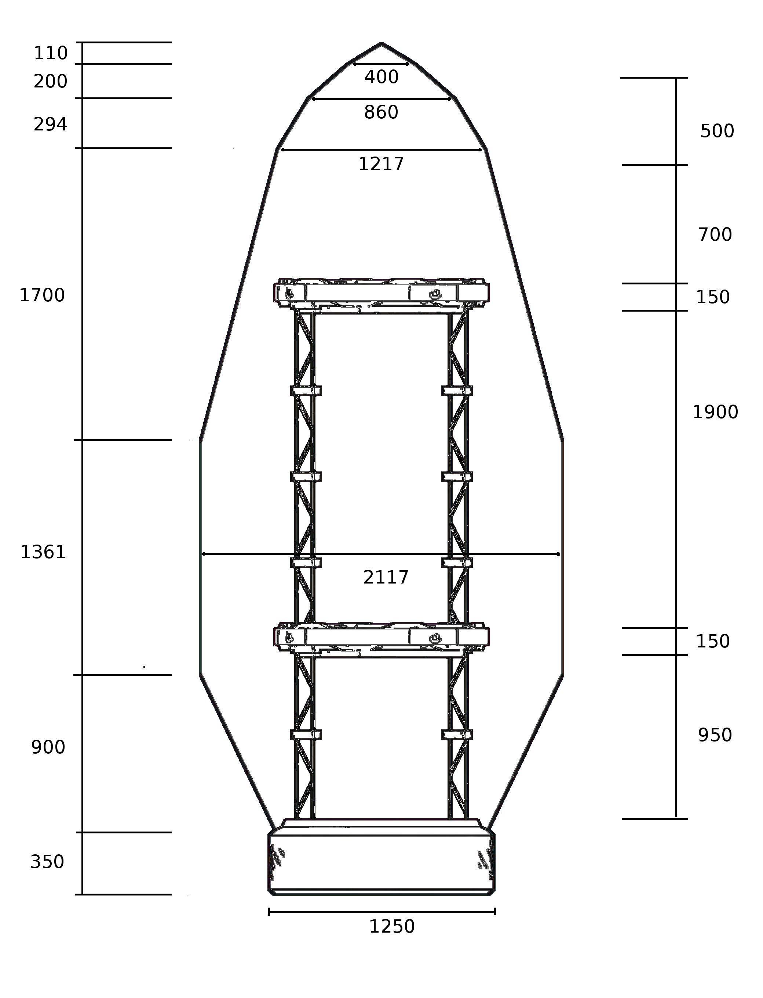

Type A2 fairing blueprints, single launch
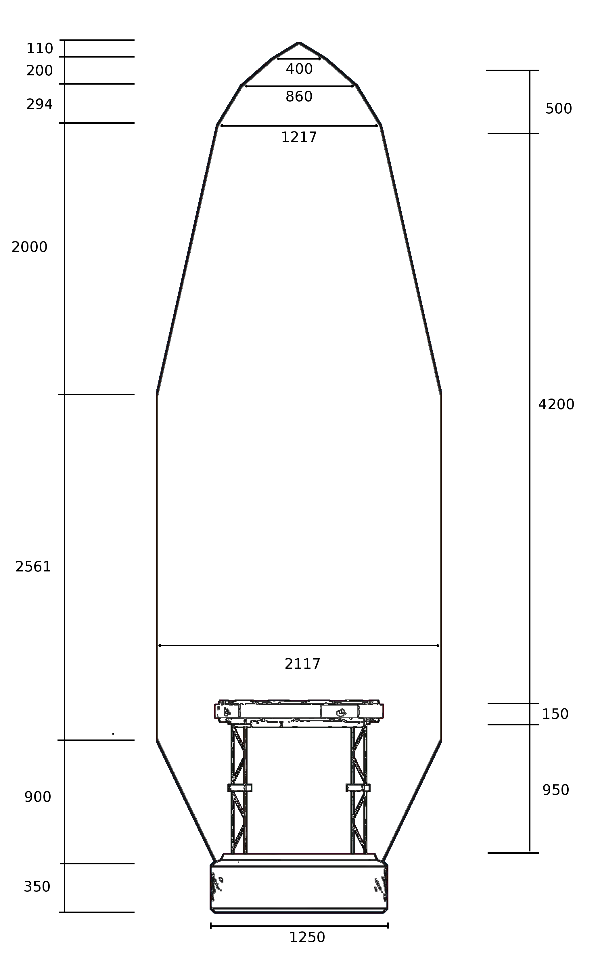

Type A2 fairing blueprints, dual launch

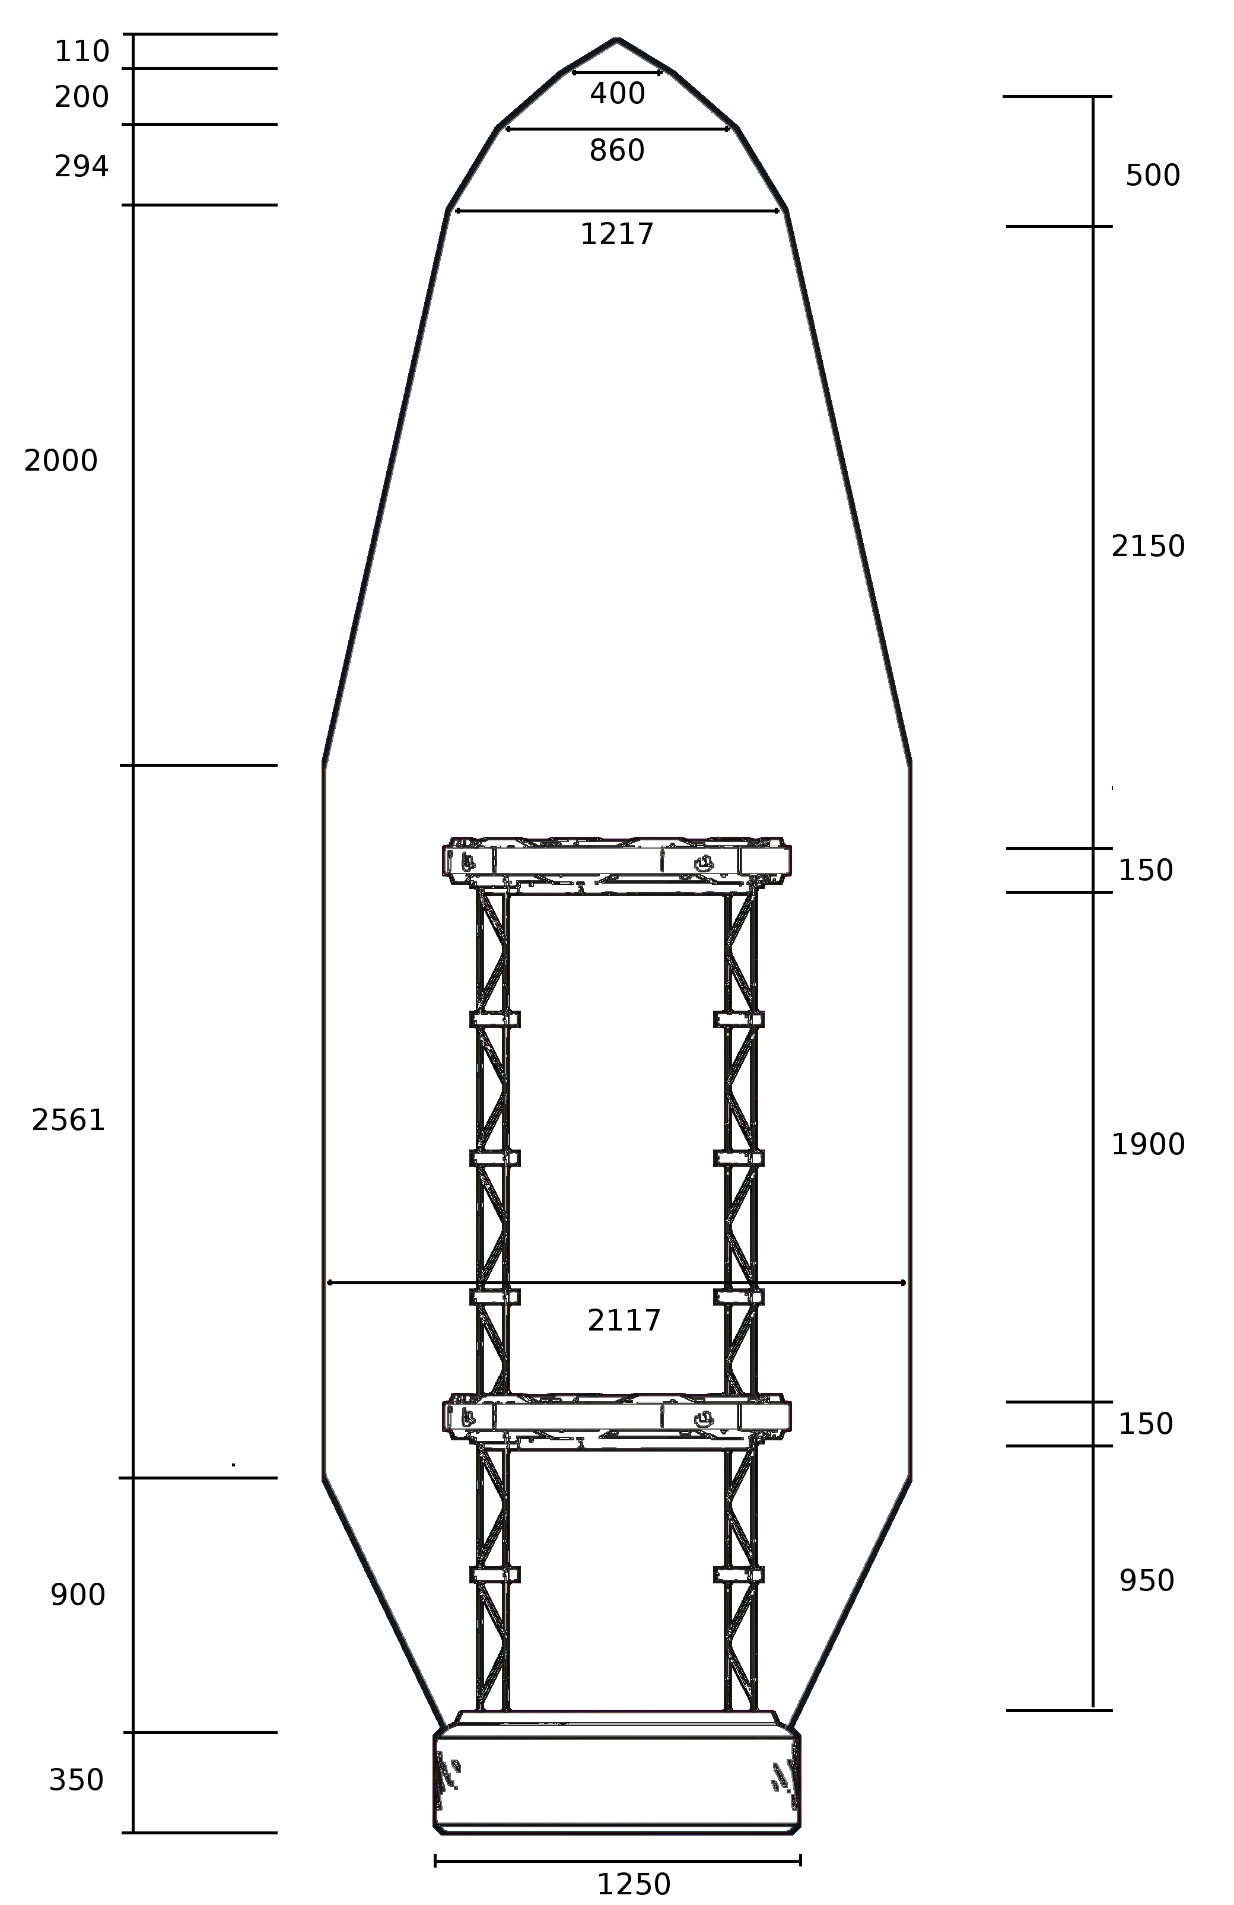

Type A3 fairing blueprints, single launch
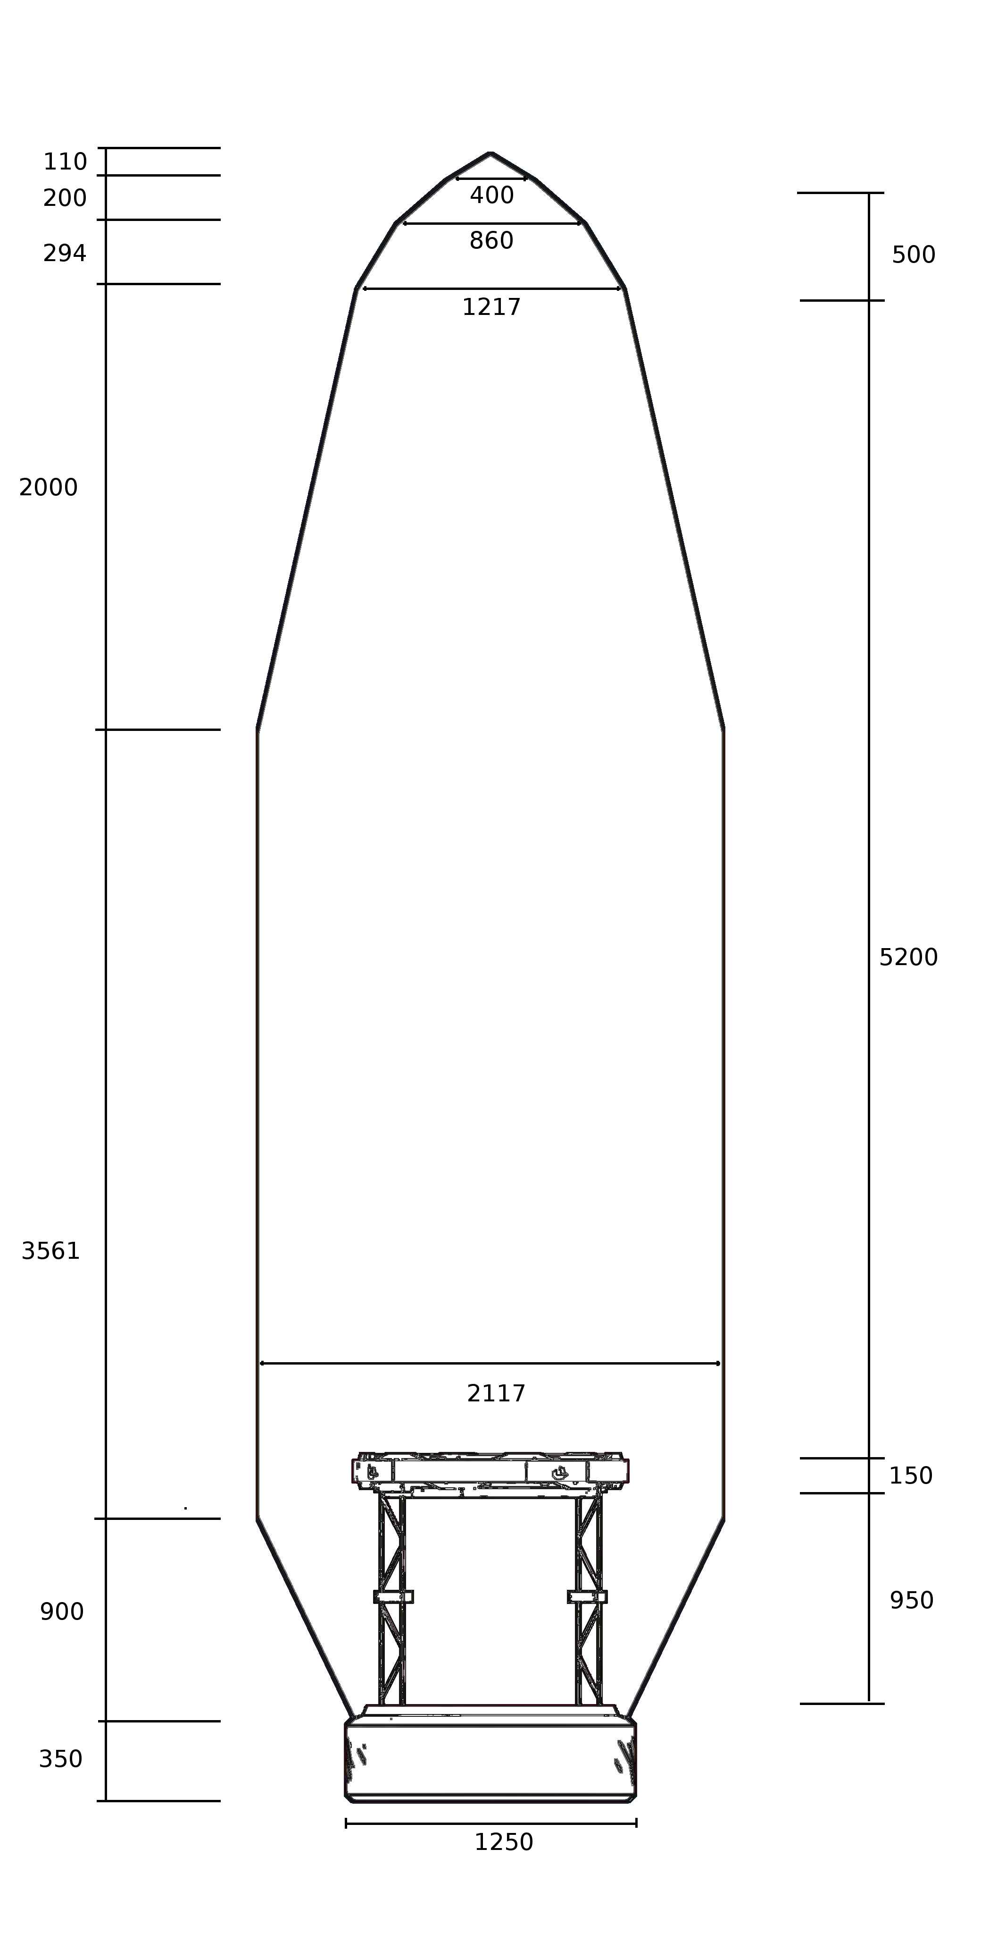

Type A3 fairing blueprints, dual launch
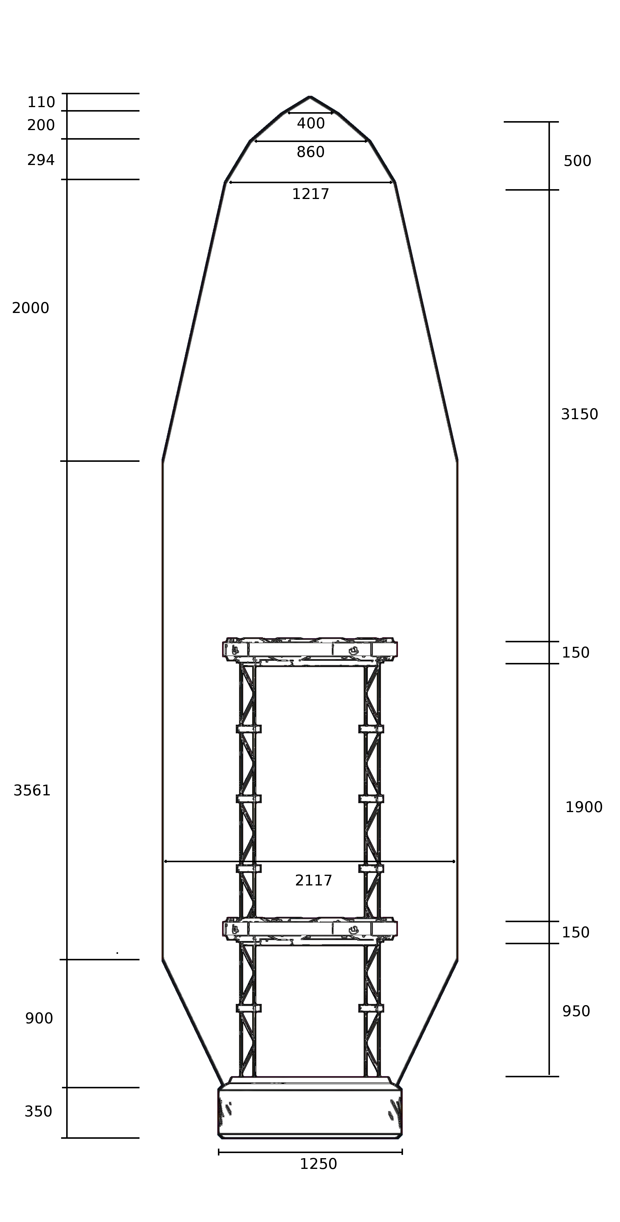

Type B1 fairing blueprints, single launch

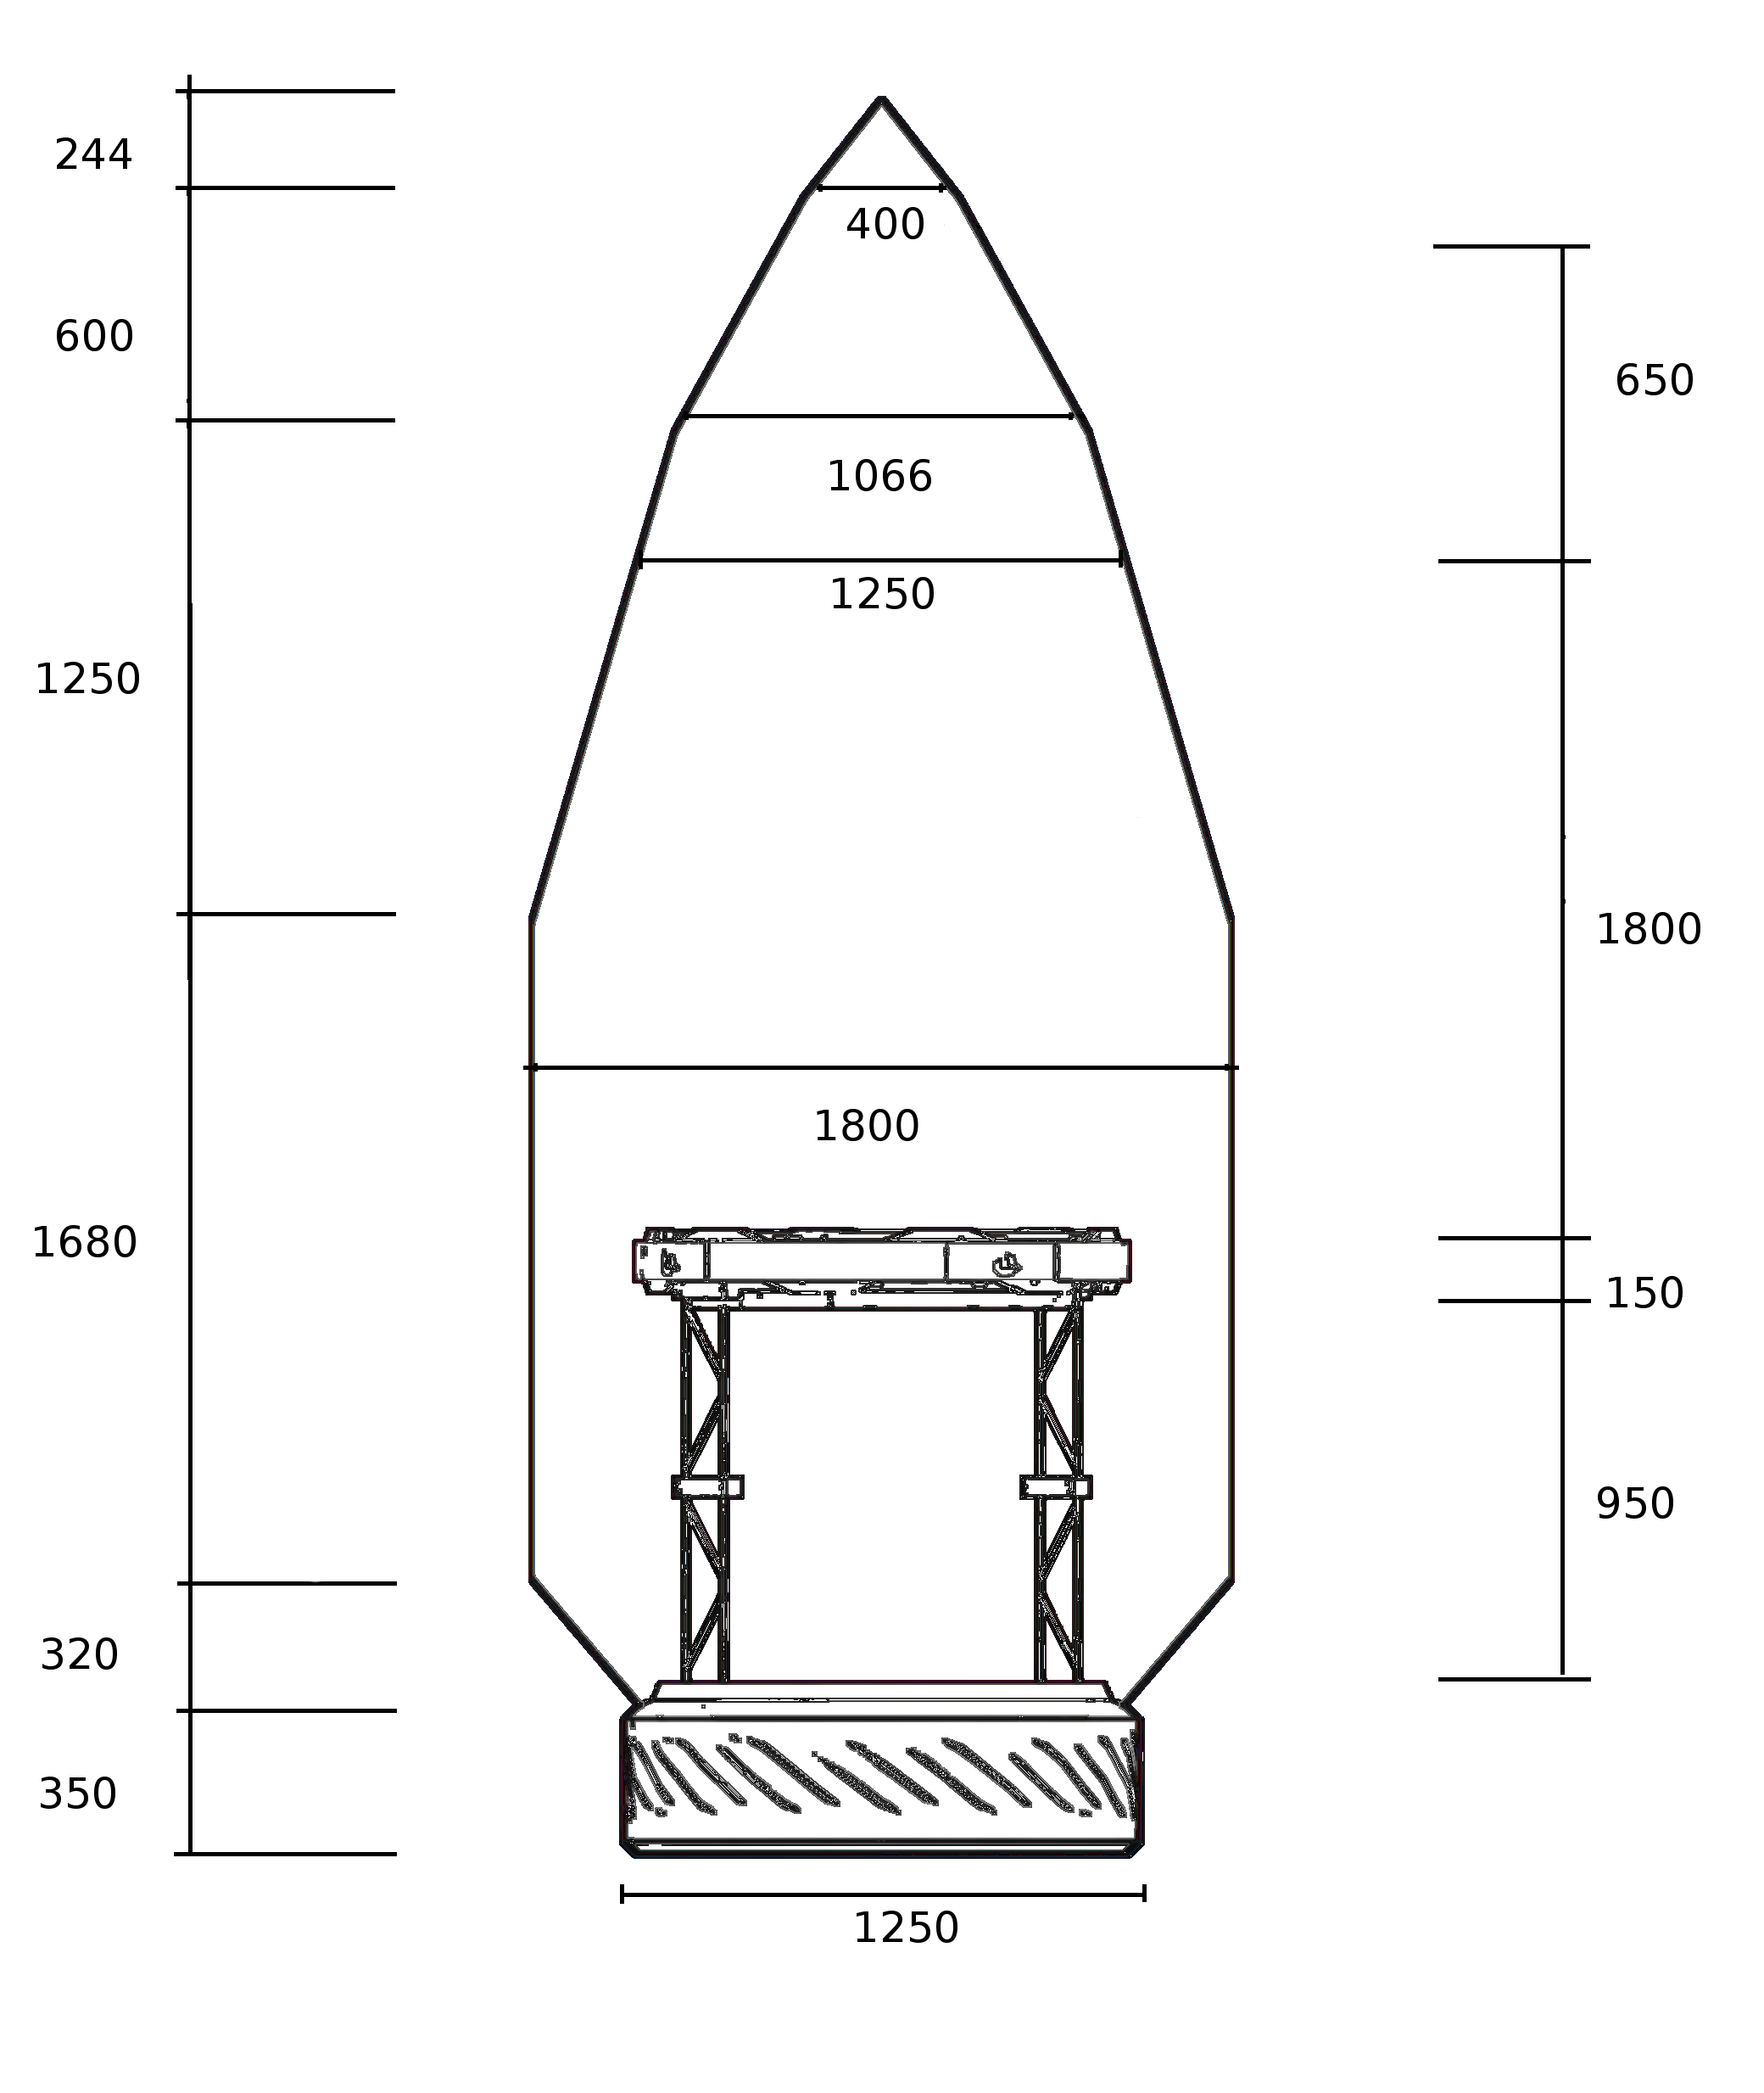

Type B2 fairing blueprints, single launch

Type B2 fairing blueprints, dual launch

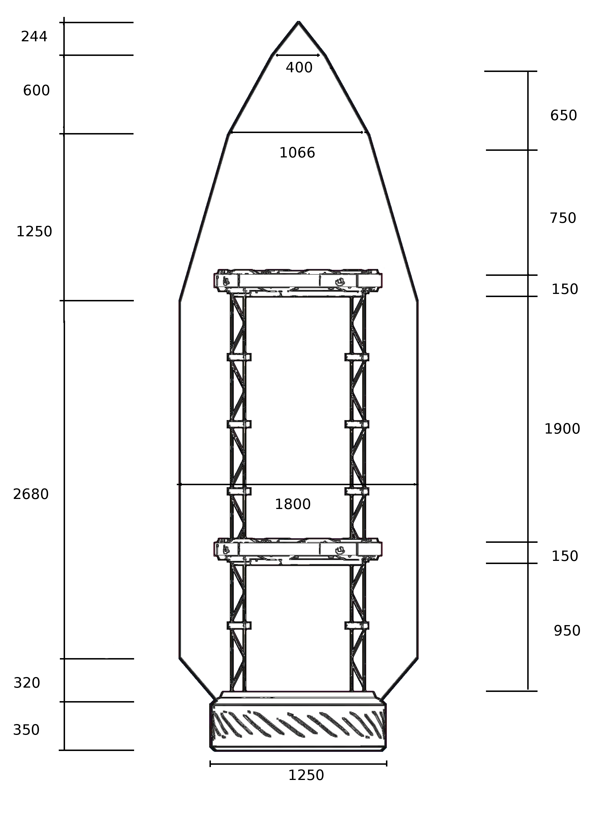

Type C1 fairing blueprints, single launch
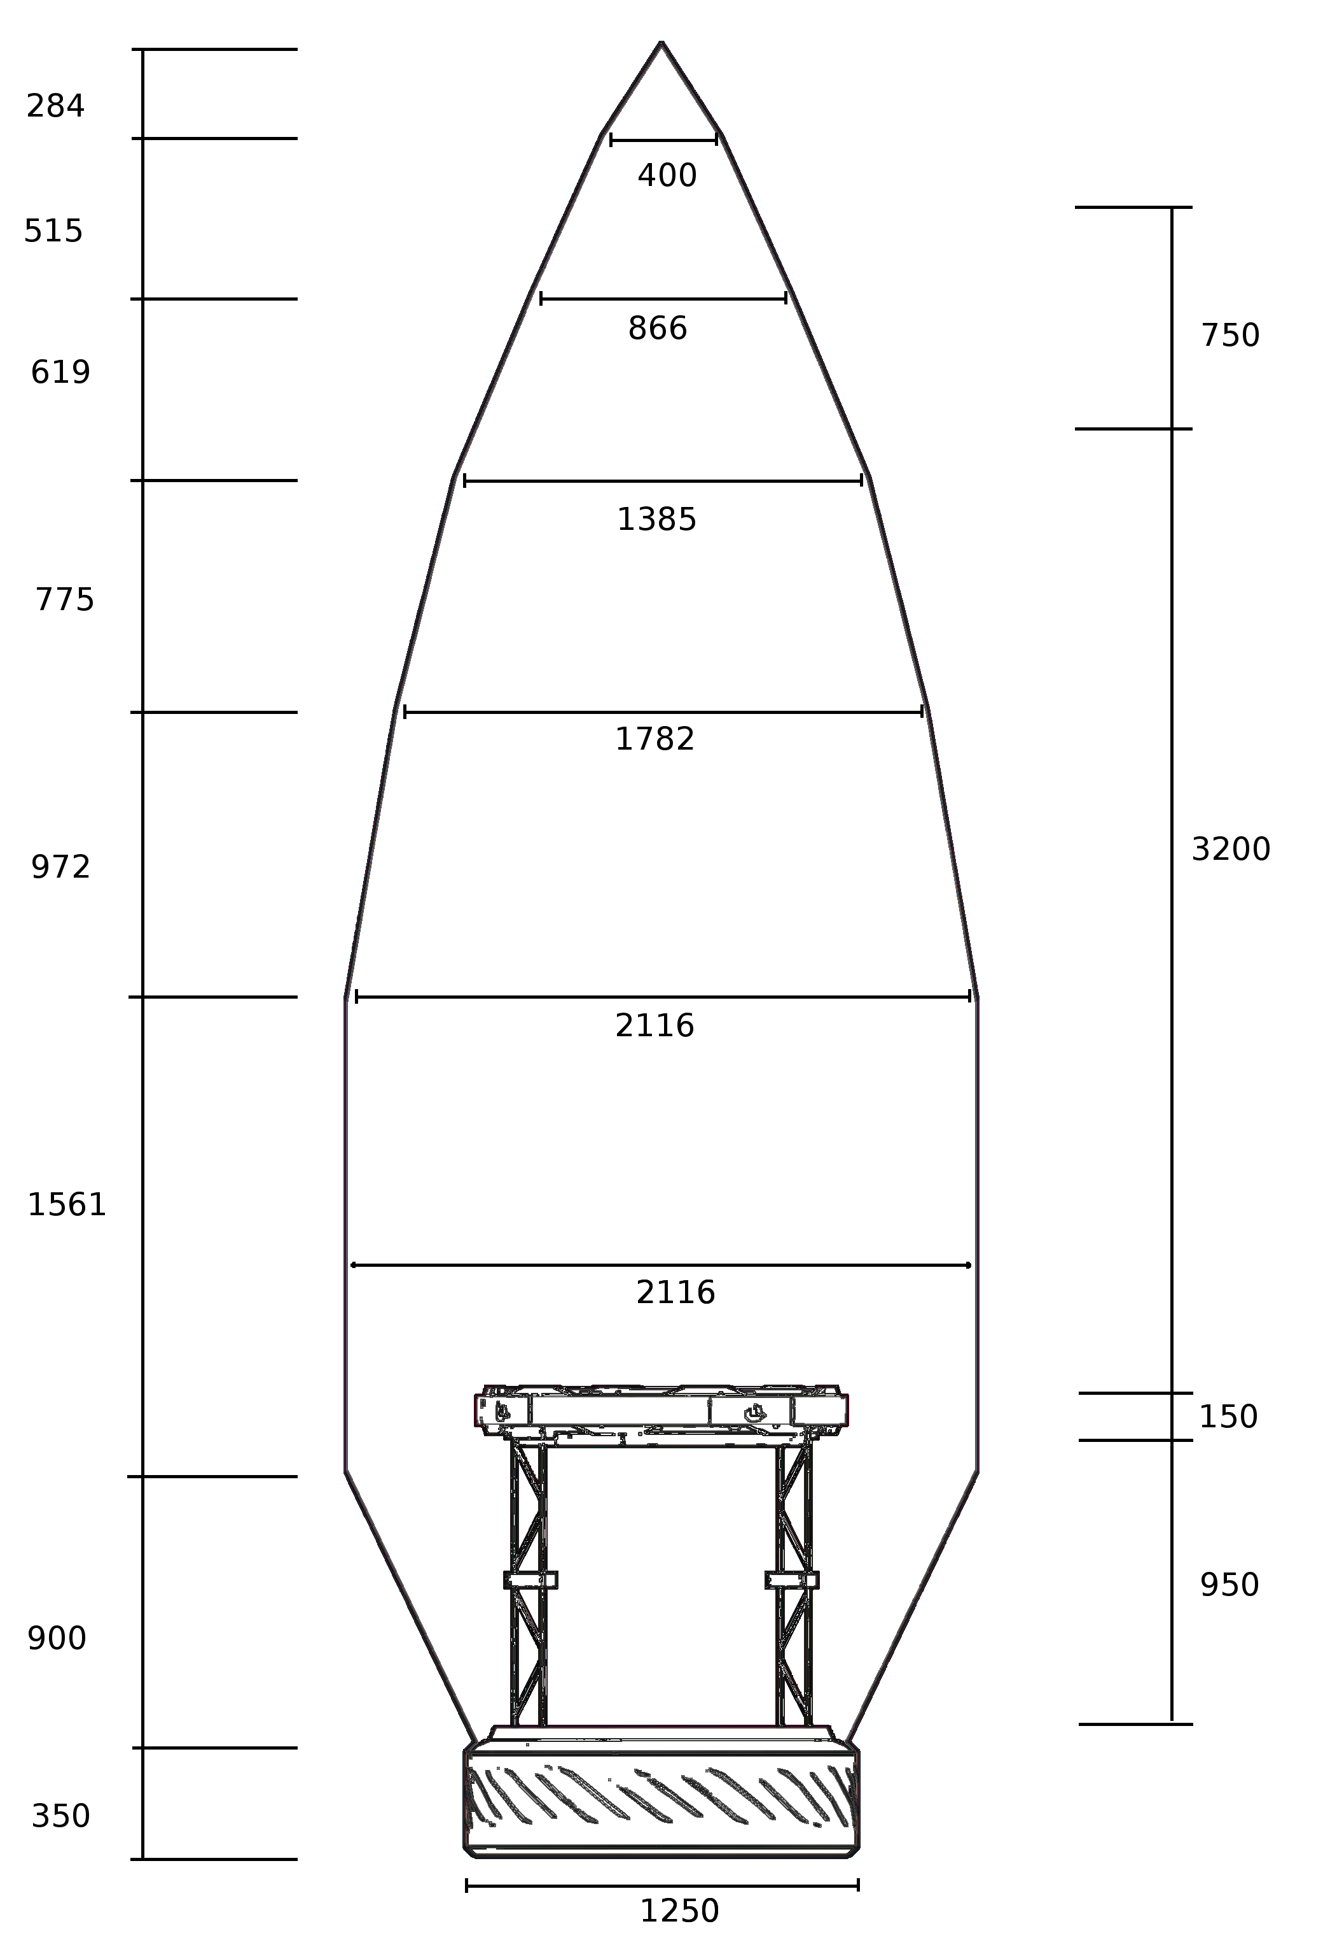

Type C1 fairing blueprints, dual launch
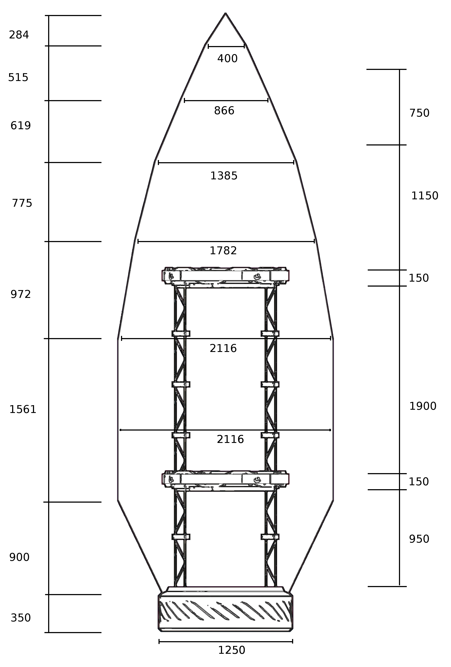

Type C2 fairing blueprints, single launch
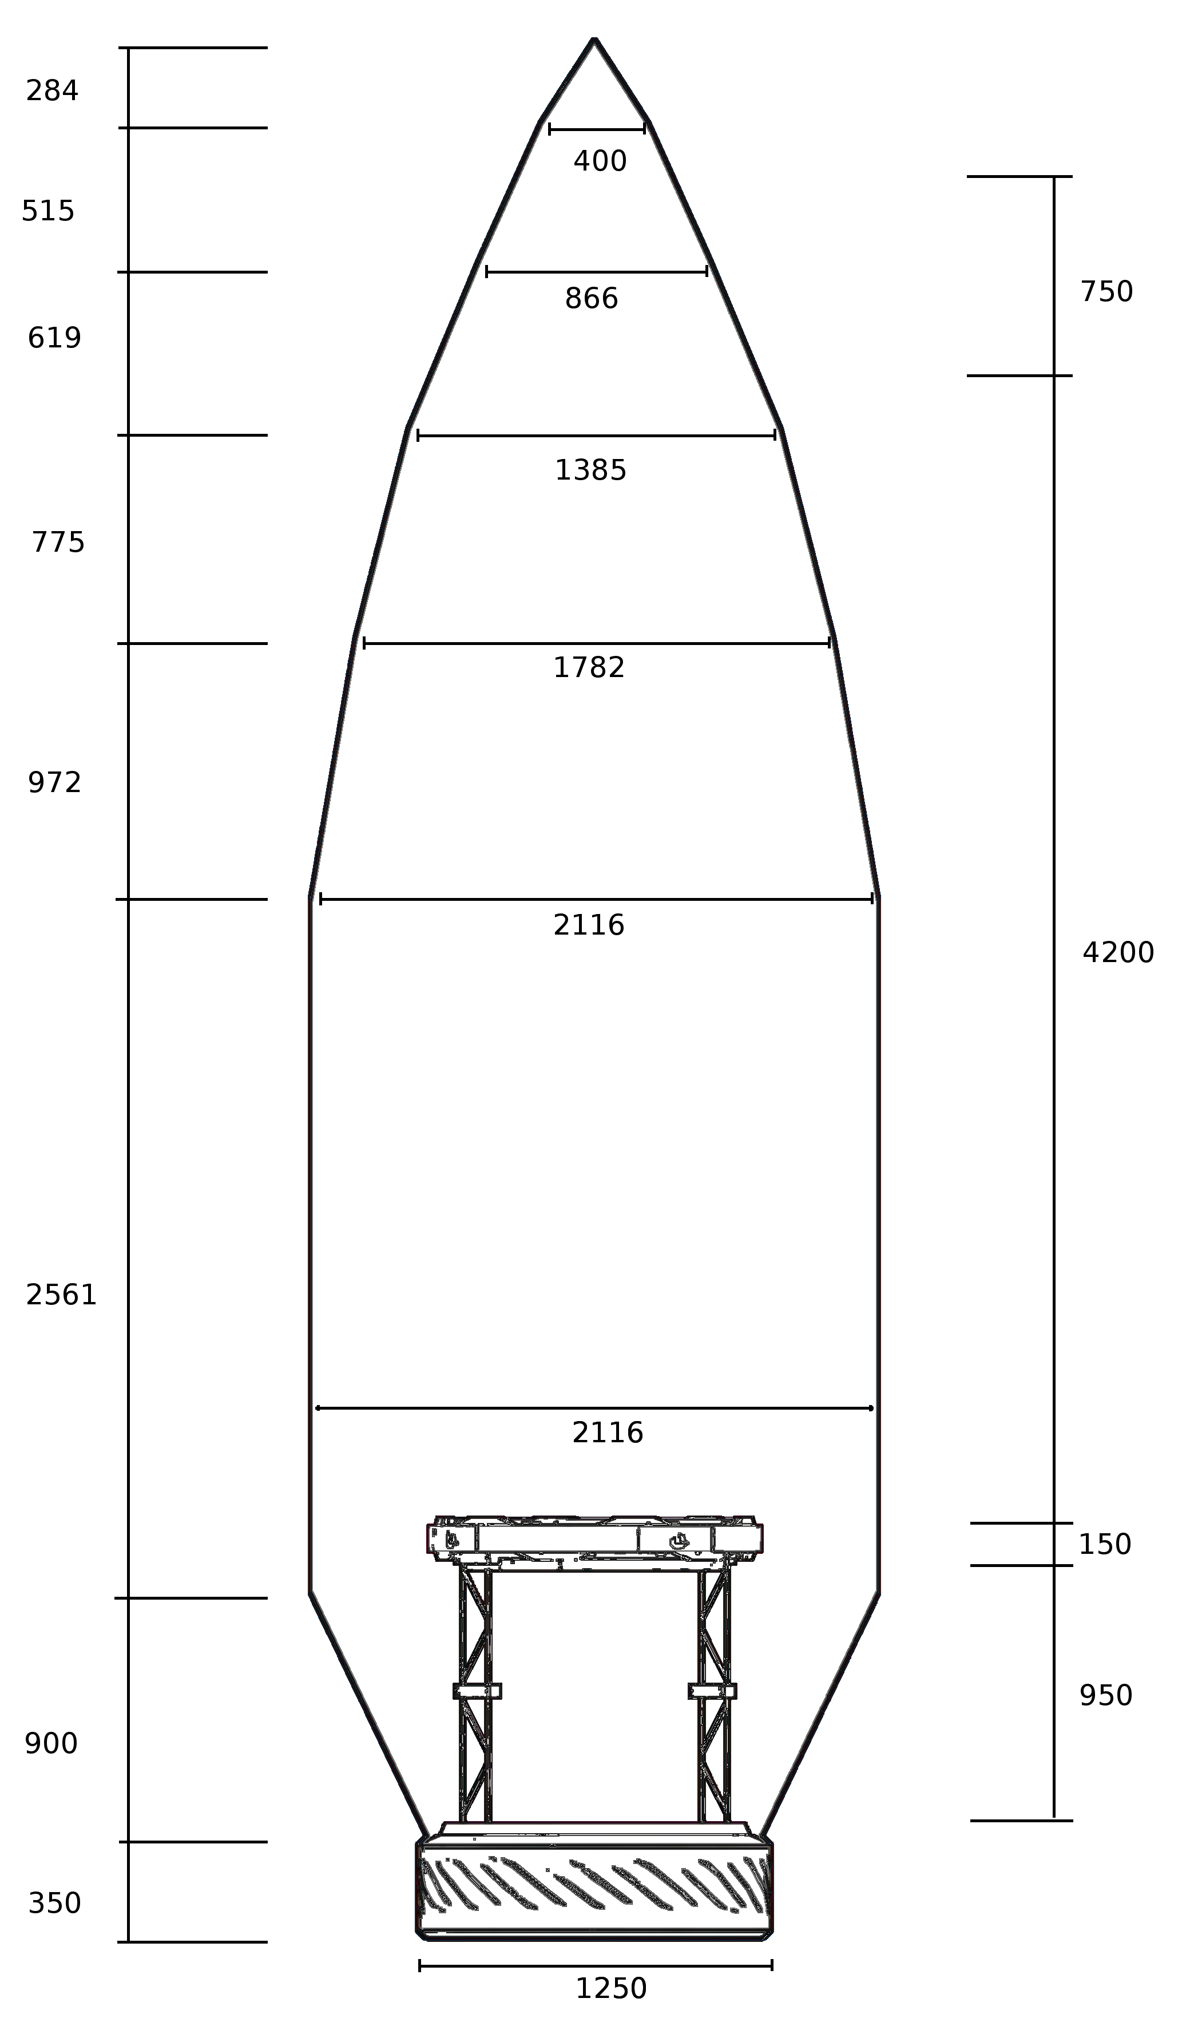

Type C2 fairing blueprints, dual launch
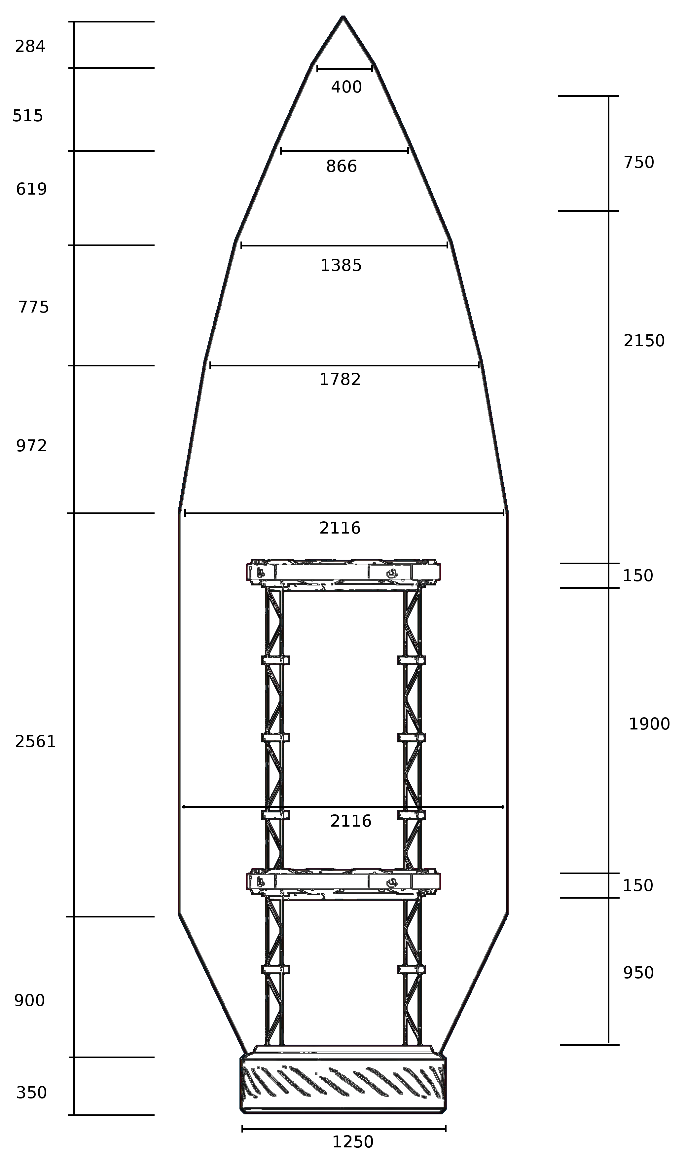

Type C3 fairing blueprints, single launch
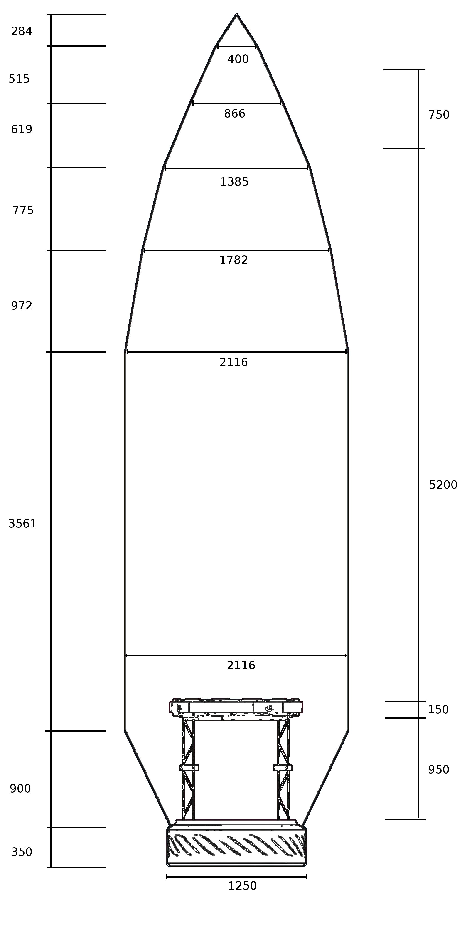

Type C3 fairing blueprints, dual launch
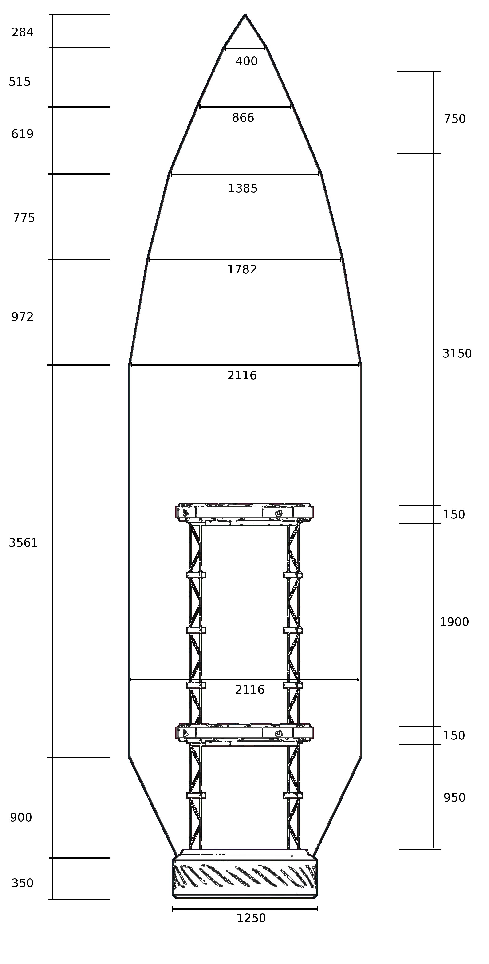

Test data
Type | Test type | Avionics | Lower Payload |  |  |  | Upper Payload |  |  |  | Notes | Result
Type | Test type | Avionics | Type | H | D | Mass | Type | H | D | Mass | Notes | Result
A1 | SINGLE | R3-H01Q2R | M1231 | 2200 | 900 | 620 | N/P | N/A | N/A | N/A | PL ejection on second attempt | PASS
A1 | CSM | None | AOC-3 | 2400 | 1600 | 2054 | N/P | N/A | N/A | N/A |  | PASS
A3 | DUAL | R3-H11Q0X | M1302 | 2200 | 1000 | 525 | M1301 | 3400 | 1500 | 1630 | Modified 1301 variant to fit | PASS
A2 | DUAL/STACK | R3-N11O0X | 2x M1402 | 1500 | 1100 | 780 | 2x M1108 | 2600 | 1200 | 1880 | Modified 1402 | FAIL, UPL antennas clipped
A2 | DUAL/STACK | R3-N11O0X | 2x M1402 | 1500 | 1100 | 780 | 2x M1108 | 2600 | 1200 | 1880 | Repeat of last test, shifted down | PASS
B1/2 | SINGLE | R3-H01O0X | AOC-1 | 2000 | 1400 | 1130 | N/P | N/A | N/A | N/A | Capsule + Av bay | PASS
B2/2 | CSM | None | AOC-2 | 3700 | 1400 | 2335 | N/P | N/A | N/A | N/A | Fairing stuck to capsule, wedged itself out | PARTIAL PASS
B1/2 | SINGLE | None | AOC-1 | 2000 | 1400 | 1130 | N/P | N/A | N/A | N/A | Capsule + Av bay | PASS
B2/2 | SINGLE | None | AOC-1 | 2000 | 1400 | 1130 | N/P | N/A | N/A | N/A | Capsule + Av bay | PASS
B1/2 | CSM | None | AOC-1 | 2000 | 1400 | 1130 | N/P | N/A | N/A | N/A | Snagged | PARTIAL PASS
B1/2 | CSM | None | AOC-1 | 2000 | 1400 | 1130 | N/P | N/A | N/A | N/A | With spacer between decoupler & heat shd | PARTIAL PASS
B2/2 | CSM | None | AOC-1 | 2400 | 1600 | 2054 | N/P | N/A | N/A | N/A | Snagged | PARTIAL PASS
B2/2 | CSM | None | AOC-3 | 2400 | 1600 | 2054 | N/P | N/A | N/A | N/A | Snagged and broke solar panels | FAIL
B1 | CSM | None | AOC-3 | 2400 | 1600 | 2054 | N/P | N/A | N/A | N/A | Design change, fairing now splits in 4 parts | PASS
B2 | CSM | None | AOC-2 | 3700 | 1400 | 2335 | N/P | N/A | N/A | N/A |  | PASS
B1 | SINGLE | R3-H01O1R | M1103 | 1300 | 1100 | 580 | N/P | N/A | N/A | N/A |  | PASS
B2 | SINGLE | R3-H01O1R | M1103 | 1300 | 1100 | 580 | N/P | N/A | N/A | N/A |  | PASS
C1 | CSM | None | AOC-3 | 2400 | 1600 | 2054 | N/P | N/A | N/A | N/A | Fairing initially snags, but reliably releases. Best result with 150% force | PASS
C1 | FIXED | None | M1401 | 1500 | 1000 | 490 | N/P | N/A | N/A | N/A |  | PASS
C2 | SINGLE | R3-H01O1R | M1301 | 4300 | 1500 | 1780 | N/P | N/A | N/A | N/A |  | PASS
C2 | DUAL | R3-H01O1R | M1103 | 1300 | 1100 | 580 | M1231 | 2200 | 900 | 620 |  | PASS
C3 | SINGLE | R3-H21O1X | M1301 | 4300 | 1500 | 1780 | N/P | N/A | N/A | N/A | Fairing snagged on wheel, then released | PASS
C3 | CSM/DUAL | None | AOC-3 | 2400 | 1600 | 2054 | M1302 | 2200 | 1000 | 525 | Fairing snags, then deploys | PASS

Test report: test#4

Test type
Dual launch, fairing A2.

Payload
2 x Model 1402 satellites (lower bay), 2 x model 1108 satellites (upper bay).

Failure type
Antennas stripped off upper payload during fairing deployment, both model 1108 satellites were stripped of antennas.

Root cause
Despite not clipping the outer fairing material, the antenna pivots were intersecting the inner, brown coloured, fairing liner. This caused at least one antenna to be torn apart, and the resulting debris impacted other antennas in the upper model 1108 device. Due to the way model 1108 units stack, the antenna dishes of the upper unit rest in close proximity of the antenna pivots of the lower unit. The debris resulting from the tirn antennas impacted the lower unit antenna pivots as well, tearing away the lower unit’s antennas as well.
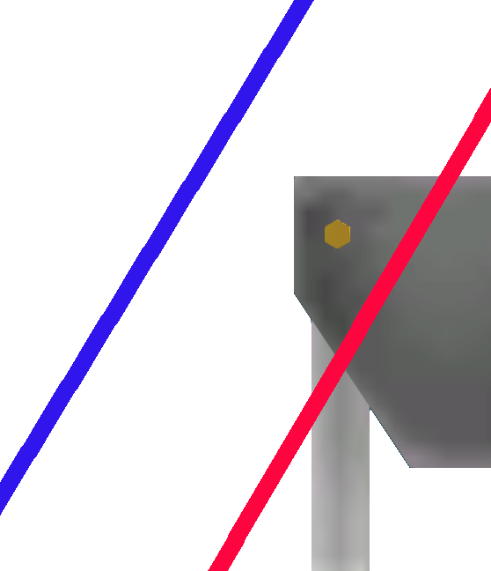
The contact between the antenna pivots and the inner fairing liner was discovered during during inspection while the rocket was on the pad. Selecting an inner antenna and zooming in allows the inner payload fairing to be inspected. This fairing is not present during VAB assembly. The inner liner is not immediately obvious even during pad inspection. Changing the observation angle sometime allows the liner boundary to be seen as a line, parallel to the outer grey fairing. During the on-pad inspection, this component was seen clipping the antenna pivots, up to approximately the pivot axle (seen as the red line in the image to the right). This is not seen in the VAB, which only shows the outer layer (in blue). This contact between the inner liner and parts of the satellite does not always cause damage. Only sensitive components, like antennas, were susceptible. Tests involving solar panels (both in arnoured cases and without them) were put in the same position and proven to be in contact with the inner liner did not sustain the same damage. Moreover, two antennas were left in place during this test. Only one was damaged. It seems likely that the fairing damaged some, but not all of the antenna pivots, but the debris created initially then struck and damaged the rest of the antennas.

Corrective measures
Based on the analysis of this test failure, we can conclude that the fairing is thicker than it appears to be in the VAB. It is therefore recommended to leave a 10 cm gap between the fairing and the payload. This recommendation applies especially to fragile elements, including antennas and solar panels.
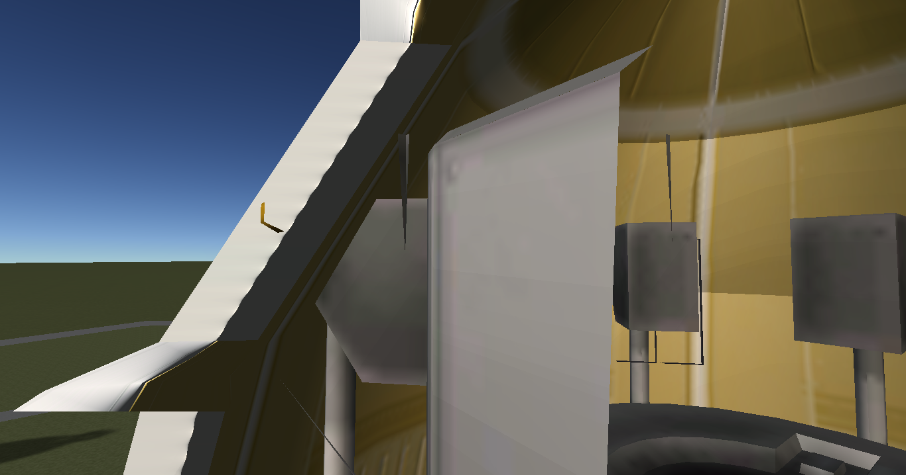

Test re-run
For a re-run of this test, both payload bay decouplers were moved one node down. This caused the payloads to be shifted down, which caused them to be positioned where the fairing had a larger diameter, effectively moving the fairing away from the payload.

Test report: test #7

Test type
Capsule service module for AOC-2 3 man capsule. Multiple capsules on subsequent related tests.

Payload
AOC-2 capsule on test #7, AOC-1 and AOC-3 on tests #10,#11,#12 and #13.

Failure type
Two part B fairings failed to detach when deployed if the launch vehicle is in service module configuration.

Root cause
Fairing gets stuck on heat shield or other capsule parts. Fairing ejection mechanism on 2 section B type fairings tend to propel the fairing sections forward. With a payload bay present, nothing obstructs this forward movement. The fairing pieces then strike the lower bay decoupler, which propel the section outwards.
When a capsule is directly connected to the rocket stage, this forward movement is impeded. The fairing sections either get stuck between the heat shield and fairing base, or impacts solar panels, RCS pods or other external features. The forward movement is impeded because the capsule has a full 125 cm diameter at its rear. The fairing either destroys the outer features, or gets stuck in them, preventing separation.
This problem is exacerbated on type B fairings, as the outward taper at the bottom of the fairing is steeper than on types A and C (which use an identical fairing base).
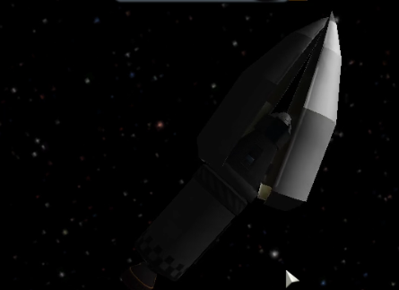
Illustration 1: Type B1/2 fairing locked onto heat shield shroud

Corrective measures
Several parameters were modified to test the effects on the deployment dynamics. Increasing the ejection force caused the outward force to increase somewhat, altering the proportion of lateral to forward motion and improving clearance. Although this corrected the issue when the capsule’s heat shield was connected using a shroud, the increase in ejection force to 150% did not correct the issue when the capsule was directly connected to the fairing base.
The definitive solution involved a change in the number of the number of sections from 2 to 4. A two section fairing creates a 180 degree half ring in its base on deployment, which snags the capsule’s heat shield and external features. A four section fairing creates four 90 degree sections, which tend to move outwards easily and are not as capable of snagging the capsule’s external features. The smaller sections also increase the range of directions where the fairing parts can move without locking onto the heat shield, improving the chances of successful separation.

