WRITE YOUR TITLE HERE

1st author’s Name SURNAME

University, Department,

City/Country,
Email address

2nd author’s Name SURNAME

University, Department,

City/Country,
Email address

Abstract
Write your abstract here.

Key words: Keyword 1, Keyword 2, Keyword 3, Keyword 4, Keyword 5.

1st Section Heading
Write your article here

2nd Section Heading
Write your article here
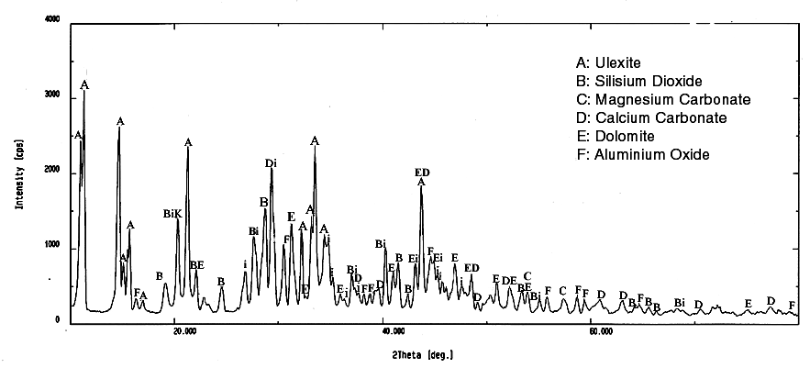
Figure 1. X-Ray difractrogram of the original ulexite mineral.
Example of figure is given in Figure 1.
Table 1. Parameters and their values corresponding to their levels to be studied in experiments
Parameters |  | Level
 |  | 1 | 2 | 3 | 4 | 5 | 6
A | Membran pore size (μm) | 0.2 (PTFE) | 0.45(PTFE) | 1(PTFE) | 0.45(Ethyl Acetate) | blue band | black band
B | Crossflow rate  (L.dk⁻¹) | 5,3 | 6,8 | 8,3
C | Transmembran Pressure (kPa) | 200 | 300 | 400
Example of table is given in Table 1.

References
[1]. 1st reference
[2]. 2nd reference

