Capstone Project Milestone 2 Report
Project title: Multi-Agent Incident Response via Controlled Fault Injection

Basic Information
Student name | Email
Student 1 name | email
Student 2 name | email
Student 3 name | email
Student 4 name | email
Student 5 name | email

Stakeholder name: Krithika Hegde Meeting date: November 8, 2026 confirm after the meeting

Section 1 Stakeholder Follow Up and Final Deliverables (10 points)
Complete after the stakeholder meeting. Nothing in this section may be filled in before it takes place.
Participants: names. Meeting notes: brief notes, here or in an appendix.
Presented: confirm what was actually shown. Planned: a live diagnosis in the dashboard comparing both conditions, the results in Table 1, and the failure cases in Section 5.
Useful results and unmet needs: stakeholder's view.
Feedback | Team response | Next action
feedback | what changed, or why not | action
feedback | what changed, or why not | action
feedback | what changed, or why not | action

Agreed final deliverables, functionality and success criteria: as confirmed with the stakeholder.

Section 2 Implemented Agentic System (25 points)
The system takes one service log and returns a fault class from a fixed taxonomy (dependency_down, slow_query, pool_exhausted, no_fault), an explanation citing evidence, a confidence score, ranked alternatives and a remediation step. Figure 1 shows the implemented workflow and what remains planned. A deterministic toy service injects a known fault into each run, and the ground truth is written to a sidecar file no model sees. In the proposed pipeline, a parser turns the raw log into a structured summary, one LLM call reasons over that summary, and a lookup table returns the remediation. Baseline A sends the raw log to the same LLM prompt instead. Both make exactly one LLM call, so a difference reflects the input representation rather than extra calls.
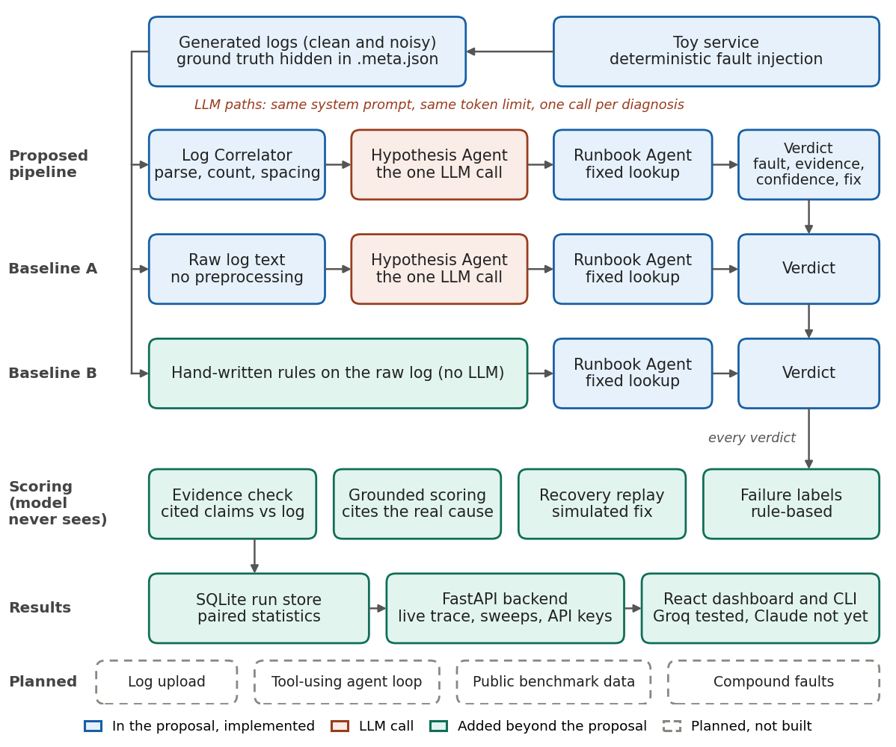
Figure 1. Implemented workflow, baselines, scoring and planned components.
Mechanism | When used | Reads and updates | Effect on later steps
Log Correlator (deterministic agent) | First pipeline step | Reads raw log. Produces counts, failing ids, spacing and latency statistics, and filters unrelated warnings. | Its summary is the only input the LLM sees.
Hypothesis Agent (LLM reasoning) | The single model call, in both LLM conditions | Reads the taxonomy and either the summary or the raw log. Produces the fault, explanation, confidence and ranking. | The label selects the runbook entry and is what gets scored.
Runbook Agent (deterministic agent) | After the hypothesis | Reads the label. Returns a fixed remediation. | Ends the run.
Coordination and state | Every run | A fixed sequential orchestrator emits a trace event per step. Each run is stored in SQLite with its inputs, usage and scores. | Drives the live dashboard trace and all later analysis.
Verification | After each run | Reads the explanation, log and hidden ground truth. Checks cited evidence, grounding and, in recovery mode, replays the proposed fix on the toy service. | Affects scoring only. It does not change the agent's answer.
Error handling and recovery | On failure | Tolerant JSON parsing, recovery of the fault label from broken JSON, retries with backoff on rate limits, and stopping a model at its daily quota. | Separates API failures from model failures in the results.

Design justification. Parsing, counting and table lookup are arithmetic and retrieval rather than reasoning, so they are deterministic. This also holds LLM calls equal across conditions, which the comparison depends on. The system has no planner, tool-calling loop or long-term memory. Its coordination is a fixed sequence, and verification happens after the answer rather than feeding back into it. A tool-using agent loop is listed as remaining work in Section 6.
Models and services. Groq-hosted openai/gpt-oss-120b, openai/gpt-oss-20b and qwen/qwen3.8-27b through the OpenAI SDK. A Claude client is implemented but has not yet been run against the live API. The application uses FastAPI, SQLite, React with Vite, and Recharts.
Changes from the proposal. The evaluation now spans several hosted models. Noise mode gives both database faults the same error name, so a single string cannot identify the fault. The summary gained failure-spacing fields. Evidence checking, grounded scoring, simulated recovery, failure labels and a web interface were added. Confirm and extend against the Milestone 1 report.

Section 3 Preliminary Evaluation Results and Analysis (30 points)

Datasets
Dataset | Source and generation | Size | What it tests
D1 Noisy | Generated by the toy service with unrelated warnings, 0 to 2 red-herring transient errors, irregular fault timing and one shared error name for database faults. | 40 logs: 10 per fault class, 30 requests each | Whether a system can separate faults by failure pattern when error names do not reveal them.
D2 Clean | Generated by the toy service as described in the proposal, with a distinct error name per fault and regular fault timing. | 40 logs: 10 per fault class, 30 requests each | The proposal's original task and conditions.
D3 Proposal | The stakeholder's own published logs and labels, from the proposal repository. Field order and level markers were normalized; no values changed. | 16 logs: 4 per fault class, 30 requests each | Performance on stakeholder-provided data, and the closest comparison with the proposal's Claude Opus results.

Ground truth is recorded when each log is generated. Generation is deterministic given a fault type and run number, and no train/test split applies because no component is trained. All three datasets are synthetic. D1 and D2 come from our rebuilt generator, and D3 comes from the proposal's generator. No public benchmark has been run yet.

Baselines and evaluation conditions
- Baseline A, raw-log LLM: the same LLM and system prompt, given the unprocessed log. It tests the value of preprocessing at equal LLM calls.
- Baseline B, rules only: hand-written string and pattern rules with no LLM. It tests whether an LLM is needed at all. It was written with knowledge of the generator, so it is an upper-bound control rather than a fair competitor.
All compared systems received the same logs. LLM runs used temperature 0, a 2,048-token output limit, one call per diagnosis, no tools, and prompt-based JSON with one shared parser for every provider. Reasoning effort was not separately controlled on Groq. Rate-limited calls were retried, and calls that still failed are excluded and reported.

Metrics
Accuracy counts the fault the model named. Strict also requires valid JSON. Proposal criterion requires the correct fault and no cited evidence missing from the log, matching the proposal's definition of success. Grounded also requires citing the real cause: an injected request or failure spacing, or for slow_query a measured latency. False alarm is the share of no_fault logs called a fault. Operational measures are mean tokens and mean model latency. Evidence checks use deterministic text rules, which were refined on D1, so those two columns need confirmation on fresh data.

Results
Table 1. Measured results. Bold rows are the proposed system. Proposal is the proposal criterion. Sec. is mean model latency in seconds.
Data | Method | Model | n | Accuracy [95% CI] | Strict | Proposal | Grounded | False alarm | Tokens in/out | Sec.
D1 Noisy | B: Rules | none | 40 | 100.0% [0.91, 1.00] | n/a | n/a | n/a | 0.0% | none | <1
D1 Noisy | A: Raw log | Qwen3.8 27B | 40 | 92.5% [0.80, 0.97] | 92.5% | 92.5% | 92.5% | 0.0% | 2247 / 243 | 11.0
D1 Noisy | Pipeline | Qwen3.8 27B | 40 | 100.0% [0.91, 1.00] | 100.0% | 100.0% | 100.0% | 0.0% | 909 / 219 | 11.2
D1 Noisy | A: Raw log | gpt-oss-120b | 36 | 94.4% [0.82, 0.98] | 88.9% | 88.9% | 88.9% | 22.2% | 1844 / 544 | 14.3
D1 Noisy | Pipeline | gpt-oss-120b | 36 | 94.4% [0.82, 0.98] | 94.4% | 94.4% | 94.4% | 22.2% | 900 / 519 | 7.6
D1 Noisy | A: Raw log | gpt-oss-20b | 40 | 92.5% [0.80, 0.97] | 92.5% | 92.5% | 92.5% | 0.0% | 1843 / 707 | 16.1
D1 Noisy | Pipeline | gpt-oss-20b | 40 | 95.0% [0.83, 0.99] | 95.0% | 95.0% | 95.0% | 20.0% | 898 / 627 | 8.2
D2 Clean | B: Rules | none | 40 | 100.0% [0.91, 1.00] | n/a | n/a | n/a | 0.0% | none | <1
D2 Clean | A: Raw log | Qwen3.8 27B | 40 | 100.0% [0.91, 1.00] | 100.0% | 100.0% | 100.0% | 0.0% | 1964 / 235 | 12.0
D2 Clean | Pipeline | Qwen3.8 27B | 40 | 100.0% [0.91, 1.00] | 100.0% | 100.0% | 100.0% | 0.0% | 834 / 217 | 13.3
D2 Clean | A: Raw log | gpt-oss-120b | 40 | 100.0% [0.91, 1.00] | 100.0% | 92.5% | 92.5% | 0.0% | 1636 / 386 | 12.2
D2 Clean | Pipeline | gpt-oss-120b | 40 | 100.0% [0.91, 1.00] | 100.0% | 100.0% | 100.0% | 0.0% | 836 / 385 | 6.6
D2 Clean | A: Raw log | gpt-oss-20b | 40 | 95.0% [0.83, 0.99] | 95.0% | 92.5% | 90.0% | 10.0% | 1636 / 474 | 12.0
D2 Clean | Pipeline | gpt-oss-20b | 40 | 100.0% [0.91, 1.00] | 100.0% | 100.0% | 100.0% | 0.0% | 836 / 441 | 7.4
D3 Proposal | B: Rules | none | 16 | 100.0% [0.81, 1.00] | n/a | n/a | n/a | 0.0% | none | <1
D3 Proposal | A: Raw log | gpt-oss-120b | 8 | 87.5% [0.53, 0.98] | 87.5% | 75.0% | 75.0% | 50.0% | 1526 / 580 | 8.6
D3 Proposal | Pipeline | gpt-oss-120b | 7 | 100.0% [0.65, 1.00] | 100.0% | 100.0% | 100.0% | 0.0% | 843 / 477 | 4.8
D3 Proposal | A: Raw log | gpt-oss-20b | 16 | 81.2% [0.57, 0.93] | 81.2% | 75.0% | 68.8% | 75.0% | 1526 / 550 | 10.0
D3 Proposal | Pipeline | gpt-oss-20b | 16 | 81.2% [0.57, 0.93] | 81.2% | 81.2% | 81.2% | 75.0% | 837 / 558 | 7.9

Table 2. Paired comparison of the pipeline and Baseline A on identical logs.
Data | Model | Pairs | Only baseline A right | Only pipeline right | Exact McNemar p
D1 Noisy | Qwen3.8 27B | 40 | 0 | 3 | 0.250
D1 Noisy | gpt-oss-120b | 36 | 2 | 2 | 1.000
D1 Noisy | gpt-oss-20b | 40 | 1 | 2 | 1.000
D2 Clean | Qwen3.8 27B | 40 | 0 | 0 | 1.000
D2 Clean | gpt-oss-120b | 40 | 0 | 0 | 1.000
D2 Clean | gpt-oss-20b | 40 | 0 | 2 | 0.500
D3 Proposal | gpt-oss-120b | 7 | 0 | 1 | 1.000
D3 Proposal | gpt-oss-20b | 16 | 0 | 0 | 1.000

Where the pipeline improves. On D1 and D2, the pipeline matched or exceeded Baseline A on all six model and dataset combinations, using smaller models available on a free tier rather than a frontier model. On D1, which removes identifying error names and adds red herrings, Qwen3.8 27B reached 100% with the pipeline against 92.5% from raw logs. Deterministic preprocessing cut input tokens by about half at the same LLM call count, and all 236 pipeline answers were usable, against 231 of 236 for Baseline A. Because each comparison uses at most 40 paired logs, we report these as directional results with exact p-values in Table 2, and larger sweeps are planned in Section 6.
Where it performs similarly. On D2, Qwen3.8 27B and gpt-oss-120b were 100% accurate in both LLM conditions across all 40 pairs, matching the 100% the proposal reported with Claude Opus on its own logs. Opus was not run on D2, so this is not a direct comparison. gpt-oss-20b reached 100% with the pipeline and 95% with Baseline A, from one false alarm and one empty answer on no_fault logs. On D1, gpt-oss-120b raised the same number of false alarms in both conditions (2 of 9 no_fault logs), so the summary did not protect it from red-herring errors. Confidence calibration was mixed: Brier score improved for Qwen3.8 27B (0.065 to 0.002), was flat for gpt-oss-120b (0.050 to 0.048), and worsened for gpt-oss-20b (0.028 to 0.048).
Where it underperforms. Baseline B, the rules-only control, scored 100% on both datasets, above every LLM condition. These datasets therefore saturate, so accuracy alone cannot show the value of the proposed system, which motivates the harder conditions in Section 6. On D1, gpt-oss-20b with the pipeline raised 2 false alarms where Baseline A raised none, although Baseline A returned empty answers on 2 other no_fault logs.
Stakeholder logs (D3). The rules control scored 16 of 16, and the proposal published 16 of 16 for Claude Opus in both conditions on these logs. gpt-oss-20b reached 13 of 16 in both conditions, so on this dataset the smaller model did not match the proposal's frontier-model result. The pipeline tied Baseline A on every completed pair and used 837 input tokens against 1,526. gpt-oss-120b is reported on 7 completed pairs after a rate limit, and Qwen3.8 27B is omitted because too few pairs completed. Our rebuilt parser reproduced the published summary for pool_exhausted_run1 exactly, which supports the fidelity of the rebuild.
Possible explanations. We expected weaker models to benefit most from structure, and this pilot does not support that: the largest gain was on Qwen3.8 27B, which scores highest of the three on the Artificial Analysis Intelligence Index. Its Baseline A misses on D1 included 2 dependency_down logs read as pool_exhausted, which the spacing fields directly address. That is suggestive only, because those fields were designed with the fault patterns in mind.
Limits of this pilot. A free-tier daily quota stopped gpt-oss-120b at 36 of 40 pairs on D1. D2 is complete at 40 pairs per model. D3 is limited by the same quotas. The evidence rules were frozen after refinement on D1. On an earlier partial D2 run they flagged two runs, and manual inspection found both flags were scorer errors (for example, treating "3.2 ms above the baseline" as a latency measurement), and the flags on the full D2 run were not individually reviewed, so the Proposal criterion and Grounded columns may understate D2 and their ability to catch real fabrication remains unmeasured. Not yet completed: longer-log sweeps, a parser without spacing fields, a live Claude run, a recovery sweep, and any public benchmark.

Section 4 Demo or Case Study (15 points)
Task and expected outcome. An actual run on pool_exhausted_run1_noisy, a 30-request log from D1, using Qwen3.8 27B with recovery scoring on. The injected fault is a connection-pool burst on requests 12 to 18. Requests 9 and 11 are red-herring TimeoutError transients, and the log contains unrelated warnings. Expected output: pool_exhausted, evidence from the log, and a fix that restores the service.
Intermediate actions. The Log Correlator read the log and produced the summary in Figure 3: 21 successes, 9 errors, failing ids 9 and 11 to 18, longest contiguous run 8, mean latency 48.1 ms, with 6 unrelated warnings filtered out. That summary was the only input to the Hypothesis Agent, which is the coordination step in Figure 1. The agent's label then selected the runbook entry.
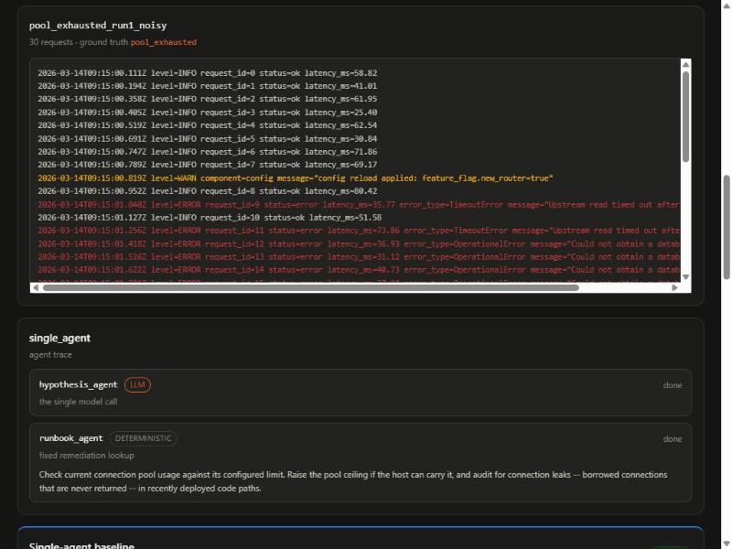
Figure 2. The raw log shown to Baseline A, followed by its agent trace.
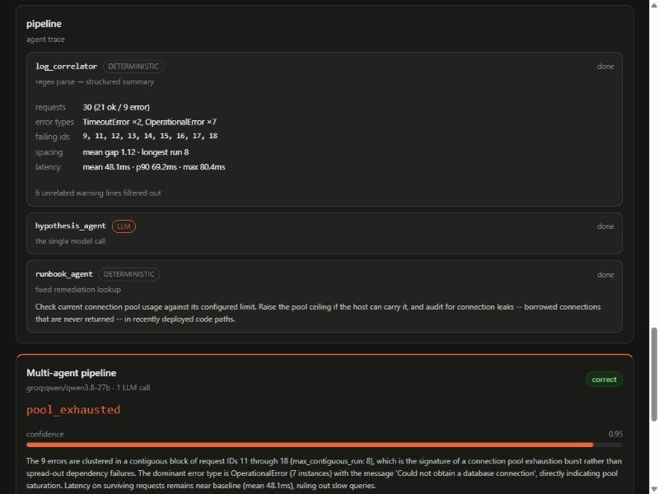
Figure 3. Pipeline trace: the deterministic summary and the steps that followed it.
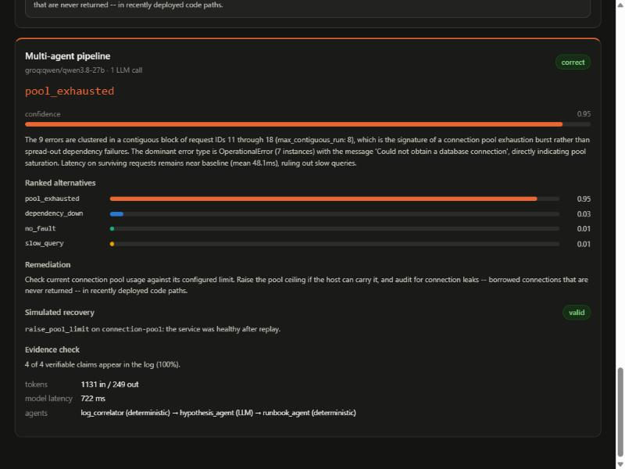
Figure 4. Final pipeline output with confidence, alternatives, recovery replay and evidence check.
Final output. The pipeline returned pool_exhausted at 0.95 confidence and chose raise_pool_limit on connection-pool. The toy service was replayed with that fix and was healthy afterward, and 4 of 4 checkable claims appeared in the log. It used 1,131 input and 249 output tokens. Baseline A also answered correctly on this log, using 2,439 input and 283 output tokens. The task was satisfied, and Section 5 examines a flaw in this same run.

Section 5 Failure Analysis and Current Limitations (10 points)
Case 1: false alarm from a red herring (reasoning). On no_fault_run3_noisy, gpt-oss-20b with the pipeline predicted dependency_down at 0.90 confidence. Observed: the log's only error is one TimeoutError on request 2, and the explanation cites it as a dependency timeout, although the prompt says isolated transients are not a fault. Suspected cause: the summary reports errors without separating isolated ones, and the model treats any error as a signal. Proposed fix: add an isolated-error count to the summary, or a minimum-evidence rule. Check: the false-alarm rate on no_fault logs in a fresh sweep.
Case 2: partially correct demo run (parsing). In Section 4 the pipeline reached the right answer but described the burst as requests 11 to 18, with 9 errors and a run of 8. Observed: the injected burst is 12 to 18, and request 11 is a red herring next to it. Baseline A, reading the raw log, correctly identified 12 to 18. Diagnosis: the correlator measures spacing across all error types, so a transient error beside the burst extends it. Proposed fix: compute spacing per error type. Check: a test that the reported run matches injected ids on D1.
Case 3: unusable output (output handling). Four of 116 raw-log answers on D1 could not be used, against 0 of 116 pipeline answers. Two gpt-oss-120b answers contained "confidence": 0. nine, which is invalid JSON after a correct fault label. Two gpt-oss-20b answers used all 2,048 output tokens and returned no visible answer. The first is observed model behavior. The second suggests reasoning consumed the token budget on the longer input, but that is not confirmed. Proposed fix: provider-level structured output as a separately reported condition, and a larger token limit where rate limits allow. Check: the malformed and empty-answer counts.
Case 4: false alarms on stakeholder logs (prompt). On D3, gpt-oss-20b labeled 3 of 4 no_fault logs as slow_query in both conditions. Observed: on no_fault_run2 the explanation calls a mean of 48.8 ms elevated against the ~45 ms baseline in the prompt, while slow-query logs in D3 average about 600 ms. Suspected cause: the prompt's single baseline figure, taken from our generator, anchors the model. Proposed fix: give a healthy range or let the model compare against the run's own distribution. Check: the false-alarm rate on D3.
Broader limitations. The task covers one simulated service, four known classes and logs only, and accuracy is near the ceiling, leaving little room to show differences. The parser was written with knowledge of the injected patterns, so a pipeline advantage may not transfer. The rules control also reached 100%, so the current datasets cannot separate stronger methods. Free-tier quotas limit sample size, and the Claude path is untested live. The system cannot yet read real logs.

Section 6 Remaining Work Before the Final Submission (10 points)
Priority | Current gap | Planned improvement | Owner | Done when
Required | Differences are not statistically significant | Freeze the scorers, then run more logs per model | names | Paired tests reported on fresh logs
Required | Task is near ceiling and may favor the parser | Run 75 and 150-request logs, remove the spread-versus-cluster hint, and add a parser without spacing fields | names | Results show where, if anywhere, structure helps
Required | Both datasets are synthetic | Run a public benchmark subset such as OpenRCA 2.0, or justify the alternative with the stakeholder | names | A results table includes external data
Required | Limited agentic behavior | Decide with the stakeholder whether to add a tool-using diagnosis loop, then implement and evaluate it | names | New condition evaluated, or decision documented
Required | Known parsing and false-alarm failures | Apply the fixes from Section 5 | names | Failure cases rechecked
Required | Stakeholder sign-off, final report, presentation and demo | Follow up on the deliverables in Section 1 and prepare the final materials | names | Submitted and rehearsed
Optional | Real-log use | Log upload, flexible parsing, secret redaction and an unknown class | names | An uploaded log returns a cited diagnosis
Optional | Coverage and packaging | Live Claude run, compound faults, recovery sweep, Docker and CI | names | Each runs and is reported

Section 7 GitHub Repository and Team Contributions
Repository: https://github.com/EroNinja/agent-av-planner Branch: main Commit: b94b143 (tag milestone-2). Setup and run instructions are in README.md. Confirm the grader has access before submitting.
Name | GitHub username | Actual contributions | Commits or pull requests
Student 1 | username | summary, including work not reflected in commits | links
Student 2 | username | summary, including work not reflected in commits | links
Student 3 | username | summary, including work not reflected in commits | links
Student 4 | username | summary, including work not reflected in commits | links
Student 5 | username | summary, including work not reflected in commits | links

Describe dataset preparation, evaluation, stakeholder communication and writing. If the course requires disclosure of AI assistance, state it here.

