CIVE 202 Project 3 Report: Transportation Systems
University of Nebraska-Lincoln

CIVE 202 Group 7

March 31, 2026

Table of Contents
Introduction 3
Methods 3
Results & Discussion 3
Reference List 4

Introduction
Understanding traffic behavior and travel patterns is essential for improving transportation systems and informing effective planning decisions. This project utilizes data from the Federal Highway Administration using tools in Python. The goal is to integrate data analysis, visualization, and simulation to gain meaningful insights into transportation systems. By combining real-world datasets with computational modeling, this study highlights relationships between driver behavior, traffic flow, and transportation planning outcomes.
Data from the National Household Travel Survey (NHTS) and the Next Generation Simulation (NGSIM) program to examine travel characteristics and traffic dynamics. The NHTS dataset provides insight into travel patterns, trip purposes, and transportation modes across a broad population. While the NGSIM dataset offers high-resolution vehicle trajectory data, allowing for detailed analysis of speed, acceleration, and vehicle interactions. In addition to exploratory data analysis and visualization, this study incorporates simulation techniques to better understand traffic flow behavior. The Intelligent Driver Model (IDM) is applied to represent vehicle-following dynamics under varying conditions.
A Jupyter Notebook was developed to present the code structure. Additionally, an annotated code document was developed to describe Excel-to-Python logic through detailed line-by-line explanations. This technical report also supplements all Python logic. Throughout the project, a timesheet and Gantt Chart were utilized to ensure project coherence and completion. Finally, a GitHub repository storing all code, documentation, and a README file with user guide information was developed.

Table 1: Final Deliverables
Deliverable | Files Included | Date
Raw Data File | CIVE202_Spring2025_ Group7_Project3_Raw | 3/31/26
Python Code | CIVE202_Spring2025_ Group7_Project3_Code.ipynb | 3/31/26
Organized Files | GitHub Link containing this data | 3/31/26
Scope of Work | CIVE202_Spring2025_ Group7_Project3_SOW.DOCX | 3/31/26
Annotated Code | CIVE202_Spring2025_ Group7_Project3_ACD.DOCX | 3/31/26
Written Report | CIVE202_Spring2025_Group7_Project3_Report.DOCX | 3/31/26

Methods
First, all data was analyzed to develop an understanding of desired results. The CSV and Metadata files from NHTS data were examined to identify available variables. These variables enabled analysis of travel patterns, transportation modes, trip purposes, and broader transportation planning insights. From the NGSIM dataset, driver-specific variables including speed, acceleration, time, and location were analyzed. In particular, speed and acceleration were used to evaluate driver behavior, while time-based data provided insight into traffic conditions at specific times. Additionally, lane-level speed distributions were used to assess lane usage patterns.
A Jupyter notebook was then developed to organize data importation, analysis, visualization, and simulation in a structured workflow. The notebook includes a bar chart, histogram, boxplot, and a time-series plot to demonstrate key aspects of the provided data. The Python libraries Seaborn and Matplotlib were used to create customized graphs with clearly labeled axes, titles, and legends.
To simulate traffic behavior, the Intelligent Driver Model (IDM) was implemented to represent vehicle-following dynamics under varying traffic conditions. Parameters like speed, acceleration, spacing, and deceleration were incorporated into the model to reflect realistic driving behavior. This simulation provides insight into how individual driver behaviors can influence overall traffic system performance.

Results & Discussion

Organization and visualization of the extensive transportation data provided by the National Household Travel survey (NHTS), and the Next Generation Simulation (NGSIM) has revealed a lot about the data, as well as making it more presentable to our clients.

The first graph we created shows the number of vehicles in circulation that take various types of fuel.

Figure 1.1 Vehicles Fuel Type Bar Chart
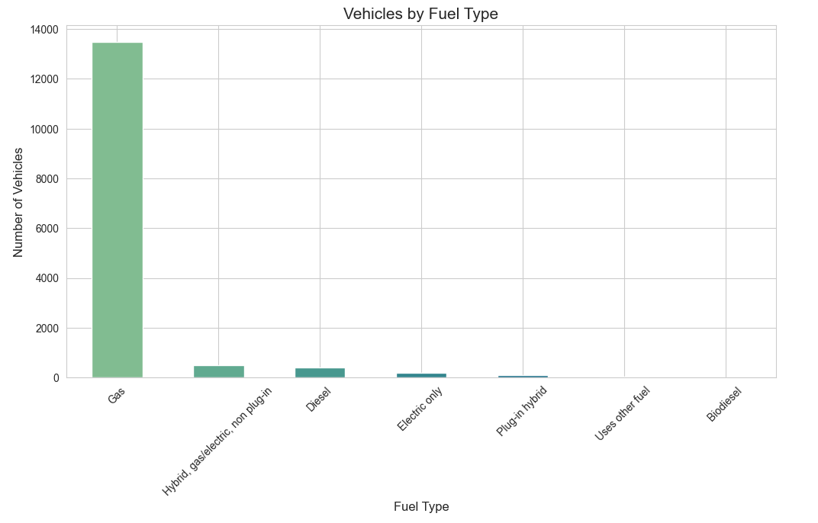
When concerned with traffic planning this shows that a vast majority of the vehicles on the road use gas as their primary fuel type. Following gas, the most prevalent vehicle fuel type is hybrid then diesel, followed by electric only. Only a small fraction of cars uses fuel types other than gas. This tells us that it is important to have frequent gas stations, and that electric plug in stations, and diesel gas stations can be more infrequent.

The next relationship we visualized is a histogram showing the amount of vehicles by age that are used in a rural setting versus an urban setting.

Figure 1.2 Urban vs Rural Vehicle Histogram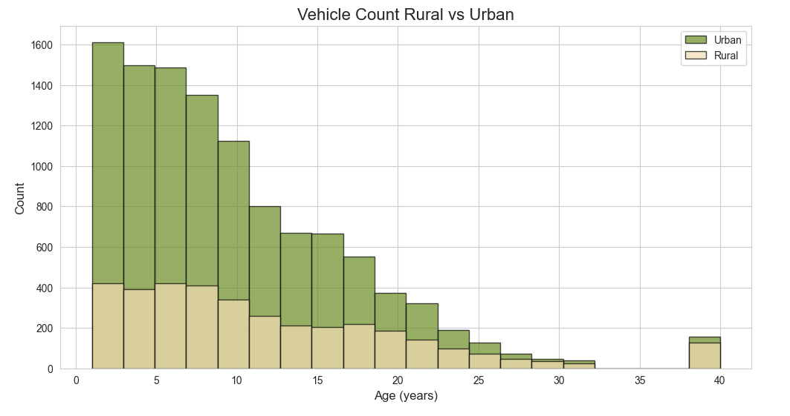
What this plot shows us is that the majority, about 75% of newer vehicles are being used in an urban setting. It also shows us that as a car gets older, it is more likely to be used in a rural setting. The age that reflects when a majority of cars switch from urban to rural use is about 20 years old. This reflects the economic status of urban and rural areas, as well as the age of people in rural areas, and road conditions. One reason people may prefer older cars in rural areas is because the road conditions are expected to be hard on the car, and newer cars would depreciate greatly in value on those roads.

The next figure we plotted compares the make of the vehicle to the vehicle age.

Figure 1.3 Vehicle Age by Make Boxplot
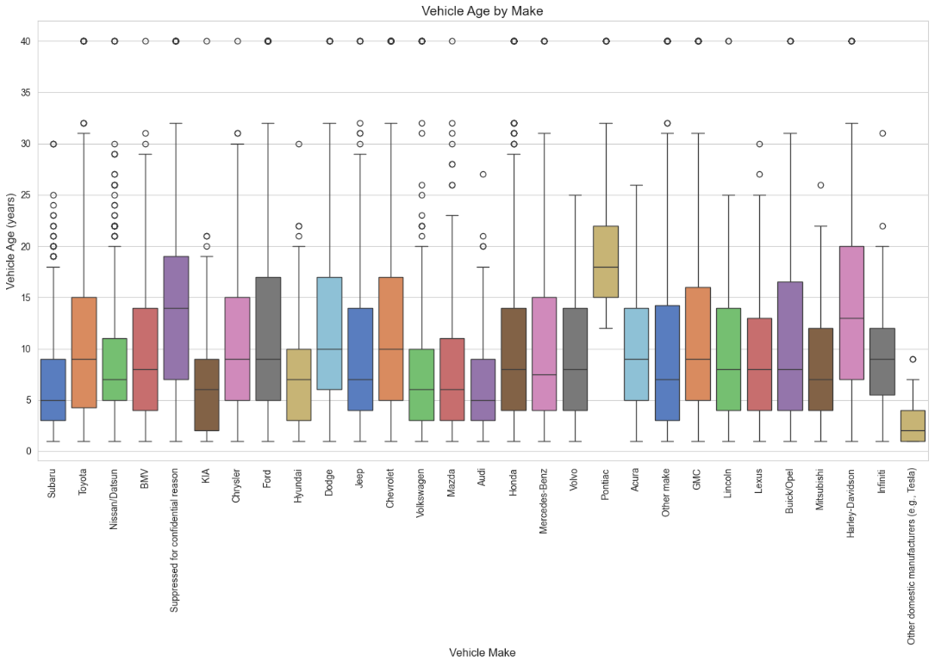
This plot shows the average vehicle age by the make, as well as the minimum and max value, and any outliers. This visual is important to the transportation industry because older it reveals insight into safety risks, as older cars do not have as many newer safety features. It shows what vehicles have the most longevity, in this case it is makes like Harley Davidson, Ford, and Dodge. It also gives information about consumer behavior, all which is important information to know in transportation planning.

The next plot we created is follower speed time series plot.

Figure 1.4 Follower Speed Time Series Plot
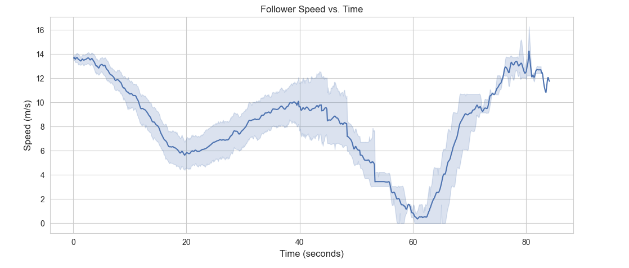
This plot shows how a driver adjusts their speed as traffic changes. This information is important for understanding safety measures as well as traffic control. It shows that follower speed has a lot of variability that needs to be planned for. It also shows waves that indicate periods of acceleration and deceleration.

The next plot created to show our client is a time series plot showing the trajectory of a leader car and a follower car.

Figure 1.5 Car Trajectories Time Series Plot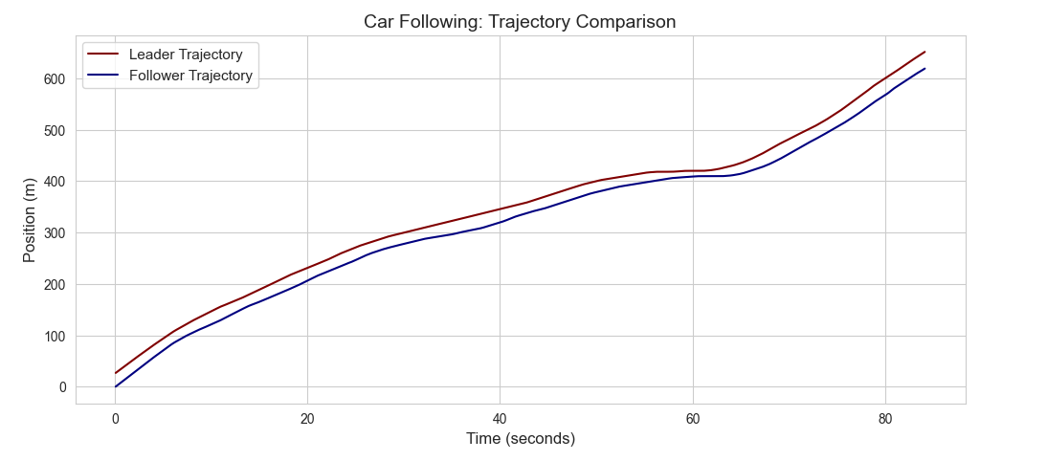
This plot is important because it shows how a vehicle’s position changes over time I relation to another vehicle in front of it. This helps engineers understand driver behavior and identify possible safety risks. For example, this plot shows that the cars get closest when the lead vehicle is coming to a stop around 60 seconds. This information can help improve safety on the road.

The final graph uses the intelligent driven model (IDM) to simulate vehicle behavior.
Figure 1.6 Simulated Follower Speed
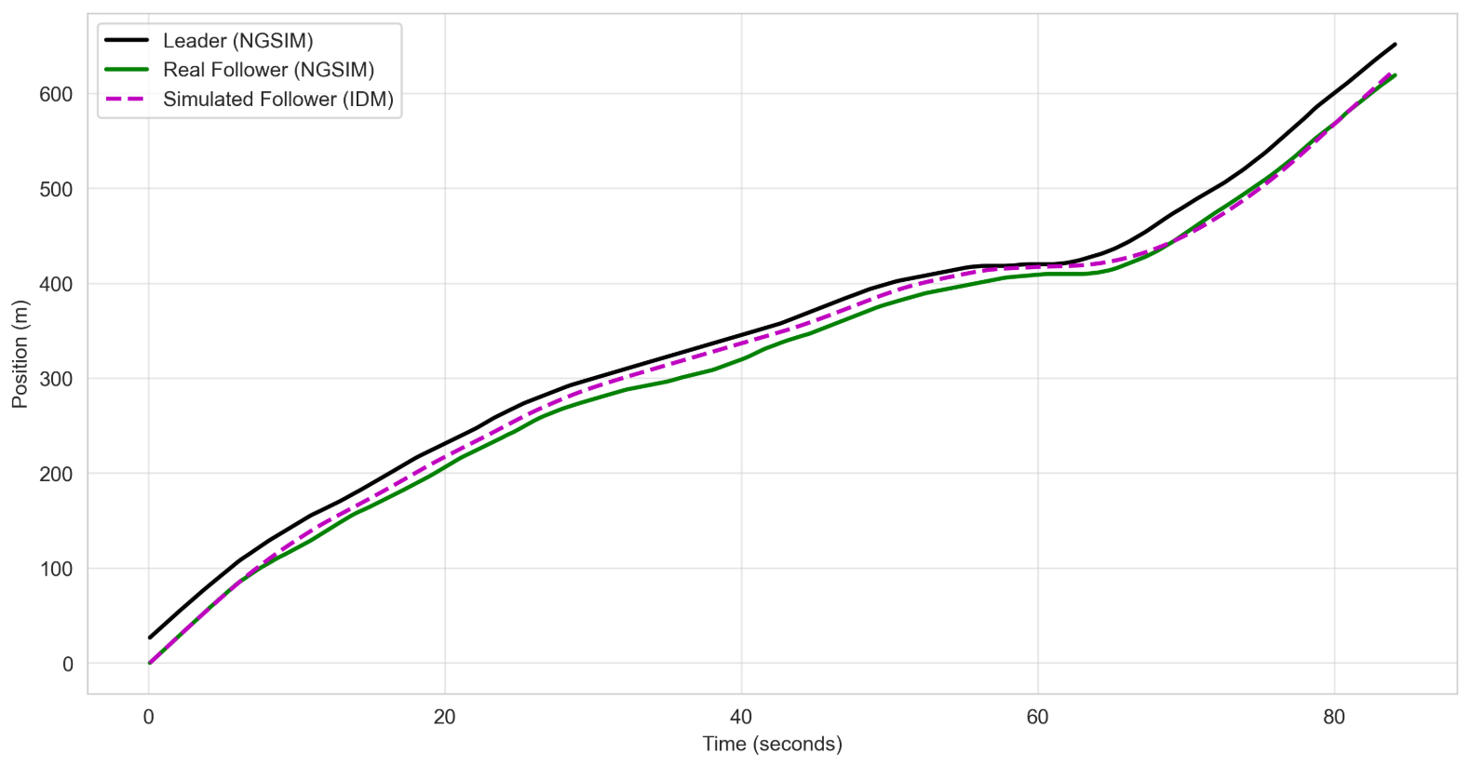
This graph is important because it shows the accuracy of the simulated follower data, to the real follower data. The simulated follower is on average, closer to the leader than the real follower, which is not completely accurate, but allows for a factor of safety when using the simulated follower model. This figure shows the accuracy of the IDM model.

Reference List
[1] Federal Highway Administration. (2022). 2022 National Household Travel Survey, U.S. Department of Transportation, Washington, DC. Available online: https://nhts.ornl.gov.
[2] "U.S. Department of Transportation Federal Highway Administration. (2016). Next Generation Simulation (NGSIM) Vehicle Trajectories and Supporting Data. [Dataset]. Provided by ITS DataHub through Data.transportation.gov. Accessed 2026-03-05 from http://doi.org/10.21949/1504477"

