# Converting GeoTIFF Imagery to Optimized JPG Compressed Tiff Imagery

# *Tuning and Preprocessing Imagery for the ArcGIS Server Image Extension*

# Overview

The ArcGIS Server Image Extension allows you to manage, process, and quickly serve large quantities of raster data for visualization and analysis to a variety of clients. The online help article: [An overview of the ArcGIS Server Image Extension](http://help.arcgis.com/en/arcgisdesktop/10.0/help/index.html#/Image_extension/0053000000pr000000/) includes a section on Key Features. The article states *“One of the most important key features of Image Extension is on-the-fly server-based image processing. The Image Server resolves bottlenecks in conventional image-processing workflows by enabling the raster datasets to be stored directly as files on servers, then processed and distributed directly without* ***extensive preprocessing*** *or loading of the data into a database.”* The key phrase in this statement is extensive preprocessing, while you do not necessarily preprocess your data, there is some preprocessing that you should consider before publishing your imagery. Preprocessing will allow the organization to achieve maximum results and performance especially if imagery is to be deployed via ArcGIS Server Image Service to be used in conjunction with the ArcGIS Server Rest API, [ArcGIS Server API for Flex](http://help.arcgis.com/en/webapi/flex/), [ArcGIS Server API for JavaScript](http://help.arcgis.com/en/webapi/javascript/arcgis/) and [ArcGIS API for Microsoft Silverlight™/WPF™](http://help.arcgis.com/en/webapi/silverlight/index.html).

This document explains the steps necessary to preprocess imagery using, FWTools and GDAL (Geospatial Data Abstraction Library) by ***Frank Warmerdam*** encapsulated inside a simplified python utility that presents the user with a dialog. While you can preprocess imagery out of the box in ArcGIS 10, ArcGIS 10 does not expose all of the parameters built into GDAL. Additionally there is no way to compress imagery for use in the Image Extension prior to ArcGIS 10. The benefit of Image compression is that it will significantly improve performance on large *.tiff images by improving draw speed, faster statistics calculations and enable mosaic methods to work at smaller scales. This translates to faster drawing times when the imagery is published as an image service using ArcGIS Server. The table below provides a comparison of the image sizes before and after compression using a variety of scenarios. The source imagery used to test this application came from the State of Ohio, Ohio Statewide Imagery Program(OSIP) <http://ogrip.oit.ohio.gov/ProjectsInitiatives/StatewideImagery.aspx>

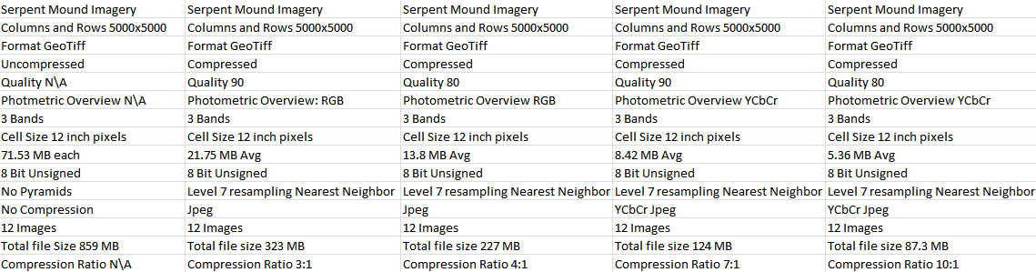

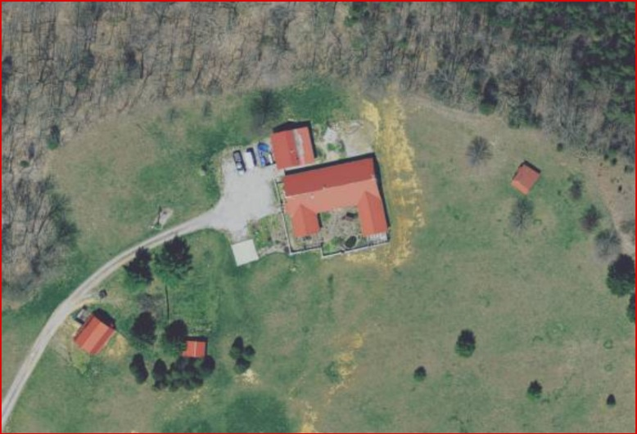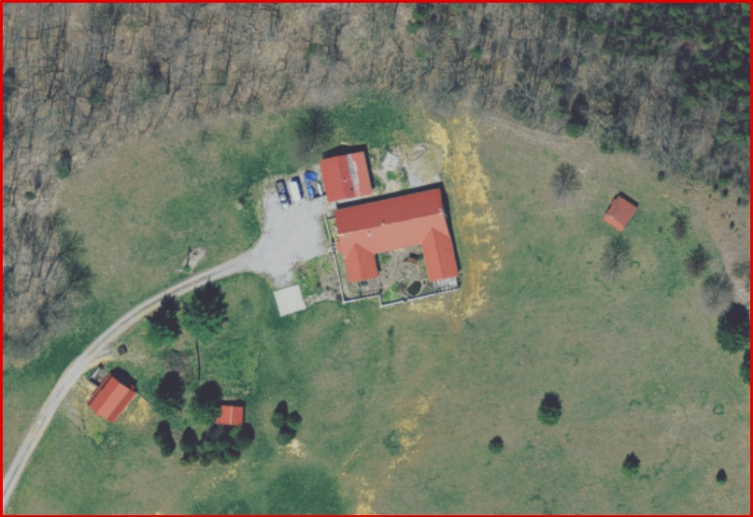

Uncompressed Image 71 MB 1:800 Compressed YcBcR Quality 80 5.3 MB 1:800

# Installation Instructions

1. Download and Install FWTools on a server or workstation with access to the source GeoTIFF imagery you wish to compress. Download FWTools at <http://fwtools.maptools.org/>. The GDAL or Geospatial Data Abstraction Library is part of the FWTools Download and it contains the compression algorithms necessary to preprocess the imagery.
2. Note the directory location where FWTools resides.
3. Unzip CompressImagery.zip to any location on the server where FWTools is installed in Step 1.
4. Navigate to the directory CompressImagery that was deflated in Step 3.
5. Open CompressImagery.cfg using Notepad or a text editor. Replace the path to FWTools with the path that you recorded in Step 1.
6. Save the Configuration File and exit.
7. Double click on CompressImagery.pyw to open the Compress Imagery dialog

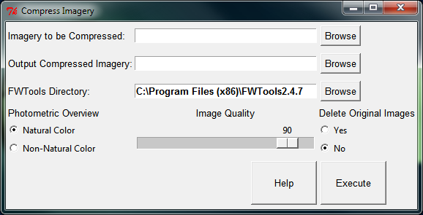

1. Click the Help button to access the How To Guide with step by step instructions for compressing imagery.

# How to Guide

1. Double click on CompressImagery.pyw to open the Compress Imagery dialog



**\*\*\*NOTE*** If you use a Python IDE like Aptana Studio and PyDev or PythonWin, when you double click on the CompressImagery.pwy may not launch. The .pyw needs to be associated with pythonw.exe. To work around this problem Right Click on the Compress Imagery.pyw. Choose Properties and click on the General Tab.**

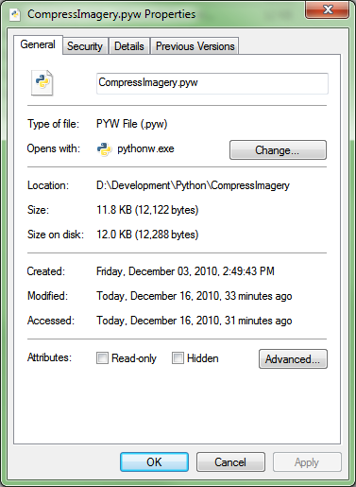

**The “Opens With” section of the dialog should be set to pythonw.exe. If it is set to none or another application like PythonWin then choose the Change button, browse to C:\Python26\ArcGIS10, and choose pythonw.exe. Pythonw.exe opens python applications without the python console window. Since this application is self-contained in a python GUI we do not require the console window for feedback or input to run this tool.**

1. Click on the browse button to locate the directory whose imagery you want to compress.
2. 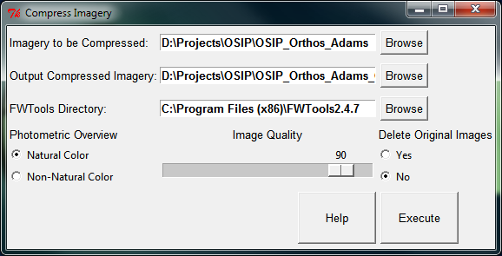When you select the folder with imagery you want to compress a message box will ask you if you would like to create a new directory (Yes) or choose an existing directory (No).
3. Set the location of FWTools if the location displayed is incorrect. The location displayed is based on the information you provided in step 5 when you opened the configuration file and modified the FWTools path.
4. Set the Photometric Overview
   1. Natural Color – Use natural color imagery like 3 Band Color Othrophotos: This option forces GDAL to use YCbCr color model, which is better for natural color imagery as it converts the imagery to a color space that is better compressed, by making use of the correlation between the bands.
   2. Non-Natural Color – Use non-natural color imagery like 3 or 4 Band Color Infrared Imagery: This option forces GDAL to use RGB color model to compress imagery. Using the Natural Color option on non-natural color imagery will corrupt the output-compressed images. Make sure the option to Delete Original Images is set to no when working with 4 band images. A dialog will verify that you are using Natural color imagery when natural color is selected. If the imagery is non-natural the validation tool will set the images to non-natural color for you.
5. Set the Image Quality
   1. Set the JPEG quality when using JPEG compression. A value of 100 is best quality (least compression), and 1 is worst quality (best compression). The default is 90. If you set the quality below 80 a warning message will pop up verifying that you understand that the resulting imagery could introduce subimage artifacts and a loss of resolution. **Note\*** It is recommended that you copy a set of images to a directory on your system and test these setting before running this tool on an entire directory of images.
6. Delete Original Images – This setting will delete the directory containing the original images. By default, all images are saved. Use this setting with caution.
7. Execute – Execute will validate all of the settings in the dialog to make sure they are correct and then the process will begin running. The time it takes this process to run is dependent on the size of the imagery that needs to be compressed as well as the complexity. 4 Band images take longer to process than 3 band images. **Test a sample set of images before running against an entire directory. It is easier to run this routine on 4 or 5 images and find out that the results are wrong than to run against a directory of 1000 images.**