**Example Folate biosynthesis genes in Bacteria**

**Papers for Background**

https://www.ncbi.nlm.nih.gov/pubmed/27618105

<https://www.ncbi.nlm.nih.gov/pubmed/25210598>

<https://www.ncbi.nlm.nih.gov/pubmed/21999246>

<https://www.ncbi.nlm.nih.gov/pubmed/19897652>

<https://www.ncbi.nlm.nih.gov/pubmed/19395485>

<https://www.ncbi.nlm.nih.gov/pubmed/18931107>

https://www.ncbi.nlm.nih.gov/pubmed/17645794

**Genes and resources do to get the HMM and profiles and sequences**

**The fasta files for Ps-blast you can get from the Uniprot entries given for each genes**

**The HMM files you can get from the Panther links in yellow**

**The HMMs from TIGRFAM you should get from the ftp site site pink nore**

**FolE**

<https://www.uniprot.org/uniprot/P0A6T5>

HAMAP

<https://hamap.expasy.org/signature/MF_00223.txt>

TIGRFaM

<http://tigrfams.jcvi.org/cgi-bin/HmmReportPage.cgi?acc=TIGR00063>

site for HMM

<http://www.pantherdb.org/panther/family.do?clsAccession=PTHR11109>

can get Pfam HMM

here <http://pfam.xfam.org/family/PF01227>

FolE2

<https://www.uniprot.org/uniprot/P94398>

HAMAP PROFILE

<https://hamap.expasy.org/signature/MF_01527_A.txt>

<http://tigrfams.jcvi.org/cgi-bin/HmmReportPage.cgi?acc=TIGR00294>

<http://pfam.xfam.org/family/PF02649>

<http://www.pantherdb.org/panther/family.do?clsAccession=PTHR36445:SF1>

FOLB

<https://www.uniprot.org/uniprot/P0AC16>

PSSM

<https://www.ncbi.nlm.nih.gov/Class/Structure/pssm/pssm_viewer.cgi?mode=Position&cd=cd00651>

<http://tigrfams.jcvi.org/cgi-bin/HmmReportPage.cgi?acc=TIGR00525>

http://www.pantherdb.org/panther/family.do?clsAccession=PTHR42844:SF1

THE PFAM IS BOTH FOR FOLX AND FOLB

<http://pfam.xfam.org/family/PF02152>

FOLX

https://www.uniprot.org/uniprot/P0AC19

<http://www.pantherdb.org/panther/family.do?clsAccession=PTHR42844:SF2>

THE PTPS PROTEINS ARE PART OF ONE SUPERFAMILY BUT NEEDS MOTIFS TO SEPARATE THEM

<http://pfam.xfam.org/family/PF01242>

PTPS-III

<https://www.uniprot.org/uniprot/E7FHF1>

MOTIF:

PTPS-II

<https://www.uniprot.org/uniprot/Q03393>

get cyanobacteria example

<https://prosite.expasy.org/PS00987>

PTPS-I/QUED

<https://www.uniprot.org/uniprot/P65870>

<http://tigrfams.jcvi.org/cgi-bin/HmmReportPage.cgi?acc=TIGR03367>

GET MOTIFS

<https://pubs.acs.org/doi/suppl/10.1021/cb200329f/suppl_file/cb200329f_si_001.pdf>

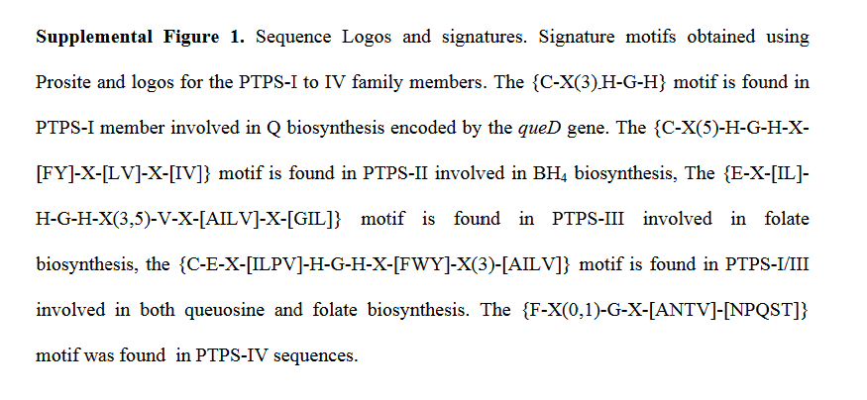

FOLA

<https://www.uniprot.org/uniprot/P0ABQ4>

http://www.pantherdb.org/panther/family.do?clsAccession=PTHR22778:SF16

<https://www.ncbi.nlm.nih.gov/Class/Structure/pssm/pssm_viewer.cgi?mode=Position&cd=cd00209>

<http://pfam.xfam.org/family/PF00186>

FOLM

<https://www.uniprot.org/uniprot/P0AFS3>

<http://www.pantherdb.org/panther/family.do?clsAccession=PTHR43639:SF1>

FolM belongs to a subset of the short-chain dehydrogenase/reductase (SDR) family having the characteristic motif TGX3RXG (in place of TGX3GXG, which typifies other SDRs).

FOLK

<https://www.uniprot.org/uniprot/P26281>

<https://www.ncbi.nlm.nih.gov/Class/Structure/pssm/pssm_viewer.cgi?mode=Position&cd=cd00483>

<http://pfam.xfam.org/family/PF01288>

<http://www.pantherdb.org/panther/family.do?clsAccession=PTHR43071:SF1>

<http://tigrfams.jcvi.org/cgi-bin/HmmReportPage.cgi?acc=TIGR01496>

FOLP

https://www.uniprot.org/uniprot/P0AC13

<http://pfam.xfam.org/family/PF00809>

<https://www.ncbi.nlm.nih.gov/Class/Structure/pssm/pssm_viewer.cgi?mode=Position&cd=cd00739>

<http://tigrfams.jcvi.org/cgi-bin/HmmReportPage.cgi?acc=TIGR01496>

<http://www.pantherdb.org/panther/family.do?clsAccession=PTHR20941:SF1>

FOLC

<https://www.uniprot.org/uniprot/P08192>

<http://tigrfams.jcvi.org/cgi-bin/HmmReportPage.cgi?acc=TIGR01499>

http://www.pantherdb.org/panther/family.do?clsAccession=PTHR11136

FOLC2

https://www.uniprot.org/uniprot/O84617

<http://tigrfams.jcvi.org/cgi-bin/HmmReportPage.cgi?acc=TIGR04132>

go to the ftp site and get v15 HMM file

<ftp://ftp.jcvi.org/pub/data/TIGRFAMs/>

read <ftp://ftp.jcvi.org/pub/data/TIGRFAMs/NEW_TIGRFAMs_RELEASE.adapt_release.15>

to see how to get the HMMs

Tutorials to do

How to Download HMMs from family databases

Panther

TIGRFAM

PFAM

How to create HMM from PSSM ( CDD database)

How to create your own HMM

How to get get your Profile from Prosite

How to create your profile?

How to choose your genomes in PATRIC