EROL KOÇOĞLU - 150200107
UML DIAGRAM OF CLASSES
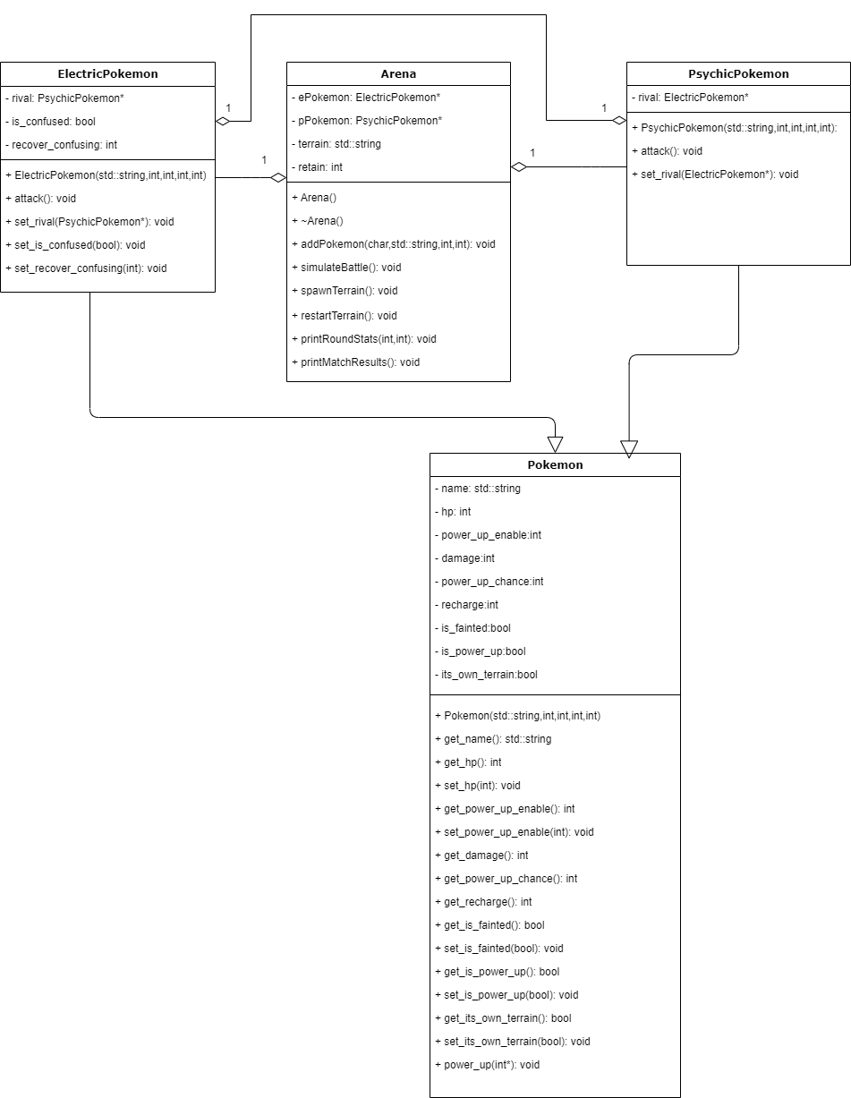
All fields are private. Also; name, damage, power_up_chance and recharge are constant. An arena has 1 ElectricPokemon* and 1 PsychicPokemon*. ElectricPokemon has 1 PsychicPokemon rival and PsychicPokemon has 1 ElectricPokemon rival. These two types of classes are inherited from Pokemon class. The battles are carried out by the arena through making pokemons attack each other one by one until one of them is fainted. They attack each other with attack() methods by decreasing their HPs.

