**Clinical Data Management: E-CRF Applications, a Brief Survey**

Erol Özkan

Department of Computer Engineering

Hacettepe University

Ankara, Turkey

erolozkan@outlook.com

ABSTRACT

CDM is the generation of high quality, reliable, statistically robust data from clinical trials. Generated data is useful from drug development to marketing. It helps to evaluate medicines, find answers to the research questions and proving or disproving hypothesizes. In this review, we will explain practices implemented in CDM in order to collect high quality data. We will explain standards and guidelines, processes, and roles with different responsibilities in CDM. Furthermore, we will review and compare different governmental, commercial and open source CDM tools in terms of their functionality.

KEYWORDS

Clinical Data Management; CDM processes; CDM standards and guidelines; CDM roles and responsibilities; CDM tools.

ACM Reference format:

Erol Özkan. 2018. Clinical Data Management: E-CRF Applications, a Brief Survey. *CMP652 - Next Generation Database Management Systems (Spring 2018)*, *Department of Computer Engineering, Hacettepe University, 6 pages.*

1  INTRODUCTION

CDM is the process of collection, cleaning, and management of data from clinical trials [1]. Generated data is used to prove or disapprove hypothesis and evaluate medicines. Thus, the type and quality of the data plays a very important role. In this respect, the key objective of CDM is to offer high quality data by keeping the number of errors and missing data as low as possible [2]. To meet this objective, various practices are implemented to ensure that the obtained data is complete and accurate.

Firstly, CDM has standards and guidelines. Some standards are applied to ensure that the collected data is complete, valid and reliable. Along with these standards, there are guidelines, which explains the best practices in CDM. Secondly, CDM has different processes. Data managed in various processing steps. This ensures that the data is error-free, valid, and statistically sound. Finally, there are variety of roles with different responsibilities in CDM. Different team members actively involved in all stages of CDM activities.

Collection of high quality data in CDM is facilitated by the use of software applications [2]. These applications are named Clinical Data Management Systems (CDMS). They offer various functionalities that help to collect high quality data in CDM. Furthermore, they help for management and storage of collected data. These systems have enabled CDM to handle large trials and ensure the data quality even in large and complex trials [2].

CRF (case report form) is employed in CDM, also in CDMS. The data in clinical trials are documented using these forms [2].

1.1  High Quality of Data

High quality data can be defined as the data, which is suitable and accurate for statistical quantification. Since generated data is highly important in CDM, data should be complete, accurate, reliable, valid and statistically robust. In addition, it should have minimal or no misses. Most importantly, generated data should have “acceptable level of variation”. It should not affect the conclusion of the study [1]. Furthermore, the data should satisfy the protocol specific parameters and it should be compliable with the protocol necessities [2].

Without high quality of data, companies would not be able to provide the safety and efficacy validations for medicines. Unfortunately, in today’s high-pressured, fast-paced clinical development environment a huge challenge exists with the cleanliness, completeness and quality of clinical trial data. Clinical teams are spending valuable time cleaning data rather than analyzing it.

In this review, we will cover the general aspects of CDM. We will explain standards and guidelines, processes, and roles with assigned responsibilities in CDM. In addition, we will review and compare both commercial and open source CDM tools.

The remainder of the paper is organized as follows. In Section 2, we explain the related work. In Section 3, CDM standards and guidelines are reviewed. In Section 4, we detail the activities performed to collect high quality data in CDM. Roles with assigned responsibilities are explained in Section 5. In Section 6, CDM tools are detailed and compared. Finally, we conclude our work in Section 7.

2  RELATED WORK

**Krishnankutty et al. [1]** review the data management practices in clinical researches. They give an overview of the tools and standards adopted in CDM as well as the roles and responsibilities. In addition, they cover processes involved in CDM.

**Gazali et al. [2]** review the artificial intelligence based clinical data management systems. They cover the general aspects of the clinical data management systems and point out the importance of CRF and the data management procedures. In addition, they review some tools and discuss how CDM tools perform various functions to keep the data in a managed, secured and an accessible form.

**Lu and Su [3]** explain the current status, challenges, and future directions for CDM. They discuss sponsor and site users needs, processes, the standard operating procedures, work practices, guidelines, and business documents in CDM. In this viewpoint, they focus on some topics critical to CDM.

**Matkar and Gangawane [4]** give their reader an outline of data management within a clinical research. They review practices followed along with activities involved in CDM. They explain CRF annotation, CRF designing, data extraction, data entry, data validation, database designing, database locking, discrepancy management and medical coding. In addition, they point out regulatory requirements remains to be filled in these activities.

**Manickavasakam and Sofia [5]** provide an overview of data quality management practices in CDM. They discuss following headings: database, data validation, kinds of data, documents that govern data management, ICH guidelines, data handling and management, electronic data processing, clinical data management audits, database closure, data storage, data archival and recent advances in CDM.

3  Standards and Guidelines

Industry relies on the data for evaluation of medicines. CDM must provide high-quality data. Hence, CDM has standards and guidelines that is adopted [1]. Some procedures and controls are put in place to ensure the authenticity, integrity and confidentiality of data [1]. In CDM, the collection and management of data is done in accordance with regulatory standards and guidelines.

**The Code of Federal Regulations (CFR)** is the general and permanent rules and regulations published in the Federal Register in USA [6]. It is divided into 50 titles, which includes various subjects such as; agriculture, aliens and nationality, animals and animal products, food and drugs [6]. In USA, the data submitted to regulatory authorities must be collected according to 21 CFR part 11. 21 CFR part 11 is applicable to records in electronic format, which are created, modified, maintained, archived, retrieved, or transmitted [7]. These rules try to ensure that collected data accurate, reliable, and consistent. There are many CDM systems available, which are named 21 CFR part 11-compliant. These systems try to ensure accuracy of data with the use of secure, computer-generated, time-stamped audit trails.

**Good Clinical Practice (GCP)** is an international ethical and scientific quality standard for the performance of a clinical trial on medicinal products involving humans [8]. It describes the ethical and scientific aspects of a clinical trial and includes all aspects in CDM from the trial start to are reported [8]. According to the GCP, it is obligatory for the investigator to ensure the accuracy, legibility, completeness and timeliness of the data. This includes ensuring the completion of all the sections including header with identifying items in CRF, properly checking the alterations that have been made, proper record and documentation of adverse events.

**Good Clinical Data Management Practices (GCDMP)** is a guideline that explains the best practices for CDM [9]. It was published in September 2000 by Society for Clinical Data Management (SCDM). However, it has undergone several revisions thereafter. GCDMP covers the CDM process by highlighting the minimum standards and best practices in 20 chapters [9]. Currently, it is the industry standard and is used as a guidance tool for clinical data managers when preparing for CDM training and education [1].

**The Study Data Tabulation Model Implementation Guide for Human Clinical Trials (SDTMIG)** and **The Clinical Data Acquisition Standards Harmonization (CDASH)** are two more guides that was developed by Clinical Data Interchange Standards Consortium (CDISC) [10]. SDTMIG describes the details of model for the data along with standard terminologies in CDM [11]. It serves as a guide to the organization by defining the basic standards for the collection of data in a clinical trial [11]. CDASH defines the basic standards for the collection of data in a clinical trial and enlists the basic data information needed from a clinical, regulatory, and scientific perspective [12].

3.1  Standards and Guidelines in Turkey

**In Turkey,** the process of collecting and managing clinical data is done in accordance with constitution law [13]. More specifically, data is managed and shared according to Article 56 of constitution law, Law No. 3359 with Article 8 of Law No. 663 [13]. In addition, a guide which was developed by ministry of health explains the best practices should be followed in clinical trials [14]. Furthermore, personal data protection law protects the privacy of the patient [15].

4  CDM Processes

CDM is designed to deliver an error-free, valid, and statistically robust data. To meet this objective, there are various activities involved in CDM. Some of these activities are shown in Figure 1.

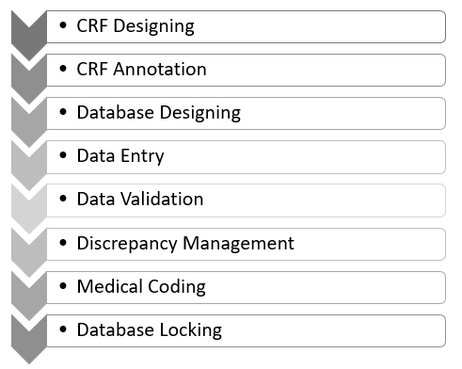

Figure 1: CDM Activities

In CDM, many activities are performed. These activities are executed with a Data Management Plan (DMP) and a Data Validation Plan (DVP). DMP is a road map to handle the data. It includes a description of the activities to be followed in CDM. DVP is to identify the discrepancies in the data. It contains edit-checks to be performed to validate the data.

**CRF Designing** is the first step in CDM. In CRF design, a Case Report Form (CRF) is designed [4]. CRF try to get input from the investigators. To design the CRF forms, CDM personnel identifies the data items to be collected and the frequency of collection regarding the visit plan of the patient in the trial. CRF forms should be concise, self-explanatory, and user-friendly. The data fields should be clearly defined and consistent. An example CRF is shown in Figure 2.

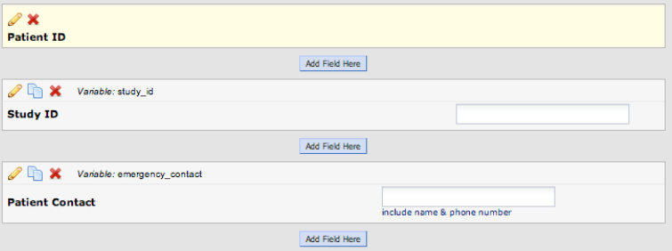

Figure 2: An example CFR

**CRF Annotation** is a CDM process that the filling instructions are attached to the CRF [4]. Annotations try to get error-free data from the investigators. Annotations are especially useful with questions that have discrete value options by coding all possible options for the question [1].

**Database Design** phase involves the design process of database for the CDM tasks to carry out [4]. In CDM, data is collected and stored in a database. Databases can store varying details including; objectives, intervals, visits, investigators, sites and patients [1]. The exact design of the database depends on the CDM application.

**Data Collection** is done utilizing the CRF. CRF may exist in the form of a paper or an electronic version (e-CRF) [1]. In case of Paper CRF, Paper is employed to collect the data. Individuals translate the data to the database by means of data entry. Meanwhile, in case of e-CRF, the data is entered directly at a site by investigator. There is a less chances of error and discrepancies are resolved faster. In addition, there is a reduced time to collect data.

**CRF Tracking** phase includes the monitoring entries for completeness. CDM team tracks the retrieved CRFs and maintain their record. Checks in phase include missing pages, missing data and illegible data. If there is a problem, a clarification is obtained from the investigator.

**Data Entry** takes place according to the guidelines prepared along with the DMP. Data Entry is only applicable to the paper CRF. Usually, two operators perform the data entry. This ensures that there is a lesser error rate, cleaner database, and the collected data is more consistent. In addition, it helps to identify the transcription errors and discrepancies.

**Data Validation** is the validation process that data is tested for validity. In this phase, discrepancies are identified. Discrepancy is defined as a data point that fails to pass a validation check. Discrepancies may be due to inconsistent data, missing data, range checks, and deviations. To identify discrepancies check programs are written. For example, if the age of the patient should be between 18-65 years, a discrepancy generated when this condition is not met.

**Discrepancy Management** helps to clean the data for deviations. In this phase, responsible team members review the discrepancies and try to resolve these discrepancies with the documentary proof. In addition, they investigate the reason. When a resolution is provided, discrepancy will be closed and the database will updated. Otherwise, discrepancies are marked as irresolvable. Discrepancy management is an important step for collection of cleaner data. That is why it is executed at regular intervals.

**Medical Coding** is the process that reported medical terms in the CRF are identified and classified. Investigators may use different terms for the same events. In this phase, medical terminologies are classified to ensure data consistency and avoid unnecessary duplication [4]. Medical coding requires the knowledge of medical terminology, disease entities, drugs, pathological processes [1]. In addition, it requires knowledge about the structure of electronic medical dictionaries for classifications [1]. For this reason, some medical dictionaries are used such as MedDRA and WHODD [4].

**Database Locking** is the CDM process that database is locked for before final analyses. Final validations may be run before locking as a quality check and assurance. These validations may be in the form of a checklist. After final validations are passed, the database is locked. Statistical analysis, data extraction and archival follows the database locking process [4].

4  Teams and Responsibilities

CDM requires a variety of roles and responsibilities [1]. These roles take part in all stage of CDM. Some roles in CDM includes; data manager, database designer, medical coder, clinical data coordinator, quality control associate and data entry associate [16]. **Data manager** supervises the CDM process. Prepares the DMP, approves the procedures and documents related to CDM activities [16]. **Database designer** performs the CRF annotation, creates the study database, enables data validation, designs data entry screens and performs edit checks using dummy data [16]. **Medical coder** codes variations such as adverse events and medical history [16]. **Clinical data coordinator** designs the CRF, prepares the filling instructions and develops discrepancy protocols [16]. **Quality control associate** checks the accuracy of data entry and performs data audits [16]. Finally, **data entry associate** tracks the receipt of CRF pages and enters data into the database [16].

4  Clinical Data Management Systems (CDMS)

Quality of clinical data can successfully be achieved by the clinical data management system (CDMS) [2]. CDMS support all the aspects of a clinical trial starting from submission of the study to the archival [2]. Many organizations such as the medical, research, biotechnology and pharmaceuticals are relying on the data collected from CDMS [2]. These tools enables the collection of high quality data even in complex and large trials [1].

CDM tools accelerate the timeline of the study and control cost of the study. They have ability to provide accurate predictions for the clinical trials. They enable a modeling, scheduling, recruiting, and assisting CDM [2]. They implement the guidelines and standards for CDM. They maintain audit trail and provide easy identification and resolution of data discrepancies.

There are a variety of systems that are used as CDM tools. Most of these tools are commercial but there are also some open source tools available. In addition, there exists tools that supported by governmental agencies. Some of governmental, commercial and open source tools are shown in Table 1.

Table 1: Some CDM Tools

|  |  |  |
| --- | --- | --- |
| Governmental | Commercial | Open Source |
| E-nabız | Redcap,  OpenClinica,  ClintrialWorks,  Eclinical Suite,  Macro,  Oracle Clinical. | TrialDB,  OpenCdms,  Phosco. |

Commercial tools include Redcap, OpenClinica, Oracle Clinical, ClintrialWorks, Macro and Eclinical Suite. One drawback of these tools is that they are expensive [2]. Among open source tools, there are OpenCdms, TrialDB, and Phosco. They are available as free of cost. Unfortunately, some of them are at the end of their life cycle.

4.1  Comparison of CDM Tools

CDM systems have the necessary features for monitoring and processing quality in clinical trials [2]. They maintain audit history and thereby offer uncomplicated access to data inconsistencies [2].

Comparison of CDM Tools is given in Table 2.

**E-Nabız** is a web-based application where the health data of Turkish citizens are collected by health institutions [17]. Collected data can be accessed by citizens via internet or mobile devices. Health information and medical background of citizens are managed and reached from a single place. It aims to increase the quality and speed of the diagnosis and treatment process by establishing a strong communication network between patients and investigators [17]. Example screenshot of E-Nabız is shown in Figure 3.

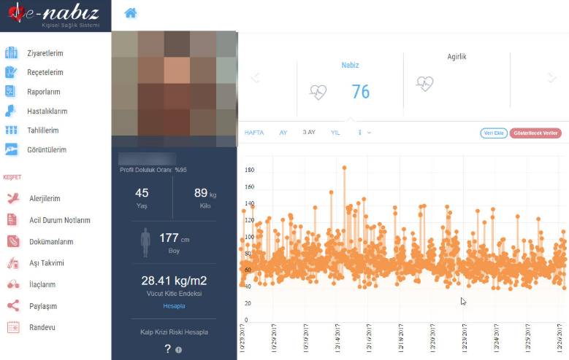

Figure 3: A screenshot of E-Nabız

**REDCap** is a secure web application for building and managing online surveys and databases [18]. It is used to collect data compliant with 21 CFR Part 11, FISMA, and HIPAA [18]. It is designed and developed by Vanderbilt University. It does not require any programming skills and there is no need to set up a database. It supports easy exports, daily backups and audit trail [19]. It is a very robust tool and users are in control of their data. However, some users reported that it does have a learning curve and users make some mistakes using the software [19].

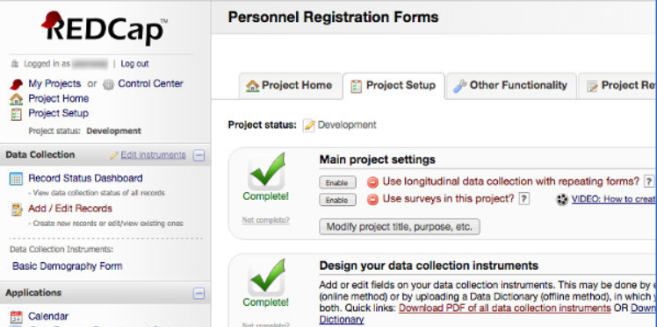

Figure 4: A screenshot of RedCap

**OpenClinica** is a powerful electronic data capture and clinical data management tool with data visualization and reporting capabilities [20]. It has drag-and-drop design interface, real-time edit checks, skip logic, and auto-save features [20]. It supports emails, randomization, annotations, edit checks and queries [20]. In addition, it is compliant with GCP, 21 CFR Part 11 and HIPAA. Unfortunately, there is both commercial and community versions of the software, and community version lacks most of the features such as drag-and-drop design interface, real-time edit checks, and offline data capture [20].

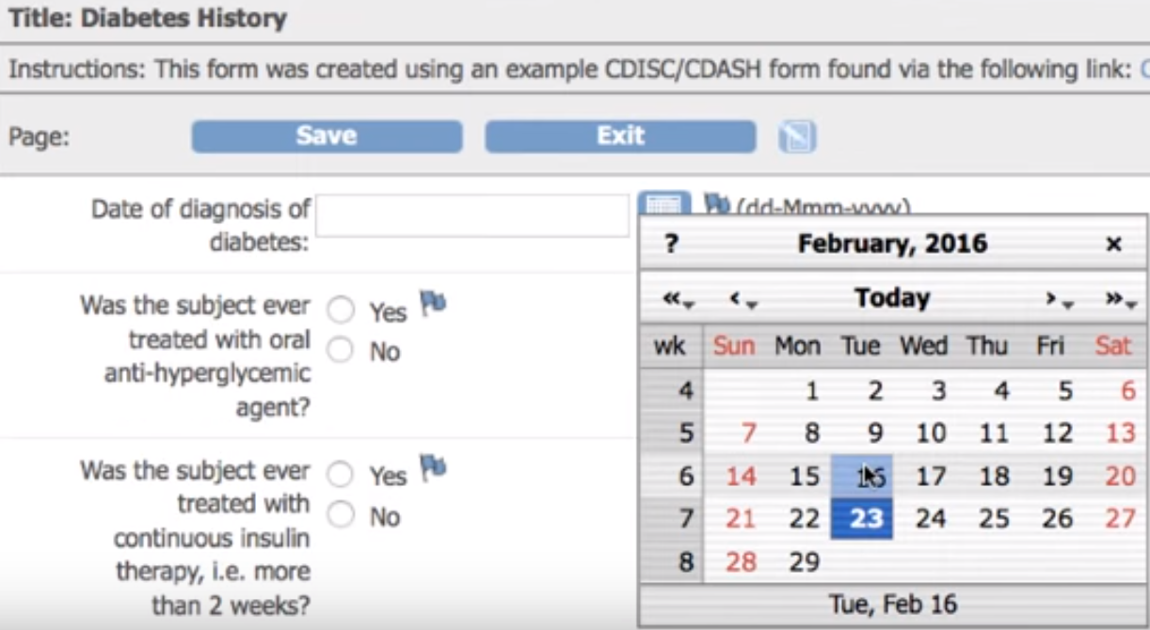

Figure 5: A screenshot of OpenClinica

**ClinTrial-Works** is a clinical trial management system that was developed by a small company with the same name [21]. It is affordable, reliable, secure cloud-based technology solution for clinical trials [21]. It stores study participants with search capabilities [22]. It holds information of patients, patient visits, communications, diagnostics and medications [22]. It has financial management, scheduling and reporting capabilities. It can store online documents along with many details [22]. However, it does not allow for customized CRF [22].

Table 2: Comparison of CDM Tools

|  |  |  |  |  |  |  |  |  |  |  |
| --- | --- | --- | --- | --- | --- | --- | --- | --- | --- | --- |
|  | **E-Nabız** | **Redcap** | **Open-Clinica** | **Clintrial-Works** | **Eclinical Suite** | **Macro** | **Oracle Clinical** | **TrialDB** | **Open-CDMS** | **Phosco** |
| **Commercial** | X | **√** | **√** | √ | √ | √ | √ | X | X | X |
| **Customizable CRF** | X | **√** | **√** | X | √ | √ | √ | √ | √ | √ |
| **Data Entry** | √ | √ | √ | √ | √ | √ | √ | √ | √ | ? |
| **CFR Annotation** | ? | **√** | **√** | ? | √ | √ | **√** | **√** | **√** | **√** |
| **Data Validation** | ? | **√** | **√** | ? | √ | √ | **√** | **√** | **√** | √ |
| **Visualization/Reporting** | ? | √ | √ | √ | √ | √ | √ | √ | ? | ? |
| **Data Import/Exports** | ? | √ | √ | ? | √ | √ | √ | ? | √ | ? |
| **Medical Coding** | ? | ? | ? | ? | √ | √ | ? | √ | ? | ? |
| **User Management** | √ | √ | ? | √ | √ | √ | √ | √ | √ | ? |
| **Query Management** | ? | X | √ | √ | ? | ? | √ | ? | ? | ? |
| **Audit Trail** | ? | √ | √ | √ | √ | √ | √ | ? | √ | ? |
| **E-mail Support** | ? | √ | √ | ? | √ | √ | ? | ? | √ | ? |
| **Skip Logic** | ? | √ | ? | ? | ? | ? | ? | √ | ? | ? |
| **Randomization** | ? | X | √ | ? | ? | ? | √ | ? | √ | ? |
| **Financial Management** | X | X | X | √ | X | X | X | X | X | X |
| **GCP Compliant** | ? | ? | √ | ? | ? | ? | ? | ? | ? | ? |
| **FISMA Compliant** | ? | √ | √ | ? | ? | ? | ? | √ | ? | ? |
| **CFR part 11 Compliant** | ? | √ | √ | ? | √ | √ | √ | ? | ? | ? |
| **HIPAA Compliant** | ? | √ | √ | ? | √ | ? | √ | ? | ? | √ |
| **Operating Systems** | Owned By  Government | Linux, Unix, Windows, Mac | Linux, Windows | Cloud Based | ? | ? | Windows | ? | End Of Life | Java, End Of Life |

**Eclinical Suite** is a comprehensive, fully validated, 21 CFR 11 compliant and fully customizable web-based clinical trial platform [23]. It provides significant time and cost savings during the course of clinical trial processes and enables users to intelligently manage the complexities of clinical trials [24]. It permits users to submit traceable, reliable and standardized data and allows regulatory agencies to easily audit study conduct and compliance. It supports data management features and powerful real-time queries. Eclinical Suite designed and developed by Axiom Real-Time Metrics and it is provided with technical assistance, helpdesk and training [23].

**Macro** is a electronic data capture tool that supports data integrity, data management and compliance [25]. It allows users to quickly input, monitor and run reports on subject data to collect accurate and reliable data for analysis [25]. It is GCP Compliant and has audit trail capability [25]. It assures that the rights and safety of trial subjects are protected, and collected data is credible and accurate [25]. It supports for drag and drop form design, data monitoring, online and offline data entry, east data imports, data validation and medical coding [25].

**Oracle Clinical** is a CDM system that includes features such as study design, randomization, data entry, batch data loading, custom validation, discrepancy management, and data extraction [26]. It enables management of all clinical data in a single system, improving accuracy, visibility, and data integrity [26]. In addition, it integrates with Oracle databases [27] and Remote Data Capture [27] system by Oracle.

**TrialDB** is a web-based clinical trials database system used for the storage and management of clinical data [28]. It can manage an arbitrary number of studies, with no limits on the number of patients per study or the number of parameters that are tracked [28]. It is used to generate CRFs as web pages and it supports for validation of individual elements based on data type, range, and non-empty checks. In addition, CRFs may include skip logic, which certain elements are dynamically enabled or disabled based on the values of previously entered. It relies on a rich data library that contains information about clinical facts that has a high-order grouping. Also, access to a number of vocabularies such as ICD-10, DSM-IV, the Cerner/Multum Drug Lexicon, the NCI Common Toxicity Criteria are supported [28]. It is designed and maintained by Yale University and it is freely available under the GNU General Public License [29].

**OpenCDMS** is a community effort to develop a robust, commercial-grade, full-featured and open source CDMS for studies and trials [30]. It is developed to enable clinical researchers to manage the full life cycle of their clinical research project, from design to archival, without any specialist knowledge of databases or IT systems [30]. OpenCDMS provides visual design interface to develop, implement, and manage large-scale studies and trials. It has customizable data set definitions, validation rules and scheduling [31]. It support for randomization, emails, SMS text messages, reporting. In addition, it supports audit trail, easy data import/exports and role based access control [31].

**Phosco** is a complete electronic data capture system used in clinical trials [32]. It has a GUI for designing CRF along with databases. It is written in Java and supports ANSI-standard SQL engines. It has data validation, monitoring, discrepancy management and audit trail capabilities. It has a low-cost commercial license and an essentially free academic license [32].

4  Conclusion

CDM is process of the generation data from clinical trials. Generated data is used for drug development to marketing. That is why; data should be complete, accurate, reliable, valid and statistically robust. In this review, we explained general aspects of CDM, including; standards and guidelines, processes, and roles with assigned responsibilities. Furthermore, we reviewed and compared different governmental, commercial and open source CDM tools in terms of their functionality.

We conclude that, there is a huge amount of clinical data that is generated from clinical trials. Hence, some standards and best practices must be followed. In addition, some proven activities must be performed. Thankfully, technological advancements have let to these activities carried out in CDM tools. In return, collection of high quality data in even in large and complex trials became possible. Regardless of the challenges, CDM is rapidly developing into a standardized system. Future directions may be on the confidential collection and submission of subject data in clinical trials.

REFERENCES

1. Krishnankutty, B., Bellary, S., Kumar, N.B.R., Moodahadu, L.S., Data management in clinical research: An overview, Indian J Pharmacol, **2012**.
2. Gazali, Kaur, S., Singh, I., Artificial intelligence based clinical data management systems: A review, Informatics in Medicine Unlocked, **2017**.
3. Lu, Z., Su, J., Clinical data management: Current status, challenges, and future directions from industry perspectives, Open Access Journal of Clinical Trials Dovepress, June **2010**.
4. Matkar, S., Gangawane A., An outline of data management in clinical research, International Journal of Clinical Trials, **2017**.
5. Manickavasakam, Sofia, H.N., Data Management in Clinical Research. Journal of Siddha, vol:2, Issue:1, page.no.60-66. 2. 60-66., **2009**.
6. General Information About Code of Federal Regulations (CFR), Access Url: "https://www.govinfo.gov/help/cfr", Last Access: May 2019.
7. Code of Federal Regulations (CFR), CFR Title 21, Access Url: "https://www.fda.gov/media/75414/download", Last Access: May 2019.
8. Good Clinical Practice (GCP), Access Url: "https://www.ich.org/fileadmin/Public_Web_Site/ICH_Products/Guidelines/Efficacy/E6/E6_R1_Guideline.pdf", Last Access: May 2019.
9. Good Clinical Data Management Practices (GCDMP), Access Url: "https://www.mci-registrations.com/be-bruga/mci-registrations/scdm/files/gcdmp/en/2013/Full%20GCDMP%20Oct%202013.pdf", Last Access: May 2019.
10. Clinical Data Interchange Standards Consortium (CDISC), Access Url: "https://www.cdisc.org/", Last Access: May 2019.
11. Study Data Tabulation Model (SDTMIG), Clinical Data Interchange Standards Consortium, Access Url: "https://www.cdisc.org/standards/foundational/sdtm", Last Access: May 2019.
12. The Clinical Data Acquisition Standards Harmonization (CDASH), Clinical Data Interchange Standards Consortium, Access Url: "https://www.cdisc.org/standards/foundational/cdash", Last Access: May 2019.
13. Kişisel sağlık verilerinin işlenmesi ve mahremiyetinin sağlanması hakkında yönetmelik, Regulation for clinical data in Turkey, http://www.resmigazete.gov.tr/eskiler/2017/11/20171124.htm, Last Access: May 2019.
14. Klinik kalite uygulama ve veri kalitesi iyileştirme rehberi (Clinical quality application and data quality improvement guide in Turkey), Access Url: "https://dosyamerkez.saglik.gov.tr/Eklenti/10942,klinik-kalite-uygulama-veri-kalitesi-2pdf.pdf", Last Access: May 2019.
15. Kişisel verilerin korunmasi kanunu (Privacy protection law in Turkey), Access Url: "https://www.mevzuat.gov.tr/MevzuatMetin/1.5.6698.pdf", Last Access: May 2019.
16. Roles Involved in CDM, Access Url: "https://www.mhaonline.com/faq/what-is-clinical-data-management", Last Access: May 2019.
17. E-nabız, Access Url: "https://enabiz.gov.tr/", Last Access: June 2019.
18. Redcap, Access Url: "https://www.project-redcap.org/", Last Access: June 2019.
19. Harris, P., Research Electronic Data Capture (REDCap), Vanderbilt University Medical Center, June **2018**.
20. OpenClinica, Access Url: "https://www.openclinica.com/", Last Access: June 2019.
21. ClinTrial-Works, Access Url: "https://www.clintrialworks.com/index.php", Last Access: June 2019.
22. ClinTrial-Works demo, Access Url: "https://www.youtube.com/watch?v=VuM-v_UJuH4", Last Access: June 2019.
23. Eclinical Suite, Access Url: "https://www.axiommetrics.com/fusion-eclinical-suite/" Last Access: June 2019.
24. Clinical trial management software comparison, eClinical Suite, Access Url: "https://www.capterra.com/p/134289/Fusion-eClinical-Suite/", Last Access: June 2019.
25. Macro, Access Url: "https://www.elsevier.com/solutions/macro", Last Access: June 2019.
26. Powering clinical studies with oracle clinical, Oracle Health Sciences, Oracle Health Sciences (Oracle Data Sheet), Access Url: "http://www.oracle.com/us/industries/life-sciences/045788.pdf", Last Access: June 2019.
27. Oracle health sciences inform: comprehensive clinical data capture and management cloud, Oracle Health Sciences (Oracle Data Sheet), Access Url: "http://www.oracle.com/us/industries/life-sciences/health-sciences-inform-ds-397109.pdf", Last Access: June 2019.
28. Brandt, C.A., Deshpande, A.M., Lu, C., Ananth, G., Sun, K., Gadagkar, R., Morse, R., Rodriguez, C., Miller, PL., Nadkarni, PM., TrialDB: A web-based Clinical Study Data Management System, AMIA Annu Symp Proc, **2003**.
29. TrialDB, Access Url: "http://www.openhealthnews.com/content/trialdb", Last Access: June 2019.
30. OpenCDMS, Access Url: "https://www.medfloss.org/node/408", Last Access: June 2019
31. OpenCDMS project page, Access Url: "https://www.limswiki.org/index.php/OpenCDMS", Last Access: June 2019.
32. Phosco, Access Url: "https://wiki.phosco.info/index.php/Main_Page", Last Access: June 2019.