Abstract
Object Tracking Assignment

Erol Özkan
Department of Computer Engineering, Hacettepe University
erolozkan@outlook.com
Object tracking has become one of the most important problem domains in computer vision during the last decade. It creates basics for many applications, such as automatic video surveillance, autonomous robotic systems, human-computer interfaces, augmented reality, and e-healthcare. A number of different tracking techniques have been developed. However, there are still some limitations that arise from problems such as illuminations and occlusion. In this paper, we review and experiment Kanade–Lucas–Tomasi (KLT) feature tracker. Then, we try to implement a simple object tracker algorithm based on background subtraction technique.

Introduction
Object Tracking is the process of finding the location of one or more moving objects in a video volume. However, the task of detecting and tracking objects in motion is difficult to accomplish; because, the illumination conditions may vary and the object may be non-rigid, articulated, or occluded by background objects. That’s why tracking performance can drop significantly.
In order to solve the above mentioned problems, numerous tracking algorithms have been proposed. In this paper, firstly, we review Kanade–Lucas–Tomasi (KLT) feature tracker and make some test with it. Then we try to implement a simple object tracker algorithm based on background subtraction technique which analyzes the sequential video frames and outputs the segmented objects between frames.
The remainder of this paper is structured as follows. Next section briefly describes the Kanade–Lucas–Tomasi (KLT) Tracker. Section 3 addresses our method for object tracking task. Experimental results and concluding remarks are presented in Section 4 and Section 5 respectively.

Related Word
Object tracking techniques employ different target object representation methods based on appearance based, model based, contour based, feature based and hybrid. Appearance based tracking methods use visual information of object projection like color, texture, shape etc. on image plane. These methods deal with simple object transformations like translation and rotation but sensitive to illumination changes. Model based methods use prior information about object shape. These methods address problem of object tracking under illumination changes, change in object viewing angle and partial occlusion. But their computational cost is more. Contour-based tracking methods track object by considering their outline as boundary contours. These methods enable the tracking of both rigid and non-rigid objects. Feature based methods used to describe objects. This process follows different steps as recognizing and tracking the object by extracting elements, to cluster elements in higher level features and to match these extracted features between images in successive frames. These methods perform well in partial occlusion and in tracking very small objects. The major drawback of feature based methods is the correct distinction between the target object and background features.

Method
A technique that is used for tracking objects in a video volume is called Optical flow. Optical flow technique is used for describing motion in computer vision. It is applied on a series of images. It calculates velocity vectors for points in the images and shows approximate positions of points in the next image sequence. In computer vision, the main problem is calculating optical flow or motion velocity. Due to this problem many techniques have been developed for calculating optical flow. Next section describes an object traction technique called KLT Kanade–Lucas–Tomasi feature tracker.

Kanade–Lucas–Tomasi (KLT) Tracker
Kanade-Lucas-Tomasi(KLT) is a feature-tracking algorithm which tracks a set of points. It is used for many applications such as video stabilization, camera motion estimation, and object tracking. It works particularly well for tracking objects that do not change shape and for those that exhibit visual texture.
Kanade-Lucas-Tomasi method uses differentiation of two frames, in other words it calculates difference between two images. It tracks objects based on Sum of Squared Difference (SSD) criteria which is applied to find the feature point whose window minimizes the following energy function:

The KLT algorithm can be divided into two main parts. During the detection process, salient feature points are found and added to the already existing ones. Then, in the tracking process for each feature point its corresponding motion vector is calculated.

Feature Point Detection
The task here is to detect new feature points in a given image and add them to the already existing feature points. In order to track feature points reliably, their pixel neighborhood should by richly structured. As a measure of “structuredness” of the neighborhood of a pixel p, one can define the structure matrix G as:
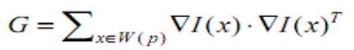

Its eigen values λ1, λ2 (which are guaranteed to be ≥ 0 as the matrix is positive semi-definite) deliver useful information about the neighborhood region W. If W is completely homogenous, then λ1 = λ2 = 0. In contrast, λ1 > 0, λ2 = 0 indicates that W contains an edge and λ1 > 0, λ2 > 0 indicates a corner. Strong corners that have higher λ1, λ2 values are extracted by KLT tracer.
The whole feature detection process is composed of the following steps:
- Calculate structure matrix G and cornerness λ for each pixel in the image I.
- Calculate the maximum cornerness λmax occurring in the image.
- Keep all pixels that have a cornerness λ larger than a certain percentage (5% - 10%) of λmax.
- Do a non-maxima suppression within the 3 x 3 pixel neighborhood of the remaining points to keep only
- The local maxima.
- From the remaining points, add as many new points to the already existing points as needed, starting with the points with the highest cornerness values. To avoid points concentrated in some area of the image, newly added points must have a specific minimum distance (e.g. 5 or 10 pixels) to the already existing points as well as to other newly added points (Minimum-DistanceEnforcement).

Feature Point Tracking
In the tracking step, we denote I as the current image and J as the immediately next image in the sequence. We want to calculate for each feature point p in image I its corresponding motion vector v so that its tracked position in image J is p + v. As “goodness” criterion of v we take the SSD error function

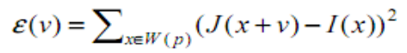

It measures the image intensity deviation between a neighborhood of the feature point position in I and its potential position in J and should be zero in the ideal case. Setting the first derivative of ε(v) to zero and approximating J(x + v) by its first order Taylor expansion around v = 0 results in a better estimate v1. By repeating this multiple times, we obtain an iterative update scheme for v which is summarized below:

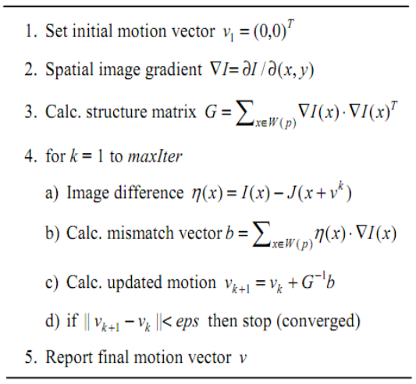

Here, if the quality of a tracked feature point decreases below a chosen threshold, that point is removed from consideration. To compensate, new features are identified in the same window. The feature point with the minimum criteria is retained if its SSD is below a certain threshold.

Multiple Scale Feature Tracking
Most of the point tracker implementations of the KLT algorithm uses image pyramids. In this kind of implementations, each level is reduced in resolution by a factor of two compared to the previous level. This enables the algorithm to track the points at multiple scales which in turn allows the algorithm to handle larger displacements of points between frames. Figure 1 shows image pyramids.
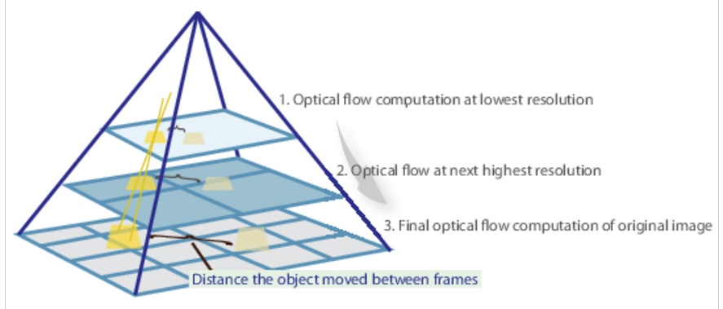
Figure 1 : Image Pyramids

Experimental Results
Firstly we experiment KLT tracer. Figure 2-6 shows the 1, 10, 30, 50 and 83th frames in our video sequence. A KLT tracer implementation is used to track a human who is walking on a street.

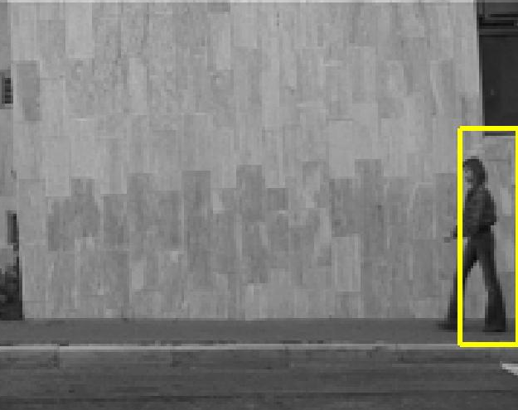
Figure 2 : First Frame

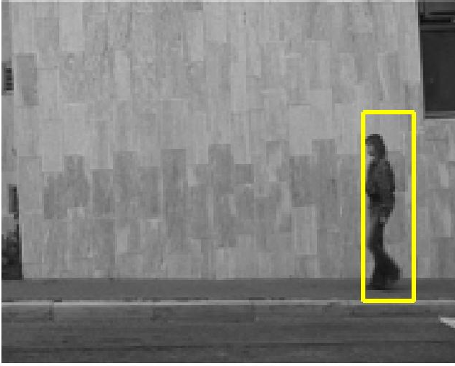
Figure 3 : 10th Frame

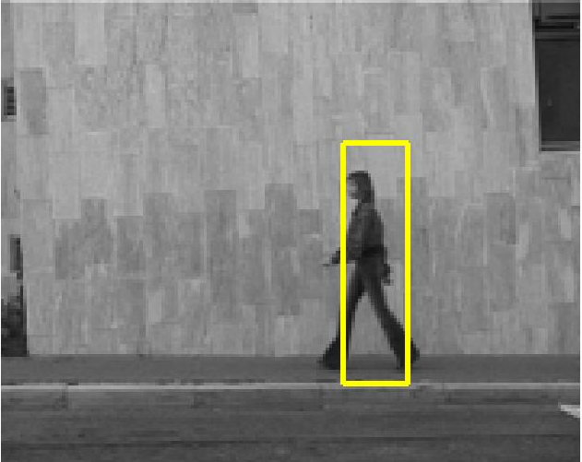
Figure 4 : 30th Frame
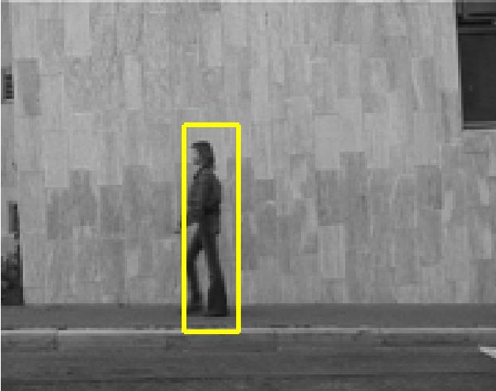
Figure 5 : 50th Frame

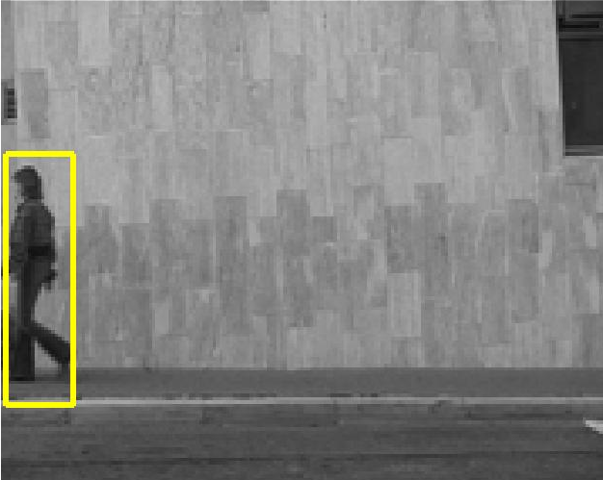
Figure 6 : 83th Frame

Then, we implement a background subtraction method to detect our object. For this purpose we need a background. That’s why we compose multiple frames in a video sequence and use this image as our template. The figure 7-9 shows our background image that is composed of 3, 10, 20 frames respectively.


Figure 7 : Composition of 3 Frames

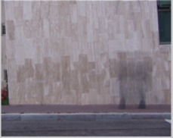
Figure 8 : Composition of 10 Frames


Figure 9 : Composition of 20 Frames

Afterwards, we subsract each frame from our backgournd. Figure 10-12 shows the substracted images from 10 and 20 image backgrounds.

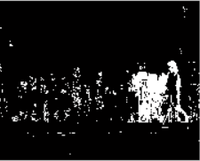
Figure 10 : Subtraction from 10 Frame Background

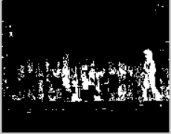
Figure 11 : Subtraction from 20 Frame Background


Figure 12 : Thresholding 10 Frame Subtraction

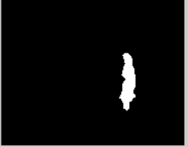
Figure 13 : Thresholding 20 Frame Subtraction

Summary
Visual object tracking is subjected to varying real life situations like illumination changes, affine transformations and speedy motion of the target object. In this paper, we analyzed the Lucas-Kanade method to estimate the direction and the speed of a moving objects in a video volume. Then we implemented a simple object tracker algorithm based on background subtraction technique. We composed multiple images in a video sequence and used this image as our background.

References
- Visual Object Tracking Based on Local Steering Kernels and Color Histograms Olga Zoidi, Anastasios Tefas, Member, IEEE, and Ioannis Pitas, Fellow, IEEE TRANSACTIONS ON CIRCUITS AND SYSTEMS FOR VIDEO TECHNOLOGY VOL:25 NO:3 YEAR 2013.
- Visual tracking and recognition using appearance: Adaptive models in particle filters- S. Zhou, R. Chellappa, and B. Moghaddam IEEE Trans. Image Process., vol. 13, no. 11, pp. 1434–1456, Nov. 2004.
- Understanding the Basis of the Kalman Filter Via a Simple and Intuitive Derivation, Ramsey Faragher , IEEE Signal Processing Magazine SEPT. 2012.
- A. Cavallaro, O. Steiger, and T. Ebrahimi, ―Tracking video objects in cluttered background,‖ IEEE Trans. Circuits Syst. Video Technol., vol. 15, Apr. 2005.
- Tracking of Multiple Objects under Partial Occlusion.C Bing Han, Christopher Paulson, Taoran Lu, Dapeng Wu, Jian Li, SPIE-Research Gate 2009.
- Real-time Visual Tracking of Aircrafts. Ajmal S. Mian. Digital Image Computing: Techniques and Applications 978-0-7695-3456-/08 $25.00 © 2008 IEEE DOI 10.1109/DICTA.2008.33.

