EROL ÖZKAN

Text mınıng

ASSIGNMENT 4

**TABLE OF CONTENT**

IntroductIon 4

Graph Constructıon 4

Samplıng 5

Results 6

Reuters Dataset Results 8

**LIST OF FIGURES**

Şekil 1: Parsed Graph Visualization From Input Matrix 4

Şekil 2 : Graph Visualization - Initial Seeds with "x%3==1” 5

Şekil 3 : Graph Visualization - Initial Seeds with "x%4==1” 6

Şekil 4 : Graph Visualization - Results For "x%3==1” 7

Şekil 5 : Graph Visualization - Results For "x%4==1” 7

**LIST OF TABLES**

Tablo 1 : Input Matrix 4

Tablo 2 : True Labels 5

Tablo 3 : Sampled Set with "x%3==1” 5

Tablo 4 : Sampled Set with x%4==1 6

Tablo 5: Results For “x%3 == 1” & ACCURANCY = 1 6

Tablo 6 : Results For “x%4 == 1” & ACCURANCY = 0,81 7

Tablo 7 : Modulo 2 Operation Seeds Information 8

Tablo 8 : Modulo 20 Operation Seeds Information 8

Tablo 9 : Modulo 100 Operation Seeds Information 8

Tablo 10 : Modulo 500 Operation Seeds Information 8

Tablo 11 : Modulo 2 Operation Accurancy - 0.211850501367 8

Tablo 12 : Modulo 20 Operation Accurancy - 0.238468550593 9

Tablo 13 : Modulo 100 Operation Accurancy - 0.360984503191 9

Tablo 14 : Modulo 500 Operation Accurancy - 0.457064721969 9

# Introduction

In this assignment we try to implement a semi-supervised, transductive learning approach which assumes that each data point can be linearly reconstructed from its neighborhood. We propagate the labels from the labeled points to the whole dataset using their neighborhoods. We test our code on a small dataset as well as on the suplied Reuters dataset.

# Graph Construction

We start with building a graph G = {V, E} where the set of nodes V represents set of documents and E is the set of edges whose weights is the similarities between these documents. We build our graph based on k-NN graph scheme by assigning the most similar documents as edges to every node. So, in our graph, every node pair share an undirected edge when two nodes are k-nearest neighbors. We select k value as 3 in our tests. Also we do not take into account edges with weight below 0.

Table 1 shows an example input matrix.

Tablo 1 : Input Matrix

|  |  |  |  |  |  |  |  |  |  |  |
| --- | --- | --- | --- | --- | --- | --- | --- | --- | --- | --- |
| 0 | 0.7 | 0 | 0 | 0.7 | 0 | 0 | 0 | 0 | 0 | 0 |
| 0.7 | 0 | 0 | 0 | 0.5 | 0 | 0 | 0 | 0 | 0 | 0 |
| 0 | 0 | 0 | 1 | 0 | 0 | 0 | 0 | 0 | 0 | 0.7 |
| 0 | 0 | 1 | 0 | 0.3 | 0 | 0 | 0 | 0 | 0.5 | 0 |
| 0.7 | 0.5 | 0 | 0.3 | 0 | 1 | 0 | 0 | 0 | 0 | 0 |
| 0 | 0 | 0 | 0 | 1 | 0 | 0.5 | 0 | 0.7 | 0 | 0 |
| 0 | 0 | 0 | 0 | 0 | 0.5 | 0 | 0.7 | 0 | 0 | 0 |
| 0 | 0 | 0 | 0 | 0 | 0 | 0.7 | 0 | 1 | 0 | 0 |
| 0 | 0 | 0 | 0 | 0 | 0.7 | 0 | 1 | 0 | 0 | 0 |
| 0 | 0 | 0 | 0.5 | 0 | 0 | 0 | 0 | 0 | 0 | 0.7 |
| 0 | 0 | 0.7 | 0 | 0 | 0 | 0 | 0 | 0 | 0.7 | 0 |

Figure 1 shows the parsed graph based on this input matrix.

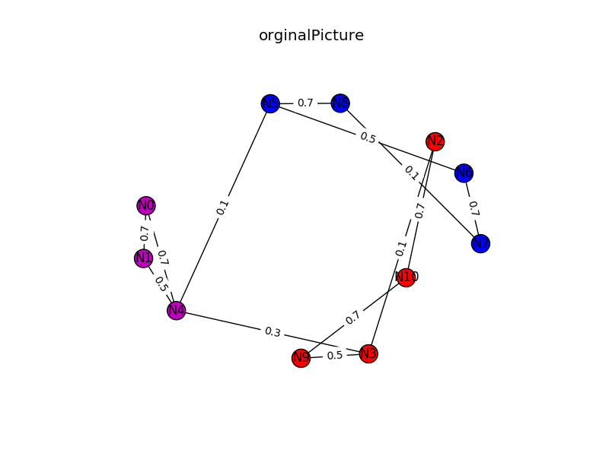

Şekil 1: Parsed Graph Visualization From Input Matrix

# Sampling

For this example, there are 11 vertices in our graph, with the nodes labeled with one of three categories: namely; acq, earn, and interest.

Table 2 shows true labels for this example.

Tablo 2 : True Labels

|  |  |
| --- | --- |
| **Node Name** | **Node Label** |
| N0 | interest |
| N1 | interest |
| N2 | earn |
| N3 | earn |
| N4 | interest |
| N5 | acq |
| N6 | acq |
| N7 | acq |
| N8 | acq |
| N9 | earn |
| N10 | earn |

We sample this set by taking values after desired modulo operation.

Table 3 shows sampled set with “x%3==1”.

Tablo 3 : Sampled Set with "x%3==1”

|  |  |
| --- | --- |
| **Node Name** | **Node Label** |
| N1 | interest |
| N4 | interest |
| N7 | acq |
| N10 | earn |

Figure 2 shows sampled nodes in other words initial seeds in our graph. Here red node represents “earn” class while purple and blue nodes represensts “interest” and “ack” classes respectively.

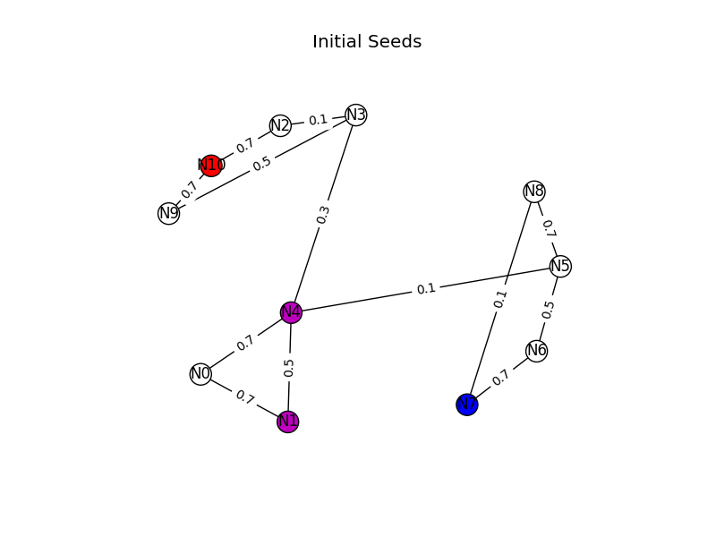

Şekil 2 : Graph Visualization - Initial Seeds with "x%3==1”

We also sample this set with a different modulo operation.

Table 4 shows sampled set with “x%4==1”.

Tablo 4 : Sampled Set with x%4==1

|  |  |
| --- | --- |
| **Node Name** | **Node Label** |
| N1 | interest |
| N5 | acq |
| N9 | earn |

Figure 3 shows sampled nodes in our graph. Again, red node represents “earn” class while purple and blue nodes represensts “interest” and “ack” classes respectively.

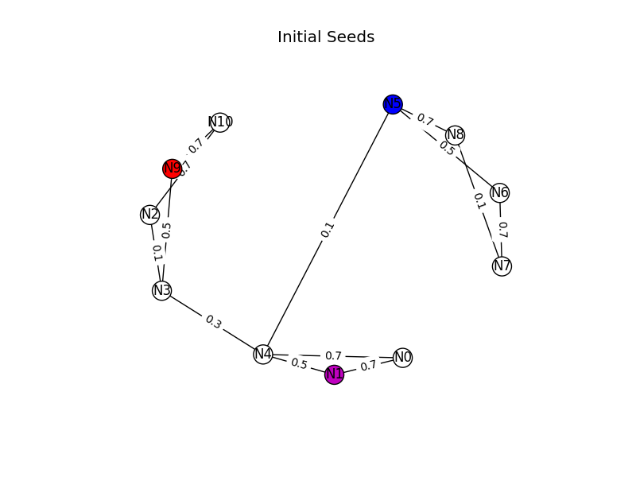

Şekil 3 : Graph Visualization - Initial Seeds with "x%4==1”

# Results

We evaluate our label propagation algorithm and get the following result as shown in Table 6. We are able to get an accurancy of 1.

Tablo 5: Results For “x%3 == 1” & ACCURANCY = 1

|  |  |  |  |  |  |
| --- | --- | --- | --- | --- | --- |
| **time** | **nodeName** | **seedLabel** | **assignedLabel** | **trueLabel** | **result** |
| 2017-01-15 09:45:25.350074 | N10 | earn | earn | earn | True |
| 2017-01-15 09:45:25.350134 | N8 | - | acq | acq | True |
| 2017-01-15 09:45:25.350161 | N9 | - | earn | earn | True |
| 2017-01-15 09:45:25.350177 | N0 | - | interest | interest | True |
| 2017-01-15 09:45:25.350190 | N1 | interest | interest | interest | True |
| 2017-01-15 09:45:25.350204 | N2 | - | earn | earn | True |
| 2017-01-15 09:45:25.350216 | N3 | - | earn | earn | True |
| 2017-01-15 09:45:25.350229 | N4 | interest | interest | interest | True |
| 2017-01-15 09:45:25.350242 | N5 | - | acq | acq | True |
| 2017-01-15 09:45:25.350254 | N6 | - | acq | acq | True |
| 2017-01-15 09:45:25.350267 | N7 | acq | acq | acq | True |

Figure 4 shows labeled graph after label propagation algorithm. Sampled nodes were "x%3==1”.

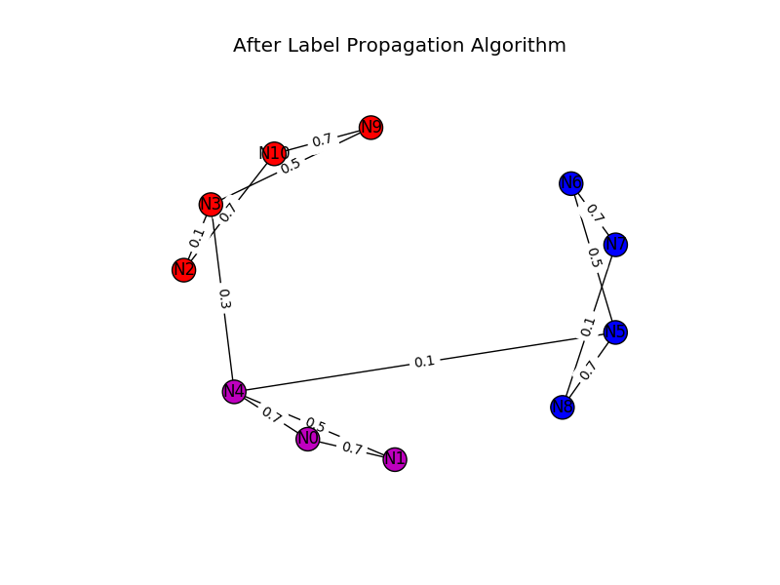

Şekil 4 : Graph Visualization - Results For "x%3==1”

We also evaluate our label propagation algorithm on set sampled with “x%4 == 1”. We are able to get a accurancy of 0,81 here.

Tablo 6 : Results For “x%4 == 1” & ACCURANCY = 0,81

|  |  |  |  |  |  |
| --- | --- | --- | --- | --- | --- |
| **time** | **nodeName** | **seedLabel** | **assignedLabel** | **trueLabel** | **result** |
| 2017-01-15 09:53:29.098965 | N10 | - | earn | earn | True |
| 2017-01-15 09:53:29.099050 | N8 | - | acq | acq | True |
| 2017-01-15 09:53:29.099089 | N9 | earn | interest | earn | False |
| 2017-01-15 09:53:29.099117 | N0 | - | interest | interest | True |
| 2017-01-15 09:53:29.099141 | N1 | interest | interest | interest | True |
| 2017-01-15 09:53:29.099163 | N2 | - | earn | earn | True |
| 2017-01-15 09:53:29.099186 | N3 | - | interest | earn | False |
| 2017-01-15 09:53:29.099210 | N4 | - | interest | interest | True |
| 2017-01-15 09:53:29.099235 | N5 | acq | acq | acq | True |
| 2017-01-15 09:53:29.099260 | N6 | - | acq | acq | True |
| 2017-01-15 09:53:29.099285 | N7 | - | acq | acq | True |

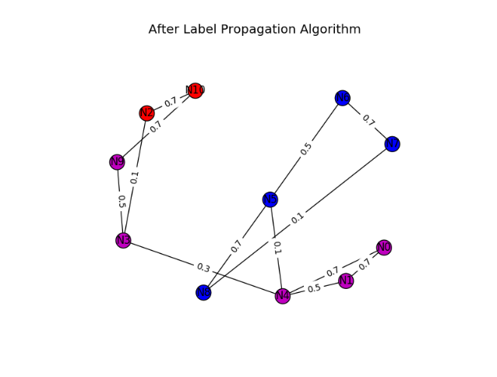

Şekil 5 : Graph Visualization - Results For "x%4==1”

# Reuters Dataset Results

Further, we test our code with suplied Reuters dataset. In suplied dataset there are a total of 5.485 vertices in our graph, with the nodes labeled with one of eight categories: namely; acq, crude, earn, grain, interest, money-fx, ship, trade. We apply different modulo operations (x%2, x%20, x%100, x%500) for sampling and we get the initial seeds that has the following structure.

Tablo 7 : Modulo 2 Operation Seeds Information

|  |  |  |
| --- | --- | --- |
| **Label** | **Number Of Seeds** | **Percentage In Seeds** |
| earn | 1415 | %51.6046681255 |
| money-fx | 117 | %4.26695842451 |
| trade | 135 | %4.92341356674 |
| acq | 788 | %28.7381473377 |
| grain | 22 | %0.802334062728 |
| interest | 105 | %3.82932166302 |
| crude | 108 | %3.93873085339 |
| ship | 52 | %1.89642596645 |

Tablo 8 : Modulo 20 Operation Seeds Information

|  |  |  |
| --- | --- | --- |
| **Label** | **Number Of Seeds** | **Percentage In Seeds** |
| earn | 145 | %52.7272727273 |
| money-fx | 9 | %3.27272727273 |
| trade | 16 | %5.81818181818 |
| acq | 77 | %28.0 |
| grain | 1 | %0.363636363636 |
| interest | 7 | %2.54545454545 |
| crude | 12 | %4.36363636364 |
| ship | 8 | %2.90909090909 |

Tablo 9 : Modulo 100 Operation Seeds Information

|  |  |  |
| --- | --- | --- |
| **Label** | **Number Of Seeds** | **Percentage In Seeds** |
| earn | 35 | %63.6363636364 |
| money-fx | 2 | %3.63636363636 |
| trade | 2 | %3.63636363636 |
| acq | 11 | %20.0 |
| interest | 1 | %1.81818181818 |
| crude | 4 | %7.27272727273 |

Tablo 10 : Modulo 500 Operation Seeds Information

|  |  |  |
| --- | --- | --- |
| **Label** | **Number Of Seeds** | **Percentage In Seeds** |
| earn | 6 | %54.5454545455 |
| acq | 4 | %36.3636363636 |
| interest | 1 | %9.09090909091 |

We calculate accurancy after applying label propagaion algorithm and get the following results.

Tablo 11 : Modulo 2 Operation Accurancy - 0.211850501367

|  |  |
| --- | --- |
| **Label** | **Number Of Nodes** |
| trade | 997 |
| crude | 829 |
| earn | 794 |
| interest | 704 |
| acq | 648 |
| grain | 590 |
| money-fx | 480 |
| ship | 443 |

Tablo 12 : Modulo 20 Operation Accurancy - 0.238468550593

|  |  |
| --- | --- |
| **Label** | **Number Of Nodes** |
| acq | 1446 |
| earn | 1033 |
| trade | 922 |
| interest | 700 |
| ship | 538 |
| crude | 480 |
| money-fx | 313 |
| grain | 53 |

Tablo 13 : Modulo 100 Operation Accurancy - 0.360984503191

|  |  |
| --- | --- |
| **Label** | **Number Of Nodes** |
| earn | 2141 |
| acq | 1828 |
| crude | 685 |
| interest | 432 |
| money-fx | 247 |
| trade | 152 |

Tablo 14 : Modulo 500 Operation Accurancy - 0.457064721969

|  |  |
| --- | --- |
| **Label** | **Number Of Nodes** |
| earn | 2973 |
| acq | 2319 |
| interest | 193 |

What we choose will propagate more than others…