CISC 327 A4 (Fall 2025)
Eron Chung (20393151)
Date: Dec 2, 2025
Repository: https://github.com/EronChung/cisc327-library-management-a2-3151

E2E Testing Approach
For my E2E tests, I used Playwright to automate user flow tests in a browser session.
The tests run through adding, borrowing, and removing a book, and can be found in `tests/test_e2e.py`.

Test # | Actions | Expected Results
1 | - Assert that the page title is correct (sanity check to see if on the right page)  - Go to the “Add book” page  - Fill in the fields and click “Add book to catalog” (this sends you back to the catalog page)  - Borrow the newly added book with the patron ID `123456`  - Assert that the confirmation UI element appeared | - No runtime errors  - Confirmation UI element appeared for borrow
2 | - Assert that the page title is correct (sanity check to see if on the right page)  - Go to the “Return book” page  - Fill in the fields and click “Process return”  - Assert that the confirmation UI element appeared  - Fill in the fields for a different book and click “Process return”  - Assert that the error UI element appeared | - No runtime errors  - Confirmation UI element appeared for return  - Error UI element appeared for invalid return

Execute Instructions
- Clone repository
- Run `python -m venv venv` to create virtual environment
- Run `source venv/bin/activate` in Linux, or `venv\Scripts\activate` on Windows
- Run `pip install -r requirements.txt` to install dependencies

- Run `python app.py`
- In a new terminal, run `pytest tests/test_e2e.py --headed --slowmo 500` to run E2E tests

- Run `docker build -t library-app .` to build the Docker container
- Run `docker container run -p 5000:5000 library-app` to run the container

Dockerization

Build
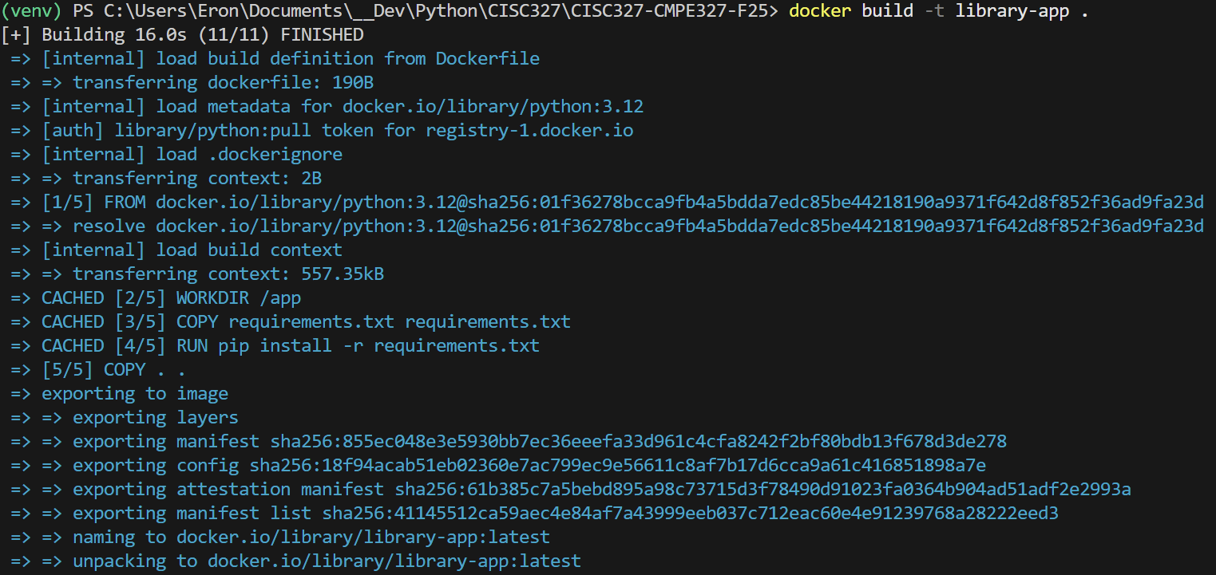

Run
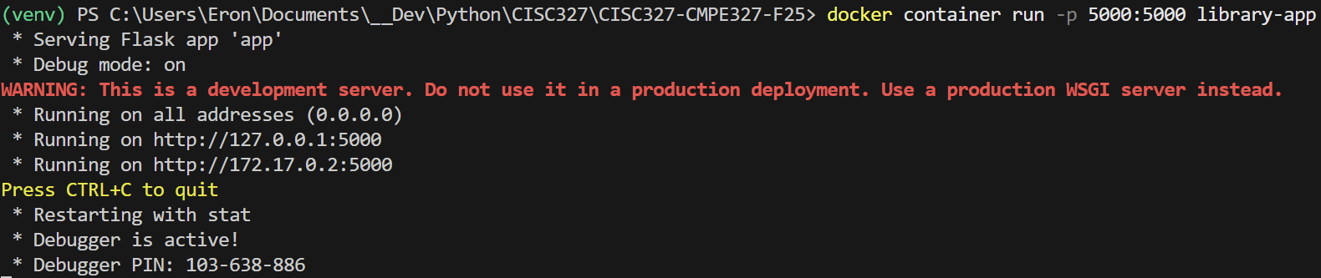

Docker Hub

Push
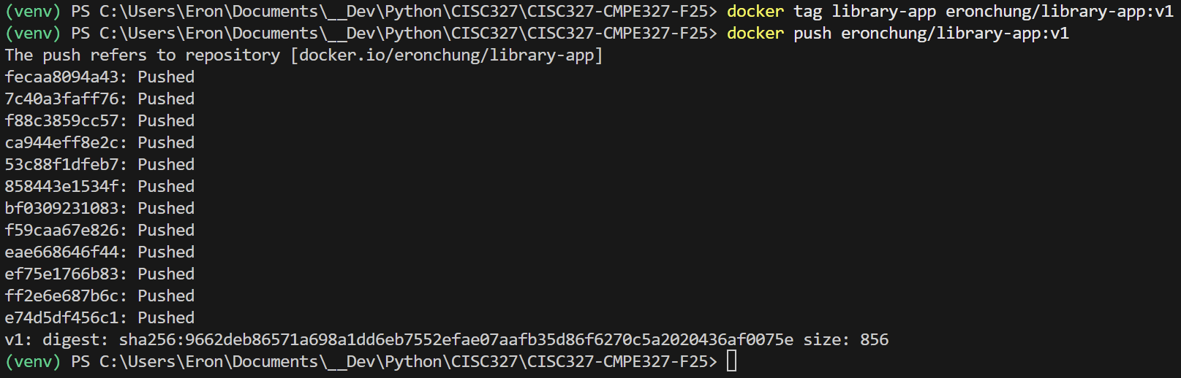
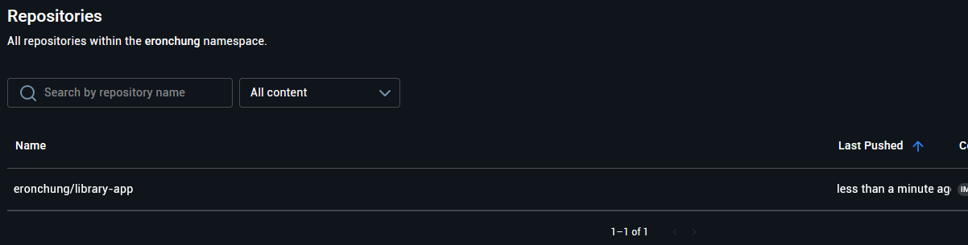

Pull and Run
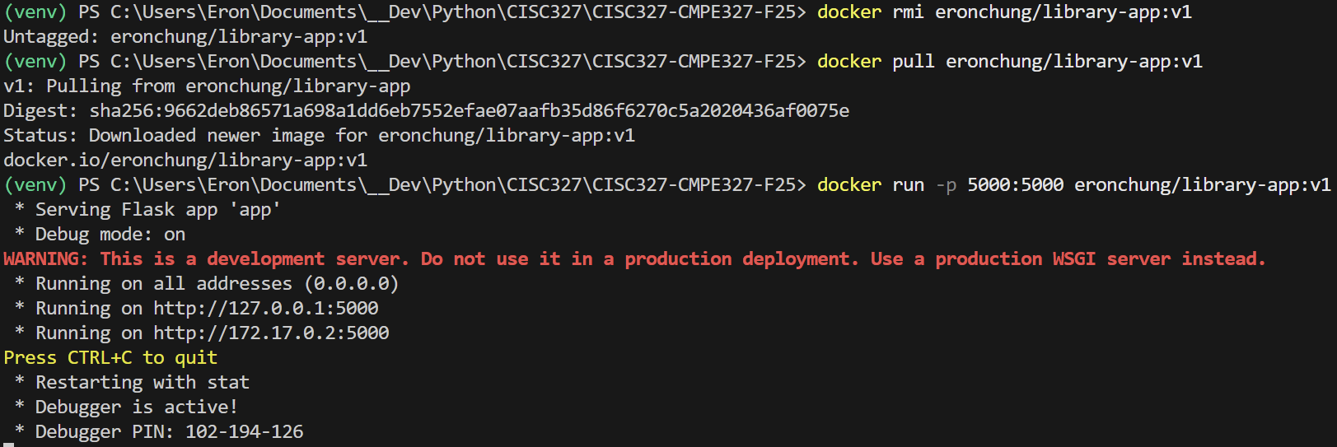

Challenges

Having not worked with Flask before, basically all of these assignments had me consulting various documentations a lot and watching tutorial videos on how to set up different things.

