CISC 327 A3 (Fall 2025)
Eron Chung (20393151)
Repository: https://github.com/EronChung/cisc327-library-management-a2-3151

Stubbing vs Mocking
A stub is a fake replacement value used in place of a real one provided/returned by actual functionality, and is set with a value relevant to the test case it’s created in; they are essentially hardcoded values/constants. A mock is a fake representation of an entire object that simulates the behavior of the real object’s functionality without actually engaging with the real implementation, which may not be available (such as with the payment gateway here); it’s similar to a stub in that it returns fake replacement data, but has the ability to assert that passed in input params are actually valid, as well as check if a function was or was not called.

pay_late_fees
- `calculate_late_fee_for_book` was stubbed in each case to provide the necessary `fee_info`s.
- `PaymentGateway` was mocked in each case as the gateway is part of what is being tested.
  - Mocking it over stubbing also allows asserting if a gateway function was (not) called.

refund_late_fee_payment
- `PaymentGateway` was mocked in each case as the gateway is part of what is being tested.
  - Mocking it over stubbing also allows asserting if a gateway function was (not) called.

Test Execution Instructions
- Clone repository
- Run `python -m venv venv` to create virtual environment
- Run `source venv/bin/activate` in Linux, or `venv\Scripts\activate` on Windows
- Run `pip install -r requirements.txt` to install dependencies

New Test Cases
Name | Purpose | Stubs | Mocks
test_successful_payment | Test a successful payment. | calculate_late_fee_for_book | PaymentGateway
test_payment_declined_by_  gateway_limit_exceeded | Test getting declined by payment service (limit exceeded). | calculate_late_fee_for_book | PaymentGateway
test_payment_invalid_patron | Test invalid patron ID. | calculate_late_fee_for_book | PaymentGateway
test_payment_zero_late_fees | Test with no late fees. | calculate_late_fee_for_book | PaymentGateway
test_payment_network_error | Test gateway network error exception. | calculate_late_fee_for_book | PaymentGateway
-------------------- | -------------------- | -------------------- | --------------------
test_successful_refund | Test a successful refund. |  | PaymentGateway
test_refund_invalid_id | Test an invalid transaction ID. |  | PaymentGateway
test_refund_amount_  negative | Test a negative refund amount. |  | PaymentGateway
test_refund_amount_zero | Test a refund amount of 0. |  | PaymentGateway
test_refund_amount_  exceeds_15 | Test a refund amount over 15. |  | PaymentGateway
-------------------- | -------------------- | -------------------- | --------------------
test_add_book_invalid_  duplicate_isbn | Test adding a book with an ISBN already in use (input same as first valid test).
test_add_book_database_  error | Test adding a book with an ISBN already in use (input same as first valid test). | insert_book
-------------------- | -------------------- | -------------------- | --------------------
test_borrow_book_invalid_  no_copies | Test borrowing a book with no more copies left. | get_book_by_id
test_borrow_book_invalid_  borrow_limit | Test database error when adding a book. | get_patron_borrow_count

Coverage Analysis
These branches were covered to reach 81%:

add_book_to_catalog
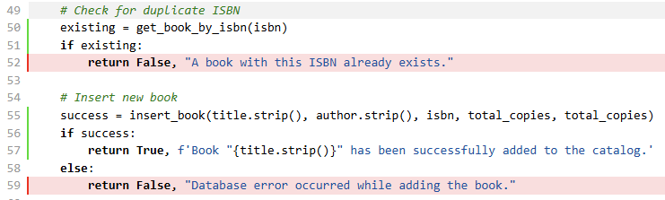

borrow_book_by_patron
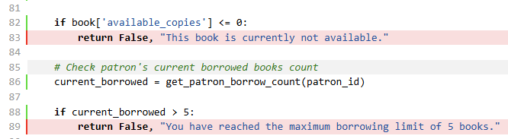

Negative test cases were written to reach these branches.
In order to not have to manipulate the database for testing as was done before, some functions were stubbed:
- `insert_book`: Stubbed to simulate a database error
- `get_book_by_id`: Stubbed to simulate having no copies left
- `get_patron_borrow_count`: Stubbed to simulate the patron having reached the borrow limit

Screenshots
