

Application ERON Santé

Andria Capai 07 juin 2021

1

**Contents**

1. Introduction 4
2. Management method 5
3. Specifications 7
   1. Company Eron 7
   2. Objective qualitative of Application 9
   3. Customer/User target 10
   4. Quantitative objectives 10
   5. Project’s Scope 11
   6. Design and Ergonomy 12
      1. Wireframe 12
      2. Mockup 13
4. Code App 14
5. Appendices 15
6. To discuss and to validate 16
7. External ressources 17

**Authors of requirements specifications and group of expressing needs**

Name/Email Role

Damien Vert / [damien.v@eronservice.fr](mailto:damien.v@eronservice.fr) Executive Project Bryan Lebar / [bryan.l@eronservice.fr](mailto:bryan.l@eronservice.fr) IT Manager

Andria Capai / [andria.c@eronservice.fr](mailto:andria.c@eronservice.fr) Application Developper and author of th

Name/Email Role

Thomas Berton / [thomas.berton83@gmail.com](mailto:thomas.berton83@gmail.com) Partner Developper. Tecnical Manager o

Alex Iosoni / [alex.iasoni25@gmail.com](mailto:alex.iasoni25@gmail.com) Partner Developper . Tecnical Manager

**History of changes and revisions to this document**

Version number Date Description and circumstance about modification of Spec

v 0.1 (Initial) 07/06/2021 Specification draft , which the initial requirements specifi

**Validations**

Version number Reviewer’s Name and Role Date and signature Possible comments o

V 0.1 (Initial)

# Introduction

This file is a description of Mobile App EronSante. The goal of this file is to describe all steps from specifications, wireframe, mockup, workflow, code de- velopped management method, softwares use, perspectives

The main goal of this app is to offer for users the possibility to : discover courses medical education , to buy or ask more information about these courses, connect to their account in order complete their training, see their progression, deadline monitoring and also information about EronSante company.

# Management method

Below is every human ressources with their duties/functions need to know in order to manage the project :

* + Direction:
    - Damien Vert (chef executive) : [damien.v@eronservice.fr](mailto:damien.v@eronservice.fr)
    - Arthur Balme (chef executive) : [arthur.b@eronservice.fr](mailto:arthur.b@eronservice.fr)
    - Fabien Direction ERON / EFIA : [fabien.balme@gmail.com](mailto:fabien.balme@gmail.com)
  + Administrative / Financial Manager
    - Philippe Vert : [daf@eronservice.fr](mailto:daf@eronservice.fr)
  + Communication:
    - Louis Serge Real del Sarte : [lsdelsarte@eronservice.fr](mailto:lsdelsarte@eronservice.fr)
    - Alexandra Lages : [alexandralages1@gmail.com](mailto:alexandralages1@gmail.com)
  + Teaching Manager:
    - Marielle Glikpo : [marielle.g@eronservice.fr](mailto:marielle.g@eronservice.fr)
    - Bouchra : [resp.pedago@eronservice.fr](mailto:resp.pedago@eronservice.fr)
  + IT manager:
    - Bryan Lebar : [bryan.l@eronservice.fr](mailto:bryan.l@eronservice.fr)
  + Developper Partner :
    - Thomas Berton : [thomas.berton83@gmail.com](mailto:thomas.berton83@gmail.com)
    - Alex Iasoni : [alex.iasoni25@gmail.com](mailto:alex.iasoni25@gmail.com)

In order to success to build the app, we are using **Agile method (Scrum)**

(sprint’s time to be define but pribably 2 weeks) with software **trello**. Also

Thomas Berton and Alex Iasoni ask ERON to communicate via WhatsApp about the App and Website/CRM. Trello board named : ”Appli Mobile”.

# Specifications

## Company Eron

**ERON Santé** is a company in continuing education for medical personal online. Profession fields target are : Doctors, Dentists, Nurses, Physiotherapists and Pharmacists.

**Training courses** number are estimated at more than 5000 .

**Certification Qualiopi, Datadock, AFAQ 9001** are all gets by ERON Santé which is a proof of high quality training.

**6 days / 7 days** of avaiblity to advice learner medical employees.

**Bloc skills** are built and think with expert in order to offer the best training four their learner.

Thanks to their huge social network ERON Santé , gets more than **1 million of users**.

**Functionning** of the company is articulated with 2 main mplayers : **Profes- sionnal trainers** and **Health Professionnal liberals**.

* **Health Professionnal liberals** gets 14 credits (14Hours) paid by the State and which is manage by **Développement Professionnel Continu(DPC)** and they can also get training paid by **Union nationale des professions libérales UNPL** which have the **Fonds interprofessionnel de Formation des Professionnels libéraux (FIFPL)** . To get those formation financed by State and FIFPL **EronSanté** use the **Commercial website** (describe below) Finally the **Helat Professionnal liberals** can also choose to pay

by theirself training offer by **EronSanté** on the website **Gafeo** (describe below)

[**Their commercial website**](https://eronsante.com/qui-sommes-nous-notre-organisation/) is built with **CMS Wordpress** and gets 5 main view

:

* Home [website](https://eronsante.com/)
* Our Training [website](https://eronsante.com/nos-formations/)
* Actuality [website](https://eronsante.com/actualites/)
* Who are ? [website](https://eronsante.com/qui-sommes-nous/)
* Contact [website](https://eronsante.com/contact-service-client/) The website allow medical professional visitor to:
* browse training list organize by topic ( Doctors, Dentists, Nurses, Physio- therapists and Pharmacists) and to see for each training description : **Short Description, Objectives,Content, DPC number, Duration**.
* Book training by a **Button Booking** which redirect to [**typeform**](https://erons.typeform.com/to/g5qYvNaf)with 10 questions:
  + Ask visitor if it is sure to be medical professional and to be interested by subscribe to their training
  + professionnal type
  + choose training
  + period to pass training session (15 days)
  + name
  + email
  + date of birth

[**Their website for learner (E-learning Platform)**](https://eronsante.com/qui-sommes-nous-notre-organisation/) is **Learning Management System (LMS)** and write with programmation langage Python. Here are struc- ture of website :

* Login view
* Main View with :
  + Top left menu hamburger (wich change content according to the page)

∗ Dashbaord with courses subscribed

* + Top right avatar with profile section
* Shop view : where it is possible to pay for more training by personnal funds.

The **customer relationship management (CRM)** is **dolibarr** and provide by

**open-dsi**. **Dolibarr** is write with **Python language**. [Link to Website](https://eron-dlb.open-dsi.fr/doliprod/index.php?mainmenu=home).

## Objective qualitative of Application

The company EronSanté’s need/requirement to creat a mobile application from scratch was born by mutlitple facts :

* + - More and more feedback from users/learners using website would like to get their training courses on mobile or tablet.
    - Company startegy is to :
      * increase fidelity of their learners by allow learners to follow their train- ing session on mobile or tablet
      * target younger health professionnal (currently main users are 40-50 years old)
      * In the future to create a ”Eron Academy” where learners invest trust in EronSnaté based on philosophy/idea and keep users longer such as vision of 3 years

## Customer/User target

Here are information about profile users of Application EronSanté, based on usual users on current website and on strategy company :

* + - Persona Learner :
      * Age : >40 years old
      * Experience work : many years
      * Profession type : Doctors, Dentists, Nurses, Physiotherapists and Phar- macists
      * Platform device : tablet, smartphone
      * View picture persona in section Appendices
    - Persona visitor :
      * Age : 20 -30 years old
      * Experience work : Juniors
      * Profession type : Doctors, Dentists, Nurses, Physiotherapists and Phar- macists
      * Platform device : tablet, smartphone
      * View picture persona in section Appendices

## Quantitative objectives

* + - Target number of download on Store App ?
    - Target of typeform filled with the app
    - Target number of users complete lesson with app

## Project’s Scope

* + - Language App : French
    - Language Programmation :
      * FrontEnd Framework : ReactNative was choose at the beginning with ERON Team. After meeting on 2nd of June 2O21 with 2 developper Thomas Berton and Alex Lisoni , they ask us to change and use Angular Ionic;
      * Software Development: AndroidStudio and XCode
      * Compiler and bundler : Expo
    - Platform : iOS / Android
    - Devices app run on : tablet , Smartphone
    - Type of Application : showcase/ Learning / Shop
    - Module of website to integrate :
      * News
      * Shop (from FIFPL or Dcp)

∗ typeform

* + - * Catalogues
    - App screens and features :
      * Home screen (everybody) with :

∗ Training by category

∗ News

∗ Contacts

∗ FAQ

* + - * Login screen (learner):

∗ Profil screen:

* + - * + Notification (date start and end of training session) (features)
        + Contacts
        + FAQ

∗ Personnal Training (screen)

* + - * + Sumup /progress (screen)
        + List of training susbscribe (screen)

∗ Shop screen with 3 steps (features) and only paid by personal founds :

* + - * + User information
        + Order’s details
        + secured payment
    - App functions: The app will allow user to see catalogues, news EronSanté, login (if they follow courses), see details of their training (start-end date session, number of hour spend, percentage completion),read and complete module training, to be redirect to shop training link with Dpc account.

## Design and Ergonomy

### Wireframe

To list all of features needed for the Application we describe User stories:

* + - * As a **learner** I want to **connect with my login and password** so that I can **access to my personnal account**.
      * As a **Learner** I want to **access to my lessons on smartphone/tablet** so

that I can **complete training’s module easily and everywhere**

* + - * As a **Learner** I want to **be notified when the deadline is coming** so that I can **finish training in time**
      * As a **Learner** I want to **see sumup of all my training** so that I know **more about my training progress**
      * As a **Learner** I want to **contact customer service** so that I can **get more informations, no available in the App FAQ**
      * As a **Visitor** I want to **see informations about ERON** so that I can **contact them**
      * As a **Visitor** I want to **see all training offer by ERON** so that I can **Sub- scribe to training session with DPC or FIFPL credits**
      * As a **Visitor** I want to **know news about my job** so that I can **get infor- mation about my job directly on my smartphone**

### Mockup

Figma will be used in order to design mockup.

# Code App

# Appendices

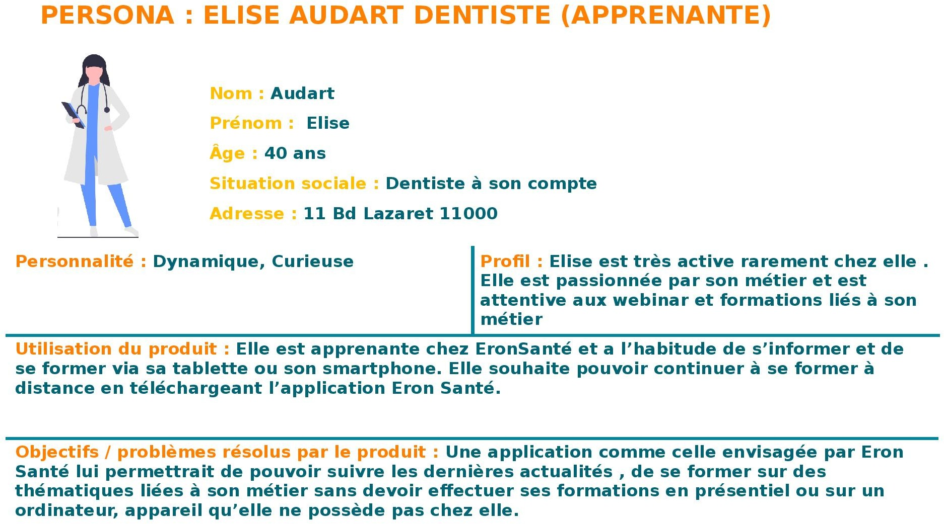

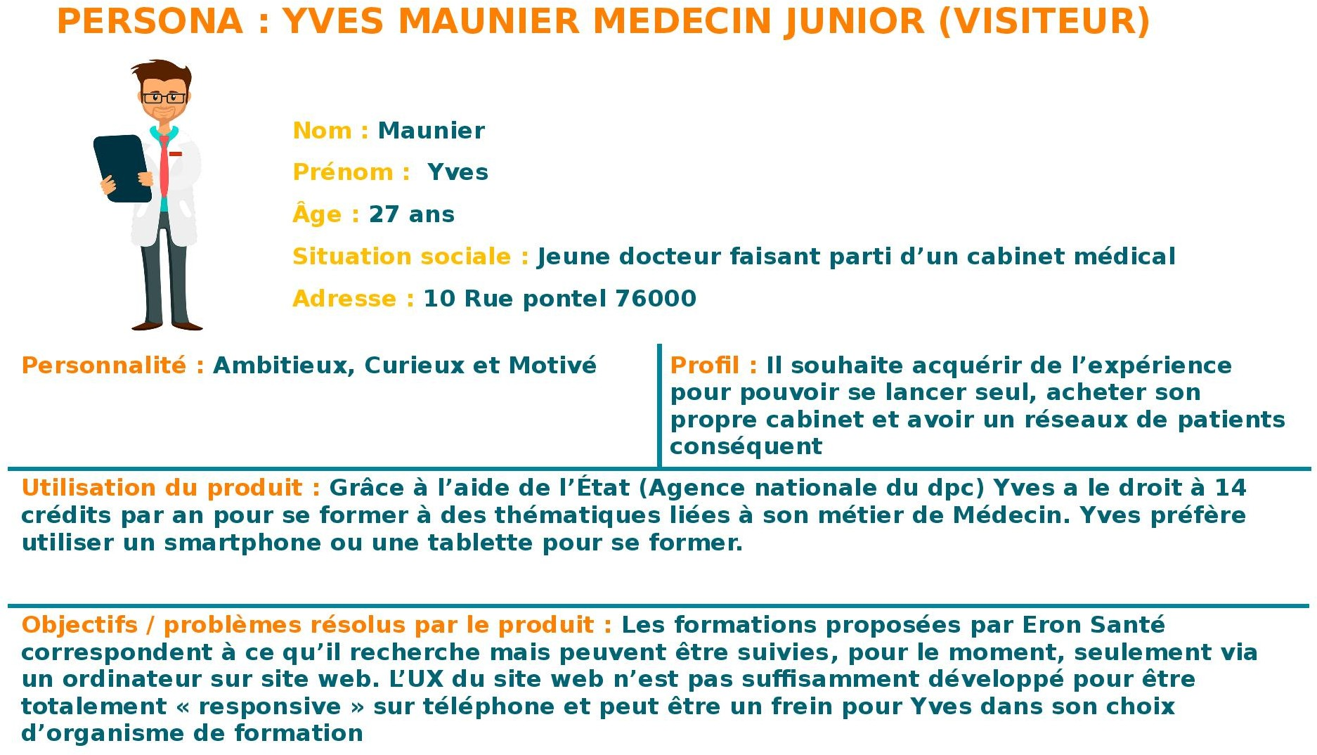

# To discuss and to validate

Questions / Matter of discussion Context of

Does the learner will get directly the training activated after the payment ? Wireframe

Another tab for shop to let the learner by training Wireframe

How precisely the learner could choose to be notified for deadline training ? Wireframe

# External ressources