Licenciatura em Eng. Informática

**Tecnologias Internet 2**

STATEMENT

I, __________________Eron Krasniqi____________________ , student No. ____23455, the undersigned, declare, under my honor, that the authorship of this work was mine.

I am aware that, in accordance with 21th Article of the Academic Regulation in use at ESTT, in case of false declaration, my work will be canceled.

Tomar, __25_ (day) from ____06________ (month) from ___2021____

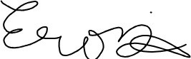

__________________________________________

(signature)