Contents

[Help Documentation 2](#_Toc471114067)

[Cardfight Vanguard Card Creator 2](#_Toc471114068)

[Open Card Art 2](#_Toc471114069)

[Code 4](#_Toc471114070)

[Name 4](#_Toc471114071)

[Border 5](#_Toc471114072)

[Trigger 5](#_Toc471114073)

[Grade 6](#_Toc471114074)

[Power 6](#_Toc471114075)

[Shield 6](#_Toc471114076)

[Clan 7](#_Toc471114077)

[Nation 7](#_Toc471114078)

[Race 8](#_Toc471114079)

[Legion Leader/Mate 8](#_Toc471114080)

[Illust/Design 9](#_Toc471114081)

[Effect 9](#_Toc471114082)

[Flavour 10](#_Toc471114083)

[Exporting 10](#_Toc471114084)

[Data 10](#_Toc471114085)

[Card Image 11](#_Toc471114086)

[Fanon CardTable 11](#_Toc471114087)

[External Program Documentation 12](#_Toc471114088)

[Nation 12](#_Toc471114089)

[Effect 12](#_Toc471114090)

# Help Documentation

## Cardfight Vanguard Card Creator

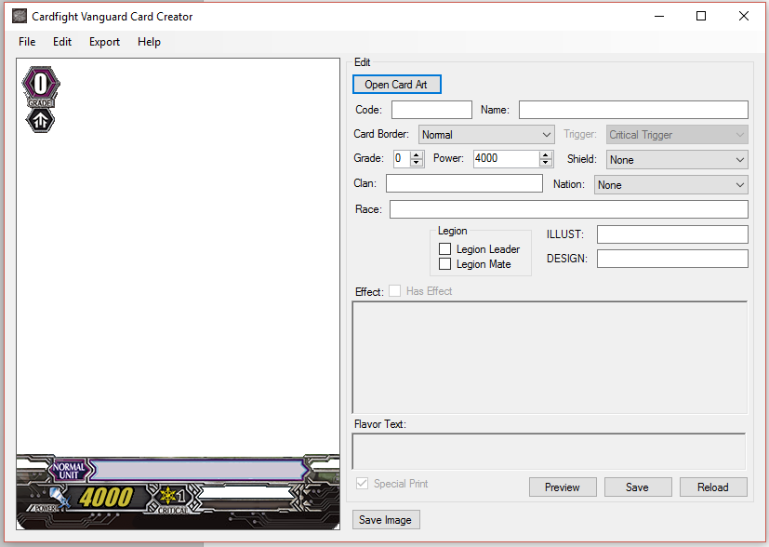

## Open Card Art

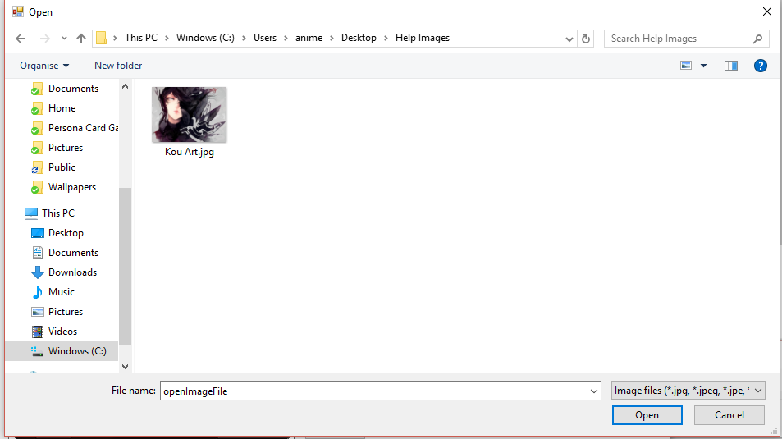 The “Open Card Art” press thing is the top most press thing. It lets you to open a picture for you to use. Find the image that you want to use for your card and open it.

The image you pick will fit into the picture on its own. Though make sure to pick a bigger picture for a better image.

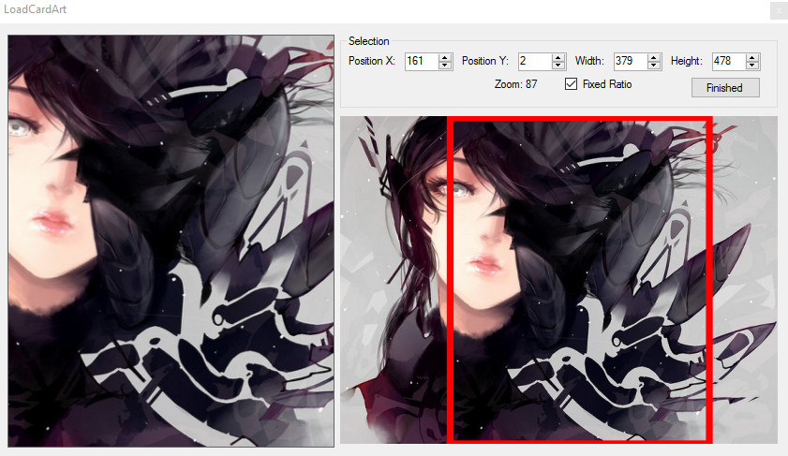Once opened it will show a screen for you to change the picture. You can look in and out of the image. You can also move the image around. The left picture will show you what will be shown on the card. The red lines let you move the part of the picture to show. The red lines won’t let you move it outside of the picture.

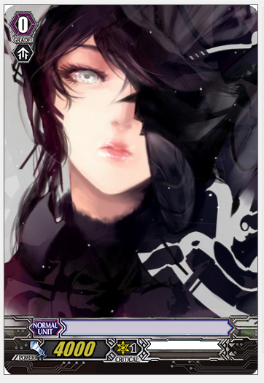

## Code

This box tells it what to show in the bottom left of the picture. You just enter in what you want and it'll show up but it can only show 15 Letters, Numbers, and Spaces. You can see it in the picture on the left with a red circle around it.

## Name

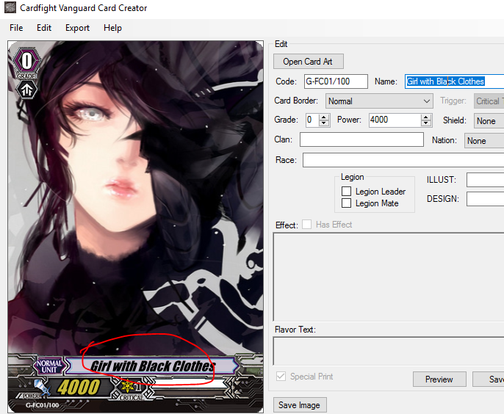

This is the name of the card you want to make. You should be careful with long names because it might go outside of the box in the middle, and that would make the picture not look very nice. If it doesn't go outside the box, it might make it look really pressed in and that won't look nice either.

## Border

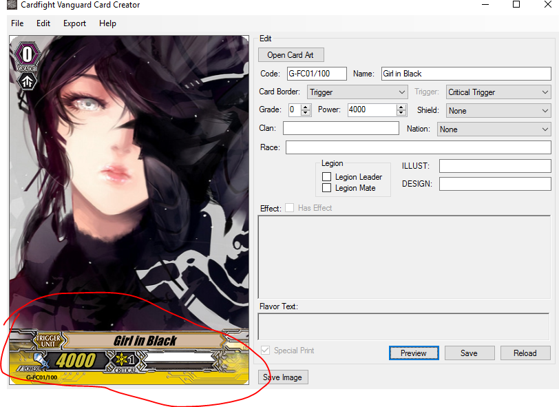

This is the box of the card you can choose from 4 Boxes that are chosen in the drop down box. You can choose Kind of Dark Blue, Yellow, Red, and Green each with the kind of card it is on it as well. You are not able to add more kinds because the real game only has 4, and I won't add more unless the real game gets more.

## Trigger

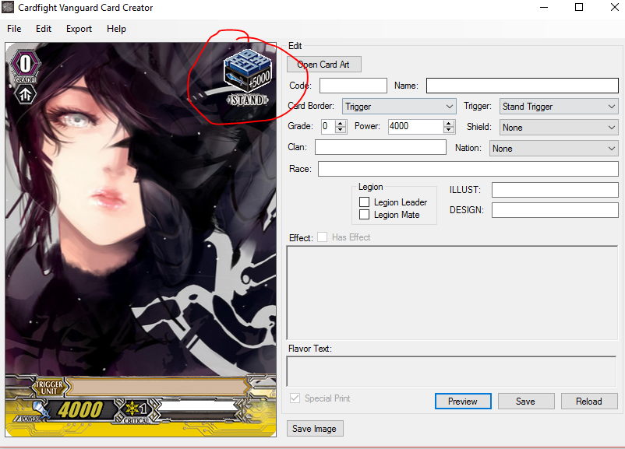You can only use this if you are using a yellow box. If you are not using a yellow box, you cannot use this box to put in a picture you want. You can choose from a yellow star, red box, blue box or green box to put in as your picture.

## Grade

This is the position of power for your card, that tells many people when they can start to use your card after a set number of turns. In the real game, it is normal for higher position of power to have higher power. In this box you can choose up to 5 positions of power. There is 0, 1, 2, 3, and 4. The number 4 picture will change if your box is red or green givng it some gold.

## Power

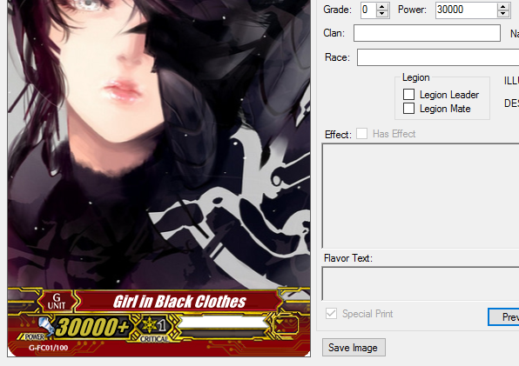

This box lets you put in a number up to 99000 and if you have a red box then there will be + at the end of the number. This is the power of your card.

## Shield

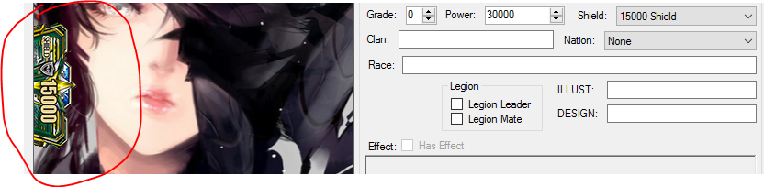

This is the guard power of your card, you can only choose 5 kinds of pictures for this to put in. You can have no picture, special 0, 5000, 10000 or 15000 for the picture. The 15000 image is in the real game used with the green box.

## Clan

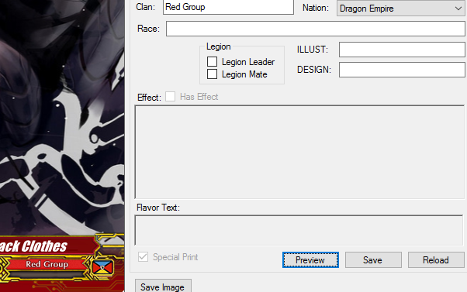

This is the group your card is from, in the real game there are a lot of groups you can choose from. You can also make your own group by putting in your own words. This card is from the "Red Group". You can only have a group if your card has a larger group it is from.

## Nation

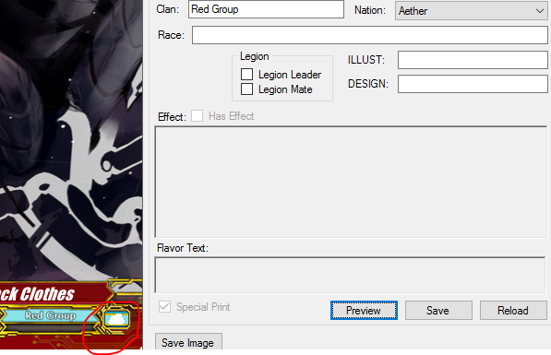

This is the bigger group your card is from, in the real game there is only 6 groups but you can add in more groups. Though be careful as you might not be able to use the card maker again if you break it. In this one, there is seven groups because one of them is a larger group from the card game follow people. This is a light blue larger group.

If you choose a bigger group then, the picture of the bigger group will be shown in the bottom right of the picture.

## Race

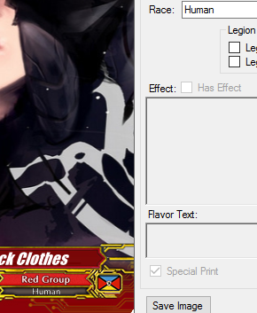This is the kind of thing that the card is, there are many kinds of things in the real game. You can even put in your own kind of thing. You can even put in two kinds of things! You just need to use a '/' to show it. Be careful though, if you have a lot of letters in the kind of thing box it might get too pressed to see.

## Legion Leader/Mate

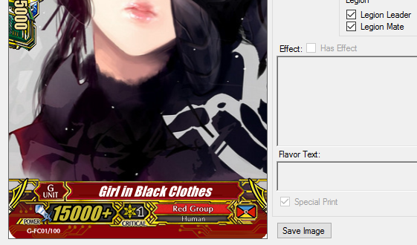

Here you have the team up leader or team up friend. The team up leader shows something on the left side of the picture and the team up friend shows something on the right side of the picture. You can also use both. You just need to choose both the Team Up Leader and Team Up Friend.

## Illust/Design

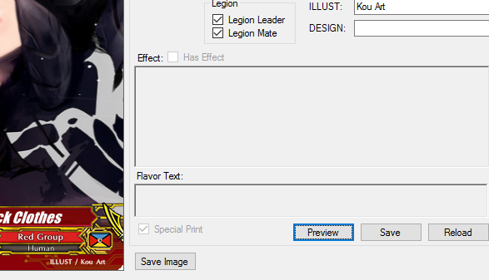

This is the name of your draw person, in other words you put the person you drew your card art for you here. Make sure you put in the name of your draw person! They should have the note for their great work. You should also make sure you ask the person before you use their picture for your card art. It's a very nice thing to do.

If you do not ask be careful when sharing it with everyone through the information sharer through your computer.

## Effect

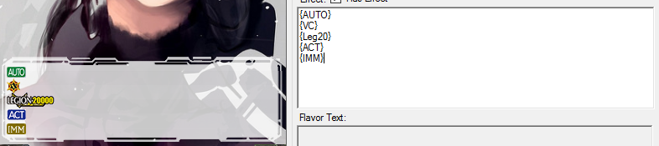

This is your card's special power to be used in the game. You use it by writing in the words that you want to use. The real game uses words that mean important things in the game. These important words can be found here. The real game also uses images to show important things as well in the game. You can put the images on the card by using the funny lines '{' and '}' and words in between.

If you need to know what words do what things in the funny lines. If you know how to add in your own images, you can also change the words to make it easier for you. You can see here:

|  |  |
| --- | --- |
| Key | Image |
| [[ | 【 |
| ]] | 】 |
| << | « |
| >> | » |
| {CB(X)} | C:\Users\anime\AppData\Local\Microsoft\Windows\INetCacheContent.Word\Icon_CB.PNG |
| {CC(X)} | C:\Users\anime\AppData\Local\Microsoft\Windows\INetCacheContent.Word\Icon_CC.PNG |
| {SB(X)} | C:\Users\anime\AppData\Local\Microsoft\Windows\INetCacheContent.Word\Icon_SB.PNG |
| {SC(X)} | C:\Users\anime\AppData\Local\Microsoft\Windows\INetCacheContent.Word\Icon_SC.PNG |
| {AUTO} | C:\Users\anime\AppData\Local\Microsoft\Windows\INetCacheContent.Word\Ability_AUTO.PNG |
| {CONT} | C:\Users\anime\AppData\Local\Microsoft\Windows\INetCacheContent.Word\Ability_CONT.PNG |
| {ACT} | C:\Users\anime\AppData\Local\Microsoft\Windows\INetCacheContent.Word\Ability_ACT.PNG |
| {IMM} | C:\Users\anime\AppData\Local\Microsoft\Windows\INetCacheContent.Word\Ability_IMM.PNG |
| {Critical} | C:\Users\anime\AppData\Local\Microsoft\Windows\INetCacheContent.Word\Icon_Critical.png |
| {Boost} | C:\Users\anime\AppData\Local\Microsoft\Windows\INetCacheContent.Word\Icon_Boost.png |
| {Heal} | C:\Users\anime\AppData\Local\Microsoft\Windows\INetCacheContent.Word\Heal.png |
| {Intercept} | C:\Users\anime\AppData\Local\Microsoft\Windows\INetCacheContent.Word\Icon_Intercept.png |
| {LB} | C:\Users\anime\AppData\Local\Microsoft\Windows\INetCacheContent.Word\Icon_LB.PNG |
| {Legion} | C:\Users\anime\AppData\Local\Microsoft\Windows\INetCacheContent.Word\Icon_Legion.png |
| {Power} | C:\Users\anime\AppData\Local\Microsoft\Windows\INetCacheContent.Word\Icon_Power.png |
| {Rest} | C:\Users\anime\AppData\Local\Microsoft\Windows\INetCacheContent.Word\Icon_Rest.png |
| {Shield} | C:\Users\anime\AppData\Local\Microsoft\Windows\INetCacheContent.Word\Icon_Shield.png |
| {Stand} | C:\Users\anime\AppData\Local\Microsoft\Windows\INetCacheContent.Word\Icon_Stand.png |
| {Twin} | C:\Users\anime\AppData\Local\Microsoft\Windows\INetCacheContent.Word\Icon_Twin.png |
| {1/Turn} | C:\Users\anime\AppData\Local\Microsoft\Windows\INetCacheContent.Word\1-Turn.png |
| {GB1} | C:\Users\anime\AppData\Local\Microsoft\Windows\INetCacheContent.Word\GB_1.png |
| {GB2} | C:\Users\anime\AppData\Local\Microsoft\Windows\INetCacheContent.Word\GB_2.png |
| {GB3} | C:\Users\anime\AppData\Local\Microsoft\Windows\INetCacheContent.Word\GB_3.png |
| {LB4} | C:\Users\anime\AppData\Local\Microsoft\Windows\INetCacheContent.Word\LB_4.png |
| {LB5} | C:\Users\anime\AppData\Local\Microsoft\Windows\INetCacheContent.Word\LB_5.png |
| {Leg20} | C:\Users\anime\AppData\Local\Microsoft\Windows\INetCacheContent.Word\Leg_20.png |
| {Leg21} | C:\Users\anime\AppData\Local\Microsoft\Windows\INetCacheContent.Word\Leg_21.png |
| {Leg22} | C:\Users\anime\AppData\Local\Microsoft\Windows\INetCacheContent.Word\Leg_22.png |
| {Link} | C:\Users\anime\AppData\Local\Microsoft\Windows\INetCacheContent.Word\Link.png |
| {RF} | C:\Users\anime\AppData\Local\Microsoft\Windows\INetCacheContent.Word\RF.PNG |
| {G-Guardian} | C:\Users\anime\AppData\Local\Microsoft\Windows\INetCacheContent.Word\G-Guardian.png |
| {Stride} | C:\Users\anime\AppData\Local\Microsoft\Windows\INetCacheContent.Word\Stride.png |
| {RC} | C:\Users\anime\AppData\Local\Microsoft\Windows\INetCacheContent.Word\Symbol_RC.PNG |
| {GC} | C:\Users\anime\AppData\Local\Microsoft\Windows\INetCacheContent.Word\Symbol_GC.PNG |
| {VC} | C:\Users\anime\AppData\Local\Microsoft\Windows\INetCacheContent.Word\Symbol_VC.PNG |

You can also change the kind of the word by using these:

If you want to make words red you can use:<r>[Words in Here]</r>, if you want to make words strong you can use: <b>[Words in Here]</r>, if you want to make words bent you can use: <i>[Words in Here]</i>

|  |  |
| --- | --- |
| Use | Formatting |
| <r></r> | Red Colour |
| <i></i> | *Italics* |
| <b></b> | **Bold** |

Spaces ' ' and Bottom Lines '\_' are used to cut up your words, images need to be their own word. If you use a space ' ' then it will move itself so that it fills up the line if you use Bottom Lines '\_' then it will stay next to the other word or picture.

## Flavour

These are special words on your cards that gives them feeling, think what kind of things you'd like your card to say. Then put it in, be careful though if you use too many words it will go off the screen. If you make new lines you can add in more words and it will be put in the middle for you.

If you have words for your special power. These words will move up for you so you don't need to do anything.



## Exporting

### Data

This is the information kept for your card. Make sure you keep it safe and don't lose it. By keeping this you can change the information on your card at any time you like. If you can change the information you can then change the picture it gives you easily without problems.

### Card Image

The picture it shows you on the left is the picture that it will give you. You choose a place to keep it on your computer and then you can send it to friends and other people. You can also put it up on the place many people put their own [not-real](http://cardfightvanguardfanon.wikia.com/wiki/Cardfight!!_Vanguard_Fanon_Wiki) cards.

### Fanon CardTable

This lets you put up your picture and card for everyone to see. It will lead you to the place you should put it up if you can reach it on your computer. It is very good for sharing your cards with everyone. Make sure you read the page it shows you so that the people [keeping the place clean](http://cardfightvanguardfanon.wikia.com/wiki/Special:ListUsers/sysop) don't get angry.

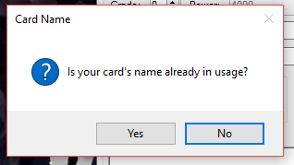

When you press this thing, it will ask you if the name you picked has been used by someone else or if there is a real card with the same name, it will then give you something to put into the page you make.

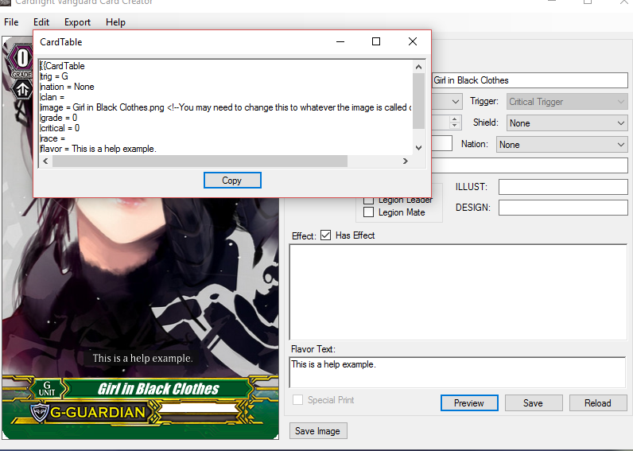

Press the ‘press box' at the bottom of the box this means all you have to do is use two keys to put it into your page. Use Ctrl+V.

# External Program Documentation

## Nation

The nations.txt file allows you to edit the nations available to you. There are 9 pre-programmed nations.

In order to add a nation, you’ll need to make sure you use the vertical bar ‘|’ and the semi-colon ‘;’ to separate your information. ‘;’ separates each nation and ‘|’ separates the information for your Nation.

The order for the information in each Nation goes like this: “{Nation Name} | {Flag Image} | {Nation Colour} | {Clan Text Colour} {Clan Outline Colour};”.

{Nation Name} can be any characters that don’t use the vertical bar ‘|’ or the semi-colon ‘;’ for it.

{Flag Image} must be the name of the image with its extension like “example.png” and the image must be in the same folder as the replacements.txt. If you don’t want a Flag just don’t put in anything.

{Nation Colour}, {Clan Text Colour} and {Clan Outline Colour} must be in HEXADECIMAL. If you require help on choosing a colour you may go to <http://www.w3schools.com/colors/colors_picker.asp> to help you choose a colour. These colours must begin with the hash ‘#’ or it will not work and break the program.

An example would be:

|  |
| --- |
| Special | Flag\_Special.png | #ffffff | #000000 | #ffffff; |
| {Nation Name} | {Flag Image} | {Nation Colour} | {Clan Text Colour} {Clan Outline Colour}; |

## Effect

You can add more icons in for the effect text to replace. Though you can edit the text file, just like the above you must end each one with a semi-colon ‘;’. To separate the replacement and the Image use the equals sign ‘=’.

You are not required to have separate lines between semi-colons ‘;’, but it helps you in reading the replacements.txt easier so it is recommended.

If you start a line using the hash ‘#’ sign the whole line will be ignored and be treated as a ‘comment’.

This is the style that you want to write it in:

|  |
| --- |
| {TextToReplace} = {Image}; |

{TextToReplace} can be any word without a semi-colon ‘;’ or equals ‘=’. It can also not start with a hash ‘#’.

{Image} is the name of the image in the same folder as the replacement.

This is an example:

|  |
| --- |
| LB4 = LB\_4.png; |