Coffee shop

1. Baza de date pe care am conceput-o mediaza serviciile prestate de un local tip cafenea in care clientii pot comanda produse derivate din cafea si imprumuta carti in incinta cafenelei, in limita disponibilitatii inventarului de ingrediente si bibliotecii de lectura. Un client poate lasa un review pentru eventualul feedback pe care l-a avut, si poate beneficia de eventuale promotii, dar care nu se vor aplica in numar mai mare de una per comanda.
2. Diagrama ERD:

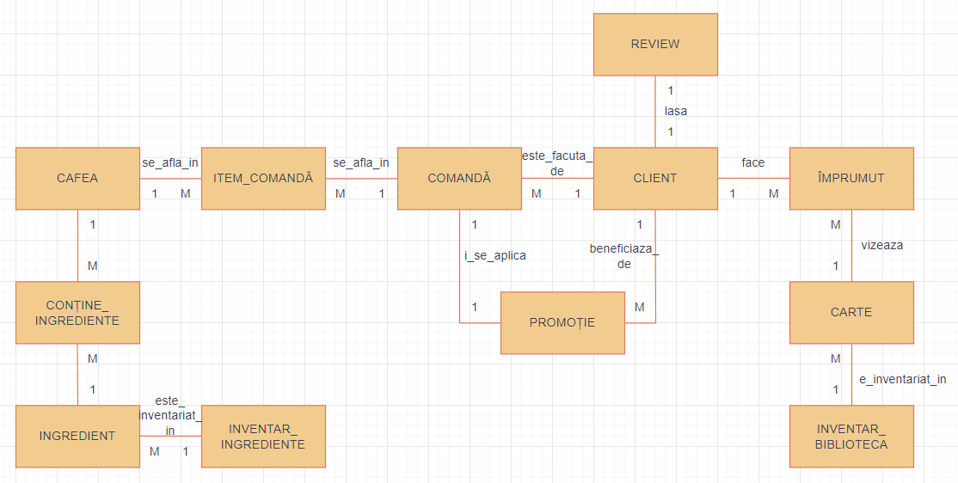

3. Diagrama conceptuala:

__________________________________________________________________________________________

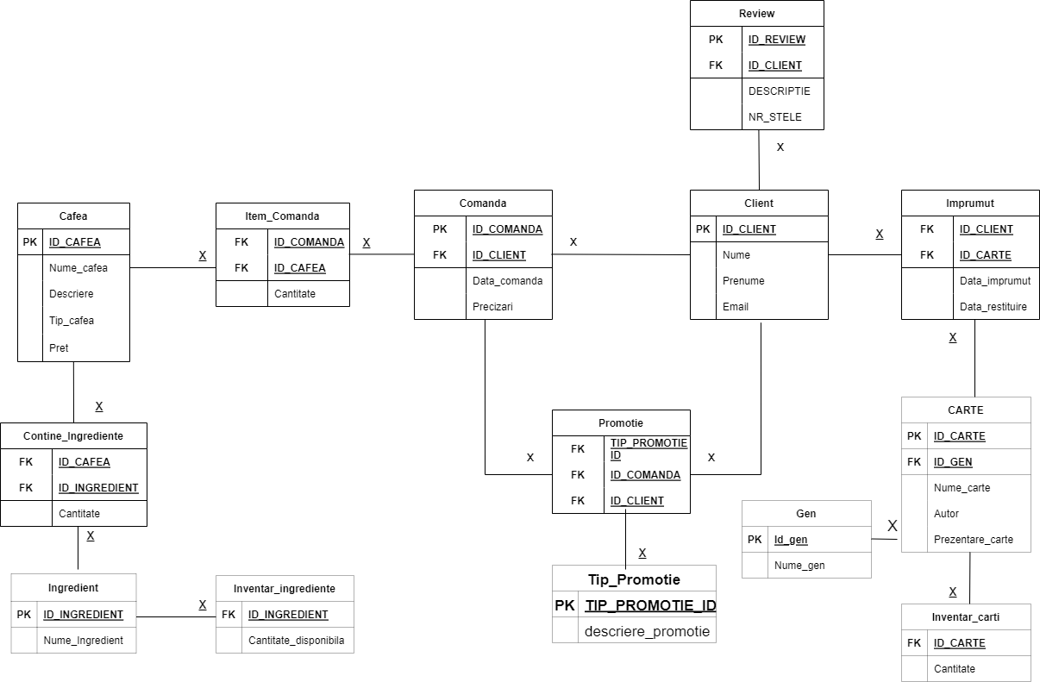

__________________________________________________________________________________________

4.

Crearea tabelelor:

**create** **table** **client**  
(  
id_client number(7),  
nume varchar2(20) **constraint** client_nume **not** null,  
prenume varchar2(20) **constraint** client_prenume **not** null,  
email varchar2(20),  
**CONSTRAINT** client_pk PRIMARY **KEY** (id_client),  
**CONSTRAINT** email_unique **unique** (email)  
);  
   
**create** **table** comanda  
(  
id_comanda number(9),  
id_client number(7) **constraint** com_id_client_null **not** null,  
data_comanda date **constraint** data_com_null **not** null,  
precizari varchar2(64),  
**CONSTRAINT** comanda_pk PRIMARY **KEY** (id_comanda),  
**CONSTRAINT** comanda_client_fk **FOREIGN** **KEY** (id_client)  
**references** **client**(id_client)  
);

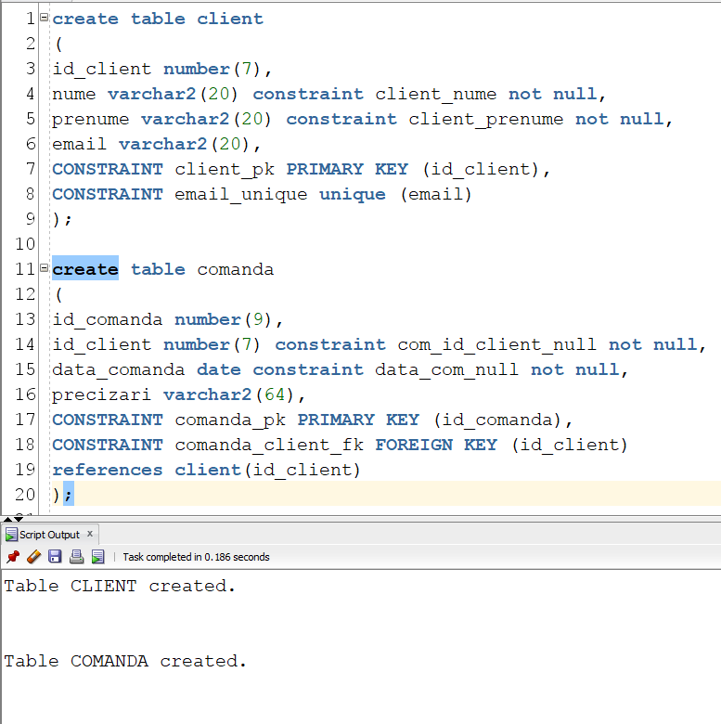

**create** **table** cafea  
(  
id_cafea number(7),  
nume_cafea varchar2(20) **constraint** ncaf_null **not** null,  
descriere varchar2(64) **constraint** descrierecaf_null **not** null,  
tip_cafea varchar2(20) **constraint** tipcaf_null **not** null,  
pret number(3) **constraint** pret_null **not** null,  
**CONSTRAINT** cafea_pk PRIMARY **KEY** (id_cafea)  
);  
   
**create** **table** item_comanda  
(  
id_comanda number(9) **constraint** itmcom_com_null **not** null,  
id_cafea number(7) **constraint** itmcom_caf_null **not** null,  
cantitate number(2) **constraint** itcmcom_cantitate **not** null,  
**CONSTRAINT** item_comanda_cafea_fk **FOREIGN** **KEY** (id_cafea)  
**references** cafea(id_cafea),  
**CONSTRAINT** item_comanda_comanda_fk **FOREIGN** **KEY** (id_comanda)  
**references** comanda(id_comanda)  
);

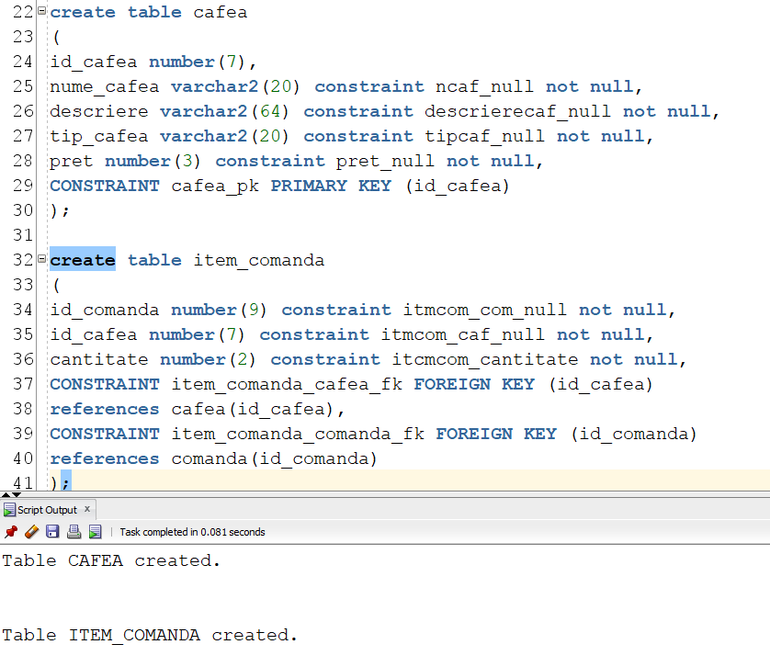

**create** **table** ingredient  
(  
id_ingredient number(7),  
nume_ingredient varchar2(20) **constraint** ingr_nume_null **not** null,  
**constraint** ingredient_pk primary **key** (id_ingredient)  
);  
   
**create** **table** contine_ingrediente  
(  
id_cafea number(7) **constraint** ci_caf_null **not** null,  
id_ingredient number(7) **constraint** ci_ing_null **not** null,  
cantitate number(4) **constraint** ci_cant_null **not** null,  
**constraint** ci_cafea_fk **foreign** **key** (id_cafea)  
**references** cafea(id_cafea),  
**constraint** ci_ingredient_fk **foreign** **key** (id_ingredient)  
**references** ingredient(id_ingredient)  
);

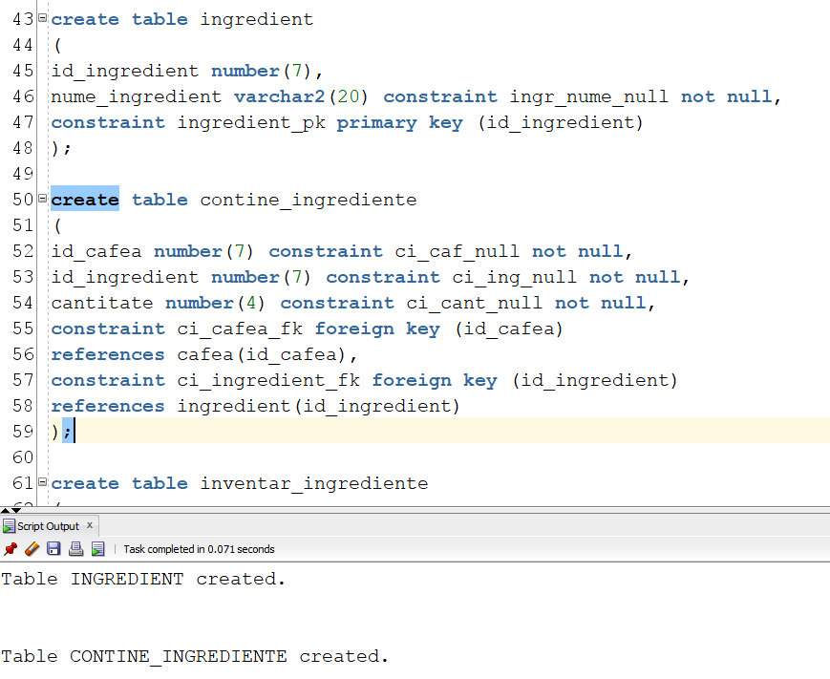

**create** **table** inventar_ingrediente  
(  
id_ingredient number(7),  
cantitate_disponibila number(9) **constraint** inv_ing_cant_null **not** null,   
**constraint** inv_ing_ingredient_fk **foreign** **key**(id_ingredient)  
**references** ingredient(id_ingredient)  
);  
   
**create** **table** review  
(  
id_review number(7),  
id_client number(7) **constraint** rev_client_null **not** null,  
descriptie varchar2(64),  
nr_stele number(1) **constraint** nr_stele_null **not** null,  
**constraint** review_pk primary **key** (id_review),  
**constraint** client_review_fk **foreign** **key** (id_client)   
**references** **client**(id_client),  
**check** (nr_stele >0),  
**check** (nr_stele <6)  
);

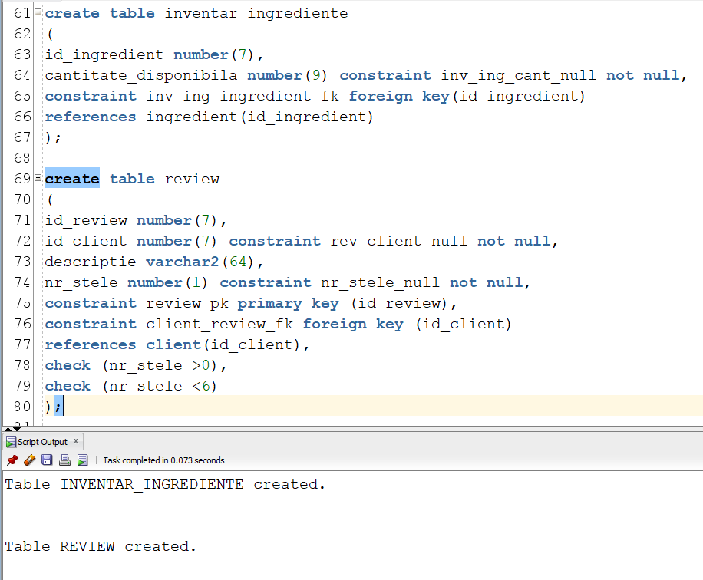

**create** **table** promotie  
(  
id_promotie number(7),  
id_comanda number(9) **constraint** prom_com_null **not** null,  
id_client number(7) **constraint** prom_client_null **not** null,  
**constraint** promotie_pk primary **key**(id_promotie),  
**constraint** promotie_comanda_fk **foreign** **key**(id_comanda)  
**references** comanda(id_comanda),  
**constraint** promotie_client_fk **foreign** **key**(id_client)  
**references** **client**(id_client)  
);  
   
**create** **table** tip_promotie  
(  
id_promotie number(7) **constraint** tipprom_id_null **not** null,  
detalii_promotie varchar2(20) **constraint** tipprom_detalii **not** null,  
**constraint** tip_promotie_promotie_fk **foreign** **key**(id_promotie)  
**references** promotie(id_promotie)  
);

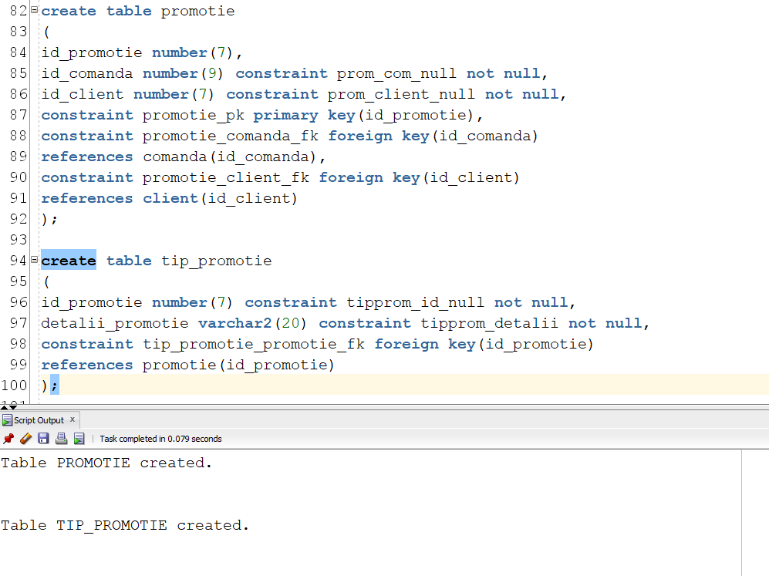

**create** **table** gen  
(  
id_gen number(7),  
nume_gen varchar2(20) **constraint** numegen_null **not** null,  
**constraint** id_gen_pk primary **key**(id_gen)  
);  
   
**create** **table** carte  
(  
id_carte number(7),  
id_gen number(7) **constraint** carte_gen_null **not** null,  
nume_carte varchar2(20) **constraint** carte_nume_null **not** null,  
autor varchar2(20) **constraint** carte_autor_null **not** null,  
prezentare_carte varchar2(64),  
**constraint** carte_gen_fk **foreign** **key** (id_gen)   
**references** gen(id_gen),  
**constraint** carte_pk primary **key** (id_carte)   
);

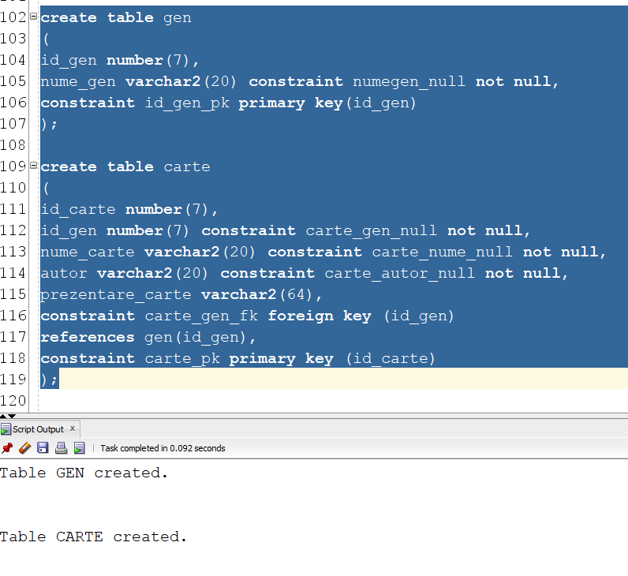

**create** **table** imprumut  
(  
id_client number(7) **not** null,  
id_carte number(7) **not** null,  
data_imprumut date **not** null,  
data_restituire date,  
**constraint** imprumut_client_fk **foreign** **key** (id_client)   
**references** **client**(id_client),  
**constraint** imprumut_carte_fk **foreign** **key** (id_carte)   
**references** carte(id_carte)  
);  
   
**create** **table** inventar_carti  
(  
id_carte number(7) **not** null,  
cantitate number(2) **not** null,  
**constraint** ic_fk **foreign** **key** (id_carte)  
**references** carte(id_carte)  
);

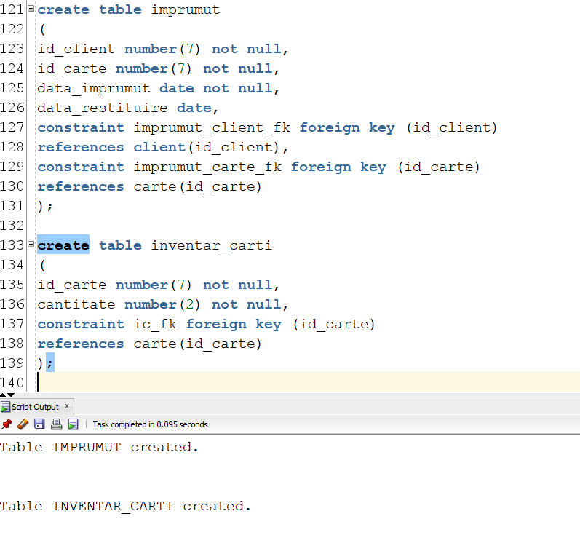

Modificari (pentru inserari):

**alter** **table** cafea  
**modify** nume_cafea varchar2(40);  
   
**alter** **table** cafea  
**modify** descriere varchar2(80);

**alter** **table** tip_promotie  
**modify** detalii_promotie varchar2(80);  
   
**alter** **table** tip_promotie  
**add** tip_promotie_id number(3) **not** null;  
   
**alter** **table** tip_promotie  
**drop** **column** id_promotie;  
   
**alter** **table** tip_promotie  
**add** tip_promotie_id number(3) **not** null;  
   
**alter** **table** tip_promotie  
**add** primary **key** (tip_promotie_id);  
   
**alter** **table** promotie  
**drop** **column** id_promotie;  
   
**alter** **table** promotie  
**add** tip_promotie_id number(3) **not** null;  
   
**alter** **table** promotie  
**add** **foreign** **key** (tip_promotie_id) **references** tip_promotie(tip_promotie_id);

5.

**create** **sequence** cafeaid_seq   
**start** **with** 1  
**increment** **by** 1;  
   
**insert** **into** cafea **values**  
(cafeaid_seq.nextval, 'Espresso scurt', 'Un shot concentrat de espresso', 'Small', 7);  
   
**insert** **into** cafea **values**  
(cafeaid_seq.nextval, 'Espresso lung', 'Un shot de espresso preparat cu o cantitate mai mare de apa', 'Small', 7);  
   
**insert** **into** cafea **values**  
(cafeaid_seq.nextval, 'Caffe Latte', 'Cafea echilibrata cu lapte fierbinte si acoperita cu un strat fin de spuma', 'Grande', 8);  
   
**insert** **into** cafea **values**  
(cafeaid_seq.nextval, 'Vanilla Latte', 'Cafea echilibrata cu lapte fierbinte si aromata cu sirop de vanilie', 'Grande', 10);  
   
**insert** **into** cafea **values**  
(cafeaid_seq.nextval, 'Caffe Mocha', 'Espresso combinat cu sirop de ciocolată și lapte fierbinte', 'Grande', 10);  
   
**insert** **into** cafea **values**  
(cafeaid_seq.nextval, 'Gingerbread Latte',   
'Siropul de turtă dulce și siropul mocha sunt amestecate cu espresso si lapte, topping de napolitane', 'Venti', 20);  
   
**insert** **into** cafea **values**  
(cafeaid_seq.nextval, 'Iced Caramel Macchiato', 'Espresso cu sirop de caramel, vanilie si cuburi de gheata', 'Venti', 18);

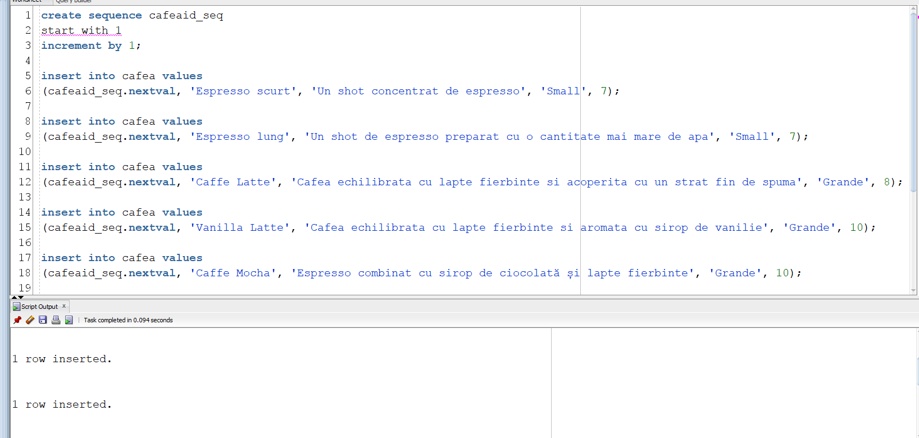

**create** **sequence** ingredientid_seq   
**start** **with** 1  
**increment** **by** 1;  
   
**insert** **into** ingredient **values**  
(ingredientid_seq.nextval, 'Cafea boabe');  
   
**insert** **into** ingredient **values**  
(ingredientid_seq.nextval, 'Lapte');  
   
**insert** **into** ingredient **values**  
(ingredientid_seq.nextval, 'Sirop de vanilie');  
   
**insert** **into** ingredient **values**  
(ingredientid_seq.nextval, 'Sirop de ciocolata');  
   
**insert** **into** ingredient **values**  
(ingredientid_seq.nextval, 'Sirop mocha');  
   
**insert** **into** ingredient **values**  
(ingredientid_seq.nextval, 'Sirop turta dulce');  
   
**insert** **into** ingredient **values**  
(ingredientid_seq.nextval, 'Sirop caramel');  
   
**insert** **into** ingredient **values**  
(ingredientid_seq.nextval, 'Napolitane sfaramate');  
   
**insert** **into** ingredient **values**  
(ingredientid_seq.nextval, 'Cuburi de gheata');

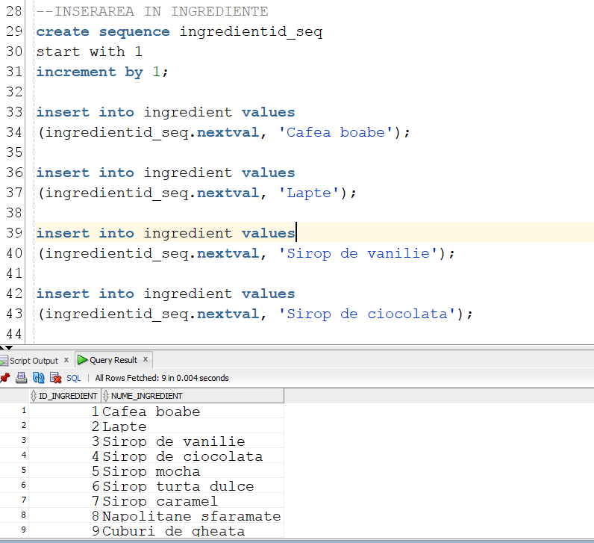

insert into contine_ingrediente values  
(1, 1, 10);  
   
insert into contine_ingrediente values  
(2, 1, 10);  
   
insert into contine_ingrediente values  
(3, 1, 20);  
   
insert into contine_ingrediente values  
(3, 2, 300);  
   
insert into contine_ingrediente values  
(4, 1, 20);  
   
insert into contine_ingrediente values  
(4, 2, 300);  
   
insert into contine_ingrediente values  
(4, 3, 25);  
   
insert into contine_ingrediente values  
(5, 1, 20);  
   
insert into contine_ingrediente values  
(5, 2, 300);  
   
insert into contine_ingrediente values  
(5, 4, 25);  
   
insert into contine_ingrediente values  
(6, 1, 30);  
   
insert into contine_ingrediente values  
(6, 2, 300);  
   
insert into contine_ingrediente values  
(6, 6, 25);  
   
insert into contine_ingrediente values  
(6, 5, 25);  
   
insert into contine_ingrediente values  
(6, 8, 35);  
   
insert into contine_ingrediente values  
(7, 1, 30);  
   
insert into contine_ingrediente values  
(7, 7, 25);  
   
insert into contine_ingrediente values  
(7, 3, 25);  
   
insert into contine_ingrediente values  
(7, 9, 3);

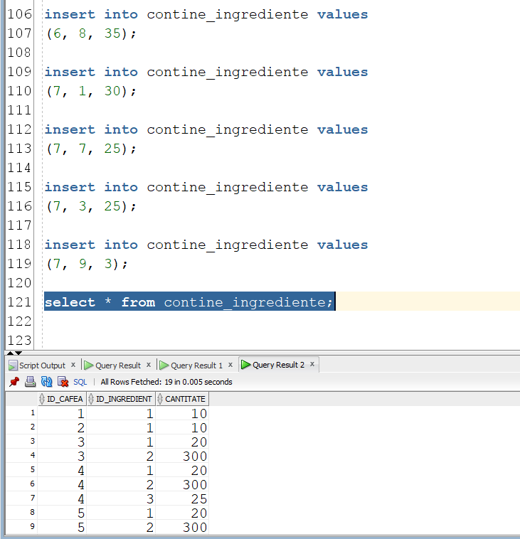

**insert** **into** inventar_ingrediente **values**  
(1, 100000);  
   
**insert** **into** inventar_ingrediente **values**  
(2, 50000);  
   
**insert** **into** inventar_ingrediente **values**  
(3, 4000);  
   
**insert** **into** inventar_ingrediente **values**  
(4, 4000);  
   
**insert** **into** inventar_ingrediente **values**  
(5, 4000);  
   
**insert** **into** inventar_ingrediente **values**  
(6, 2000);  
   
**insert** **into** inventar_ingrediente **values**  
(7, 4000);  
   
**insert** **into** inventar_ingrediente **values**  
(8, 1000);  
   
**insert** **into** inventar_ingrediente **values**  
(9, 100);

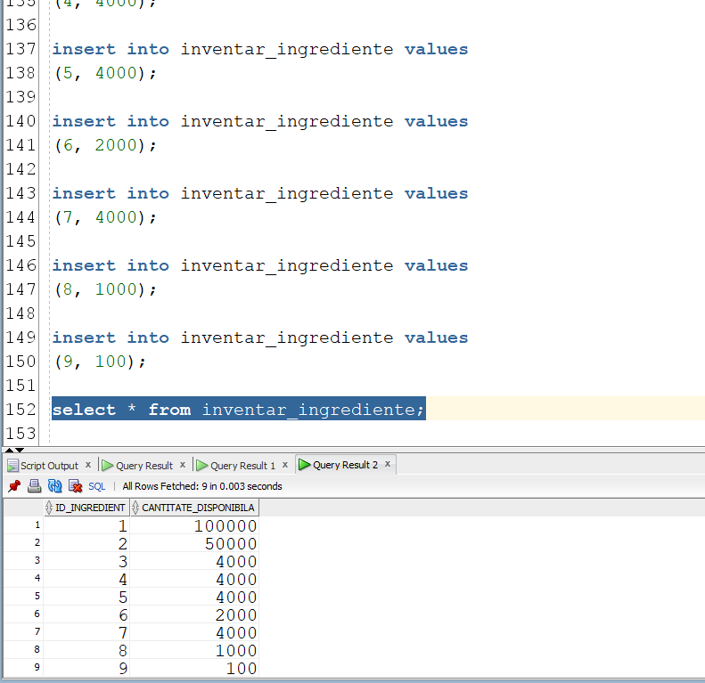

**insert** **into** **client**  
**values (**1, 'Smith', 'Maximilian', 'SmithMax@yahoo.com');  
   
**insert** **into** **client**  
**values (**2, 'Holt', 'Scarlet', 'HoltSc@yahoo.com');  
   
**insert** **into** **client**  
**values (**3, 'Munoz', 'Lottie', 'MunozLott@yahoo.com');  
   
**insert** **into** **client**  
**values (**4, 'Jane', 'Alexander', 'JaneAlex@yahoo.com');  
   
**insert** **into** **client**  
**values (**5, 'Phelps', 'Jason', '[JasonPhel@yahoo.com](mailto:JasonPhel@yahoo.com)');

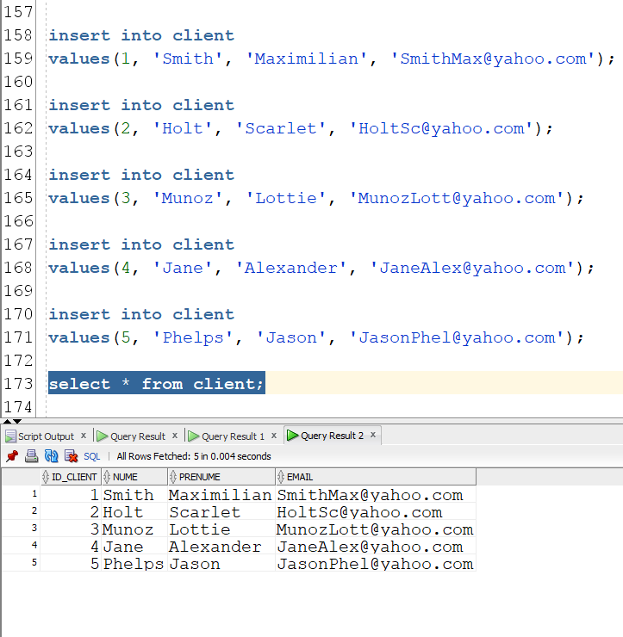

**create** **sequence** idcomanda_seq    
**start** **with** 1  
**increment** **by** 1;  
   
**insert** **into** comanda  
**values**(idcomanda_seq.nextval, '1', **to_date**('2022-10-14', 'yyyy-mm-dd'), null);  
   
**insert** **into** comanda  
**values**(idcomanda_seq.nextval, '1', **to_date**('2022-10-15', 'yyyy-mm-dd'), 'Gingerbread coffee-ul sa nu aiba napolitane peste.');  
   
**insert** **into** comanda  
**values**(idcomanda_seq.nextval, '2', **to_date**('2022-10-14', 'yyyy-mm-dd'), null);  
   
**insert** **into** comanda  
**values**(idcomanda_seq.nextval, '2', **to_date**('2022-10-15','yyyy-mm-dd'), null);  
   
**insert** **into** comanda  
**values**(idcomanda_seq.nextval, '3', **to_date**('2022-10-14','yyyy-mm-dd'), null);  
   
**insert** **into** comanda  
**values**(idcomanda_seq.nextval, '3', **to_date**('2022-10-15','yyyy-mm-dd'), null);  
   
**insert** **into** comanda  
**values**(idcomanda_seq.nextval, '4', **to_date**('2022-10-15','yyyy-mm-dd'), null);  
   
**insert** **into** comanda  
**values**(idcomanda_seq.nextval, '5', **to_date**('2022-10-15','yyyy-mm-dd'), '4 cuburi de gheata in Iced Caramel Machiatto');  
   
**insert** **into** comanda  
**values**(idcomanda_seq.nextval, '5', **to_date**('2022-10-14','yyyy-mm-dd'), null);

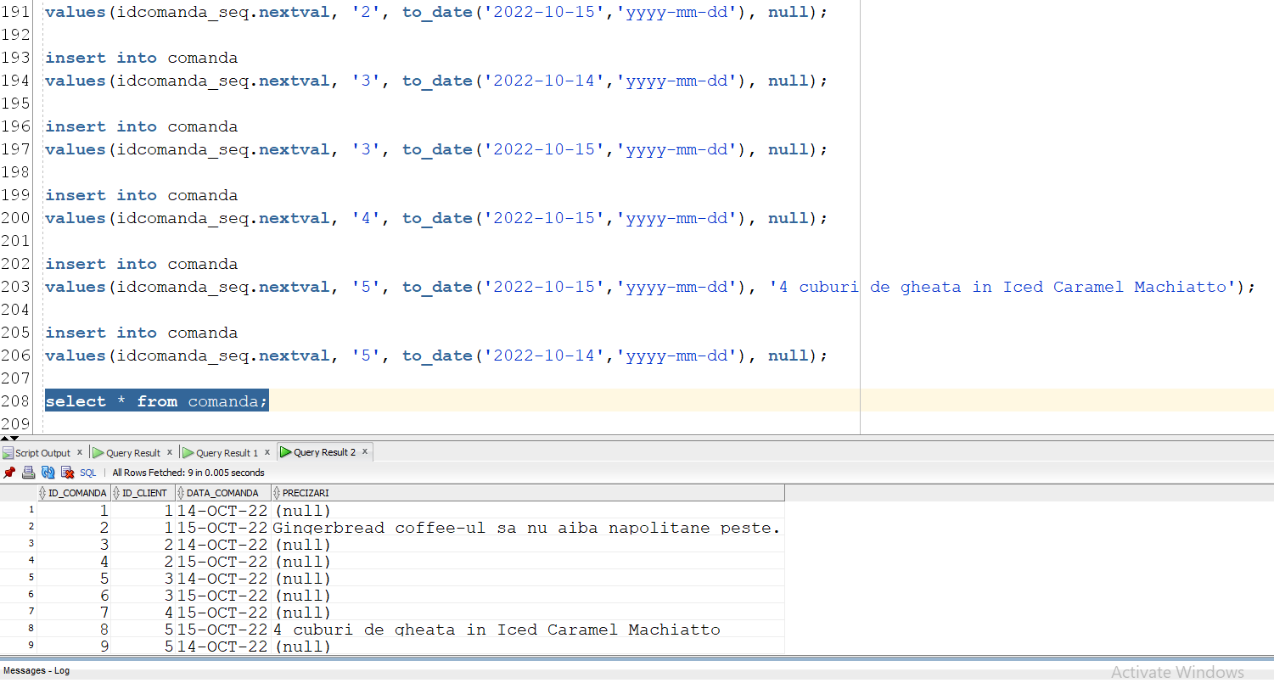

insert into item_comanda  
values(1, 1, 1);  
   
insert into item_comanda  
values(1, 3, 1);  
   
insert into item_comanda  
values(2, 6, 1);  
   
insert into item_comanda  
values(3, 4, 1);  
   
insert into item_comanda  
values(4, 5, 2);  
   
insert into item_comanda  
values(5, 2, 1);  
   
insert into item_comanda  
values(5, 7, 2);  
   
insert into item_comanda  
values(6, 4, 2);  
   
insert into item_comanda  
values(7, 1, 4);  
   
insert into item_comanda  
values(8, 7, 1);  
   
insert into item_comanda  
values(9, 5, 2);

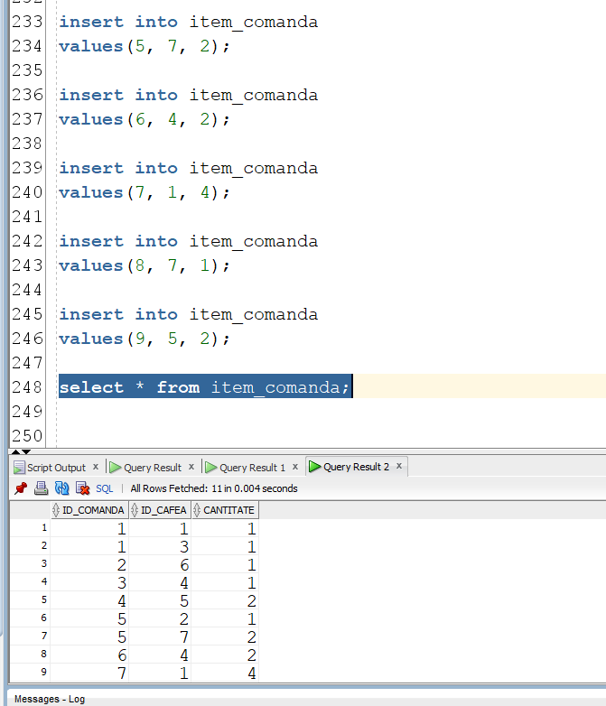

**create** **sequence** reviewid_seq  
**start** **with** 1  
**increment** **by** 1;  
   
**insert** **into** review  
**values**(reviewid_seq.nextval, 1, 'Servire 10/10', 5);  
   
**insert** **into** review  
**values**(reviewid_seq.nextval, 3, null, 4);  
   
**insert** **into** review  
**values**(reviewid_seq.nextval, 2, null, 3);  
   
**insert** **into** review  
**values**(reviewid_seq.nextval, 4, 'Local dragut, voi reveni! :D', 5);  
   
**insert** **into** review  
**values**(reviewid_seq.nextval, 5, 'The coffee was great', 5);

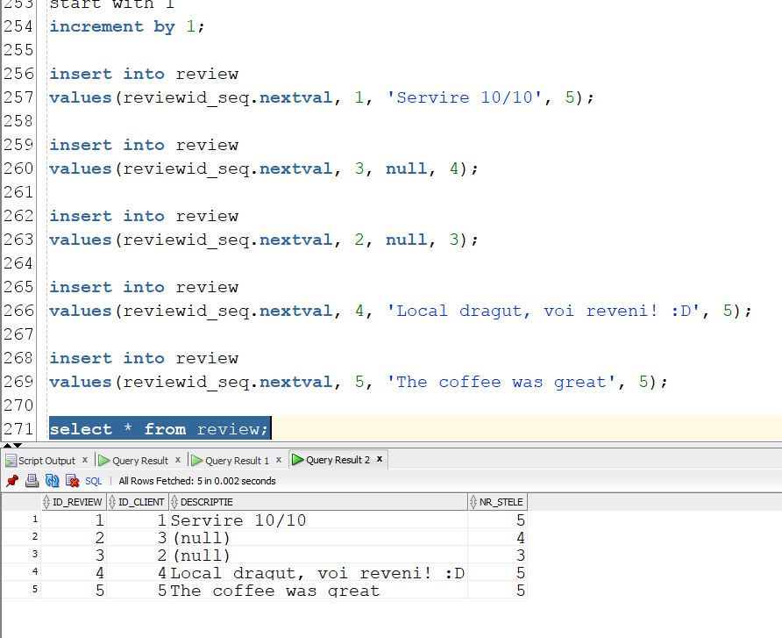

**insert** **into** gen  
**values**(1, 'Actiune');

**insert** **into** gen  
**values**(2, 'Sci-fi');  
   
**insert** **into** gen  
**values**(3, 'Aventura');  
   
**insert** **into** gen  
**values**(4, 'Non-fictiune');  
   
**insert** **into** gen  
**values**(5, 'Dragoste');

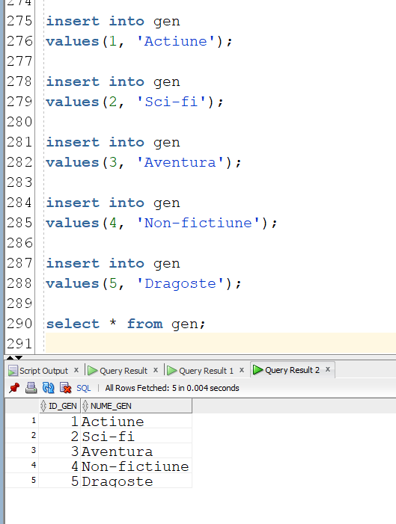

**create** **sequence** carteid_seq  
**start** **with** 1  
**increment** **by** 1;  
   
**insert** **into** carte  
**values**(carteid_seq.nextval, 1, 'Treasure Island', 'R. L. Stevenson',null);  
   
**insert** **into** carte  
**values**(carteid_seq.nextval, 1, 'Desert Star', 'Michael Connelly',null);  
   
**insert** **into** carte  
**values**(carteid_seq.nextval, 2, 'Dune', 'Frank Herbert',null);  
   
**insert** **into** carte  
**values**(carteid_seq.nextval, 2, 'Frankenstein', 'Mary Shelley',null);  
   
**insert** **into** carte  
**values**(carteid_seq.nextval, 2, 'Nineteen Eighty-Four', 'George Orwell',null);  
   
**insert** **into** carte  
**values**(carteid_seq.nextval, 3, 'The Call of the Wild', 'George Orwell',null);  
   
**insert** **into** carte  
**values**(carteid_seq.nextval, 3, 'Odyssey', 'Homer', null);  
   
**insert** **into** carte  
**values**(carteid_seq.nextval, 4, 'The Right Stuff', 'Tom Wolfe', null);  
   
**insert** **into** carte  
**values**(carteid_seq.nextval, 5, 'It Starts with Us', 'Colleen Hoover', null);

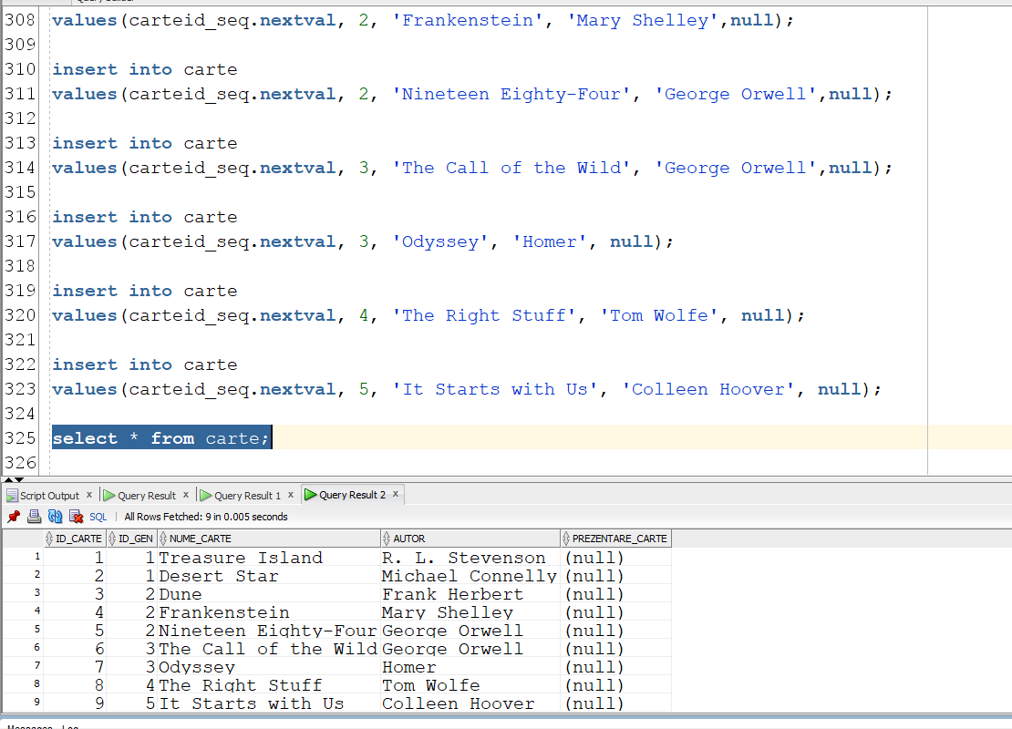

**insert** **into** inventar_carti  
**values**(1, 1);  
   
**insert** **into** inventar_carti  
**values**(2, 2);  
   
**insert** **into** inventar_carti  
**values**(3, 1);  
   
**insert** **into** inventar_carti  
**values**(4, 2);  
   
**insert** **into** inventar_carti  
**values**(5, 3);  
   
**insert** **into** inventar_carti  
**values**(6, 1);  
   
**insert** **into** inventar_carti  
**values**(7, 3);  
   
**insert** **into** inventar_carti  
**values**(8, 1);  
   
**insert** **into** inventar_carti  
**values**(9, 2);

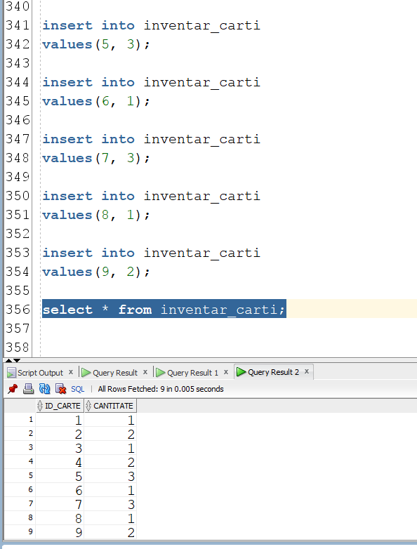

**insert** **into** imprumut  
**values** (1,3, **TO_DATE**('2022-10-14 08:30:25', 'YYYY-MM-DD HH24:MI:SS'),  
            **TO_DATE**('2022-10-14 10:30:09', 'YYYY-MM-DD HH24:MI:SS'));  
              
**insert** **into** imprumut  
**values** (1,1, **TO_DATE**('2022-10-15 12:05:07', 'YYYY-MM-DD HH24:MI:SS'),  
            **TO_DATE**('2022-10-15 12:59:04', 'YYYY-MM-DD HH24:MI:SS'));  
              
**insert** **into** imprumut  
**values** (2,4, **TO_DATE**('2022-10-14 10:34:17', 'YYYY-MM-DD HH24:MI:SS'),  
            **TO_DATE**('2022-10-14 11:27:23', 'YYYY-MM-DD HH24:MI:SS'));  
              
**insert** **into** imprumut  
**values** (2,9, **TO_DATE**('2022-10-15 8:02:23', 'YYYY-MM-DD HH24:MI:SS'),  
            **TO_DATE**('2022-10-15 8:41:29', 'YYYY-MM-DD HH24:MI:SS'));  
   
**insert** **into** imprumut  
**values** (3,2, **TO_DATE**('2022-10-14 18:01:01', 'YYYY-MM-DD HH24:MI:SS'),  
            **TO_DATE**('2022-10-14 18:28:35', 'YYYY-MM-DD HH24:MI:SS'));  
              
**insert** **into** imprumut  
**values** (3,7, **TO_DATE**('2022-10-14 18:28:35', 'YYYY-MM-DD HH24:MI:SS'),  
            **TO_DATE**('2022-10-14 19:00:00', 'YYYY-MM-DD HH24:MI:SS'));  
              
**insert** **into** imprumut  
**values** (3,2, **TO_DATE**('2022-10-15 16:11:10', 'YYYY-MM-DD HH24:MI:SS'),  
            **TO_DATE**('2022-10-15 17:41:22', 'YYYY-MM-DD HH24:MI:SS'));  
   
**insert** **into** imprumut  
**values** (4,3, **TO_DATE**('2022-10-15 12:11:10', 'YYYY-MM-DD HH24:MI:SS'),  
            **TO_DATE**('2022-10-15 12:41:22', 'YYYY-MM-DD HH24:MI:SS'));  
   
**insert** **into** imprumut  
**values** (5,1, **TO_DATE**('2022-10-14 15:13:10', 'YYYY-MM-DD HH24:MI:SS'),  
            **TO_DATE**('2022-10-14 15:49:28', 'YYYY-MM-DD HH24:MI:SS'));  
   
**insert** **into** imprumut  
**values** (5,1, **TO_DATE**('2022-10-15 18:11:10', 'YYYY-MM-DD HH24:MI:SS'),  
            **TO_DATE**('2022-10-15 19:00:00', 'YYYY-MM-DD HH24:MI:SS'));

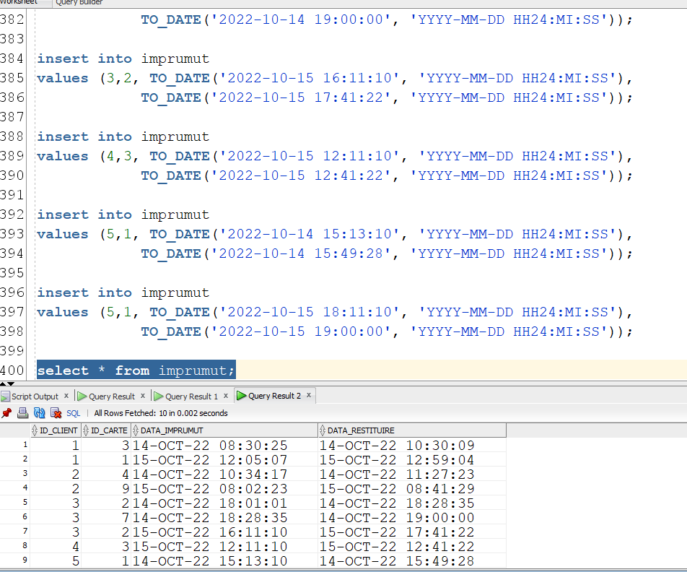

**insert** **into** tip_promotie  
**values**('La 5 comenzi, primesti o cafea small gratuita.', 1);   
   
**insert** **into** tip_promotie  
**values**('Daca lasi un review de 5 stele primesti 10% discount la urmatoarea ta comanda.', 2);

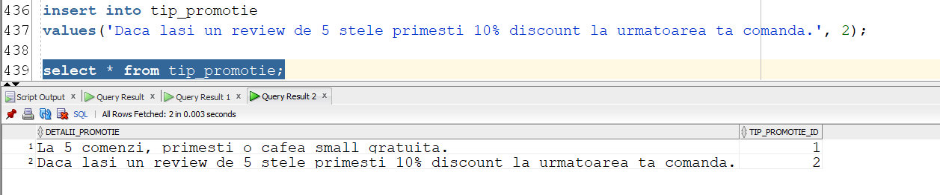

insert into promotie  
values(1,1,2);  
   
insert into promotie  
values(7,4,2);  
   
insert into promotie  
values(9,5,2);

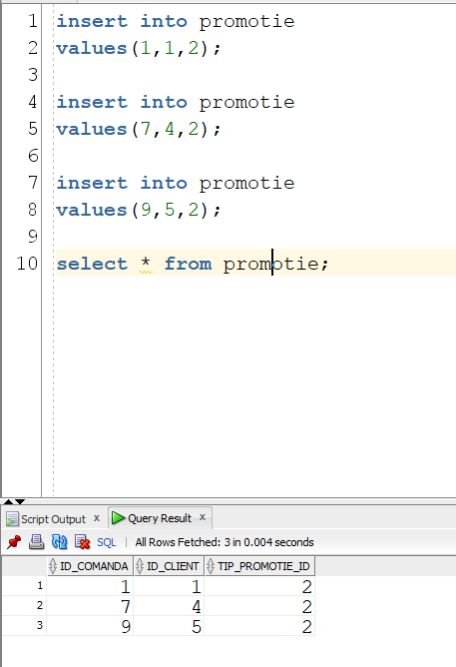

Modificare pt exercitiul 9:

**update** **client**  
    **set** **nume** = 'Jane'  
    where nume = 'Holt';

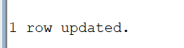

6.

-- Sa se implementeze o procedura care afiseaza clientul care **a** citit cel mai mult timp  
-- si numarul de ore pe care l-**a** citit.  
-- Idee: inregistrez fiecare imprumut intr-un tabel imbricat cu   
-- **in** care retin durata timpului de citit si id-**ul** clientului **in** cauza.  
-- Adun timpurile de citit retinute **in** tabelul imbricat intr-un tablou indexat.  
-- Intr-un **if** clasic determin clientul care **a** citit cel mai mult.

**create** **or replace** **procedure** reading_time  
**is**  
    **type** c_r **is** record  
    (  
    client_id client.id_client%type,  
    readingTime float --in ore  
    );  
    **type** hours_read **is** **table** **of** c_r;  --tablou imbricat  
    client_read_time hours_read;  
    **type** tr **is** **table** **of** c_r **index** **by** pls_integer; --tablou indexat   
    totalReading tr;  
    maxReadingTime FLOAT := 0;  
    idClientMax number(8);  
    numeClient client.nume%type;  
    prenumeClient client.prenume%type;  
    idClient client.id_client%type;  
**begin**  
    **select** id_client, (data_restituire - data_imprumut)*24  
    bulk collect **into** client_read_time  
    **from** imprumut;  
      
    **for** i **in** client_read_time.first..client_read_time.last **loop**  
        idClient:= client_read_time(i).client_id;  
        totalReading(idClient).client_id := client_read_time(i).client_id;  
        totalReading(idClient).readingTime := 0;  
    **end** **loop**;  
   
    **for** i **in** client_read_time.first..client_read_time.last **loop**  
        idClient:= client_read_time(i).client_id;  
        totalReading(idClient).readingTime := totalReading(idClient).readingTime + client_read_time(i).readingTime;  
          
        **if** totalReading(idClient).readingTime > maxReadingTime **then**  
            maxReadingTime := totalReading(idClient).readingTime;  
            idClientMax := idClient;  
        **end** **if**;  
    **end** **loop**;  
      
    **select** c.nume, c.prenume **into** numeClient, prenumeClient  
    **from** client c  
    **where** idClientMax = c.id_client;  
      
    dbms_output.put_line('Clientul ' || numeClient || ' ' || prenumeClient ||' a citit cel mai mult timp' ||  
    ', in total ' || trunc(maxReadingTime,2) || ' ore.');  
**end**;  
   
**begin**  
    reading_time();  
**end**;

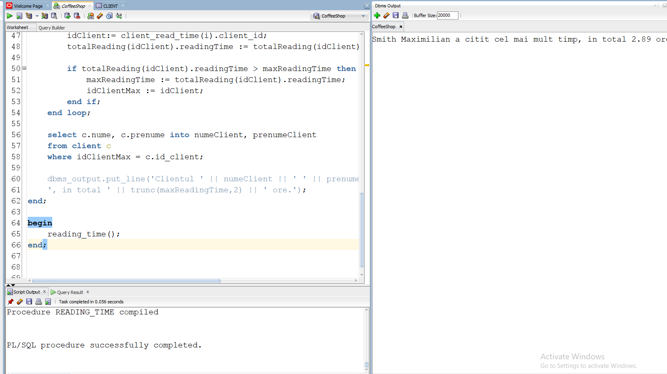

7.

- --7.  
--Pentru un client al carui nume e dat de la tastatura,  
--sa se afiseze, totalul de ingrediente care a fost folosit  
--in prepararea comenzilor lui, de-a lungul istoricului sau  
--de comenzi  
**create** **or replace** **procedure** coffee_times  
(client_nume client.nume%type,  
client_prenume client.prenume%type)  
**is**   
    **cursor** c **is**   
    **select** id_comanda **from** comanda  
    **where** id_client = (**select** id_client **from** client   
    **where** upper(nume) = upper(client_nume)   
    **and** upper(prenume) = upper(client_prenume));  
      
    **cursor** c1(id_com comanda.id_comanda%type) **is**   
    **select** id_cafea, cantitate **from** item_comanda  
    **where** id_comanda = id_com;  
      
    **cursor** c2(idcaf cafea.id_cafea%type)  
    **is** **select** id_ingredient, cantitate  
    **from** contine_ingrediente **where** id_cafea = idcaf;  
      
    cafeaCantitate c1%rowtype;  
    ingredientCantitate c2%rowtype;  
      
    **type** ingred **is** record  
    (  
    id_ing ingredient.id_ingredient%type,  
    cantitate contine_ingrediente.cantitate%type  
    );  
    **type** ingTab **is** **table** **of** ingred;  
    ingredientsTable ingTab := ingTab();  
    nringred number(4);  
    ingredientName ingredient.nume_ingredient%type;  
    nrclienti number(4);  
    notfoundexc **exception**;  
**begin**  
    **select** count(id_client) **into** nrclienti **from** client   
    **where** upper(nume) = upper(client_nume)   
    **and** upper(prenume) = upper(client_prenume);  
      
    **if** nrclienti = 0 **then**  
        **raise** notfoundexc;   
    **end** **if**;  
   
    **select** count(*) **into** nringred   
    **from** ingredient;  
    ingredientsTable.extend(nringred+1);  
    **for** i **in** 1..nringred **loop**  
        ingredientsTable(i).id_ing := i;  
        ingredientsTable(i).cantitate := 0;  
    **end** **loop**;  
    **for** comanda_entry **in** c **loop** --ciclu cursor  
        **open** c1(comanda_entry.id_comanda);  
        **loop**  
            **fetch** c1 **into** cafeaCantitate; --cursor clasic  
            **exit** **when** c1%NOTFOUND;  
                **for** ingredientCantitate **in** c2(cafeaCantitate.id_cafea) **loop**  
                    --acum am: in comanda_entry Id comanda  
                    --in cafeaCantitate id_cafea si cantitatea cafelei  
                    --in ingredientCantitate id_ingredient si cantitatea ingredientului  
                    ingredientsTable(ingredientCantitate.id_ingredient).cantitate :=   
                    ingredientsTable(ingredientCantitate.id_ingredient).cantitate +   
                    cafeaCantitate.cantitate * ingredientCantitate.cantitate;  
                **end** **loop**;  
        **end** **loop**;  
        **close** c1;  
    **end** **loop**;  
    dbms_output.put_line('Clientul cu numele ' || client_nume || ' ' || client_prenume || ' a comandat:');  
    **for** i **in** ingredientsTable.first..ingredientsTable.last **loop**  
        **select** nume_ingredient **into** ingredientName   
        **from** ingredient  
        **where** id_ingredient = i;  
        dbms_output.put_line(ingredientsTable(i).cantitate || ' ' || ingredientName);  
    **end** **loop**;  
    **exception**  
    **when** notfoundexc **then**  
    dbms_output.put_line('Clientul nu exista.');  
    **when** others **then**  
    dbms_output.put_line('');  
**end**;  
   
**BEGIN**  
  coffee_times('Phelps','Jason');  
**END**;

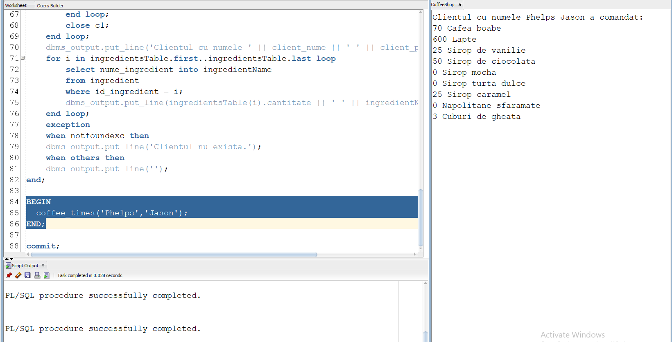

8  
  
8  
  
--Sa se scrie o functie care returneaza numarul mediu  
--de comenzi facute de un client care a lasat un review  
--de X stele (x fiind parametru dat), si afiseaza descriptiile review-urilor **in** cauza (daca   
--nu exista cel putin o descriere, se va apela o exceptie).

**create** **or replace** **function** avg_orders(stele review.nr_stele%type)  
**return** float **is**   
no_reviews **EXCEPTION**;  
PRAGMA exception_init(no_reviews, -20001);  
   
no_descriptions **EXCEPTION**;  
PRAGMA exception_init(no_descriptions, -20002);  
   
orderNumber float;  
**type** descriptionAndCount **is** record  
(  
id_client client.id_client%type,  
countOfOrders number(6),  
review_description review.descriptie%type  
);  
**type** descCount **is** **table** **of** descriptionAndCount **index** **by** pls_integer;  
reviewTable descCount;   
numberOfOrders number(4) := 0;  
numberOfClients number(4) :=0;  
numberOfDescriptions number(4) :=0;  
**begin**  
    **select** count(*) **into** numberOfClients  
    **from** review  
    **where** nr_stele = stele;  
      
    **if** numberOfClients =0 **then**  
        raise_application_error(-20001, '');  
    **end** **if**;  
    numberOfClients := 0;  
    **select** max(c.id_client), count(com.id_comanda), max(r.descriptie) bulk collect **into** reviewTable  
    **from** review r   
    **join** client c   
    **on** r.id_client = c.id_client  
    **join** comanda com   
    **on** com.id_client = c.id_client  
    **where** r.nr_stele = stele  
    **group** **by** c.id_client;  
    dbms_output.put_line('Descrieri review-uri:');  
    **for** i **in** reviewTable.first..reviewTable.last **loop**  
       numberOfOrders := numberOfOrders + reviewTable(i).countOfOrders;  
       numberOfClients := numberOfClients +1;  
       **if** reviewTable(i).review_description **is** **not** **null** **then**  
       dbms_output.put_line(reviewTable(i).review_description);  
       numberOfDescriptions := numberOfDescriptions + 1;  
       **end** **if**;  
    **end** **loop**;  
    **if** numberOfDescriptions =0 **then**  
    raise_application_error(-20002,'');  
    **end** **if**;  
    orderNumber := numberOfOrders * 1.0 / numberOfClients;  
    **return** trunc(orderNumber,3);  
    **exception**  
    **when** no_reviews **then**  
    dbms_output.put_line('Niciun review cu numarul de stele specificat');  
    **return** -1;  
    **when** no_descriptions **then**  
    dbms_output.put_line('Niciun review cu numarul de stele specificat care sa aiba descriere');  
    **return** -1;  
**end** avg_orders;

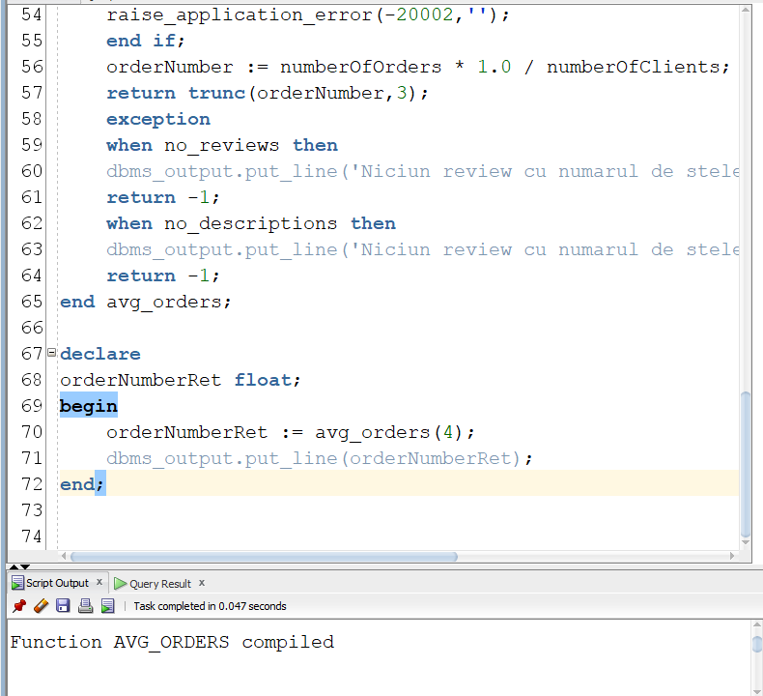

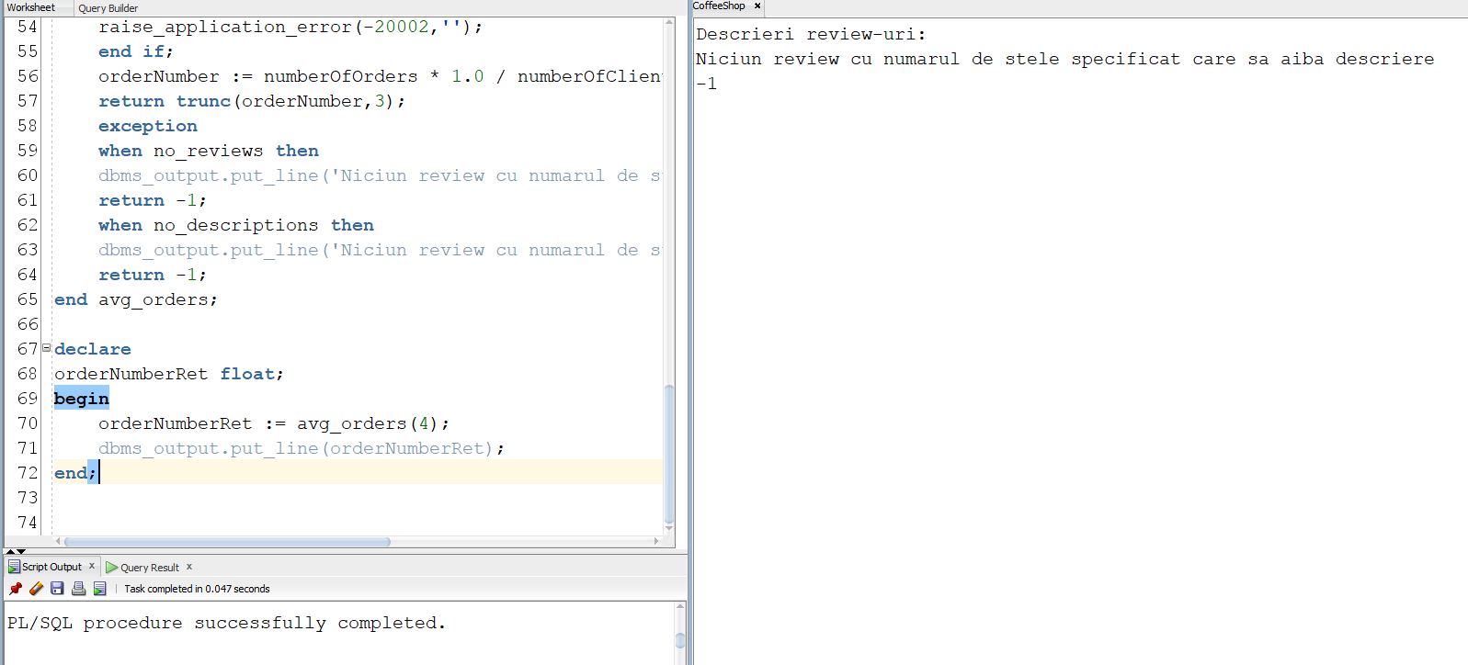

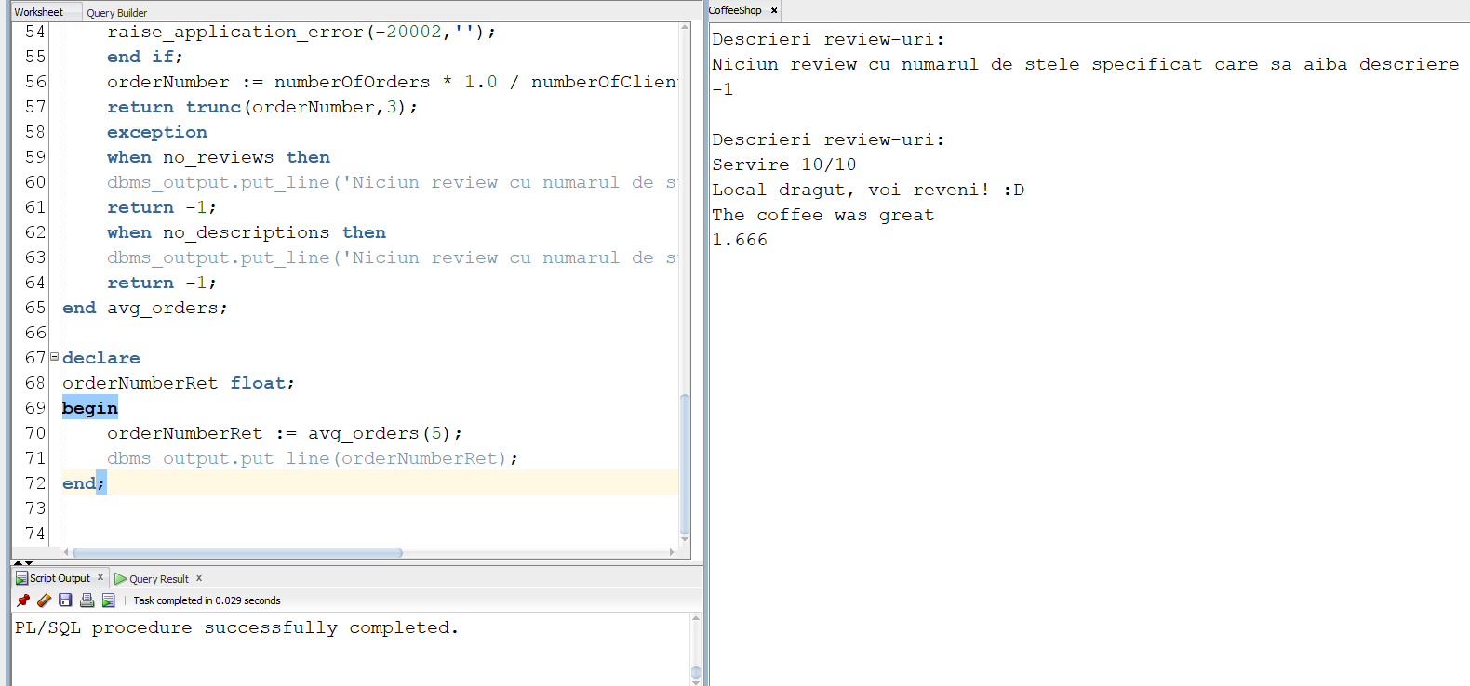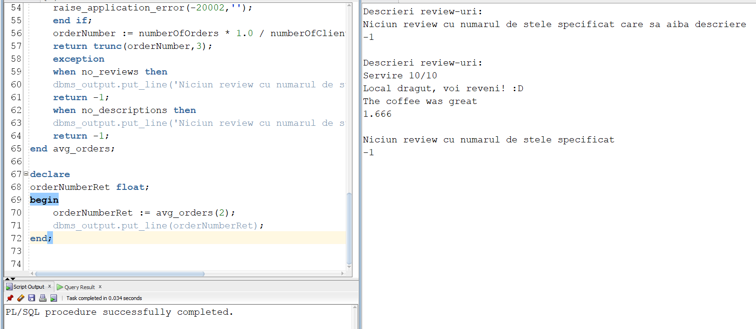

9.   
--9. Pentru un client cu numele dat de la tastatura,  
-- sa se verifice daca clientul a comandat o cafea venti si  
-- a imprumutat o carte din categoria actiune in cadrul aceleasi vizite.

**create** **or replace** **procedure** client_check  
(client_name client.nume%type)  
**is**  
    **cursor** c1(cid client.id_client%type) **is**   
    **select** c.id_client, caf.tip_cafea, g.nume_gen, com.data_comanda, imp.data_imprumut  
    **from** client c   
    **join** comanda com   
    **on** com.id_client = c.id_client  
    **join** item_comanda ic  
    **on** ic.id_comanda = com.id_comanda  
    **join** cafea caf  
    **on** caf.id_cafea = ic.id_cafea  
    **join** imprumut imp   
    **on** imp.id_client = c.id_client  
    **join** carte car   
    **on** car.id_carte = imp.id_carte  
    **join** gen g  
    **on** g.id_gen = car.id_gen  
    **where** id_client = cid;  
    clientId client.id_client%type;   
    ok boolean := **false**;  
**begin**  
    **select** id_client **into** clientId  
    **from** client c  
    **where** upper(c.nume) = upper(client_name);  
      
    **for** fullElem **in** c1(clientId) **loop**  
        **if** fullElem.tip_cafea = 'Venti' **and** fullElem.nume_gen = 'Actiune' **and**   
        trunc(fullElem.data_comanda) = trunc(fullElem.data_imprumut) **then**  
        ok := **true**;  
        **end** **if**;  
    **end** **loop**;  
      
    **if** ok = **true** **then**  
        dbms_output.put_line('Clientul ' || client_name || ' indeplineste criteriile.');  
    **else**  
        dbms_output.put_line('Clientul ' || client_name || ' nu indeplineste criteriile.');  
    **end** **if**;  
    **exception**  
        **when** no_data_found **then**  
        dbms_output.put_line('Niciun client cu numele specificat.');  
        **when** too_many_rows **then**  
        dbms_output.put_line('Mai multi clienti au numele specificat.');  
**end**;

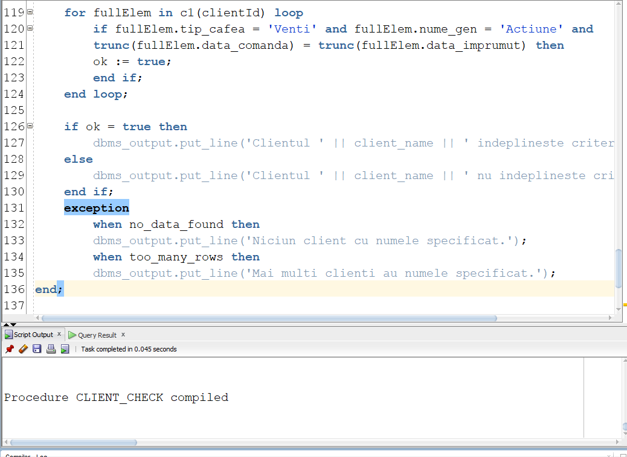

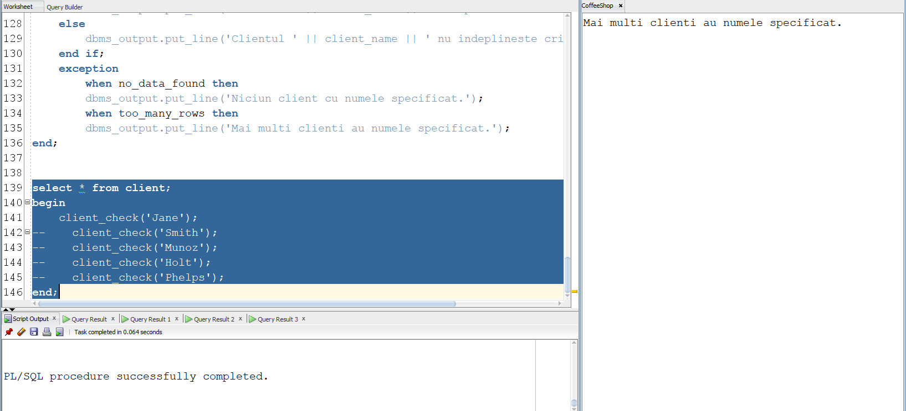

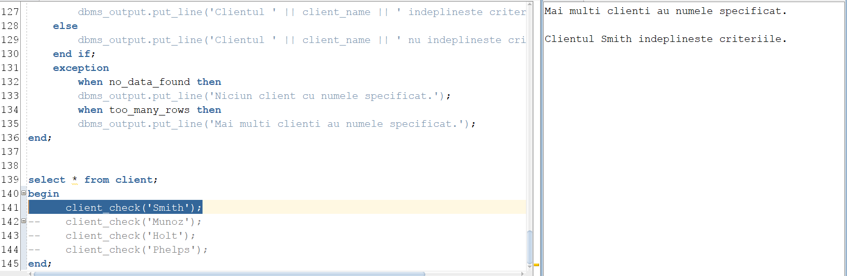

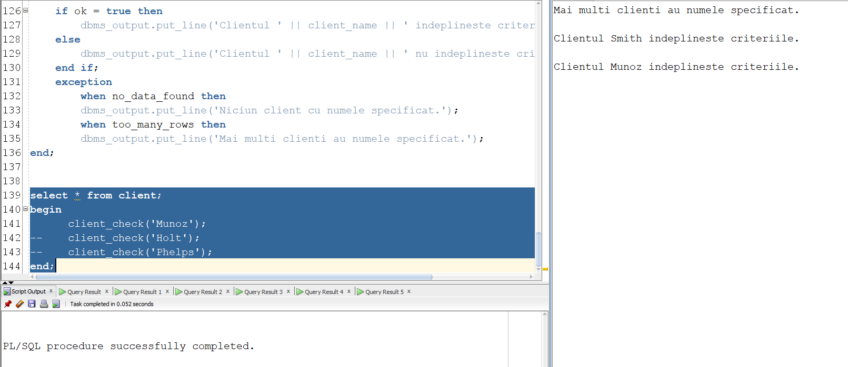

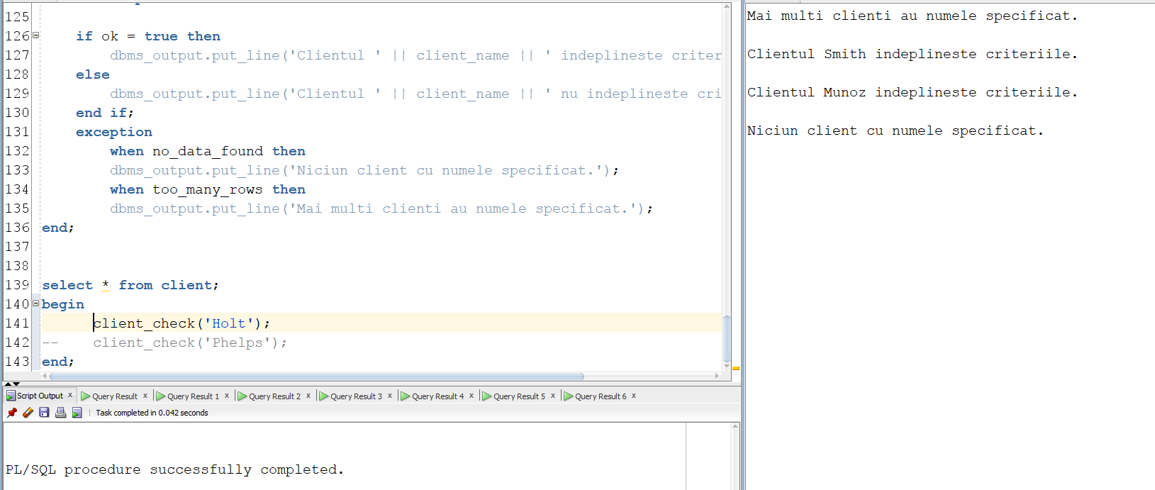

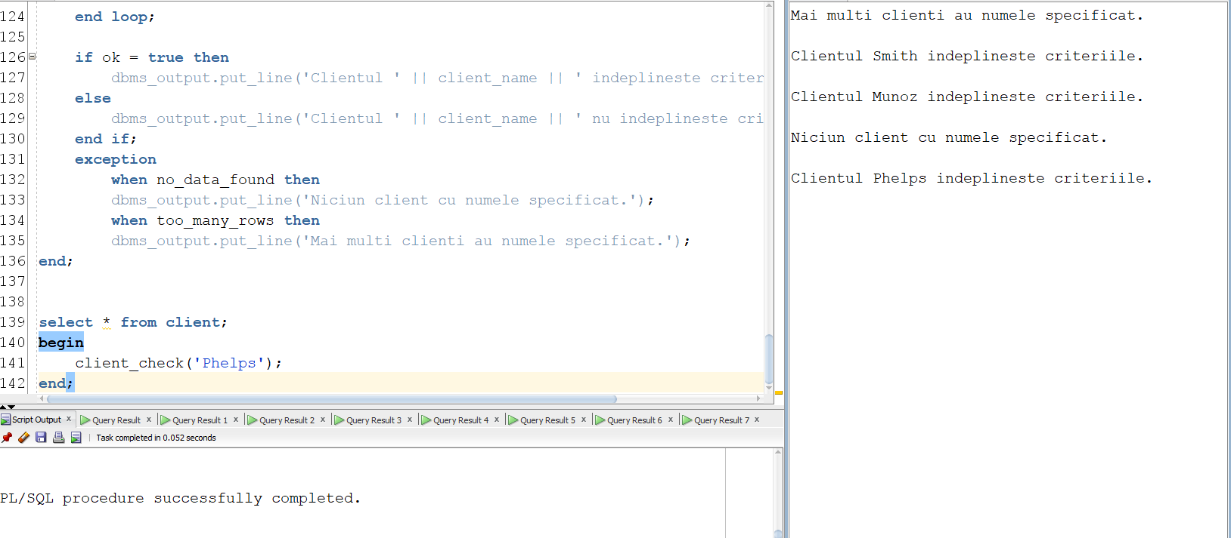

10.

10. --Definiti un trigger care sa introduca intr-un tabel nou definit de  
-- notificari cate un anunt pentru fiecare ingredient al  
-- carui stoc a scazut peste limita admisa.  
**create** **table** notificari   
(  
id_notificare number(3),  
descriere varchar2(100),  
data_notificare date,  
**constraint** id_notificare_pk **primary key** (id_notificare)  
);  
   
**create** **sequence** notificari_seq  
**start** **with** 1  
**increment** **by** 1;  
   
**create** **or replace** **trigger** forbidden_access  
    **after** **insert** **on** item_comanda  
**declare**  
qantitate inventar_ingrediente.cantitate_disponibila%type;  
numeIng ingredient.nume_ingredient%type;  
**begin**  
    **for** i **in** 1..9 **loop**   
        **select** cantitate_disponibila **into** qantitate  
        **from** inventar_ingrediente  
        **where** id_ingredient = i;  
          
        **if** i=1 **and** qantitate <5000 **then**  
            **insert** **into** notificari **values** (notificari_seq.nextval, 'Trebuie cumparata cafea.', sysdate);  
              
        **elsif** i=2 **and** qantitate <2500 **then**  
            **insert** **into** notificari **values** (notificari_seq.nextval, 'Trebuie cumparat lapte.', sysdate);  
              
        **elsif** i>2 **and** i<8 **and** qantitate <500 **then**  
            **select** nume_ingredient **into** numeIng  
            **from** ingredient  
            **where** id_ingredient = i;  
              
            **insert** **into** notificari **values**(notificari_seq.nextval, 'Trebuie cumparat' || numeIng, sysdate);  
        **elsif** i=8 **and** qantitate <100 **then**  
            **insert** **into** notificari **values**(notificari_seq.nextval, 'Trebuie cumparate napolitane.', sysdate);  
        **elsif** i=9 **and** qantitate <5 **then**  
            **insert** **into** notificari **values**(notificari_seq.nextval, 'Trebuie cumparate cuburi de gheata.', SYSDATE);  
        **end** **if**;  
    **end** **loop**;  
**end**;  
   
**begin**  
    **insert** **into** item_comanda **values** (10, 7, 33);  
**end**;  
**select** * **from** notificari;  
**commit**;

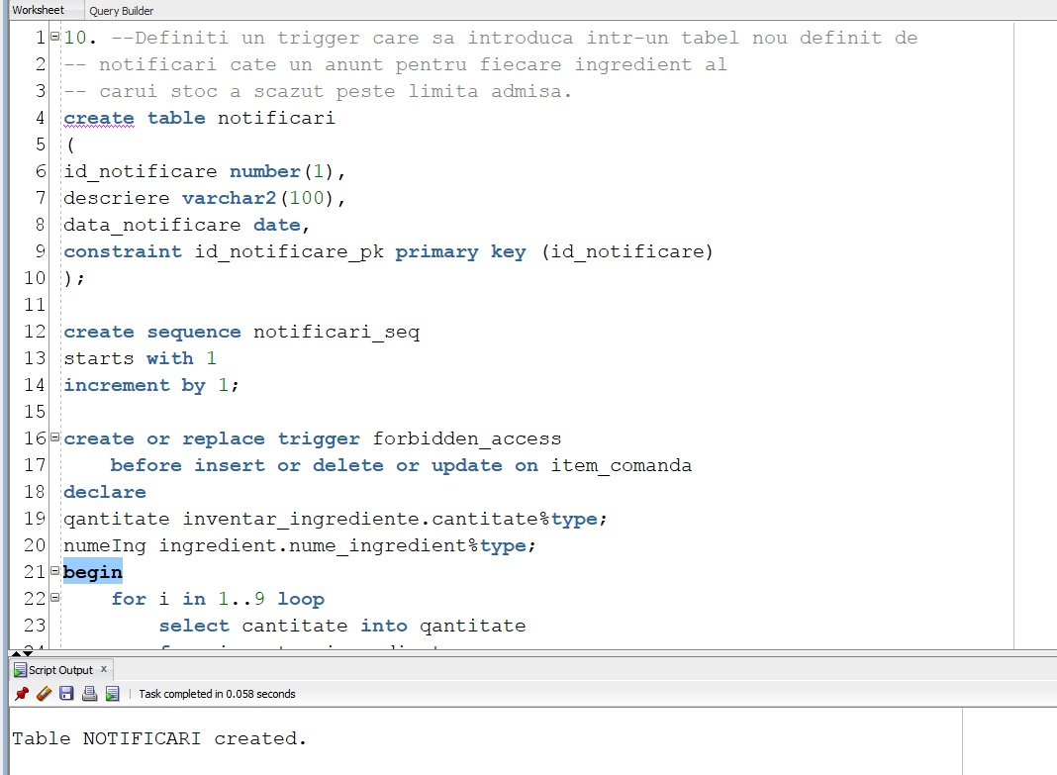

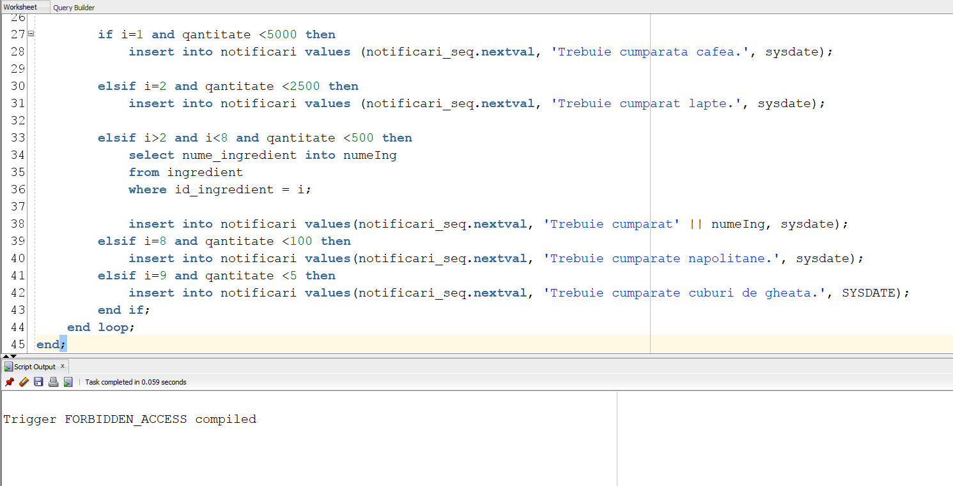

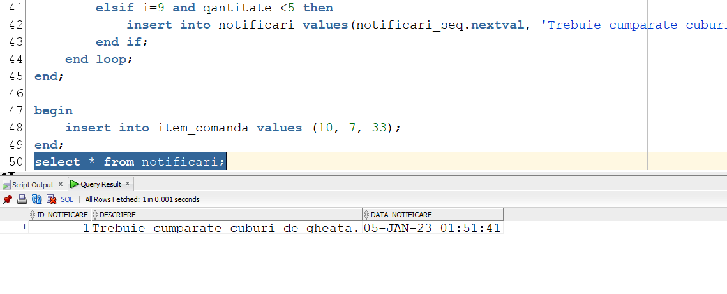

11.  
-- Creati un trigger care, odata introdusa o cafea ca membra a unei comenzi,  
-- scade din inventarul ingredientelor pe care le contine cantitatile   
-- respective.  
   
**create** **or replace** **trigger** triggerInventory  
    **after** **insert** **on** item_comanda  
    **for** **each** **row**  
**declare**  
    **cursor** c(id_caf cafea.id_cafea%type) **is** **select**   
    id_ingredient, cantitate **from** contine_ingrediente ci  
    **where** ci.id_cafea = id_caf;   
    c_d inventar_ingrediente.cantitate_disponibila%type;  
**begin**  
    **for** i **in** c(:new.id_cafea) **loop**  
        **select** cantitate_disponibila **into** c_d  
        **from** inventar_ingrediente  
        **where** id_ingredient = i.id_ingredient;  
        **if** c_d < :new.cantitate * i.cantitate **then**  
            **rollback**;  
            RAISE_APPLICATION_ERROR (-20010, 'Nu sunt destule ingrediente pentru prepararea comenzii');  
        **else**  
            **update** inventar_ingrediente  
            **set** cantitate_disponibila = cantitate_disponibila - :new.cantitate * i.cantitate  
            **where** id_ingredient = i.id_ingredient;  
        **end** **if**;  
    **end** **loop**;  
**end**;

**select** * **from** inventar_ingrediente;  
   
**insert** **into** comanda **values**(10, 1, **to_date**('16-10-2022', 'DD-MM-YYYY'), null);  
**insert** **into** item_comanda **values**(10, 5, 2);

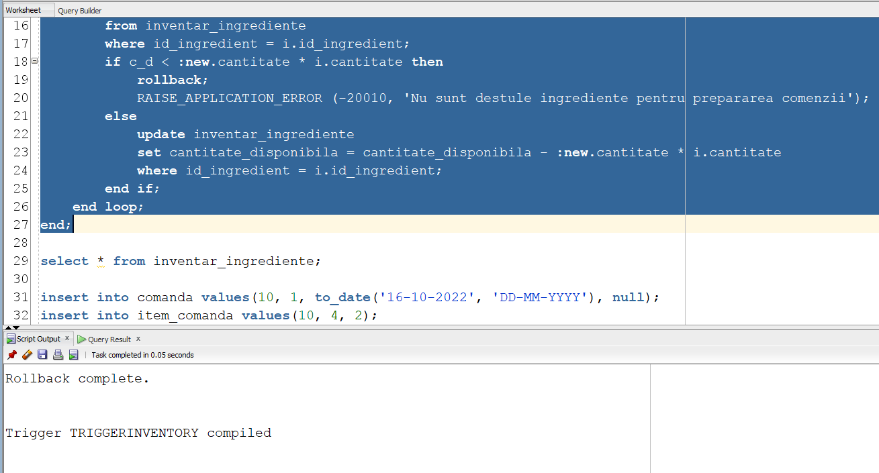

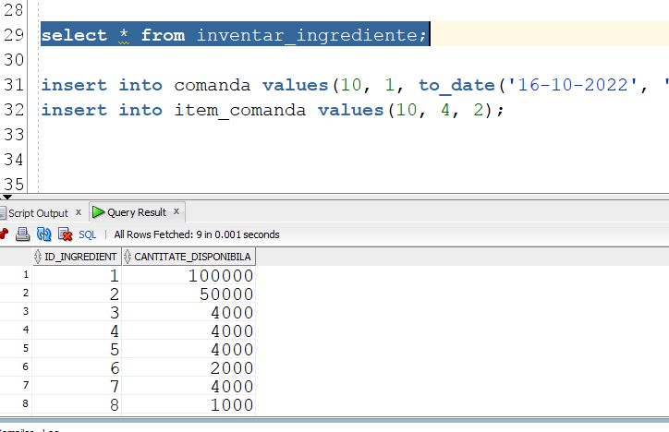

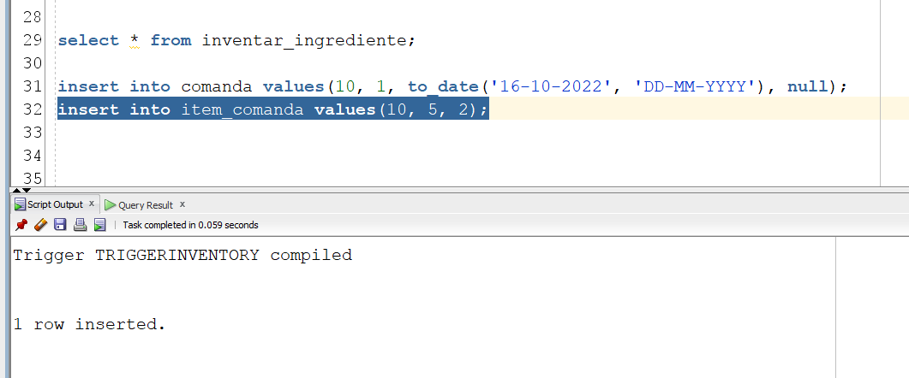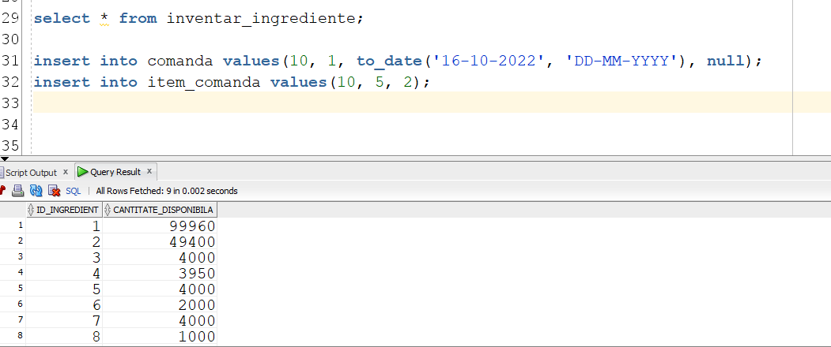

12.  
   
--12.

--Definiti un trigger de tip LDD care sa retina intr-un tabel auxiliar istoricul  
--comenzilor de tip LDD apelate de catre un user. Totodata, interziceti stergerea  
--tabelelor de catre oricare alt utilizator decat adminul.  
**create** **table** user_history  
(  
user_name varchar2(20),  
**event**      varchar2(20),    
obj_name varchar2(20),  
**data**      date       
);  
   
**create** **or** **replace** **trigger** ldd_trigger  
**before** **create** **or** **alter** **or** **drop** **on** **schema**  
**begin**  
    **if** sys.sysevent = 'DROP' **and** **user**!= 'DUDU' **then**  
        RAISE_APPLICATION_ERROR(-20014, 'Numai administratorul poate folosi comanda drop table.');  
    **end** **if**;  
    **insert** **into** user_history **values**(SYS.LOGIN_USER, SYS.SYSEVENT, SYS.DICTIONARY_OBJ_NAME, **SYSDATE**);  
**end**;  
   
**create** **table** something(  
nimic varchar2(10)  
);  
   
**select** * **from** user_history;  
**drop** **table** something;  
/

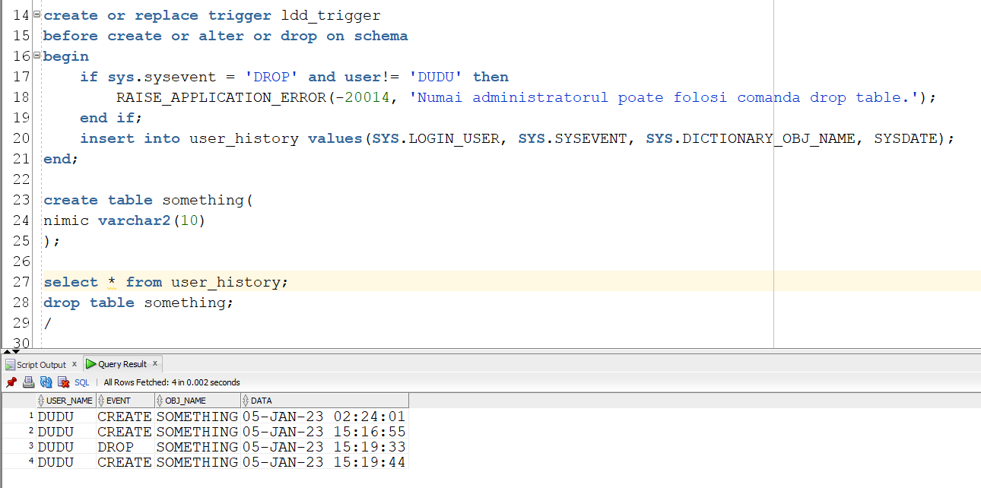

13.

**create** **or replace** package pachet_sgbd **as**  
--6.  
**procedure** reading_time;  
--7.  
**procedure** coffee_times (client_nume client.nume%type,   
                        client_prenume client.prenume%type);  
--8.  
**function** avg_orders(stele review.nr_stele%type)   
    **return** float;  
--9.  
**procedure** client_check (client_name client.nume%type);  
**end** pachet_sgbd;

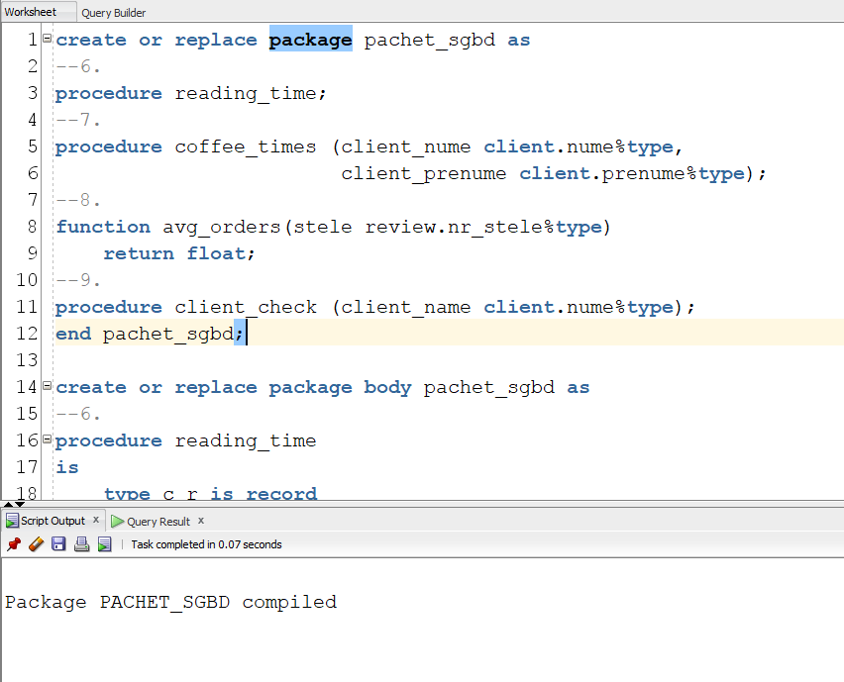

**create** **or replace** package body pachet_sgbd **as**  
--6.  
**procedure** reading_time  
**is**  
    **type** c_r **is** record  
    (  
    client_id client.id_client%type,  
    readingTime float --in ore  
    );  
    **type** hours_read **is** **table** **of** c_r;  --tablou imbricat  
    client_read_time hours_read;  
    **type** tr **is** **table** **of** c_r **index** **by** pls_integer; --tablou indexat   
    totalReading tr;  
    maxReadingTime FLOAT := 0;  
    idClientMax number(8);  
    numeClient client.nume%type;  
    prenumeClient client.prenume%type;  
    idClient client.id_client%type;  
**begin**  
    **select** id_client, (data_restituire - data_imprumut)*24  
    bulk collect **into** client_read_time  
    **from** imprumut;  
      
    **for** i **in** client_read_time.first..client_read_time.last **loop**  
        idClient:= client_read_time(i).client_id;  
        totalReading(idClient).client_id := client_read_time(i).client_id;  
        totalReading(idClient).readingTime := 0;  
    **end** **loop**;  
   
    **for** i **in** client_read_time.first..client_read_time.last **loop**  
        idClient:= client_read_time(i).client_id;  
        totalReading(idClient).readingTime := totalReading(idClient).readingTime + client_read_time(i).readingTime;  
          
        **if** totalReading(idClient).readingTime > maxReadingTime **then**  
            maxReadingTime := totalReading(idClient).readingTime;  
            idClientMax := idClient;  
        **end** **if**;  
    **end** **loop**;  
      
    **select** c.nume, c.prenume **into** numeClient, prenumeClient  
    **from** client c  
    **where** idClientMax = c.id_client;  
      
    dbms_output.put_line('Clientul ' || numeClient || ' ' || prenumeClient ||' a citit cel mai mult timp' ||  
    ', in total ' || trunc(maxReadingTime,2) || ' ore.');  
**end**;  
--7.  
**procedure** coffee_times  
(client_nume client.nume%type,  
client_prenume client.prenume%type)  
**is**   
    **cursor** c **is**   
    **select** id_comanda **from** comanda  
    **where** id_client = (**select** id_client **from** client   
    **where** upper(nume) = upper(client_nume)   
    **and** upper(prenume) = upper(client_prenume));  
      
    **cursor** c1(id_com comanda.id_comanda%type) **is**   
    **select** id_cafea, cantitate **from** item_comanda  
    **where** id_comanda = id_com;  
      
    **cursor** c2(idcaf cafea.id_cafea%type)  
    **is** **select** id_ingredient, cantitate  
    **from** contine_ingrediente **where** id_cafea = idcaf;  
      
    cafeaCantitate c1%rowtype;  
    ingredientCantitate c2%rowtype;  
      
    **type** ingred **is** record  
    (  
    id_ing ingredient.id_ingredient%type,  
    cantitate contine_ingrediente.cantitate%type  
    );  
    **type** ingTab **is** **table** **of** ingred;  
    ingredientsTable ingTab := ingTab();  
    nringred number(4);  
    ingredientName ingredient.nume_ingredient%type;  
    nrclienti number(4);  
    notfoundexc **exception**;  
**begin**  
    **select** count(id_client) **into** nrclienti **from** client   
    **where** upper(nume) = upper(client_nume)   
    **and** upper(prenume) = upper(client_prenume);  
      
    **if** nrclienti = 0 **then**  
        **raise** notfoundexc;   
    **end** **if**;  
   
    **select** count(*) **into** nringred   
    **from** ingredient;  
    ingredientsTable.extend(nringred+1);  
    **for** i **in** 1..nringred **loop**  
        ingredientsTable(i).id_ing := i;  
        ingredientsTable(i).cantitate := 0;  
    **end** **loop**;  
    **for** comanda_entry **in** c **loop** --ciclu cursor  
        **open** c1(comanda_entry.id_comanda);  
        **loop**  
            **fetch** c1 **into** cafeaCantitate; --cursor clasic  
            **exit** **when** c1%NOTFOUND;  
                **for** ingredientCantitate **in** c2(cafeaCantitate.id_cafea) **loop**  
                    --acum am: in comanda_entry Id comanda  
                    --in cafeaCantitate id_cafea si cantitatea cafelei  
                    --in ingredientCantitate id_ingredient si cantitatea ingredientului  
                    ingredientsTable(ingredientCantitate.id_ingredient).cantitate :=   
                    ingredientsTable(ingredientCantitate.id_ingredient).cantitate +   
                    cafeaCantitate.cantitate * ingredientCantitate.cantitate;  
                **end** **loop**;  
        **end** **loop**;  
        **close** c1;  
    **end** **loop**;  
    dbms_output.put_line('Clientul cu numele ' || client_nume || ' ' || client_prenume || ' a comandat:');  
    **for** i **in** ingredientsTable.first..ingredientsTable.last **loop**  
        **select** nume_ingredient **into** ingredientName   
        **from** ingredient  
        **where** id_ingredient = i;  
        dbms_output.put_line(ingredientsTable(i).cantitate || ' ' || ingredientName);  
    **end** **loop**;  
    **exception**  
    **when** notfoundexc **then**  
    dbms_output.put_line('Clientul nu exista.');  
    **when** others **then**  
    dbms_output.put_line('');  
**end**;  
   
--8.  
**function** avg_orders(stele review.nr_stele%type)  
**return** float **is**   
no_reviews **EXCEPTION**;  
PRAGMA exception_init(no_reviews, -20001);  
   
no_descriptions **EXCEPTION**;  
PRAGMA exception_init(no_descriptions, -20002);  
   
orderNumber float;  
**type** descriptionAndCount **is** record  
(  
id_client client.id_client%type,  
countOfOrders number(6),  
review_description review.descriptie%type  
);  
**type** descCount **is** **table** **of** descriptionAndCount **index** **by** pls_integer;  
reviewTable descCount;   
numberOfOrders number(4) := 0;  
numberOfClients number(4) :=0;  
numberOfDescriptions number(4) :=0;  
**begin**  
    **select** count(*) **into** numberOfClients  
    **from** review  
    **where** nr_stele = stele;  
      
    **if** numberOfClients =0 **then**  
        raise_application_error(-20001, '');  
    **end** **if**;  
    numberOfClients := 0;  
    **select** max(c.id_client), count(com.id_comanda), max(r.descriptie) bulk collect **into** reviewTable  
    **from** review r   
    **join** client c   
    **on** r.id_client = c.id_client  
    **join** comanda com   
    **on** com.id_client = c.id_client  
    **where** r.nr_stele = stele  
    **group** **by** c.id_client;  
    dbms_output.put_line('Descrieri review-uri:');  
    **for** i **in** reviewTable.first..reviewTable.last **loop**  
       numberOfOrders := numberOfOrders + reviewTable(i).countOfOrders;  
       numberOfClients := numberOfClients +1;  
       **if** reviewTable(i).review_description **is** **not** **null** **then**  
       dbms_output.put_line(reviewTable(i).review_description);  
       numberOfDescriptions := numberOfDescriptions + 1;  
       **end** **if**;  
    **end** **loop**;  
    **if** numberOfDescriptions =0 **then**  
    raise_application_error(-20002,'');  
    **end** **if**;  
    orderNumber := numberOfOrders * 1.0 / numberOfClients;  
    **return** trunc(orderNumber,3);  
    **exception**  
    **when** no_reviews **then**  
    dbms_output.put_line('Niciun review cu numarul de stele specificat');  
    **return** -1;  
    **when** no_descriptions **then**  
    dbms_output.put_line('Niciun review cu numarul de stele specificat care sa aiba descriere');  
    **return** -1;  
**end** avg_orders;  
   
--9.  
**procedure** client_check  
(client_name client.nume%type)  
**is**  
    **cursor** c1(cid client.id_client%type) **is**   
    **select** c.id_client, caf.tip_cafea, g.nume_gen, com.data_comanda, imp.data_imprumut  
    **from** client c   
    **join** comanda com   
    **on** com.id_client = c.id_client  
    **join** item_comanda ic  
    **on** ic.id_comanda = com.id_comanda  
    **join** cafea caf  
    **on** caf.id_cafea = ic.id_cafea  
    **join** imprumut imp   
    **on** imp.id_client = c.id_client  
    **join** carte car   
    **on** car.id_carte = imp.id_carte  
    **join** gen g  
    **on** g.id_gen = car.id_gen  
    **where** id_client = cid;  
    clientId client.id_client%type;   
    ok boolean := **false**;  
**begin**  
    **select** id_client **into** clientId  
    **from** client c  
    **where** upper(c.nume) = upper(client_name);  
      
    **for** fullElem **in** c1(clientId) **loop**  
        **if** fullElem.tip_cafea = 'Venti' **and** fullElem.nume_gen = 'Actiune' **and**   
        trunc(fullElem.data_comanda) = trunc(fullElem.data_imprumut) **then**  
        ok := **true**;  
        **end** **if**;  
    **end** **loop**;  
      
    **if** ok = **true** **then**  
        dbms_output.put_line('Clientul ' || client_name || ' indeplineste criteriile.');  
    **else**  
        dbms_output.put_line('Clientul ' || client_name || ' nu indeplineste criteriile.');  
    **end** **if**;  
    **exception**  
        **when** no_data_found **then**  
        dbms_output.put_line('Niciun client cu numele specificat.');  
        **when** too_many_rows **then**  
        dbms_output.put_line('Mai multi clienti au numele specificat.');  
**end**;  
**end** pachet_sgbd;

